# Supplementary Material

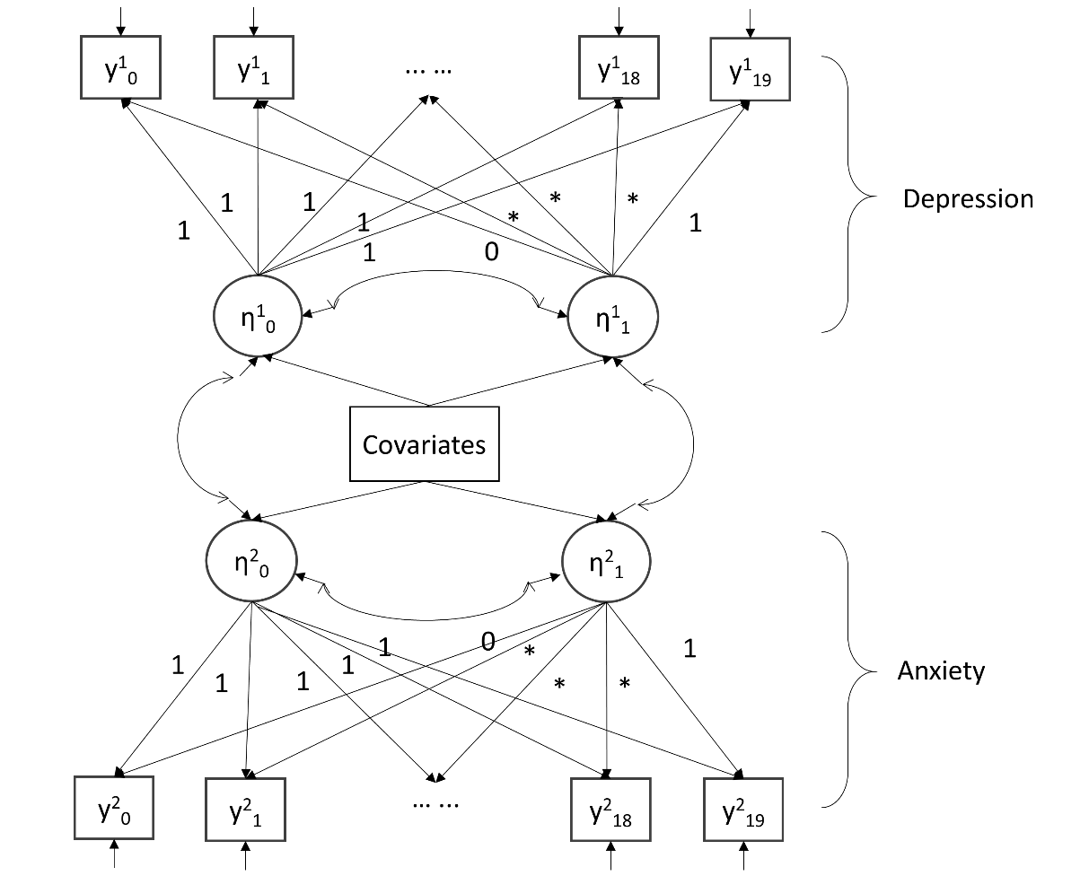

Figure S1. Conditional multi-process LGM

Table S1 Unweighted and weighted descriptive statistics by week

|  |  |  |  |  |  |  |
| --- | --- | --- | --- | --- | --- | --- |
|  | Week 1  (N=16,794) | | Week 2  (N=19,350) | | Week 3  (N=26,020) | |
|  | Raw | Weighted | Raw | Weighted | Raw | Weighted |
| Gender, women | 74.4% | 48.7% | 75.3% | 50.2% | 74.7% | 48.9% |
| Age |  |  |  |  |  |  |
| 18-29 | 7.6% | 17.9% | 7.8% | 18.6% | 7.1% | 17.4% |
| 30-45 | 30.7% | 27.4% | 31.0% | 27.9% | 29.8% | 27.0% |
| 46-59 | 31.7% | 23.9% | 31.6% | 23.5% | 32.7% | 24.3% |
| 60+ | 30.0% | 30.8% | 29.5% | 30.0% | 30.4% | 31.3% |
| Ethnicity, BAME | 4.7% | 13.9% | 5.0% | 14.9% | 4.6% | 13.1% |
| Education |  |  |  |  |  |  |
| GCSE or below | 13.2% | 32.4% | 12.8% | 32.0% | 13.6% | 33.7% |
| A-levels or equivalent | 17.1% | 32.8% | 16.6% | 32.2% | 17.4% | 32.8% |
| Degree or above | 69.8% | 34.8% | 70.6% | 35.9% | 69.0% | 33.5% |
| Household income <30k | 36.9% | 46.8% | 36.2% | 46.0% | 37.3% | 46.9% |
| Living status |  |  |  |  |  |  |
| Alone | 19.3% | 18.5% | 19.1% | 18.1% | 19.3% | 18.6% |
| With others (not children) | 53.7% | 56.7% | 53.8% | 56.6% | 53.4% | 55.9% |
| With others (including children) | 27.0% | 24.9% | 27.0% | 25.3% | 27.3% | 25.6% |
| Diagnosed mental illness | 17.7% | 18.5% | 17.3% | 18.5% | 17.8% | 18.7% |

|  |  |  |  |  |  |  |
| --- | --- | --- | --- | --- | --- | --- |
|  | Week 4  (N=26,452) | | Week 5  (N=25,798) | | Week 6  (N=24,838) | |
|  | Raw | Weighted | Raw | Weighted | Raw | Weighted |
| Gender, women | 75.0% | 49.3% | 74.9% | 49.5% | 75.4% | 50.4% |
| Age |  |  |  |  |  |  |
| 18-29 | 7.1% | 17.3% | 7.1% | 17.9% | 6.7% | 17.6% |
| 30-45 | 29.5% | 26.7% | 28.4% | 25.4% | 27.3% | 24.5% |
| 46-59 | 32.7% | 24.2% | 32.6% | 24.0% | 32.8% | 24.0% |
| 60+ | 30.8% | 31.8% | 31.9% | 32.7% | 33.1% | 33.8% |
| Ethnicity, BAME | 4.6% | 13.2% | 4.6% | 13.1% | 4.4% | 13.2% |
| Education |  |  |  |  |  |  |
| GCSE or below | 13.4% | 33.6% | 13.2% | 33.5% | 12.9% | 33.0% |
| A-levels or equivalent | 17.2% | 32.2% | 17.1% | 32.7% | 16.8% | 32.6% |
| Degree or above | 69.5% | 34.1% | 69.7% | 33.8% | 70.3% | 34.4% |
| Household income <30k | 36.9% | 46.4% | 37.5% | 47.3% | 37.4% | 47.4% |
| Living status |  |  |  |  |  |  |
| Alone | 19.7% | 19.0% | 20.1% | 19.3% | 20.5% | 19.3% |
| With others (not children) | 53.3% | 56.1% | 53.9% | 56.8% | 54.3% | 57.7% |
| With others (including children) | 26.9% | 25.0% | 26.0% | 23.9% | 25.3% | 23.0% |
| Diagnosed mental illness | 17.7% | 18.6% | 17.7% | 18.7% | 17.8% | 19.2% |

|  |  |  |  |  |  |  |
| --- | --- | --- | --- | --- | --- | --- |
|  | Week 7  (N=24,689) | | Week 8  (N=25,321) | | Week 9  (N=24,553) | |
|  | Raw | Weighted | Raw | Weighted | Raw | Weighted |
| Gender, women | 75.6% | 50.2% | 75.6% | 50.2% | 75.5% | 49.9% |
| Age |  |  |  |  |  |  |
| 18-29 | 6.4% | 17.2% | 6.3% | 16.3% | 6.2% | 16.3% |
| 30-45 | 26.6% | 23.7% | 25.9% | 23.3% | 25.4% | 22.8% |
| 46-59 | 33.2% | 24.6% | 33.2% | 25.0% | 33.4% | 25.0% |
| 60+ | 33.9% | 34.5% | 34.5% | 35.4% | 35.0% | 35.9% |
| Ethnicity, BAME | 4.5% | 13.0% | 4.6% | 13.2% | 4.4% | 13.1% |
| Education |  |  |  |  |  |  |
| GCSE or below | 12.8% | 33.0% | 12.7% | 32.8% | 12.7% | 32.7% |
| A-levels or equivalent | 16.7% | 32.3% | 16.6% | 32.1% | 16.6% | 32.5% |
| Degree or above | 70.5% | 34.8% | 70.7% | 35.1% | 70.7% | 34.8% |
| Household income <30k | 37.2% | 46.7% | 37.2% | 46.6% | 37.6% | 46.8% |
| Living status |  |  |  |  |  |  |
| Alone | 21.0% | 19.9% | 21.3% | 20.0% | 21.3% | 20.2% |
| With others (not children) | 54.2% | 57.3% | 54.4% | 57.5% | 54.7% | 57.6% |
| With others (including children) | 24.8% | 22.8% | 24.3% | 22.5% | 23.9% | 22.2% |
| Diagnosed mental illness | 17.2% | 18.7% | 17.2% | 18.7% | 17.1% | 18.9% |

|  |  |  |  |  |  |  |
| --- | --- | --- | --- | --- | --- | --- |
|  | Week 10  (N=23,718) | | Week 11  (N=23,020) | | Week 12  (N=22,063) | |
|  | Raw | Weighted | Raw | Weighted | Raw | Weighted |
| Gender, women | 75.9% | 50.5% | 75.9% | 50.5% | 75.8% | 50.5% |
| Age |  |  |  |  |  |  |
| 18-29 | 5.9% | 15.5% | 5.7% | 15.3% | 5.5% | 14.5% |
| 30-45 | 24.7% | 22.3% | 24.3% | 21.9% | 23.7% | 21.3% |
| 46-59 | 33.7% | 25.4% | 33.6% | 25.2% | 33.4% | 25.3% |
| 60+ | 35.7% | 36.9% | 36.5% | 37.6% | 37.4% | 38.8% |
| Ethnicity, BAME | 4.4% | 12.9% | 4.3% | 12.4% | 4.1% | 11.9% |
| Education |  |  |  |  |  |  |
| GCSE or below | 12.7% | 32.8% | 12.7% | 32.9% | 12.9% | 34.0% |
| A-levels or equivalent | 16.6% | 32.2% | 16.5% | 32.3% | 16.5% | 31.5% |
| Degree or above | 70.7% | 35.0% | 70.8% | 34.8% | 70.6% | 34.5% |
| Household income <30k | 37.7% | 46.9% | 38.1% | 47.8% | 38.6% | 47.9% |
| Living status |  |  |  |  |  |  |
| Alone | 21.5% | 20.4% | 21.9% | 20.5% | 22.0% | 20.8% |
| With others (not children) | 55.0% | 58.0% | 55.0% | 58.3% | 55.3% | 58.6% |
| With others (including children) | 23.5% | 21.7% | 23.1% | 21.2% | 22.6% | 20.7% |
| Diagnosed mental illness | 16.9% | 18.4% | 16.8% | 18.3% | 16.6% | 18.1% |

|  |  |  |  |  |  |  |
| --- | --- | --- | --- | --- | --- | --- |
|  | Week 13  (N=21,434) | | Week 14  (N=20,877) | | Week 15  (N=20,149) | |
|  | Raw | Weighted | Raw | Weighted | Raw | Weighted |
| Gender, women | 75.7% | 49.8% | 75.8% | 50.0% | 75.5% | 49.7% |
| Age |  |  |  |  |  |  |
| 18-29 | 5.4% | 14.5% | 5.1% | 14.1% | 4.8% | 12.9% |
| 30-45 | 23.4% | 21.2% | 23.0% | 20.7% | 22.3% | 20.2% |
| 46-59 | 33.3% | 24.9% | 33.2% | 25.1% | 33.4% | 25.5% |
| 60+ | 38.0% | 39.4% | 38.6% | 40.1% | 39.4% | 41.4% |
| Ethnicity, BAME | 4.2% | 12.2% | 4.1% | 11.9% | 3.9% | 11.3% |
| Education |  |  |  |  |  |  |
| GCSE or below | 12.8% | 33.6% | 13.1% | 34.2% | 13.2% | 35.1% |
| A-levels or equivalent | 16.4% | 31.8% | 16.4% | 31.5% | 16.6% | 30.9% |
| Degree or above | 70.8% | 34.6% | 70.5% | 34.3% | 70.3% | 34.0% |
| Household income <30k | 38.6% | 48.0% | 39.0% | 48.2% | 39.3% | 48.4% |
| Living status |  |  |  |  |  |  |
| Alone | 22.2% | 20.9% | 22.3% | 21.0% | 22.6% | 21.2% |
| With others (not children) | 55.5% | 58.9% | 55.6% | 59.1% | 55.8% | 59.2% |
| With others (including children) | 22.3% | 20.2% | 22.1% | 19.9% | 21.5% | 19.6% |
| Diagnosed mental illness | 16.5% | 17.6% | 16.3% | 17.6% | 16.1% | 17.1% |

|  |  |  |  |  |  |  |
| --- | --- | --- | --- | --- | --- | --- |
|  | Week 16  (N=19,357) | | Week 17  (N=18,908) | | Week 18  (N=18,369) | |
|  | Raw | Weighted | Raw | Weighted | Raw | Weighted |
| Gender, women | 75.7% | 49.8% | 75.5% | 49.4% | 75.5% | 49.3% |
| Age |  |  |  |  |  |  |
| 18-29 | 4.8% | 12.9% | 4.5% | 12.4% | 4.5% | 12.2% |
| 30-45 | 22.1% | 19.9% | 21.7% | 20.0% | 21.4% | 19.7% |
| 46-59 | 33.1% | 25.0% | 33.0% | 25.1% | 33.0% | 25.3% |
| 60+ | 40.0% | 42.2% | 40.8% | 42.5% | 41.2% | 42.9% |
| Ethnicity, BAME | 4.0% | 11.4% | 4.0% | 11.5% | 4.0% | 11.2% |
| Education |  |  |  |  |  |  |
| GCSE or below | 13.3% | 35.1% | 13.4% | 35.3% | 13.6% | 35.6% |
| A-levels or equivalent | 16.5% | 31.2% | 16.6% | 31.4% | 16.7% | 31.1% |
| Degree or above | 70.2% | 33.7% | 69.9% | 33.4% | 69.7% | 33.3% |
| Household income <30k | 39.6% | 49.3% | 39.8% | 49.5% | 40.2% | 49.5% |
| Living status |  |  |  |  |  |  |
| Alone | 22.9% | 21.4% | 22.8% | 21.6% | 23.0% | 21.9% |
| With others (not children) | 55.9% | 59.4% | 56.2% | 59.5% | 56.3% | 59.5% |
| With others (including children) | 21.2% | 19.2% | 21.0% | 18.9% | 20.7% | 18.5% |
| Diagnosed mental illness | 16.3% | 17.3% | 16.0% | 17.0% | 16.0% | 16.9% |

|  |  |  |  |  |  |  |
| --- | --- | --- | --- | --- | --- | --- |
|  | Week 19  (N=17,673) | | Week 20  (N=17,139) | |  | |
|  | Raw | Weighted | Raw | Weighted |  |  |
| Gender, women | 75.5% | 49.2% | 75.5% | 49.6% |  |  |
| Age |  |  |  |  |  |  |
| 18-29 | 4.5% | 12.5% | 4.3% | 11.7% |  |  |
| 30-45 | 21.2% | 19.6% | 20.6% | 19.1% |  |  |
| 46-59 | 32.8% | 24.9% | 33.0% | 25.4% |  |  |
| 60+ | 41.6% | 43.0% | 42.1% | 43.9% |  |  |
| Ethnicity, BAME | 3.9% | 11.6% | 3.9% | 10.8% |  |  |
| Education |  |  |  |  |  |  |
| GCSE or below | 13.4% | 35.2% | 13.7% | 35.5% |  |  |
| A-levels or equivalent | 16.7% | 31.6% | 16.7% | 31.5% |  |  |
| Degree or above | 69.9% | 33.2% | 69.6% | 33.0% |  |  |
| Household income <30k | 40.2% | 49.4% | 40.4% | 49.8% |  |  |
| Living status |  |  |  |  |  |  |
| Alone | 23.3% | 21.8% | 23.2% | 22.2% |  |  |
| With others (not children) | 56.6% | 59.9% | 56.9% | 59.6% |  |  |
| With others (including children) | 20.1% | 18.3% | 20.0% | 18.2% |  |  |
| Diagnosed mental illness | 16.0% | 16.9% | 15.8% | 16.9% |  |  |

Table S2: Levels of anxiety and depression in the sample (weighted)

|  |  |  |  |  |
| --- | --- | --- | --- | --- |
|  | Anxiety | | Depression | |
|  | Mean (SD) | % ≥10 | Mean (SD) | % ≥10 |
| Total sample | 5.7 (5.6) | 22.6% | 6.6 (6.0) | 25.1% |
| Gender |  |  |  |  |
| Men | 4.3 (3.5) | 14.1% | 5.4 (4.0) | 18.6% |
| Women | 7.2 (7.3) | 31.5% | 7.5 (7.7) | 31.9% |
| Age |  |  |  |  |
| 18-29 | 7.6 (3.8) | 34.4% | 8.3 (4.0) | 32.7% |
| 30-45 | 7.2 (6.2) | 30.4% | 7.5 (6.5) | 30.9% |
| 46-59 | 5.8 (6.4) | 21.4% | 6.9 (7.3) | 27.8% |
| 60+ | 3.2 (4.1) | 9.6% | 4.2 (4.7) | 13.3% |
| Ethnicity |  |  |  |  |
| White | 5.7 (5.9) | 22.7% | 6.4 (6.4) | 25.1% |
| BAME | 5.7 (3.2) | 21.8% | 6.9 (3.3) | 24.7% |
| Education |  |  |  |  |
| GCSE or below | 5.4 (3.7) | 21.5% | 6.4 (4.0) | 26.0% |
| A-levels or equivalent | 6.0 (4.2) | 25.2% | 7.0 (4.7) | 28.1% |
| Degree or above | 5.6 (7.3) | 21.1% | 6.0 (7.5) | 21.3% |
| Household income |  |  |  |  |
| ≥30k | 5.5 (5.8) | 20.2% | 5.7 (5.9) | 19.7% |
| <30k | 5.9 (5.2) | 25.2% | 7.3 (5.9) | 31.2% |
| Living status |  |  |  |  |
| Alone | 5.1 (5.4) | 20.5% | 7.1 (6.6) | 29.3% |
| With others (not children) | 5.3 (5.3) | 20.6% | 5.9 (5.6) | 22.0% |
| With others (including children) | 6.9 (6.1) | 28.5% | 7.3 (6.4) | 28.8% |
| Diagnosed mental illness |  |  |  |  |
| No | 4.6 (4.9) | 15.5% | 5.1 (5.0) | 16.9% |
| Yes | 10.6 (5.8) | 53.7% | 12.3 (6.7) | 60.9% |

Table S3 Results from the conditional multi-process LGM model

|  |  |  |  |  |  |  |
| --- | --- | --- | --- | --- | --- | --- |
|  | **Anxiety** | | | **Depression** | | |
|  | b | se | p | b | se | p |
| **Main Structure** |  |  |  |  |  |  |
| Intercept (I) | 5.35 | 0.23 | <0.001 | 7.49 | 0.25 | <0.001 |
| Slope (S) | -1.93 | 0.26 | <0.001 | -2.52 | 0.28 | <0.001 |
| **Slope Structure** |  |  |  |  |  |  |
| Week 1 (Y0) | 0.00 | -- | -- | 0.00 | -- | -- |
| Week 2 (Y1) | 0.04 | 0.02 | 0.020 | -0.03 | 0.02 | 0.171 |
| Week 3 (Y1) | 0.17 | 0.02 | <0.001 | 0.07 | 0.02 | 0.004 |
| Week 4 (Y1) | 0.28 | 0.02 | <0.001 | 0.19 | 0.02 | <0.001 |
| Week 5 (Y1) | 0.36 | 0.02 | <0.001 | 0.29 | 0.02 | <0.001 |
| Week 6 (Y1) | 0.39 | 0.02 | <0.001 | 0.26 | 0.02 | <0.001 |
| Week 7 (Y1) | 0.46 | 0.02 | <0.001 | 0.33 | 0.02 | <0.001 |
| Week 8 (Y1) | 0.53 | 0.02 | <0.001 | 0.41 | 0.02 | <0.001 |
| Week 9 (Y1) | 0.60 | 0.02 | <0.001 | 0.49 | 0.02 | <0.001 |
| Week 10 (Y1) | 0.68 | 0.02 | <0.001 | 0.60 | 0.02 | <0.001 |
| Week 11 (Y1) | 0.72 | 0.02 | <0.001 | 0.64 | 0.03 | <0.001 |
| Week 12 (Y1) | 0.75 | 0.02 | <0.001 | 0.68 | 0.03 | <0.001 |
| Week 13 (Y1) | 0.82 | 0.02 | <0.001 | 0.76 | 0.02 | <0.001 |
| Week 14 (Y1) | 0.89 | 0.02 | <0.001 | 0.85 | 0.02 | <0.001 |
| Week 15 (Y1) | 0.93 | 0.02 | <0.001 | 0.89 | 0.02 | <0.001 |
| Week 16 (Y1) | 0.96 | 0.02 | <0.001 | 0.94 | 0.02 | <0.001 |
| Week 17 (Y1) | 0.98 | 0.02 | <0.001 | 1.00 | 0.02 | <0.001 |
| Week 18 (Y1) | 1.01 | 0.02 | <0.001 | 0.99 | 0.02 | <0.001 |
| Week 19 (Y1) | 1.00 | 0.02 | <0.001 | 1.00 | 0.02 | <0.001 |
| Week 20 (Y1) | 1.00 | -- | -- | 1.00 | -- | -- |
| **Covariance Structure** |  | |  | |  | |
| I (anxiety) with S (anxiety) | -9.40 | | 0.71 | | <0.001 | |
| I (depression) with S (depression) | -6.99 | | 0.73 | | <0.001 | |
| I (anxiety) with I (depression) | 20.46 | | 0.56 | | <0.001 | |
| S (anxiety) with S (depression) | 18.64 | | 1.23 | | <0.001 | |
| I (anxiety) with S (depression) | -8.53 | | 0.73 | | <0.001 | |
| I (depression) with S (anxiety) | -7.07 | | 0.68 | | <0.001 | |

Notes: Model controlled for covariates, including gender, age, ethnicity, education, income, living status and pre-existing mental health conditions