Table S1 Population-based HIV Impact Assessment (PHIA) survey questions used to determine HIV testing history and knowledge of HIV status (1-4). Each unanswered question was marked as NA.

Questions | Ever tested and received results | Awareness of HIV-positive status
Question for all participants
What was the result of your last HIV test? | Participants who responded “positive”, “unknown/indeterminate” or “negative” were defined as self-reported ever tested and received results, while participants who responded “did not receive results”, were defined as self-reported never tested and received results. | Participants who responded “positive”, were defined as self-reported aware of HIV-positive status. Participants who responded “negative”, “unknown/indeterminate”, “don’t know” or “did not receive results”, were defined as self-reported unaware of HIV-positive status.
Questions for women who ever visited a health facility during pregnancy
Did you test positive for HIV before your pregnancy with [NAME]? | Participants who responded “yes” or “no”, were defined as self-reported ever tested and received results. Participants who responded “did not receive results”, were defined as self-reported never tested and received results. | Participants who responded “yes”, were defined as self-reported aware of HIV-positive status, while participants who responded “no” or “don’t know”, were defined as self-reported unaware of HIV-positive status.
What was the result of your last HIV test during your pregnancy with [NAME]? | Participants who responded “positive”, “unknown/indeterminate” or “negative” were defined as self-reported ever tested and received results, while participants who responded “did not receive results”, were defined as self-reported never tested and received results. | Participants who responded “positive”, were defined as self-reported aware of HIV-positive status, while participants who responded “negative”, “unknown/indeterminate”, “don’t know” or “did not receive results” were defined as self-reported unaware of HIV-positive status.
What was the result of the HIV test during labor? | Participants who responded “positive”, “unknown/indeterminate” or “negative”, were defined as self-reported ever tested and received results, while participants who responded “did not receive results”, were defined as self-reported never tested and received results. | Participants who responded “positive”, were defined as self-reported aware of HIV-positive status, while participants who responded “negative”, “unknown/indeterminate”, “don’t know” or “did not receive results” were defined as self-reported unaware of HIV-positive status.

Table S2 Prior distributions and interpretation of the unknown parameters used in the Bayesian latent class model.
Symbol | Description | Prior distribution | Reference
$$π$$ | True proportion of PLHIV ever tested / aware of HIV-positive status | ~Uniform(0%, 100%) | NA
$$Se_{SR_{pos}}$$ | Sensitivity of self-reports among PLHIV with detectable antiretroviral (ARV) metabolites | ~Uniform(0%, 100%) | NA
$$Se_{SR_{neg}}$$ | Sensitivity of self-reports among PLHIV without detectable ARV metabolites | ~Uniform(0%, 100%) | NA
$$Sp_{SR}$$ | Specificity of self-reports | 100% | Assumed
$${Cov}_{ARV}$$ | Proportion of PLHIV with detectable ARV | ~Uniform(0%, 100%) | NA
$$Sp_{ARV}$$ | Specificity of ARV metabolite status | 100% | Assumed
Ratio | Prevalence ratio of non-disclosure for the outcome of interest (ever tested or awareness) among PLHIV with detectable ARV metabolites compared to those without detectable ARV metabolites | exp (  $N$ (log (1.48), 4.0)) | (5)

Text S1. Likelihood equations of the latent data
$$Y_{1}=A+B; Y_{2}=C+D; Y_{3}=E+F; Y_{4}=G+H$$
$Y_{1}, Y_{2}, Y_{3}, Y_{4} \sim Multi (p_{1},p_{2}, p_{3}, p_{4};N)$ (1)
$p_{1}= π*Se_{SR_{pos}}* {Cov}_{ARV}+\left(1-π\right)*\left(1-Sp_{SR}\right)*(1-Sp_{ARV})$ (2)
$p_{2}= π*Se_{SR_{neg}}*(1-{Cov}_{ARV})+\left(1-π\right)*\left(1-Sp_{SR}\right)*Sp_{ARV}$ (3)
$p_{3}=π*(1-Se_{SR_{pos}})* {Cov}_{ARV}+\left(1-π\right)*Sp_{SR}*(1-Sp_{ARV})$ (4)
$p_{4}=π*(1-Se_{SR_{neg}})*\left(1-{Cov}_{ARV}\right)+\left(1-π\right)*Sp_{SR}*Sp_{ARV}$ (5)
$Se_{SR_{neg}}=1-Ratio*(1-Se_{SR_{pos}})$ (6)

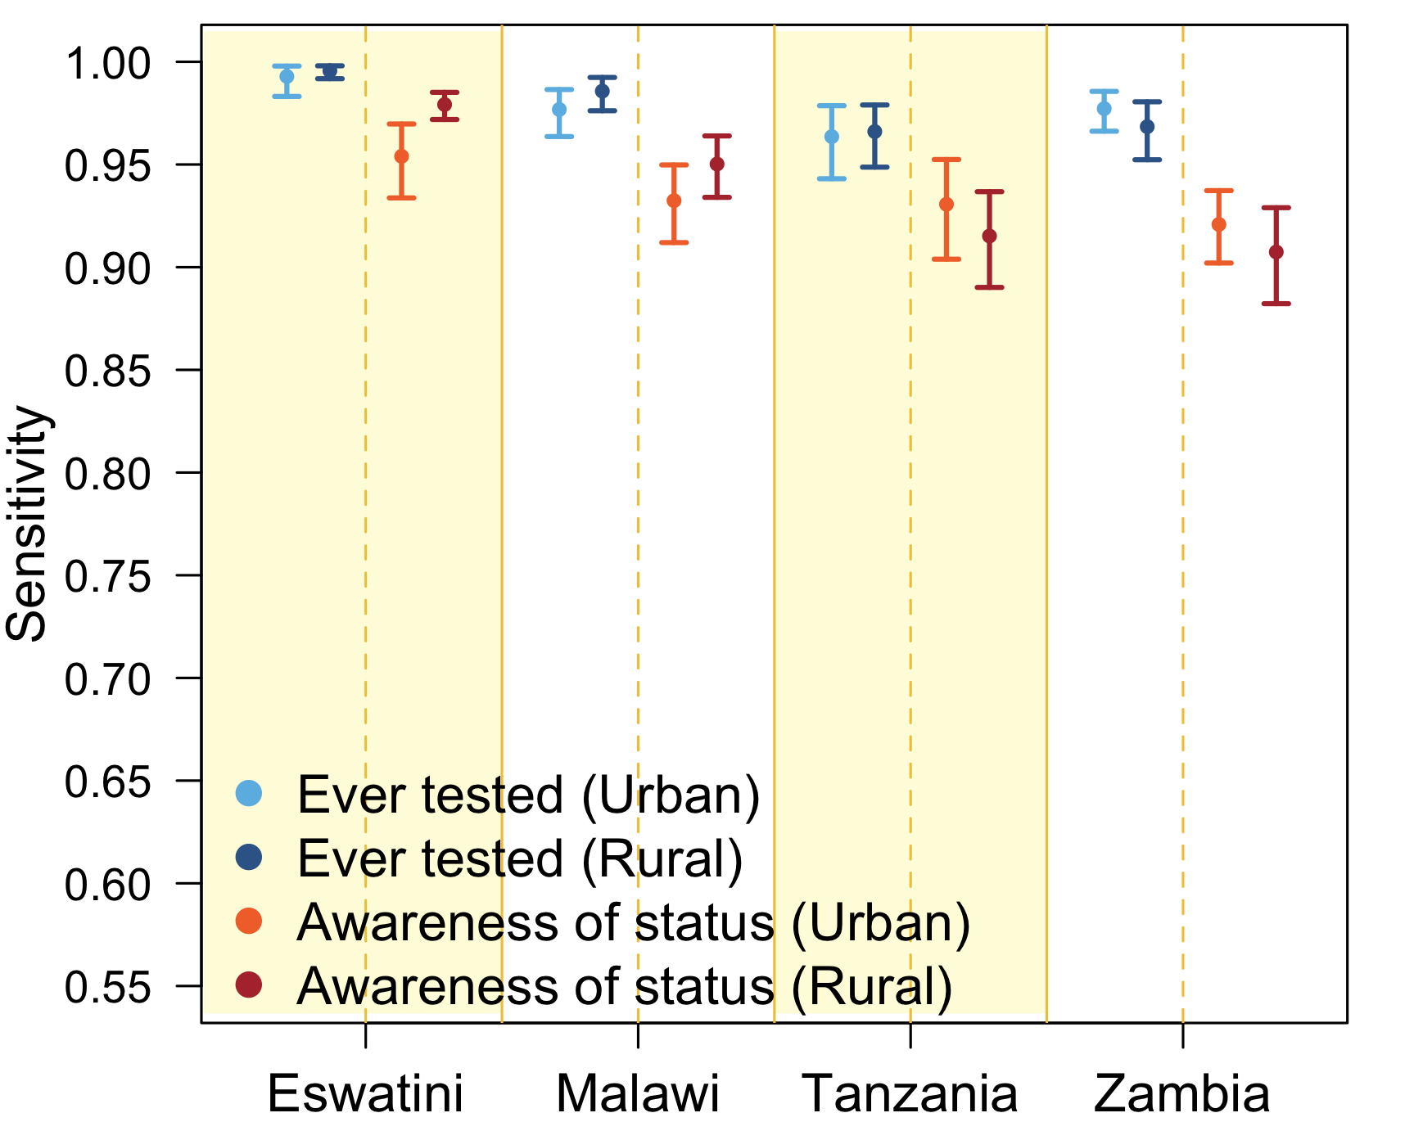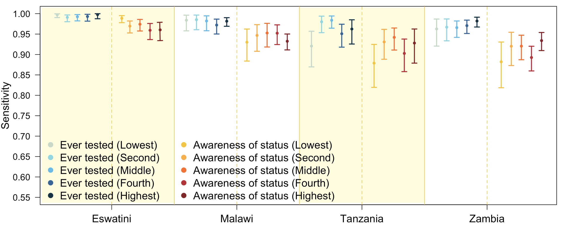
A
B

Figure S1 Marginal posterior medians and 95% credible intervals. Sensitivity of self-reported ever tested and received results and awareness of HIV-positive status among people living with HIV (PLHIV) with detectable ARV metabolites by: (A) household location (Urban / Rural) and (B) socioeconomic status.

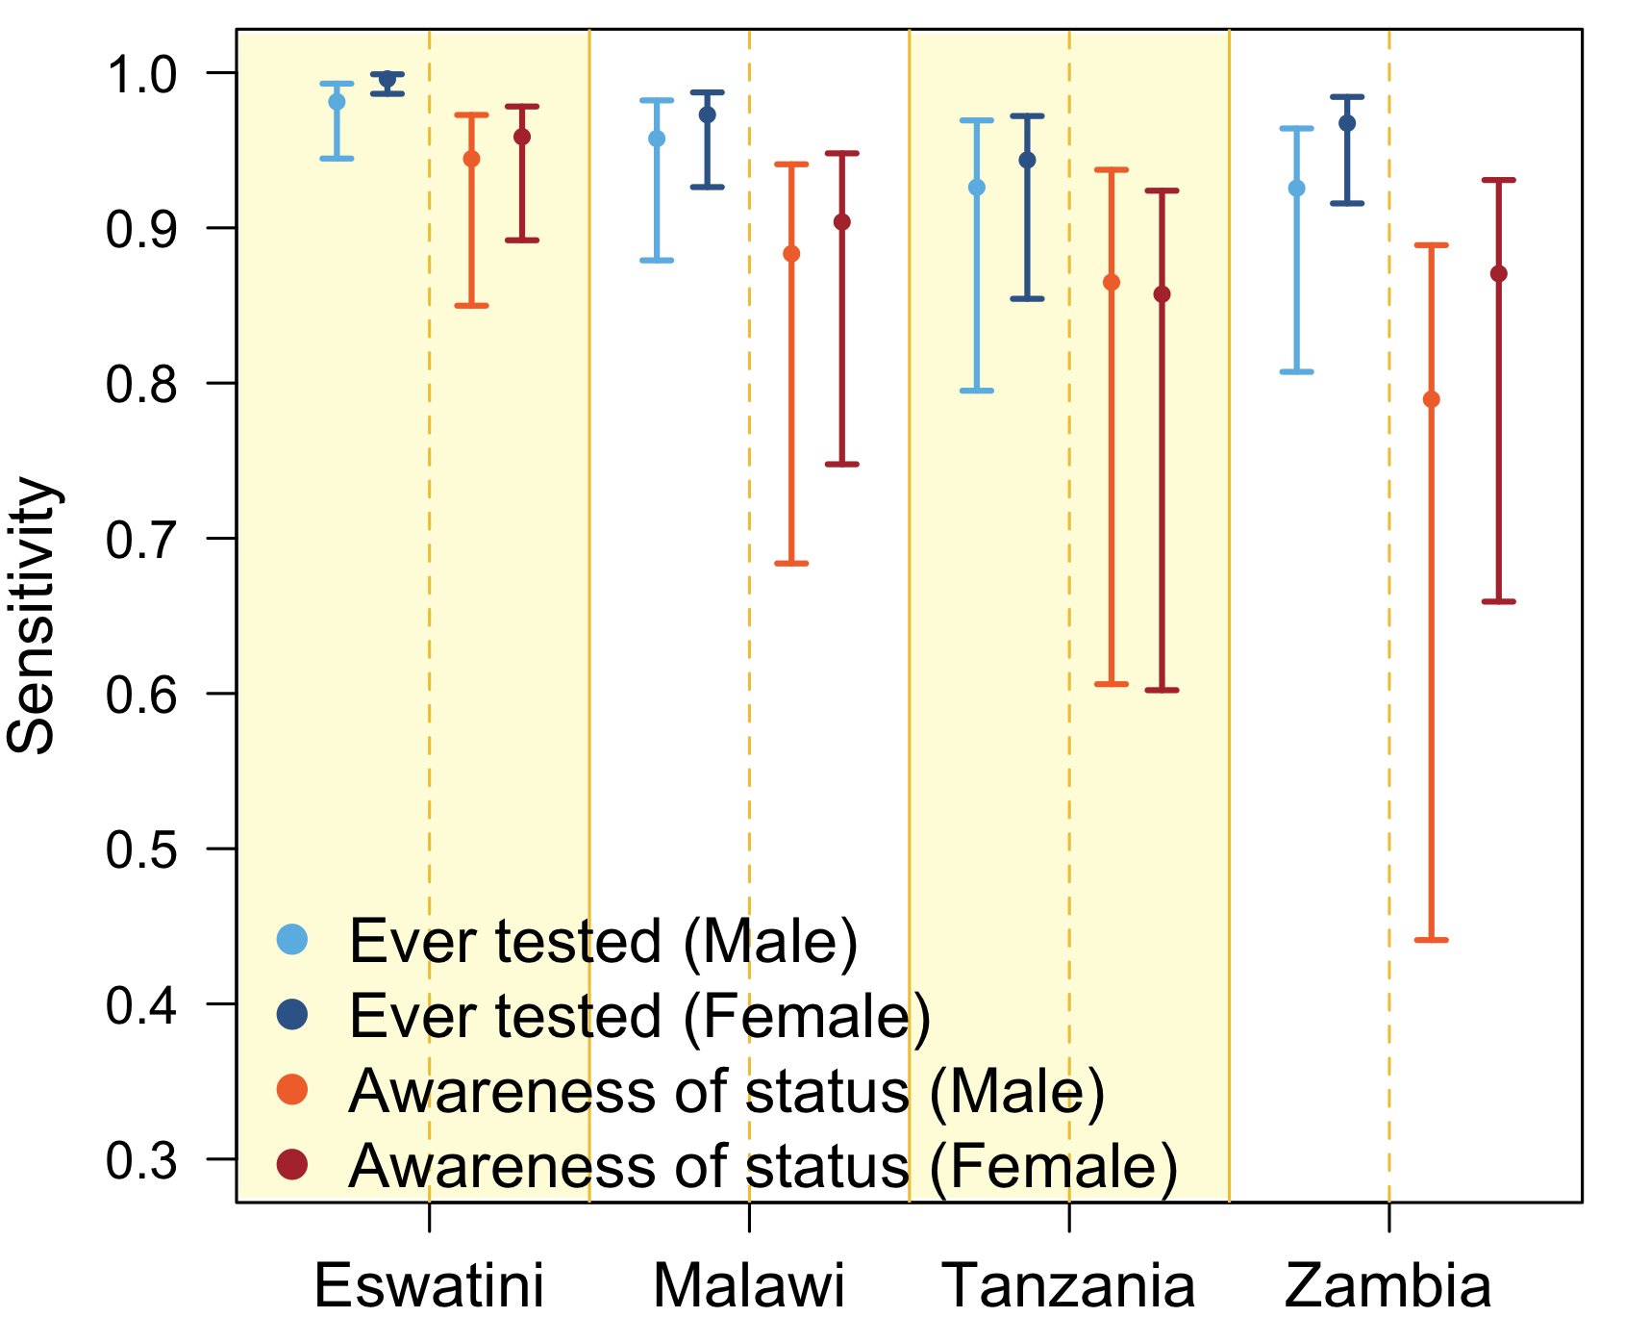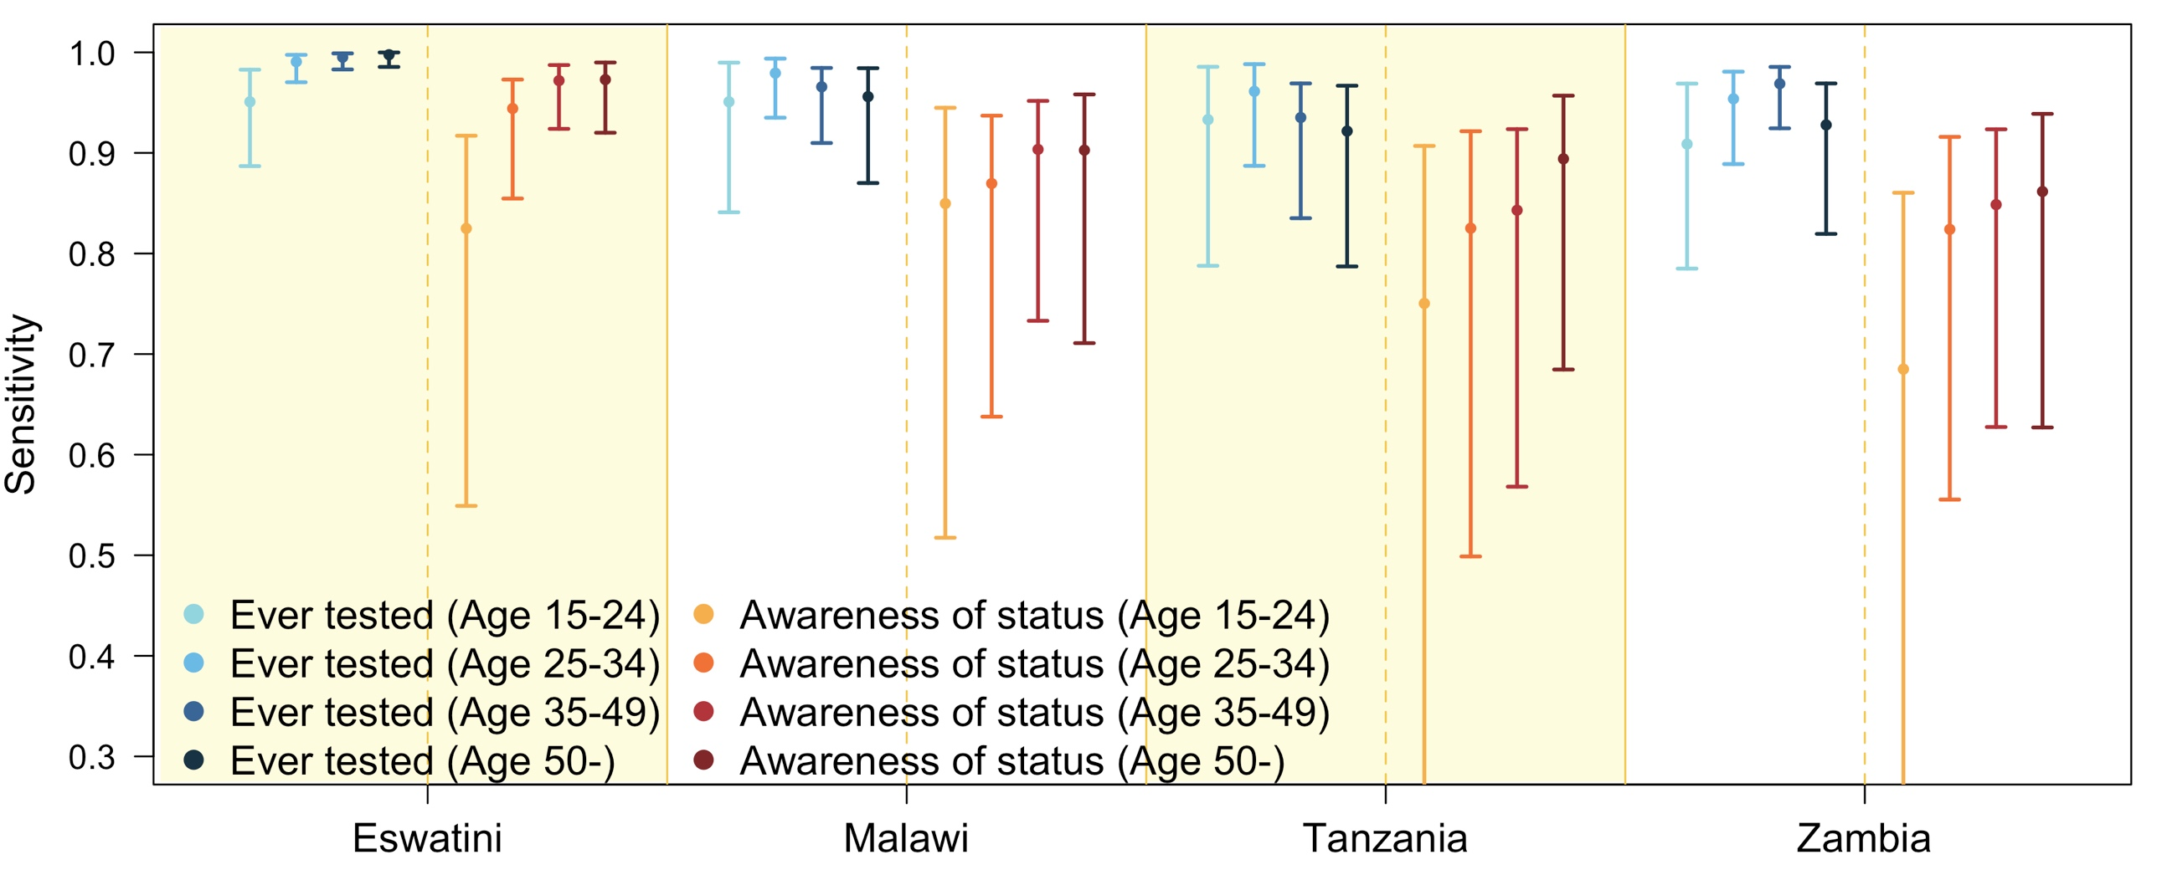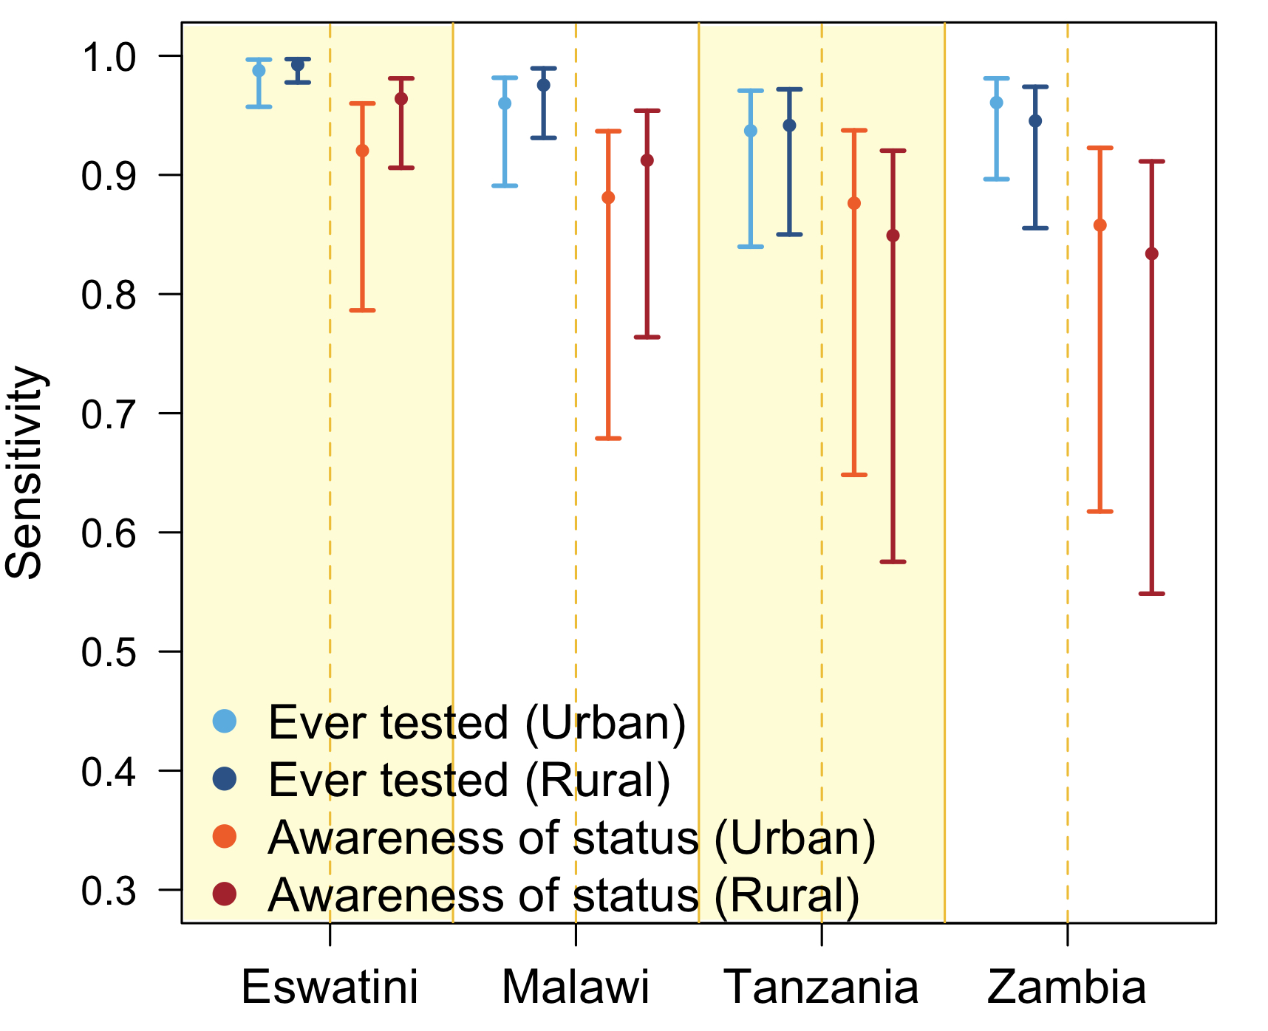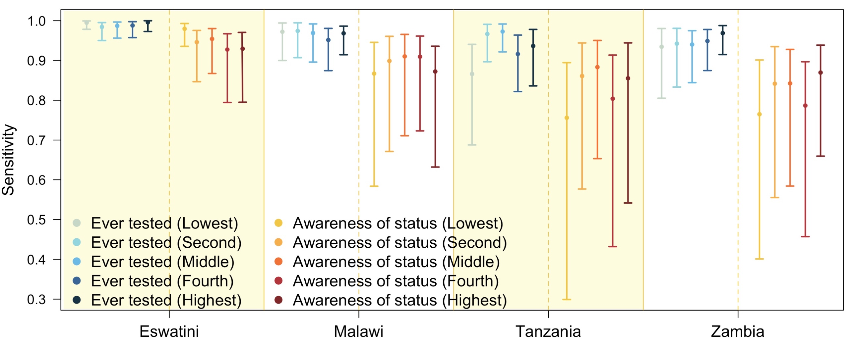\
C
D
A
B
Figure S2 Marginal posterior medians and 95% credible intervals. Sensitivity of self-reported ever tested and received results and awareness of HIV-positive status among people living with HIV (PLHIV) without detectable ARV by: (A) gender, (B) age groups, (C) urban/rural and (D) socioeconomic status.
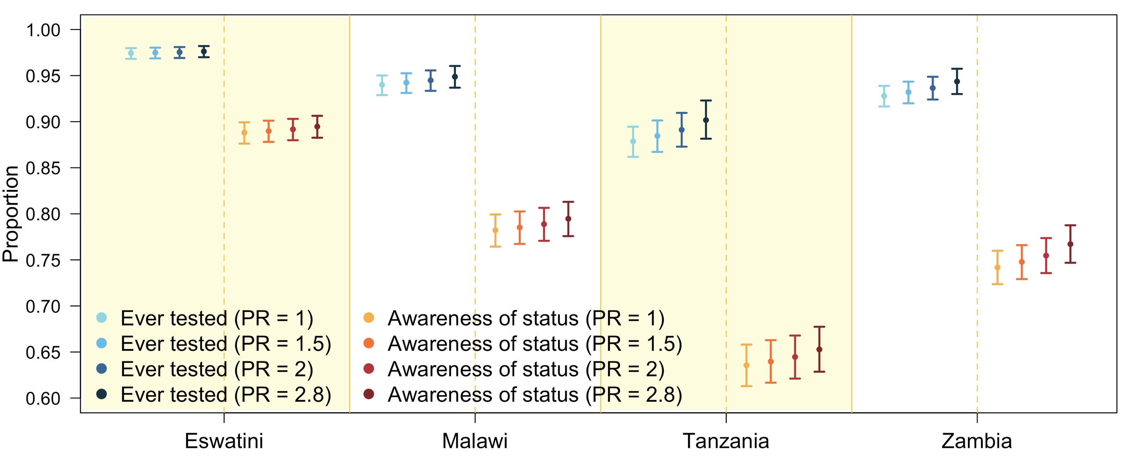
Figure S3 Marginal posterior medians and 95% credible intervals. Proportion ever tested and received results and awareness of HIV-positive status among people living with HIV (PLHIV) with varying prevalence ratio (PR) of non-disclosure priors comparing PLHIV without detectable ARV metabolites to PLHIV with detectable ARV metabolites.

Table S3 Marginal posterior medians and 95% credible intervals (CrI). Sensitivity of self-reported ever tested and received results and awareness of HIV-positive status among people living with HIV with ARV (ARV+) and without detectable ARV (ARV-).

 |  | Eswatini |  |  | Malawi |  | Tanzania |  |  | Zambia
 | ARV status | Median | 95% CrI | Median |  | 95% CrI |  | Median | 95% CrI | Median | 95% CrI
Overall | ARV+ | 97.4% | (96.7%, 98.0%) | 94.3% |  | (93.0%, 95.4%) |  | 92.3% | (90.5%, 93.8%) | 91.6% | (90.1%, 92.9%)
 | ARV- | 95.5% | (88.7%, 97.5%) | 90.1% |  | (74.5%, 94.4%) |  | 86.6% | (65.2%, 92.5%) | 85.4% | (62.4%, 91.6%)
Female | ARV+ | 97.6% | (96.8%, 98.3%) | 94.6% |  | (93.1%, 95.8%) |  | 92.1% | (90.0%, 93.9%) | 92.9% | (91.2%, 94.4%)
 | ARV- | 95.9% | (89.2%, 97.8%) | 90.4% |  | (74.8%, 94.8%) |  | 85.7% | (60.2%, 92.4%) | 87.0% | (65.9%, 93.1%)
Male | ARV+ | 96.8% | (95.3%, 97.9%) | 93.4% |  | (90.8%, 95.5%) |  | 92.5% | (88.9%, 95.4%) | 88.4% | (85.3%, 91.1%)
 | ARV- | 94.5% | (85.0%, 97.3%) | 88.3% |  | (68.4%, 94.1%) |  | 86.5% | (60.6%, 93.7%) | 79.0% | (44.1%, 88.9%)
Age 15-24 years | ARV+ | 90.1% | (85.4%, 93.8%) | 91.9% |  | (85.3%, 96.3%) |  | 87.2% | (77.9%, 93.7%) | 83.9% | (76.1%, 90.0%)
 | ARV- | 82.5% | (54.9%, 91.7%) | 85.0% |  | (51.7%, 94.5%) |  | 75.0% | (26.5%, 90.7%) | 68.5% | (25.4%, 86.0%)
Age 25-34 years | ARV+ | 96.8% | (95.3%, 98.0%) | 93.0% |  | (90.2%, 95.2%) |  | 91.0% | (86.6%, 94.4%) | 91.0% | (87.7%, 93.7%)
 | ARV- | 94.4% | (85.5%, 97.3%) | 87.0% |  | (63.8%, 93.7%) |  | 82.5% | (49.9%, 92.2%) | 82.4% | (55.5%, 91.6%)
Age 35-49 years | ARV+ | 98.4% | (97.5%, 99.1%) | 94.8% |  | (93.1%, 96.2%) |  | 92.0% | (89.3%, 94.2%) | 92.2% | (90.2%, 93.9%)
 | ARV- | 97.2% | (92.4%, 98.7%) | 90.4% |  | (73.3%, 95.2%) |  | 84.3% | (56.8%, 92.4%) | 84.9% | (62.8%, 92.4%)
Age 50+ years | ARV+ | 98.5% | (97.1%, 99.3%) | 94.8% |  | (91.6%, 97.0%) |  | 94.6% | (91.2%, 97.0%) | 92.9% | (89.2%, 95.7%)
 | ARV- | 97.3% | (92.0%, 99.0%) | 90.3% |  | (71.1%, 95.8%) |  | 89.4% | (68.5%, 95.7%) | 86.2% | (62.7%, 93.9%)
Urban | ARV+ | 95.4% | (93.4%, 97.0%) | 93.2% |  | (91.2%, 95.0%) |  | 93.1% | (90.4%, 95.2%) | 92.1% | (90.2%, 93.7%)
 | ARV- | 92.0% | (78.6%, 96.0%) | 88.1% |  | (67.9%, 93.7%) |  | 87.6% | (64.8%, 93.7%) | 85.8% | (61.8%, 92.3%)
Rural | ARV+ | 97.9% | (97.2%, 98.5%) | 95.0% |  | (93.4%, 96.4%) |  | 91.5% | (89.0%, 93.7%) | 90.7% | (88.2%, 92.9%)
 | ARV- | 96.4% | (90.6%, 98.1%) | 91.2% |  | (76.4%, 95.4%) |  | 84.9% | (57.5%, 92.0%) | 83.4% | (54.9%, 91.1%)

Table S3 (Cont.)
 |  | Eswatini |  | Malawi |  | Tanzania |  | Zambia
 | ARV status | Median | 95% CrI | Median | 95% CrI | Median | 95% CrI | Median | 95% CrI
SES (Lowest) | ARV+ | 98.9% | (97.8%, 99.5%) | 93.0% | (88.4%, 96.2%) | 87.9% | (81.9%, 92.5%) | 88.2% | (81.9%, 93.0%)
 | ARV- | 98.0% | (93.5%, 99.3%) | 86.7% | (58.4%, 94.5%) | 75.6% | (29.9%, 89.4%) | 76.5% | (40.1%, 90.1%)
SES (Second) | ARV+ | 97.0% | (95.3%, 98.2%) | 94.7% | (90.8%, 97.3%) | 93.1% | (88.8%, 96.2%) | 92.0% | (87.3%, 95.4%)
 | ARV- | 94.6% | (84.7%, 97.5%) | 89.9% | (67.1%, 96.1%) | 86.1% | (57.7%, 94.4%) | 84.2% | (55.5%, 93.5%)
SES (Middle) | ARV+ | 97.4% | (95.8%, 98.6%) | 95.3% | (91.8%, 97.6%) | 94.2% | (91.1%, 96.5%) | 92.0% | (88.7%, 94.7%)
 | ARV- | 95.4% | (86.7%, 98.0%) | 91.0% | (71.1%, 96.5%) | 88.3% | (65.3%, 95.0%) | 84.2% | (58.4%, 92.8%)
SES (Fourth) | ARV+ | 95.9% | (93.7%, 97.6%) | 95.2% | (92.4%, 97.3%) | 90.3% | (85.8%, 93.8%) | 89.3% | (86.0%, 92.0%)
 | ARV- | 92.7% | (79.4%, 96.7%) | 90.9% | (72.3%, 96.1%) | 80.4% | (43.2%, 91.3%) | 78.7% | (45.7%, 89.7%)
SES (Highest) | ARV+ | 96.0% | (93.4%, 97.9%) | 93.2% | (91.1%, 95.0%) | 92.8% | (87.9%, 96.2%) | 93.4% | (91.0%, 95.4%)
 | ARV- | 92.9% | (79.5%, 97.0%) | 87.2% | (63.2%, 93.6%) | 85.5% | (54.2%, 94.4%) | 86.9% | (66.0%, 93.8%)

References
1. Swaziland HIV incidence measurement survey 2 (SHIMS2) 2016-2017 adult survey quetionnaire. New York, NY; April 2019.
2. Tanzania HIV impact survey (THIS) 2016-2017 adult survey questionnaire. New York, NY; December 2018.
3. Malawi population-based HIV impact assessment (MPHIA) 2015-2016 adult survey questionnaire. New York, NY; December 2018.
4. Zambia population-based HIV impact assessment (ZAMPHIA) 2016-2017 adult survey questionnaire. New York, NY; February 2019.
5. Fuente-Soro L, Lopez-Varela E, Augusto O, Sacoor C, Nhacolo A, Honwana N, et al. Monitoring progress towards the first UNAIDS target: understanding the impact of people living with HIV who re-test during HIV-testing campaigns in rural Mozambique. J Int AIDS Soc. 2018;21(4):e25095.

