SUPPLEMENTARY APPENDIX

This appendix has been provided by the authors to give readers additional information about their work.

Supplement to: Pace R, Williams J, Järvinen K, et al. COVID-19 and human milk: SARS-CoV-2, antibodies, and neutralizing capacity

Supplementary Materials and Methods
- Milk and breast swab samples collected at home
- Milk samples collected in hospitals
- RNA extraction
- SARS-CoV-2 RT-qPCR assay
- Validation of SARS-CoV-2 RT-qPCR for use with human milk
- Sample processing for ELISA and microneutralization (MN) assays

Supplementary Table 1. Studies examining human milk for evidence of SARS-CoV-2 via RT-qPCR.
Supplementary Table 2. Breast swabs with evidence of SARS-CoV-2 viral presence.
Supplementary Figure 1. Correlation of IgA antibody concentrations with MN titers.

1. Milk and breast swab samples collected at home
Prior to each milk collection, women were asked to put on a face mask and gloves and open and assemble the provided sterile manual breast pump (Harmony, Medela). After assembling the pump, women removed their gloves, washed their hands with soap and warm water for at least 20 sec, and dried their hands with a provided paper towel. Women then swabbed the nipple and areola of the breast from which they were planning on collecting milk by wiping a nylon-flocked swab (catalog #552C, COPAN Diagnostics; Murrieta, CA) premoistened with 100 µL Dulbecco's phosphate-buffered saline (DPBS) (Gibco #14190144, Thermo Fisher Scientific, Waltham, MA) in a circular motion for at least 10 sec. The swab head was then broken into a cryovial for storage. Following swabbing, the breast was then washed with soap and warm water for 1 min. After drying the breast with a provided paper towel, participants repeated the swabbing procedure. Women then donned new gloves and while continuing to wear a facemask and gloves, collected up to 30 mL of milk into provided sterile containers. In some cases, milk was aliquoted by the women into cryovials using sterile transfer pipettes. In other cases, the collection container was capped for storage. All samples were stored frozen in the participant’s freezer and shipped to the University of Idaho or to the University of Rochester. When women provided more than one milk sample, pump parts were sterilized using a microwave steam bag (Quick Clean Micro-Steam, Medela). After sterilization, pumps were dried completely and stored in a provided, clean plastic bag until the next sample collection.

2. Milk samples collected in hospitals
Sterile milk collection kits (Symphony double pump kit, Medela), breast cleaning, and milk handling instructions similar to those used for at-home collections were provided to participants who were immediately postpartum and had tested positive for COVID-19 per routine on admission to the labor and delivery unit at Brigham and Women’s Hospital (Boston, MA). Milk was self-collected by participants after opening and attaching the sterile pump kit to their hospital grade pump (Symphony, Medela). Samples were stored at -80°C and subsequently shipped on dry ice to the University of Idaho for analysis.

3. RNA extraction
Milk was thawed on ice, mixed 1:1 with 2X DNA/RNA Shield (Zymo Research), and incubated for 10 min. For milk analysis, 400 µL of the 1:1 solution or 400 µL of supernatant fluid following centrifugation of the 1:1 solution at 1,600 x g, 15 min at 4°C was used as the input for RNA isolation. For breast swabs, swab heads were immersed in 400 μL 1X DNA/RNA shield (Zymo Research), pulse vortexed for 20 seconds, incubated for 10 min, centrifuged at 500 x g for 1 min at 22°C, and then 400 μL of the liquid aspirated and used as input for RNA isolation. For extraction negative controls, 400 μL 1X DNA/RNA shield was used as the input.

4. SARS-CoV-2 RT-qPCR assay
Two methods were employed for the RT-qPCR reactions to detect SARS-CoV-2 in human milk. Both methods used the CDC-designed 2019-nCoV RT-qPCR assay and included three single-plex primer and TaqMan probe sets targeting the N1 and N2 regions of the SARS-CoV-2 nucleocapsid gene as well as the human RNase P gene. Primers and probes were obtained from Integrated DNA Technologies (IDT; Coralville, IA). Genomic SARS-CoV-2 RNA (isolate USA-WA1/2020, catalog # NR-52285) obtained through BEI Resources (Manassas, VA) was used as a standard to ascertain viral genome copy numbers. RT-qPCR method A included use of TaqPath 1-step RT-qPCR master mix, CG (Thermo Fisher Scientific) on an Applied Biosystems Fast 7500 qPCR instrument per the CDC protocol. Briefly, the run mode was set to “standard 7500” and cycling parameters were set to run for 2 min at 25°C; 15 min at 50°C; 2 min at 95°C; followed by 3 sec at 95°C and 30 sec at 55°C for 45 cycles. All samples were run in duplicate as 20 μL reactions, and Ct values ≥40 were interpreted as a negative result. In addition to biological samples, each plate contained a no-template control, inter-assay control (extracted milk with heat-inactivated virus spike-in), and dilution series of SARS-CoV-2 genomic RNA. RT-qPCR method B was similar except it used Bio-Rad Reliance One Step master mix, a Bio-Rad CFX96 instrument (Bio-Rad, Hercules, CA), and primer/probe sets obtained from IDT. Cycling parameters for method B were as follows: 10 min at 50°C and 1 min at 95°C followed by 40 cycles of 3 sec at 95°C and 30 sec at 55°C.

5. Validation of SARS-CoV-2 RT-qPCR for use with human milk
To validate the RNA extraction and RT-qPCR for detecting SARS-CoV-2 RNA in human milk, a baseline for the analytical sensitivity/specificity of virus detection and percent recovery of heat-inactivated virus (and viral genomic RNA) present in human milk were determined through a series of experiments. Heat-inactivated SARS-CoV-2 (isolate USA-WA1/2020, catalog #NR-52286), genomic SARS-CoV-2 RNA (isolate USA-WA1/2020, catalog #NR-52285) were obtained through the Biodefense and Emerging Infections Research Resources Repository (BEI Resources, Manassas, VA). Plasmid controls for severe acute respiratory syndrome-associated coronavirus (SARS-CoV; catalog #10006624), Middle East respiratory syndrome coronavirus (MERS-CoV; catalog #10006623), human ribonuclease P protein subunit p30 (RPP30; catalog #10006626) were obtained through IDT (Coralville, IA).

To examine the specificity of the primer/probes used, plasmids targeting SARS-CoV and MERS-CoV were tested in the RT-qPCR assay. No signal was detectable for either plasmid. The effect of RNA isolation method, milk fraction (i.e., whole milk, cell pellet/lipid layer, and supernatant), and storage conditions (i.e., fresh, stored two days at 4°C, and stored seven days at -20°C) on viral detection was evaluated using milk collected from three self-reported healthy women and spiked with known quantities of heat-inactivated virus. Additionally, storage conditions that simulated home sample storage by participants and shipping was evaluated. Milk samples were spiked as done previously. Total RNA was isolated from milk samples spiked at a concentration of ~8 genome equivalents/μL heat-inactivated virus (or left unspiked) using silica column- (Qiagen Viral RNA mini kit) and magnetic bead-based methods (Zymo Quick-DNA/RNA Viral MagBead kit) (n = 108). No false SARS-CoV-2 RNA positives were detected (defined by having at least one duplicate positive for both SARS-CoV-2 N1 and N2 gene targets, both duplicates positive for host RNase P gene target; Ct values <40). Furthermore, the storage/time conditions tested did not have a dramatic impact on the detection of SARS-CoV-2 RNA in milk. Sensitivity of SARS-CoV-2 RNA detection was lowest for whole milk and highest for supernatant, with the supernatant/magnetic bead RNA isolation method having the best performance.

The impact of the milk matrix on percent recovery of virus was also validated by spiking heat-inactivated virus and viral RNA into milk and DPBS prior to and after RNA extraction. Although no difference was found in the percent recovery of virus based on milk fraction or when viral RNA was spiked, Ct values for samples spiked with heat-inactivated virus were higher suggesting differences in the efficiency of viral lysis. When Ct values for milk spiked with heat-inactivated virus were normalized to Ct values for DPBS spiked with heat-inactivated virus, only ~3% of virus was lost due to milk matrix effects.

6. Sample processing for ELISA and microneutralization (MN) assays
To delipidate milk, samples were thawed on ice and centrifuged at 10,000 x g at 4°C for 10 min. Milk supernatant was collected by piercing the solidified lipid layer with a pipette and carefully withdrawing the soluble phase. The centrifugation was repeated as necessary, and the resulting clear supernatant was used for ELISA assays immediately or aliquoted and frozen for MN assays. If frozen, samples were reclarified by centrifugation as above upon thawing.

Study | Location | Participants, n | Participants with  SARS-CoV-2+ milk, n (%)
AlZaghal et al., 2020¹ | Jordan | 1 | 0 (0)
Bastug et al., 2020² | Turkey | 1 | 1 (100)
Bertino et al., 2020³ | Italy | 12 | 1 (8.3)
Buonsenso et al., 2020⁴* | Italy | 2 | 1 (50)
Chambers et al., 2020⁵ | USA | 18 | 1 (5.6)
Chen et al., 2020⁶ | China | 6 | 0 (0)
Costa et al., 2020⁷* | Italy | 2 | 1 (50)
Cui et al., 2020⁸ | China | 1 | 0 (0)
De Socio et al., 2020⁹ | Italy | 1 | 0 (0)
Deng et al., 2020¹⁰ | China | 6 | 0 (0)
Dong, Chi et al., 2020¹¹ | China | 1 | 0 (0)
Dong, Tian et al., 2020¹² | China | 1 | 0 (0)
Fan et al., 2020¹³ | China | 2 | 0 (0)
Fenizia et al., 2020¹⁴ | Italy | 11 | 1 (9.1)
Gidlof et al., 2020¹⁵ | Sweden | 1 | 0 (0)
Groß et al., 2020¹⁶ | Germany | 2 | 1 (50)
Han et al., 2020¹⁷ | Korea | 1 | 0 (0)
Kalafat et al., 2020¹⁸ | Turkey | 1 | 0 (0)
Kam et al., 2020¹⁹ | Singapore | 1 | 0 (0)
Kirtsman et al., 2020²⁰ | Canada | 1 | 1 (100)
Lang et al., 2020²¹ | China | 1 | 0 (0)
Li, Hu, et al., 2020²² | China | 1 | 0 (0)
Li, Zhao, et al., 2020²³ | China | 1 | 0 (0)
Liu, Wang, Li, et al., 2020²⁴ | China | 10 | 0 (0)
Liu, Wang, Zhang, et al., 2020²⁵ | China | 2 | 0 (0)
Luo et al., 2020²⁶ | China | 23 | 0 (0)
Marin Gabriel et al., 2020²⁷ | Spain | 7 | 0 (0)
Peng et al., 2020²⁸ | China | 1 | 0 (0)
Perrone et al., 2020²⁹ | Italy | 1 | 0 (0)
Piersigilli et al., 2020³⁰ | Belgium | 1 | 0 (0)
Sahin et al., 2020³¹ | Turkey | 29 | 0 (0)
Salvatori et al., 2020³² | Italy | 2 | 0 (0)
Schoenmakers et al., 2020³³ | Netherlands | 1 | 0 (0)
Tam et al., 2020³⁴ | Australia | 1 | 1 (100)
Walczak et al., 2020³⁵ | Australia | 1 | 0 (0)
Wang et al., 2020³⁶ | China | 1 | 0 (0)
Wu et al., 2020³⁷ | China | 3 | 1 (33)
Xiong et al., 2020³⁸ | China | 1 | 0 (0)
Yan et al., 2020³⁹ | China | 12 | 0 (0)
Yu et al., 2020⁴⁰ | China | 1 | 0 (0)
Yuehua et al., 2020⁴¹ | China | 1 | 0 (0)
Zhu et al., 2020⁴² | China | 5 | 1 (20)
TOTAL | - | 176 | 10 (5.7)
Supplementary Table 1. Studies examining human milk for evidence of SARS-CoV-2 via RT-qPCR. *Buonsenso et al., 2020 and Costa et al., 2020 reported on the same participants and are both included for completeness, but not duplicated in the total counts.

 |  | Ct values for SARS-CoV-2 RT-qPCR targets
Participant | Collection | Before Breast Washing | After Breast Washing
A | First  Second | N1: 34.9/35.2, N2: 37.0/nd  N1: nd, N2: 37.2/nd | nd  nd
B | First  Second | N1: 30.4/30.7, N2: 30.4/30.9  N1: 34.0/34.5, N2: 36.1/nd | nd  nd
F* | First  Second  Third | nd  N1: nd; N2: 38.0/nd  nd | N1: 36.1/nd; N2: nd  nd  nd
G | First  Second | N1: 35.9/nd; N2: nd  nd | nd  nd
J | First  Second | N1: 36.0/nd; N2: nd  nd | nd  nd

Supplemental Table 2. Breast swabs with evidence of SARS-CoV-2 viral presence. A total of 35 sets of breast swabs (n = 70) were collected. Only samples that had any detectable signal are shown. Ct values for RT-qPCR duplicates of each SARS-CoV-2 target are given. Samples with Ct values acquired for both RT-qPCR duplicates of a given target are indicated in bold. nd = not detected. *For this subject, all swabs which were supposed to be collected after breast washing and prior to milk collections were collected after milk collections.

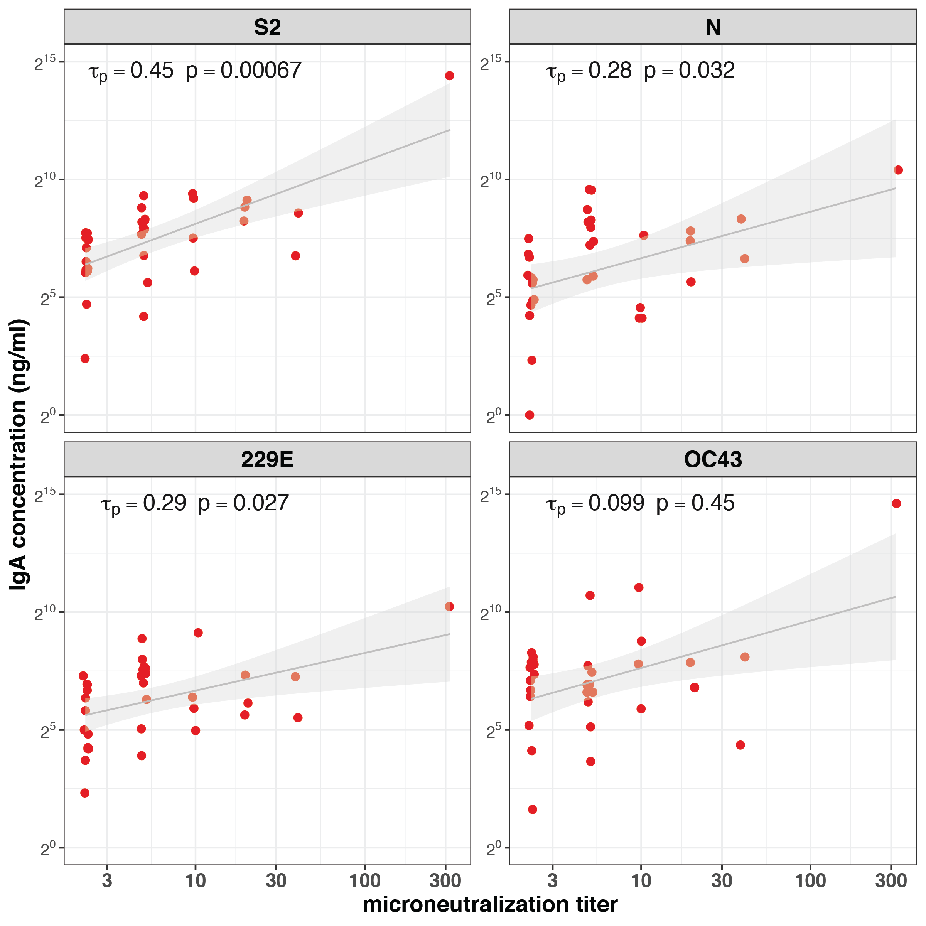
Supplementary Figure 1. Correlation between concentrations of IgA specific to SARS-CoV-2 S2 and N proteins and sCoV S proteins and microneutralization titers in milk produced by COVID-19 infected women. Kendall rank correlation 𝜏_{p} and associated p-value as shown. A linear model was fit to log transformed IgA concentrations and MN titers and is shown (black line) with 95% confidence interval (grey shading) for visualization purposes only.

References
1. AlZaghal LA, AlZaghal N, Alomari SO, Obeidat N, Obeidat B, Hayajneh WA. Multidisciplinary team management and cesarean delivery for a Jordanian woman infected with SARS-COV-2: A case report. Case Rep Womens Health 2020;27:e00212.
2. Bastug A, Hanifehnezhad A, Tayman C, et al. Virolactia in an asymptomatic mother with COVID-19. Breastfeeding Med 2020;15(8):488-491.
3. Bertino E, Moro GE, De Renzi G, et al. SARS-CoV-2 in human breast milk and neonatal outcome: A collaborative study. SSRN Journal 2020; DOI:10.2139/ssrn.3611974. preprint.
4. Buonsenso D, Costa S, Sanguinetti M, et al. Neonatal late onset infection with severe acute respiratory syndrome coronavirus 2. Am J Perinatol 2020;37(08):869–72.
5. Chambers C, Krogstad P, Bertrand K, et al. Evaluation for SARS-CoV-2 in breast milk from 18 infected women. JAMA 2020;e2015580.
6. Chen H, Guo J, Wang C, et al. Clinical characteristics and intrauterine vertical transmission potential of COVID-19 infection in nine pregnant women: a retrospective review of medical records. Lancet 2020;395(10226):809–15.
7. Costa S, Posteraro B, Marchetti S, et al. Excretion of SARS-CoV-2 in human breast milk. Clin Microbiol Infect 2020;S1198-743X(20)30304-9.
8. Cui Y, Tian M, Huang D, et al. A 55-day-old female infant infected with 2019 novel coronavirus disease: presenting with pneumonia, liver injury, and heart damage. J Infect Dis 2020;376:584–7.
9. De Socio GV, Malincarne L, Arena S, et al. Delivery in asymptomatic Italian woman with SARS-CoV-2 infection. Mediterr J Hematol Infect Dis 2020;12(1):e2020033.
10. Deng G, Zeng F, Zhang L, Chen H, Chen X, Yin M. Characteristics of pregnant COVID-19 patients with liver injury. J Hepatol 2020;S0168-8278(20)30395-0.
11. Dong Y, Chi X, Hai H, et al. Antibodies in the breast milk of a maternal woman with COVID-19. Emerg Microbes Infect 2020;9(1):1467–9.
12. Dong L, Tian J, He S, et al. Possible vertical transmission of SARS-CoV-2 from an infected mother to her newborn. JAMA 2020;323(18):1846-1848.
13. Fan C, Lei D, Fang C, et al. Perinatal Transmission of COVID-19 associated SARS-CoV-2: Should we worry? Clin Infect Dis 2020;ciaa226.
14. Fenizia C, Biasin M, Cetin I, et al. in−utero mother−to−child SARS−CoV−2 transmission: Viral detection and fetal immune response. medRxiv 2020;2020.07.09.20149591. preprint.
15. Gidlöf S, Savchenko J, Brune T, Josefsson H. COVID‐19 in pregnancy with comorbidities: More liberal testing strategy is needed. Acta Obstet Gynecol Scand 2020;99(7):948–9.
16. Groß R, Conzelmann C, Müller JA, et al. Detection of SARS-CoV-2 in human breastmilk. Lancet 2020;395(10239):1757–8.
17. Han MS, Seong M-W, Heo EY, et al. Sequential analysis of viral load in a neonate and her mother infected with SARS-CoV-2. Clin Infect Dis 2020;35:e124.
18. Kalafat E, Yaprak E, Cinar G, et al. Lung ultrasound and computed tomographic findings in pregnant woman with COVID‐19. Ultrasound Obstet Gynecol 2020;55(6):835–7.
19. Kam K-Q, Yung CF, Cui L, et al. A well infant with coronavirus disease 2019 (COVID-19) with high viral load. Clin Infect Dis 2020;361:1701.
20. Kirtsman M, Diambomba Y, Poutanen SM, et al. Probable congenital SARS-CoV-2 infection in a neonate born to a woman with active SARS-CoV-2 infection. CMAJ 2020;192(24):E647–50.
21. Lang G-J, Zhao H. Can SARS-CoV-2-infected women breastfeed after viral clearance? J Zhejiang Univ Sci B 2020;21(5):405–7.
22. Li Y, Hu Y, Yu Y, et al. Positive result of Sars‐Cov‐2 in faeces and sputum from discharged patient with COVID‐19 in Yiwu, China. J Med Virol 2020;10.1002/jmv.25905.
23. Li Y, Zhao R, Zheng S, et al. Lack of vertical transmission of severe acute respiratory syndrome coronavirus 2, China. Emerging Infect Dis 2020;26(6):727.
24. Liu W, Wang J, Li W, Zhou Z, Liu S, Rong Z. Clinical characteristics of 19 neonates born to mothers with COVID-19. Front Med 2020;14(2):193–198.
25. Liu W, Wang Q, Zhang Q, Chen L, Chen J, Zhang B. Coronavirus disease 2019 (COVID-19) during pregnancy: A case series. Preprints 2020;2020020373. preprint.
26. Luo Q, Chen L, Yao D, et al. Safety of breastfeeding in mothers with SARS-CoV-2 infection. medRxiv 2020;2020.05.30.20033407. preprint.
27. Marín Gabriel MÁ, Malalana Martínez AM, Marín Martínez ME, Anel Pedroche J. Negative transmission of SARS-CoV-2 to hand-expressed colostrum from SARS-CoV-2–positive mothers. Breastfeeding Med 2020;15(8):492-494.
28. Peng Z, Wang J, Mo Y, et al. Unlikely SARS-CoV-2 vertical transmission from mother to child: A case report. J Infect Public Health 2020;13(5):818–20.
29. Perrone S, Giordano M, Meoli A, et al. Lack of viral transmission to preterm newborn from a COVID‐19 positive breastfeeding mother at 11 days postpartum. J Med Virol 2020;0002(20):319149.
30. Piersigilli F, Carkeek K, Hocq C, et al. COVID-19 in a 26-week preterm neonate. Lancet Child Adolesc Health 2020;4(6):476–8.
31. Sahin D, Tanacan A, Erol SA, et al. A pandemic center’s experience of managing pregnant women with COVID‐19 infection in Turkey: A prospective cohort study. Int J Gynaecol Obstet 2020;10.1002/ijgo.13318.
32. Salvatori G, De Rose DU, Concato C, et al. Managing COVID-19-positive maternal–infant dyads: An Italian experience. Breastfeeding Med 2020;15(5):347–348.
33. Schoenmakers S, Snijder P, Verdijk R, et al. SARS-CoV-2 placental infection and inflammation leading to fetal distress and neonatal multi-organ failure in an asymptomatic woman. medRxiv 2020;2020.06.08.20110437. preprint.
34. Tam PCK, Ly KM, Kernich ML, et al. Detectable severe acute respiratory syndrome coronavirus 2 (SARS-CoV-2) in human breast milk of a mildly symptomatic patient with coronavirus disease 2019 (COVID-19). Clin Infect Dis 2020;ciaa673.
35. Walczak A, Wilks K, Shakhovskoy R, et al. COVID-19 in a complex obstetric patient with cystic fibrosis. Infect, Dis & Health 2020;0(0).
36. Wang S, Guo L, Chen L, et al. A case report of neonatal COVID-19 infection in China. Clin Infect Dis 2020;348:1953.
37. Wu Y, Liu C, Dong L, Chen Y, Liu J, Zhang C. Viral shedding of COVID-19 in pregnant women. SSRN Journal 2020; DOI: 10.2139/ssrn.3562059. preprint.
38. Xiong X, Wei H, Zhang Z, et al. Vaginal delivery report of a healthy neonate born to a convalescent mother with COVID­‐19. J Med Virol 2020;10.1002/jmv.25857.
39. Yan J, Guo J, Fan C, et al. Coronavirus disease 2019 in pregnant women: a report based on 116 cases. Am J Obstet Gynecol 2020;223(1):111.e1–111.e14.
40. Yu Y, Li Y, Hu Y, Bin Li, Xu J. Breastfed 13 month-old infant of a mother with COVID-19 pneumonia: a case report. Int Breastfeed J 2020;15(1):1–6.
41. Yuehua Z, Daojiong L, Meifang X, et al. A case of three-month-old infant with new coronavirus infection. Chinese Journal of Pediatrics 2020;58(3):182–4.
42. Zhu C, Liu W, Su H, et al. Breastfeeding risk from detectable severe acute respiratory syndrome coronavirus 2 in breastmilk. J Infection 2020;81(3):452-482.

