Supplementary file

- Sample distribution

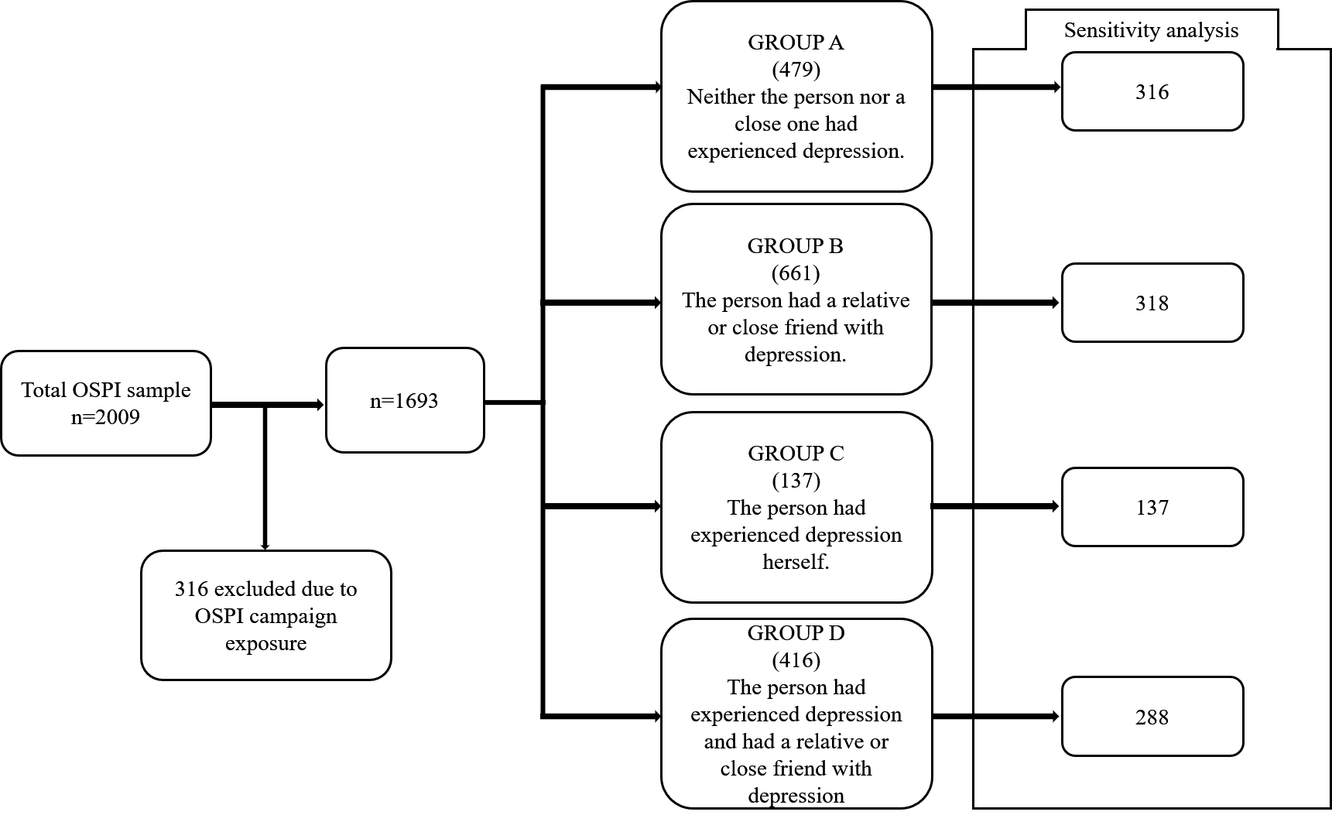

- Previous experience with depression grouping

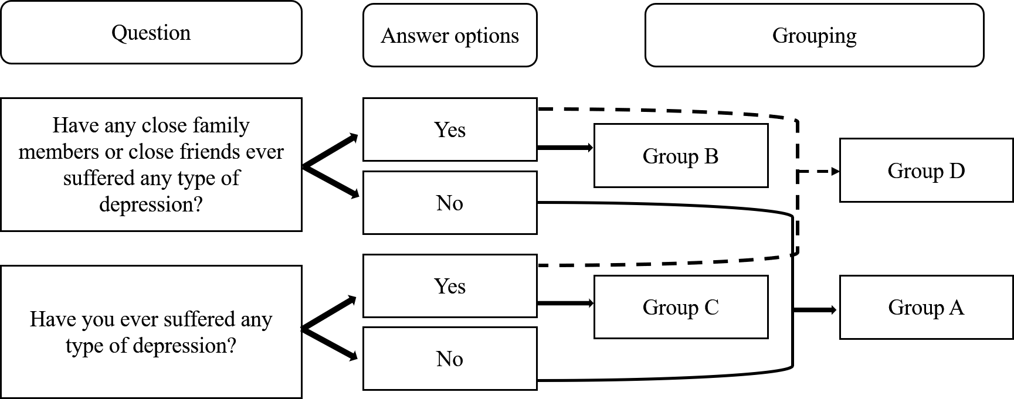

- Sample characteristics

Sample = 1693
 |  | Group A  (479) | Group B  (661) | Group C  (137) | Group D  (416) | Test
Age  Mean (SD) |  | 47.59 (19.81) | 44.31 (17.52) | 55.49 (17.52) | 49.15 (16.29) | F_{(3,1689)} = 16.99 p<0.001
Male % |  | 57.8% | 48.3% | 35.1% | 33.2% | χ²= 263.22 p<0.001
Female % |  | 42.2% | 51.7% | 64.9% | 66.8% | χ²= 173.4 p<0.001
Professional status | Employed | 49.6% | 61.4% | 38.2% | 54.5% | χ²= 305.13 p<0.001
 | Student | 13.3% | 12.9% | 3.1% | 4.8% | χ²= 105.39 p<0.001
 | Retired | 30% | 17.5% | 45.8% | 30% | χ²= 33.71 p<0.001
 | Unemployed | 7.1% | 8.2% | 12.9% | 10.7% | χ²= 21.68 p<0.001

- Sensitivity analysis sample description

Sample = 1053

 |  | Group A  (479) | Group B  (661) | Group C  (137) | Group D  (416) | Test
Age  Mean (SD) |  | 54.09 (19.07) | 50.98 (18.95) | 55.49 (17.56) | 51.42  (17.48) | F_{(3,1049)} = 18.03 p<0.001
Male % |  | 57.9% | 44.3% | 35.1% | 33.3% | χ²= 231.3 p<0.001
Female % |  | 42.1% | 55.7% | 64.9% | 66.7% | χ²= 186.7 p<0.001
Professional status | Employed | 40.2% | 40.6% | 38.2% | 37.3% | χ²= 23.78 p<0.001
 | Student | 4.1% | 3.8% | 3.1% | 6.6% | χ²= 13.52 p=0.08
 | Retired | 44.9% | 38.1% | 45.8% | 41.5% | χ²= 12.27 p=0.06
 | Unemployed | 10.4% | 17.6% | 12.9% | 14.6% | χ²= 19.75 p<0.001

