Supplementary Figures

**Sleep-related traits and attention-deficit/hyperactivity disorder comorbidity: shared genetic risk factors, molecular mechanisms, and causal effects**

**Authors**

Marina Xavier Carpena¹, Carolina Bonilla²,3, Alicia Matijasevich¹,², Thais Martins-Silva¹, Julia P. Genro4, Mara Helena Hutz5, Luis Augusto Rohde6, Luciana Tovo-Rodrigues ¹

**Affiliations**

¹Post-Graduate Program in Epidemiology, Federal University of Pelotas, Pelotas, Brazil;

²Department of Preventive Medicine, Faculty of Medicine, University of São Paulo, São Paulo, Brazil;

³ Population Health Sciences, University of Bristol, Bristol, United Kingdom.

4 Programa de Pós-Graduação em Biociências, Universidade Federal de Ciências da Saúde de Porto Alegre,Porto Alegre, Brazil

5Federal University of Rio Grande do Sul, Department of Genetics, Porto Alegre, Brazil

6 Federal University of Rio Grande do Sul, Department of Psychiatry, Child & Adolescent Psychiatry Unit,Hospital de Clinicas de Porto Alegre, Porto Alegre, Brazil;

**Corresponding authors**: Marina Xavier Carpena – [marinacarpena_@hotmail.com](mailto:marinacarpena_@hotmail.com); Luciana Tovo-Rodrigues – [luciana.tovo@gmail.com](mailto:luciana.tovo@gmail.com)

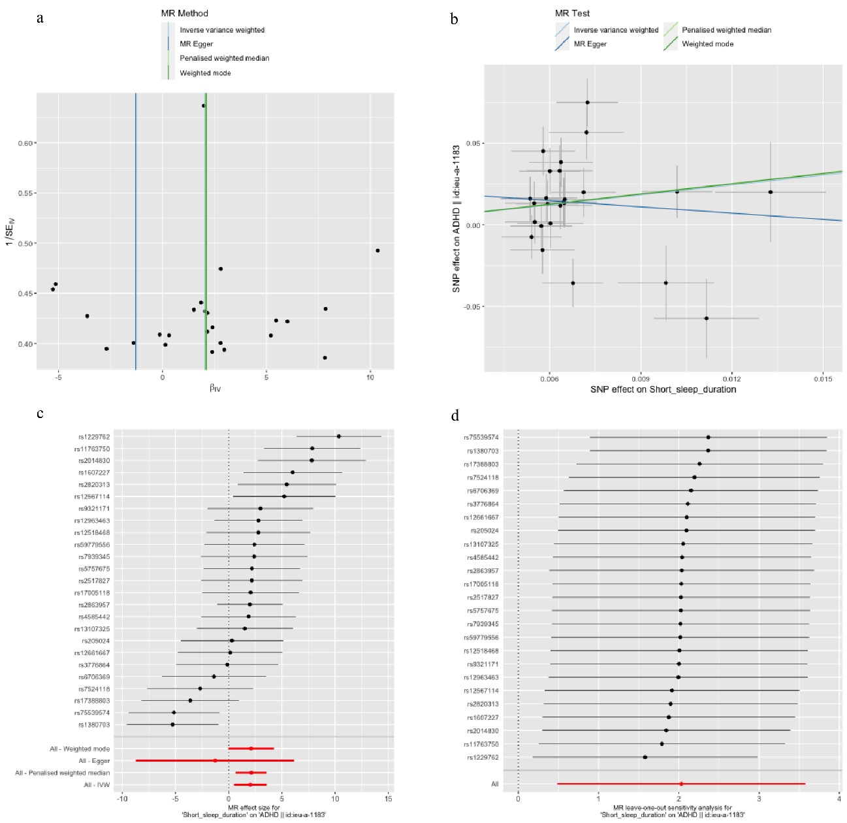

Figure S1. Figures to represent the MR analyses considering short sleep duration as exposure and ADHD as outcome. **a.** Funnel plot; **b.** Scatter plot; **c.** Forest plot; **d.** Leave-one-out plot.

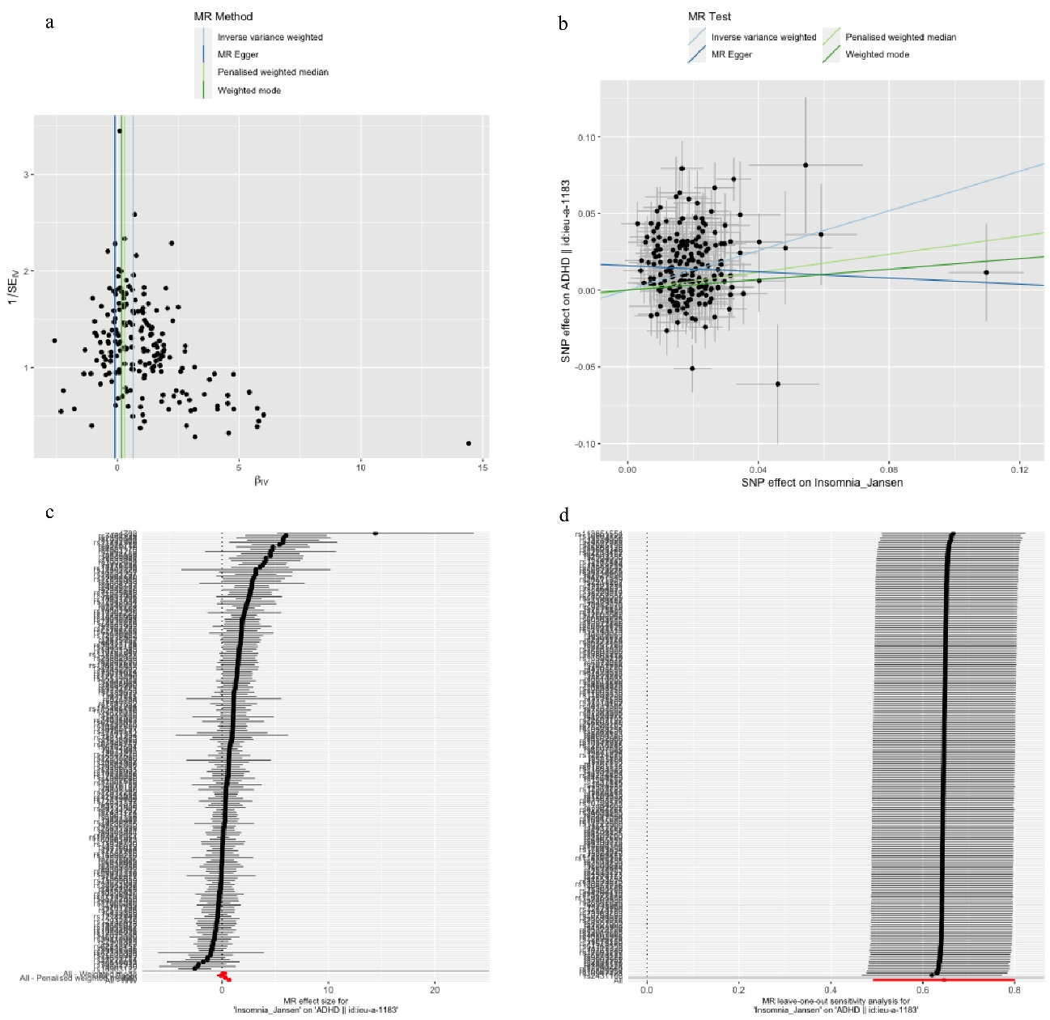

Figure S2. Figures to represent the MR analyses considering Insomnia (data set from Jansen et al., 2019) as exposure and ADHD as outcome. **a.** Funnel plot; **b.** Scatter plot; **c.** Forest plot; **d.** Leave-one-out plot.

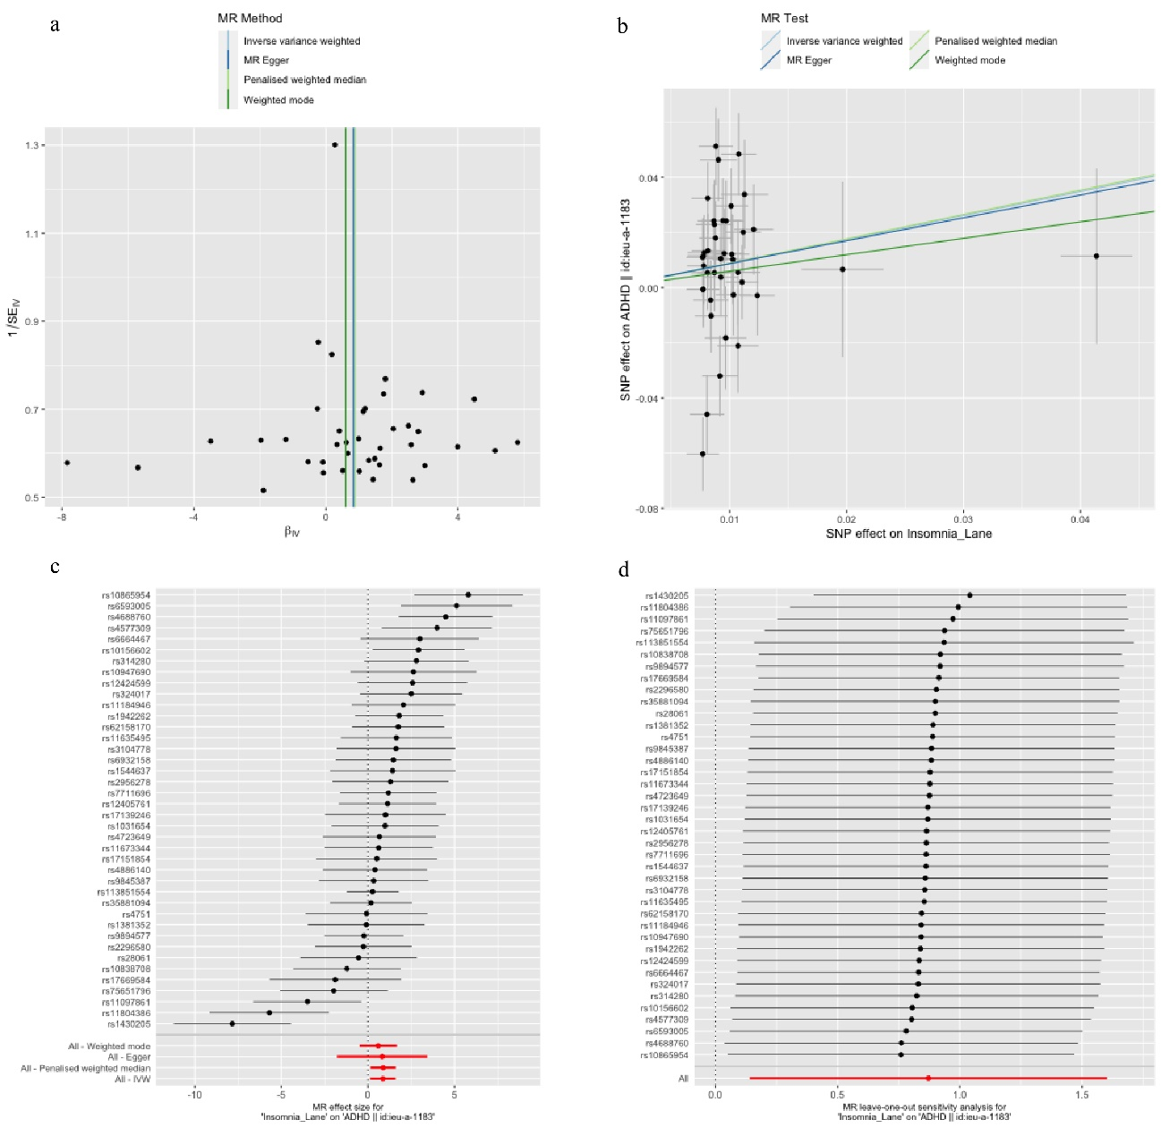

Figure S3. Figures to represent the MR analyses considering Insomnia (data set from Lane et al., 2019) as exposure and ADHD as outcome. **a.** Funnel plot; **b.** Scatter plot; **c.** Forest plot; **d.** Leave-one-out plot.

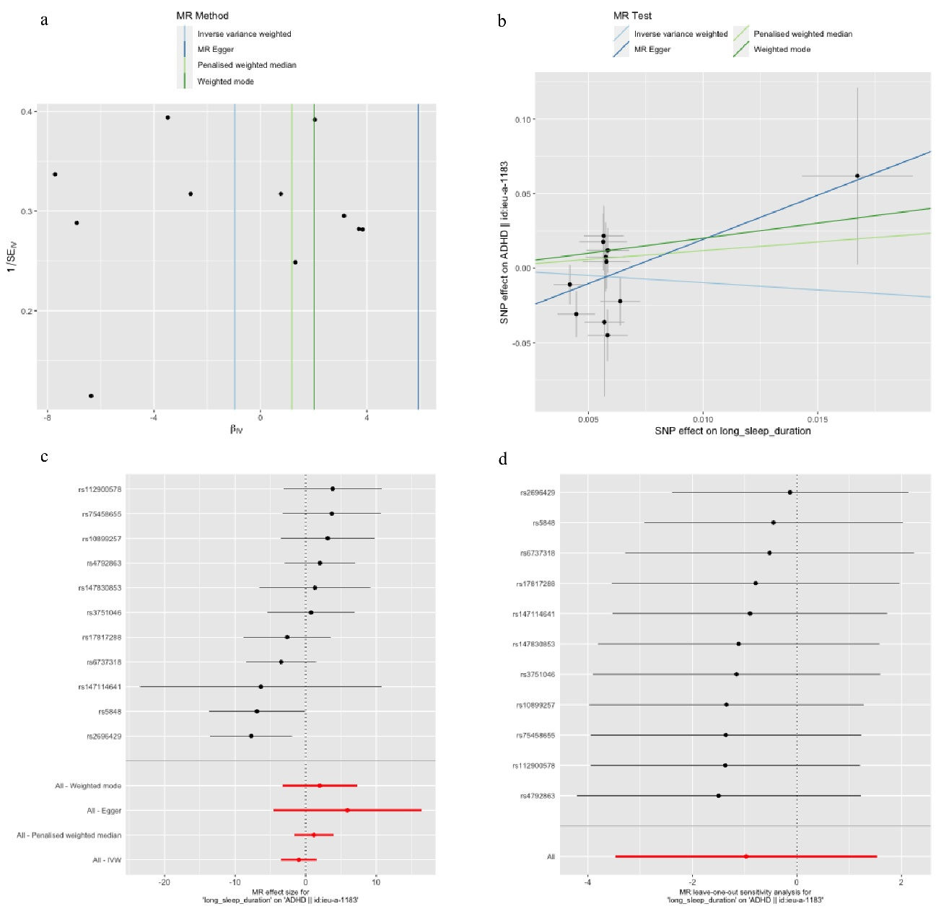

Figure S4. Figures to represent the MR analyses considering long sleep duration as exposure and ADHD as outcome. **a.** Funnel plot; **b.** Scatter plot; **c.** Forest plot; **d.** Leave-one-out plot.

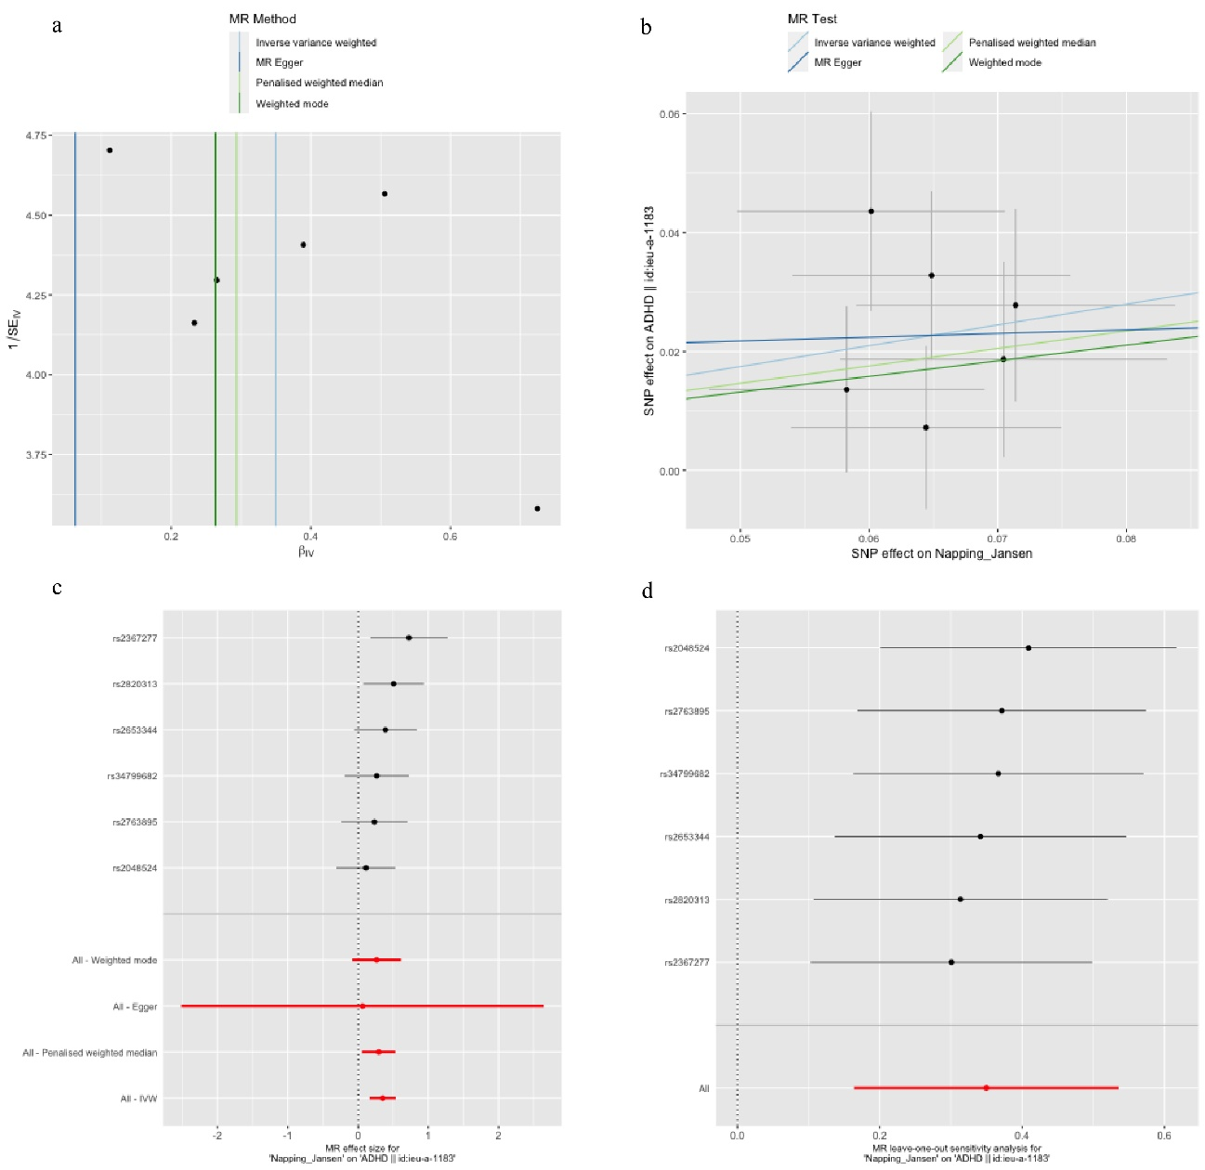

Figure S5. Figures to represent the MR analyses considering daytime napping as exposure and ADHD as outcome. **a.** Funnel plot; **b.** Scatter plot; **c.** Forest plot; **d.** Leave-one-out plot.

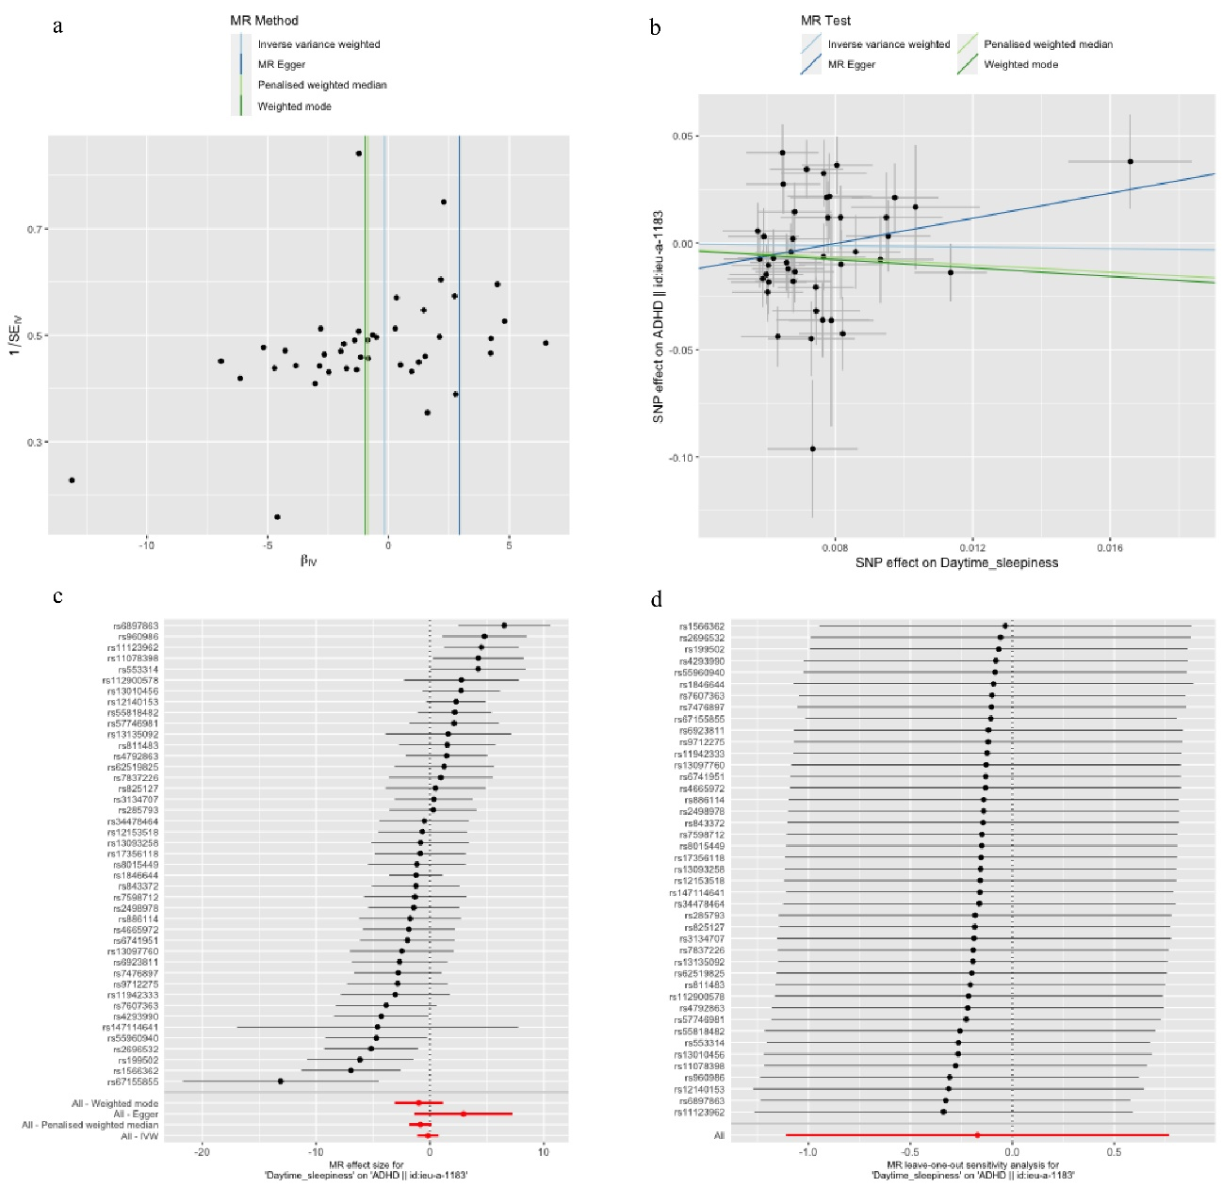

Figure S6. Figures to represent the MR analyses considering daytime sleepiness as exposure and ADHD as outcome. **a.** Funnel plot; **b.** Scatter plot; **c.** Forest plot; **d.** Leave-one-out plot.

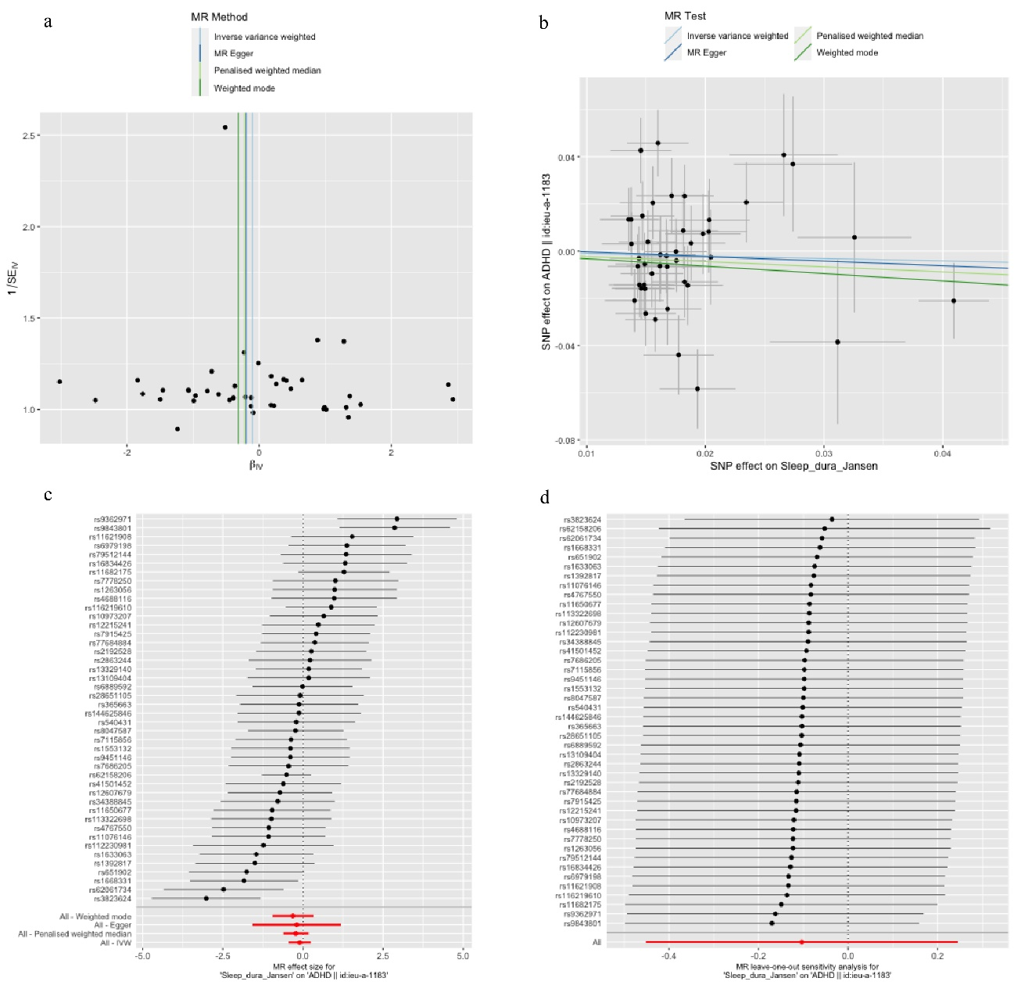

Figure S7. Figures to represent the MR analyses considering sleep duration as exposure and ADHD as outcome. **a.** Funnel plot; **b.** Scatter plot; **c.** Forest plot; **d.** Leave-one-out plot.

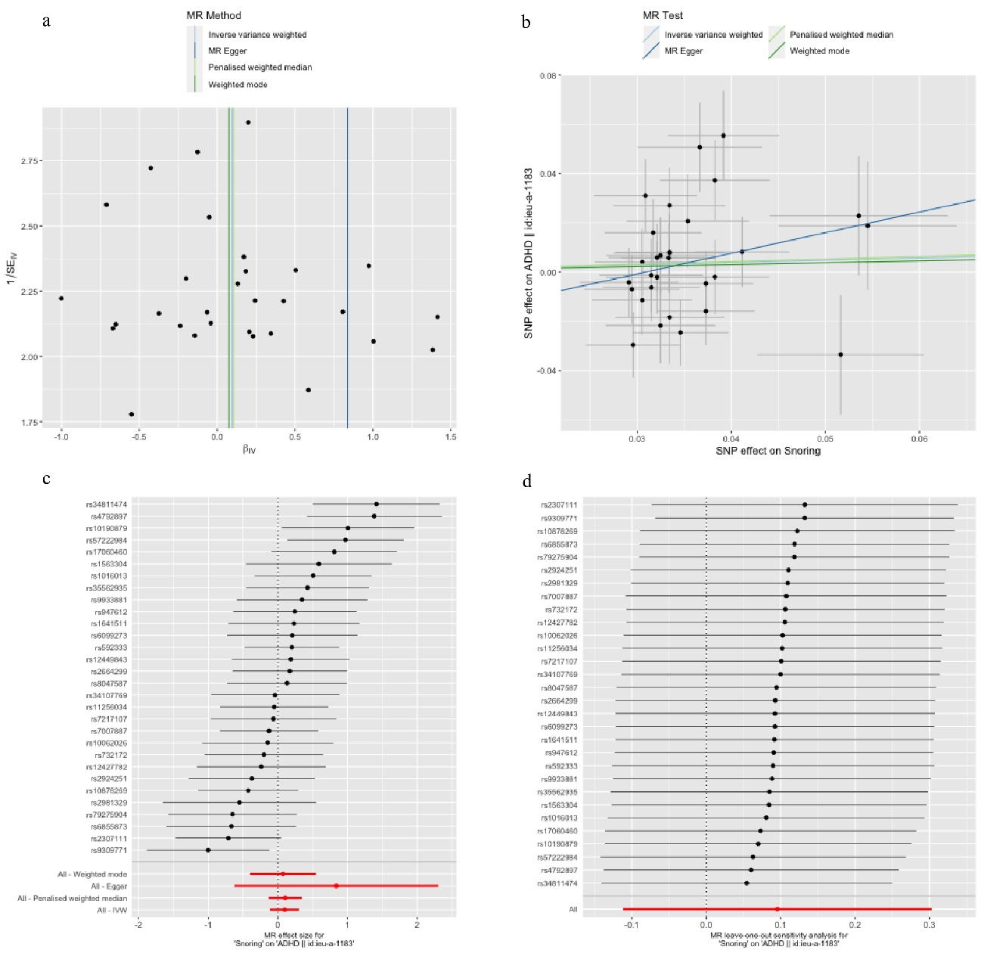

Figure S8. Figures to represent the MR analyses considering snoring as exposure and ADHD as outcome. **a.** Funnel plot; **b.** Scatter plot; **c.** Forest plot; **d.** Leave-one-out plot.

Figure S9. Figures to represent the MR analyses considering ease getting up as exposure and ADHD as outcome. **a.** Funnel plot; **b.** Scatter plot; **c.** Forest plot; **d.** Leave-one-out plot.

Figure S10. Figures to represent the MR analyses considering morningness as exposure and ADHD as outcome. **a.** Funnel plot; **b.** Scatter plot; **c.** Forest plot; **d.** Leave-one-out plot.

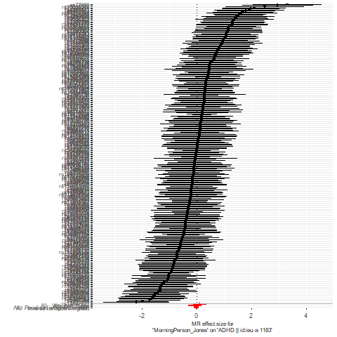

Figure S11. Figures to represent the MR analyses considering morning person as exposure and ADHD as outcome. **a.** Funnel plot; **b.** Scatter plot; **c.** Forest plot; **d.** Leave-one-out plot.

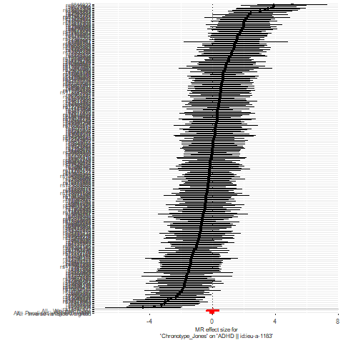

Figure S12. Figures to represent the MR analyses considering chronotype as exposure and ADHD as outcome. **a.** Funnel plot; **b.** Scatter plot; **c.** Forest plot; **d.** Leave-one-out plot.

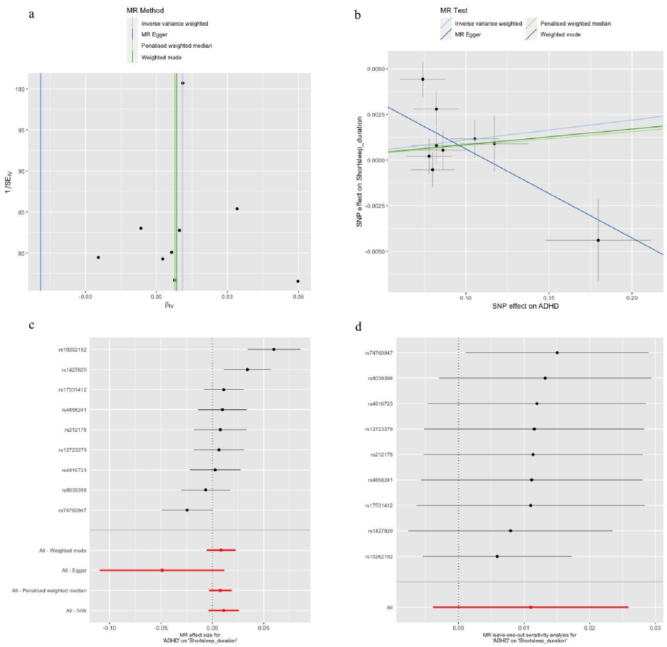

Figure S13. Figures to represent the MR analyses considering ADHD as exposure and short sleep duration as outcome. **a.** Funnel plot; **b.** Scatter plot; **c.** Forest plot; **d.** Leave-one-out plot.

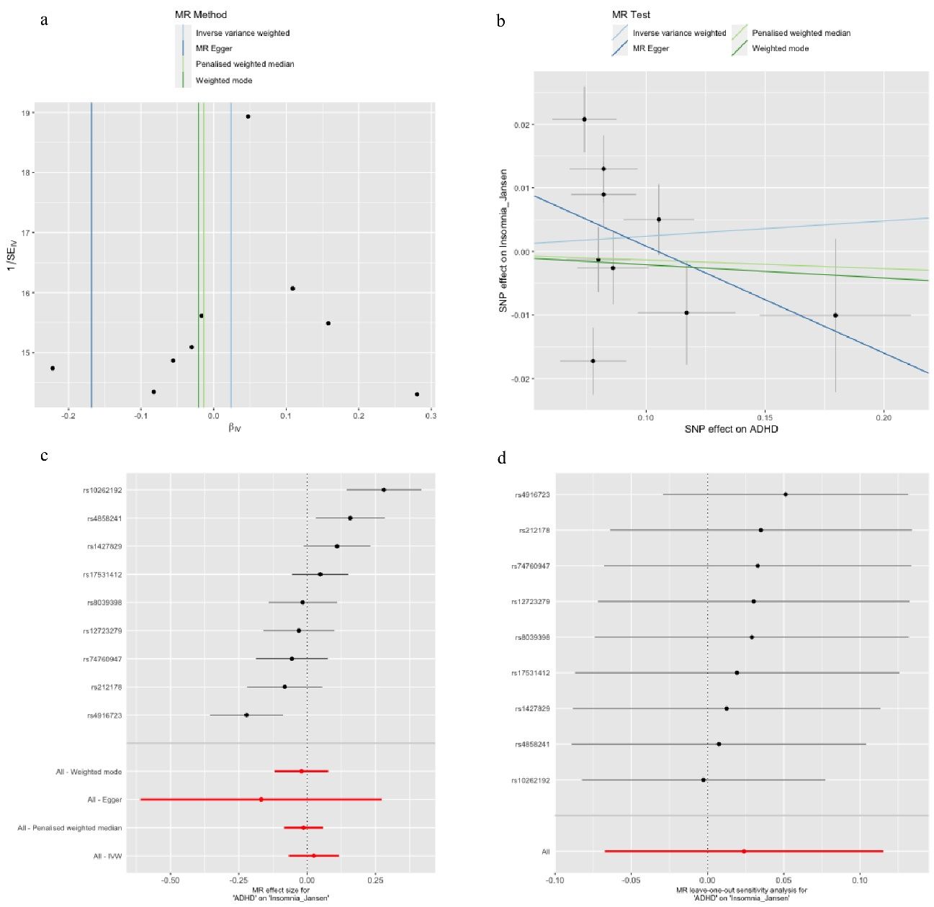

Figure S14. Figures to represent the MR analyses considering ADHD as exposure and Insomnia (data set from Jansen et al., 2019) as outcome. **a.** Funnel plot; **b.** Scatter plot; **c.** Forest plot; **d.** Leave-one-out plot.

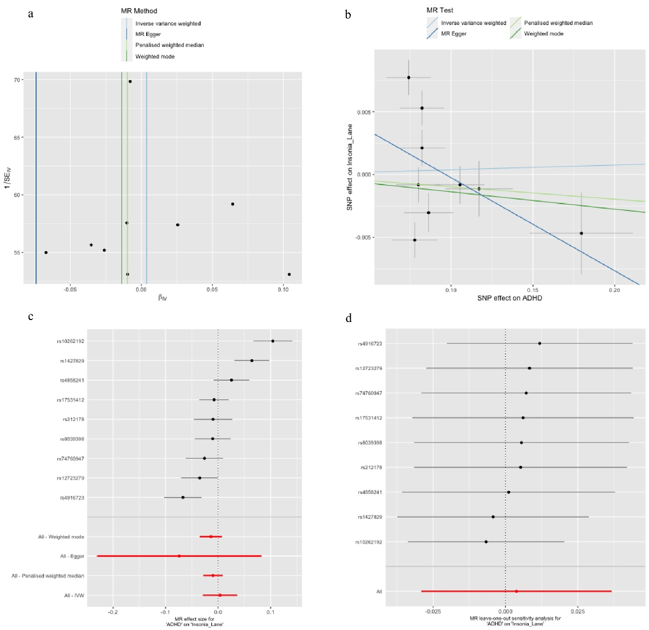

Figure S15. Figures to represent the MR analyses considering ADHD as exposure and Insomnia (data set from Lane et al., 2019) as outcome. **a.** Funnel plot; **b.** Scatter plot; **c.** Forest plot; **d.** Leave-one-out plot.

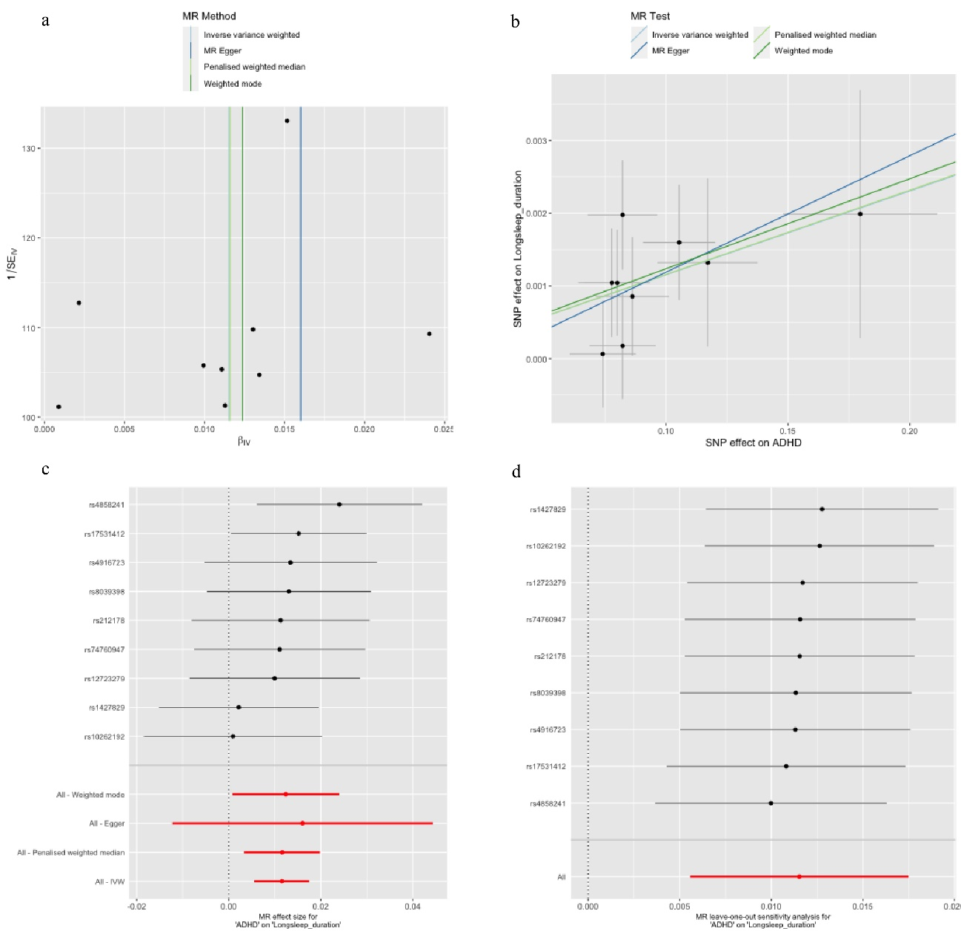

Figure S16. Figures to represent the MR analyses considering ADHD as exposure and long sleep duration as outcome. **a.** Funnel plot; **b.** Scatter plot; **c.** Forest plot; **d.** Leave-one-out plot.

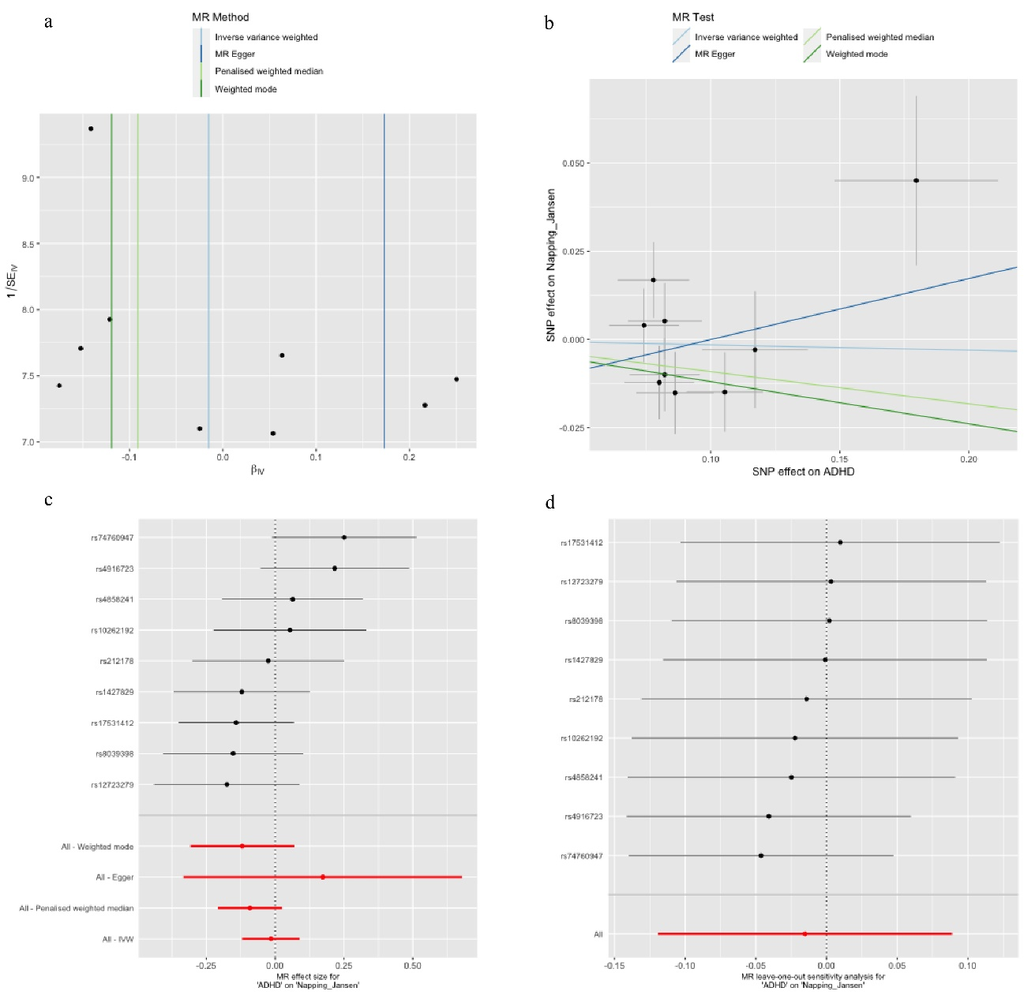

Figure S17. Figures to represent the MR analyses considering ADHD as exposure and daytime napping as outcome. **a.** Funnel plot; **b.** Scatter plot; **c.** Forest plot; **d.** Leave-one-out plot.

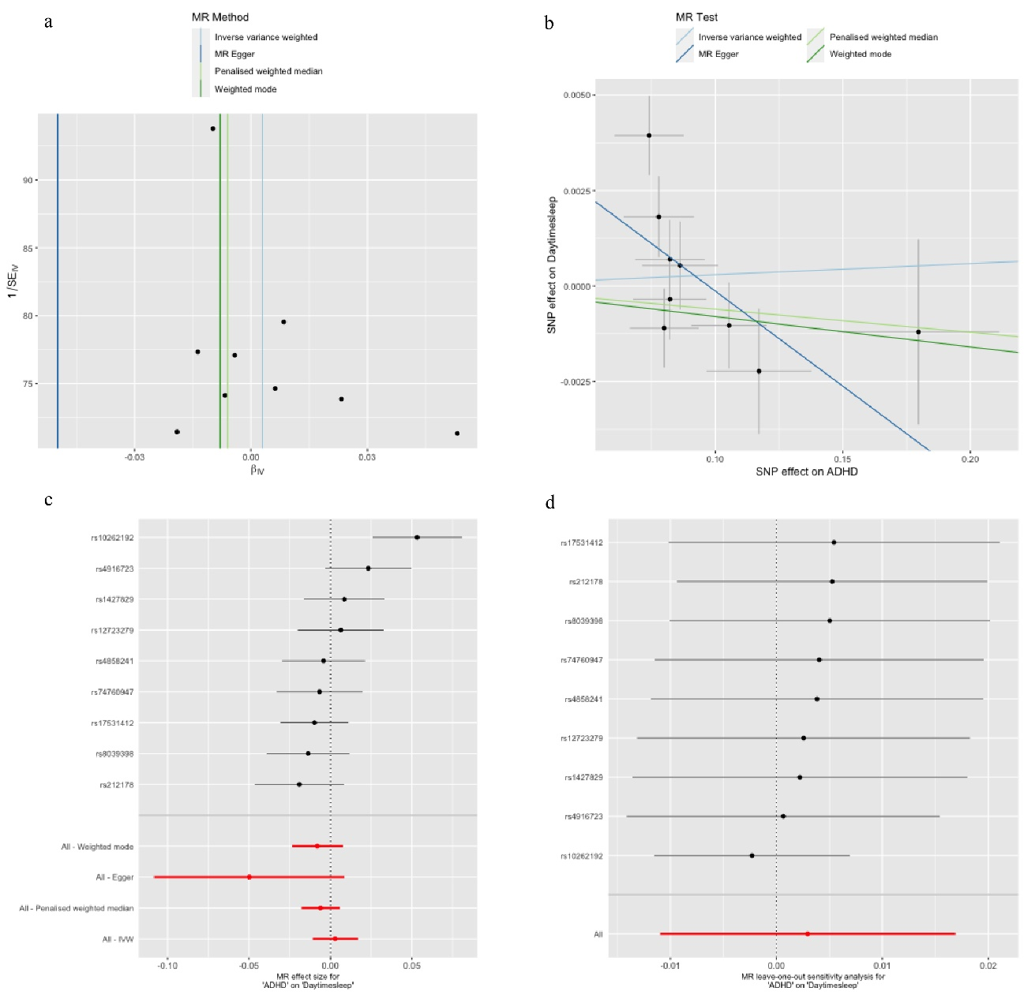

Figure S18. Figures to represent the MR analyses considering ADHD as exposure and daytime sleepiness as outcome. **a.** Funnel plot; **b.** Scatter plot; **c.** Forest plot; **d.** Leave-one-out plot.

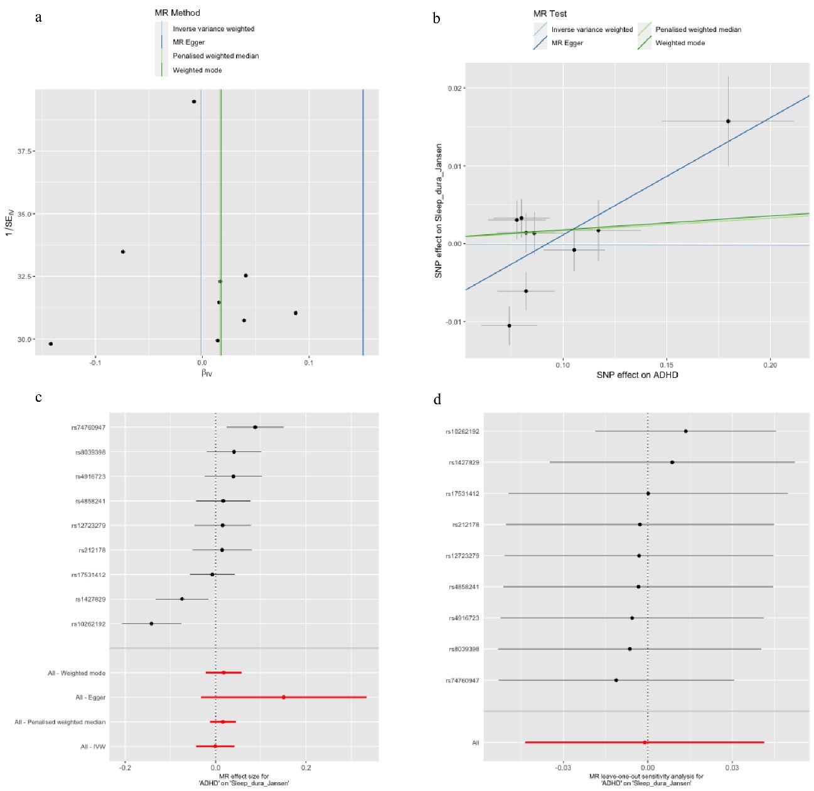Figure S19. Figures to represent the MR analyses considering ADHD as exposure and sleep duration as outcome. **a.** Funnel plot; **b.** Scatter plot; **c.** Forest plot; **d.** Leave-one-out plot.

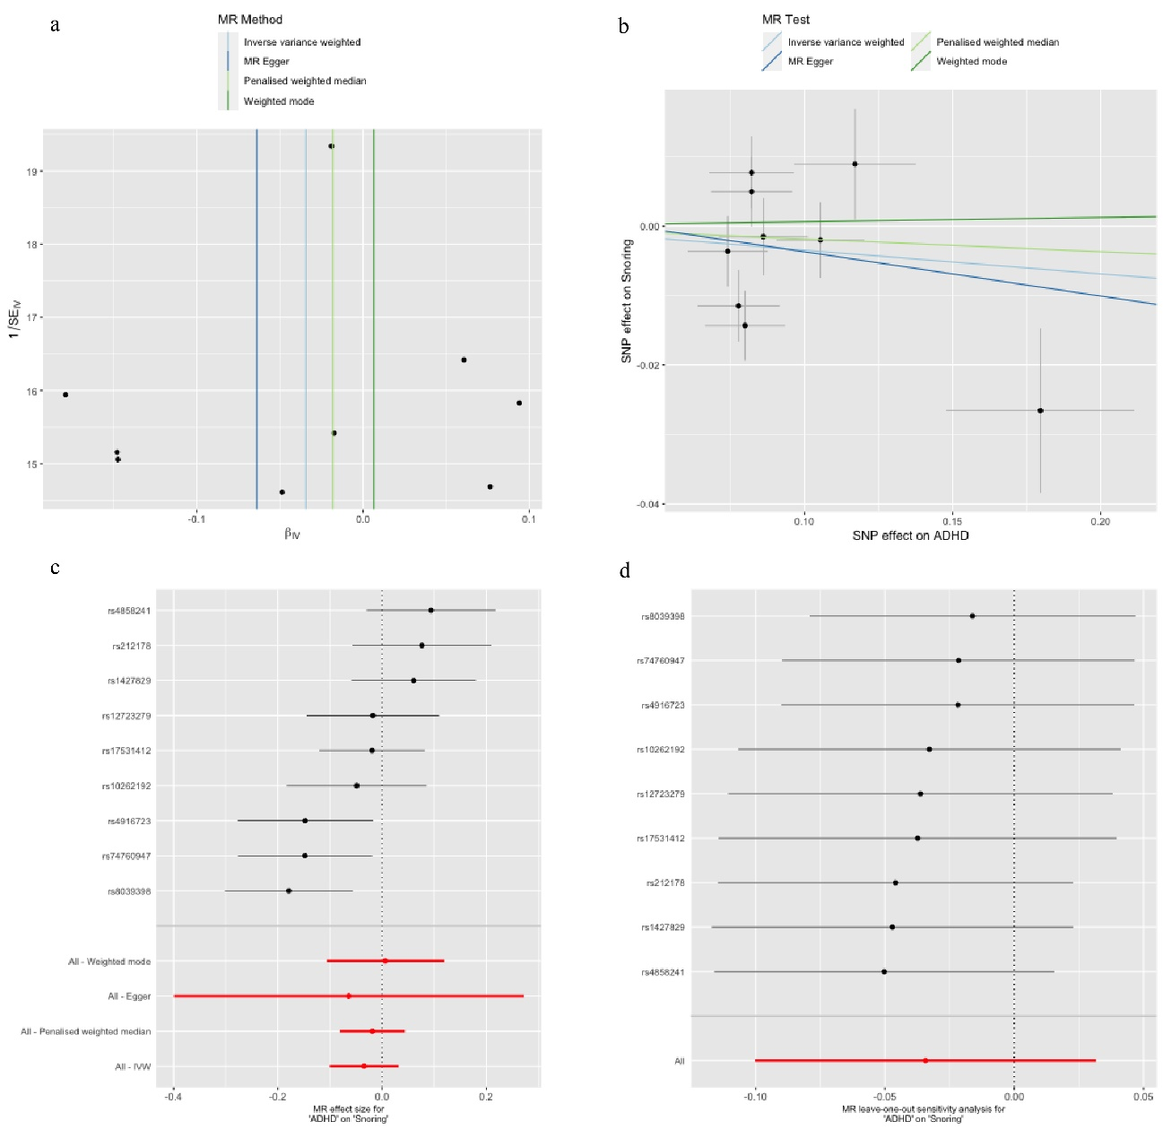

Figure S20. Figures to represent the MR analyses considering ADHD as exposure and snoring as outcome. **a.** Funnel plot; **b.** Scatter plot; **c.** Forest plot; **d.** Leave-one-out plot.

Figure S21. Figures to represent the MR analyses considering ADHD as exposure and ease getting up as outcome. **a.** Funnel plot; **b.** Scatter plot; **c.** Forest plot; **d.** Leave-one-out plot.

Figure S22. Figures to represent the MR analyses considering ADHD as exposure and morningness as outcome. **a.** Funnel plot; **b.** Scatter plot; **c.** Forest plot; **d.** Leave-one-out plot.

Figure S23. Figures to represent the MR analyses considering ADHD as exposure and morning person as outcome. **a.** Funnel plot; **b.** Scatter plot; **c.** Forest plot; **d.** Leave-one-out plot.

Figure S24. Figures to represent the MR analyses considering ADHD as exposure and chronotype as outcome. **a.** Funnel plot; **b.** Scatter plot; **c.** Forest plot; **d.** Leave-one-out plot.