A | 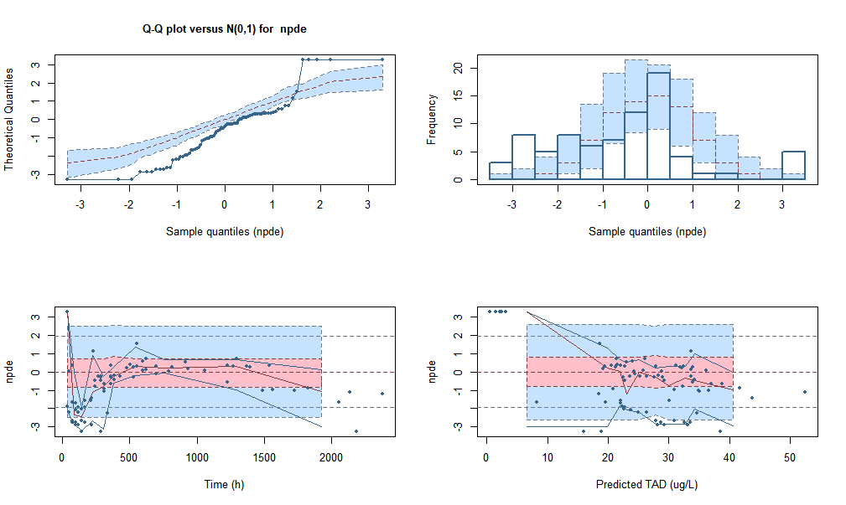

B | 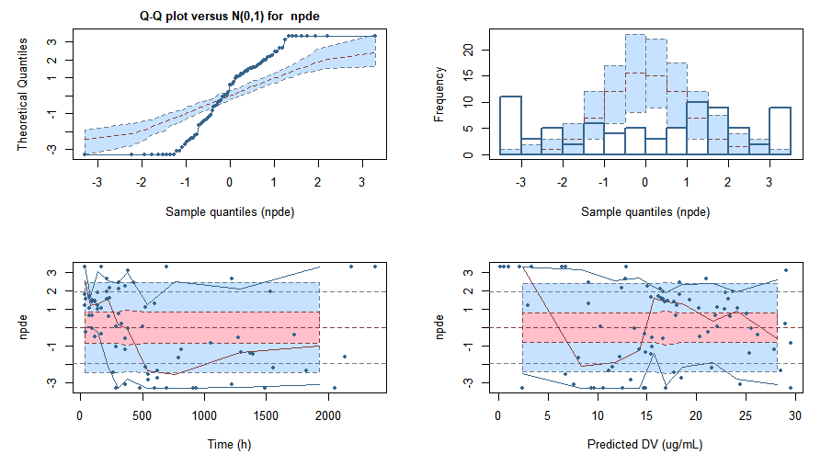

C | 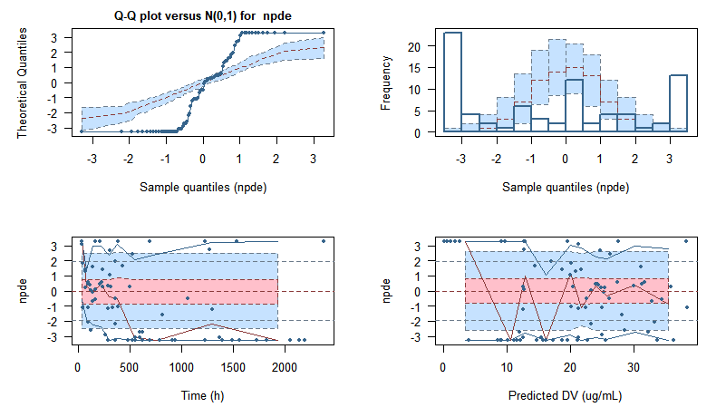

D | 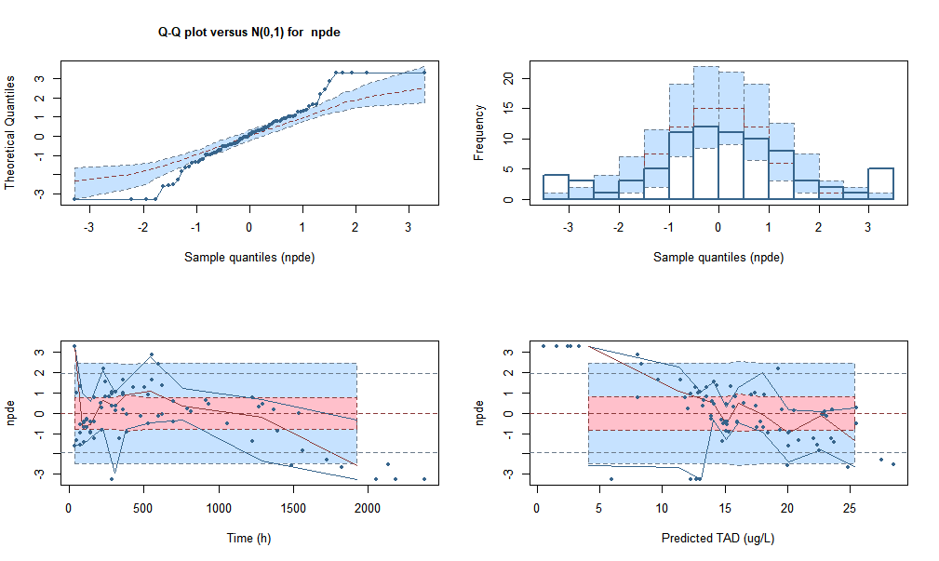

E | 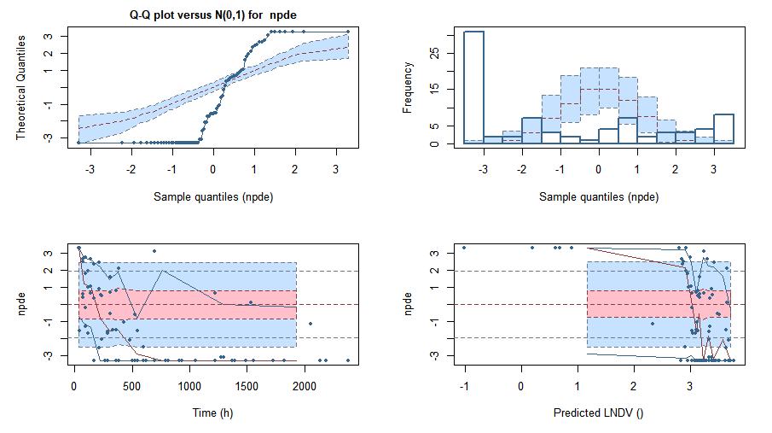

Figure S3. Normalized prediction distribution error (NPDE) plots of external validation data set for the investigated models, Moffett et al. (A), Yukawa et al. (B), Voller et al. (C), Vucicevic et al. (D), Grasela et al. (E): Quantile-quantile (q-q) plot of NPDE versus the expected standard normal distribution (upper left). Histogram of npde with the density of the standard normal distribution (upper right). The blue prediction intervals are obtained from the theoretical normal distribution. Scatterplot of the npde versus time after first dose in hour (lower left). The pink areas are the prediction interval for the median, while the blue areas show the prediction areas for the boundaries of the 95% prediction intervals. Scatterplot of npde versus predicted concentrations in ug/mL (lower right).

