Supplementary figures belonging to:

“Efficacy assessment of newly-designed and locally-produced filtering facemasks during the SARS-CoV-2 pandemic.”

Fig. S1. Experimental setup of the NaCl particle penetration test

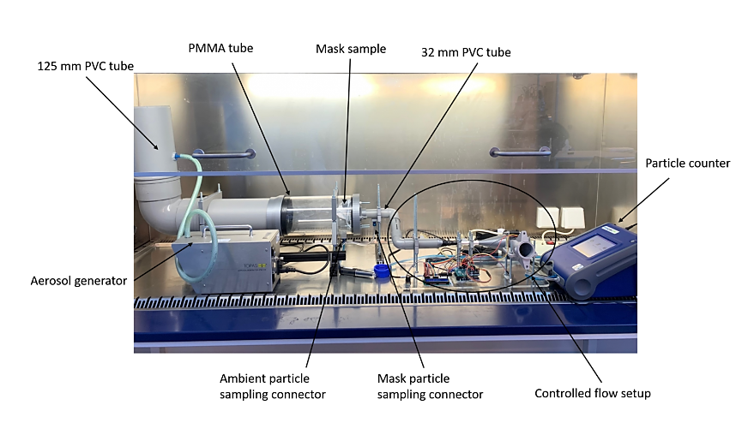
Fig S2. Experimental setup of the breathing resistance test

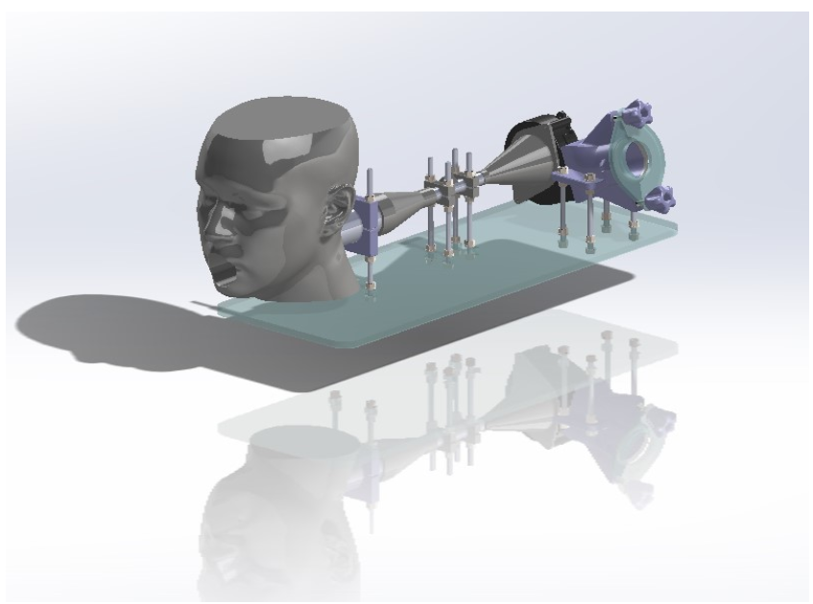

Fig. S3. Experimental setup of the virus filtration test

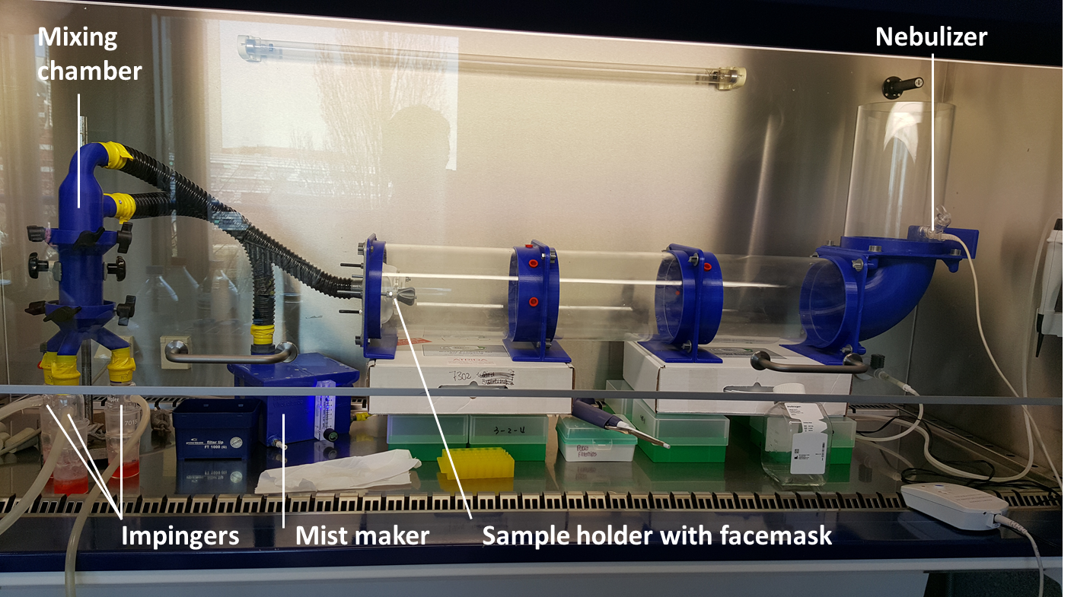

Fig. S4. NaCl penetration in mask Reinier-0.1 measured by Proquaris according to NEN149

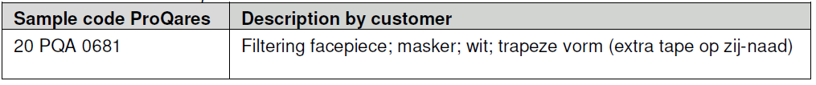
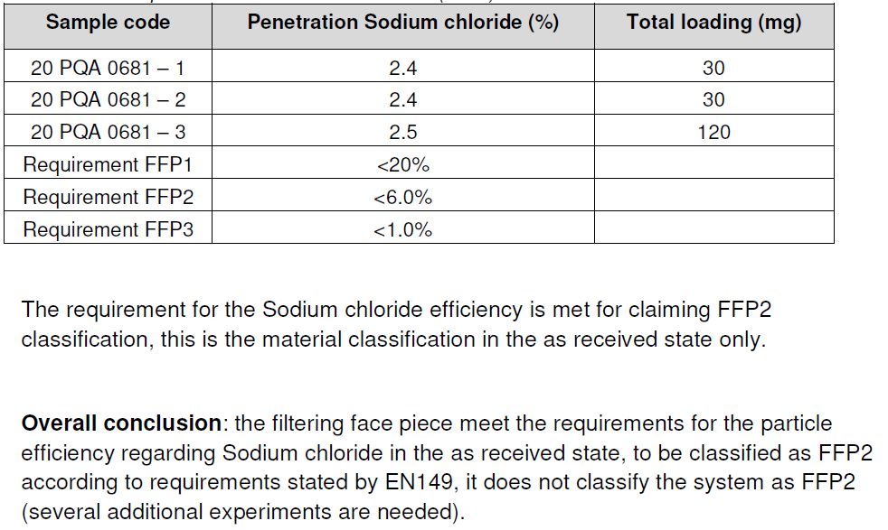

Fig. S5. NaCl penetration in mask DSM-1.0 measured by Proquaris according to NEN149
