**Supplementary Table 1. Combinations of the PCI outcomes observed in the present study**

|  |  |  |  |  |  |
| --- | --- | --- | --- | --- | --- |
| **AKI** | **Bleeding** | **Stroke** | **Death** | **N** | **%** |
| No | No | No | No | 25,823 | 92.21 |
| No | No | No | Yes | 116 | 0.41 |
| No | No | Yes | No | 41 | 0.15 |
| No | No | Yes | Yes | 1 | 0.00 |
| No | Yes | No | No | 680 | 2.43 |
| No | Yes | No | Yes | 50 | 0.18 |
| No | Yes | Yes | No | 6 | 0.02 |
| No | Yes | Yes | Yes | 5 | 0.02 |
| Yes | No | No | No | 932 | 3.33 |
| Yes | No | No | Yes | 65 | 0.23 |
| Yes | No | Yes | No | 9 | 0.03 |
| Yes | No | Yes | Yes | 2 | 0.01 |
| Yes | Yes | No | No | 206 | 0.74 |
| Yes | Yes | No | Yes | 58 | 0.21 |
| Yes | Yes | Yes | No | 9 | 0.03 |
| Yes | Yes | Yes | Yes | 2 | 0.01 |

**Supplementary Table 2. Estimates of variable importance in the MLP models for each outcome.** Model 1 variables are indicated by a blue background and Model 2 variables are indicated by a green background. Variables are sorted in deceasing order of importance.

|  |  |  |  |
| --- | --- | --- | --- |
| **Model** | **Rank** | **AKI** | |
| **Variable** | **Importance** |
| 1 | 1 | Currently not on dialysis | 25.41 |
| 1 | 2 | PCI status, Emergent | 14.11 |
| 1 | 3 | Hospital status, Inpatient | 13.23 |
| 1 | 4 | CKD, Present | 12.77 |
| 1 | 5 | Troponin T | 12.14 |
| 1 | 6 | Inpatient | 11.90 |
| 1 | 7 | Anemia, Present | 11.28 |
| 1 | 8 | NYHA class4 in past 2 weeks | 10.08 |
| 1 | 9 | Age | 9.89 |
| 1 | 10 | History of other major surgery | 9.88 |
| 1 | 11 | Cardiogenic shock within past 24 h | 9.52 |
| 1 | 12 | Past history of PCI, absent | 8.34 |
| 1 | 13 | CKMB | 8.06 |
| 1 | 14 | Transfer in from another acute care facility | 7.89 |
| 1 | 15 | Symptom onset time, afternoon | 7.59 |
| 1 | 16 | Cardiogenic shock at start pf PCI | 7.56 |
| 1 | 17 | History of PAD, Present | 7.43 |
| 1 | 18 | Diabetes, Present | 7.31 |
| 1 | 19 | Cardiomyopathy/LV dysfunction, Present | 6.88 |
| 1 | 20 | PCI for high-risk NSTEMI/UA | 6.80 |
| 2 | 1 | IABP in place at start of PCI | 2.43 |
| 2 | 2 | IABP inserted during PCI | 2.26 |
| 2 | 3 | Drug eluting stents, 0 | 1.97 |
| 2 | 4 | Closure device not used | 1.78 |
| 2 | 5 | Prasugrel not used | 1.59 |
| 2 | 6 | Mechanical ventricular support inserted after PCI | 1.57 |
| 2 | 7 | IABP inserted after PCI | 1.50 |
| 2 | 8 | Transfemoral access | 1.49 |
| 2 | 9 | Bare metal stents, 3 | 1.42 |
| 2 | 10 | Ticagrelor not used | 1.31 |
| **Model** | **Rank** | **Bleed** | |
| **Variable** | **Importance** |
| 1 | 1 | History of other major surgery | 36.10 |
| 1 | 2 | Anemia, Present | 27.54 |
| 1 | 3 | Cardiogenic shock within past 24 h | 14.35 |
| 1 | 4 | PCI status, Emergent | 13.44 |
| 1 | 5 | PCI Status, Salvage | 12.18 |
| 1 | 6 | Not on thrombolytics | 10.86 |
| 1 | 7 | Inpatient | 10.57 |
| 1 | 8 | Cardiomyopathy/LV dysfunction, Present | 10.02 |
| 1 | 9 | PCI for high-risk NSTEMI/UA | 9.39 |
| 1 | 10 | Gender, female | 9.14 |
| 1 | 11 | Coronary calcium score, not available | 8.70 |
| 1 | 12 | PCI done on Thursday | 8.46 |
| 1 | 13 | Race, White | 8.21 |
| 1 | 14 | No history of heart failure | 7.89 |
| 1 | 15 | Rescue PCI for STEMI | 7.86 |
| 1 | 16 | SPECT MPI result, Indeterminate | 6.99 |
| 1 | 17 | Hypertension, Present | 6.86 |
| 1 | 18 | CKD, Present | 6.67 |
| 1 | 19 | Cardiogenic shock at start pf PCI | 6.39 |
| 1 | 20 | Stenosis in the circumflex artery | 6.30 |
| 2 | 1 | IABP inserted during PCI | 4.74 |
| 2 | 2 | IABP in place at start of PCI | 3.63 |
| 2 | 3 | Transfemoral access | 3.63 |
| 2 | 4 | Fluoroscopy time | 3.48 |
| 2 | 5 | Mechanical ventricular support inserted after PCI | 3.18 |
| 2 | 6 | Mechanical ventricular support inserted during PCI | 2.98 |
| 2 | 7 | Glycoprotein IIb/IIIa inhibitor, used | 2.56 |
| 2 | 8 | Closure device not used | 2.42 |
| 2 | 9 | Bivairudin not used | 2.20 |
| 2 | 10 | Drug eluting stents, 0 | 2.12 |
| **Model** | **Rank** | **Stroke** | |
| **Variable** | **Importance** |
| 1 | 1 | History of heart failure withn 2 weeks, Present | 2.49 |
| 1 | 2 | Stenosis in grafts in ramus | 1.46 |
| 1 | 3 | Stenosis in proximal LAD | 1.35 |
| 1 | 4 | Dyslipidemia, absent | 1.19 |
| 1 | 5 | Chronic lung disease, absent | 1.19 |
| 1 | 6 | Antianginal medication, other | 1.17 |
| 1 | 7 | CKMB | 1.17 |
| 1 | 8 | PCI done one Wednesday | 1.14 |
| 1 | 9 | Vessels affected, 1 | 1.12 |
| 1 | 10 | CKD, Present | 1.11 |
| 1 | 11 | Anatianginals, ranolazine | 1.11 |
| 1 | 12 | Cardiogenic shock within past 24 h | 1.10 |
| 1 | 13 | Hemoglobin concentration | 1.09 |
| 1 | 14 | Time to emergency department | 1.02 |
| 1 | 15 | Stress exercise test, Positive | 1.00 |
| 1 | 16 | Stress CTA result, No Disease | 0.96 |
| 1 | 17 | PCI for high-risk NSTEMI/UA | 0.93 |
| 1 | 18 | Stress echocardiography, High risk | 0.92 |
| 1 | 19 | Stress CTA result, 2 vessels | 0.92 |
| 1 | 20 | Symptom onset time, afternoon | 0.90 |
| 2 | 1 | Drug eluting stents, unknown | 1.03 |
| 2 | 2 | Mechanical ventricular support inserted after PCI | 0.76 |
| 2 | 3 | Drug eluting stents, 5 | 0.74 |
| 2 | 4 | Ticagrelor, 2 | 0.74 |
| 2 | 5 | Ticlopidine, unknown | 0.57 |
| 2 | 6 | Ticagrelor, used | 0.54 |
| 2 | 7 | Low molecular weight heparin, 2 | 0.46 |
| 2 | 8 | Aspirin, unknown | 0.44 |
| 2 | 9 | Clopidogrel, unknown | 0.44 |
| 2 | 10 | Ticlopidine, used | 0.41 |
| **Model** | **Rank** | **Death** | |
| **Variable** | **Importance** |
| 1 | 1 | Cardiogenic shock within past 24 h | 14.87 |
| 1 | 2 | Cardiogenic shock at start pf PCI | 7.86 |
| 1 | 3 | History of cardiac arrest within 24 hours=1 | 7.08 |
| 1 | 4 | Stenosis in the circumflex artery | 5.89 |
| 1 | 5 | History of heart failure withn 2 weeks, Present | 5.57 |
| 1 | 6 | CKD, Present | 5.25 |
| 1 | 7 | PCI status, Emergent | 5.24 |
| 1 | 8 | CKMB | 4.90 |
| 1 | 9 | Troponin T | 4.87 |
| 1 | 10 | Dyslipidemia, absent | 4.75 |
| 1 | 11 | NYHA class4 in past 2 weeks | 4.66 |
| 1 | 12 | Door to balloon time | 4.26 |
| 1 | 13 | Not on thrombolytics | 4.04 |
| 1 | 14 | Age | 3.81 |
| 1 | 15 | Cardiomyopathy/LV dysfunction, Present | 3.62 |
| 1 | 16 | Stress exercise tes, Positive | 3.48 |
| 1 | 17 | Other procedure with diagnostic cath | 3.32 |
| 1 | 18 | Anemia, Present | 3.30 |
| 1 | 19 | PCI done from 12:00 Noon to 6:00 PM | 3.12 |
| 1 | 20 | Anginal classification, CCS IV | 3.12 |
| 2 | 1 | Closure device not used | 2.85 |
| 2 | 2 | Drug eluting stents, 0 | 2.84 |
| 2 | 3 | IABP in place at start of PCI | 2.84 |
| 2 | 4 | Mechanical ventricular support inserted after PCI | 2.82 |
| 2 | 5 | IABP inserted after PCI | 2.60 |
| 2 | 6 | Transfemoral access | 2.22 |
| 2 | 7 | Aspirin, not used | 2.22 |
| 2 | 8 | Unfractionated heparin, used | 2.21 |
| 2 | 9 | Clopidogrel, not used | 2.19 |
| 2 | 10 | Prasugrel not used | 1.87 |
| **Model** | **Rank** | **Any adverse outcome** | |
| **Variable** | **Importance** |
| 1 | 1 | History of other major surgery | 38.78 |
| 1 | 2 | Anemia, Present | 27.22 |
| 1 | 3 | PCI status, Emergent | 24.74 |
| 1 | 4 | Cardiogenic shock within past 24 h | 24.16 |
| 1 | 5 | Currently not on dialysis | 21.48 |
| 1 | 6 | Inpatient | 20.09 |
| 1 | 7 | Hospital status, Inpatient | 19.21 |
| 1 | 8 | NYHA class4 in past 2 weeks | 18.41 |
| 1 | 9 | Troponin T | 17.20 |
| 1 | 10 | History of cardiac arrest within 24 hours=1 | 16.74 |
| 1 | 11 | Not on thrombolytics | 14.84 |
| 1 | 12 | Cardiomyopathy/LV dysfunction, Present | 14.42 |
| 1 | 13 | Serum creatinine | 14.11 |
| 1 | 14 | PCI for high-risk NSTEMI/UA | 13.86 |
| 1 | 15 | Rescue PCI for STEMI | 13.80 |
| 1 | 16 | Cardiogenic shock at start pf PCI | 13.27 |
| 1 | 17 | Door to balloon time | 12.29 |
| 1 | 18 | PCI Status, Salvage | 11.93 |
| 1 | 19 | Stenosis in the circumflex artery | 11.53 |
| 1 | 20 | CKD, Present | 11.47 |
| 2 | 1 | IABP in place at start of PCI | 4.68 |
| 2 | 2 | IABP inserted during PCI | 4.68 |
| 2 | 3 | Drug eluting stents, 0 | 4.06 |
| 2 | 4 | Mechanical ventricular support inserted after PCI | 3.86 |
| 2 | 5 | Fluoroscopy time | 3.85 |
| 2 | 6 | Transfemoral access | 3.80 |
| 2 | 7 | Prasugrel not used | 2.93 |
| 2 | 8 | Mechanical ventricular support inserted during PCI | 2.92 |
| 2 | 9 | IABP inserted after PCI | 2.76 |
| 2 | 10 | Mechanical ventricular support before PCI | 2.45 |

**Supplementary Figure 1. Convergence of the MLP-based classifier.** Gray boxes indicate that that model performance improved in the training as well as test set and hence indicated learning. The white portion of the plot indicated that the model performance improved in the training set only implying potential overfitting.

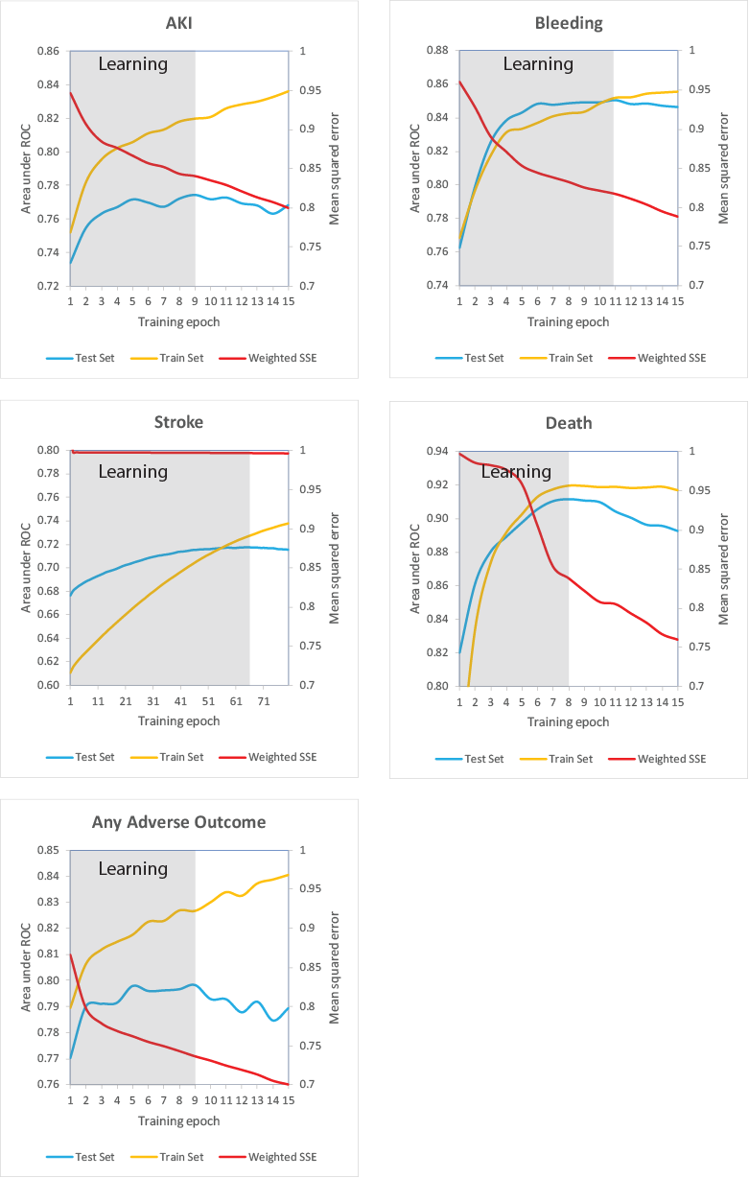

**Supplementary Figure 2. Likelihood of study outcomes based on the deciles of pre-PCI predicted probability (vertical axis) and PCI-related predicted probability (horizontal axis).** The numbers show likelihood ratios for each combination on a color-coded background. Deciles are indicated as D1-D10.

