SUPPLEMENTARY APPENDIX

Supplemental Table 1: MEDLINE Search Strategy – Ovid Interface
MEDLINE search strategy – Ovid Interface
1 Hypertension/dt and (resistant or uncontrolled or refractory).tw.
2 ((resistant or uncontrolled or refractory) adj3 (hypertens* or blood pressure or bp)).tw.
3 ATRH.tw.
4 resistant hypertension.kw.
5 or/1-4
6 Medication Adherence/ or Patient Compliance/
7 (adheren* or nonadheren* or complian* or noncomplian*).tw,kf.
8 6 or 7
9 5 and 8
10 exp Cohort Studies/
11 (cohort or retrospective* or prospective*).tw,kf.
12 Cross-Sectional Studies/
13 (cross-sectional or prevalence).tw,kw.
14 randomized controlled trial.pt.
15 controlled clinical trial.pt.
16 randomi?ed.ab.
17 placebo.ab.
18 clinical trials as topic.sh.
19 randomly.ab.
20 trial.ti.
21 or/10-20
22 9 and 21
23 (infant/ or child/) not adult/
24 22 not 23

Supplemental Figure 1: Regression of Mean Age on Logit Event Rate
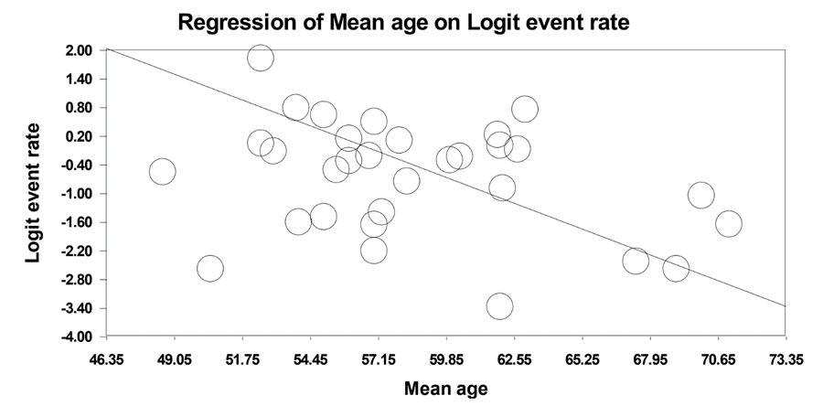

Supplemental Figure 2: Regression of Proportion of Men on Logit Event Rate
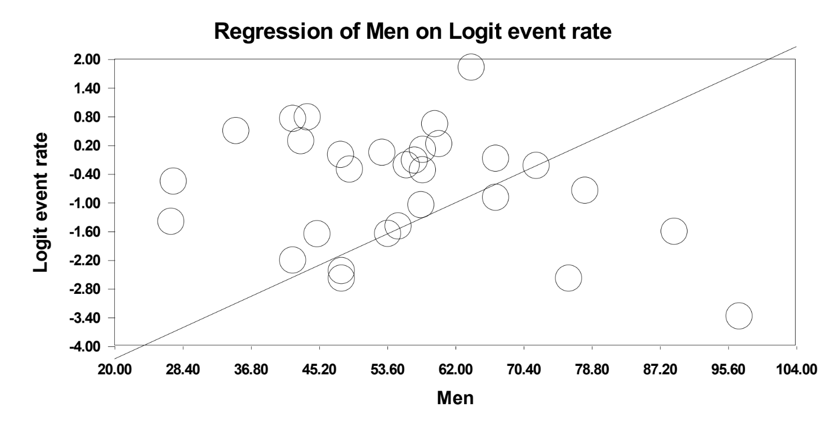Supplemental Figure 3: Regression of Publication date on Logit Event Rate
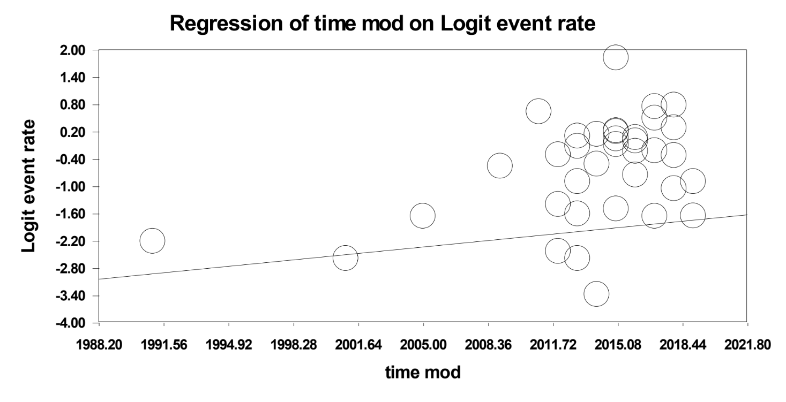

Supplemental Figure 4: Regression of Sample Size on Logit Event Rate
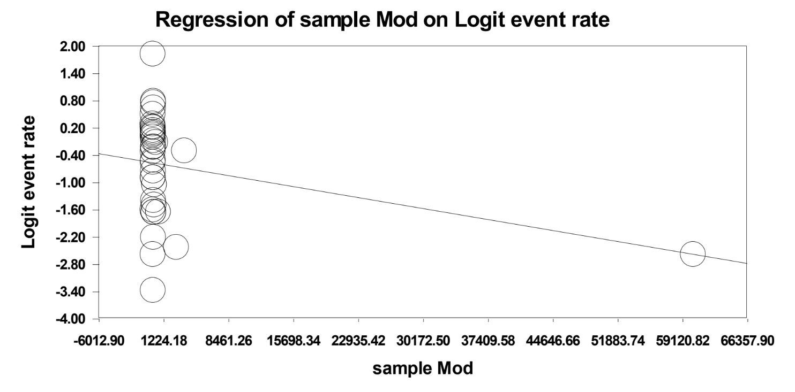
Supplemental Figure 5: Regression of Sample Size excluding one study on Logit Event Rate with Exclusion of One Large Study
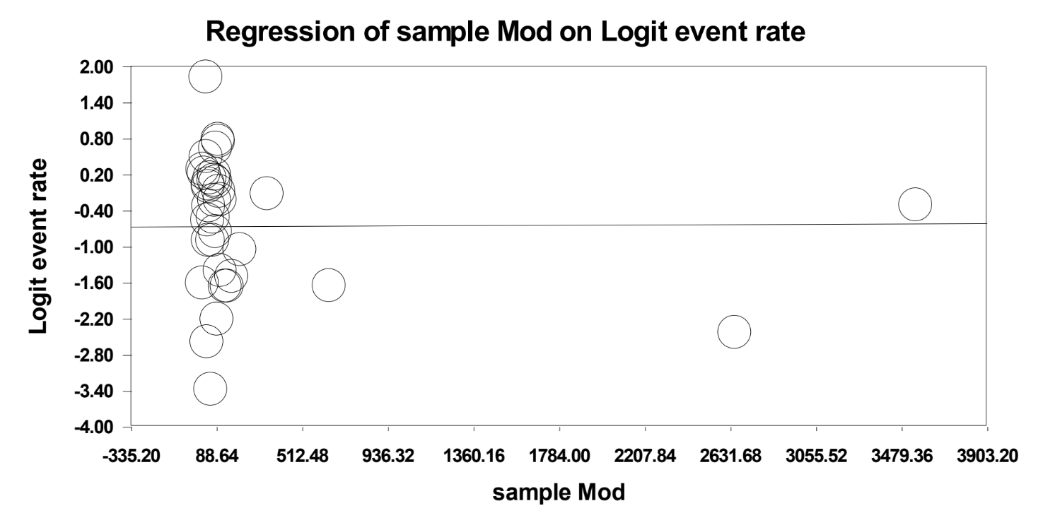
 | Domains of the Newcastle-Ottawa Scale
Study | Representativeness of the exposed cohort | Selection of the non-exposed cohort | Ascertainment of exposure | Demonstration that outcome of interest was NOT present at start of study | Comparability of cohorts on the basis of design/analysis | Assessment of outcome | Was follow-up long enough for outcomes to occur? | Adequacy of cohort follow-up | Total Number of Stars
Avataneo²² | A (*) | N/A | N/A | A (*) | N/A | A (*) | A (*) | A (*) | 5
Azizi²⁸ | D | N/A | N/A | B | N/A | A (*) | A (*) | A (*) | 3
Beaussier²⁹ | B (*) | N/A | N/A | B | N/A | B (*) | A (*) | A (*) | 4
Brinker¹¹ | B (*) | N/A | N/A | B | N/A | A (*) | B | B (*) | 3
Bunker³⁰ | B (*) | N/A | N/A | A (*) | N/A | A (*) | A (*) | A (*) | 5
Burnier³¹ | B (*) | N/A | N/A | B | N/A | B (*) | A (*) | A (*) | 4
Ceral³² | B (*) | N/A | N/A | A (*) | N/A | A (*) | B | A (*) | 4
Corrêa²³ | A (*) | N/A | N/A | B | N/A | A (*) | A (*) | A (*) | 4
Daugherty³³ | B (*) | N/A | N/A | B | N/A | B (*) | A (*) | A (*) | 4
de Jager³⁴ | B (*) | N/A | N/A | B | N/A | A (*) | A (*) | B (*) | 4
de Jesus³⁵ | A (*) | N/A | N/A | B | N/A | C | A (*) | A (*) | 3
de Souza³⁶ | A (*) | N/A | N/A | B | N/A | C | A (*) | A (*) | 3
Durand²⁴ | B (*) | N/A | N/A | B | N/A | A (*) | A (*) | B (*) | 4
Elmula³⁷ | B (*) | N/A | N/A | B | N/A | A (*) | A (*) | A (*) | 4
Ewen³⁸ | B (*) | N/A | N/A | B | N/A | A (*) | B | B (*) | 3
Ewen³⁹ | A (*) | N/A | N/A | A (*) | N/A | A (*) | B | A (*) | 4
Florczak²¹ | A (*) | N/A | N/A | B | N/A | A (*) | B | A (*) | 3
Garg⁴⁰ | B (*) | N/A | N/A | B | N/A | B (*) | A (*) | A (*) | 4
Grigoryan⁴¹ | B (*) | N/A | N/A | B | N/A | B (*) | A (*) | A (*) | 4
Hameed⁴² | A (*) | N/A | N/A | A (*) | N/A | A (*) | A (*) | A (*) | 5
Hayes⁴³ | B (*) | N/A | N/A | B | N/A | B (*) | A (*) | A (*) | 4
Heimark⁴⁴ | A (*) | N/A | N/A | B | N/A | A (*) | A (*) | A (*) | 4
Irvin⁴⁵ | B (*) | N/A | N/A | B | N/A | C | A (*) | A (*) | 3
Jung⁴⁶ | A (*) | N/A | N/A | B | N/A | A (*) | B | A (*) | 3
Kociánová⁴⁷ | B (*) | N/A | N/A | A (*) | N/A | A (*) | A (*) | A (*) | 5
Massierer⁴⁸ | B (*) | N/A | N/A | B | N/A | B (*) | A (*) | A (*) | 4
Pandey²⁵ | B (*) | N/A | N/A | A (*) | N/A | A (*) | B | C | 3
Porter²⁰ | B (*) | N/A | N/A | B | N/A | B (*) | A (*) | B (*) | 4
Pucci⁴⁹ | A (*) | N/A | N/A | B | N/A | A (*) | B | A (*) | 3
Rosa⁵⁰ | A (*) | N/A | N/A | B | N/A | A (*) | A (*) | A (*) | 4
Ruzicka²⁶ | B (*) | N/A | N/A | A (*) | N/A | A (*) | A (*) | B (*) | 5
Schmieder⁵¹ | A (*) | N/A | N/A | B | N/A | A (*) | B | A (*) | 3
Sim¹⁹ | B (*) | N/A | N/A | B | N/A | B (*) | A (*) | A (*) | 4
Štrauch²⁷ | A (*) | N/A | N/A | A (*) | N/A | A (*) | A (*) | A (*) | 5
Velasco⁵² | B (*) | N/A | N/A | A (*) | N/A | A (*) | B | A (*) | 4
Yakovlevitch⁵³ | A (*) | N/A | N/A | B | N/A | B (*) | A (*) | A (*) | 4
Detail of abbreviations : N/A – Non-Applicable
Supplemental Table 2: Quality Assessment

Supplemental Figure 6: Funnel Plot of Included Studies

