**Supplementary File**

1. **Drinking water ladder**:

Unimproved – Limited – Basic – Improved - Safely Managed (depicting Bad to good situations) (Source: washdata.org/monitoring/drinking-water)

|  |  |  |
| --- | --- | --- |
| **No.** | **Category** | **Explanation** |
| 1 | Surface water (drinking water) facilities | Share of population drinking water directly from a river, dam, lake, pond, stream, canal or irrigation canal. |
| 2 | Unimproved drinking water facilities | Share of population drinking water from an unprotected dug well or unprotected spring. |
| 3 | Limited drinking water facilities | Share of population drinking water from an improved source for which collection time exceeds 30 minutes for a roundtrip including queuing. |
| 4 | Basic drinking water facilities | Share of population drinking water from an improved source, provided collection time is not more than 30 minutes for a roundtrip including queuing. |
| 5 | Improved drinking water facilities | Those that have the potential to deliver safe water by nature of their design and construction, and include: piped water, boreholes or tube wells, protected dug wells, protected springs, rainwater, and packaged or delivered water. |
| 6 | Safely managed drinking water facilities | Share of population drinking water from an improved water source which is located on premises, available when needed and free from faecal and priority chemical contamination. |

1. **Sanitation ladder**:

Open – Unimproved – Limited – Basic – Improved - Safely managed (depicting Bad to good situations) (Source: washdata.org/monitoring/sanitation)

|  |  |  |
| --- | --- | --- |
| **No.** | **Category** | **Explanation** |
| 1 | Open defecation | Share of population with disposal of human faeces in fields, forests, bushes, open bodies of water, beaches and other open spaces or with solid waste. |
| 2 | Unimproved sanitation facilities | Share of population with use pit latrines without a slab or platform, hanging latrines or bucket latrines. |
| 3 | Limited sanitation facilities | Share of population who use improved facilities shared between two or more households. |
| 4 | Basic sanitation facilities | Share of population who use improved facilities which are not shared with other households. |
| 5 | Improved sanitation facilities | Those designed to hygienically separate excreta from human contact, and include: flush/pour flush to the piped sewer system, septic tanks or pit latrines; ventilated improved pit latrines, composting toilets or pit latrines with slabs. |
| 6 | Safely managed sanitation facilities | Share of population who use improved facilities which are not shared with other households and where excreta are safely disposed in situ or transported and treated off-site. |

Calculation of indicators of Covid-19:

Recovery rate (RR) = (total recovered/total confirmed) *100

Case fatality rate (CFR) = (total death/ total confirmed) *100

Connection of Water to UN – SDG:

Target 6.1, 'By 2030, achieve universal and equitable access to safe and affordable drinking water for all'.

**Indicators for socioeconomy of Water**

|  |  |  |  |  |  |
| --- | --- | --- | --- | --- | --- |
| **No.** | **Indicators** | **Acronym** | **No.** | **Sub-indicators** | **N** |
| 1 | Unimproved water services | UWS | 1 | overall (% of population) | 138 |
| UWS - R | 2 | rural (% of rural population) | 155 |
| UWS - U | 3 | urban (% of urban population) | 157 |
| 2 | Limited water services (not more than 30 min) | LWS | 4 | overall (% of population) | 116 |
| LWS - R | 5 | rural (% of rural population) | 113 |
| LWS - U | 6 | urban (% of urban population) | 114 |
| 3 | Basic drinking water service | BDWS | 7 | overall (% of population) | 175 |
| BDWS - R | 8 | rural (% of rural population) | 157 |
| BDWS - U | 9 | urban (% of urban population) | 158 |
| 4 | Improved water source | IWS | 10 | overall (% of population with access) | 171 |
| IWS – R | 11 | rural (% of rural population with access) | 170 |
| IWS – U | 12 | urban (% of urban population with access) | 172 |
| 5 | Improved water services, non-piped | IWS - NP | 13 | overall (% of population) | 174 |
| IWS - NP - R | 14 | rural (% of rural population) | 154 |
| IWS - NP - U | 15 | urban (% of urban population) | 156 |
| 6 | Improved water services, piped | IWS - P | 16 | overall (% of population) | 174 |
| IWS - P - R | 17 | rural (% of rural population) | 155 |
| IWS - P - U | 18 | urban (% of urban population) | 157 |
| 7 | Improved water services, available when needed | IWS - AN | 19 | overall (% of population) | 68 |
| IWS - AN - R | 20 | rural (% of rural population) | 54 |
| IWS - AN - U | 21 | urban (% of urban population) | 67 |
| 8 | Improved water services, accessible on premises | IWS - AP | 22 | overall (% of population) | 175 |
| IWS - AP - R | 23 | rural (% of rural population) | 156 |
| IWS - AP - U | 24 | urban (% of urban population) | 158 |
| 9 | Improved water services, free from contamination | IWS - FC | 25 | overall (% of population) | 82 |
| 10 | Safely managed drinking water service | SMDWS | 26 | overall (% of population) | 82 |

Connection of Sanitation to UN – SDG:

Target 6.2 "by 2030, achieve access to adequate and equitable sanitation and hygiene for all and end open defecation, paying special attention to the needs of women and girls and those in vulnerable situations"

**Indicators for socioeconomy of Sanitation**

|  |  |  |  |  |  |
| --- | --- | --- | --- | --- | --- |
| **No.** | **Indicators** | **Acronym** | **No.** | **Sub-indicators** | **N** |
| 1 | Open defecation | OD | 1 | overall (% of population) | 175 |
| OD - R | 2 | rural (% of rural population) | 155 |
| OD - U | 3 | urban (% of urban population) | 157 |
| 2 | Unimproved sanitation facilities | USF | 4 | overall (% of population) | 175 |
| USF - U | 5 | urban (% of urban population) | 157 |
| 3 | Limited (shared) sanitation facilities | LSF | 6 | overall (% of population) | 175 |
| LSF - R | 7 | rural (% of rural population) | 156 |
| LSF - U | 8 | urban (% of urban population) | 157 |
| 4 | Basic sanitation service | BSS | 9 | overall (% of population) | 175 |
| BSS - R | 10 | rural (% of rural population) | 155 |
| BSS - U | 11 | urban (% of urban population) | 157 |
| 5 | Improved sanitation facilities | ISF | 12 | overall (% of population) | 171 |
| ISF - R | 13 | rural (% of rural population) | 170 |
| ISF - U | 14 | urban (% of urban population) | 171 |
| 6 | Improved sanitation facilities (excluding shared) - Latrines and other | ISF - L | 15 | overall (% of population) | 173 |
| ISF - L - R | 16 | rural (% of rural population) | 148 |
| ISF - L - U | 17 | urban (% of urban population) | 149 |
| 7 | Improved sanitation facilities (excluding shared) - Septic tanks | ISF - ST | 18 | overall (% of population) | 157 |
| ISF - ST - R | 19 | rural (% of rural population) | 136 |
| ISF - ST - U | 20 | urban (% of urban population) | 135 |
| 8 | Improved sanitation facilities (excluding shared) - Sewer connections | ISF - SC | 21 | overall (% of population) | 172 |
| ISF - SC - R | 22 | rural (% of rural population) | 146 |
| ISF - SC - U | 23 | urban (% of urban population) | 148 |
| 9 | Improved sanitation facilities (excluding shared) - Wastewater treated | ISF - WT | 24 | overall (% of population) | 105 |
| ISF - WT - R | 25 | rural (% of rural population) | 83 |
| ISF - WT - U | 26 | urban (% of urban population) | 82 |
| 10 | Improved sanitation facilities - Disposed in situ | ISF - D | 27 | overall (% of population) | 76 |
| 11 | Improved sanitation facilities - Safely managed | ISF - SM | 28 | overall (% of population) | 76 |

**Indicators for socioeconomy of Hygiene**

|  |  |  |  |  |  |
| --- | --- | --- | --- | --- | --- |
| **No.** | **Indicators** | **Acronym** | **No.** | **Sub-indicators** | **N** |
| 1 | Basic handwashing facilities | BHF | 1 | overall (% of population) | 77 |
| BHF - R | 2 | rural (% of rural population) | 71 |
| BHF - U | 3 | urban (% of urban population) | 70 |
| 2 | Limited (without water or soap) handwashing facilities | LHF | 4 | overall (% of population) | 71 |
| LHF - R | 5 | rural (% of rural population) | 71 |
| LHF - U | 6 | urban (% of urban population) | 70 |
| 3 | No facilities | NF | 7 | overall (% of population) | 71 |
| NF - R | 8 | rural (% of rural population) | 71 |
| NF - U | 9 | urban (% of urban population) | 70 |

**Change in number of significantly correlated WASH indicators:**

|  |  |  |  |  |  |
| --- | --- | --- | --- | --- | --- |
| **No.** | **Date** | **Water (%)** | **Sanitation (%)** | **Hygiene (%)** | **Gross (%)** |
| 1 | 30-03-2020 | 75.38 | 68.57 | 51.11 | 68.89 |
| 2 | 30-04-2020 | 79.23 | 59.28 | 28.89 | 63.17 |
| 3 | 30-05-2020 | 90 | 79.28 | 24.44 | 75.87 |
| 4 | 30-06-2020 | 83.08 | 80 | 24.44 | 73.33 |

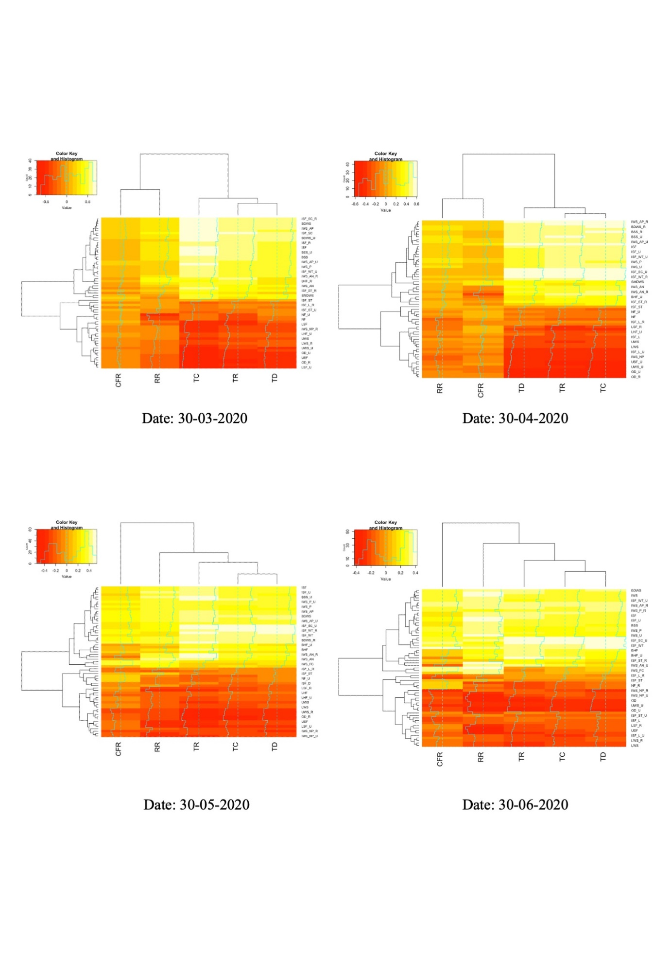

Fig. Heatmap of correlation between various indicators of WASH and Covid-19 for 4 months (March – June 2020).

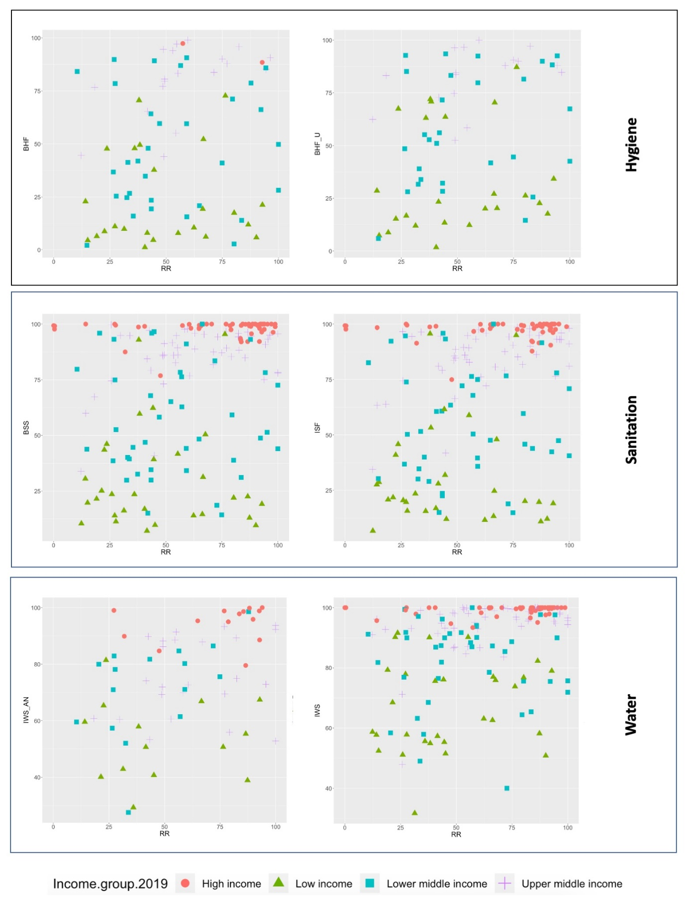

Fig. Scatterplot of various indicators of WASH and Covid-19 in relation to 4 income groups (by World Bank) of the world.

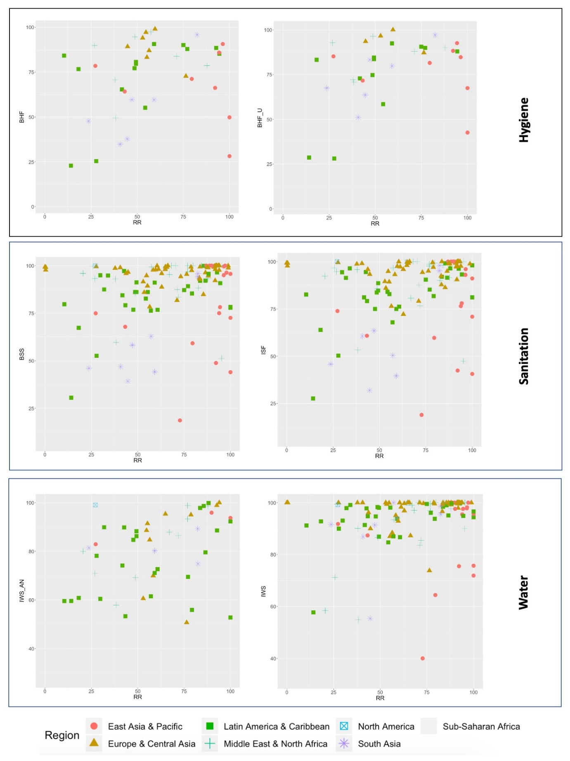

Fig. Scatterplot of various indicators of WASH and Covid-19 in relation to 7 geographic zones in the world.