Supplementary Table 1. Number of samples and significant heritable genes.
Tissue |  | Abbreviation | ªSample Size | ^{b}Mean heritability | ^{c}Highly heritable genes
Blood | Whole blood | BLD | 575 | 0.016 | 2,239
 | Lymphoblastoid cell lines | Geuvadis | 358 |  | -
Brain | Amygdala | AMY | 120 | 0.043 | 1,192
 | Anterior cingulate cortex BA24 | ACC | 137 | 0.039 | 1,248
 | Caudate basal ganglia | CBG | 174 | 0.035 | 1,573
 | Cerebellar hemisphere | CEH | 159 | 0.046 | 2,010
 | Cerebellum | CER | 190 | 0.046 | 2,606
 | Cortex | COR | 185 | 0.037 | 1,769
 | Frontal cortex BA9 | FRO | 159 | 0.038 | 1,549
 | Hippocampus | HIP | 152 | 0.034 | 1,220
 | Hypothalamus | HYP | 158 | 0.033 | 1,220
 | Nucleus accumbens basal ganglia | NAB | 183 | 0.031 | 1,391
 | Putamen basal ganglia | PBG | 155 | 0.036 | 1,427
 | Spinal cord cervical c-1 | SCC | 116 | 0.047 | 1,335
 | Substantia nigra | SUB | 102 | 0.049 | 1,092
 | Brain Total |  | 1,990 | 0.040 | 19,632
ªUse only European samples; ^{b}Average cis heritability of all available genes; ^{c}The genes located in major histocompatibility complex (MHC) region were removed. The MHC region occurs on chromosome 6, between the flanking genetic markers MOG and COL11A2 (from 6p22.1 to 6p21.3 about 29Mb to 33Mb on the hg38 assembly).

Type | Source | URLs
HMM | Roadmap | https://egg2.wustl.edu/roadmap/data/byFileType/chromhmmSegmentations/ChmmModels/coreMarks/jointModel/final/
TFBS | ENCODE | http://hgdownload.cse.ucsc.edu/goldenPath/hg19/encodeDCC/wgEncodeAwgTfbsUniform/
DHS | Roadmap | https://egg2.wustl.edu/roadmap/data/byFileType/peaks/consolidated/narrowPeak/
Supplementary Table 2. List of all publicly available epigenomic element files used for training the models.

Supplementary Table 3. Information for the GWASs summary data used in this study.
Exposure | Case | Control | URL | PMID
BD_2019 | 20,352 | 31,358 | https://www.med.unc.edu/pgc/download-results/bip/ | 31043756
BD_2012 | 7,481 | 9,250 | https://www.med.unc.edu/pgc/download-results/bip/ | 21926972

Supplementary Table 4. The correlation between SNP number in the best model and model performance.
Tissue | Mean SNP number | Mean R² | r | P-value
Brain Amygdala | 7.70 | 0.13 | -0.10 | 1.48×10⁻³
Brain Anterior cingulate cortex BA24 | 7.82 | 0.13 | -0.08 | 9.73×10⁻³
Brain Caudate basal ganglia | 8.52 | 0.12 | -0.11 | 1.12×10⁻⁵
Brain Cerebellar Hemisphere | 7.48 | 0.15 | -0.06 | 4.19×10⁻³
Brain Cerebellum | 7.33 | 0.15 | -0.05 | 0.05
Brain Cortex | 7.56 | 0.12 | -0.05 | 0.01
Brain Frontal Cortex BA9 | 8.03 | 0.13 | -0.10 | 2.21×10⁻⁵
Brain Hippocampus | 8.12 | 0.11 | -0.08 | 1.77×10⁻³
Brain Hypothalamus | 8.14 | 0.11 | -0.09 | 6.88×10⁻⁴
Brain Nucleus accumbens basal ganglia | 7.84 | 0.11 | -0.07 | 2.91×10⁻³
Brain Putamen basal ganglia | 8.10 | 0.12 | -0.11 | 1.22×10⁻⁸
Brain Spinal cord cervical c-1 | 8.12 | 0.15 | -0.12 | 9.86×10⁻⁶
Brain Substantia nigra | 7.84 | 0.16 | -0.13 | 5.93×10⁻⁵

Supplementary Table 5. Significant ETWAS genes for BD.
Tissue | Gene | Best eQTL | ªCross-validation R² | TWAS Z-score | ^{b}TWAS P-value
CBG | NEK4 | rs2019065 | 0.108 | 6.03 | 1.66×10⁻⁹
ACC | NEK4 | rs2255107 | 0.073 | 5.78 | 7.38×10⁻⁹
NAB | WDR82 | rs1108842 | 0.098 | 5.70 | 1.20×10⁻⁸
PBG | POC1A | rs2710323 | 0.064 | 5.70 | 1.22×10⁻⁸
NAB | PHF7 | rs1108842 | 0.086 | 5.65 | 1.61×10⁻⁸
NAB | RRP9 | rs13079063 | 0.064 | 5.62 | 1.93×10⁻⁸
PBG | GPR62 | rs2164884 | 0.097 | 5.62 | 1.94×10⁻⁸
CER | PBX4 | rs2288865 | 0.072 | 5.60 | 2.13×10⁻⁸
CEH | RP11-382A20.3 | rs8034801 | 0.094 | 5.59 | 2.32×10⁻⁸
CEH | HDAC5 | rs7207464 | 0.093 | 5.58 | 2.41×10⁻⁸
FRO | PACS1 | rs7114014 | 0.107 | 5.55 | 2.84×10⁻⁸
SUB | LMAN2L | rs11891926 | 0.146 | -5.48 | 4.36×10⁻⁸
NAB | GPR62 | rs7652667 | 0.064 | 5.47 | 4.46×10⁻⁸
NAB | FTCD | rs2839258 | 0.195 | -5.39 | 7.08×10⁻⁸
CEH | ASB16 | rs9910055 | 0.185 | 5.34 | 9.29×10⁻⁸
HYP | BRF2 | rs12549353 | 0.141 | 5.33 | 1.01×10⁻⁷
ACC | PPM1M | rs9881468 | 0.104 | 5.29 | 1.25×10⁻⁷
NAB | RFT1 | rs1004807 | 0.157 | 5.26 | 1.43×10⁻⁷
HYP | POC1A | rs3755799 | 0.075 | 5.20 | 1.99×10⁻⁷
FRO | GNL3 | rs7618915 | 0.094 | 5.20 | 2.02×10⁻⁷
CBG | GLT8D1 | rs8906 | 0.066 | 5.13 | 2.90×10⁻⁷
PBG | GNL3 | rs3733039 | 0.065 | 5.11 | 3.26×10⁻⁷
NAB | CACNA1D | rs4282054 | 0.07 | 5.09 | 3.52×10⁻⁷
CER | ADD3 | rs4918489 | 0.155 | 5.09 | 3.68×10⁻⁷
CEH | FADS1 | rs174568 | 0.197 | -5.07 | 3.90×10⁻⁷
NAB | GLYCTK | rs9823697 | 0.101 | 4.98 | 6.25×10⁻⁷
HIP | HIST2H3C | rs1964542 | 0.067 | -4.96 | 7.12×10⁻⁷
CBG | GNL3 | rs35526119 | 0.037 | 4.96 | 7.19×10⁻⁷
SCC | SEMA3G | rs12635140 | 0.041 | 4.93 | 8.40×10⁻⁷
PBG | DUSP7 | rs10865974 | 0.072 | 4.91 | 9.29×10⁻⁷
ACC | TKT | rs13071584 | 0.102 | 4.90 | 9.81×10⁻⁷
ACC | TEX264 | rs12637997 | 0.082 | 4.88 | 1.06×10⁻⁶
NAB | ALAS1 | rs1080500 | 0.098 | 4.86 | 1.17×10⁻⁶
HYP | PROSC | rs12335077 | 0.078 | 4.84 | 1.30×10⁻⁶
COR | HIST2H2AA3 | rs2039800 | 0.034 | -4.83 | 1.39×10⁻⁶
CER | FADS1 | rs174535 | 0.174 | -4.82 | 1.43×10⁻⁶
SCC | ZNF584 | rs1550813 | 0.168 | 4.82 | 1.45×10⁻⁶
AMY | PPM1M | rs11177 | 0.119 | 4.81 | 1.49×10⁻⁶
FRO | MUS81 | rs1939212 | 0.128 | 4.81 | 1.51×10⁻⁶
FRO | GLYCTK | rs610060 | 0.1 | 4.79 | 1.65×10⁻⁶
CER | CDAN1 | rs1359003 | 0.073 | 4.78 | 1.73×10⁻⁶
NAB | NEK4 | rs731831 | 0.131 | 4.77 | 1.88×10⁻⁶
HYP | BAP1 | rs2336146 | 0.101 | 4.76 | 1.98×10⁻⁶
PBG | GLYCTK | rs2564932 | 0.085 | 4.71 | 2.48×10⁻⁶
ªThe cross-validation R² value between predicted and observed gene expression is based on tenfold cross-validation within training data. ^{b}To account for multiple testing, we used a significance threshold of 8.41×10⁻⁶ for all phenotypes. Note: CBG, Brain Caudate basal ganglia; ACC, Brain Anterior cingulate cortex BA24; NAB, Brain Nucleus accumbens basal ganglia; PBG, Brain Putamen basal ganglia; CER, Brain Cerebellum; CEH, Brain Cerebellar Hemisphere; FRO, Brain Frontal Cortex BA9; SUB, Brain Substantia nigra; HYP, Brain Hypothalamus; HIP, Brain Hippocampus; SCC, Brain Spinal cord cervical c-1; COR, Brain Cortex; AMY, Brain Amygdala.

Supplementary Table 6. Differential gene and transcript expression for conditionally independent BD genes in PsychENCODE.
 | Gene/transcript Name | log2FC/Beta | P value
Differential Gene Expression | BRF2 | 0.054 | 1.50E-03
 | PACS1 | 0.045 | 4.21E-03
Differential Transcript Expression | LMAN2L-008 | 0.422 | 6.81E-05
 | PBX4-006 | 0.247 | 3.33E-03
 | ZNF584-008 | 0.142 | 8.36E-03
 | ADD3-018 | -0.224 | 0.014
 | BRF2-001 | 0.041 | 0.014
 | LMAN2L-002 | -0.197 | 0.018
 | ADD3-021 | 0.183 | 0.023
 | FTCD-006 | 0.132 | 0.027
 | ADD3-003 | 0.048 | 0.035
 | LMAN2L-007 | 0.036 | 0.044
 | PBX4-005 | -0.144 | 0.045
Differential Transcript Usage | FADS1-022 | 0.147 | 2.16E-03
 | PBX4-006 | 2.441 | 6.54E-03
 | PBX4-002 | -1.508 | 0.015
 | HDAC5-007 | -0.325 | 0.017
 | PBX4-003 | -1.186 | 0.040
 | PACS1-001 | 0.872 | 0.043
 | HIST2H2AA3-001 | -1.83E-14 | 0.045
Differential Transcript Expression: transcript-level quantifications from RSEM were used as inputs; Differential Transcript Usage: isoform percentage data reported by RSEM was used as inputs.

Supplementary Table 7. Mouse model phenotypes of conditionally independent BD genes.
Gene | MGI phenotypes
HDAC5 | cardiac hypertrophy
PACS1 | abnormal seminal vesicle morphology
ASB16 | abnormal heart morphology; abnormal heart shape; abnormal thymus morphology; decreased circulating alanine transaminase level; decreased circulating alkaline phosphatase level; enlarged thymus; increased caudal vertebrae number
FADS1 | abnormal enterocyte proliferation; decreased interferon-gamma secretion; decreased prostaglandin level; decreased tumor necrosis factor secretion; increased prostaglandin level; abnormal circulating lipid level; abnormal lipid level; abnormal mononuclear cell morphology; decreased regulatory T cell number; increased sensitivity to xenobiotic induced morbidity/mortality; premature death; abnormal seminal vesicle morphology; abnormal testis morphology; hypoactivity; improved glucose tolerance; small testis
CDAN1 | embryonic lethality between implantation and somite formation, complete penetrance; abnormal embryo size; embryonic growth retardation; abnormal behavior; abnormal heart morphology; abnormal testis morphology; enlarged heart; small testis; embryonic lethality prior to organogenesis; prenatal lethality prior to heart atrial septation; preweaning lethality, incomplete penetrance
MGI: Mouse Genome Informatics.

Supplementary Table 8. Validation of novel loci in subsequent BD studies.
Gene | Tissue | ETWAS P-value | 2012 GWAS |  |  | 2019 GWAS
 |  |  | Best SNP | Best SNP P-value |  | Best SNP | Best SNP P-value
TKT | SCC | 4.63×10⁻⁹ | rs736408 | 2.00×10⁻⁷ |  | rs2302417 | 4.93×10⁻⁹
GLT8D1 | NAB | 2.65×10⁻⁸ | rs736408 | 2.00×10⁻⁷ |  | rs2302417 | 4.93×10⁻⁹
GLT8D1 | CBG | 6.96×10⁻⁷ | rs736408 | 2.00×10⁻⁷ |  | rs2302417 | 4.93×10⁻⁹
NEURL3 | SUB | 7.19×10⁻⁷ | rs6746896 | 4.20×10⁻⁷ |  | rs57195239 | 5.77×10⁻⁹
Note: Conditionally independent novel genes identified by ETWAS in the 2012 BD GWAS (did not overlap a genome-wide significant SNP in 500 kb), with corresponding best SNP P-value in the 2019 study.

Supplementary Figure 1. The distribution of the number of tissues in which highly heritable genes are located. Among the significantly heritable genes, we found that almost half of them (5,155/9,492) are significant only in one brain tissue.

Supplementary Figure 2. Correlation of gene expression heritability in different brain tissues. The correlation is calculated for highly heritable genes with the Pearson method.

Supplementary Figure 3. Cross-validated prediction performance according to heritability quantiles. The performance of gene expression prediction is better in highly heritable genes.

Supplementary Figure 4. The correlation coefficient R² of the best prediction models in the rest brain tissues were sorted according to the active annotation number and grouped into three categories: 0, 1, ≥2. One asterisk (*) indicates P-value smaller than 0.05 (P < 0.05), two asterisks (**) indicates P-value smaller than 0.01 (P < 0.01).

Supplementary Figure 5. The epigenomic annotation distributions of the SNPs used for all genes and the best ETWAS models in brain tissues. (A) The best SNP sets is distributed in the active HMM annotation at a frequency of 1.32-1.45 times that of all variants. (B) The best SNP sets is distributed in the TFBS region at a frequency of 2.12-2.43 times that of all variants. (C) The best SNP sets is distributed in the DHS region at a frequency of 1.70-2.40 times that of all variants.

Supplementary Figure 6. Accuracy of individual-level expression imputation models. Accuracy was estimated using cross-validation R² between predicted and true expression. Bars show the mean estimate across 11 cohorts and five methods: Top, single best cis-eQTL in the locus; Lasso, L1 penalty as a variable selection method to select a sparse of predictors; Enet, combines the L1 and L2 penalties of Lasso and ridge regression to perform variable selection; ETWAS.lasso and ETWAS.enet, epigenetic element-based transcriptome-wide association studies (Methods).
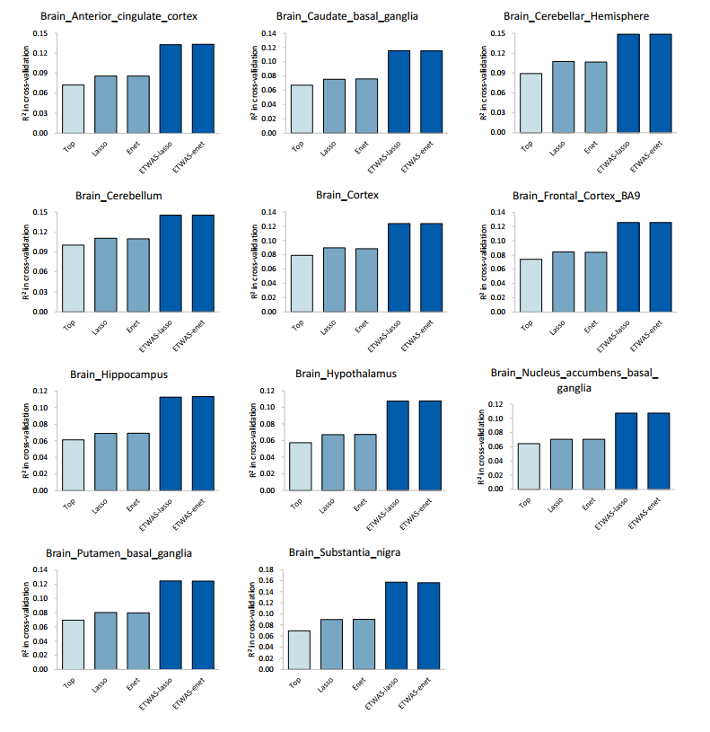

Supplementary Figure 7. Examples of well-predicted genes on a separate cohort. These plots show the observed versus predicted levels of expression for six genes trained in GTEx whole blood. Observed levels were form RNA-seq data in lymphoblastoid cell lines generated by the Geuvadis. Each plot shows the measured expression values (x-axis) versus the expression predictions on the test data (y-axis), where every dot represents one individual in the test data. The liner model (blue line) and 95% confidence interval (gray region) for each plot is also shown along with the gene name, and test R² values.

Supplementary Figure 8. Quantile-quantile plot of R² between predicted and observed expression levels in GTEx whole blood.

Supplementary Figure 9. Regional association of TWAS hits. The conditionally significant genes are shown in green. The bottom panel shows a regional Manhattan plot of the GWAS data before (gray) and after (blue) conditioning on the predicted expression of the green genes.

Supplementary Figure 10. Regional association of TWAS hits. The conditionally significant genes are shown in green. The bottom panel shows a regional Manhattan plot of the GWAS data before (gray) and after (blue) conditioning on the predicted expression of the green genes.

Supplementary Figure 11. The common genes shared by ETWAS and 2019 GWAS data reported genes with highly heritability.

