Polygenic scores for intelligence, educational attainment and schizophrenia are differentially associated with core autism features, IQ, and adaptive behaviour in autistic individuals

Supplementary Texts and Figures

Contents
eFigure 1: Correlation heatmap of the phenotypic correlations in SSC 3
eFigure 2: Correlation heatmap of the phenotypic correlations in AGRE 4
eFigure 3: Correlation heatmap of the phenotypic correlations in AGRE 5
eFigure 4: Polygenic score association of the three phenotypes with autism core features, measures of IQ, and adaptive behaviour (males-only) 6
eFigure 5: Polygenic score association of the three phenotypes with autism core features, measures of IQ, and adaptive behaviour (IQ > 70 only) 7
eMethods 1: Description of the cohorts 8
eMethods 2: Genetic quality control and generation of polygenic scores 9
eMethods 3: Autism core and associated features included in the analyses 10
eMethods 4: Correlation between phenotypes 11
eTable 1: Power calculations 13
eTable 2: Total number of SNPs included in the PGS 14
eTable 3: Phenotypic correlations in the SSC 15
eTable 4: Phenotypic correlations in AGRE 17
eTable 5: Phenotypic correlations in AIMS-2-TRIALS LEAP 19
eTable 6: Polygenic score association (non-stratified) 21
eTable 7: Polygenic score association (males-only) 23
eTable 8: Polygenic score association (IQ > 70) 25
List of authors and their affiliations for the EU-AIMS LEAP group 28

eFigure 1: Correlation heatmap of the phenotypic correlations in SSC
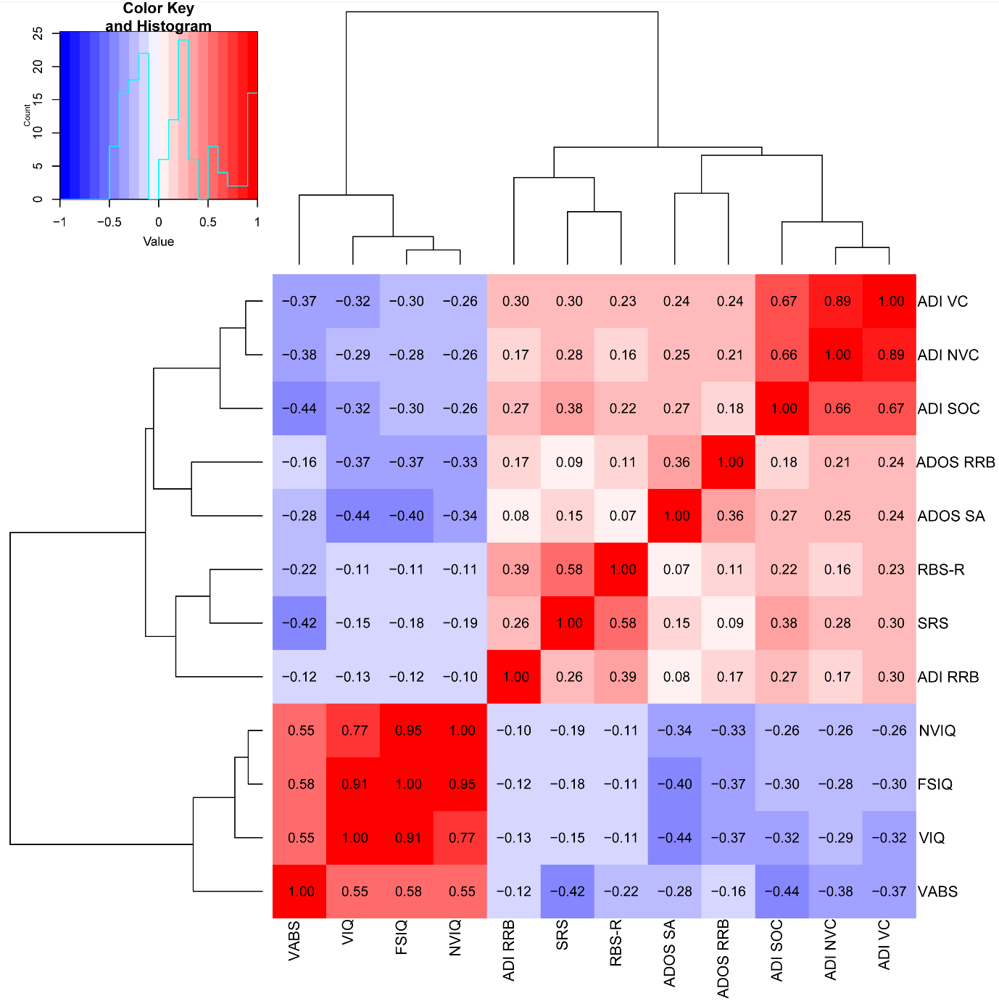

This figure provides the correlation heatmap for the phenotypic correlations for 12 autism core and associated features in the SSC. Hierarchical clustering tree is also provided for each of the plots. Red colour indicates a positive correlation, while blue indicates a negative correlation. Correlation coefficients are provided inside the box. The autism core and associated features are: ADOS - Social Affect (ADOS SA); ADOS - Restricted and Repetitive Behaviour domain total score (ADOS RRB); ADI - Communication (verbal) domain total score (ADI VC); ADI - Communication (nonverbal) domain total score (ADI NVC); ADI - Restricted and repetitive behaviour domain total score (ADI RRB); ADI - Social domain total score (ADI SOC); Repetitive Behaviour Scale – Revised (RBS-R); Vineland Adaptive Behaviour Composite Standard scores (VABS); Parent-reported Social Responsiveness Scale - Total raw scores (SRS); Full-scale IQ (FSIQ); Verbal IQ (VIQ); and Non-verbal IQ (NVIQ).

eFigure 2: Correlation heatmap of the phenotypic correlations in AGRE
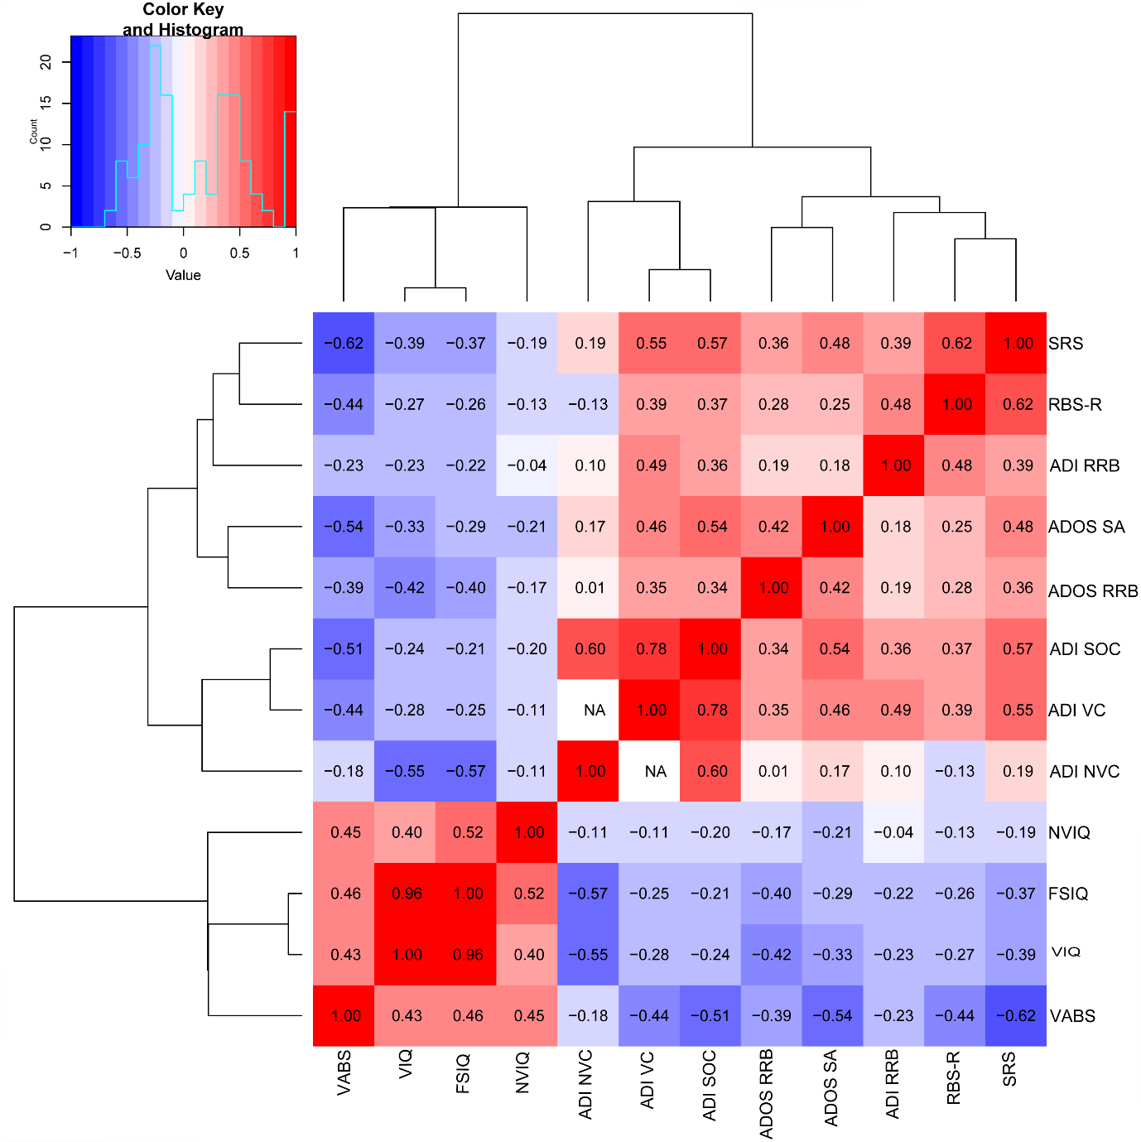
This figure provides the correlation heatmap for the phenotypic correlations for 12 autism core and associated features in the AGRE cohort. Hierarchical clustering tree is also provided for each of the plots. Red colour indicates a positive correlation, while blue indicates a negative correlation. Correlation coefficients are provided inside the box. We did not identify individuals who had both ADI VC and ADI NVC scores in the AGRE cohort, and hence could not calculate the correlations between these two core features in the AGRE cohort. The autism core and associated features are: ADOS - Social Affect (ADOS SA); ADOS - Restricted and Repetitive Behaviour domain total score (ADOS RRB); ADI - Communication (verbal) domain total score (ADI VC); ADI - Communication (nonverbal) domain total score (ADI NVC); ADI - Restricted and repetitive behaviour domain total score (ADI RRB); ADI - Social domain total score (ADI SOC); Repetitive Behaviour Scale – Revised (RBS-R); Vineland Adaptive Behaviour Composite Standard scores (VABS); Parent-reported Social Responsiveness Scale - Total raw scores (SRS); Full-scale IQ (FSIQ); Verbal IQ (VIQ); and Non-verbal IQ (NVIQ).

eFigure 3: Correlation heatmap of the phenotypic correlations in AGRE
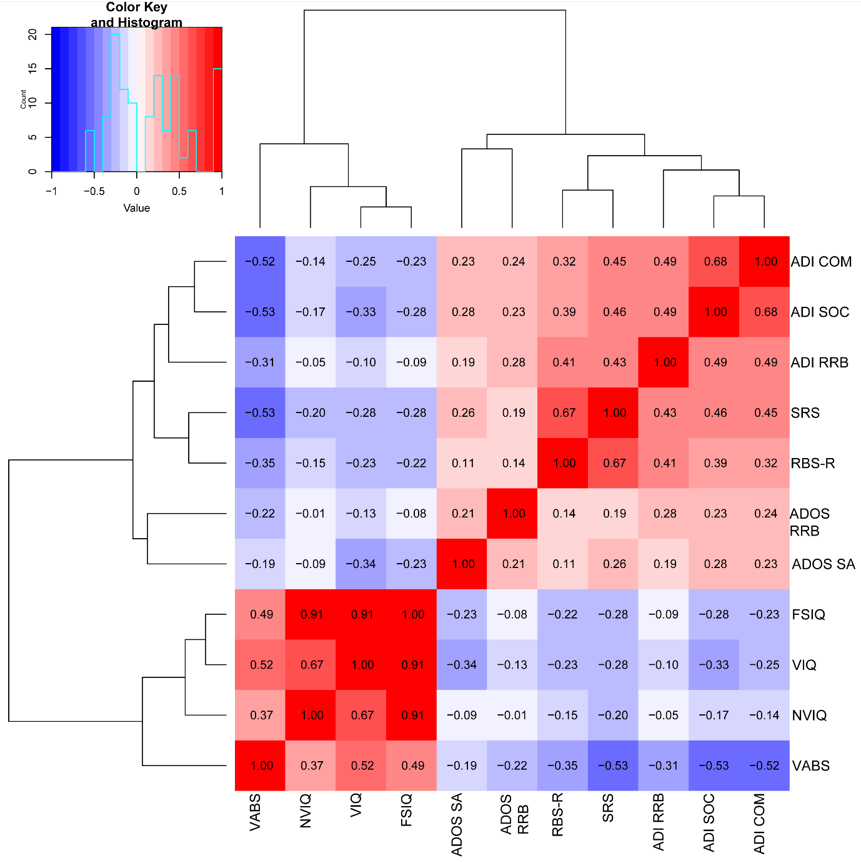
This figure provides the correlation heatmap for the phenotypic correlations for 11 core features, measures of IQ and adaptive behaviour in the AIMS-2-TRIAL LEAP cohort. Hierarchical clustering tree is also provided for each of the plots. Red colour indicates a positive correlation, while blue indicates a negative correlation. Correlation coefficients are provided inside the box. The autism core and associated features are: ADOS - Social Affect (ADOS SA); ADOS - Restricted and Repetitive Behaviour domain total score (ADOS RRB); ADI - Communication domain total score (ADI COM); ADI - Restricted and repetitive behaviour domain total score (ADI RRB); ADI - Social domain total score (ADI SOC); Repetitive Behaviour Scale – Revised (RBS-R); Vineland Adaptive Behaviour Composite Standard scores (VABS); Parent-reported Social Responsiveness Scale - Total raw scores (SRS); Full-scale IQ (FSIQ); Verbal IQ (VIQ); and Non-verbal IQ (NVIQ).

eFigure 4: Polygenic score association of the three phenotypes with autism core features, measures of IQ, and adaptive behaviour (males-only)
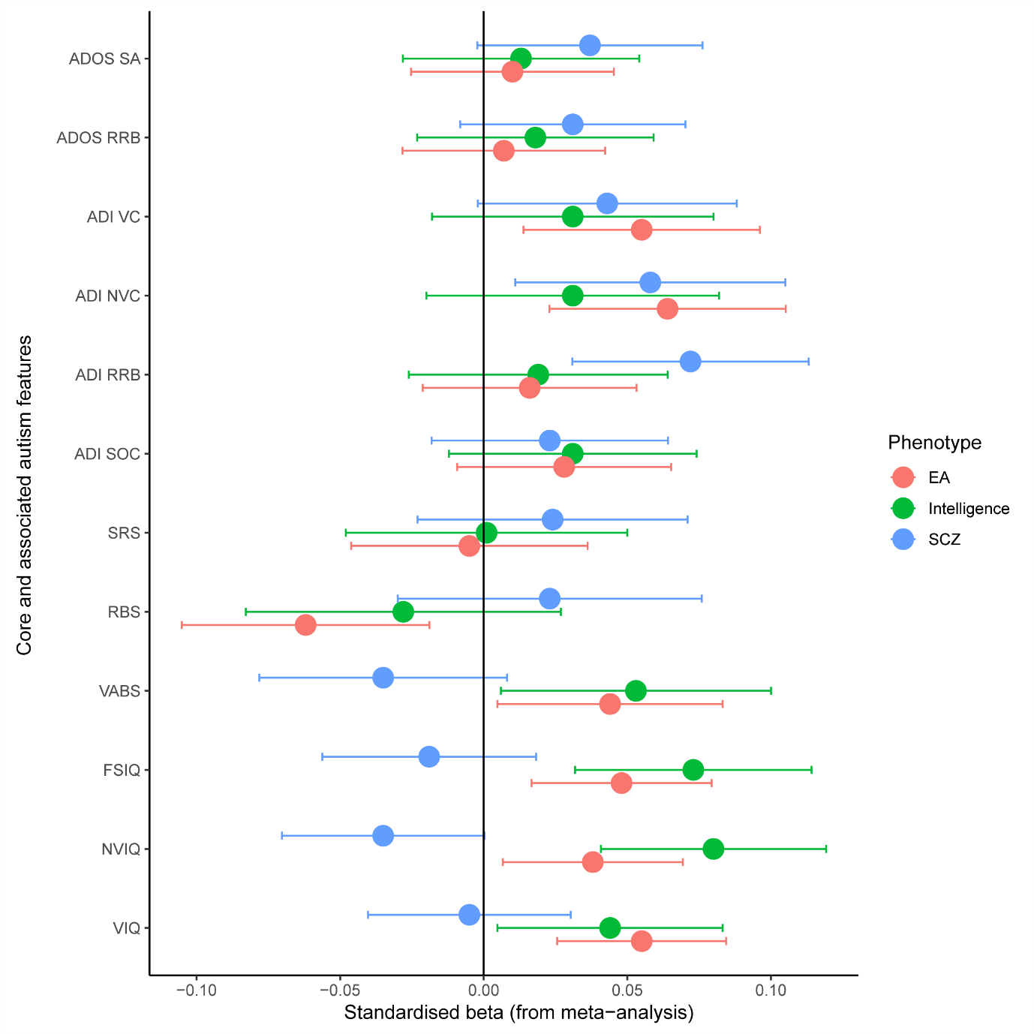
This figure provides the meta-analysed (males-only) regression Beta and the associated 95% confidence intervals for the three phenotypes (EA = educational attainment, SCZ = schizophrenia, and intelligence) against the 12 autism core and associated features. The core and associated features are: ADOS - Social Affect (ADOS SA); ADOS - Restricted and Repetitive Behaviour domain total score (ADOS RRB); ADI - Communication (verbal) domain total score (ADI VC); ADI - Communication (nonverbal) domain total score (ADI NVC); ADI - Restricted and repetitive behaviour domain total score (ADI RRB); ADI - Social domain total score (ADI SOC); Repetitive Behaviour Scale – Revised (RBS); Vineland Adaptive Behaviour Composite Standard scores (VABS); Parent-reported Social Responsiveness Scale - Total raw scores (SRS); Full-scale IQ (FSIQ); Verbal IQ (VIQ); and Non-verbal IQ (NVIQ).

eFigure 5: Polygenic score association of the three phenotypes with autism core features, measures of IQ, and adaptive behaviour (IQ > 70 only)

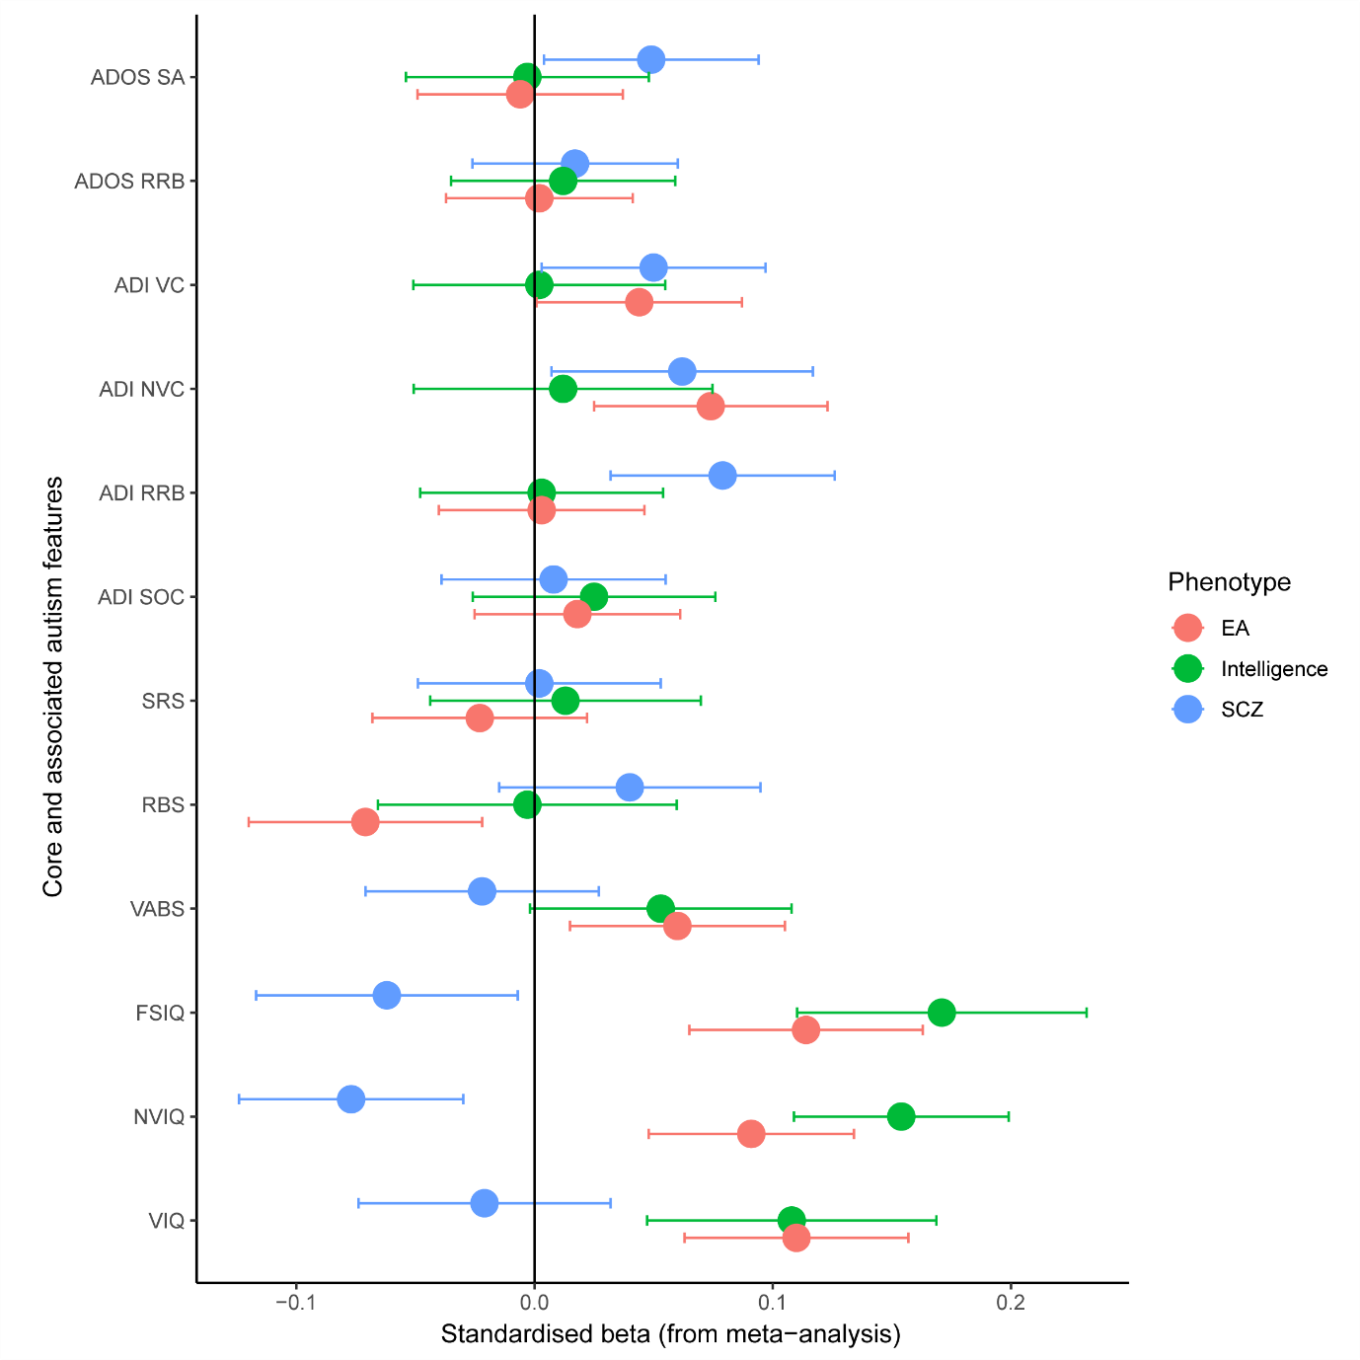
This figure provides the meta-analysed (IQ > 70-only) regression Beta and the associated 95% confidence intervals for the three phenotypes (EA = educational attainment, SCZ = schizophrenia, and intelligence) against the 12 autism core and associated features. The core and associated features are: ADOS - Social Affect (ADOS SA); ADOS - Restricted and Repetitive Behaviour domain total score (ADOS RRB); ADI - Communication (verbal) domain total score (ADI VC); ADI - Communication (nonverbal) domain total score (ADI NVC); ADI - Restricted and repetitive behaviour domain total score (ADI RRB); ADI - Social domain total score (ADI SOC); Repetitive Behaviour Scale – Revised (RBS); Vineland Adaptive Behaviour Composite Standard scores (VABS); Parent-reported Social Responsiveness Scale - Total raw scores (SRS); Full-scale IQ (FSIQ); Verbal IQ (VIQ); and Non-verbal IQ (NVIQ).

eMethods 1: Description of the cohorts

The Simons Simplex Collection (SSC) is a cohort of deeply phenotyped ‘simplex’ autism families (N = 2,600), where only one individual in the family has an autism diagnosis. Families typically are trios (parents and an autistic child) or quads which additionally includes one non-autistic sibling. The SSC applied stringent inclusion and exclusion criteria, and used a battery of diagnostic measures to identify autistic individuals. The study excluded families if a relative also had a diagnosis of autism. Further, the study excluded autistic individual who were 18 years of age. A total of 2,576 families were genotyped using one of three SNP arrays.

The Autism Genetic Resource Exchange (AGRE) is a second cohort of deeply phenotyped autism families, the majority of whom are multiplex (1,271 multiplex and 465 simplex families) which includes a total of 3,348 autistic individuals. The AGRE had less severe exclusion criteria – for instance, they did not exclude autistic individuals who did not meet the cut-off for the cut-off for the Autism Diagnostic Interview–Revised (ADI) or the Autism Diagnostic Observation Schedule- G (ADOS). Further, phenotypic data was not uniformly collected across all individuals. Families were genotyped by different centres. For this study, we used data only on individuals who were genotyped at the Children’s Hospital of Philadelphia as these met our inclusion criteria (i.e. were of primarily European ancestry).

The final cohort is the AIMS-2-TRIALS LEAP cohort, also known as the EU-AIMS LEAP cohort. This Europe-based cohort consists of 437 autistic individuals and 300 non-autistic individuals with or without ID. The AIMS-2-TRIALS LEAP autistic individuals were between 6–30 years of age. The AIMS-2-TRIALS had a more relaxed inclusion criteria – autistic individuals who did not meet the cut-off for ADI or ADOS were not excluded. Further, individuals were not excluded if they had a diagnosis of a psychiatric condition due to the high co-occurrence of psychiatric conditions with autism (1). Genotype data was available on 343 autistic individuals, of which a maximum of 262 individuals were included based on multiple quality control criteria.

eMethods 2: Genetic quality control and generation of polygenic scores

Individuals in the SSC were genotyped on three different platforms (Illumina Omni2.5, Illumina 1Mv3, or Illumina 1Mv1). Individuals from the AGRE cohort included in this study were genotyped on one platform - Illumina 550k platform. Imputation and QC was conducted separately for each platform and then merged post-imputation. Prior to imputation, we excluded participants if they had a genotyping rate < 95%, heterozygosity above or below 3 SD from the mean, mismatched in reported and genetic sex, and families with mendelian errors > 5%. We removed SNPs that deviated from Hardy-Weinberg Equilibrium (P < 1x10⁻⁶), had Mendelian errors in more than 10% of the families, and SNPs that were not genotyped in more than 10% of the families. Both the SSC and the AGRE cohorts consist of families. To identify individuals of primarily European Ancestry using genetics, we conducted multidimensional scaling on the parents. We excluded individuals if either one of their parents were above or below 5 SD from the means of the first and second genetic principal components generated in the CEU and TSI subpopulations of the HapMap3 phase 3 (2). Genetic principal components were generated retaining unrelated individuals in the SSC, AGRE, and HapMap populations using SNPs with a minor allele frequency > 5%, and pruned using an r² of 0.2. Phasing and imputation was conducted using the Michigan Imputation Server (3) using the 1000 genomes Phase 3 v5 as the reference panel (4). To ensure that only well-imputed SNPs were included in the downstream analyses, we excluded SNPs with a minor allele frequency < 1% and SNPs with an imputation r² < 0.6.

The AIMS-2-TRIALS LEAP samples were genotyped using the Infinium OmniExpress-24v1 BeadChip. A similar QC procedure was applied as described above and imputation was conducted on the Michigan Imputation server using the HRC r1.1 2016 reference panel for a European population because the majority of individuals in the LEAP cohort were from European ancestry (5). Principal components were generated, and their dimensionality was further reduced using the first genetic principal components to 2 components (x-umap-spread and y-umap-spread columns) (https://arxiv.org/abs/1802.03426). Density based-clustering on these clusters identified individuals of European ancestry. We included only unrelated individuals.

PGS are weighted averages of the total number of trait increasing alleles in an individual for a particular phenotype. The weights are derived from the GWAS regression Betas from the training dataset. SNPs were chosen that were present in both the training and the testing datasets. We clumped SNPs using an imputation r² of 0.1, and a physical distance of 250 kb. The total number of SNPs included in the creation of the PGS is provided in Supplementary Table 2. For the target dataset, we included only SNPs with a minor allele frequency > 1% and with imputation r² ≥ 0.6, representing a subset of high-confidence SNPs. Gene dosages were converted to hard calls by Plink (6).

eMethods 3: Autism core and associated features included in the analyses

In the Autism Diagnostic Observation Schedule – second edition (ADOS) (7), we included the social affect (ADOS SA) and the restricted and repetitive behaviour domain scores (ADOS RRB). ADOS is a widely used, semi-structured assessment of the core features of autism, with the two standardised scales mapping onto the two diagnostic criteria for autism as set out by the DSM-5. Scores are calculated based on observations during the period of assessment (i.e. 30 – 45 minutes) and may not necessarily reflect behaviours over the lifetime. Higher scores indicate greater difficulties.

For the Autism and the Autism Diagnostic Interview – Revised (ADI) (8), we used total scores from the social domain (ADI SOC), the restricted and repetitive behaviour domain (ADI RRB) and both the verbal (ADI VC) and nonverbal communication (ADI VC) subdomains. The ADI is a companion instrument to the ADOS which uses a semi-structured parent-interview to diagnose autism. The three-domain division of the ADI reflects the older diagnostic criteria for autism (i.e. DSM IV and ICD-10). Higher scores in all three indicate greater difficulties.

We included total scores on the Social Responsiveness Scale – 2 (SRS) (9), where we used the parent report version of the SRS. The SRS is a 65-item questionnaire that primarily investigates social impairment in autistic individuals. The SRS has five related subscales: social awareness, social cognition, social communication, social motivation, and restricted interests and repetitive behaviour. Given the similarities between most of the subscales, we used the total score for analyses. Higher scores indicate greater difficulties in social responsiveness.

We also included total scores on the Repetitive Behaviour Scale – Revised (RBS) (10), which was parent-report. The RBS is a measure developed to specifically measure restricted and repetitive behaviours in autistic individuals and captures stereotyped, self-injurious, sameness, compulsive, ritualistic, and restricted behaviour(11). The RBS-R comprises 43 questions. Higher scores indicate more restricted and repetitive behaviour.
Adaptive behaviour was measures using the Vineland Adaptive Behaviour Scales (VABS). It is parent-based report on behaviours observed in natural contexts. The scores are normalised with a mean of 100, and a standard deviation of 15 after accounting for age. higher VABS scores are associated with better adaptative skills.
IQ was measured using multiple different instruments in different cohorts. We included Full-scale IQ (FSIQ), non-verbal IQ (or performance IQ) (NVIQ), verbal IQ (VIQ) in all three cohorts. We used these different measures of IQ to investigate if there is any heterogeneity in the association of polygenic scores for these different measures of intelligence in autistic individuals

eMethods 4: Correlation between phenotypes

For all three cohorts, we computed correlations between the core autism features, measures of IQ, and adaptive behaviour using Pearson’s correlations. For the SSC and the AIMS-2-TRIALS LEAP cohorts, correlations were calculated only using individuals included in the genetic analyses to better map shared genetics with phenotypic correlations. However, for the AGRE dataset, we did not identify a group of individuals who had information on all 12 core and associated autism features and genetic data. Consequently, we used a subset of individuals who had scores on all autism core and associated features regardless of whether they were included in the genetic analyses. We included only one individual per family as siblings would introduce non-independence between data points.

We clustered the features using hierarchical clustering based on Euclidean distance.

eMethods 5: Data, software, and code availability

- Data from the SSC is available upon application from here: https://www.sfari.org/resource/sfari-base/.
- Data from AGRE is available upon application from here: https://research.agre.org/
- Further information about data access from the AIMS-2-TRIALS is available here: https://www.aims-2-trials.eu/
- Summary statistics of the GWAS for educational attainment was downloaded from here: https://www.thessgac.org/data
- Summary statistics for the GWAS of intelligence was downloaded from here: https://ctg.cncr.nl/software/summary_statistics
- Summary statistics for the GWAS of schizophrenia was downloaded from here: https://www.med.unc.edu/pgc/results-and-downloads/

- PRSice 2 is available here: https://www.prsice.info/
- Michingan Imputation server is available here: https://imputationserver.sph.umich.edu/start.html

- Code used for QC and imputation is available here: https://github.com/autism-research-centre/SSC_liftover_imputation
- Code used for polygenic score analyses is available here: https://github.com/vwarrier/autism_heterogeneity

eTable 1: Power calculations

 | Genetic correlation | EA | Intelligence | Schizophrenia | ADHD | Depression | Subjective well-being | Neuroticism
Power | 0.1 | 0.28 | 0.2 | 0.2 | 0.11 | 0.16 | 0.08 | 0.17
 | 0.2 | 0.8 | 0.6 | 0.61 | 0.3 | 0.48 | 0.21 | 0.53
 | 0.3 | 0.98 | 0.91 | 0.92 | 0.58 | 0.82 | 0.41 | 0.86
 | 0.4 | 0.99 | 0.99 | 0.99 | 0.82 | 0.97 | 0.63 | 0.98
 | 0.5 | 1 | 0.99 | 0.99 | 0.95 | 0.99 | 0.82 | 0.99
 | SNP heritability | 0.15 | 0.21 | 0.24 | 0.21 | 0.09 | 0.04 | 0.1
 | Sample size | 766345 | 269867 | 135236 | 55374 | 500199 | 298420 | 449484
 | Case proportion | NA | NA | 0.41 | 0.36 | 0.34 | NA | NA
 | Population prevalence | NA | NA | 0.01 | 0.01 | 0.1 | NA | NA
 | Targer sub-phenotype heritability | 0.15 | 0.15 | 0.15 | 0.15 | 0.15 | 0.15 | 0.15

The table provides the power calculations for seven well-powered GWAS of phenotypes that are genetically correlated with autism. SNP heritability, Sample size, Case proportion, Population prevalence, and Target sub-phenotype heritability were all provided. Statistical power at various genetic correlation estimates are provided in red.

eTable 2: Total number of SNPs included in the PGS

 | SSC | AGRE | AIMS-2-TRIAL LEAP
Educational attainment (P = 1) | 135,817 | 273,004 | 298,840
Intelligence (P = 1) | 128,573 | 250,459 | 269,449
Schizophrenia (P = 0.1) | 50,126 | 84,647 | 85,231

This table provides the number of SNPs included in the PGS analyses

eTable 3: Phenotypic correlations in the SSC

p1 | p2 | cor | p
ADI NVC | ADI SOC | 0.68397 | 0.00E+00
ADI NVC | SRS | 0.31537 | 0.00E+00
ADI NVC | RBS-R | 0.17503 | 0.00E+00
ADI NVC | ADI RRB | 0.1334 | 2.50E-10
ADI NVC | NVIQ | -0.36947 | 0.00E+00
ADI NVC | FSIQ | -0.3896 | 0.00E+00
ADI NVC | VIQ | -0.39738 | 0.00E+00
ADI NVC | VABS | -0.46294 | 0.00E+00
ADI RRB | RBS-R | 0.36649 | 0.00E+00
ADI RRB | ADI SOC | 0.22995 | 0.00E+00
ADI RRB | SRS | 0.22752 | 0.00E+00
ADI RRB | NVIQ | -0.03718 | 7.91E-02
ADI RRB | FSIQ | -0.0489 | 2.10E-02
ADI RRB | VIQ | -0.05226 | 1.36E-02
ADI RRB | VABS | -0.0612 | 3.82E-03
ADI SOC | SRS | 0.41006 | 0.00E+00
ADI SOC | RBS-R | 0.2366 | 0.00E+00
ADI SOC | NVIQ | -0.35933 | 0.00E+00
ADI SOC | FSIQ | -0.38927 | 0.00E+00
ADI SOC | VIQ | -0.40797 | 0.00E+00
ADI SOC | VABS | -0.49323 | 0.00E+00
ADI VC | ADI NVC | 0.88845 | 0.00E+00
ADI VC | ADI SOC | 0.66647 | 0.00E+00
ADI VC | ADI RRB | 0.29687 | 0.00E+00
ADI VC | SRS | 0.29247 | 0.00E+00
ADI VC | RBS-R | 0.22598 | 0.00E+00
ADI VC | NVIQ | -0.26449 | 0.00E+00
ADI VC | FSIQ | -0.29893 | 0.00E+00
ADI VC | VIQ | -0.31546 | 0.00E+00
ADI VC | VABS | -0.36163 | 0.00E+00
ADOS RRB | ADI NVC | 0.25908 | 0.00E+00
ADOS RRB | ADI VC | 0.23681 | 0.00E+00
ADOS RRB | ADI SOC | 0.22731 | 0.00E+00
ADOS RRB | ADI RRB | 0.14111 | 2.14E-11
ADOS RRB | SRS | 0.13839 | 5.65E-11
ADOS RRB | RBS-R | 0.13394 | 2.11E-10
ADOS RRB | VABS | -0.2468 | 0.00E+00
ADOS RRB | NVIQ | -0.40157 | 0.00E+00
ADOS RRB | FSIQ | -0.43931 | 0.00E+00
ADOS RRB | VIQ | -0.44597 | 0.00E+00
ADOS SA | ADOS RRB | 0.39309 | 0.00E+00
ADOS SA | ADI SOC | 0.3309 | 0.00E+00
ADOS SA | ADI NVC | 0.32187 | 0.00E+00
ADOS SA | ADI VC | 0.24335 | 0.00E+00
ADOS SA | SRS | 0.21543 | 0.00E+00
ADOS SA | RBS-R | 0.1033 | 1.47E-06
ADOS SA | ADI RRB | 0.04275 | 4.68E-02
ADOS SA | VABS | -0.38697 | 0.00E+00
ADOS SA | NVIQ | -0.4412 | 0.00E+00
ADOS SA | FSIQ | -0.48969 | 0.00E+00
ADOS SA | VIQ | -0.51525 | 0.00E+00
FSIQ | NVIQ | 0.96639 | 0.00E+00
FSIQ | VIQ | 0.94023 | 0.00E+00
NVIQ | VIQ | 0.83946 | 0.00E+00
RBS-R | SRS | 0.57636 | 0.00E+00
RBS-R | VIQ | -0.1484 | 1.86E-12
RBS-R | NVIQ | -0.15547 | 1.53E-13
RBS-R | FSIQ | -0.15571 | 1.46E-13
RBS-R | VABS | -0.23737 | 0.00E+00
SRS | VIQ | -0.23006 | 0.00E+00
SRS | FSIQ | -0.25133 | 0.00E+00
SRS | NVIQ | -0.25905 | 0.00E+00
VABS | FSIQ | 0.67918 | 0.00E+00
VABS | NVIQ | 0.66141 | 0.00E+00
VABS | VIQ | 0.65828 | 0.00E+00
VABS | SRS | -0.4505 | 0.00E+00

eTable 4: Phenotypic correlations in AGRE

p1 | p2 | cor | p
ADI RRB | ADI NVC | 0.09801 | 8.15E-02
ADI SOC | ADI NVC | 0.60346 | 0.00E+00
FSIQ | ADI NVC | -0.57134 | 2.08E-02
NVIQ | ADI NVC | -0.10989 | 3.41E-01
RBS-R | ADI NVC | -0.12773 | 2.10E-01
SRS | ADI NVC | 0.18882 | 8.54E-03
VIQ | ADI NVC | -0.5515 | 2.68E-02
VABS | ADI NVC | -0.18154 | 8.52E-03
FSIQ | ADI RRB | -0.21503 | 4.07E-06
NVIQ | ADI RRB | -0.04347 | 1.44E-01
RBS-R | ADI RRB | 0.47964 | 0.00E+00
SRS | ADI RRB | 0.38539 | 0.00E+00
VIQ | ADI RRB | -0.22627 | 1.14E-06
VABS | ADI RRB | -0.22596 | 5.00E-14
ADI RRB | ADI SOC | 0.3581 | 0.00E+00
FSIQ | ADI SOC | -0.20989 | 6.95E-06
NVIQ | ADI SOC | -0.19625 | 2.68E-11
RBS-R | ADI SOC | 0.36549 | 0.00E+00
SRS | ADI SOC | 0.57205 | 0.00E+00
VIQ | ADI SOC | -0.24156 | 1.95E-07
VABS | ADI SOC | -0.5125 | 0.00E+00
ADI NVC | ADI VC | NA | NA
ADI RRB | ADI VC | 0.49247 | 0.00E+00
ADI SOC | ADI VC | 0.78274 | 0.00E+00
FSIQ | ADI VC | -0.24993 | 1.28E-07
NVIQ | ADI VC | -0.10648 | 5.29E-04
RBS-R | ADI VC | 0.38921 | 0.00E+00
SRS | ADI VC | 0.54706 | 0.00E+00
VIQ | ADI VC | -0.27871 | 3.08E-09
VABS | ADI VC | -0.44357 | 0.00E+00
ADI NVC | ADOS RRB | 0.01181 | 8.48E-01
ADI RRB | ADOS RRB | 0.18758 | 7.45E-12
ADI SOC | ADOS RRB | 0.34357 | 0.00E+00
ADI VC | ADOS RRB | 0.34789 | 0.00E+00
ADOS SA | ADOS RRB | 0.42017 | 0.00E+00
FSIQ | ADOS RRB | -0.3958 | 0.00E+00
NVIQ | ADOS RRB | -0.16582 | 1.17E-07
RBS-R | ADOS RRB | 0.27923 | 4.30E-11
SRS | ADOS RRB | 0.35843 | 0.00E+00
VIQ | ADOS RRB | -0.42486 | 0.00E+00
VABS | ADOS RRB | -0.39348 | 0.00E+00
ADI NVC | ADOS SA | 0.17342 | 4.41E-03
ADI RRB | ADOS SA | 0.18374 | 2.00E-11
ADI SOC | ADOS SA | 0.54091 | 0.00E+00
ADI VC | ADOS SA | 0.46278 | 0.00E+00
FSIQ | ADOS SA | -0.28602 | 3.63E-10
NVIQ | ADOS SA | -0.21157 | 1.13E-11
RBS-R | ADOS SA | 0.25142 | 3.35E-09
SRS | ADOS SA | 0.48068 | 0.00E+00
VIQ | ADOS SA | -0.33096 | 2.39E-13
VABS | ADOS SA | -0.54072 | 0.00E+00
NVIQ | FSIQ | 0.52379 | 0.00E+00
FSIQ | RBS-R | -0.26066 | 8.20E-07
NVIQ | RBS-R | -0.12695 | 6.76E-03
SRS | RBS-R | 0.62395 | 0.00E+00
VIQ | RBS-R | -0.27446 | 1.90E-07
VABS | RBS-R | -0.4397 | 0.00E+00
FSIQ | SRS | -0.37157 | 1.33E-09
NVIQ | SRS | -0.19063 | 2.19E-07
VIQ | SRS | -0.38831 | 1.85E-10
FSIQ | VIQ | 0.95876 | 0.00E+00
FSIQ | VABS | 0.4584 | 0.00E+00
NVIQ | VABS | 0.44737 | 0.00E+00
SRS | VABS | -0.61563 | 0.00E+00
VIQ | VABS | 0.43315 | 0.00E+00
NVIQ | VIQ | 0.39555 | 0.00E+00

eTable 5: Phenotypic correlations in AIMS-2-TRIALS LEAP

p1 | p2 | cor | p
VIQ | NVIQ | 0.67529 | 0.00E+00
VIQ | FSIQ | 0.91398 | 0.00E+00
NVIQ | FSIQ | 0.90751 | 0.00E+00
VIQ | ADI SOC | -0.2925 | 3.20E-06
NVIQ | ADI SOC | -0.15923 | 1.24E-02
FSIQ | ADI SOC | -0.25034 | 6.72E-05
VIQ | ADI COM | -0.22736 | 3.34E-04
NVIQ | ADI COM | -0.13126 | 3.97E-02
FSIQ | ADI COM | -0.1977 | 1.76E-03
ADI SOC | ADI COM | 0.67175 | 0.00E+00
VIQ | ADI RRB | -0.0873 | 1.73E-01
NVIQ | ADI RRB | -0.01856 | 7.72E-01
FSIQ | ADI RRB | -0.06117 | 3.37E-01
ADI SOC | ADI RRB | 0.45883 | 2.29E-14
ADI COM | ADI RRB | 0.48676 | 4.44E-16
VIQ | ADOS SA | -0.33055 | 2.14E-07
NVIQ | ADOS SA | -0.11732 | 7.26E-02
FSIQ | ADOS SA | -0.24885 | 1.08E-04
ADI SOC | ADOS SA | 0.21818 | 9.87E-04
ADI COM | ADOS SA | 0.15419 | 2.07E-02
ADI RRB | ADOS SA | 0.18429 | 5.56E-03
VIQ | ADOS RRB | -0.16187 | 1.30E-02
NVIQ | ADOS RRB | -0.01332 | 8.39E-01
FSIQ | ADOS RRB | -0.10459 | 1.08E-01
ADI SOC | ADOS RRB | 0.20572 | 1.92E-03
ADI COM | ADOS RRB | 0.2044 | 2.06E-03
ADI RRB | ADOS RRB | 0.24821 | 1.69E-04
ADOS SA | ADOS RRB | 0.24823 | 1.13E-04
VIQ | SRS | -0.28953 | 1.61E-05
NVIQ | SRS | -0.20899 | 2.02E-03
FSIQ | SRS | -0.27678 | 3.41E-05
ADI SOC | SRS | 0.41248 | 3.71E-10
ADI COM | SRS | 0.35101 | 1.43E-07
ADI RRB | SRS | 0.37995 | 1.01E-08
ADOS SA | SRS | 0.23727 | 7.40E-04
ADOS RRB | SRS | 0.18438 | 9.13E-03
VIQ | VABS | 0.48263 | 4.04E-14
NVIQ | VABS | 0.35987 | 4.58E-08
FSIQ | VABS | 0.46982 | 1.56E-13
ADI SOC | VABS | -0.50433 | 3.33E-15
ADI COM | VABS | -0.47761 | 1.36E-13
ADI RRB | VABS | -0.32639 | 1.06E-06
ADOS SA | VABS | -0.15358 | 2.57E-02
ADOS RRB | VABS | -0.20716 | 2.49E-03
SRS | VABS | -0.52758 | 1.42E-14
VIQ | RBS-R | -0.22274 | 1.01E-03
NVIQ | RBS-R | -0.13429 | 4.87E-02
FSIQ | RBS-R | -0.18479 | 6.21E-03
ADI SOC | RBS-R | 0.38315 | 8.74E-09
ADI COM | RBS-R | 0.3047 | 6.56E-06
ADI RRB | RBS-R | 0.40439 | 1.05E-09
ADOS SA | RBS-R | 0.09651 | 1.75E-01
ADOS RRB | RBS-R | 0.12555 | 7.72E-02
SRS | RBS-R | 0.65458 | 0.00E+00
VABS | RBS-R | -0.34649 | 1.27E-06

eTable 6: Polygenic score association (non-stratified)

Intelligence PGS
 | SSC |  |  | AGRE |  |  | LEAP |  |  | Meta-analysis
 | N | Beta | SE | N | Beta | SE | N | Beta | SE | Total N | Betameta | SEmeta | Pmeta | qmeta | R² (%)
ADOS SA | 2165 | 0.018 | 0.026 | 929 | 0.003 | 0.028 | 171 | 0.003 | 0.078 | 3265 | 0.011 | 0.019 | 5.69E-01 | 6.60E-01 | 0.0121
ADOS RRB | 2233 | 0.004 | 0.026 | 929 | 0.007 | 0.03 | 171 | 0.023 | 0.076 | 3333 | 0.006 | 0.019 | 7.34E-01 | 8.01E-01 | 0.0036
ADI VC | 1978 | 0.039 | 0.031 | 805 | 0.037 | 0.038 | 182 | -0.138 | 0.075 | 2965 | 0.022 | 0.023 | 3.32E-01 | 4.85E-01 | 0.0484
ADI NVC | 2232 | 0.024 | 0.029 | 395 | 0.060 | 0.053 | 182 | -0.138 | 0.075 | 2809 | 0.015 | 0.024 | 5.35E-01 | 6.58E-01 | 0.0225
ADI RRB | 2232 | 0.013 | 0.029 | 1200 | 0.038 | 0.031 | 182 | -0.048 | 0.076 | 3614 | 0.019 | 0.020 | 3.37E-01 | 4.85E-01 | 0.0361
ADI SOC | 2232 | 0.013 | 0.029 | 1200 | 0.040 | 0.030 | 182 | -0.131 | 0.075 | 3614 | 0.015 | 0.020 | 4.59E-01 | 6.12E-01 | 0.0225
RBS | 2232 | -0.026 | 0.029 | 95 | -0.201 | 0.106 | 160 | 0.014 | 0.081 | 2487 | -0.032 | 0.026 | 2.19E-01 | 3.75E-01 | 0.1024
VABS | 2233 | 0.069 | 0.029 | 727 | 0.062 | 0.04 | 160 | 0.032 | 0.075 | 3120 | 0.063 | 0.022 | 4.24E-03 | 1.91E-02 | 0.3969
SRS | 2223 | 0.010 | 0.029 | 652 | -0.033 | 0.039 | 159 | -0.020 | 0.080 | 3034 | -0.007 | 0.022 | 7.64E-01 | 8.09E-01 | 0.0049
FSIQ | 2229 | 0.071 | 0.020 | 22 | 0.063 | 0.566 | 192 | 0.183 | 0.074 | 2443 | 0.079 | 0.024 | 5.12E-05 | 6.69E-04 | 0.6241
NVIQ | 2232 | 0.093 | 0.021 | 562 | 0.050 | 0.042 | 190 | 0.150 | 0.074 | 2984 | 0.088 | 0.018 | 1.06E-06 | 3.82E-05 | 0.7744
VIQ | 2232 | 0.052 | 0.019 | 22 | 0.083 | 0.570 | 189 | 0.196 | 0.073 | 2443 | 0.061 | 0.018 | 7.79E-04 | 5.21E-03 | 0.3721
Educational attainment PGS
 | SSC |  |  | AGRE |  |  | LEAP |  |  | Meta-analysis
 | N | Beta | SE | N | Beta | SE | N | Beta | SE | Total N | Betameta | SEmeta | Pmeta | qmeta | R² (%)
ADOS SA | 2165 | 0.0001 | 0.02 | 929 | 0.030 | 0.028 | 171 | -0.038 | 0.070 | 3265 | 0.008 | 0.016 | 6.24E-01 | 7.02E-01 | 0.0064
ADOS RRB | 2233 | 0.006 | 0.02 | 929 | -0.021 | 0.029 | 171 | 0.108 | 0.068 | 3333 | 0.004 | 0.016 | 8.18E-01 | 8.41E-01 | 0.0016
ADI VC | 1978 | 0.065 | 0.024 | 805 | 0.040 | 0.036 | 182 | -0.011 | 0.069 | 2965 | 0.052 | 0.019 | 6.73E-03 | 2.69E-02 | 0.2704
ADI NVC | 2232 | 0.058 | 0.022 | 395 | 0.045 | 0.054 | 182 | -0.011 | 0.069 | 2809 | 0.051 | 0.020 | 9.88E-03 | 3.23E-02 | 0.2601
ADI RRB | 2232 | 0.010 | 0.022 | 1200 | 0.027 | 0.030 | 182 | 0.07 | 0.069 | 3614 | 0.019 | 0.017 | 2.63E-01 | 4.11E-01 | 0.0361
ADI SOC | 2232 | 0.020 | 0.022 | 1200 | 0.035 | 0.030 | 182 | -0.065 | 0.069 | 3614 | 0.020 | 0.017 | 2.46E-01 | 4.03E-01 | 0.0400
RBS | 2232 | -0.046 | 0.022 | 95 | -0.110 | 0.102 | 160 | -0.012 | 0.073 | 2487 | -0.046 | 0.021 | 2.64E-02 | 7.32E-02 | 0.2116
VABS | 2233 | 0.035 | 0.022 | 727 | 0.057 | 0.039 | 160 | 0.099 | 0.067 | 3120 | 0.045 | 0.018 | 1.51E-02 | 4.53E-02 | 0.2025
SRS | 2223 | -0.0004 | 0.022 | 652 | -0.001 | 0.038 | 159 | -0.024 | 0.074 | 3034 | -0.002 | 0.019 | 9.20E-01 | 9.20E-01 | 0.0004
FSIQ | 2229 | 0.049 | 0.016 | 22 | 0.392 | 0.445 | 192 | 0.166 | 0.066 | 2443 | 0.055 | 0.015 | 2.62E-04 | 2.36E-03 | 0.3025
NVIQ | 2232 | 0.037 | 0.016 | 562 | 0.048 | 0.041 | 190 | 0.189 | 0.066 | 2984 | 0.046 | 0.015 | 1.47E-03 | 7.57E-03 | 0.2116
VIQ | 2232 | 0.053 | 0.014 | 22 | 0.572 | 0.43 | 189 | 0.114 | 0.066 | 2443 | 0.057 | 0.014 | 5.58E-05 | 6.69E-04 | 0.3249
Schizophrenia PGS
 | SSC |  |  | AGRE |  |  | LEAP |  |  | Meta-analysis
 | N | Beta | SE | N | Beta | SE | N | Beta | SE | Total N | Betameta | SEmeta | Pmeta | qmeta | R² (%)
ADOS SA | 2165 | 0.014 | 0.023 | 929 | 0.075 | 0.028 | 171 | -0.019 | 0.079 | 3265 | 0.039 | 0.018 | 2.85E-02 | 7.33E-02 | 0.152
ADOS RRB | 2233 | 0.034 | 0.023 | 929 | 0.034 | 0.029 | 171 | -0.04 | 0.077 | 3333 | 0.034 | 0.018 | 5.88E-02 | 1.24E-01 | 0.114
ADI VC | 1978 | 0.040 | 0.027 | 805 | 0.006 | 0.036 | 182 | 0.157 | 0.075 | 2965 | 0.028 | 0.022 | 7.03E-02 | 1.41E-01 | 0.077
ADI NVC | 2232 | 0.063 | 0.026 | 395 | -0.02 | 0.053 | 182 | 0.157 | 0.075 | 2809 | 0.047 | 0.023 | 9.88E-03 | 3.23E-02 | 0.224
ADI RRB | 2232 | 0.079 | 0.026 | 1200 | 0.024 | 0.03 | 182 | 0.166 | 0.075 | 3614 | 0.056 | 0.019 | 8.68E-04 | 5.21E-03 | 0.312
ADI SOC | 2232 | 0.007 | 0.025 | 1200 | 0.0004 | 0.03 | 182 | 0.148 | 0.075 | 3614 | 0.004 | 0.019 | 4.84E-01 | 6.22E-01 | 0.002
RBS | 2232 | 0.029 | 0.026 | 95 | 0.175 | 0.105 | 160 | 0.15 | 0.081 | 2487 | 0.037 | 0.025 | 4.77E-02 | 1.07E-01 | 0.138
VABS | 2233 | 0.006 | 0.025 | 727 | -0.087 | 0.038 | 160 | -0.113 | 0.076 | 3120 | -0.023 | 0.021 | 1.50E-01 | 2.70E-01 | 0.052
SRS | 2223 | 0.015 | 0.026 | 652 | 0.073 | 0.038 | 159 | 0.056 | 0.082 | 3034 | 0.033 | 0.021 | 9.10E-02 | 1.72E-01 | 0.110
FSIQ | 2229 | -0.007 | 0.018 | 22 | -0.851 | 0.398 | 192 | -0.126 | 0.078 | 2443 | -0.009 | 0.018 | 4.01E-01 | 5.55E-01 | 0.008
NVIQ | 2232 | -0.022 | 0.018 | 562 | -0.079 | 0.041 | 190 | -0.104 | 0.077 | 2984 | -0.031 | 0.017 | 3.49E-02 | 8.37E-02 | 0.098
VIQ | 2232 | -0.004 | 0.017 | 22 | -0.73 | 0.488 | 189 | -0.116 | 0.078 | 2443 | -0.005 | 0.017 | 5.49E-01 | 6.58E-01 | 0.002
This table provides the results from the regression of the three phenotypes against the 12 autism sub-phenotypes for all three cohorts, and the meta-analysed values. Beta = regression beta, SE = Standard error, Pmeta = p-value of the meta-analysis, qmeta = FDR adjusted p-values of the meta-analyses, N = sample size, Total N = total number individuals in the meta-analysis, R² (%) = Variance explained by PGS in %

eTable 7: Polygenic score association (males-only)

Intelligence PGS
 | SSC |  |  | AGRE |  |  | LEAP |  |  |  | Meta-analysis
 | N | Beta | SE | N | Beta | SE | N | Beta | SE | Total N | Betameta | SEmeta | Pmeta | qmeta | R² (%)
ADOS SA | 1876 | 0.012 | 0.028 | 715 | 0.006 | 0.033 | 171 | 0.076 | 0.097 | 2762 | 0.013 | 0.021 | 5.42E-01 | 6.29E-01 | 0.0169
ADOS RRB | 1937 | 0.016 | 0.028 | 715 | 0.021 | 0.034 | 171 | 0.007 | 0.097 | 2823 | 0.018 | 0.021 | 3.95E-01 | 4.88E-01 | 0.0324
ADI VC | 1718 | 0.026 | 0.033 | 611 | 0.061 | 0.044 | 182 | -0.066 | 0.094 | 2511 | 0.031 | 0.025 | 2.26E-01 | 3.76E-01 | 0.0961
ADI NVC | 1936 | 0.023 | 0.031 | 311 | 0.099 | 0.059 | 182 | -0.066 | 0.094 | 2429 | 0.031 | 0.026 | 2.30E-01 | 3.76E-01 | 0.0961
ADI RRB | 1936 | 0.019 | 0.031 | 922 | 0.028 | 0.036 | 182 | -0.042 | 0.095 | 3040 | 0.019 | 0.023 | 4.07E-01 | 4.88E-01 | 0.0361
ADI SOC | 1936 | 0.013 | 0.031 | 922 | 0.073 | 0.035 | 182 | -0.107 | 0.094 | 3040 | 0.031 | 0.022 | 1.65E-01 | 2.97E-01 | 0.0961
RBS | 1936 | -0.029 | 0.031 | 59 | -0.176 | 0.120 | 160 | 0.077 | 0.097 | 2155 | -0.028 | 0.028 | 3.27E-01 | 4.53E-01 | 0.0784
VABS | 1936 | 0.071 | 0.030 | 561 | 0.044 | 0.045 | 160 | -0.068 | 0.090 | 2657 | 0.053 | 0.024 | 2.93E-02 | 8.11E-02 | 0.2809
SRS | 1936 | 0.0003 | 0.031 | 445 | -0.027 | 0.051 | 159 | 0.114 | 0.098 | 2540 | 0.001 | 0.025 | 9.68E-01 | 9.68E-01 | 0.0001
FSIQ | 1936 | 0.069 | 0.021 | 12 | - | - | 192 | 0.157 | 0.088 | 2128 | 0.073 | 0.021 | 3.85E-04 | 4.62E-03 | 0.5329
NVIQ | 1936 | 0.085 | 0.023 | 450 | 0.038 | 0.048 | 190 | 0.141 | 0.088 | 2576 | 0.080 | 0.020 | 6.61E-05 | 2.38E-03 | 0.64
VIQ | 1936 | 0.038 | 0.020 | 12 | - | - | 189 | 0.159 | 0.088 | 2125 | 0.044 | 0.020 | 2.51E-02 | 8.11E-02 | 0.1936
Educational attainment PGS
 | SSC |  |  | AGRE |  |  | LEAP |  |  |  | Meta-analysis
 | N | Beta | SE | N | Beta | SE | N | Beta | SE | Total N | Betameta | SEmeta | Pmeta | qmeta | R² (%)
ADOS SA | 1876 | -0.001 | 0.022 | 715 | 0.028 | 0.033 | 171 | 0.050 | 0.086 | 2762 | 0.010 | 0.018 | 5.89E-01 | 6.63E-01 | 0.01
ADOS RRB | 1937 | 0.005 | 0.021 | 715 | -0.012 | 0.034 | 171 | 0.143 | 0.085 | 2823 | 0.007 | 0.018 | 7.04E-01 | 7.68E-01 | 0.0049
ADI VC | 1718 | 0.069 | 0.026 | 611 | 0.024 | 0.042 | 182 | 0.032 | 0.085 | 2511 | 0.055 | 0.021 | 9.32E-03 | 4.19E-02 | 0.3025
ADI NVC | 1936 | 0.067 | 0.024 | 311 | 0.058 | 0.060 | 182 | 0.032 | 0.085 | 2429 | 0.064 | 0.021 | 2.98E-03 | 1.79E-02 | 0.4096
ADI RRB | 1936 | 0.00071 | 0.02389 | 922 | 0.048 | 0.035 | 182 | 0.031 | 0.086 | 3040 | 0.016 | 0.019 | 3.90E-01 | 4.88E-01 | 0.0256
ADI SOC | 1936 | 0.029 | 0.024 | 922 | 0.038 | 0.034 | 182 | -0.033 | 0.085 | 3040 | 0.028 | 0.019 | 1.36E-01 | 2.58E-01 | 0.0784
RBS | 1936 | -0.060 | 0.024 | 59 | -0.175 | 0.106 | 160 | -0.014 | 0.090 | 2155 | -0.062 | 0.022 | 5.27E-03 | 2.71E-02 | 0.3844
VABS | 1936 | 0.033 | 0.024 | 561 | 0.074 | 0.045 | 160 | 0.081 | 0.081 | 2657 | 0.044 | 0.020 | 2.93E-02 | 8.11E-02 | 0.1936
SRS | 1936 | 0.002 | 0.024 | 445 | -0.039 | 0.049 | 159 | 0.017 | 0.093 | 2540 | -0.005 | 0.021 | 8.26E-01 | 8.50E-01 | 0.0025
FSIQ | 1936 | 0.044 | 0.016 | 12 | - | - | 192 | 0.153 | 0.079 | 2128 | 0.048 | 0.016 | 2.79E-03 | 1.79E-02 | 0.2304
NVIQ | 1936 | 0.029 | 0.018 | 450 | 0.058 | 0.047 | 190 | 0.168 | 0.078 | 2576 | 0.038 | 0.016 | 1.68E-02 | 6.41E-02 | 0.1444
VIQ | 1936 | 0.053 | 0.015 | 12 | - | - | 189 | 0.087 | 0.080 | 2125 | 0.055 | 0.015 | 3.18E-04 | 4.62E-03 | 0.3025
SCZ PGS
 | SSC |  |  | AGRE |  |  | LEAP |  |  |  | Meta-analysis
 | N | Beta | SE | N | Beta | SE | N | Beta | SE | Total N | Betameta | SEmeta | Pmeta | qmeta | R² (%)
ADOS SA | 1876 | 0.016 | 0.025 | 715 | 0.076 | 0.032 | 171 | -0.013 | 0.100 | 2762 | 0.037 | 0.020 | 5.88E-02 | 1.41E-01 | 0.1369
ADOS RRB | 1937 | 0.022 | 0.025 | 715 | 0.044 | 0.034 | 171 | 0.061 | 0.099 | 2823 | 0.031 | 0.020 | 1.16E-01 | 2.32E-01 | 0.0961
ADI VC | 1718 | 0.047 | 0.030 | 611 | 0.015 | 0.042 | 182 | 0.150 | 0.094 | 2511 | 0.043 | 0.023 | 6.58E-02 | 1.48E-01 | 0.1849
ADI NVC | 1936 | 0.075 | 0.028 | 311 | -0.057 | 0.059 | 182 | 0.150 | 0.094 | 2429 | 0.058 | 0.024 | 1.78E-02 | 6.41E-02 | 0.3364
ADI RRB | 1936 | 0.083 | 0.028 | 922 | 0.031 | 0.035 | 182 | 0.235 | 0.094 | 3040 | 0.072 | 0.021 | 6.99E-04 | 6.29E-03 | 0.5184
ADI SOC | 1936 | 0.021 | 0.028 | 922 | 0.004 | 0.034 | 182 | 0.183 | 0.094 | 3040 | 0.023 | 0.021 | 2.71E-01 | 4.24E-01 | 0.0529
RBS | 1936 | 0.015 | 0.028 | 59 | 0.090 | 0.130 | 160 | 0.161 | 0.161 | 2155 | 0.023 | 0.027 | 3.95E-01 | 4.88E-01 | 0.0529
VABS | 1936 | -0.0001 | 0.028 | 561 | -0.097 | 0.043 | 160 | -0.113 | 0.076 | 2657 | -0.035 | 0.022 | 1.10E-01 | 2.32E-01 | 0.1225
SRS | 1936 | -0.004 | 0.028 | 445 | 0.101 | 0.049 | 159 | 0.069 | 0.102 | 2540 | 0.024 | 0.024 | 3.12E-01 | 4.53E-01 | 0.0576
FSIQ | 1936 | -0.014 | 0.019 | 12 | - | - | 192 | -0.133 | 0.095 | 2128 | -0.019 | 0.019 | 3.22E-01 | 4.53E-01 | 0.0361
NVIQ | 1936 | -0.021 | 0.020 | 450 | -0.089 | 0.046 | 190 | -0.110 | 0.093 | 2576 | -0.035 | 0.018 | 5.36E-02 | 1.38E-01 | 0.1225
VIQ | 1936 | -0.001 | 0.018 | 12 | - | - | 189 | -0.125 | 0.095 | 2125 | -0.005 | 0.018 | 7.79E-01 | 8.25E-01 | 0.0025
This table provides the results from the regression of the three phenotypes against the 12 autism sub-phenotypes for all three cohorts, and the meta-analysed values. Beta = regression beta, SE = Standard error, Pmeta = p-value of the meta-analysis, qmeta = FDR adjusted p-values of the meta-analyses, N = sample size, Total N = total number individuals in the meta-analysis, R² (%) = Variance explained by PGS in %

eTable 8: Polygenic score association (IQ > 70)

Intelligence PGS
 | SSC |  |  | AGRE |  |  | LEAP |  |  | Meta-analysis
 | N | Beta | SE | N | Beta | SE | N | Beta | SE | Total N | Betameta | SEmeta | Pmeta | Qmeta | R² (%)
ADOS SA | 1505 | 0.019 | 0.035 | 494 | -0.038 | 0.044 | 212 | -0.002 | 0.086 | 2211 | -0.003 | 0.026 | 9.12E-01 | 9.44E-01 | 0.0009
ADOS RRB | 1569 | -0.011 | 0.032 | 494 | 0.041 | 0.041 | 212 | 0.042 | 0.083 | 2275 | 0.012 | 0.024 | 6.31E-01 | 9.04E-01 | 0.0144
ADI VC | 1568 | 0.034 | 0.035 | 467 | 0.006 | 0.049 | 224 | -0.182 | 0.082 | 2259 | 0.002 | 0.027 | 9.44E-01 | 9.44E-01 | 0.0004
ADI NVC | 1568 | 0.048 | 0.035 | 45 | 0.015 | 0.181 | 224 | -0.182 | 0.082 | 1837 | 0.012 | 0.032 | 6.97E-01 | 9.29E-01 | 0.0144
ADI RRB | 1568 | 0.004 | 0.035 | 512 | 0.036 | 0.047 | 224 | -0.097 | 0.082 | 2304 | 0.003 | 0.026 | 8.97E-01 | 9.44E-01 | 0.0009
ADI SOC | 1568 | 0.032 | 0.035 | 512 | 0.072 | 0.047 | 224 | -0.148 | 0.081 | 2304 | 0.025 | 0.026 | 3.37E-01 | 6.07E-01 | 0.0625
RBS | 1568 | 0.0006 | 0.035 | 46 | -0.372 | 0.221 | 196 | 0.029 | 0.088 | 1810 | -0.003 | 0.032 | 9.12E-01 | 9.44E-01 | 0.0009
VABS | 1568 | 0.073 | 0.035 | 381 | -0.015 | 0.055 | 197 | 0.087 | 0.081 | 2146 | 0.053 | 0.028 | 5.74E-02 | 1.22E-01 | 0.2809
SRS | 1568 | 0.025 | 0.035 | 301 | -0.018 | 0.063 | 198 | 0.0001 | 0.086 | 2067 | 0.013 | 0.029 | 6.53E-01 | 9.04E-01 | 0.0169
FSIQ | 1568 | 0.161 | 0.034 | 19 | - | - | 235 | 0.224 | 0.080 | 1803 | 0.171 | 0.031 | 5.04E-08 | 9.07E-07 | 2.9241
NVIQ | 1568 | 0.187 | 0.034 | 518 | 0.084 | 0.046 | 233 | 0.164 | 0.043 | 2319 | 0.154 | 0.023 | 2.74E-11 | 9.86E-10 | 2.3716
VIQ | 1568 | 0.089 | 0.033 | 19 | - | - | 233 | 0.216 | 0.080 | 1801 | 0.108 | 0.031 | 4.83E-04 | 2.90E-03 | 1.1664
Educational attainment PGS
 | SSC |  |  | AGRE |  |  | LEAP |  |  | Meta-analysis
 | N | Beta | SE | N | Beta | SE | N | Beta | SE | Total N | Betameta | SEmeta | Pmeta | Qmeta | R² (%)
ADOS SA | 1505 | -0.020 | 0.026 | 494 | 0.043 | 0.043 | 212 | -0.034 | 0.077 | 2211 | -0.006 | 0.022 | 7.95E-01 | 9.44E-01 | 0.0036
ADOS RRB | 1569 | -0.010 | 0.025 | 494 | -0.015 | 0.041 | 212 | 0.159 | 0.074 | 2275 | 0.002 | 0.020 | 9.36E-01 | 9.44E-01 | 0.0004
ADI VC | 1568 | 0.057 | 0.027 | 467 | 0.002 | 0.048 | 224 | 0.045 | 0.075 | 2259 | 0.044 | 0.022 | 4.77E-02 | 1.07E-01 | 0.1936
ADI NVC | 1568 | 0.076 | 0.027 | 45 | 0.132 | 0.231 | 224 | 0.045 | 0.075 | 1837 | 0.074 | 0.025 | 2.98E-03 | 1.19E-02 | 0.5476
ADI RRB | 1568 | -0.021 | 0.026 | 512 | 0.051 | 0.047 | 224 | 0.077 | 0.074 | 2304 | 0.003 | 0.022 | 8.89E-01 | 9.44E-01 | 0.0009
ADI SOC | 1568 | 0.022 | 0.027 | 512 | 0.021 | 0.046 | 224 | -0.023 | 0.074 | 2304 | 0.018 | 0.022 | 4.24E-01 | 6.71E-01 | 0.0324
RBS | 1568 | -0.071 | 0.026 | 46 | -0.192 | 0.194 | 196 | -0.050 | 0.079 | 1810 | -0.071 | 0.025 | 4.51E-03 | 1.62E-02 | 0.5041
VABS | 1568 | 0.068 | 0.027 | 381 | 0.012 | 0.055 | 197 | 0.088 | 0.072 | 2146 | 0.060 | 0.023 | 8.05E-03 | 2.63E-02 | 0.36
SRS | 1568 | -0.030 | 0.027 | 301 | 0.001 | 0.063 | 198 | 0.001 | 0.079 | 2067 | -0.023 | 0.023 | 3.22E-01 | 6.07E-01 | 0.0529
FSIQ | 1568 | 0.110 | 0.026 | 19 | - | - | 235 | 0.146 | 0.072 | 1803 | 0.114 | 0.025 | 3.32E-06 | 3.98E-05 | 1.2996
NVIQ | 1568 | 0.095 | 0.026 | 518 | 0.046 | 0.045 | 233 | 0.171 | 0.072 | 2319 | 0.091 | 0.022 | 2.92E-05 | 2.10E-04 | 0.8281
VIQ | 1568 | 0.112 | 0.026 | 19 | - | - | 233 | 0.095 | 0.072 | 1801 | 0.110 | 0.024 | 4.43E-06 | 3.99E-05 | 1.21
SCZ PGS
 | SSC |  |  | AGRE |  |  | LEAP |  |  | Meta-analysis
 | N | Beta | SE | N | Beta | SE | N | Beta | SE | Total N | Betameta | SEmeta | Pmeta | Qmeta | R² (%)
ADOS SA | 1505 | 0.023 | 0.030 | 494 | 0.111 | 0.041 | 212 | -0.007 | 0.084 | 2211 | 0.049 | 0.023 | 3.66E-02 | 9.24E-02 | 0.2401
ADOS RRB | 1569 | 0.027 | 0.028 | 494 | 0.014 | 0.040 | 212 | -0.056 | 0.082 | 2275 | 0.017 | 0.022 | 4.47E-01 | 6.71E-01 | 0.0289
ADI VC | 1568 | 0.036 | 0.030 | 467 | 0.030 | 0.047 | 224 | 0.203 | 0.080 | 2259 | 0.050 | 0.024 | 3.85E-02 | 9.24E-02 | 0.25
ADI NVC | 1568 | 0.041 | 0.030 | 45 | 0.115 | 0.190 | 224 | 0.203 | 0.080 | 1837 | 0.062 | 0.028 | 2.51E-02 | 7.12E-02 | 0.3844
ADI RRB | 1568 | 0.077 | 0.030 | 512 | 0.053 | 0.046 | 224 | 0.168 | 0.080 | 2304 | 0.079 | 0.024 | 9.33E-04 | 4.80E-03 | 0.6241
ADI SOC | 1568 | -0.004 | 0.030 | 512 | -0.014 | 0.045 | 224 | 0.156 | 0.079 | 2304 | 0.008 | 0.024 | 7.34E-01 | 9.44E-01 | 0.0064
RBS | 1568 | 0.024 | 0.030 | 46 | 0.264 | 0.178 | 196 | 0.119 | 0.086 | 1810 | 0.040 | 0.028 | 1.50E-01 | 3.00E-01 | 0.16
VABS | 1568 | 0.010 | 0.030 | 381 | -0.074 | 0.053 | 197 | -0.127 | 0.079 | 2146 | -0.022 | 0.025 | 3.79E-01 | 6.50E-01 | 0.0484
SRS | 1568 | -0.006 | 0.030 | 301 | 0.025 | 0.060 | 198 | 0.023 | 0.086 | 2067 | 0.002 | 0.026 | 9.20E-01 | 9.44E-01 | 0.0004
FSIQ | 1568 | -0.051 | 0.030 | 19 | - | - | 235 | -0.145 | 0.083 | 1803 | -0.062 | 0.028 | 2.57E-02 | 7.12E-02 | 0.3844
NVIQ | 1568 | -0.070 | 0.030 | 518 | -0.077 | 0.044 | 233 | -0.126 | 0.083 | 2319 | -0.077 | 0.024 | 1.15E-03 | 5.18E-03 | 0.5929
VIQ | 1568 | -0.008 | 0.029 | 19 | - | - | 233 | -0.130 | 0.083 | 1801 | -0.021 | 0.027 | 4.47E-01 | 6.71E-01 | 0.0441
This table provides the results from the regression of the three phenotypes against the 12 autism sub-phenotypes for all three cohorts, and the meta-analysed values. Beta = regression beta, SE = Standard error, Pmeta = p-value of the meta-analysis, qmeta = FDR adjusted p-values of the meta-analyses, N = sample size, Total N = total number individuals in the meta-analysis, R² (%) = Variance explained by PGS in %

References
1. Lai M-C, Kassee C, Besney R, Bonato S, Hull L, Mandy W, et al. (2019): Prevalence of co-occurring mental health diagnoses in the autism population: a systematic review and meta-analysis. The Lancet Psychiatry 6: 819–829.
2. Gibbs RA, Belmont JW, Hardenbol P, Willis TD, Yu F, Zhang H, et al. (2003): The International HapMap Project. Nature 426: 789–796.
3. Das S, Forer L, Schönherr S, Sidore C, Locke AE, Kwong A, et al. (2016): Next-generation genotype imputation service and methods. Nat Genet 48: 1284–1287.
4. Gibbs RA, Boerwinkle E, Doddapaneni H, Han Y, Korchina V, Kovar C, et al. (2015): A global reference for human genetic variation. Nature 526: 68–74.
5. Delaneau O, Marchini J, McVean GA, Donnelly P, Lunter G, Marchini JL, et al. (2014): Integrating sequence and array data to create an improved 1000 Genomes Project haplotype reference panel. Nat Commun 5: 3934.
6. Purcell S, Neale B, Todd-Brown K, Thomas L, Ferreira MAR, Bender D, et al. (2007): PLINK: a tool set for whole-genome association and population-based linkage analyses. Am J Hum Genet 81: 559–75.
7. Lord C, Risi S, Lambrecht L, Cook EH, Leventhal BL, DiLavore PC, et al. (2000): The autism diagnostic observation schedule-generic: a standard measure of social and communication deficits associated with the spectrum of autism. J Autism Dev Disord 30: 205–23.
8. Lord C, Rutter M, Le Couteur A, Crawley D, Wooldridge C, Goyard D, et al. (1994): Autism Diagnostic Interview-Revised: A revised version of a diagnostic interview for caregivers of individuals with possible pervasive developmental disorders. J Autism Dev Disord 24: 659–685.
9. Constantino JN, Davis SA, Todd RD, Schindler MK, Gross MM, Brophy SL, et al. (2003): Validation of a Brief Quantitative Measure of Autistic Traits: Comparison of the Social Responsiveness Scale with the Autism Diagnostic Interview-Revised. J Autism Dev Disord 33: 427–433.
10. Bodfish JW, Symons FJ, Parker DE, Lewis MH (2000): Varieties of Repetitive Behavior in Autism: Comparisons to Mental Retardation. J Autism Dev Disord 30: 237–243.
11. Lam KSL, Aman MG (2007): The Repetitive Behavior Scale-Revised: Independent Validation in Individuals with Autism Spectrum Disorders. J Autism Dev Disord 37: 855–866.

List of authors and their affiliations for the EU-AIMS LEAP group

KCL: Dr Antonia San Jose Caceres, Hannah Hayward, Daisy Crawley, Jessica Faulkner, Jessica Sabet, Claire Ellis, Bethany Oakley, Dr. Eva Loth, Prof. Tony Charman, Prof. Declan Murphy

University of Cambridge: Dr. Rosemary Holt , Jack Waldman, Jessica Upadhyay,
Nicola Gunby, Dr. Meng-Chuan Lai, Gwilym Renouf, Dr. Amber Ruigrok, Emily Taylor, Dr. Hisham Ziauddeen, Dr. Julia Deakin, Professor Simon Baron-Cohen

UMC Utrecht: Sara Ambrosino di Bruttopilo, Sarai van Dijk, Yvonne Rijks, Tabitha Koops, Miriam Douma, Alyssia Spaan, Iris Selten, Maarten Steffers, Anna Ver Loren van Themaat

Central Institute of Mental Health Mannheim: Dr. Nico Bast, Dr. Sarah Baumeister

Radboudumc: Dr Larry O’Dwyer, Carsten Bours, Annika Rausch
Dr. Daniel von Rhein, Ineke Cornelissen, Yvette de Bruin,
Maartje Graauwmans

Karolinska Institutet: Elzbieta Kostrzewa, Elodie Cauvet, Dr. Kristiina Tammimies, Rouslan Sitnikow

Institut Pasteur: Dr. Guillaume Dumas, Dr. Yang-Min Kim

