ASSESSING THE RELATIONSHIP BETWEEN MONOALLELIC PARK2 MUTATIONS AND PARKINSON’S RISK

SUPPLEMENTARY INFORMATION
Supplementary Table 1: Meta-analyses of heterozygous PARK2 mutation carriers in studies that investigated and excluded PD patients with biallelic PARK2 mutations.
 | Study | PD |  | Controls |  | OR (95% CI)
 |  | Carrier | Non-carrier | Carrier | Non-carrier
 | Benitez et al. 2016 | 3 | 466 | 2 | 335 | 1.08 (0.18-6.49)
 | Brooks et al. 2009 | 9 | 241 | 5 | 271 | 2.02 (0.67-6.12)
 | Clark et al. 2006 | 5 | 95 | 0 | 105 | 12.15 (0.66-222.68)
 | Hertz et al. 2006 | 5 | 82 | 0 | 50 | 6.73 (0.37-124.37)
 | Klein et al. 2005 | 1 | 62 | 0 | 100 | 4.82 (0.19-120.27)
 | Lesage et al. 2008 | 9 | 150 | 0 | 170 | 21.35 (1.24-372.96)
 | Lincoln et al. 2003 | 9 | 304 | 6 | 186 | 0.92 (0.32-2.62)
 | Spataro et al. 2017 | 4 | 240 | 1 | 144 | 2.40 (0.27-21.68)
 | Wiley et al. 2004 | 5 | 96 | 0 | 45 | 5.19 (0.28-95.82)
 | Pooled | 50 | 1,736 | 9 | 1,406 | 2.00 (1.10-3.62)

Key: Carrier, number of samples harbouring mutation, CI, confidence intervals; OR, odds ratio; PARK2, Parkin (NM_013988 and NM_004562); PD, Parkinson’s cases.

Supplementary Table 2: Meta-analyses of heterozygous PARK2 variant carriers, excluding p.R275W (c.823C>T, rs34424986).
Study | PD |  | Controls |  | OR (95% CI)
 | Carrier | Non-carrier | Carrier | Non-carrier
Bandres-Ciga et al. 2016 | 1 | 125 | 0 | 97 | 2.33 (0.09-57.84)
Benitez et al. 2016 | 1 | 468 | 0 | 337 | 2.16 (0.09-53.21)
Bras et al. 2008 | 4 | 55 | 0 | 126 | 20.51 (1.09-387.54)
Brooks et al. 2009 | 8 | 242 | 4 | 272 | 2.25 (0.67-7.56)
Clark et al. 2006 | 4 | 96 | 0 | 105 | 9.84 (0.54-185.15)
Erer et al. 2016 | 2 | 48 | 0 | 47 | 4.90 (0.23-104.71)
Hertz et al. 2006 | 5 | 82 | 0 | 50 | 6.73 (0.37-124.37)
Huttenlocher et al. 2015 | 22 | 1,391 | 965 | 103,355 | 1.69 (1.11-2.59)
Kann et al. 2002 | 6 | 101 | 0 | 75 | 9.67 (0.54-174.31)
Kay et al. 2010 | 17 | 1,920 | 13 | 1,629 | 1.11 (0.54-2.29)
Lesage et al. 2008 | 5 | 154 | 0 | 170 | 12.14 (0.67-221.33)
Lincoln et al. 2003 | 5 | 306 | 3 | 189 | 1.03 (0.24-4.36)
Macedo et al. 2009 | 5 | 175 | 0 | 363 | 22.78 (1.25-414.34)
Moura et al. 2013 | 2 | 133 | 0 | 200 | 7.51 (0.36-157.65)
Pankratz et al. 2011 | 10 | 386 | 8 | 848 | 2.75 (1.08-7.01)
Schlitter et al. 2006* | 1 | 93 | 0 | 149 | 4.80 (0.19-118.98)
Simon-Sanchez et al. 2008 | 3 | 269 | 4 | 271 | 0.76 (0.17-3.41)
Sironi et al. 2008 | 5 | 133 | 0 | 50 | 4.16 (0.23-76.62)
Spataro et al. 2017 | 10 | 232 | 1 | 144 | 2.40 (0.27-21.68)
Wiley et al. 2004 | 2 | 99 | 0 | 45 | 2.29 (0.11-48.60)
PPMI | 1 | 384 | 0 | 179 | 1.40 (0.06-34.55)
UKBiobank (Exome) | 1 | 113 | 140 | 38,123 | 2.41 (0.33-17.38)
Lubbe et al. (IPDGC, Exome) | 7 | 1,224 | 1 | 472 | 2.70 (0.33-21.99)
Lubbe et al. (IPDGC, NeuroX) | 17 | 6,535 | 15 | 5,678 | 0.99 (0.49-1.97)
Lubbe et al. (IPDGC, Reseq) | 12 | 3,059 | 4 | 2,158 | 2.12 (0.68-6.57)
Pooled | 150 | 17,831 | 1,158 | 155,132 | 1.76 (1.37-2.28)

Key: CI, confidence intervals; IPDGC, International Parkinson’s disease Genomics Consortium; PARK2, Parkin (NM_013988 and NM_004562); OR, odds ratio; PPMI, Parkinson’s Progression Markers Initiative; Reseq, Resequencing; *German samples only.
Supplementary Table 3: Meta-analyses of heterozygous PARK2 mutation carriers, stratified by type of mutation.
 | Study | PD |  |  | Controls |  |  |  | OR (95% CI)
 |  | Carrier | Non-carrier |  | Carrier |  | Non-carrier
Heterozygous PARK2 SNVs
 | Bandres-Ciga et al. 2016 | 1 | 125 |  | 0 |  | 97 |  | 2.33 (0.09-57.84)
 | Benitez et al. 2016 | 3 | 466 |  | 2 |  | 335 |  | 1.08 (0.18-6.49)
 | Bras et al. 2008 | 1 | 58 |  | 0 |  | 126 |  | 6.49 (0.26-161.65)
 | Brooks et al. 2009 | 2 | 242 |  | 2 |  | 274 |  | 1.13 (0.16-8.10)
 | Clark et al. 2006 | 3 | 97 |  | 0 |  | 105 |  | 7.57 (0.39-148.52)
 | Erer et al. 2016 | 2 | 48 |  | 0 |  | 47 |  | 4.90 (0.23-104.71)
 | Hertz et al. 2006 | 1 | 86 |  | 0 |  | 50 |  | 1.75 (0.07-43.81)
 | Kann et al. 2002 | 3 | 104 |  | 0 |  | 75 |  | 5.06 (0.26-99.36)
 | Klein et al. 2005 | 1 | 62 |  | 0 |  | 100 |  | 4.82 (0.19-120.27)
 | Lesage et al. 2008 | 4 | 155 |  | 0 |  | 170 |  | 9.87 (0.53-184.77)
 | Lincoln et al. 2003 | 7 | 305 |  | 5 |  | 187 |  | 0.86 (0.27-2.74)
 | Macedo et al. 2009 | 2 | 178 |  | 0 |  | 363 |  | 10.18 (0.49-213.21)
 | Moura et al. 2013 | 2 | 133 |  | 0 |  | 200 |  | 7.51 (0.36-157.65)
 | Schlitter et al. 2006* | 1 | 93 |  | 0 |  | 149 |  | 4.80 (0.19-118.98)
 | Sironi et al. 2008 | 2 | 136 |  | 0 |  | 50 |  | 1.85 (0.09-39.20)
 | Spataro et al. 2017 | 4 | 240 |  | 1 |  | 144 |  | 2.40 (0.27-21.68)
 | Wiley et al. 2004 | 3 | 98 |  | 0 |  | 45 |  | 3.23 (0.16-63.91)
 | PPMI | 4 | 381 |  | 0 |  | 179 |  | 4.24 (0.23-79.08)
 | UKBiobank (Genotype) | 15 | 1,413 |  | 2,548 |  | 309,550 |  | 1.29 (0.77-2.15)
 | UKBiobank (Exome) | 1 | 113 |  | 467 |  | 37,796 |  | 0.72 (0.10-5.14)
 | Lubbe et al. (IPDGC, Exome) | 23 | 1,208 |  | 5 |  | 468 |  | 1.78 (0.67-4.72)
 | Lubbe et al. (IPDGC, NeuroX) | 55 | 6,497 |  | 33 |  | 5,660 |  | 1.45 (0.94-2.24)
 | Lubbe et al. (IPDGC, Reseq) | 36 | 3,035 |  | 16 |  | 2,146 |  | 1.59 (0.88-2.87)
 | Pooled | 176 | 15,273 |  | 3,079 |  | 358,316 |  | 1.56 (1.22-2.00)
Heterozygous PARK2 CNVs
 | Bras et al. 2008 | 3 | 56 |  | 0 |  | 126 |  | 15.67 (0.80-308.48)
 | Brooks et al. 2009 | 7 | 243 |  | 3 |  | 273 |  | 2.62 (0.67-10.25)
 | Clark et al. 2006 | 2 | 98 |  | 0 |  | 105 |  | 5.36 (0.25-112.94)
 | Hertz et al. 2006 | 4 | 82 |  | 0 |  | 50 |  | 5.51 (0.29-104.49)
 | Huttenlocher et al. 2015 | 22 | 1,391 |  | 965 |  | 103,355 |  | 1.69 (1.11-2.59)
 | Kann et al. 2002 | 3 | 104 |  | 0 |  | 75 |  | 5.06 (0.26-99.36)
 | Kay et al. 2010 | 17 | 1,920 |  | 13 |  | 1,629 |  | 1.11 (0.54-2.29)
 | Lesage et al. 2008 | 5 | 154 |  | 0 |  | 170 |  | 12.14 (0.67-221.33)
 | Lincoln et al. 2003 | 2 | 309 |  | 1 |  | 191 |  | 1.24 (0.11-13.73)
 | Macedo et al. 2009 | 3 | 177 |  | 0 |  | 363 |  | 14.34 (0.74-279.04)
 | Pankratz et al. 2011 | 10 | 386 |  | 8 |  | 848 |  | 2.75 (1.08-7.01)
 | Simon-Sanchez et al. 2008 | 3 | 269 |  | 4 |  | 271 |  | 0.76 (0.17-3.41)
 | Sironi et al. 2008 | 3 | 135 |  | 0 |  | 50 |  | 2.61 (0.13-51.40)
 | Wiley et al. 2004 | 2 | 99 |  | 0 |  | 45 |  | 2.29 (0.11-48.60)
 | Lubbe et al. (IPDGC, NeuroX) | 11 | 6,541 |  | 4 |  | 5,689 |  | 2.39 (0.76-7.52)
 | Pooled | 97 | 11,964 |  | 998 |  | 113,240 |  | 1.85 (1.38-2.50)

Key: Carrier, number of samples harbouring mutation, CI, confidence intervals; CNV, copy number variant; IPDGC, International Parkinson’s disease Genomics Consortium; OR, odds ratio; PARK2, Parkin (NM_013988 and NM_004562); PD, Parkinson’s cases; PPMI, Parkinson’s Progression Markers Initiative; Reseq, Resequencing; SNV, single nucleotide variant; * German samples.

Supplementary Table 4: List of PARK2 mutations that were considered to be pathogenic.
Mutation
PARK2 ex10-12 del
PARK2 ex10-12 dup
PARK2 ex10 del
PARK2 ex10 dup
PARK2 ex11 del
PARK2 ex11 dup
PARK2 ex12 dup
PARK2 ex1-4 del
PARK2 ex1 del
PARK2 ex1 dup
PARK2 ex2-12 dup
PARK2 ex2-3 del
PARK2 ex2-3 dup
PARK2 ex2-4 del
PARK2 ex2-4 dup
PARK2 ex2-4 trip
PARK2 ex2-5 del
PARK2 ex2 del
PARK2 ex2 dup
PARK2 ex2 trip
PARK2 ex3-4 del
PARK2 ex3-4 dup
PARK2 ex3-5 del
PARK2 ex3-6 del
PARK2 ex3-7 del
PARK2 ex3-9 del
PARK2 ex3 del
PARK2 ex3 dup
PARK2 ex4-5 del
PARK2 ex4-6 del
PARK2 ex4-7 del
PARK2 ex4 del
PARK2 ex4 dup
PARK2 ex5-12 del
PARK2 ex5-6 del
PARK2 ex5-7 del
PARK2 ex5-8 dup
PARK2 ex5-9 dup
PARK2 ex5 del
PARK2 ex5 dup
PARK2 ex6-7 del
PARK2 ex6-8 dup
PARK2 ex6 del
PARK2 ex6 dup
PARK2 ex7-8 del
PARK2 ex7-9 del
PARK2 ex7 del
PARK2 ex7 dup
PARK2 ex8-10 del
PARK2 ex8-11 del
PARK2 ex8-9 del
PARK2 ex8 del
PARK2 ex8 dup
PARK2 ex9 del
PARK2 ex9 dup
PARK2 partial ex4 del
PARK2 promoter + ex1 del
PARK2 Met1Leu
PARK2 c.7+1G>A
PARK2 c.8-39G>A
PARK2 Ala31Asp
PARK2 Arg33Stop
PARK2 Arg33Gln
PARK2 Gln34fs
PARK2 Gln40Stop
PARK2 Arg42His
PARK2 Arg42Pro
PARK2 Asn52fs
PARK2 Asp53Stop
PARK2 Val56Glu
PARK2 Trp74fs
PARK2 Glu79Stop
PARK2 Ala82Glu
PARK2 Pro113fs / ex3 Δ40bp
PARK2 Pro133del
PARK2 Lys161Asn
PARK2 Gln171Stop
PARK2 Gly179fs
PARK2 Met192Leu
PARK2 Met192Val
PARK2 Lys211Asn
PARK2 Cys212Gly
PARK2 Cys212Tyr
PARK2 Arg234Gln
PARK2 Cys238fs
PARK2 Thr240Arg
PARK2 Thr240Met
PARK2 Val258Met
PARK2 Cys268Stop
PARK2 Arg275Trp
PARK2 Asp280Asn
PARK2 Leu283Pro
PARK2 Cys289Gly
PARK2 Ala291fs
PARK2 Gln311Stop
PARK2 Gln311His
PARK2 Cys323fs
PARK2 Val324fs
PARK2 Gly328Glu
PARK2 Arg334Cys
PARK2 Arg348fs
PARK2 Lys349fs
PARK2 Thr351Pro
PARK2 Gly359Asp
PARK2 Arg366Trp
PARK2 Arg392fs
PARK2 Glu395Stop
PARK2 Ala398Thr
PARK2 Glu409Stop
PARK2 Thr415Asn
PARK2 Asn428fs
PARK2 IVS11-3C>G
PARK2 Gly429Glu
PARK2 Gly430Asp
PARK2 Cys431Phe
PARK2 Glu444Gln
PARK2 Trp453Stop
PARK2 Asp460fs

Pathogenic PARK2 (NM_013988 and NM_004562) allele are defined according to OMIM (http://omim.org/) or the Parkinson Disease Mutation Database (http://www.molgen.vib-ua.be/PDMutDB/). Key: c., complementary DNA; del, deletion; dup, duplication; ex, exon; fs, frameshift; IVS, intervening sequence; trip, triplication; Δ40bp, 40bp deletion.
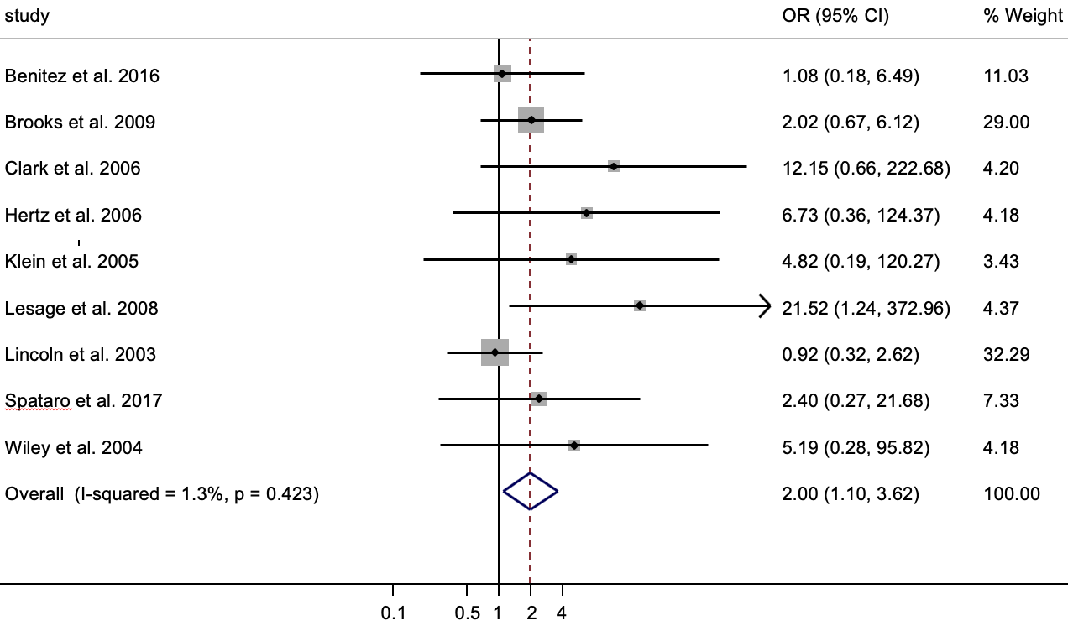
Supplementary Figure 1: Forest plot of the odds ratio (OR) of the Parkinson’s risk associated with heterozygous PARK2 mutations using published studies that investigated biallelic PARK2 mutations.
Boxes denote OR point estimates, their areas proportional to the inverse variance weight of the estimate. Horizontal lines represent 95% CIs. Vertical dashed line represents pooled OR point estimates. Key: CI, confidence intervals; PARK2, Parkin (NM_013988 and NM_004562); %, percentage.

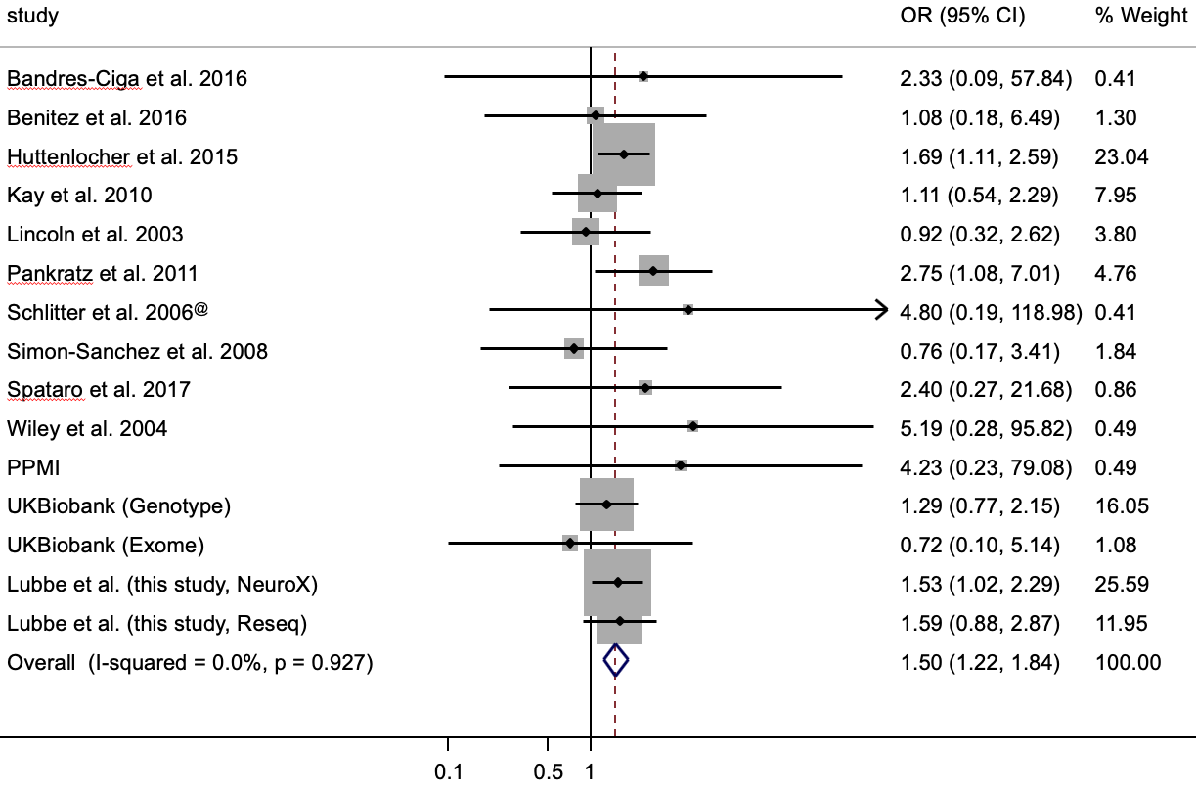
Supplementary Figure 2: Forest plot of the odds ratio (OR) of the Parkinson’s (PD) risk associated with heterozygous PARK2 mutations, excluding studies that consisted of predominantly early-onset PD cases.
Boxes denote OR point estimates, their areas proportional to the inverse variance weight of the estimate. Horizontal lines represent 95% CIs. Vertical dashed line represents pooled OR point estimates. Key: CI, confidence intervals; IPDGC, International Parkinson’s disease Genomics Consortium; PARK2, Parkin (NM_013988 and NM_004562); %, percentage; PPMI, Parkinson’s Progression Markers Initiative; Reseq, Resequencing; *German samples only.

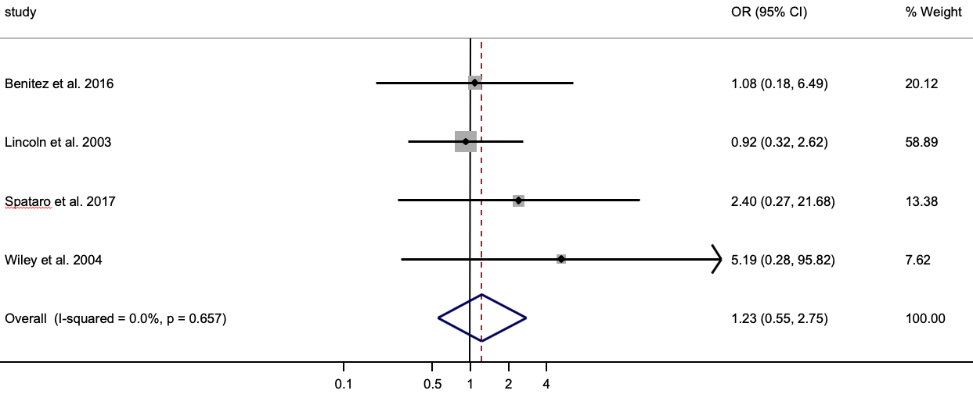
Supplementary Figure 3: Forest plot of the odds ratio (OR) of the Parkinson’s risk associated with heterozygous PARK2 mutations, in studies that assessed biallelic mutation status and do not consist of predominantly early-onset cases.
Boxes denote OR point estimates, their areas proportional to the inverse variance weight of the estimate. Horizontal lines represent 95% CIs. Vertical dashed line represents pooled OR point estimates. Key: CI, confidence intervals; PARK2, Parkin (NM_013988 and NM_004562); %, percentage.

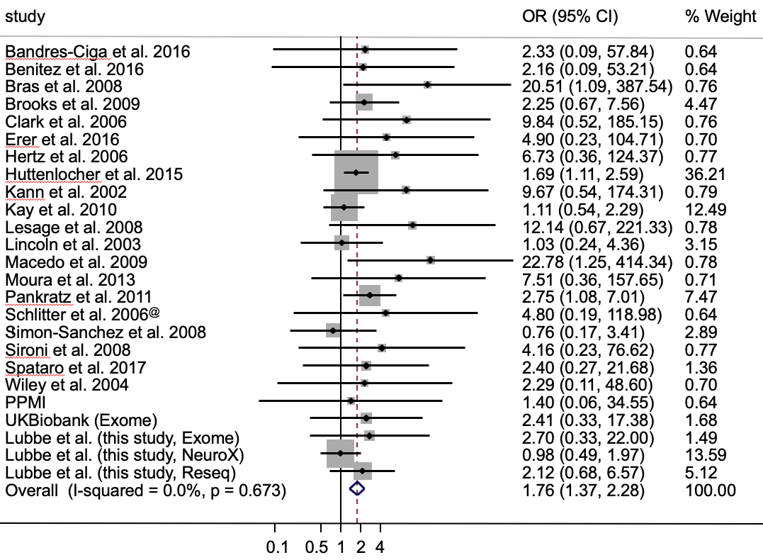
Supplementary Figure 4: Forest plot of the odds ratio (OR) of the Parkinson’s risk associated with heterozygous PARK2 mutations, excluding p.R275W (c.823C>T, rs34424986).
Boxes denote OR point estimates, their areas proportional to the inverse variance weight of the estimate. Horizontal lines represent 95% CIs. Vertical dashed line represents pooled OR point estimates. Key: CI, confidence intervals; IPDGC, International Parkinson’s disease Genomics Consortium; p., protein reference sequence; PARK2, Parkin (NM_013988 and NM_004562); %, percentage; PPMI, Parkinson’s Progression Markers Initiative; Reseq, Resequencing; *German samples only.
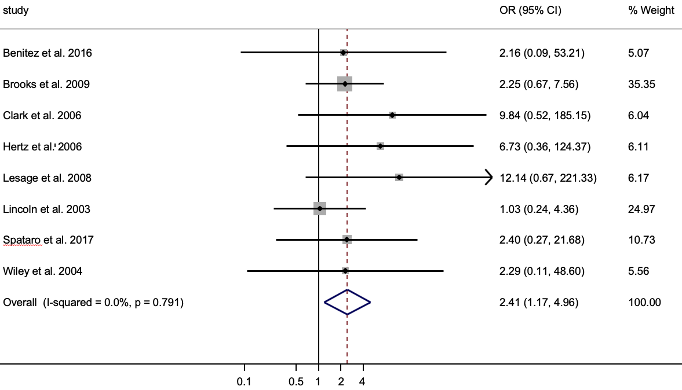
Supplementary Figure 5: Forest plot of the odds ratio (OR) of the Parkinson’s risk associated with heterozygous PARK2 mutations, excluding p.R275W (c.823C>T, rs34424986), using published studies that investigated biallelic PARK2 mutations.
Boxes denote OR point estimates, their areas proportional to the inverse variance weight of the estimate. Horizontal lines represent 95% CIs. Vertical dashed line represents pooled OR point estimates. Key: CI, confidence intervals; p., protein reference sequence; PARK2, Parkin (NM_013988 and NM_004562); %, percentage.

