Supplemental Figure 1. IL-7, IL-13, bFGF, IFN-𝝲, IL-17, G-CSF and MIP-1a are elevated in ventilated COVID-19 positive patients. (A) Patients were divided by ventilation status and cytokines were compared by Mann-Whitney test. Bars indicate mean and standard deviation; p < .05 was considered significant. Ventilated: n = 27. Not ventilated: n = 30.

Supplemental Figure 2. Patients with elevated blood glucose have increased IFN-𝝲 and IL-1ra compared to patients with normal blood glucose. (A-B) COVID-19 positive patients were stratified by elevated blood glucose (>126 mg/dl) and normal blood glucose (<126) and cytokine levels were compared using Mann-Whitney test. Bars indicate mean and standard deviation; p < .05 was considered significant. Elevated glucose: n=19. Normal glucose: n=19.

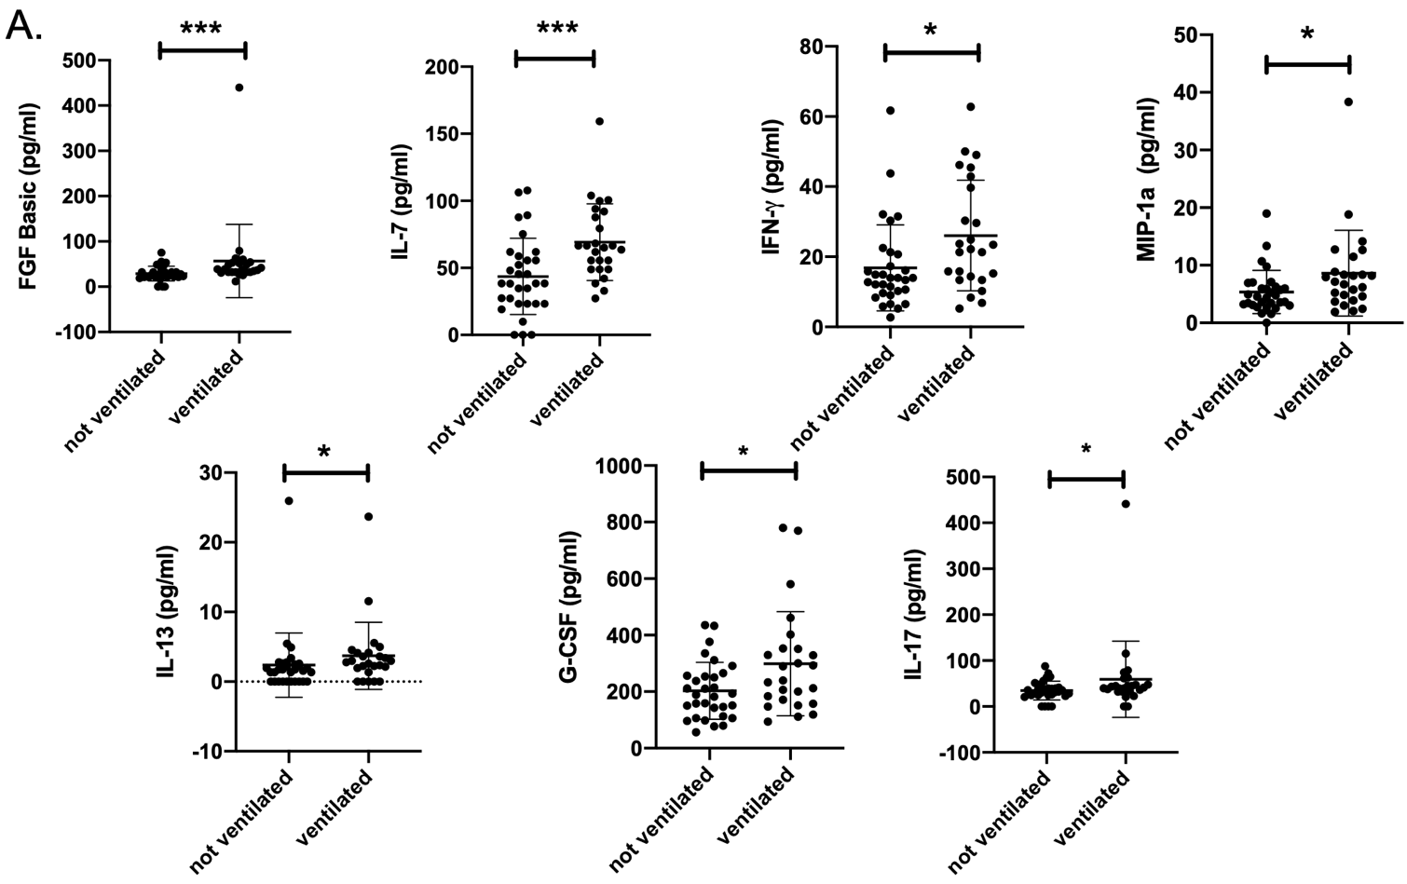
Supplemental Figure 1. IL-7, IL-13, bFGF, IFN-𝝲, IL-17, G-CSF and MIP-1a are elevated in ventilated COVID-19 positive patients.

Supplemental Figure 2. Patients with elevated blood glucose have increased IFN-𝝲 and IL-1r$α$ compared to patients with normal blood glucose.
