Supplementary Materials for

Impacts of regional climate on the COVID-19 pandemic
Minneng Wen, Liyuan Chen

Correspondence to: chenliyuan@pku.edu.cn

This PDF file includes:

Figure S1 to S3
Tables S1 to S4
Captions for Data S1

Other Supplementary Materials for this manuscript include the following:

Data S1. The COVID-19 pandemic and climate data for 194 epidemic regions in 116 countries and territories.

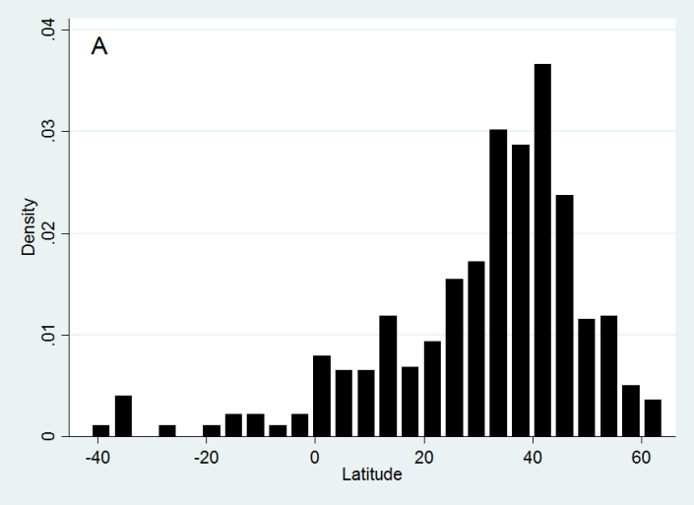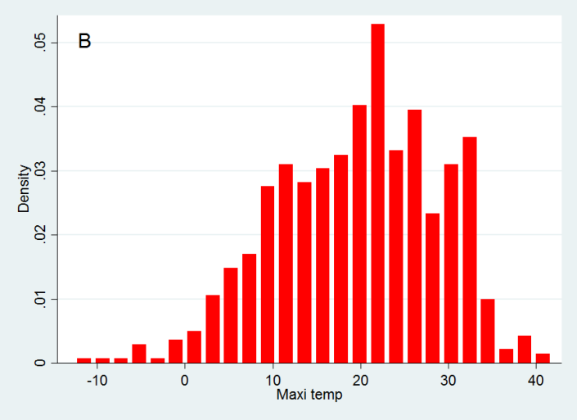
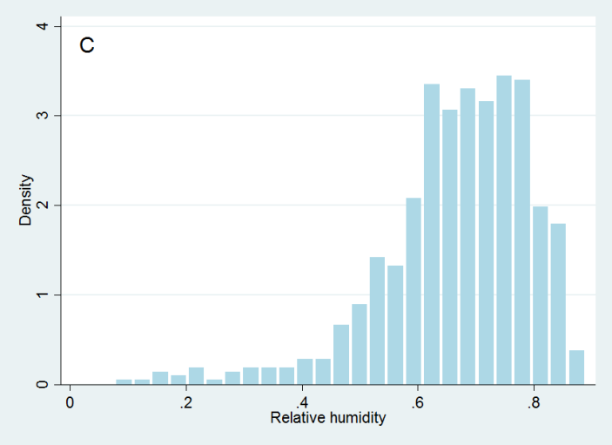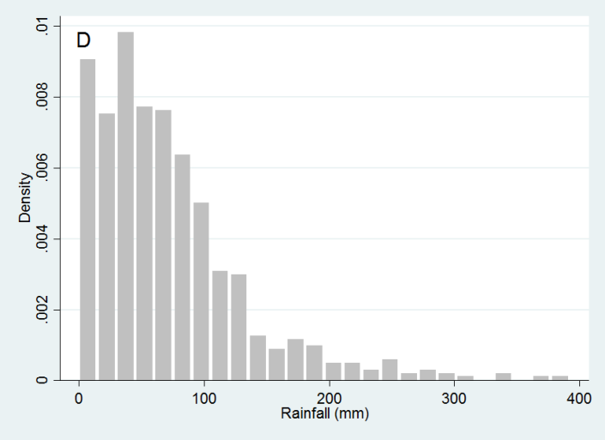
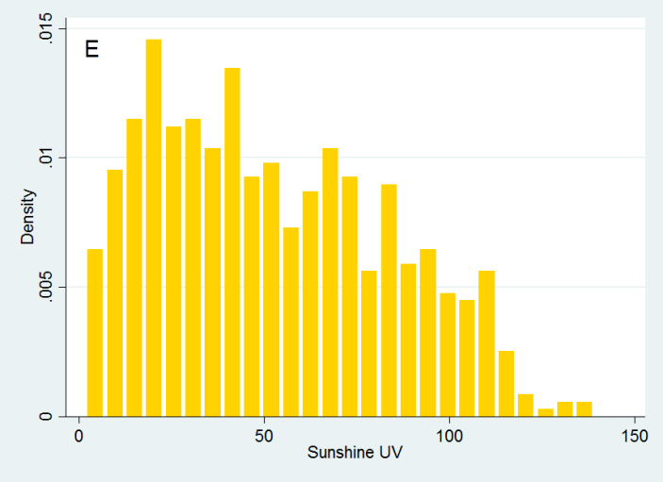

Figure S1. Histograms of absolute latitude, maximum temperature, relative humidity, rainfall, and sunshine UV.

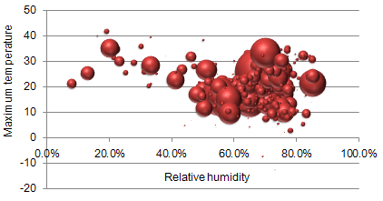
Figure S2. Bubble chart plotted between the maximum temperature and the relative humidity weighted by the number of monthly confirmed new cases.

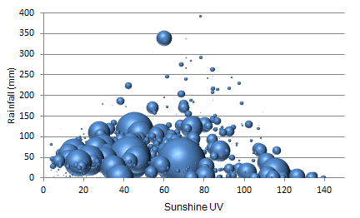
Figure S3. Bubble chart plotted between the sunshine UV and the rainfall weighted by the number of monthly confirmed new cases.

 | New cases | New deaths | Case mortality
Dec 2019 | 27 | 0 | 0%
Jan 2020 | 11814 | 260 | 2.2%
Feb 2020 | 75651 | 4003 | 5.29%
Mar 2020 | 753754 | 37500 | 4.97%
Apr 2020 | 2351179 | 189584 | 8.06%
May 2020 | 2794118 | 138062 | 4.94%
Northern hemisphere
Dec 2019-Winter | 27 | 0 | 0%
Jan 2020-Winter | 11802 | 260 | 2.2%
Feb 2020-Winter | 75638 | 4003 | 5.29%
Mar 2020-Spring | 740682 | 37121 | 5.01%
Apr 2020-Spring | 2227316 | 182323 | 8.19%
May 2020-Spring | 2252428 | 110926 | 4.92%
Subtotal | 5307893 | 334633 | 6.30%
Southern hemisphere
Dec 2019-Summer | 0 | 0 | 0%
Jan 2020-Summer | 12 | 0 | 0%
Feb 2020-Summer | 13 | 0 | 0%
Mar 2020-Autumn | 13827 | 379 | 2.74%
Apr 2020-Autumn | 123108 | 7261 | 5.90%
May 2020-Autumn | 541691 | 27136 | 5.01%
Subtotal | 678651 | 34776 | 5.12%
Table S1. Monthly distribution of confirmed new cases and deaths of the COVID-19 pandemic in the northern hemisphere (NH) and the southern hemisphere (SH).

Climate regions | Total  cases | Proportion | Total  deaths | Case  mortality
Tropical | 1129171 | 18.86% | 40556 | 3.60%
- Tropical rainforest | 137621 | 2.30% | 3452 | 2.51%
- Tropical semiarid/grasslands | 518627 | 8.66% | 29132 | 5.62%
- Tropical monsoon/wet and dry | 238800 | 3.99% | 6451 | 2.70%
- Tropical desert | 234123 | 3.91% | 1521 | 0.65%
Subtropical | 2402694 | 40.13% | 164898 | 6.86%
- Humid subtropical climate | 1462450 | 24.43% | 106662 | 7.29%
- Mediterranean climate | 645993 | 10.79% | 42865 | 6.64%
- Subtropical highland | 185537 | 3.10% | 14326 | 7.72%
- Subtropical desert | 176849 | 2.95% | 5557 | 3.14%
Temperate | 2454678 | 41.00% | 163821 | 6.67%
- Humid continental | 1351730 | 22.58% | 54275 | 4.02%
- Temperate marine | 880173 | 14.70% | 101907 | 11.58%
- Temperate semiarid/grasslands | 154171 | 2.58% | 3119 | 2.02%
- Subarctic | 469 | 0.01% | 8 | 1.71%
Temperature-group
Hot region-month (T_{max}≥20°C) | 2757875 | 46.1% | 129094 | 4.68%
Cold region-month (T_{max}<20°C) | 3228669 | 53.9% | 240315 | 7.44%
Humidity-group
Humid region-month (RH≥60%) | 4195024 | 70.1% | 266225 | 6.35%
Arid region-month (RH<60%) | 1791519 | 29.9% | 103184 | 5.76%
Rain-group
Rainy region-month (rainfall≥40mm/month) | 4217411 | 70.4% | 301044 | 7.14%
Rainless region-month (rainfall<40mm/month) | 1769133 | 29.6% | 68365 | 3.86%
UV-group
Sunny region-month (sunshine UV≥50/day) | 2669235 | 44.6% | 123777 | 4.64%
Cloudy region-month (sunshine UV<50/day) | 3317309 | 55.4% | 245632 | 7.40%
Total | 5986544 | 100% | 369409 | 6.17%
Table S2. Total confirmed COVID-19 cases and deaths in different climate regions. T_{max}: maximum temperature. RH: relative humidity.

 |  | Maximum  temperature  (℃) | Absolute  latitude  (°) | Sunshine  UV | Relative  humidity  (%) | Rainfall  (mm)
2019 | Dec | 10.8 | 31 | 13.2 | 74 | 26
2020 | Jan | 8.28 | 31 | 14.5 | 74.8 | 20.7
2020 | Feb | 9.8 | 31.9 | 18.9 | 74.1 | 55.1
2020 | Mar | 13.5 | 42.4 | 26.5 | 65.5 | 63.1
2020 | Apr | 18.3 | 39.7 | 46.4 | 62.5 | 68.2
2020 | May | 24.7 | 32.8 | 68.0 | 63.1 | 59.7
Total |  | 20.5 | 36.7 | 53.5 | 63.3 | 63.4
Table S3. Case-weighted means of climate data of central cities in COVID-19 epidemic regions. The means of absolute latitude, maximum temperature, relative humidity, rainfall, and sunshine UV are weighted by the number of monthly confirmed new cases.

 | R |  | R²
 | ln (new cases) | ln (new deaths) | ln (new cases) | ln (new deaths)
All regions
Absolute latitude | 0.122 | 0.227 | 0.0149 | 0.0515
Maximum temperature | 0.140 | 0.070 | 0.0196 | 0.0049
Relative humidity | -0.117 | -0.145 | 0.0137 | 0.0210
Monthly rainfall | 0.050 | -0.012 | 0.0025 | 0.0001
Daily sunshine UV | 0.146 | 0.038 | 0.0213 | 0.0014
Hot region-months (T_{max}≥20°C)
Absolute latitude | 0.160 | 0.366 | 0.0256 | 0.1340
Maximum temperature | 0.001 | -0.210 | 0.0000 | 0.0441
Relative humidity | -0.171 | -0.219 | 0.0292 | 0.0480
Monthly rainfall | -0.046 | -0.106 | 0.0021 | 0.0112
Daily sunshine UV | 0.142 | -0.092 | 0.0202 | 0.0085
Cold region-months (T_{max}<20°C)
Absolute latitude | 0.230 | 0.243 | 0.0529 | 0.0590
Maximum temperature | 0.341 | 0.355 | 0.1163 | 0.1260
Relative humidity | -0.031 | -0.040 | 0.0010 | 0.0016
Monthly rainfall | 0.257 | 0.181 | 0.0660 | 0.0328
Daily sunshine UV | 0.258 | 0.218 | 0.0666 | 0.0475
Humid region-months (RH≥60%)
Absolute latitude | 0.160 | 0.252 | 0.0256 | 0.0635
Maximum temperature | 0.080 | 0.020 | 0.0064 | 0.0004
Relative humidity | -0.209 | -0.190 | 0.0437 | 0.0361
Monthly rainfall | 0.001 | -0.046 | 0.0000 | 0.0021
Daily sunshine UV | 0.103 | -0.011 | 0.0106 | 0.0001
Arid region-months (RH<60%)
Absolute latitude | -0.041 | 0.092 | 0.0017 | 0.0085
Maximum temperature | 0.293 | 0.205 | 0.0858 | 0.0420
Relative humidity | -0.126 | -0.096 | 0.0159 | 0.0092
Monthly rainfall | 0.281 | 0.232 | 0.0790 | 0.0538
Daily sunshine UV | 0.264 | 0.148 | 0.0697 | 0.0219
Rainy region-months (≥40mm/month)
Absolute latitude | 0.198 | 0.301 | 0.039 | 0.091
Maximum temperature | -0.032 | -0.073 | 0.001 | 0.005
Relative humidity | -0.260 | -0.224 | 0.068 | 0.050
Monthly rainfall | -0.131 | -0.196 | 0.017 | 0.038
Daily sunshine UV | 0.053 | -0.046 | 0.003 | 0.002
Rainless region-months (<40mm/month)
Absolute latitude | 0.004 | 0.060 | 0.000 | 0.004
Maximum temperature | 0.296 | 0.278 | 0.088 | 0.077
Relative humidity | -0.116 | -0.193 | 0.013 | 0.037
Monthly rainfall | 0.004 | 0.159 | 0.000 | 0.025
Daily sunshine UV | 0.292 | 0.228 | 0.085 | 0.052
Sunny region-months (Sunshine UV≥50/day)
Absolute latitude | 0.199 | 0.361 | 0.040 | 0.130
Maximum temperature | -0.037 | -0.175 | 0.001 | 0.031
Relative humidity | -0.119 | -0.214 | 0.014 | 0.046
Monthly rainfall | 0.022 | -0.077 | 0.000 | 0.006
Daily sunshine UV | 0.042 | -0.121 | 0.002 | 0.015
Cloudy region-months (Sunshine UV<50/day)
Absolute latitude | 0.234 | 0.208 | 0.055 | 0.043
Maximum temperature | 0.194 | 0.304 | 0.038 | 0.092
Relative humidity | -0.096 | -0.056 | 0.009 | 0.003
Monthly rainfall | 0.058 | 0.092 | 0.003 | 0.008
Daily sunshine UV | 0.227 | 0.295 | 0.052 | 0.087
Table S4. Correlation between the COVID-19 pandemic and the climate of epicenters. The variables including the number of monthly confirmed new cases and deaths, absolute latitude, maximum temperature (T_{max}), relative humidity (RH), and sunshine UV. The number of monthly confirmed new cases and deaths were transformed by natural logarithm (ln).

Data S1. (separate file)
COVID-19 pandemic and climate data for 194 epidemic regions in 116 countries and territories.

