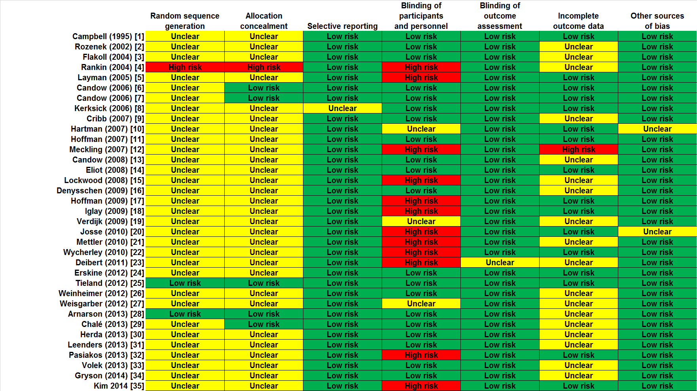

Supplementary Figure S1 Risk-of-bias assessment (1/3)
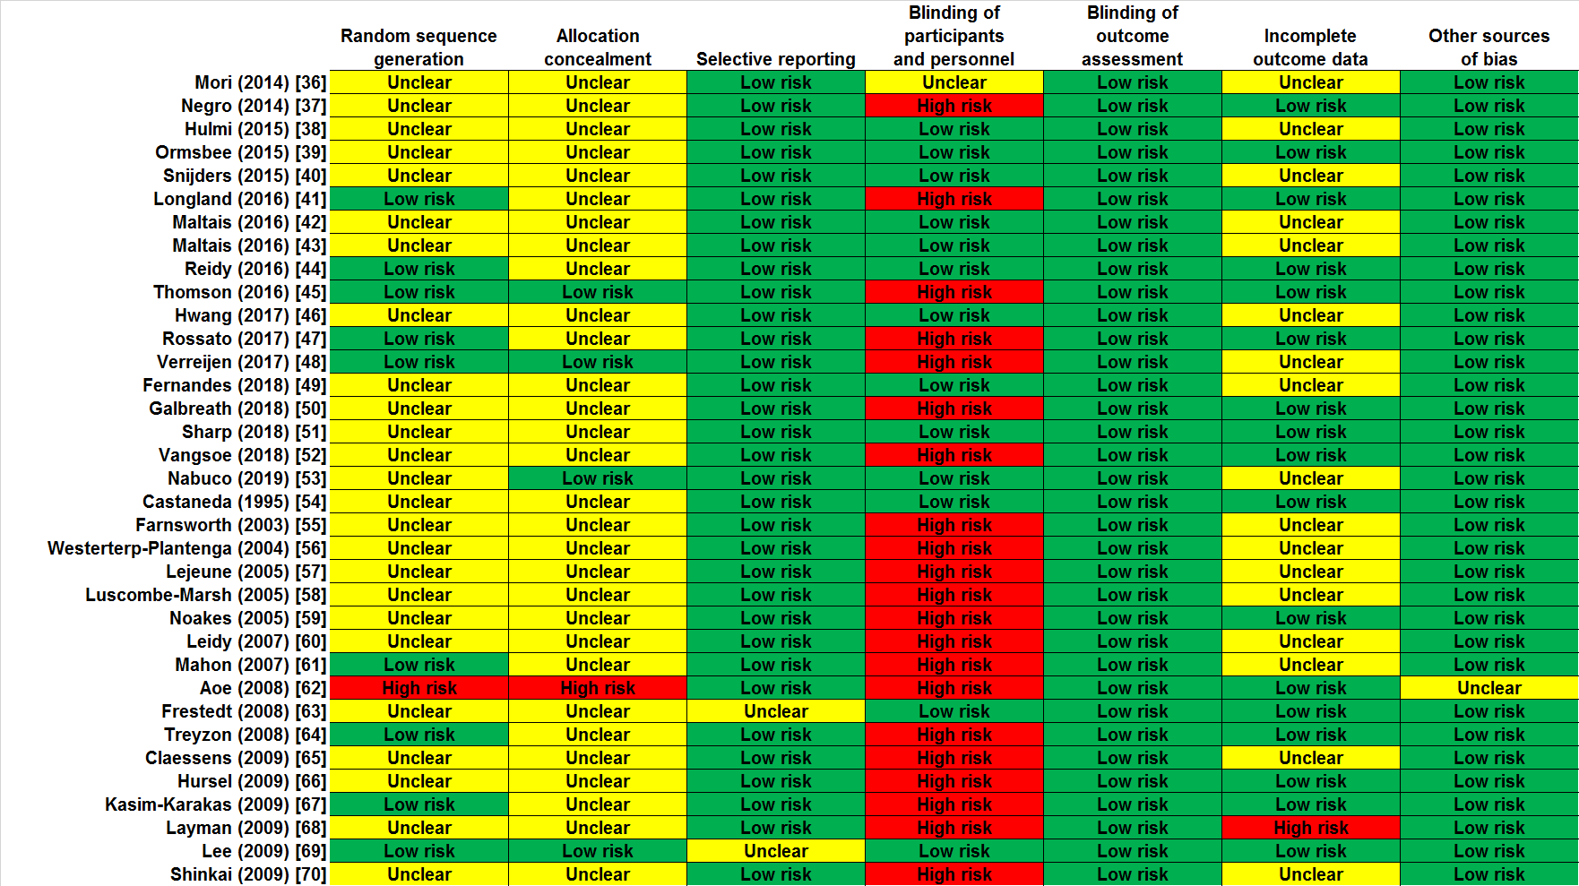

Supplementary Figure S1 Risk-of-bias assessment - continued (2/3)
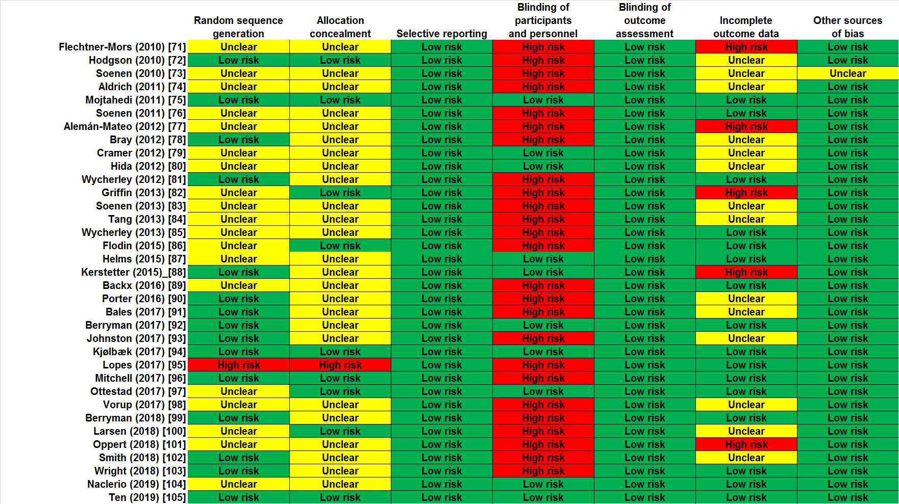

Supplementary Figure S1 Risk-of-bias assessment - continued (3/3)
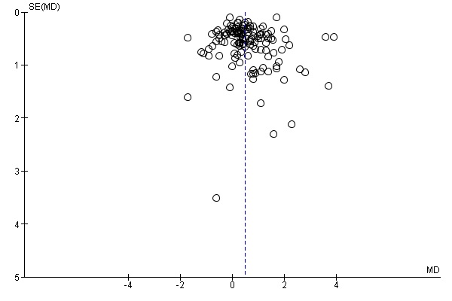
Supplementary Figure S2 Funnel plot of all included studies¹⁻¹⁰⁵ for changes in lean body mass.
A random-effects model was used.
Abbreviations: MD, mean difference between groups; SE, standard error.

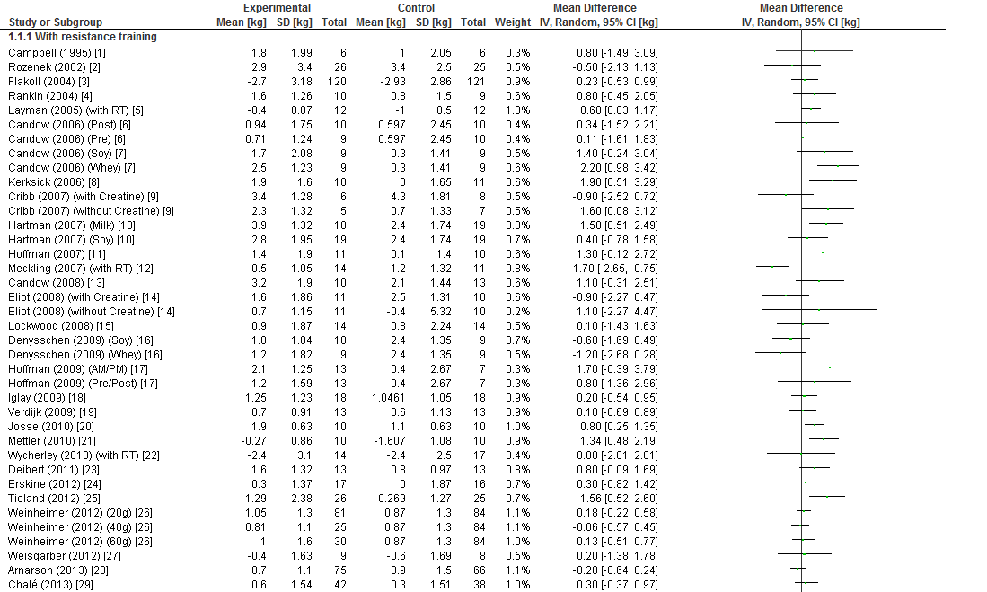
Supplementary Figure S3 Forest plot assessing the effect of protein supplementation on changes in lean body mass (1/4)
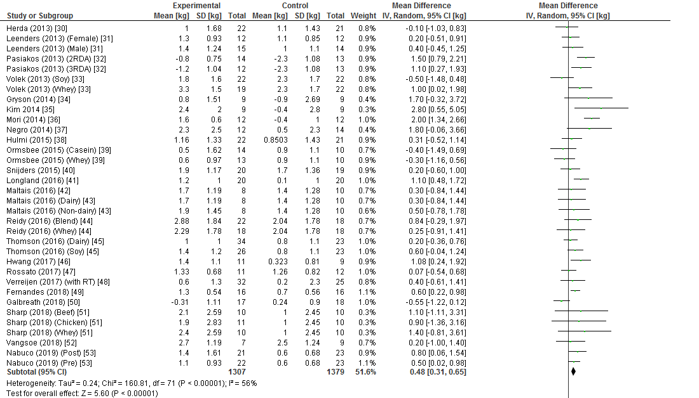
Supplementary Figure S3 Forest plot assessing the effect of protein supplementation on changes in lean body mass (2/4)
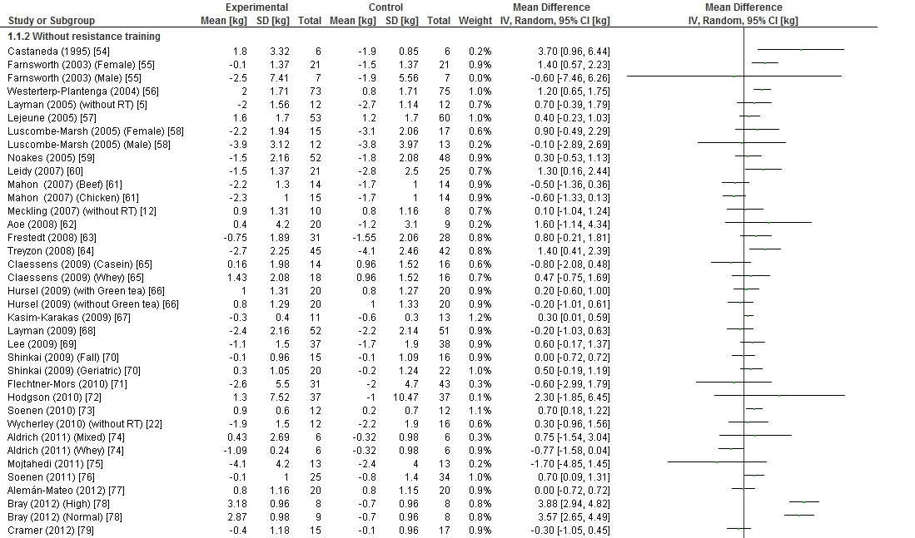
Supplementary Figure S3 Forest plot assessing the effect of protein supplementation on changes in lean body mass (3/4)
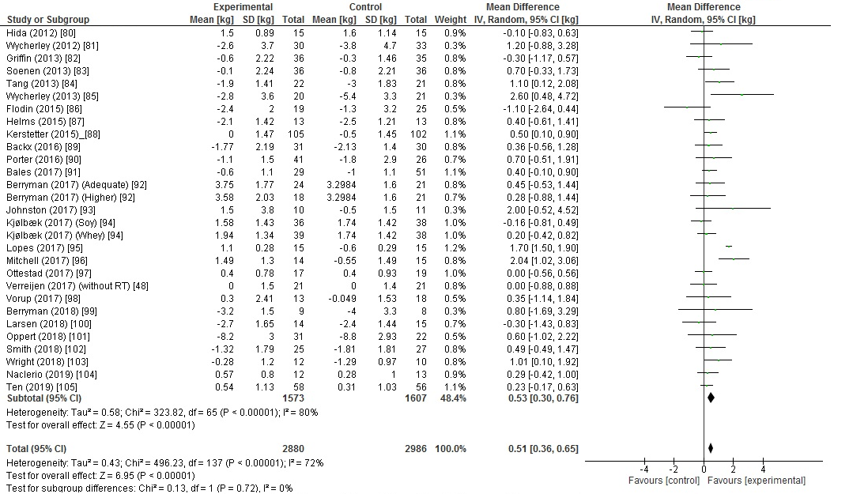
Supplementary Figure S3 Forest plot assessing the effect of protein supplementation on changes in lean body mass (4/4)
A random-effects model was used. Abbreviations: SD, Standard Deviation; CI, confidence interval.
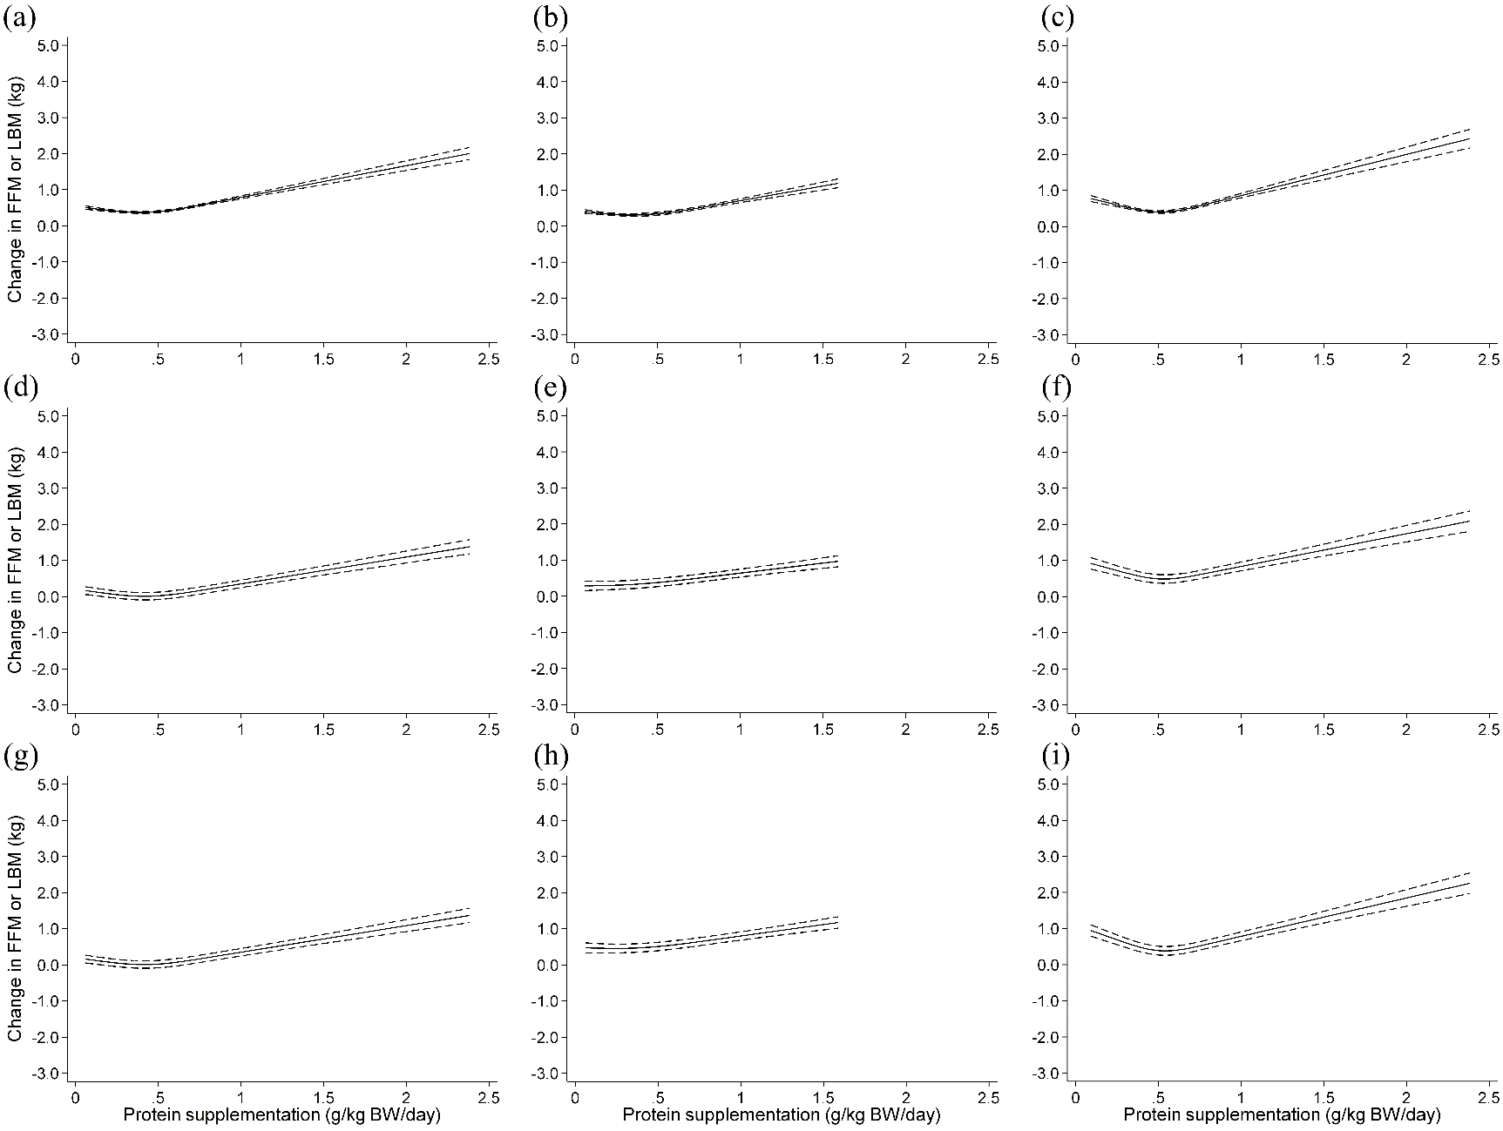
Supplementary Figure S4 Dose-response relationship between difference in supplemental protein doses and difference in lean body mass changes between groups. Spline curves illustrating the associations between difference in supplemental protein doses and difference in lean body mass changes between groups in an unadjusted model (a, b and c for all trials, trials with resistance training and without resistance training, respectively), multivariate-adjusted model 1 (d, e and f for all trials, trials with resistance training and without resistance training, respectively) or model 2 (g, h and i for all trials, trials with resistance training and without resistance training, respectively). The solid line and dashed line represent the mean and 95% conﬁdence intervals. Covariates of model 1 are age, sex, intervention period and resistance training. Covariates of model 2 are weight change in addition to the covariates of model 1.

Figure S1-S4 References
1. Campbell WW, Crim MC, Young VR, Joseph LJ, Evans WJ. Effects of resistance training and dietary protein intake on protein metabolism in older adults. Am J Physiol. 1995;268:E1143-1153.
2. Rozenek R, Ward P, Long S, Garhammer J. Effects of high-calorie supplements on body composition and muscular strength following resistance training. J Sports Med Phys Fitness. 2002;42:340-347.
3. Flakoll PJ, Judy T, Flinn K, Carr C, Flinn S. Postexercise protein supplementation improves health and muscle soreness during basic military training in Marine recruits. J Appl Physiol. (1985). 2004;96:951-956.
4. Rankin JW, Goldman LP, Puglisi MJ, Nickols-Richardson SM, Earthman CP, Gwazdauskas FC. Effect of post-exercise supplement consumption on adaptations to resistance training. J Am Coll Nutr. 2004;23:322-330.
5. Layman DK, Evans E, Baum JI, Seyler J, Erickson DJ, Boileau RA. Dietary protein and exercise have additive effects on body composition during weight loss in adult women. J Nutr. 2005;135:1903-1910.
6. Candow DG, Chilibeck PD, Facci M, Abeysekara S, Zello GA. Protein supplementation before and after resistance training in older men. Eur J Appl Physiol. 2006;97:548-556.
7. Candow DG, Burke NC, Smith-Palmer T, Burke DG. Effect of whey and soy protein supplementation combined with resistance training in young adults. Int J Sport Nutr Exerc Metab. 2006;16:233-244.
8. Kerksick CM, Rasmussen CJ, Lancaster SL, et al. The effects of protein and amino acid supplementation on performance and training adaptations during ten weeks of resistance training. J Strength Cond Res. 2006;20:643-653.
9. Cribb PJ, Williams AD, Stathis CG, Carey MF, Hayes A. Effects of whey isolate, creatine, and resistance training on muscle hypertrophy. Med Sci Sports Exerc. 2007;39:298-307.
10. Hartman JW, Tang JE, Wilkinson SB, et al. Consumption of fat-free fluid milk after resistance exercise promotes greater lean mass accretion than does consumption of soy or carbohydrate in young, novice, male weightlifters. Am J Clin Nutr. 2007;86:373-381.
11. Hoffman JR, Ratamess NA, Kang J, Falvo MJ, Faigenbaum AD. Effects of protein supplementation on muscular performance and resting hormonal changes in college football players. J Sports Sci Med. 2007;6:85-92.
12. Meckling KA, Sherfey R. A randomized trial of a hypocaloric high-protein diet, with and without exercise, on weight loss, fitness, and markers of the metabolic syndrome in overweight and obese women. Appl Physiol Nutr Metab. 2007;32:743-752.
13. Candow DG, Little JP, Chilibeck PD, et al. Low-dose creatine combined with protein during resistance training in older men. Med Sci Sports Exerc. 2008;40:1645-1652.
14. Eliot KA, Knehans AW, Bemben DA, Witten MS, Carter J, Bemben MG. The effects of creatine and whey protein supplementation on body composition in men aged 48 to 72 years during resistance training. J Nutr Health Aging. 2008;12:208-212.
15. Lockwood CM, Moon JR, Tobkin SE, et al. Minimal nutrition intervention with high-protein/low-carbohydrate and low-fat, nutrient-dense food supplement improves body composition and exercise benefits in overweight adults: a randomized controlled trial. Nutr Metab (Lond). 2008;5:11.
16. Denysschen CA, Burton HW, Horvath PJ, Leddy JJ, Browne RW. Resistance training with soy vs whey protein supplements in hyperlipidemic males. J Int Soc Sports Nutr. 2009;6:8.
17. Hoffman JR, Ratamess NA, Tranchina CP, Rashti SL, Kang J, Faigenbaum AD. Effect of protein-supplement timing on strength, power, and body-composition changes in resistance-trained men. Int J Sport Nutr Exerc Metab. 2009;19:172-185.
18. Iglay HB, Apolzan JW, Gerrard DE, Eash JK, Anderson JC, Campbell WW. Moderately increased protein intake predominately from egg sources does not influence whole body, regional, or muscle composition responses to resistance training in older people. J Nutr Health Aging. 2009;13:108-114.
19. Verdijk LB, Jonkers RA, Gleeson BG, et al. Protein supplementation before and after exercise does not further augment skeletal muscle hypertrophy after resistance training in elderly men. Am J Clin Nutr. 2009;89:608-616.
20. Josse AR, Tang JE, Tarnopolsky MA, Phillips SM. Body composition and strength changes in women with milk and resistance exercise. Med Sci Sports Exerc. 2010;42:1122-1130.
21. Mettler S, Mitchell N, Tipton KD. Increased protein intake reduces lean body mass loss during weight loss in athletes. Med Sci Sports Exerc. 2010;42:326-337.
22. Wycherley TP, Noakes M, Clifton PM, Cleanthous X, Keogh JB, Brinkworth GD. A high-protein diet with resistance exercise training improves weight loss and body composition in overweight and obese patients with type 2 diabetes. Diabetes Care. 2010;33:969-976.
23. Deibert P, Solleder F, Konig D, et al. Soy protein based supplementation supports metabolic effects of resistance training in previously untrained middle aged males. Aging Male. 2011;14:273-279.
24. Erskine RM, Fletcher G, Hanson B, Folland JP. Whey protein does not enhance the adaptations to elbow flexor resistance training. Med Sci Sports Exerc. 2012;44:1791-1800.
25. Tieland M, Dirks ML, van der Zwaluw N, et al. Protein supplementation increases muscle mass gain during prolonged resistance-type exercise training in frail elderly people: a randomized, double-blind, placebo-controlled trial. J Am Med Dir Assoc. 2012;13:713-719.
26. Weinheimer EM, Conley TB, Kobza VM, et al. Whey protein supplementation does not affect exercise training-induced changes in body composition and indices of metabolic syndrome in middle-aged overweight and obese adults. J Nutr. 2012;142:1532-1539.
27. Weisgarber KD, Candow DG, Vogt ES. Whey protein before and during resistance exercise has no effect on muscle mass and strength in untrained young adults. Int J Sport Nutr Exerc Metab. 2012;22:463-469.
28. Arnarson A, Gudny Geirsdottir O, Ramel A, Briem K, Jonsson PV, Thorsdottir I. Effects of whey proteins and carbohydrates on the efficacy of resistance training in elderly people: double blind, randomised controlled trial. Eur J Clin Nutr. 2013;67:821-826.
29. Chalé A, Cloutier GJ, Hau C, Phillips EM, Dallal GE, Fielding RA. Efficacy of whey protein supplementation on resistance exercise-induced changes in lean mass, muscle strength, and physical function in mobility-limited older adults. J Gerontol A Biol Sci Med Sci. 2013;68:682-690.
30. Herda AA, Herda TJ, Costa PB, Ryan ED, Stout JR, Cramer JT. Muscle performance, size, and safety responses after eight weeks of resistance training and protein supplementation: a randomized, double-blinded, placebo-controlled clinical trial. J Strength Cond Res. 2013;27:3091-3100.
31. Leenders M, Verdijk LB, Van der Hoeven L, et al. Protein supplementation during resistance-type exercise training in the elderly. Med Sci Sports Exerc. 2013;45:542-552.
32. Pasiakos SM, Cao JJ, Margolis LM, et al. Effects of high-protein diets on fat-free mass and muscle protein synthesis following weight loss: a randomized controlled trial. FASEB J. 2013;27:3837-3847.
33. Volek JS, Volk BM, Gomez AL, et al. Whey protein supplementation during resistance training augments lean body mass. J Am Coll Nutr. 2013;32:122-135.
34. Gryson C, Ratel S, Rance M, et al. Four-month course of soluble milk proteins interacts with exercise to improve muscle strength and delay fatigue in elderly participants. J Am Med Dir Assoc. 2014;15:958.e951-959.
35. Kim HH, Kim YJ, Lee SY, et al. Interactive effects of an isocaloric high-protein diet and resistance exercise on body composition, ghrelin, and metabolic and hormonal parameters in untrained young men: a randomized clinical trial. J Diabetes Investig. 2014;5:242-247.
36. Mori H, Niwa M. Effect of nutritional care and whey protein supplementation on the body composition and physical function in older adults after combined resistance and aerobic exercise. Jpn J Nutr Diet. 2014;72:12-20.
37. Negro M, Vandoni M, Ottobrini S, et al. Protein supplementation with low fat meat after resistance training: effects on body composition and strength. Nutrients. 2014;6:3040-3049.
38. Hulmi JJ, Laakso M, Mero AA, Hakkinen K, Ahtiainen JP, Peltonen H. The effects of whey protein with or without carbohydrates on resistance training adaptations. J Int Soc Sports Nutr. 2015;12:48.
39. Ormsbee MJ, Kinsey AW, Eddy WR, et al. The influence of nighttime feeding of carbohydrate or protein combined with exercise training on appetite and cardiometabolic risk in young obese women. Appl Physiol Nutr Metab. 2015;40:37-45.
40. Snijders T, Res PT, Smeets JS, et al. Protein ingestion before sleep increases muscle mass and strength gains during Prolonged resistance-type exercise training in healthy young men. J Nutr. 2015;145:1178-1184.
41. Longland TM, Oikawa SY, Mitchell CJ, Devries MC, Phillips SM. Higher compared with lower dietary protein during an energy deficit combined with intense exercise promotes greater lean mass gain and fat mass loss: a randomized trial. Am J Clin Nutr. 2016;103:738-746.
42. Maltais ML, Ladouceur JP, Dionne IJ. The effect of resistance training and different sources of postexercise protein supplementation on muscle mass and physical capacity in sarcopenic elderly men. J Strength Cond Res. 2016;30:1680-1687.
43. Maltais ML, Perreault K, Courchesne-Loyer A, Lagace JC, Barsalani R, Dionne IJ. Effect of resistance training and various sources of protein supplementation on body fat mass and metabolic profile in sarcopenic overweight older adult men: a pilot study. Int J Sport Nutr Exerc Metab. 2016;26:71-77.
44. Reidy PT, Borack MS, Markofski MM, et al. Protein supplementation has minimal effects on muscle adaptations during resistance exercise training in young men: a double-blind randomized clinical trial. J Nutr. 2016;146:1660-1669.
45. Thomson RL, Brinkworth GD, Noakes M, Buckley JD. Muscle strength gains during resistance exercise training are attenuated with soy compared with dairy or usual protein intake in older adults: a randomized controlled trial. Clin Nutr. 2016;35:27-33.
46. Hwang PS, Andre TL, McKinley-Barnard SK, et al. Resistance training-induced elevations in muscular strength in trained men are maintained after 2 weeks of detraining and not differentially affected by whey protein supplementation. J Strength Cond Res. 2017;31:869-881.
47. Rossato LT, Nahas PC, de Branco FMS, et al. Higher protein intake does not improve lean mass gain when compared with RDA recommendation in postmenopausal women following resistance exercise protocol: a randomized clinical trial. Nutrients. 2017;9.
48. Verreijen AM, Engberink MF, Memelink RG, van der Plas SE, Visser M, Weijs PJ. Effect of a high protein diet and/or resistance exercise on the preservation of fat free mass during weight loss in overweight and obese older adults: a randomized controlled trial. Nutr J. 2017;16:10.
49. Fernandes RR, Nabuco HCG, Sugihara Junior P, et al. Effect of protein intake beyond habitual intakes following resistance training on cardiometabolic risk disease parameters in pre-conditioned older women. Exp Gerontol. 2018;110:9-14.
50. Galbreath M, Campbell B, LaBounty P, et al. Effects of adherence to a higher protein diet on weight loss, markers of health, and functional capacity in older women participating in a resistance-based exercise program. Nutrients. 2018;10.
51. Sharp MH, Lowery RP, Shields KA, et al. The effects of beef, chicken, or whey protein after workout on body composition and muscle performance. J Strength Cond Res. 2018;32:2233-2242.
52. Vangsoe MT, Joergensen MS, Heckmann LL, Hansen M. Effects of insect protein supplementation during resistance training on changes in muscle mass and strength in young men. Nutrients. 2018;10.
53. Nabuco HCG, Tomeleri CM, Sugihara PJ, et al. Effect of whey protein supplementation combined with resistance training on cellular health in pre-conditioned older women: a randomized, double-blind, placebo-controlled trial. Arch Gerontol Geriatr. 2019;82:232-237.
54. Castaneda C, Charnley JM, Evans WJ, Crim MC. Elderly women accommodate to a low-protein diet with losses of body cell mass, muscle function, and immune response. Am J Clin Nutr. 1995;62:30-39.
55. Farnsworth E, Luscombe ND, Noakes M, Wittert G, Argyiou E, Clifton PM. Effect of a high-protein, energy-restricted diet on body composition, glycemic control, and lipid concentrations in overweight and obese hyperinsulinemic men and women. Am J Clin Nutr. 2003;78:31-39.
56. Westerterp-Plantenga MS, Lejeune MP, Nijs I, van Ooijen M, Kovacs EM. High protein intake sustains weight maintenance after body weight loss in humans. Int J Obes Relat Metab Disord. 2004;28:57-64.
57. Lejeune MP, Kovacs EM, Westerterp-Plantenga MS. Additional protein intake limits weight regain after weight loss in humans. Br J Nutr. 2005;93:281-289.
58. Luscombe-Marsh ND, Noakes M, Wittert GA, Keogh JB, Foster P, Clifton PM. Carbohydrate-restricted diets high in either monounsaturated fat or protein are equally effective at promoting fat loss and improving blood lipids. Am J Clin Nutr. 2005;81:762-772.
59. Noakes M, Keogh JB, Foster PR, Clifton PM. Effect of an energy-restricted, high-protein, low-fat diet relative to a conventional high-carbohydrate, low-fat diet on weight loss, body composition, nutritional status, and markers of cardiovascular health in obese women. Am J Clin Nutr. 2005;81:1298-1306.
60. Leidy HJ, Carnell NS, Mattes RD, Campbell WW. Higher protein intake preserves lean mass and satiety with weight loss in pre-obese and obese women. Obesity (Silver Spring). 2007;15:421-429.
61. Mahon AK, Flynn MG, Stewart LK, et al. Protein intake during energy restriction: effects on body composition and markers of metabolic and cardiovascular health in postmenopausal women. J Am Coll Nutr. 2007;26:182-189.
62. Aoe T, Imai N, Hamada K, Muratasai K. Effects of milk intake on fatigue and body composition in arthletes after physical training for 16 weeks. Hiro to kyuyono kagaku. 2008;20:95-102.
63. Frestedt JL, Zenk JL, Kuskowski MA, Ward LS, Bastian ED. A whey-protein supplement increases fat loss and spares lean muscle in obese subjects: a randomized human clinical study. Nutr Metab (Lond). 2008;5:8.
64. Treyzon L, Chen S, Hong K, et al. A controlled trial of protein enrichment of meal replacements for weight reduction with retention of lean body mass. Nutr J. 2008;7:23.
65. Claessens M, van Baak MA, Monsheimer S, Saris WH. The effect of a low-fat, high-protein or high-carbohydrate ad libitum diet on weight loss maintenance and metabolic risk factors. Int J Obes (Lond). 2009;33:296-304.
66. Hursel R, Westerterp-Plantenga MS. Green tea catechin plus caffeine supplementation to a high-protein diet has no additional effect on body weight maintenance after weight loss. Am J Clin Nutr. 2009;89:822-830.
67. Kasim-Karakas SE, Almario RU, Cunningham W. Effects of protein versus simple sugar intake on weight loss in polycystic ovary syndrome (according to the National Institutes of Health criteria). Fertil Steril. 2009;92:262-270.
68. Layman DK, Evans EM, Erickson D, et al. A moderate-protein diet produces sustained weight loss and long-term changes in body composition and blood lipids in obese adults. J Nutr. 2009;139:514-521.
69. Lee K, Lee J, Bae WK, Choi JK, Kim HJ, Cho B. Efficacy of low-calorie, partial meal replacement diet plans on weight and abdominal fat in obese subjects with metabolic syndrome: a double-blind, randomised controlled trial of two diet plans - one high in protein and one nutritionally balanced. Int J Clin Pract. 2009;63:195-201.
70. Shinkai S, Watanabe N, Lee S, Saito K, Suzuki T. Randomized controlled trial on the effects of resistance training with or without nutritional supplementation of soy peptide for the frail elderly. Jpn J Nutr Diet. 2009;67:76-83.
71. Flechtner-Mors M, Boehm BO, Wittmann R, Thoma U, Ditschuneit HH. Enhanced weight loss with protein-enriched meal replacements in subjects with the metabolic syndrome. Diabetes Metab Res Rev. 2010;26:393-405.
72. Hodgson JM, Lee YP, Puddey IB, et al. Effects of increasing dietary protein and fibre intake with lupin on body weight and composition and blood lipids in overweight men and women. Int J Obes (Lond). 2010;34:1086-1094.
73. Soenen S, Westerterp-Plantenga MS. Changes in body fat percentage during body weight stable conditions of increased daily protein intake vs. control. Physiol Behav. 2010;101:635-638.
74. Aldrich ND, Reicks MM, Sibley SD, Redmon JB, Thomas W, Raatz SK. Varying protein source and quantity do not significantly improve weight loss, fat loss, or satiety in reduced energy diets among midlife adults. Nutr Res. 2011;31:104-112.
75. Mojtahedi MC, Thorpe MP, Karampinos DC, et al. The effects of a higher protein intake during energy restriction on changes in body composition and physical function in older women. J Gerontol A Biol Sci Med Sci. 2011;66:1218-1225.
76. Soenen S, Hochstenbach-Waelen A, Westerterp-Plantenga MS. Efficacy of alpha-lactalbumin and milk protein on weight loss and body composition during energy restriction. Obesity (Silver Spring). 2011;19:370-379.
77. Aleman-Mateo H, Macias L, Esparza-Romero J, Astiazaran-Garcia H, Blancas AL. Physiological effects beyond the significant gain in muscle mass in sarcopenic elderly men: evidence from a randomized clinical trial using a protein-rich food. Clin Interv Aging. 2012;7:225-234.
78. Bray GA, Smith SR, de Jonge L, et al. Effect of dietary protein content on weight gain, energy expenditure, and body composition during overeating: a randomized controlled trial. JAMA. 2012;307:47-55.
79. Cramer JT, Housh TJ, Johnson GO, Coburn JW, Stout JR. Effects of a carbohydrate-, protein-, and ribose-containing repletion drink during 8 weeks of endurance training on aerobic capacity, endurance performance, and body composition. J Strength Cond Res. 2012;26:2234-2242.
80. Hida A, Hasegawa Y, Mekata Y, et al. Effects of egg white protein supplementation on muscle strength and serum free amino acid concentrations. Nutrients. 2012;4:1504-1517.
81. Wycherley TP, Brinkworth GD, Clifton PM, Noakes M. Comparison of the effects of 52 weeks weight loss with either a high-protein or high-carbohydrate diet on body composition and cardiometabolic risk factors in overweight and obese males. Nutr Diabetes. 2012;2:e40.
82. Griffin HJ, Cheng HL, O'Connor HT, Rooney KB, Petocz P, Steinbeck KS. Higher protein diet for weight management in young overweight women: a 12-month randomized controlled trial. Diabetes Obes Metab. 2013;15:572-575.
83. Soenen S, Martens EA, Hochstenbach-Waelen A, Lemmens SG, Westerterp-Plantenga MS. Normal protein intake is required for body weight loss and weight maintenance, and elevated protein intake for additional preservation of resting energy expenditure and fat free mass. J Nutr. 2013;143:591-596.
84. Tang M, Armstrong CL, Leidy HJ, Campbell WW. Normal vs. high-protein weight loss diets in men: effects on body composition and indices of metabolic syndrome. Obesity (Silver Spring). 2013;21:E204-210.
85. Wycherley TP, Buckley JD, Noakes M, Clifton PM, Brinkworth GD. Comparison of the effects of weight loss from a high-protein versus standard-protein energy-restricted diet on strength and aerobic capacity in overweight and obese men. Eur J Nutr. 2013;52:317-325.
86. Flodin L, Cederholm T, Saaf M, et al. Effects of protein-rich nutritional supplementation and bisphosphonates on body composition, handgrip strength and health-related quality of life after hip fracture: a 12-month randomized controlled study. BMC Geriatr. 2015;15:149.
87. Helms ER, Zinn C, Rowlands DS, Naidoo R, Cronin J. High-protein, low-fat, short-term diet results in less stress and fatigue than moderate-protein moderate-fat diet during weight loss in male weightlifters: a pilot study. Int J Sport Nutr Exerc Metab. 2015;25:163-170.
88. Kerstetter JE, Bihuniak JD, Brindisi J, et al. The effect of a whey protein supplement on bone mass in older caucasian adults. J Clin Endocrinol Metab. 2015;100:2214-2222.
89. Backx EM, Tieland M, Borgonjen-van den Berg KJ, Claessen PR, van Loon LJ, de Groot LC. Protein intake and lean body mass preservation during energy intake restriction in overweight older adults. Int J Obes (Lond). 2016;40:299-304.
90. Porter Starr KN, Pieper CF, Orenduff MC, et al. Improved function with Enhanced protein intake per meal: a pilot study of weight reduction in frail, obese older adults. J Gerontol A Biol Sci Med Sci. 2016;71:1369-1375.
91. Bales CW, Porter Starr KN, Orenduff MC, et al. Influence of protein intake, race, and age on responses to a weight-reduction intervention in obese women. Curr Dev Nutr. 2017;1.
92. Berryman CE, Sepowitz JJ, McClung HL, et al. Supplementing an energy adequate, higher protein diet with protein does not enhance fat-free mass restoration after short-term severe negative energy balance. J Appl Physiol (1985). 2017;122:1485-1493.
93. Johnston CS, Sears B, Perry M, Knurick JR. Use of novel high-protein functional food products as part of a calorie-restricted diet to reduce insulin resistance and increase lean body mass in adults: a randomized controlled trial. Nutrients. 2017;9.
94. Kjølbæk L, Sorensen LB, Sondertoft NB, et al. Protein supplements after weight loss do not improve weight maintenance compared with recommended dietary protein intake despite beneficial effects on appetite sensation and energy expenditure: a randomized, controlled, double-blinded trial. Am J Clin Nutr. 2017;106:684-697.
95. Lopes Gomes D, Moehlecke M, Lopes da Silva FB, Dutra ES, D'Agord Schaan B, Baiocchi de Carvalho KM. Whey protein supplementation enhances body fat and weight loss in women long after bariatric surgery: a randomized controlled trial. Obes Surg. 2017;27:424-431.
96. Mitchell CJ, Milan AM, Mitchell SM, et al. The effects of dietary protein intake on appendicular lean mass and muscle function in elderly men: a 10-wk randomized controlled trial. Am J Clin Nutr. 2017;106:1375-1383.
97. Ottestad I, Lovstad AT, Gjevestad GO, et al. Intake of a protein-enriched milk and effects on muscle mass and strength. A 12-week randomized placebo controlled trial among community-dwelling older adults. J Nutr Health Aging. 2017;21:1160-1169.
98. Vorup J, Pedersen MT, Brahe LK, Melcher PS, Alstrom JM, Bangsbo J. Effect of small-sided team sport training and protein intake on muscle mass, physical function and markers of health in older untrained adults: A randomized trial. PLoS One. 2017;12:e0186202.
99. Berryman CE, Young AJ, Karl JP, et al. Severe negative energy balance during 21 d at high altitude decreases fat-free mass regardless of dietary protein intake: a randomized controlled trial. FASEB J. 2018;32:894-905.
100. Larsen AE, Bibby BM, Hansen M. Effect of a whey protein supplement on preservation of fat free mass in overweight and obese individuals on an energy restricted very low caloric diet. Nutrients. 2018;10.
101. Oppert JM, Bellicha A, Roda C, et al. Resistance training and protein supplementation increase strength after bariatric surgery: a randomized controlled trial. Obesity (Silver Spring). 2018;26:1709-1720.
102. Smith GI, Commean PK, Reeds DN, Klein S, Mittendorfer B. Effect of protein supplementation during diet-induced weight loss on muscle mass and strength: a randomized controlled study. Obesity (Silver Spring). 2018;26:854-861.
103. Wright CS, Zhou J, Sayer RD, Kim JE, Campbell WW. Effects of a high-protein diet including whole eggs on muscle composition and indices of cardiometabolic health and systemic inflammation in older adults with overweight or obesity: a randomized controlled trial. Nutrients. 2018;10.
104. Naclerio F, Larumbe-Zabala E, Larrosa M, Centeno A, Esteve-Lanao J, Moreno-Perez D. Intake of animal protein blend plus carbohydrate improves body composition with no impact on performance in endurance Athletes. Int J Sport Nutr Exerc Metab. 2019;29:474-480.
105. Ten Haaf DSM, Eijsvogels TMH, Bongers C, et al. Protein supplementation improves lean body mass in physically active older adults: a randomized placebo-controlled trial. J Cachexia Sarcopenia Muscle. 2019;10:298-310.

