Supplementary Material for Less Wrong COVID-19 Projections with Interactive Assumptions

- ABM Parameter selection:
WE run multiple simulations with different combinations of the parameter to best fit the actual daily count of the new cases. Different combinations which were tested are listed in table1.
Table 1. List of parameter combinations evaluated for next 7 day predictions for each state.

State | Scenario | Rsq  Per Day | Rmse  Per Day | Mape  Per Day
Gujarat | 6.7 Crore susceptible with 80% lockdown, 40% testing & average contact rate of 5. | 0.72 | 2700.38 | 300.89
 | 2 Crore susceptible with 54% lockdown,45% testing & average contact rate of 3. | 0.994225 | 12339.44 | 196.257
 | 10 Lakh susceptible with 65% lockdown,43% testing & average contact rate of 4. | 0.96 | 574.28 | 19.82
Maharashtra | 11.42 Crore susceptible with 90% lockdown, 40% testing & average contact rate of 5. | 0.9990 | 4862.89 | 86.98
 | 11.42 Crore susceptible with 80% lockdown, 40% testing & average contact rate of 5. | 0.9990 | 6024.702 | 29.355
 | 30 Lakh susceptible with 58% lockdown,50% testing & average contact rate of 5. | 0.99907 | 2074.30 | 46.70
Delhi | 1.9 Crore susceptible with 90% lockdown, 40% testing & average contact rate of 4. | 0.9890 | 6998.55 | 88.87
 | 80 Lakh susceptible with 70% lockdown,40% testing & average contact rate of 2. | 0.995038 | 403.9084 | 46.50986
 | 1.9 Crore susceptible with 70% lockdown, 40% testing & average contact rate of 4. | 0.99912 | 4781.66 | 86.468
India | 10 Crore susceptible with 90% lockdown, 40% testing & average contact rate of 3 | 0.97442 | 4108.19 | 67.61
 | 15 Crore susceptible with 90% lockdown, 35% testing & average contact rate of 2 | 0.99944 | 5100.68 | 12.3996
Tamil Nadu | 6.79 Crore susceptible with 90% lockdown, 40% testing & average contact rate of 4 | 0.98956 | 1983.763 | 74.3682
 | 20 Lakh susceptible with 40% lockdown, 35% testing & average contact rate of 4 | 0.999115 | 2674.97 | 91.07
 | 6.79 Crore susceptible with 90% lockdown, 40% testing & average contact rate of 2 | 0.9990 | 886.029 | 66.03
Rajasthan | 6.89 Crore susceptible with 90% lockdown, 40% testing & average contact rate of 4 | 0.99871 | 407.950 | 51.46
 | 50 Lakh susceptible with 40% lockdown, 35% testing & average contact rate of 4 | 0.999007 | 9069.160 | 1157.301
 | 6.89 Crore susceptible with 70% lockdown, 55% testing & average contact rate of 4 | 0.874 | 9565.66 | 624.69
Madhya Pradesh | 7.73 Crore susceptible with 90% lockdown, 40% testing & average contact rate of 4. | 0.999373 | 1537.93 | 41.94
 | 80 Lakh susceptible with 70% lockdown,40% testing & average contact rate of 2. | 0.99544 | 1141.654 | 24.297
 | 10 Lakh susceptible with 65% lockdown,35% testing & average contact rate of 3. | 0.999735 | 236.45 | 20.55

- Compartmental Models:
Compartmental models are differential equation models used to understand disease dynamics . Here we used the SIR and SEIR Model where (S for Susceptibility, E for Exposure, I for infectious, R for Removed/Recovery).

SIR Model :
In SIR model we divide the entire population N into three blocks S, I, R i.e. N= S+I+R . This model assumes that the force of infection in the present depends on the number of infectious agents till that point of time and hence estimates the rate of flow of the individuals between the compartments.
This is described by the following system of ordinary differential equations (ODEs) :

In equation (1) 𝛃 controls how quickly susceptible population move to infectious and similarly 𝛄 controls how quickly infectious population move to recovery . and the ratio of 𝛃 and 𝛄 is defined as Reproductive No.
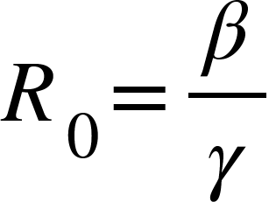

SEIR Model:
In the SEIR Model term E includes the latent phase of covid where individual is infected but not infectious .In the SEIR model we divide the total population N into 4 compartments S,E,I,R .in this model we include the parameter 𝜎 . threshold σ is identified which determines the outcome of the disease; if σ⩽1, the infected fraction of the population disappears so the disease dies out, while if σ>1, the infected fraction persists and a unique endemic equilibrium state is shown, under a mild restriction on the parameters, to be globally asymptotically stable in the interior of the feasible region. i.e. N = S+E+I+R ]. All four blocks can be modeled in by following equations

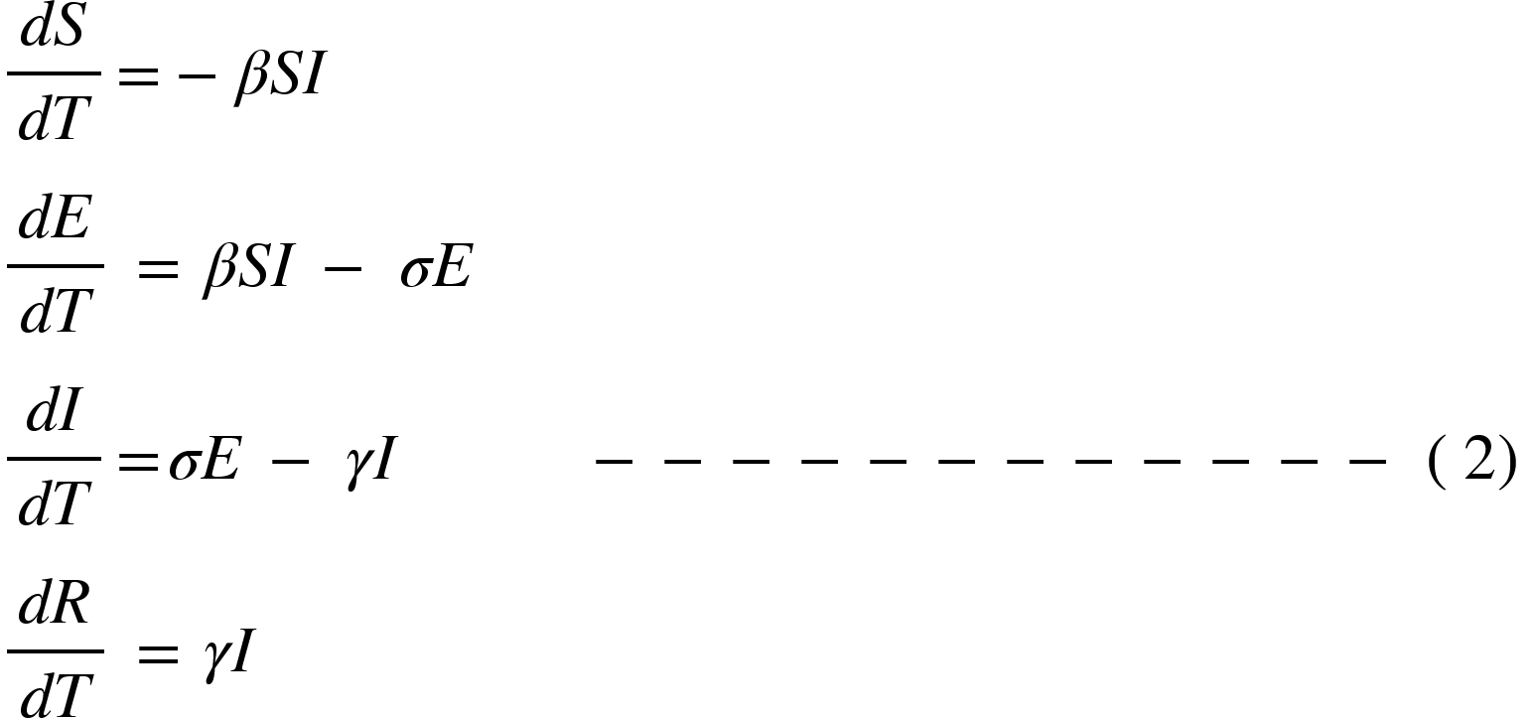

Latency in the disease delayed the start of the individual's disease, parameter controlling this delay in the model. Inclusion of latency period in SEIR does not influence the Reproductive no (R0).

- Dashboard:
An interactive dashboard http://covision.tavlab.iiitd.edu.in/ has been hosted as a web-server for the war level monitoring of the covid19 pandemic in India in public domain.

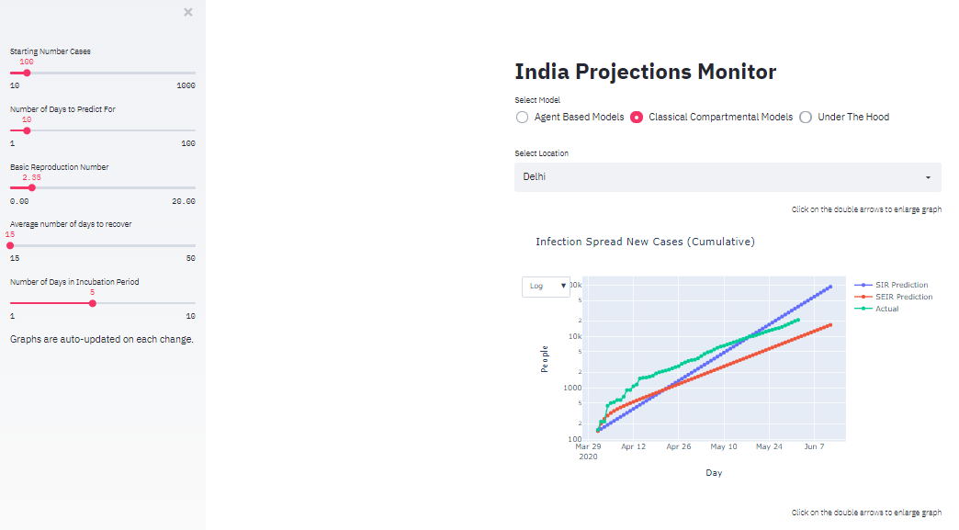

Supplementary figure 1: Interactive dashboard for Indian state-wise projections using different models and scenarios.

