SUPPLEMENTARY METHODS
Chest computed tomography-scan (CT-scan) protocol and image interpretation
Chest CT-scans were obtained with the patient in the supine position and with breath-holding following inspiration. Qualitative and semi-quantitative assessments were reached by consensus. In accordance with previous reports of COVID-19 imaging^{1,2}, the following features were recorded for each exam: ground-glass opacity (GGO), crazy paving, focal or linear consolidation. For each exam, the predominant semiological pattern was recorded. The presence of lung or pleural metastases was assessed by comparison with previous CT-scans. Patients with pre-existing equivocal findings before March 2020, such as GGO, were excluded after comparison of the study chest CT-scan with a previous CT-scan. A severity score (5 classes) was implemented according to the extent of lung parenchyma involvement³as follow : absent/minimal (0-<10%); moderate (10-25%); extensive (26-50%); severe (51-75%); critical (>75%).

Blood samples
Values of two samples tests were collected: one test called the reference test performed no more than two months before COVID-19 diagnosis and one test called COVID-19 diagnosis test performed between 7 days before COVID-19 diagnosis and 7 days after COVID-19 diagnosis. For the COVID-19 diagnosis test, most relevant values (meaning most abnormal values) were collected.

Cancer care during the COVID-19 pandemic
Starting mid-March 2020, national guidelines were published in France to help decision making for patients with cancer (fully accessible at https://www.oncopl.fr/recommandations-covid-19). These guidelines were similar for all tumor types and could be summarized as follows: 1) postpone surgery for localized stage when possible; 2) delay any medical cancer treatment for at least 15 days or until symptoms resolution if COVID-19 disease was confirmed; 3) barrier gestures were strongly reminded and advised. Dedicated patients tracks were set up for radiation therapy in radiation therapy facilities for COVID-19 positive and negative patients. Hypofractionation was preferred whenever possible⁴. Intensive care unit was organized with COVID positive and COVID negative areas and dedicated operating room (OR) was fitted with an airlock and air treatment. Surgery was maintained after tumor boards for curable solid tumor known to be resistant to chemotherapy and/or urgent surgical indication (e.g. sarcomas, melanomas, retinoblastomas, ovarian cancer, etc.) or breast cancer when surgery could not be delayed by neoadjuvant chemotherapy). In these cases, systematic COVID-19 screening was done and final decision was took by surgeons and anesthesiologists. Urgent surgery for COVID-19 positive patients were performed in a dedicated OR. All inpatients received anticoagulation therapy, either low weight molecular heparin initiated at entry, or as prescribed prior to hospitalization (refer to table 1).

References
1. Huang C, Wang Y, Li X, et al. Clinical features of patients infected with 2019 novel coronavirus in Wuhan, China. The Lancet. 2020;395(10223):497-506. doi:10.1016/S0140-6736(20)30183-5
2. Salehi S, Abedi A, Balakrishnan S, Gholamrezanezhad A. Coronavirus disease 2019 (COVID-19) imaging reporting and data system (COVID-RADS) and common lexicon: a proposal based on the imaging data of 37 studies. Eur Radiol. Published online April 28, 2020. doi:10.1007/s00330-020-06863-0
3. French Society of Radiology COVID-19 imaging guidelines. http://www.sfrnet.org/rc/org/sfrnet/nws/News/2020/20200316-155630-175/src/nws_fullText/fr/CR%20TYPE%20COVID-19%20LAST.pdf
4. Achard V, Tsoutsou P, Zilli T. Radiotherapy in the time of the Coronavirus pandemic: when less is better. Int J Radiat Oncol Biol Phys. Published online March 18, 2020. doi:10.1016/j.ijrobp.2020.03.008

SUPPLEMENTARY TABLES

Supplementary table S1. Characteristics of patients with positive chest CT-scan.

All patients with positive chest CT scan
N evaluable (%)
N=80
Median Age (IQR)  Age>70 | 61 (52-77)  18 (23%)
Gender  Male  Female | 26 (33%)  54 (67%)
Median BMI (IQR)  BMI≥30 | 25 (22-29)  13 (12%)
WHO Performance Status  0-1  2-4 | N=49  25 (51%)  24 (49%)
Comorbidities  Active smokers  Chronic lung disease  Diabetes  Hypertension  Other heart disease  Systemic disease  None of the above | 13 (16%)  4 (5%)  14 (18%)  21 (26%)  12 (15%)  2 (3%)  39 (57%)
Concomitant medications  Corticosteroids*  NSAID  ACE inhibitor / ARB  Anticoagulants  Immunosuppressants | 16 (20%)  5 (6%)  14 (18%)  22 (28%)  4 (5%)
Inpatient infection  Yes  No | 17 (21%)  63 (79%)
Site of cancer  Breast  Hematological  Lung  Gynecological  Gastrointestinal  Head & Neck  Sarcoma  Uveal melanoma  Genitourinary  Brain tumors, CNS  Other | 32 (40%)  10 (13%)  13 (16%)  6 (8%)  9 (11%)  4 (5%)  3 (4%)  2 (3%)  0  0  1 (1%)
Disease stage (solid tumors)  Localized  Advanced/metastatic | N=78  14 (20%)  64 (80%)
Pleuropulmonary metastases  (solid tumors) | N=71  29 (41%)
Number of metastatic sites  0  1-2  ≥ 3 | N=79  21 (19%)  48 (61%)  10 (13%)
Number of line of treatments  Adjuvant/neoadjuvant  Metastatic : 1-2 lines  Metastatic: ≥ 3 lines | N=78  14 (18%)  13 (17%)  51 (65%)
Therapeutic intent at entry  Curative  Disease control  Palliative | N=80  24 (30%)  32 (40%)  24 (30%)
Ongoing cancer therapy  Surgery  Chemotherapy  Radiation therapy  Endocrine therapy  Targeted therapy  Immunotherapy | N=80  2 (3%)  45 (56%)  7 (9%)  14 (18%)  14 (18%)  6 (8%)
Fever (≥38.0°C) | 39 (49%)
Cough | 28 (35%)
Dyspnea | 27 (34%)
Decreased SpO₂ (<96%) | 12 (15%)
GI disorders | 8 (10%)
Anosmia/Dysgeusia | 7 (9%)
Headache | 0
No symptom | 18 (23%)

Supplementary Table S2. Detailed CT scan pulmonary findings obtained from 71 patients.

Lung damage on CT scan at diagnosis of COVID-19
N (%)
 | Absent/ minimal (<10%) | Moderate  (10-25%) | Extensive  (26-50%) | Severe  (51-75%) | Critical (>75%)
Ground glass opacities | 18 (82%) | 13 (52%) | 8 (80%) | 2 (100%) | 1 (100%)
Crazy paving | 1 (5%) | 6 (24%) | 1 (10%) | 0 | 0
Consolidation | 3 (14%) | 6 (24% | 1 (10%) | 0 | 0
CT: computed tomography.

Supplementary Table S3. Detailed laboratory results.
For each value of interest is shown the worst result, observed at any point during follow-up.

 | N evaluable (%) | Values  (median, IQR) | % abnormal*
Hemoglobin (g/dL) | 127 | 10.7 (9.2 – 12.4) | 72%
Absolute Neutrophil count (10⁹/L) | 128 | 3.5 (2.3 – 5.0) | 16%
Absolute Lymphocyte count (10⁹/L) | 128 | 0.8 (0.5 – 1.3) | 46%
AST (IU/L) | 118 | 30.5 (24 – 50) | 36%
ALT (IU/L) | 118 | 29.5 (20 -45) | 28%
LDH (IU/L) | 59 | 311 (207 – 493) | 36%
PT (%) | 64 | 92.5 (78 – 100) | 73%
CRP (mg/L) | 82 | 66 (35 – 140) | 94%
PCT (mg/L) | 44 | 0.23 (0.1 – 0.7) | 55%
AST: Aspartate transaminase. ALT: Alanine transaminase. LDH: Lactate dehydrogenase. PT: prothrombin time. CRP: C-reactive protein. PCT: procalcitonin.
*Abnormal values were defined as follows: for blood count and liver functional tests, according to NCI-CTC AE v4.0. For other biological values, we considered abnormal any value > 2 x Upper Normal Limit.

Supplementary Table S4. Antibiotics and anti-viral agents

Type of treatment | N (%)  N=141
Antibiotics  Corticosteroids  Hydroxychloroquine  Lopinavir/ritonavir | 68 (48%)  7 (5%)  5 (4%)  4 (3%)

SUPPLEMENTARY FIGURES

Supplementary Figure S1. Paris Area “Ile-de-France” and location of Institut Curie facilities.
The seven Ile-de-France administrative boroughs (“départements”) are shown on the map, with their individual administrative numbers. The three locations of Institut Curie are shown in yellow (Core Paris), blue (Saint-Cloud, in the Hauts-de-Seine département) and red (Orsay, in the Essonne département).

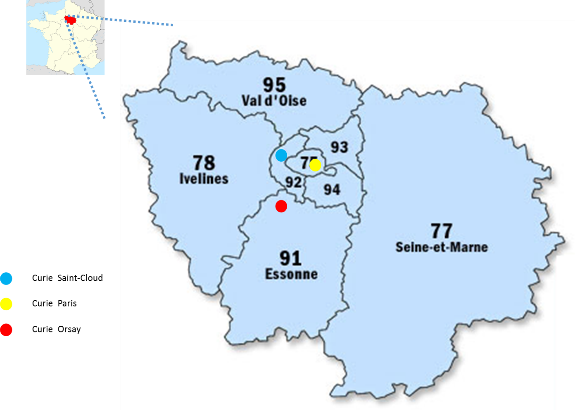

Supplementary figure S2. Per week, number of tested, confirmed and hospitalized patients at Institut Curie.
The number per week of patients undergoing an RT-PCR test (blue curve), having a positive test (orange curve) or hospitalized (green curve) is indicated in the graph. Key events are indicated below the graph. Hospitalization was triggered only by the clinical condition and only symptomatic patients with positive RT-PCR testing or positive CT-scan imaging are represented in the figure.

