De novo variants in SNAP25 cause an early onset developmental and epileptic encephalopathy
Supplemental Data
Chiara Klöckner, Heinrich Sticht, Pia Zacher, Bernt Popp, Dewi P. Bakker, Katy Barwick, Michaela V. Bonfert, Eva H. Brilstra, CareRare Canada Consortium, Wendy K. Chung, Angus J. Clarke, Patrick Devine, Jennifer Friedman, Alyssa Gates, Gabriella Horvath, Jennifer Keller-Ramey, Boris Keren, Manju A. Kurian, Virgina M. Lee, Kathleen A. Leppig, Johan Lundgren, Marie T. McDonald, Amy McTague, Heather C. Mefford, Cyril Mignot, Mohamad Mikati, Caroline Nava, F. Lucy Raymond, Julian R. Sampson, Alba Sanchis-Juan, Vandana Shashi, Joseph T.C. Shieh, Marwan Shinawi, Anne Slavotinek, Tommy Stödberg, Nicholas Stong, Jennifer A. Sullivan, Ashley C. Taylor, Tomi L. Toler, Marie-José van den Bogaard, Saskia N. van der Crabben, Koen van Gassen, Richard H. van Jaarsveld, Jessica van Ziffle, Alexandrea Wadley, Matias Wagner, Saskia B. Wortmann, Rikke S. Møller, Johannes R. Lemke and Konrad Platzer

Corresponding Author
Konrad Platzer, MD
Konrad.platzer@medizin.uni-leipzig.de

Supplemental Tables
Table S1. Detailed clinical information of all individuals with (likely) pathogenic de novo variants in SNAP25 (Excel-file)
Table S2. Detailed clinical information of all individuals with variants of unknown significance in SNAP25 (Excel-file)

Table S3.1. Information on variant location, predicted structural effects and classification according to the ACMG criteria of all (likely) pathogenic variants in SNAP25 (NM_130811.4).
individual | chr20: g. | Reference allele (Ref) | Alternate allele (Alt) | c. | p. | Origin | Domain | Main structural effect(s) | ACMG criteria
1¹ | 10265375 | A | G | c.118A>G | p.(Lys40Glu) | de novo | t-SNARE coiled coil homology 1 | Electrostatic repulsion with Glu37/Asp41 (SNAP25) | PS2_Moderate, PM2, PP2, PP3 | likely pathogenic
2/3¹/4 | 10265384 | G | C | c.127G>C | p.(Gly43Arg) | de novo | t-SNARE coiled coil homology 1 | Steric clashes with Leu160 (SNAP25) and Phe216 (Syntaxin) | PS2, PS4_Moderate, PM2, PP2, PP3 | likely pathogenic
5² | 10265399 | G | T | c.142G>T | p.(Val48Phe) | de novo | t-SNARE coiled coil homology 1 | Steric clash with Leu198 (αSNAP) | PS2_Moderate, PM2, PP2, PP3 | likely pathogenic
6³ | 10265406 | T | C | c.149T>C | p.(Leu50Ser) | de novo | t-SNARE coiled coil homology 1 | Reduced packing with Met167/Ile171 (SNAP25) | PS2_Moderate, PM2, PP2, PP3 | likely pathogenic
7 | 10273815 | T | G | c.170T>G | p.(Leu57Arg) | de novo | t-SNARE coiled coil homology 1 | Steric clash with Gln174 (SNAP25) | PS2_Moderate, PM2, PP2, PP3 | likely pathogenic
8⁴ | 10273845 | T | A | c.200T>A | p.(Ile67Asn) | de novo | t-SNARE coiled coil homology 1 | Reduced packing with Val241(Syntaxin) | PS3, PS2_Moderate, PM2, PP2, PP3 | pathogenic
9/10 | 10273857 | T | C | c.212T>C | p.(Met71Thr) | de novo | t-SNARE coiled coil homology 1 | Reduced packing with Ile192 (SNAP25) and Val244 (Syntaxin) | PS2_Moderate, PS4_Supporting, PM2, PP2, PP3 | likely pathogenic
11⁵ | 10280004 | G | T | c.496G>T | p.(Asp166Tyr) | de novo | t-SNARE coiled coil homology 2 | Steric clashes with Leu197(αSNAP) | PS2_Moderate, PM2, PP2, PP3 | likely pathogenic
12 | 10280005 | A | G | c.497A>G | p.(Asp166Gly) | de novo | t-SNARE coiled coil homology 2 | Destabilizes helix in SNAP25 | PS2_Moderate, PM2, PP2, PP3 | likely pathogenic
13 | 10280029 | A | C | c.521A>C | p.(Gln174Pro) | de novo | t-SNARE coiled coil homology 2 | Disrupts helix in SNAP25 | PS2_Moderate, PM2, PP2, PP3 | likely pathogenic
14 | 10286799 | T | C | c.575T>C | p.(Ile192Thr) | de novo | t-SNARE coiled coil homology 2 | Reduced packing with Met71(SNAP25) | PS2_Moderate, PM2, PP2, PP3 | likely pathogenic
15 | 10286817 | G | C | c.593G>C | p.(Arg198Pro) | de novo | t-SNARE coiled coil homology 2 | Disrupts helix in SNAP25 | PS2_Moderate, PM2, PP2, PP3 | likely pathogenic
16 | 10286820 | C | G | c.596C>G | p.(Ala199Gly) | de novo | t-SNARE coiled coil homology 2 | Destabilizes SNAP25 | PS2_Moderate, PM2, PP2, PP3 | likely pathogenic
17 | 10286820 | C | T | c.596C>T | p.(Ala199Val) | de novo | t-SNARE coiled coil homology 2 | Steric clashes with Phe77(VAMP2) | PS2_Moderate, PM2, PP2, PP3 | likely pathogenic
18 | 10258376 | T | G | c.114+2T>G | p.(?) | de novo | - | Complete unfolding of SNAP25 expected | PVS1_Moderate, PS2_Moderate,PM2, PP3 | likely pathogenic
19/20¹ | 10280028 | C | T | c.520C>T | p.(Gln174*) | de novo | - | Unfolding of SNAP25 expected | PVS1_Moderate, PS2, PS4_Supporting, PM2 | likely pathogenic

Table S3.2. Information on variant location, predicted structural effects and classification according to the ACMG criteria of all variants of unknown significance in SNAP25 (NM_130811.4).
individual | chr20: g. | Ref | Alt | c. | p. | Origin | Domain | main structural effect(s) | ACMG
V1 | 10258352 | G | A | c.92G>A | p.(Arg31His) | unknown | t-SNARE coiled coil homology 1 | Interaction with Glu206 (Syntaxin) disrupted, altered interaction with Glu240 (αSNAP) | PM2, PP2, PP3 | VUS
V2/V3⁶ | 10273821 | G | C | c.176G>C | p.(Arg59Pro) | paternal mosaic (50-100%) | t-SNARE coiled coil homology 1 | Disrupts helix in SNAP25 and interaction with Thr118 (αSNAP) | PM2, PP2, PP3 | VUS
V4 | unknown | G | A | c.220G>A | p.(Ala74Thr) | maternal | t-SNARE coiled coil homology 1 | Only weak effects | PM2, PP2, PP3 | VUS
V5 | 10277695 | G | A | c.404G>A | p.(Arg135His) | de novo |  | Thr138 phosphorylation likely affected | PS2_Moderate | VUS
V6 | 10279972 | G |  | c.464delG | p.(Gly155Alafs*84) | maternal |  | complete unfolding of SNAP25 expected | PVS1_Moderate, PM2 | VUS
V7 | 10286825 | A | T | c.601A>T | p.(Lys201*) | unknown |  | Disrupts packing of Met202-Leu81 (SNAP25) | PVS1_Moderate, PM2 | VUS

Table S4.1. In silico prediction of all (likely) pathogenic missense variants and conservation of affected amino acids in SNAP25 (NM_130811.4).
Indi-vidual | chr20: g. | Ref | Alt | c. | p. | CADD 1.4  (Kircher et al.)⁷ | REVEL  (Ioannidis et al.)⁸ | Mutation Taster2  (Schwarz et al.)⁹ | M-CAP 1.3  (Jagadeesh et al.)¹⁰ | Polyphen-2 v2.2.2  (Adzhubei et al.)¹¹ | GERP++  (Cooper et al.)¹² | Conser-vation | Absent from GnomAD | distance to next missense (#) *
1 | 10265375 | A | G | c.118A>G | p.(Lys40Glu) | 26,8 | 0,474 | DC | T | PrD | 5,8 | high, fruitfly | yes | -5 (1)
2/3/4 | 10265384 | G | C | c.127G>C | p.(Gly43Arg) | 31 | 0,844 | DC | D | PrD | 5,8 | high, fruitfly | yes | -8 (1)
5 | 10265399 | G | T | c.142G>T | p.(Val48Phe) | 31 | 0,781 | DC | D | PrD | 5,07 | high, fruitfly | yes | -13 (1)
6 | 10265406 | G | T | c.149T>C | p.(Leu50Ser) | 34 | 0,707 | DC | D | PrD | 5,8 | high, C. elegans | yes | +14 (1)
7 | 10273815 | T | G | c.170T>G | p.(Leu57Arg) | 27,2 | 0,814 | DC | D | PoD | 5,9 | high, C. elegans | yes | +7 (1)
8 | 10273845 | T | A | c.200T>A | p.(Ile67Asn) | 27,3 | 0,86 | DC | D | PrD | 5,9 | high, fruitfly | yes | -3 (1)
9/10 | 10273857 | T | C | c.212T>C | p.(Met71Thr) | 23,7 | 0,556 | DC | D | PoD | 5,9 | high, fruitfly | yes | +5 (1)
11 | 10280004 | G | T | c.496G>T | p.(Asp166Tyr) | 33 | 0,658 | DC | D | PrD | 6,17 | high, C. elegans | yes | +1 (1)
12 | 10280005 | A | G | c.497A>G | p.(Asp166Gly) | 34 | 0,683 | DC | D | PrD | 6,17 | high, C. elegans | yes | +1 (1)
13 | 10280029 | A | C | c.521A>C | p.(Gln174Pro) | 33 | 0,876 | DC | D | PrD | 6,17 | high, C. elegans | yes | +2 (1)
14 | 10286799 | T | C | c.575T>C | p.(Ile192Thr) | 32 | 0,656 | DC | D | PrD | 5,94 | high, zebrafish | yes | +2 (1)
15 | 10286817 | G | C | c.593G>C | p.(Arg198Pro) | 29,1 | 0,52 | DC | D | PoD | 5,94 | high, fruitfly | yes | -2 (1)
16 | 10286820 | C | G | c.596C>G | p.(Ala199Gly) | 29,8 | 0,669 | DC | T | PrD | 5,94 | high, fruitfly | yes | -3 (1)
17 | 10286821 | C | T | c.596C>T | p.(Ala199Val) | 29,7 | 0,688 | DC | T | PrD | 5,94 | high, fruitfly | yes | -3 (1)

Table S4.2. In silico prediction¹³ of the (likely) pathogenic splice site variant in SNAP25 (NM_130811.4)
Indi-vidual | chr20: g. | Ref | Alt | c. | p. | Splicing prediction | MaxEnt¹⁴ | NNSPLICE¹⁵ | SSF¹⁶
18 | 10277728 | T | G | c.114+2T>G | p.? | The splice donor site is completey abolished (MAxEntScan, NNSPLICE, SpliceSiteFinder-like) | -100.0% | -100.0% | -100.0%

Table S4.3. In silico prediction of all missense variants classified as variants of unknown significance and conservation of affected amino acids in SNAP25 (NM_130811.4).
Individual | chr20: g. | Ref | Alt | c. | p. | CADD 1.4  (Kircher et al.)⁷ | REVEL  (Ioannidis et al.)⁸ | Mutation Taster2  (Schwarz et al.)⁹ | M-CAP 1.3  (Jagadeesh et al.)¹⁰ | Polyphen-2 v2.2.2  (Adzhubei et al.)¹¹ | GERP++  (Cooper et al.)¹² | Conservation | Absent from GnomAD | distance to next missense (#)
V1 | 10258352 | G | A | c.92G>A | p.(Arg31His) | 33 | 0,58 | DC | D | PrD | 5,78 | high, fruitfly | yes | ± 0 (1)
V2/3 | 10273821 | G | C | c.176G>C | p.(Arg59Pro) | 29,9 | 0,675 | DC | D | PrD | 5,9 | high, fruitfly | yes | +5 (1)
V4 | ? | G | A | c.220G>A | p.(Ala74Thr) | 25,4 | 0,514 | DC | D | PrD | 5,9 | high, fruitfly | yes | +2 (1)
V5 | 10277695 | G | A | c.404G>A | p.(Arg135His) | 25,7 | 0,378 | DC | T | B | 5,86 | high, zebrafish | no | ± 0 (5)

Conservation was evaluated considering the following species: Homo sapiens, Pan troglodytes (chimp), Rattus norvegicus (rat), Mus musculus (mouse), Canis familiaris (dog), Ornithorhynchus anatinus (platypus), Gallus gallus (chicken), Xenopus tropicalis (frog), Tetraodon nigroviridis, Danio rerio (zebrafish), Drosophila melanogaster (fruitfly), Caenorhabditis elegans (C. elegans)

Table S5. Phenotypic overlap of the “SNAREopathies”. Abbreviations: +, association with phenotype; -, no association with phenotype
Gene | SNAP25 | STXBP1 | STX1B | VAMP2 | SYT1 | PRRT2
Phenotype |  | Epileptic encephalopathy, early infantile, 4 | Generalized epilepsy with febrile seizures plus, type 9 | Neurodevelopmental disorder with hypotonia and autistic features with or without hyperkinetic movements | Baker-Gordon syndrome | Convulsions, familial infantile, with paroxysmal choreoathetosis / Episodic kinesigenic dyskinesia 1 / Seizures, benign familial infantile, 2
MIM number |  | 612164 | 616172 | 618760 | 618218 | 602066 / 128200 / 605751
Inheritance | AD | AD | AD | AD | AD | AD
ID/DD | Yes | Yes | Yes | Yes | Yes | No
Epilepsy | Yes | Yes | Yes | Yes | No | Yes
Early-onset | + | + | + | + | - | +
Multiple seizure types | + | + | + | + | -
Abnormal EEG | + | + | + | + | + | -
Movement Disorder | Yes | Yes | Yes | Yes | Yes | Yes
Muscular hypotonia | + | + | + | + | + | -
Ataxia | + | + | + | + | +
Dystonia | + | + | + | + | + | +
Spasticity | + | +
Tremor | + | + | +
Involuntary/ repetitive movements | + |  |  | + | + | +
Further Findings
Brain volume loss | + | +
CVI | + |  |  | + | +
ASD | + | + | + | +
Behavioral issues |  | + |  | + | +
Comments |  | Stamberger et al.¹⁷ used as reference | Variants in STX1B contribute to different epilepsy phenotypes, one of them described as a developmental and epileptic encephalopathy¹⁸ | Based on the phenotypic description of five individuals¹⁹ | Based on the phenotypic description of eleven individuals ²⁰ | Heron et al. ²¹ used as reference
Supplemental Figures
Figure S1: Upset-Plot²² of recurrent phenotypic presentations. Abbreviations: DD/ID = developmental delay/intellectual disability, Sz = seizures, MD = movement disorder, CVI = cortical visual impairment
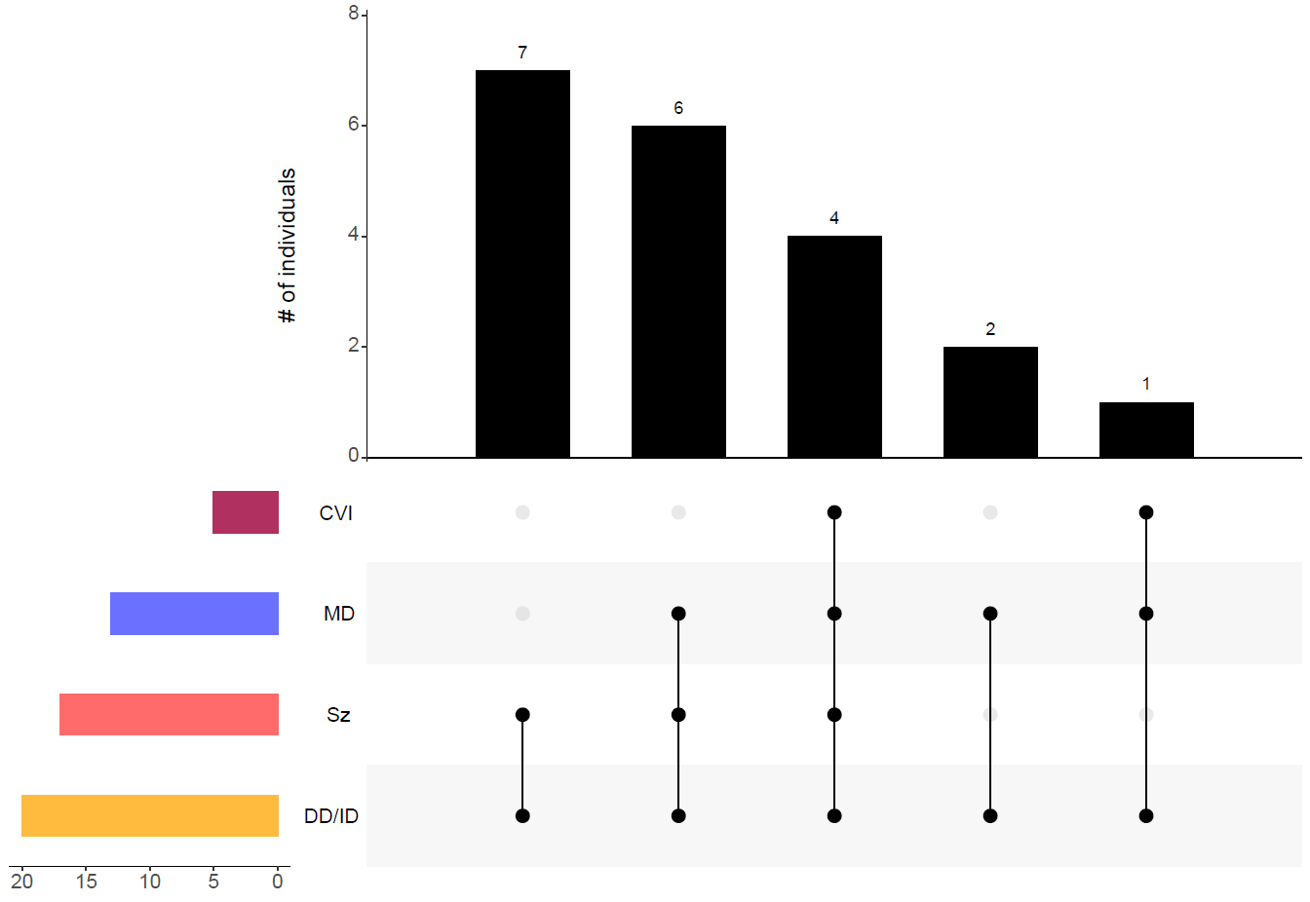
Figure S2. Phenotypic overlap of the “SNAREopathies”. STX1B is listed twice for its different phenotypic presentations.¹⁸
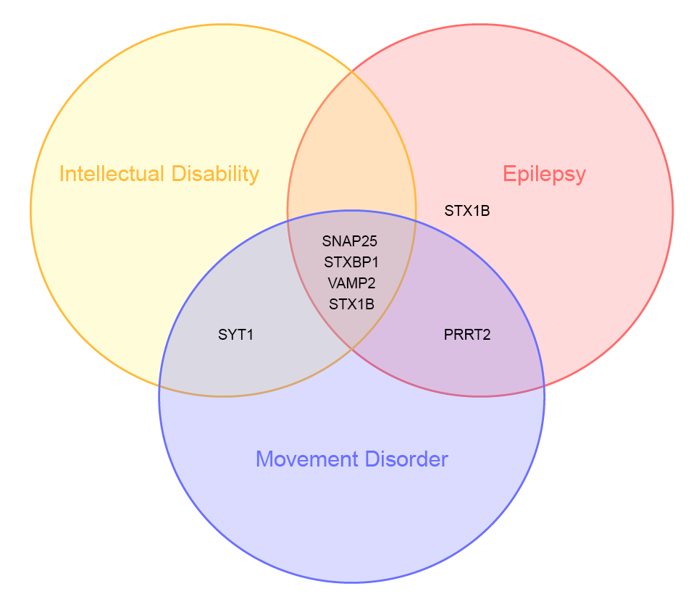
References
1. Heyne HO, Singh T, Stamberger H, et al. De novo variants in neurodevelopmental disorders with epilepsy. Nat Genet. 2018;50(7):1048-1053. doi:10.1038/s41588-018-0143-7
2. Rohena L, Neidich J, Truitt Cho M, et al. Mutation in SNAP25 as a novel genetic cause of epilepsy and intellectual disability. Rare Dis. 2013;1:e26314. doi:10.4161/rdis.26314
3. Liang J-S, Wang J-S, Lin L-J, Yang M-T, Hung K-L, Lu J-F. Genetic Diagnosis in Children with Epilepsy and Developmental Delay/Mental Retardation Using Targeted Gene Panel Analysis. Neuropsychiatry. 2018;08(05). doi:10.4172/Neuropsychiatry.1000494
4. Shen X-M, Selcen D, Brengman J, Engel AG. Mutant SNAP25B causes myasthenia, cortical hyperexcitability, ataxia, and intellectual disability. Neurology. 2014;83(24):2247-2255. doi:10.1212/WNL.0000000000001079
5. Hamdan FF, Myers CT, Cossette P, et al. High Rate of Recurrent De Novo Mutations in Developmental and Epileptic Encephalopathies. The American Journal of Human Genetics. 2017;101(5):664-685. doi:10.1016/j.ajhg.2017.09.008
6. Fukuda H, Imagawa E, Hamanaka K, et al. A novel missense SNAP25b mutation in two affected siblings from an Israeli family showing seizures and cerebellar ataxia. J Hum Genet. 2018;63(5):673-676. doi:10.1038/s10038-018-0421-3
7. Kircher M, Witten DM, Jain P, O’Roak BJ, Cooper GM, Shendure J. A general framework for estimating the relative pathogenicity of human genetic variants. Nat Genet. 2014;46(3):310-315. doi:10.1038/ng.2892
8. Ioannidis NM, Rothstein JH, Pejaver V, et al. REVEL: An Ensemble Method for Predicting the Pathogenicity of Rare Missense Variants. Am J Hum Genet. 2016;99(4):877-885. doi:10.1016/j.ajhg.2016.08.016
9. Schwarz JM, Rödelsperger C, Schuelke M, Seelow D. MutationTaster evaluates disease-causing potential of sequence alterations. Nat Methods. 2010;7(8):575-576. doi:10.1038/nmeth0810-575
10. Jagadeesh KA, Wenger AM, Berger MJ, et al. M-CAP eliminates a majority of variants of uncertain significance in clinical exomes at high sensitivity. Nat Genet. 2016;48(12):1581-1586. doi:10.1038/ng.3703
11. Adzhubei I, Jordan DM, Sunyaev SR. Predicting functional effect of human missense mutations using PolyPhen-2. Curr Protoc Hum Genet. 2013;Chapter 7:Unit7.20. doi:10.1002/0471142905.hg0720s76
12. Cooper GM, Stone EA, Asimenos G, et al. Distribution and intensity of constraint in mammalian genomic sequence. Genome Res. 2005;15(7):901-913. doi:10.1101/gr.3577405
13. Houdayer C. In silico prediction of splice-affecting nucleotide variants. Methods Mol Biol. 2011;760:269-281. doi:10.1007/978-1-61779-176-5_17
14. Yeo G, Burge CB. Maximum entropy modeling of short sequence motifs with applications to RNA splicing signals. J Comput Biol. 2004;11(2-3):377-394. doi:10.1089/1066527041410418
15. Reese MG, Eeckman FH, Kulp D, Haussler D. Improved splice site detection in Genie. J Comput Biol. 1997;4(3):311-323. doi:10.1089/cmb.1997.4.311
16. Zhang MQ. Statistical features of human exons and their flanking regions. Hum Mol Genet. 1998;7(5):919-932. doi:10.1093/hmg/7.5.919
17. Stamberger H, Nikanorova M, Willemsen MH, et al. STXBP1 encephalopathy: A neurodevelopmental disorder including epilepsy. Neurology. 2016;86(10):954-962. doi:10.1212/WNL.0000000000002457
18. Wolking S, May P, Mei D, et al. Clinical spectrum of STX1B-related epileptic disorders. Neurology. 2019;92(11):e1238-e1249. doi:10.1212/WNL.0000000000007089
19. Salpietro V, Malintan NT, Llano-Rivas I, et al. Mutations in the Neuronal Vesicular SNARE VAMP2 Affect Synaptic Membrane Fusion and Impair Human Neurodevelopment. Am J Hum Genet. 2019;104(4):721-730. doi:10.1016/j.ajhg.2019.02.016
20. Baker K, Gordon SL, Melland H, et al. SYT1-associated neurodevelopmental disorder: a case series. Brain. 2018;141(9):2576-2591. doi:10.1093/brain/awy209
21. Heron SE, Grinton BE, Kivity S, et al. PRRT2 mutations cause benign familial infantile epilepsy and infantile convulsions with choreoathetosis syndrome. Am J Hum Genet. 2012;90(1):152-160. doi:10.1016/j.ajhg.2011.12.003
22. Lex A, Gehlenborg N, Strobelt H, Vuillemot R, Pfister H. UpSet: Visualization of Intersecting Sets. IEEE Trans Vis Comput Graph. 2014;20(12):1983-1992. doi:10.1109/TVCG.2014.2346248

