Supplementary Information

Fast and easy disinfection of coronavirus-contaminated face masks using ozone gas produced by a dielectric barrier discharge plasma generator

Jinyeop Lee¹⁺, Cheolwoo Bong¹⁺, Pan K. Bae², Abdurhaman T. Abafogi¹, Seung H. Baek¹, Yong-Beom Shin^{2,3,4}, Moon S. Bak^{1,5,*}, and Sungsu Park^{1,5,6,*}

¹School of Mechanical Engineering, Sungkyunkwan University, Suwon 16419, Korea
²BioNano Health Guard Research Center (H-GUARD), Daejeon 34141, Korea
³Bionanotechnology Research Center, Korea Research Institute of Bioscience and Biotechnology (KRIBB),
Daejeon 34141, Korea
⁴Department of bioengineering, KRIBB School, University of science and Technology (UST), Daejeon 34141,
Korea
⁵Biomedical Institute for Convergence at SKKU (BICS), Sungkyunkwan University, Suwon 16419, Korea
⁶Institute of Quantum Biophysics (iQB), Sungkyunkwan University, Suwon 16419, Korea

⁺ Each contributed equally to the work.
*Correspondence and requests for materials should be addressed to M. S. Bak (moonsoo@skku.edu)/S. Park (nanopark@skku.edu).

Table S1. H1N1 titer recovered from contaminated face masks with and without exposure to ozone gas.
Treatment of face masksª contaminated with H1N1^{b} | Recovered virus^{c}  (log TCID₅₀^{c} ± S.D.)
None | 5.7 ± 0.6 (n=3)
Ozone gas (120 ppm^{d}, 5 min) | 0.3 ± 2.2 (n=3)
ª Samples (30 mm × 35 mm in size) were cut from face masks (Kleenguard®; product number Y2-44015, Kimberly-Clark Worldwide, Inc., Irving, TX, USA) with 3-layers filtering. The front side was sprayed with about 250 μL of a H1N1 strain (A/California/04/2009) culture (about 6.7 log TCID₅₀ per mL) and dried at room temperature for 15 min in a biosafety cabinet before exposed to ozone gas.
^{b} The H1N1 culture was provided by the Korea Research Institute of Bioscience and Biotechnology (KRIBB; Daejeon, Korea). It was titrated in Madin–Darby canine kidney (MDCK) cells to determine the 50% tissue culture infective dose (TCID50) by the Reed and Muench method.¹ MDCK cells were maintained in Dulbecco’s modified Eagle medium (DMEM; Therem Fischer Scientific, Waltham, MA, USA) containing 5% fetal bovine serum (FBS) (Sigma-Aldrich, St. Louis, MO. USA).
^{c} Virus particles on the samples were collected by washing the sample surface with 5 mL of PBS (phosphate buffered saline, pH 7.4) and measured using Madin–Darby canine kidney (MDCK) cells.
^{d} The ozone concentrations produced by the DBD plasma generator were measured via UV absorption spectroscopy.²
n: sample number.

Table S2. Viability of Gram-positive bacteria Staphylococcus aureus obtained from contaminated face masks with and without exposure to ozone gas.
Treatment of face masksª contaminated with H1N1ª | Viability^{c} (log CFU ± S.D.)
None | 5.2 ± 0.4 (n=6)
Ozone gas (120 ppm, 5 min) | 0 (n=6)
ªSamples (30 mm × 35 mm in size) were cut from face masks (Kleenguard®). The front side was sprayed with about 250 μL of S. aureus culture (about 8.4 log CFU per mL) and dried at room temperature for 15 min in a biosafety cabinet before exposed to ozone gas.
^{b}S. aureus (ATCC 29213) was cultured in Mueller Hinton Broth (MHB) at 37 °C and 200 rpm for 18 h until OD₆₀₀ reached 1. The bacterial number of each culture was enumerated using the standard colony counting method³ and bacterial cells at about 8.4 log colony forming unit (CFU)/mL were also prepared using phosphate-buffered saline (PBS, pH 7.4).
^{c}Bacterial cells on the samples were collected by washing the sample surface with 5 mL of PBS (pH 7.4) and measured using the standard colony counting method.

Table S3. Quantitative reverse transcription polymerase chain reaction (qRT-PCR) in washing solutions obtained from the contaminated face masks with/without the ozone gas exposure.
Treatment of face masksª contaminated  with H1N1 influenza A virus | Ct^{b} value^{c} (mean ± S.D.)
None | 28.2 ± 0.5 (n=6)
Ozone gas (120 ppm, 5 min) | 27.6±1 (n=6)
ª Samples (30 mm × 35 mm in size) were cut from face masks (Kleenguard). The front side was sprayed with about 250 μL of a H1N1 strain (A/California/04/2009) culture (about 6.7 log TCID₅₀ per mL) and dried at room temperature for 15 min in a biosafety cabinet before exposed to ozone gas.
^{b} cycle threshold (Ct) is defined as the number of cycles required for the fluorescent signal to exceed the background signal level (threshold). n: sample number.
^{c} After the treatment, the virus particles on the cuts were collected by washing the cuts with 5 mL of PBS. qRT-PCR was performed using StepOneTM Real-Time PCR system (Applied biosystems, CA, USA) and MG 2X One Step RT-PCR SYBR® Green Master Mix reagents (Cancer Rop Co Ltd., Seoul, Korea). The HA gene was amplified for the H1N1 using a forward primer (GAGCTCAGTGTCATCATTTGAA) and reverse primer (TGCTGAGCTTTGGGTATGAA) with an amplicon size of 173 bp (Bioneer, Daejeon, Korea).^{4,5} The fluorescence intensity was measured within a range of 60°C to 95°C at a 0.2°C/sec. The thermocycler conditions were: reverse transcriptase at 50°C for 30 min and initial denaturation at 95°C for 5 min followed by 45 cycles of denaturation at 95°C for 15 s, annealing at 52°C for 30 s and extension at 72°C for 30 s. To confirm that the target amplicon was properly formed, melting curve analysis was performed.

Table S4. qPCR of S. aureus in washing solutions obtained from the contaminated face masks with/without the ozone gas exposure.
Treatment of face masksª contaminated with S. aureus | Ct value^{b} (mean ± S.D.)
None | 28.9±0.4 (n=6)
Ozone gas (120 ppm, 5 min) | 32.6±1.6 (n=6)

ª Samples (30 mm × 35 mm in size) were cut from face masks (Kleenguard®). Their front side was sprayed with about 250 μL of S. aureus culture (about 8.4 log CFU per mL) and dried at room temperature for 15 min in a biosafety cabinet before exposed to ozone gas.
^{b}Quantitative PCR (qPCR) was performed using StepOneTM Real-Time PCR system and iQTM SYBR® Green supermix (Bio-RAD, CA, USA). The primers used to amplify a 207 bp amplicon size based on the nuc gene of S. aureus were (ACACCTGAAACAAAGCATCC) for the forward primer and (TAGCCAAGCCTTGACGAACT) for the reverse primer (Bioneer, Daejeon, Korea).⁶ The thermocycler conditions were initial denaturation at 95°C for 10 min followed by 45 cycles of denaturation at 95°C for 15 s, annealing at 56°C for 30 s and extension at 72°C for 30 s. To confirm that the target amplicon was properly formed, melting curve analysis was performed. The fluorescence intensity was measured within a range of 60°C to 95°C at a 0.2°C/sec.

Figure S1. LB agar images of S. aureus colonies collected from the contaminated masks (Kleenguard®) with and without ozone gas exposure (120 ppm) for 5 min.

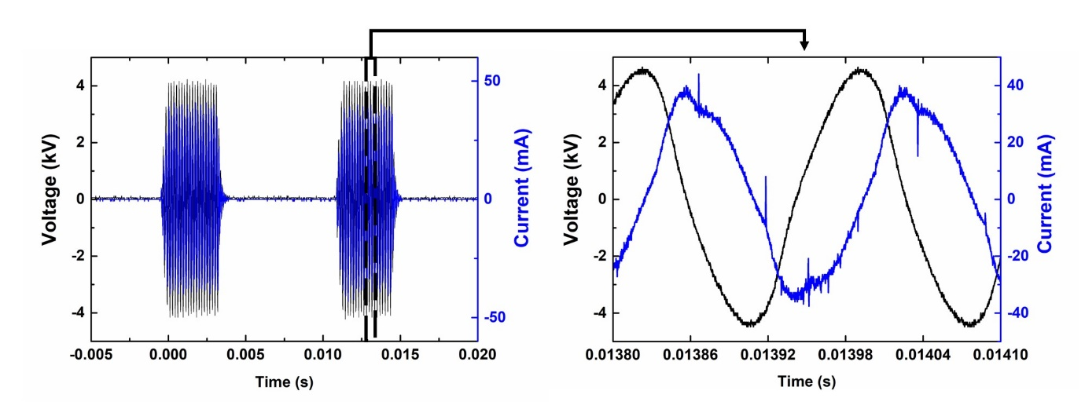
Figure S2. Voltage and current profiles when the plasma is turned on. A dielectric barrier discharge (DBD) plasma generator consists of a DC power supply, a high-voltage, high-frequency generator (GBS Elektronik Minipuls 2.2), and two electrodes that are separated by a 1 mm-thick alumina dielectric barrier. Each of the electrodes were made of perforated stainless-steel plate and aluminum tape, and they were shaped in a circle with diameter of 4.3 cm and a rectangular with 6 by 5 cm. The discharge plasmas were produced at only one side (i.e., the perforated plate) along the rims of the holes at which the strength of the electric field becomes highest. The dielectric barrier allows electrons and ions to be cumulative onto the surface, and these charges compensate for the electric field, preventing the plasma from transitioning from non-thermal to thermal plasma. Thus, in order to produce the plasma steadily, the polarity of the electric field was switched repeatedly. In the experiments, the applied voltage was sinusoidal with Pk-to-Pk voltage of 8.4 kV and the frequency of the alternating voltage was set to be 5.8 kHz. The power was maintained at 10 W by adjusting the duty cycle, the percentage of a period in which the voltage is exerted, to be 38.8% (Figure 3). The measured current is the total current, i.e., the sum of the displacement and conduction currents. The majority of the current is the displacement current, and the conduction current is responsible for the little dents and peaks in the curve. The plasma was turned on for 1 min for every 4 mins to prevent any damage from thermal heating.

References
- Reed LJ and Muench H. A simple method of estimating fifty per cent endpoints. Am J Epidemiol. 1938;27(3):493-497. doi:10.1093/oxfordjournals.aje.a118408.
- Orphal J, Staehelin J, Tamminen J, et al. Absorption cross-sections of ozone in the ultraviolet and visible spectral regions: Status report 2015. J Mol Spectrosc. 2016;327:105-121. doi: 10.1016/j.jms.2016.07.007.
- Park C, Lee J, Kim Y, et al. 3D-printed microfluidic magnetic preconcentrator for the detection of bacterial pathogen using an ATP luminometer and antibody-conjugated magnetic nanoparticles. J Microbiol Methods. 2017;132:128-133. doi: 10.1016/j.mimet.2016.12.001.
- Kim Y, Abafogi, AT, Tran, BM, et al. Integrated Microfluidic Preconcentration and Nucleic Amplification System for Detection of Influenza a Virus H1N1 in Saliva. Micromachines 2020;11(2):E203. doi: 10.3390/mi11020203.
- Fujitsuka A, Tsukagoshi H, Arakawa, M, et al. A molecular epidemiological study of respiratory viruses detected in Japanese children with acute wheezing illness. BMC Infect Dis. 2011;11:168. doi: 10.1186/1471-2334-11-168.
- Kim Y, Lee J and Park S. 3D-printed millifluidic platform enabling bacterial preconcentration and DNA purification for molecular detection of pathogens in blood. Micromachines 2018;9:472. doi:10.3390/mi9090472.

