Supplementary Figure 1

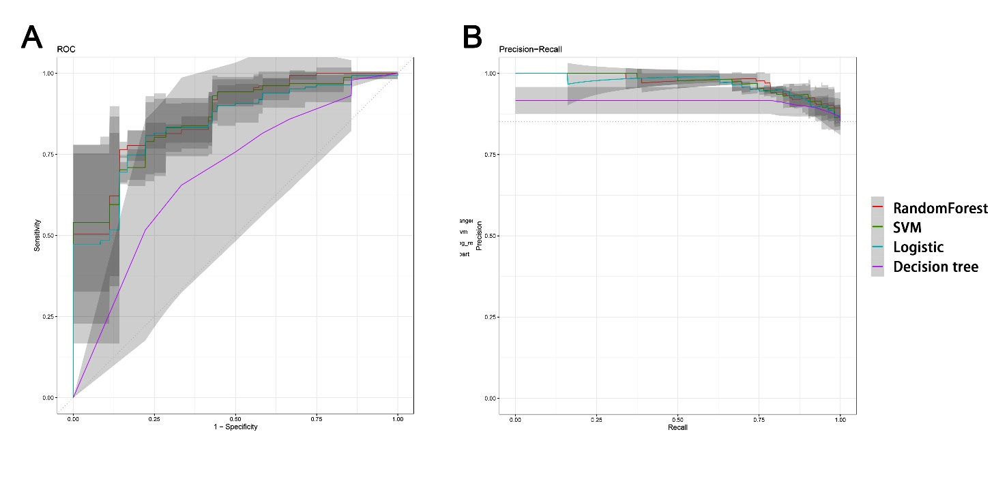
Prediction models were built using logistic regression, decision tree, random forest (RF) and support vector machine (SVM). The left panel and right panel represents the ROC curve and precision-recall curve respectively, plotted based on those models.

