 | Total(N=325) | IVIG(N=174) | Non-IVIG(N=151) | P value
WBC, (1×109/L) | 6.5(4.6-9.7) | 6.7(4.6-10.2) | 6.0(4.6-7.9) | 0.235
NEU,(1×109/L) | 4.4(2.7-7.8) | 4.9(3.1-8.1) | 3.7(2.6-6.1) | 0.036
LYM,(1×109/L) | 1.1(0.6-1.6) | 0.9(0.6-1.4) | 1.2(0.8-1.8) | <0.001
IL-6,(pg/ml) | 9.6(3.8-42.1) | 9.8(4.0-36.2) | 7.7(3.4-92.5) | 0.545
PCT,(ng/ml) | 0.1(0-0.3) | 0.1(0-0.3) | 0.1(0-0.3) | 0.286
CRP,(mg/L) | 9.2(1.7-52.7) | 11.2(3.5-77.0) | 4.8(1.1-39.9) | 0.011
FIB,(g/L) | 3.3(2.4-4.4) | 3.6(2.8-4.5) | 2.9(2.2-4.0) | 0.021
Lac, (mmol/L) | 2.1(1.5-2.9) | 2.0(0-4.0) | 2.2(1.4-3.5) | 0.535
Pa0₂/FiO₂ | 300.0(138.3-401.0) | 246.6(122.8-374.6) | 330.3(184.1-436.0) | 0.053
WBC: White blood cell count; NEU: Neutrophil ; LYM :Lymphocyte count ; IL-6: Interleutin-6；PCT: Procalcitonin; CRP: C-reactive protein; FIB:Fibrinogen; Lac :lactic acid
Supplementary Table 1: Clinical parameters after the treatment with IVIG and Non-IVIG

 | Critical type |  | P value | Severe type |  | P value
 | IVIG  (N=71) | Non-IVIG  (N=32) |  | IVIG  (N=103) | Non-IVIG  (N=119)
WBC, (1×109/L) | 7.5  (5.5-10.9) | 8.6  (4.5-20.2) | 0.531 | 6.2  (4.2-9.8) | 5.6  (4.7-7.0) | 0.285
NEU,(1×109/L) | 5.7  (3.7-8.9) | 8.0  (3.1-17.9) | 0.501 | 4.5  (2.5-8.0) | 3.4  (2.5-4.8) | 0.051
LYM,(1×109/L) | 0.6  (0.4-1.1) | 0.9  (0.4-1.4) | 0.412 | 1.1  (0.7-1.5) | 1.4  (1.0-1.9) | 0.004
IL-6,(pg/ml) | 61.1(13.2-189.4) | 50.4(29.9-2953.0) | 0.406 | 6.5  (2.2-11.6) | 4.4  (3.1-52.9) | 0.306
PCT,(ng/ml) | 0.2  (0.1-1.6) | 3.4  (0.4-15.4) | 0.001 | 0.1  (0-0.1) | 0.4  (0-0.1) | 0.076
CRP,(mg/L) | 62.8(13.9-137.7) | 75.7(23.5-133.6) | 0.902 | 4.4  (1.0-12.3) | 2.6  (0.6-9.1) | 0.218
FIB,(g/L) | 4.2  (2.6-4.7) | 2.4  (1.7-3.8) | 0.031 | 3.5  (2.8-4.4) | 3.3  (2.3-4.4) | 0.312
Lac, (mmol/L) | 2.1  (1.6-2.6) | 5.3  (2.6-13.0) | <0.001 | 2.0(1.5-2.6) | 1.8  (1.2-2.4) | 0.171
Pa0₂/FiO₂ | 148.0(92.0-282.8) | 128.0(51.7-333.0) | 0.453 | 341.4(224.8-461.2) | 361.2(299.6-456.3) | 0.314
WBC: White blood cell count; NEU: Neutrophil ; LYM :Lymphocyte count ; IL-6: Interleutin-6；PCT: Procalcitonin; CRP: C-reactive protein; FIB:Fibrinogen; Lac :lactic acid
Supplementary Table 2: Effects of IVIG on clinical parameters in subgroups of critical and severe type

Primary outcome N(%) | APACHE>11 |  | P value | APACHE≤11 |  | P value
 | IVIG  (N=24) | Non-IVIG  (N=9) |  | IVIG  (N=146) | Non-IVIG  (N=123)
28-day mortality | 15(63%) | 7(78%) | 0.407 | 6(4%) | 8(7%) | 0.378
60-day mortality | 19(79%) | 8(89%) | 0.519 | 11(8%) | 8(7%) | 0.743
 | Pa02/FiO2>100 |  | P value | Pa02/FiO2≤100 |  | P value
 | IVIG  (N=100) | Non-IVIG  (N=94) |  | IVIG  (N=10) | Non-IVIG  (N=11)
28-day mortality | 12(12%) | 9(10%) | 0.587 | 5(50%) | 5(46%) | 0.835
60-day mortality | 20(20%) | 9(10%) | 0.042 | 6(60%) | 6(55%) | 0.801
 | LYM＞0.8 |  | P value | LYM≤0.8 |  | P value
 | IVIG  (N=89) | Non-IVIG  (N=102) |  | IVIG  (N=79) | Non-IVIG  (N=34)
28-day mortality | 7(8%) | 3(3%) | 0.128 | 15(19%) | 12(35%) | 0.062
60-day mortality | 10(11%) | 3(3%) | 0.023 | 22(28%) | 13(38%) | 0.273
 | SOFA＞6 |  | P value | SOFA≤6 |  | P value
 | IVIG  (N=34) | Non-IVIG  (N=14) |  | IVIG  (N=136) | Non-IVIG  (N=127)
28-day mortality | 18(53%) | 7(50%) | 0.853 | 3(2%) | 8(6%) | 0.098
60-day mortality | 23(68%) | 8(57%) | 0.489 | 7(5%) | 8(6%) | 0.687
Supplementary Table 3: Primary outcome analysis in different subgroups with IVIG treatment or not

Secondary outcome N (%) | APACHE>11 |  | P value | APACHE≤11 |  | P value
 | IVIG  (N=24) | Non-IVIG  (N=9) |  | IVIG  (N=146) | Non-IVIG  (N=123)
In-hospital days | 17.5  (10.0-34.5) | 14.0  (5.5-23.0) | 0.254 | 24.5  (18.0-32.3) | 15.0  (13.0-21.0) | <0.001
Total course of disease ª | 26.5  (15.0-42.0) | 38.0  (27.5-42.0) | 0.102 | 33.0  (24.0-39.0) | 20.0  (16.0-29.0) | <0.001
WBC, (1×109/L) | 8.4  (6.3-15.0) | 7.9  (4.1-20.2) | 0.729 | 6.5  (4.4-9.7) | 5.7  (4.7-7.2) | 0.378
NEU,(1×109/L) | 6.5  (4.6-13.4) | 7.1  (2.7-19.0) | 0.835 | 4.6  (2.8-7.8) | 3.5  (2.5-5.0) | 0.027
LYM,(1×109/L) | 0.6  (0.3-1.5) | 0.8  (0.3-0.9) | 0.501 | 1.0  (0.6-1.4) | 1.4  (1.0-1.9) | <0.001
IL-6,(pg/ml) | 70.1(12.2-354.5) | 392.5(26.3-562.6) | 0.659 | 7.8  (3.2-27.8) | 6.6  (3.1-88.9) | 0.498
PCT,(ng/ml) | 0.5  (0.1-3.1) | 8.4  (3.2-23.8) | 0.018 | 0.1  (0-0.2) | 0  (0-0.2) | 0.017
CRP,(mg/L) | 71.7(10.8-140.8) | 110.0(59.4-209.0) | 0.301 | 10.0  (2.7-47.4) | 3.0  (1.2-15.2) | 0.002
FIB,(g/L) | 3.3  (2.3-4.5) | 2.4  (2.0-3.3) | 0.310 | 3.8  (3.0-4.6) | 2.6  (2.1-3.7) | 0.007
Lac, (mmol/L) | 2.6  (2.4-4.5) | 10.5  (2.7-11.5) | 0.109 | 1.9  (1.5-2.4) | 1.9  (1.2-2.6) | 0.724
Pa02/FiO2 | 95.0(86.0-132.0) | 60.3(42.2-164.9) | 0.039 | 304.5  (193.0-398.3) | 352.1(294.7-454.8) | 0.024
 | Pa02/FiO2>100 |  | P value | Pa02/FiO2≤100 |  | P value
 | IVIG  (N=100) | Non-IVIG  (N=94) |  | IVIG  (N=10) | Non-IVIG  (N=11)
In-hospital days | 27.0  (17.3-33.0) | 16.0  (13.0-22.0) | <0.001 | 21.5  (4.8-38.3) | 20.0  (15.0-31.0) | 0.809
Total course of disease ª | 34.0  (24.0-40.8) | 21.0  (16.0-31.0) | <0.001 | 33.5  (14.0-45.3) | 37.0  (29.0-40.0) | 0.349
WBC, (1×109/L) | 7.0  (4.9-9.8) | 5.7  (4.7-7.2) | 0.047 | 9.9  (7.3-13.3) | 7.8  (4.2-14.3) | 0.515
NEU,(1×109/L) | 5.0  (3.1-8.1) | 3.4  (2.7-4.9) | 0.004 | 6.6  (4.9-9.1) | 7.0  (2.5-13.0) | 0.897
LYM,(1×109/L) | 0.9  (0.55-1.3) | 1.4  (0.9-1.9) | <0.001 | 0.5  (0.3-1.0) | 1.0  (0.4-1.2) | 0.315
IL-6,(pg/ml) | 14.6  (5.2-70.3) | 15.9  (4.0-154.3) | 0.977 | 202.2  (2.9-2212.0) | N/A | N/A
PCT,(ng/ml) | 0.1(0-0.4) | 0.1(0-0.3) | 0.089 | 0.4(0.1-5.2) | 0.7(0-3.6) | 0.788
CRP,(mg/L) | 19.5  (6.0-114.1) | 3.6  (1.3-24.2) | <0.001 | 40.1  (20.8-94.1) | 79.7  (4.3-128.3) | 0.792
FIB,(g/L) | 3.3  (2.5-4.5) | 2.9  (2.1-3.7) | 0.119 | 4.2  (1.9-4.8) | 3.2  (2.2-4.6) | 0.505
Lac, (mmol/L) | 2.0  (1.6-2.6) | 2.1  (1.2-2.8) | 0.708 | 2.3  (1.7-10.7) | 2.7  (2.0-5.3) | 0.635
 | LYM＞0.8 |  | P value | LYM≤0.8 |  | P value
 | IVIG  (N=89) | Non-IVIG  (N=102) |  | IVIG  (N=79) | Non-IVIG  (N=34)
In-hospital days | 22.0  (17.5-33.0) | 15.0  (12.0-20.0) | <0.001 | 26.0  (16.0-33.0) | 17.0  (13.8-23.5) | 0.020
Total course of disease ª | 30.0  (23.0-39.5) | 19.0  (16.0-28.3) | <0.001 | 33.0  (22.0-39.0) | 32.0  (24.0-44.3) | 0.573
WBC, (1×109/L) | 6.7  (5.1-10.6) | 5.8  (4.8-7.1) | 0.014 | 6.7  (4.2-9.8) | 6.7  (4.3-12.9) | 0.606
NEU,(1×109/L) | 4.7  (3.2-8.5) | 3.4  (2.6-4.4) | 0.001 | 4.9  (2.7-8.1) | 4.8  (2.7-11.4) | 0.682
IL-6,(pg/ml) | 9.1  (3.7-32.7) | 4.3  (3.0-29.9) | 0.488 | 10.6  (4.0-50.1) | 561.6(27.9-2538.5) | 0.009
PCT,(ng/ml) | 0.1(0-0.5) | 0(0-0.1) | <0.001 | 0.1(0.1-0.2) | 0.3(0.1-8.4) | 0.018
CRP,(mg/L) | 10.1  (3.4-49.9) | 2.4  (0.55-7.1) | <0.001 | 18.8  (3.1-114.1) | 36.6  (5.2-103.7) | 0.626
FIB,(g/L) | 3.5  (2.9-4.9) | 3.6  (2.6-4.3) | 0.473 | 3.8  (2.6-4.4) | 2.5  (1.9-3.5) | 0.014
Lac, (mmol/L) | 2.2  (1.7-2.6) | 2.1  (1.3-2.5) | 0.221 | 1.9  (1.4-2.9) | 3.1  (1.5-10.8) | 0.120
Pa0₂/FiO₂ | 297.8(123.9-392.0) | 352.9(298.3-448.1) | 0.003 | 231.8(92.6-316.7) | 247.5(57.6-371.0) | 0.819
 | SOFA＞6 |  | P value | SOFA≤6 |  | P value
 | IVIG  (N=27) | Non-IVIG  (N=14) |  | IVIG  (N=136) | Non-IVIG  (N=127)
In-hospital days | 17.5  (10.0-28.3) | 18.5  (6.8-28.0) | 0.856 | 26.0  (18.0-33.0) | 15.0  (13.0-21.0) | <0.001
Total course of disease ª | 25.5(17.5-35.3) | 38.0(27.8-45.3) | 0.012 | 33.0  (24.3-39.8) | 20.0  (16.0-29.0) | <0.001
WBC, (1×109/L) | 7.6  (6.0-13.4) | 7.1  (3.9-15.5) | 0.559 | 6.4  (4.4-9.7) | 5.6  (4.7-7.1) | 0.278
NEU,(1×109/L) | 6.5  (4.5-17.1) | 5.3  (2.3-13.5) | 0.634 | 4.6  (2.7-7.8) | 3.4  (2.6-5.0) | 0.030
LYM,(1×109/L) | 0.6  (0.3-1.2) | 0.7  (0.4-1.5) | 0.634 | 1.0  (0.6-1.4) | 1.4  (1.0-1.9) | <0.001
IL-6,(pg/ml) | 42.5(25.5-225.3) | 204.1(31.2-655.8) | 0.736 | 7.5  (3.1-16.6) | 6.7  (3.1-74.0) | 0.693
PCT,(ng/ml) | 0.2(0.1-1.9) | 2.7(0.1-7.1) | 0.198 | 0.1(0-0.2) | 0(0-0.2) | 0.043
CRP,(mg/L) | 71.7  (10.4-134.3) | 60.1  (7.0-128.3) | 0.619 | 10.0  (2.5-32.7) | 2.8  (0.7-18.2) | 0.005
FIB,(g/L) | 3.6(2.5-4.6) | 2.7(2.2-4.1) | 0.473 | 3.9(2.9-4.5) | 3.2(2.1-3.9) | 0.019
Lac, (mmol/L) | 2.5(1.8-3.2) | 2.7(2.1-10.6) | 0.416 | 2.0(1.5-2.4) | 2.0(1.2-2.6) | 0.701
Pa0₂/FiO₂ | 108.5  (85.8-189.0) | 82.9  (48.7-320.5) | 0.592 | 297.8  (184.5-401.0) | 352.6(299.6-454.8) | 0.003
ª Total course of disease：Time from illness onset to death or discharge, days；WBC: White blood cell count; NEU: Neutrophil ; LYM :Lymphocyte count ; IL-6: Interleutin-6；PCT: Procalcitonin; CRP: C-reactive protein; FIB:Fibrinogen; Lac :lactic acid
Supplementary Table 4: Effects of IVIG treatment on secondary outcome and clinical parameters in different subgroups

 | Total  (N=174) | IVIG>15g/d  (N=74) | IVIG≤15g/d  (N=100) | P value
WBC, (1×109/L) | 6.7(4.6-10.2) | 6.7(5.1-8.8) | 6.6(4.5-11.3) | 0.523
NEU,(1×109/L) | 4.9(3.1-8.1) | 4.6(3.6-7.4) | 5.5(2.7-9.3) | 0.401
LYM,(1×109/L) | 0.9(0.6-1.4) | 0.9(0.6-1.3) | 1.0(0.6-1.4) | 0.641
IL-6,(pg/ml) | 9.8(4.0-36.2) | 15.9(7.5-91.1) | 6.5(2.0-16.9) | <0.001
PCT,(ng/ml) | 0.1(0-0.3) | 0.1(0-0.2) | 0.1(0-0.7) | 0.757
CRP,(mg/L) | 11.2(3.5-77.0) | 23.3(6.2-80.7) | 8.4(1.6-48.2) | 0.007
FIB,(g/L) | 3.6(2.8-4.5) | 3.8(3.1-4.6) | 3.6(2.7-4.5) | 0.695
Lac, (mmol/L) | 2.0(1.6-2.6) | 1.9(1.4-2.4) | 2.4(1.8-3.3) | 0.006
Pa0₂/FiO₂ | 246.6(122.8-374.6) | 316.7(210.0-388.2) | 149.0(90.5-314.3) | 0.002
WBC: White blood cell count; NEU: Neutrophil ; LYM :Lymphocyte count ; IL-6: Interleutin-6；PCT: Procalcitonin; CRP: C-reactive protein; FIB:Fibrinogen; Lac :lactic acid
Supplementary Table 5: Effects of different dose of IVIG treatment on clinical parameters in all patients

 | Critical type |  | P value | Severe type |  | P value
 | IVIG>15g/d  (N=40) | IVIG≤15g/d  (N=31) |  | IVIG>15g/d  (N=34) | IVIG≤15g/d  (N=69)
WBC,(1×109/L) | 7.1(5.5-9.0) | 9.3(5.3-14.6) | 0.066 | 6.4(4.1-9.0) | 6.2(4.2-10.3) | 0.918
NEU,(1×109/L) | 4.7(3.9-7.1) | 8.1(3.7-13.0) | 0.042 | 4.1(3.0-7.8) | 4.8(2.4-8.3) | 0.798
LYM,(1×109/L) | 0.8(0.6-1.2) | 0.5(0.3-1.0) | 0.020 | 1.0(0.4-1.5) | 1.1(0.8-1.6) | 0.413
IL-6,(pg/ml) | 61.1  (11.2-144.2) | 55.6  (19.5-618.3) | 0.438 | 11.9  (6.6-28.7) | 3.8  (1.8-8.6) | 0.002
PCT,(ng/ml) | 0.1(0.1-0.2) | 1.0(0.3-6.7) | <0.001 | 0.1(0-0.2) | 0(0-0.1) | 0.304
CRP,(mg/L) | 50.3  (11.1-130.8) | 79.4  (15.3-141.5) | 0.372 | 12.3  (4.4,24.5) | 2.9  (0.6-9.3) | 0.007
FIB,(g/L) | 2.3(1.6-3.0) | 4.2(2.6-4.7) | 0.794 | 4.0(3.1-4.7) | 3.3(2.8-4.4) | 0.445
Lac, (mmol/L) | 1.8(1.4-2.4) | 2.4(2.1-4.9) | 0.002 | 2.0(1.4-2.4) | 1.9(1.6-2.9) | 0.557
Pa0₂/FiO₂ | 249.1  (199.0-332.2) | 96.0  (86.2-143.0) | <0.0001 | 383.4  (284.0-426.0) | 300.0  (212.5-550.0) | 0.462
WBC: White blood cell count; NEU: Neutrophil ; LYM :Lymphocyte count ; IL-6: Interleutin-6；PCT: Procalcitonin; CRP: C-reactive protein; FIB:Fibrinogen; Lac :lactic acid
Supplementary Table 6: Effects of different dose of IVIG on clinical parameters in different patients

 | Total  (N=174) | IVIG>7D  (N=16) | IVIG≤7D  (N=158) | P value
WBC, (1×109/L) | 6.7(4.6-10.2) | 8.3(5.1-15.1) | 6.6(4.5-9.8) | 0.148
NEU,(1×109/L) | 4.9(3.1-8.1) | 7.3(3.3-14.7) | 4.7(2.8-8.0) | 0.114
LYM,(1×109/L) | 0.9(0.6-1.4) | 1.0(0.4-1.4) | 0.9(0.6-1.4) | 0.596
IL-6,(pg/ml) | 9.8(4.0-36.2) | 13.7(2.2-577.1) | 9.6(4.4-32.9) | 0.722
PCT,(ng/ml) | 0.1(0-0.3) | 1.8(0.1-6.6) | 0.1(0-0.2) | 0.016
CRP,(mg/L) | 11.2(3.5-77.0) | 32.7(0-123.6) | 10.9(3.5-64.9) | 0.450
FIB,(g/L) | 3.6(2.8-4.5) | 2.7(1.7-4.0) | 3.9(3.0-4.7) | 0.014
Lac, (mmol/L) | 2.0(1.6-2.6) | 2.4(1.9-8.4) | 2.0(1.5-2.5) | 0.085
Pa0₂/FiO₂ | 246.6(122.8-374.6) | 91.0(69.6-314.3) | 262.6(141.0-378.9) | 0.022
WBC: White blood cell count; NEU: Neutrophil ; LYM :Lymphocyte count ; IL-6: Interleutin-6；PCT: Procalcitonin; CRP: C-reactive protein; FIB:Fibrinogen; Lac :lactic acid
Supplementary Table 7: Effects of the timing of IVIG treatment on clinical parameters in all patients

Supplementary Figure 1

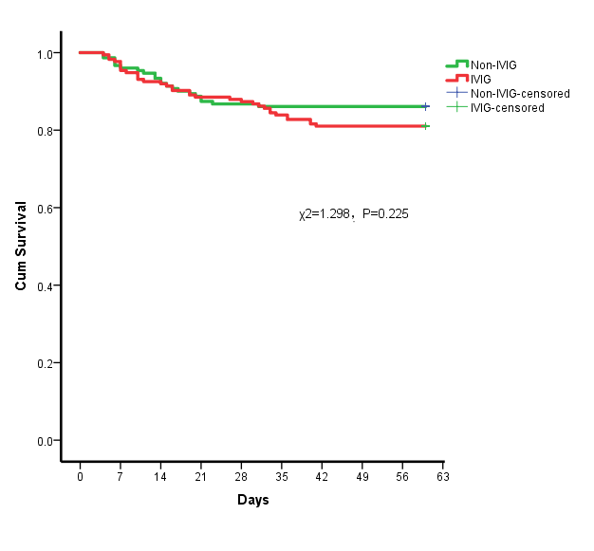
Supplementary Figure1: Effects of IVIG treatment on survival curves of 60-day mortality in all patients

Supplementary Figure 2

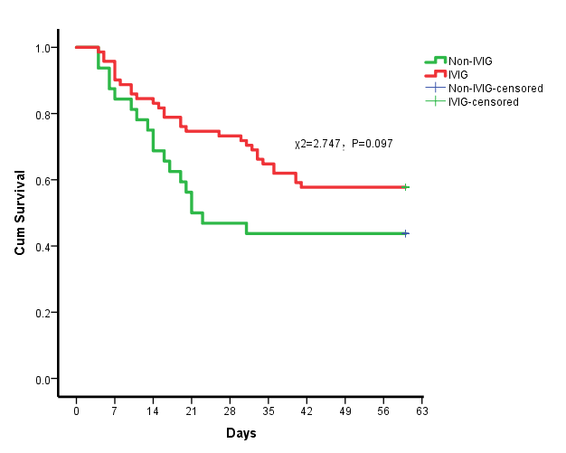

Supplementary Figure 2: Effects of IVIG treatment on Survival curves of 60-day mortality in patients with critical type

Supplementary Figure 3

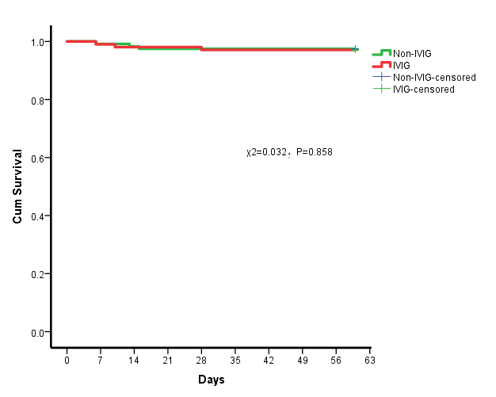

Supplementary Figure 3: Effects of IVIG treatment on Survival curves of 60-day mortality in patients with severe type

Supplementary Figure 4

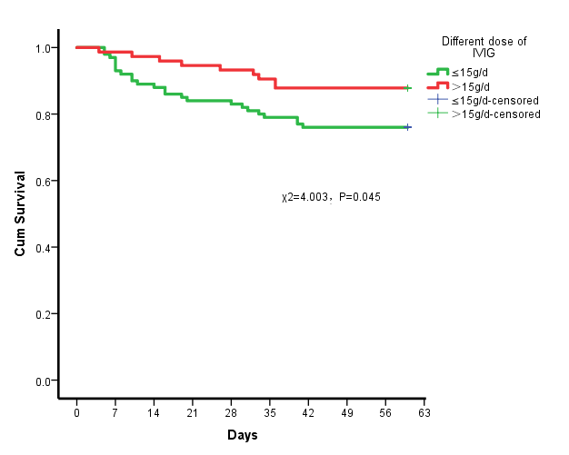

Supplementary Figure 4: effects of different dose of IVIG treatment on survival curves of 60-day mortality rate in all patients

Supplementary Figure 5

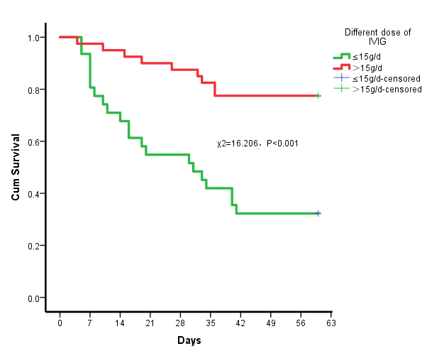
Supplementary Figure 5: effects of different dose of IVIG treatment on survival curves of 60-day mortality rate in patients with critical type

Supplementary Figure 6

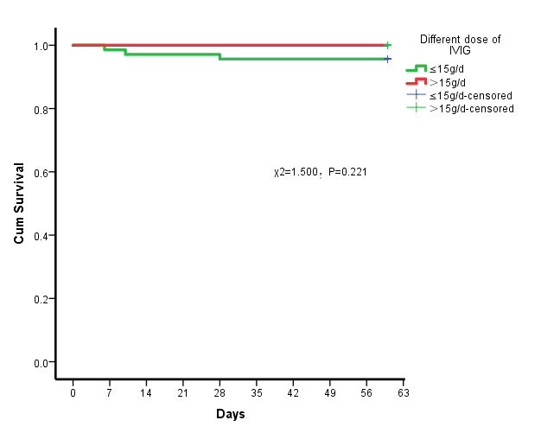

Supplementary Figure 6: effects of different dose of IVIG treatment on survival curves of 60-day mortality rate in patients with severe type

Supplementary Figure 7

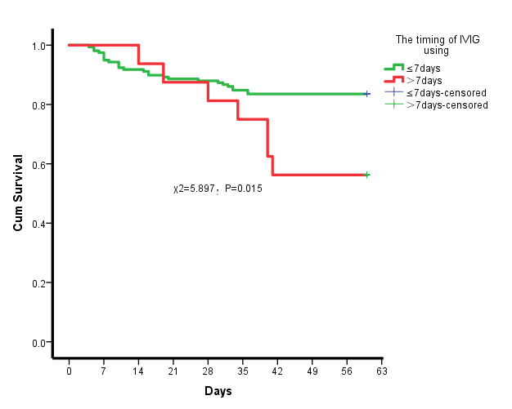

Supplementary Figure 7: effects of timing of IVIG treatment on survival curves of 60-day mortality rate in all patients

