- Supplementary Information-
Proteome-wide analysis of differentially-expressed SARS-CoV-2 antibodies in early COVID-19 infection
Xiaomei Zhang^{1,3}, Xian Wu ^{2,3}, Dan Wang^{1,3},Minya Lu^{2,3}, Xin, Hou ² ,Hongye Wang¹, Te Liang¹, Jiayu Dai¹, Hu Duan¹, Yingchun Xu², Yongzhe Li^{2,4}, Xiaobo Yu^{1,4}
¹ State Key Laboratory of Proteomics, Beijing Proteome Research Center, National Center for Protein Sciences-Beijing (PHOENIX Center), Beijing Institute of Lifeomics, Beijing, 102206, China.
² Department of Clinical Laboratory, Peking Union Medical College Hospital, Chinese Academy of Medical Science & Peking Union Medical College, Beijing 100730, China.
³These authors contributed equally to this work.
⁴Correspondence to yuxiaobo@mail.ncpsb.org, yongzhelipumch@126.com.

Supplementary Tables
Supplementary Table 1. The layout of the SARS-CoV-2 proteome microarray.
Supplementary Table 2. Differentially-expressed antibodies between COVID-19, influenza and non-influenza patients.
Supplementary Table 3. Correlation between COVID-19 specific SARS-CoV-2 antibodies and clinical indices.

Supplementary figures

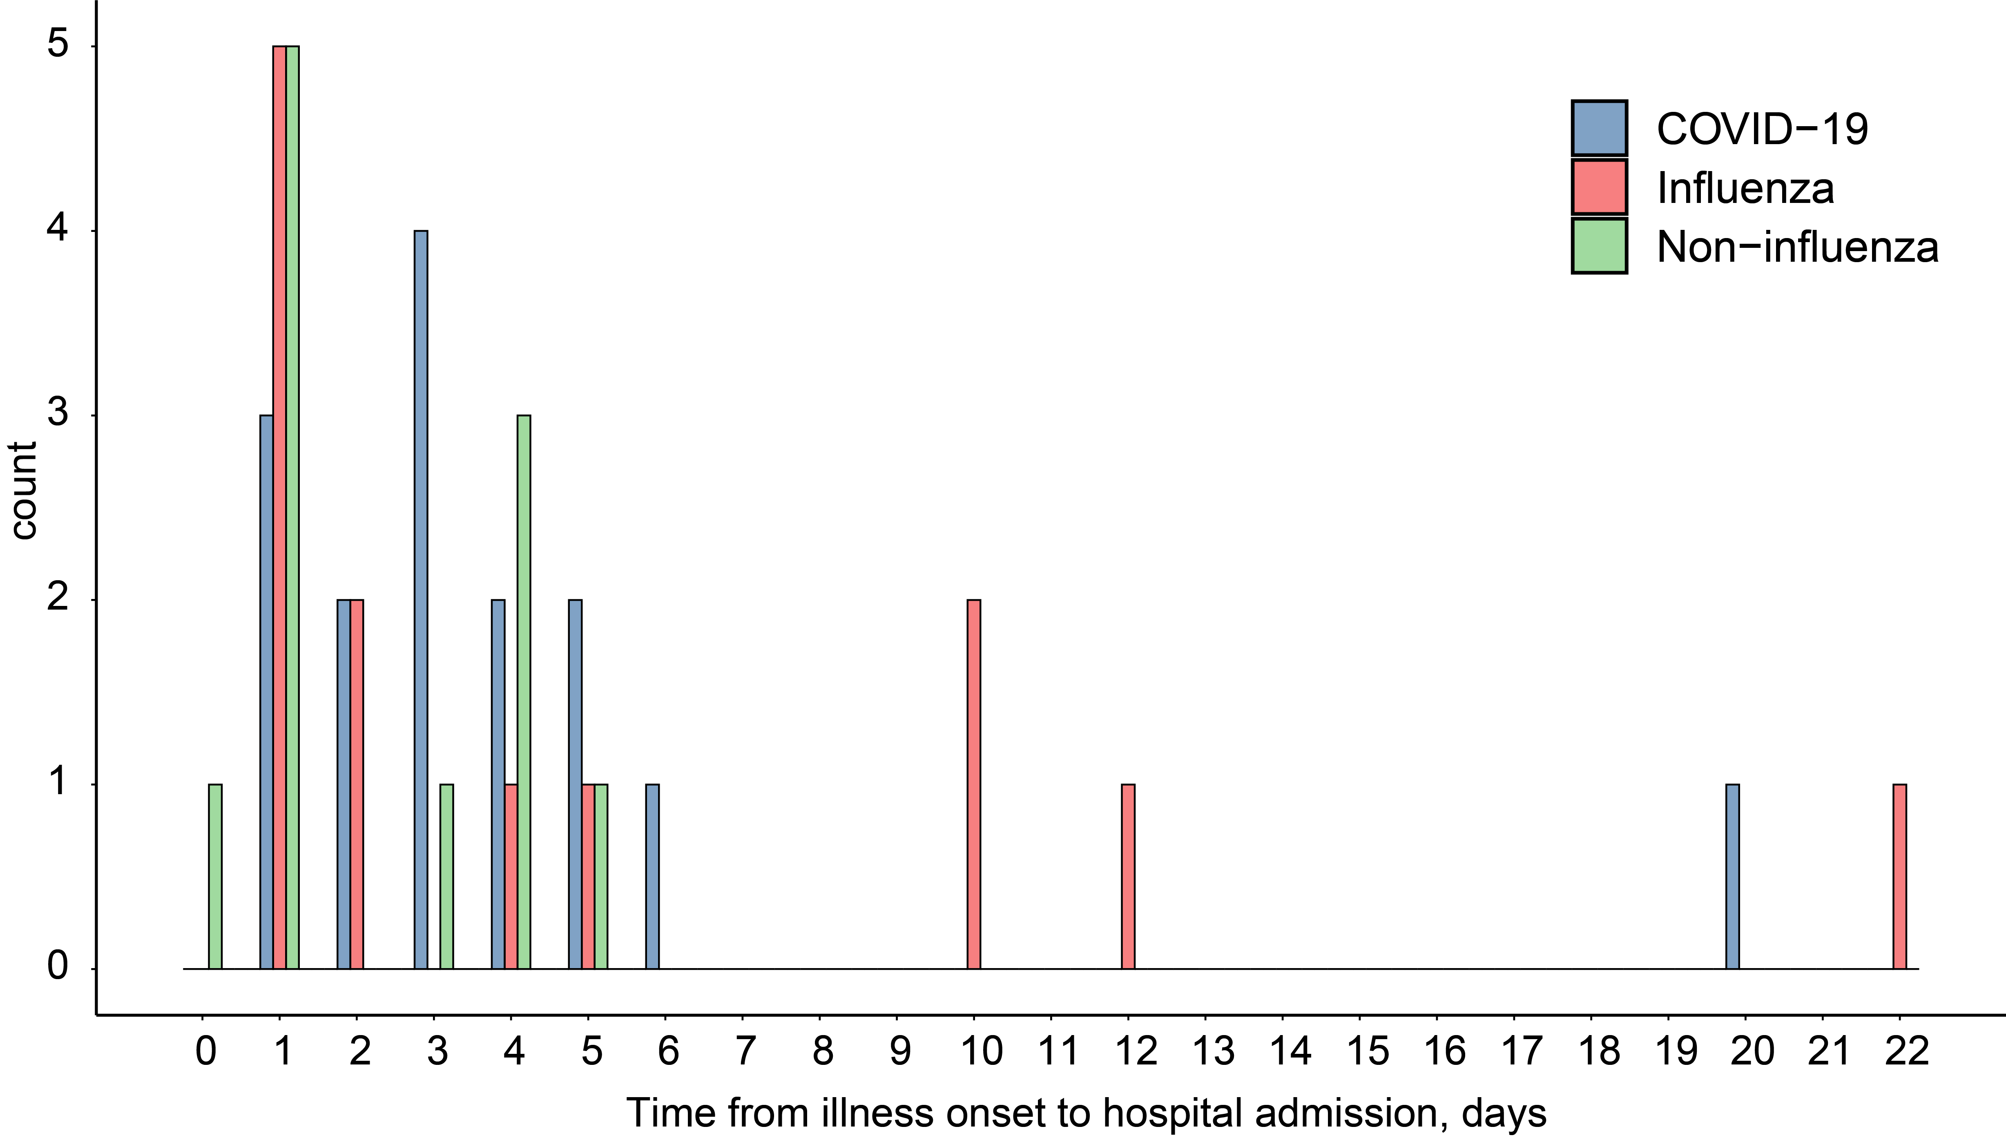

Supplementary Figure 1. Histogram analysis of the time from illness onset to hospital admission in COVID-19, influenza and non-influenza patients.

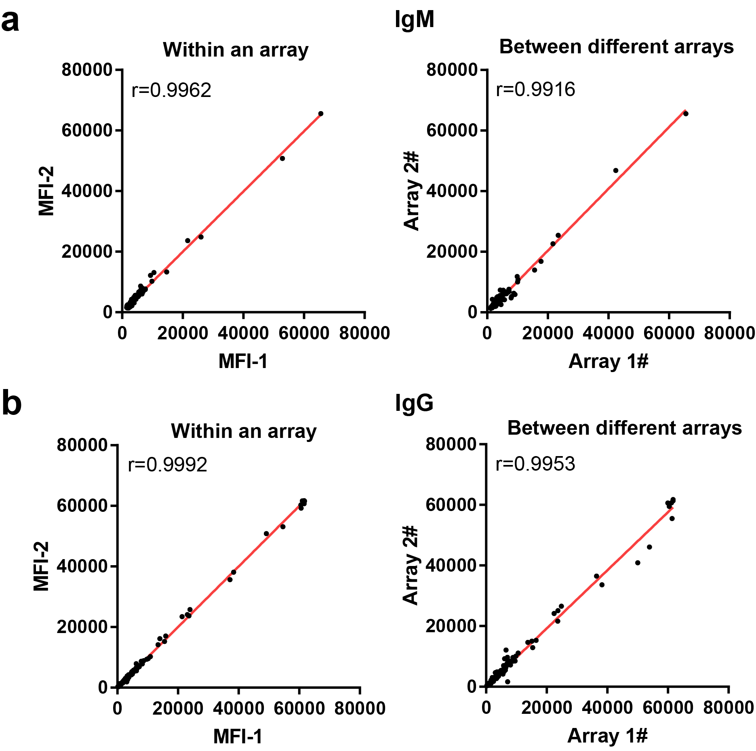
Supplementary Figure 2. Reproducibility of serological antibody detection using the SARS-CoV-2 proteome microarray. (a) and (b) are the correlation of serological IgM and IgG antibody detection within an array and between different arrays, respectively.

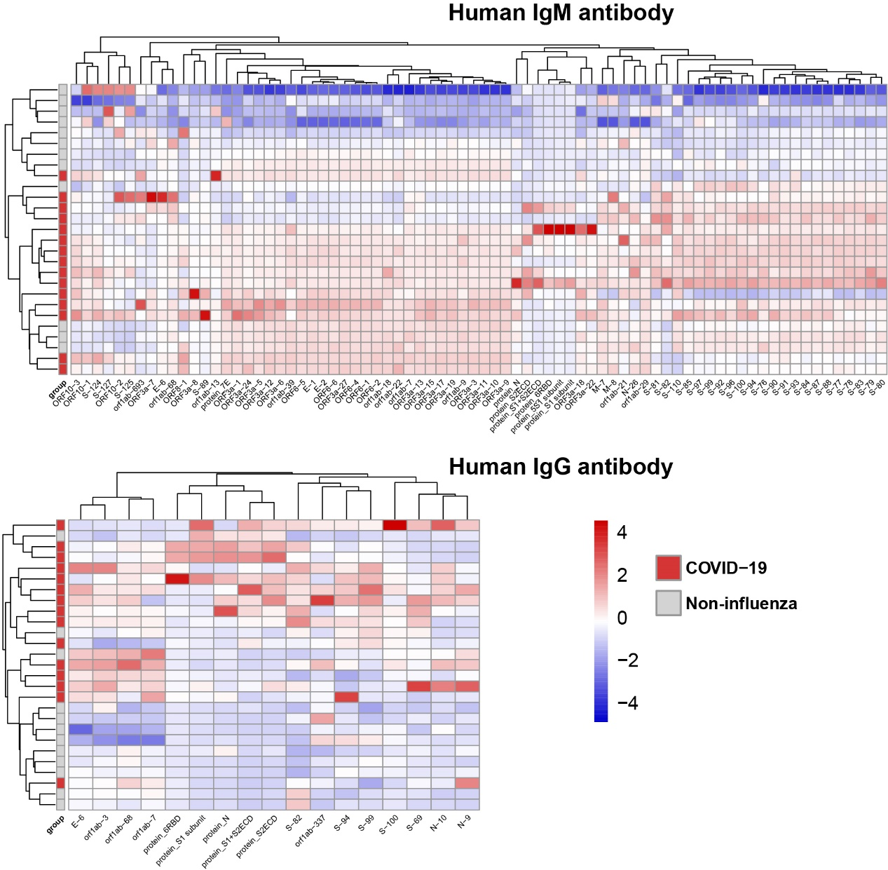
Supplementary Figure 3. Comparison of differential antibody responses to the SARS-CoV-2 proteome between the COVID-19 and non-influenza groups. The false-colored rainbow color from blue to red corresponds to the Z-score from low to high, respectively.

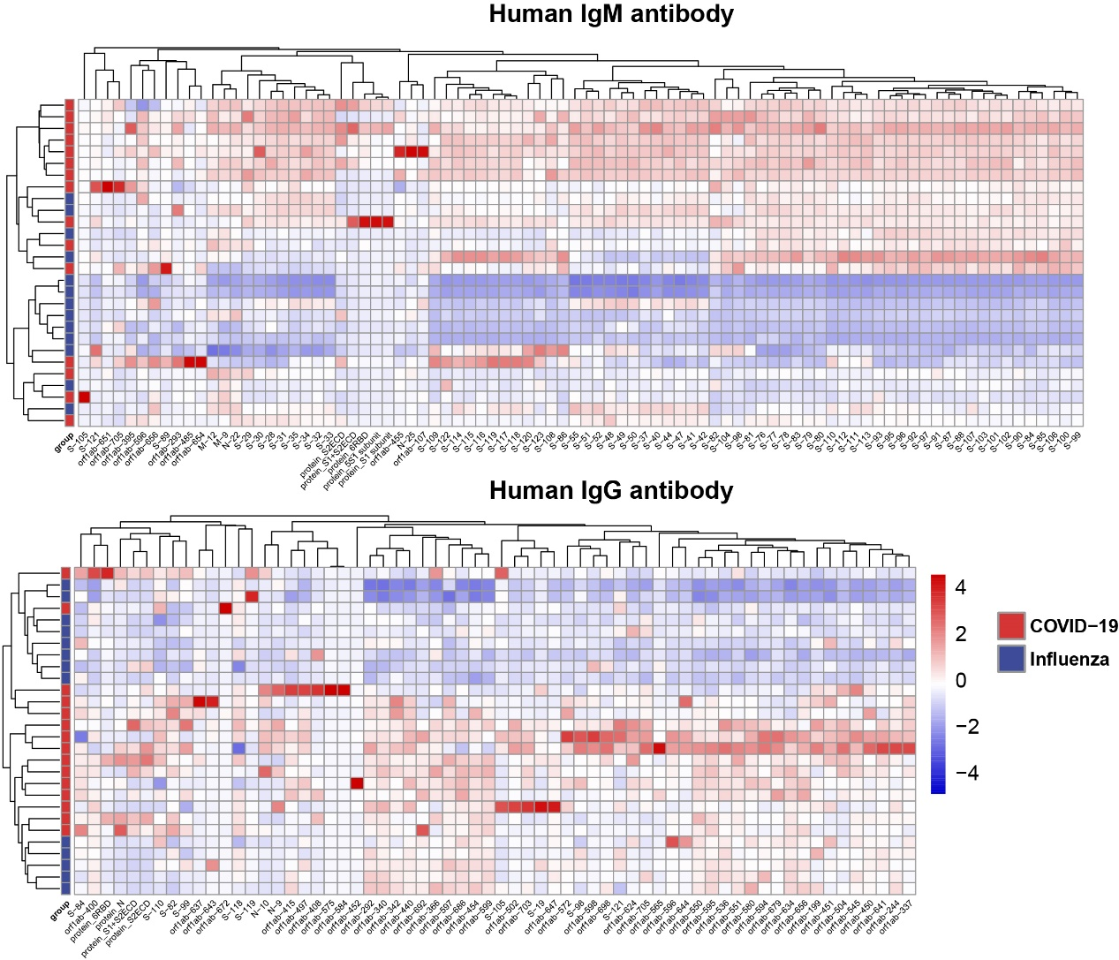
Supplementary Figure 4. Comparison of differential antibody responses to the SARS-CoV-2 proteome between the COVID-19 and influenza groups. The false-colored rainbow color from blue to red corresponds to the Z-score from low to high, respectively.

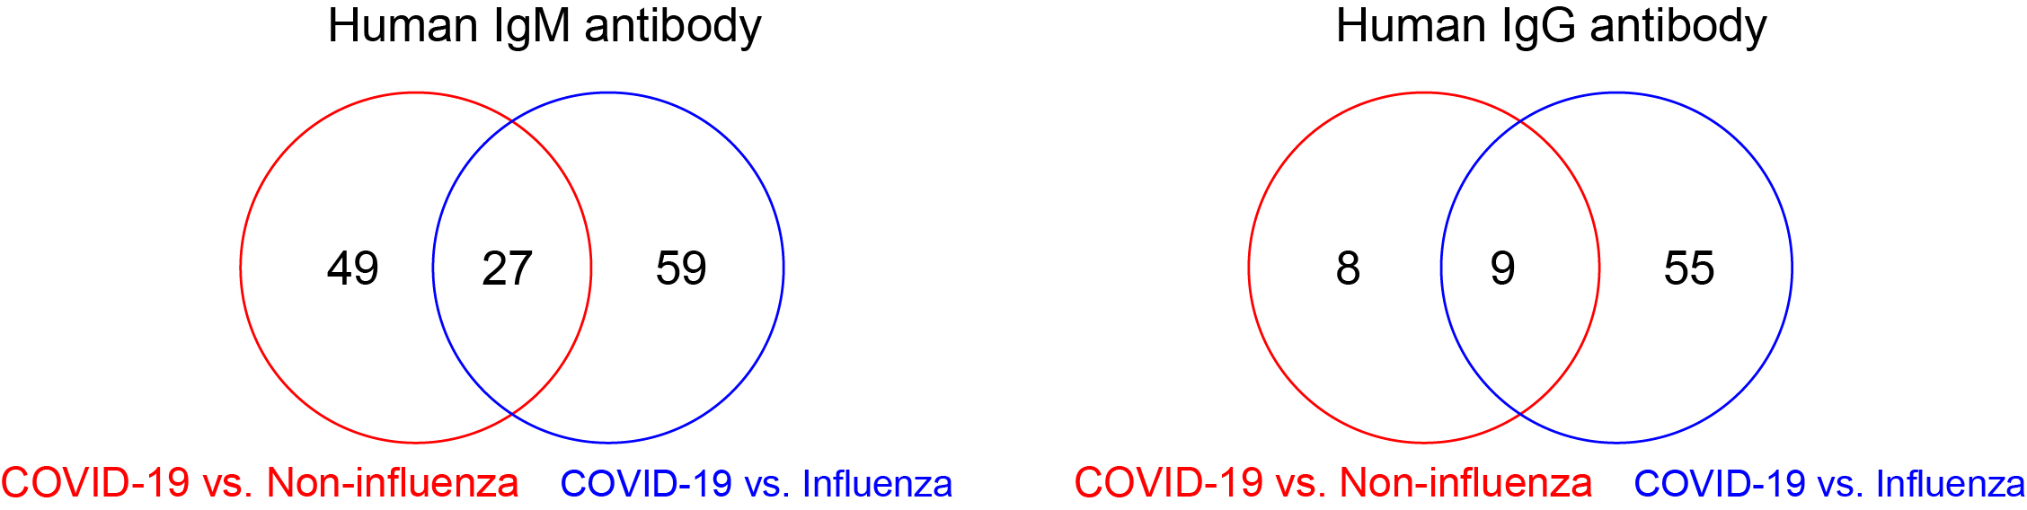
Supplementary Figure 5. Venn diagram analysis of antigens identified in the COVID-19, influenza and non-influenza patient groups.

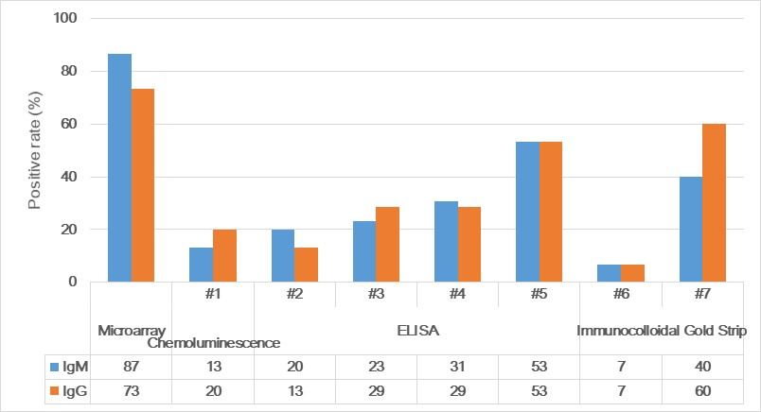
Supplementary Figure 6. Comparison of the positive rate (%) for the detection of early COVID-19 patients using different methods. Positive rate (%) refers to the test accuracy, or the % of the time in which an accurate diagnosis is made. #1-#7 are the serum antibody tests from different manufacturers.

.

