Supplementary Materials for

Real-time detection of COVID-19 epicenters using a geospatial thermometer network and influenza forecasts

S.D. Chamberlain, I. Singh, C. Ariza, A. Daitch, P. Philips, B. D. Dalziel.
Correspondence to: sam@kinsahealth.com

This PDF file includes:

Materials and Methods
Figs. S1 to S3

Materials and Methods
County-level, daily illness incidence (ILI) data is created in three steps, described in detail below: 1) calculate proportion ILI from daily fever counts per region normalized by an active user base estimate, 2) remove county ILI that falls below a minimum user base threshold, and 3) interpolate and smooth missing ILI data with information from adjacent regions. We define daily fever counts as the number of unique users per region that take multiple elevated temperature (37.7 °C) readings over the past week, and then normalize these counts by the estimated number of unique users who have used the thermometer over the past year. County ILI data is removed for regions with an insufficient user base, and we interpolate ILI for counties with missing data using k-nearest neighbors. Quality control and interpolation parameters were settled upon by comparing the resulting ILI signal to Center of Disease Control and Prevention (CDC) ILI at national and CDC region scales and choosing the parameters that minimized mean absolute error. We then re-scale thermometer incidence via a linear calibration of national-scale thermometer ILI to CDC ILI, from August 2016 through August 2019, and apply this single, linear calibration to the county data. The error we observe in our signal is normally distributed about 0 and decreases with regional sensor penetration.

We use a different approach to calculate the anomaly detection confidence boundary for region-specific examples and country-wide county-level maps. For region-specific anomaly detection, we use the ensemble of forecasts approach, as described in the manuscript, to identify ILI levels outside of expected influenza. In contrast, for daily anomaly detections across all United States counties, we run a single influenza forecast per county and define significant anomalies as ILI levels outside the upper bound of the 95% confidence internal of the influenza forecast, where the interval is based on observed ILI noise per region. Here, we use the standard deviation of county residual ILI (SD_{ILI}), calculated as described in the manuscript, to define the error in our confidence bounds. Any daily thermometer ILI that is more than 1.96・SD_{ILI} higher than the expected influenza forecast is flagged as anomalous. Expected influenza forecasts are made for every county on March 1st, 2020, and real-time thermometer ILI is compared to these forecasts, daily. The confidence boundary for this single forecast approach used across all counties is more conservative than the region-specific ensemble approach, where the confidence boundary for anomalous incidence detection maintains a larger spread across the observation period compared to the ensemble method (Fig. S3).

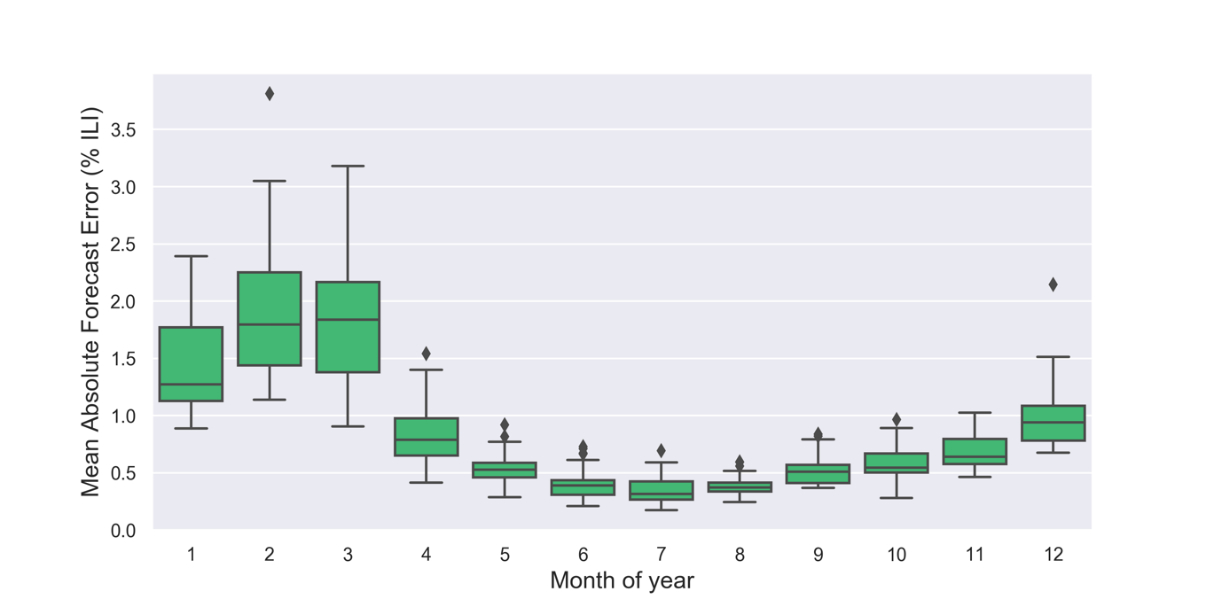

Fig. S1. Mean absolute error by month for the expected influenza forecast. Errors were calculated by hindcasting from August 1st, 2018, to March 25th, 2020 and comparing forecast output to observed thermometer-based incidence.

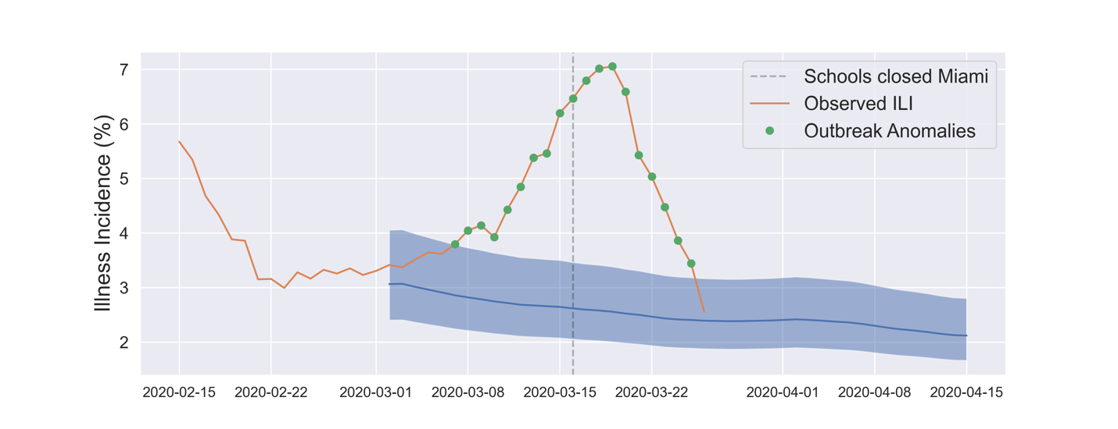

Fig. S2. Anomaly incidence detections in Miami-Dade County, FL, USA where schools closed on March 16th, 2020. The blue line and shaded region represent the median influenza forecast and 2.5-97.5th percentile of ensemble predictions, respectively.

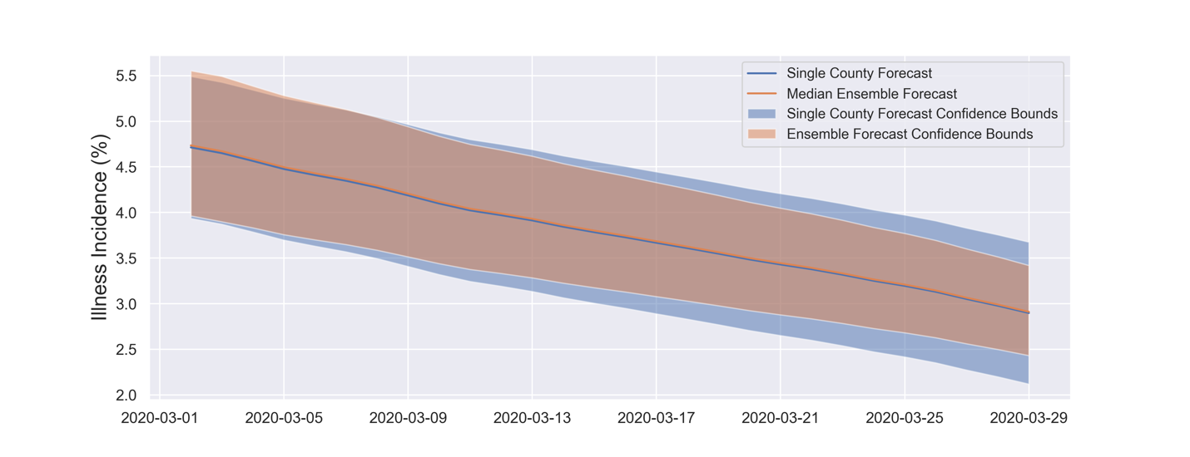

Fig. S3. Median influenza forecast and confidence boundary for Brooklyn, NY using the region-specific ensemble approach (orange line and shaded region) versus the single forecast approach (blue line and shaded region) used to detect anomalies across all US counties. The detection limits used when tracking all US counties are more conservative, as the threshold for anomaly detection stays higher throughout the observation period.

