**On the treatment effect heterogeneity of antidepressants in major depression.**

**A Bayesian meta-analysis**

**Supplementary data**

Studies included in quantitative synthesis

(meta-analysis)  
(n = 169)

Studies included in

qualitative synthesis  
(n = 169)

Studies assessed for eligibility  
(n = 304)

Studies screened  
(n = 522 )

## Eligibility

## Included

## Screening

Studies excluded, no placebo group  
(n = 218)

Studies excluded, outcome of interest not reported  
(n = 135)

**Figure 1:** PRISMA 2009 Flow Diagram.

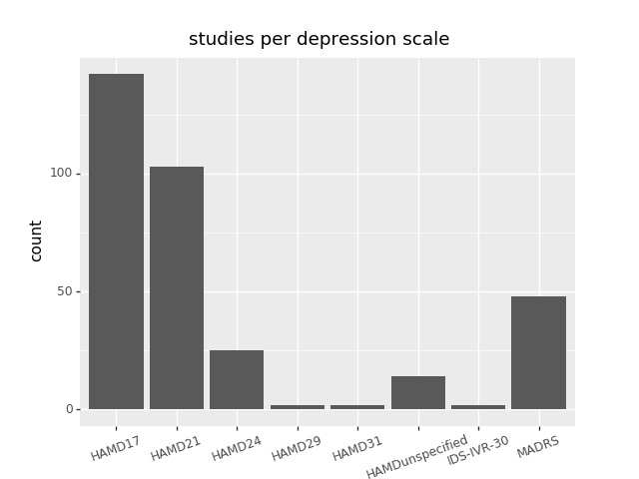

**Figure 2:** Boxplot depicting the number of included studies per respective depression scale.

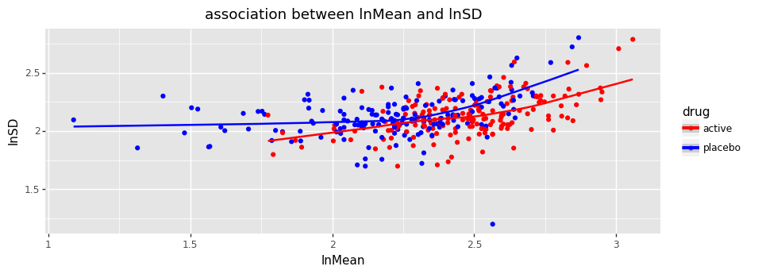

**Figure 3:** Association between the mean and the standard deviation of response in the treatment and the placebo group, depicted on a logarithmic scale.

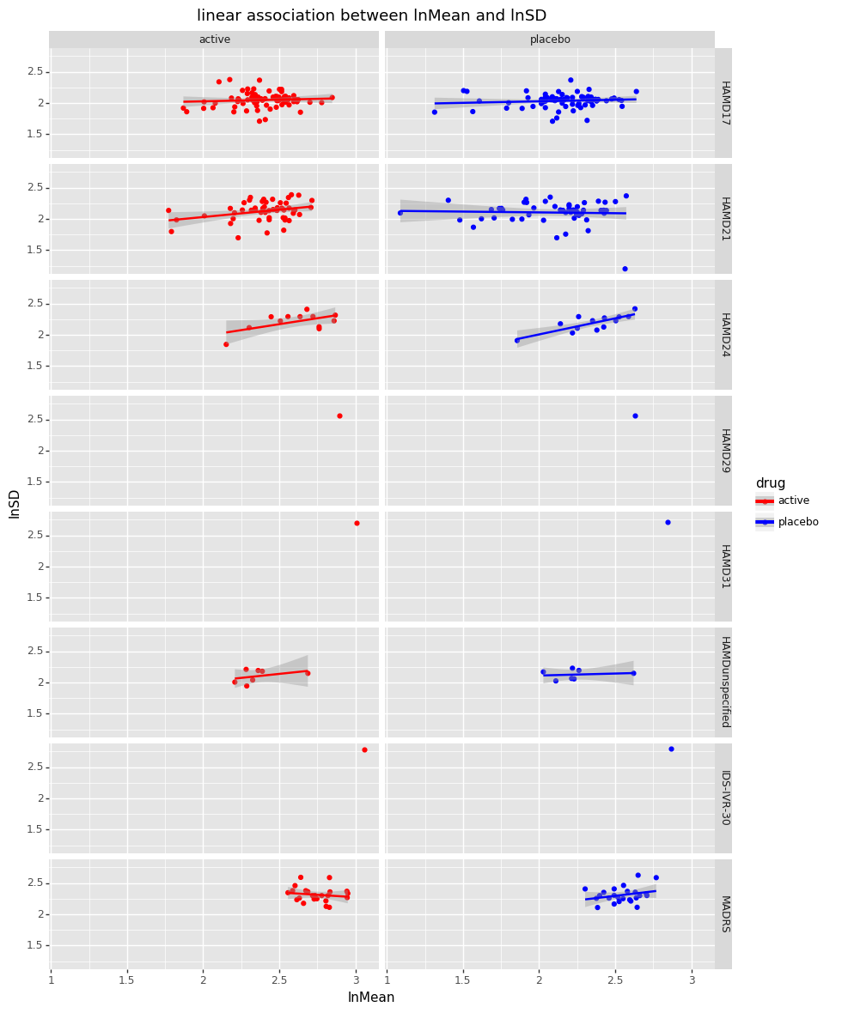

**Figure 4:** Logarithmic association between the mean and the standard deviation of response in the treatment and the placebo group by depression scale. As can be seen from the data, the degree of association varies between depression scales.

**Table 1:** Slope coefficient for simple linear association, not taking into account the existence of different depression scales. x1 = slope coefficient.

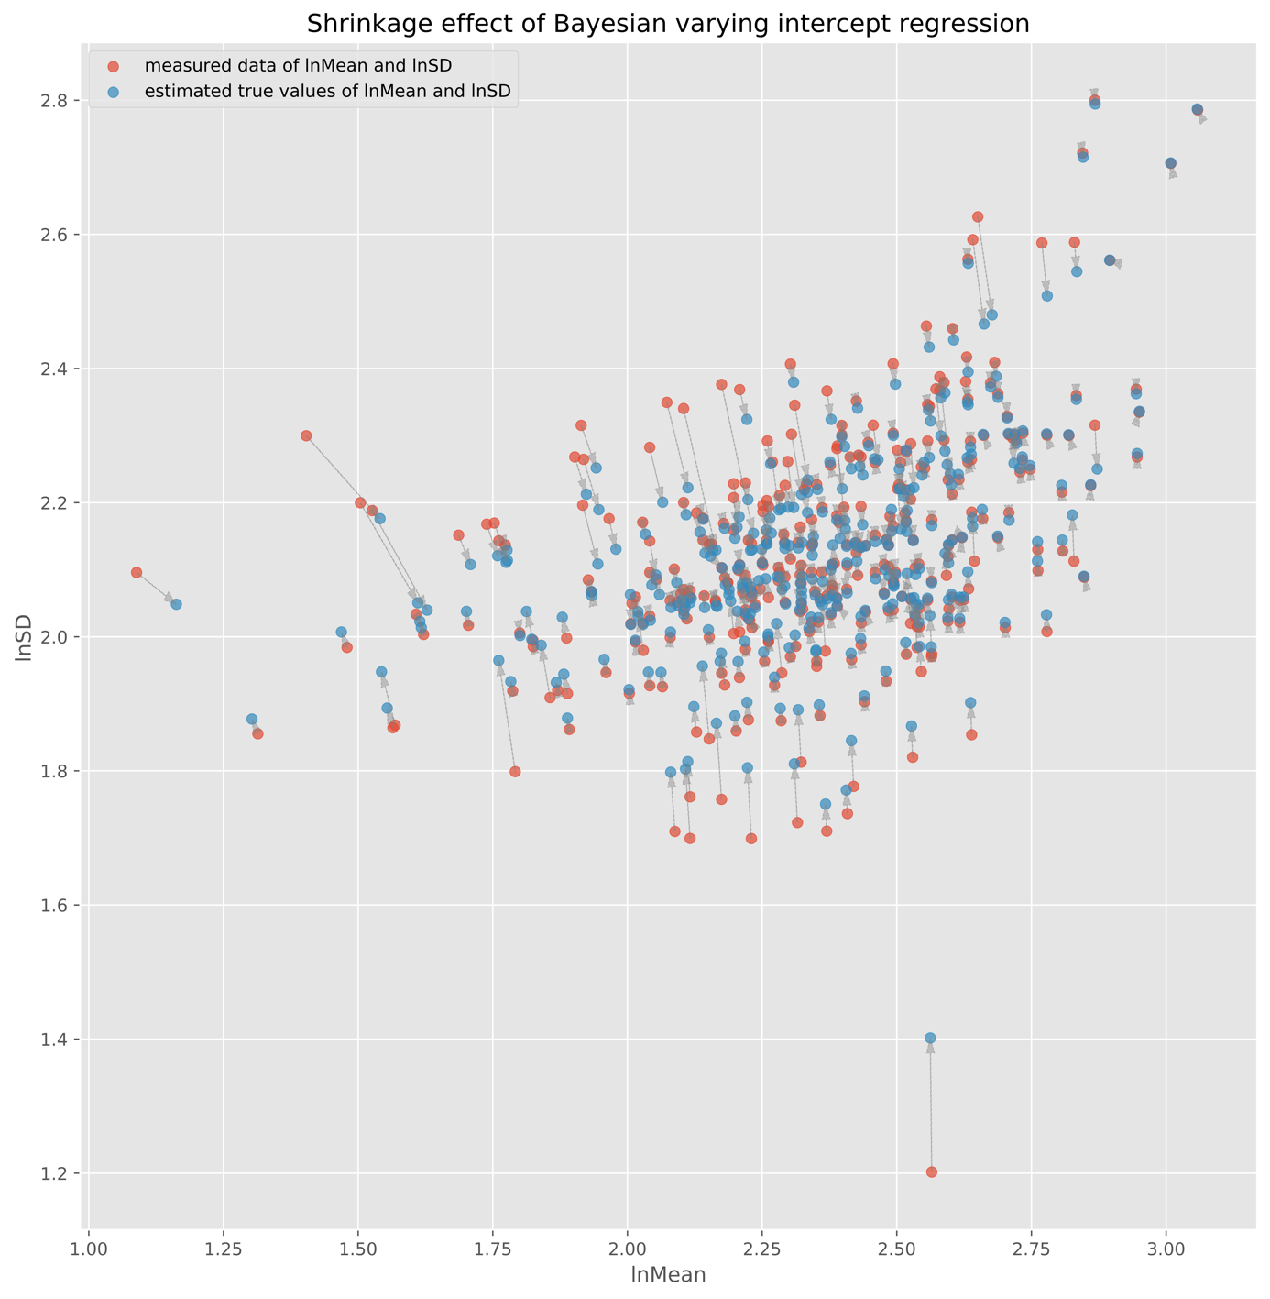

**Figure 5:** Shrinkage effect of Bayesian multi-level meta-regression model. The red dots represent the data points and the blue dots the posterior estimates of their true values.

**Table 2:** Posterior statistics for the mu and beta coefficients of the REMR.

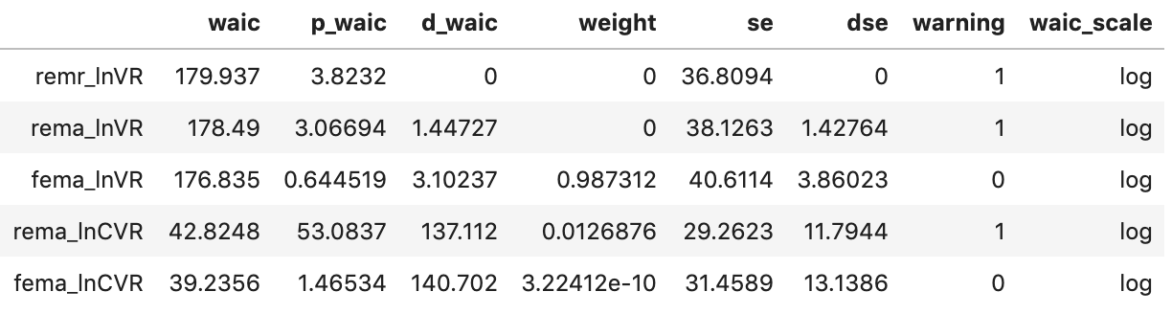

**Table 3:** WAIC statistics for the three different models. REMR: Random-effects meta-regression, REMA: Random-effects meta-analysis. The WAIC score signifies the pointwise prediction accuracy of fitted Bayesian models. Here, higher values of WAIC indicate a better out-of-sample predictive fit (“better” model).



**Figure 6:** Change score of 1000 simulated patients under placebo (blue) and under active treatment (red) for ρ = 0.0, SDTE= 1.5 and VR = 1.02. In this particular simulation, the values were: SDTE = 1.48 and VR = 1.04.

**Figure 7:** Individual treatment effect of 100 simulated patients, ρ = 0.0, SDTE = 1.48 and VR = 1.04. Value at x = 0 depicts response under placebo, value at x = 1 response under active treatment. Slopes represent individual treatment effect, which has low heterogeneity in this simulation. Blue lines indicated improvement under active treatment, red lines deterioration.

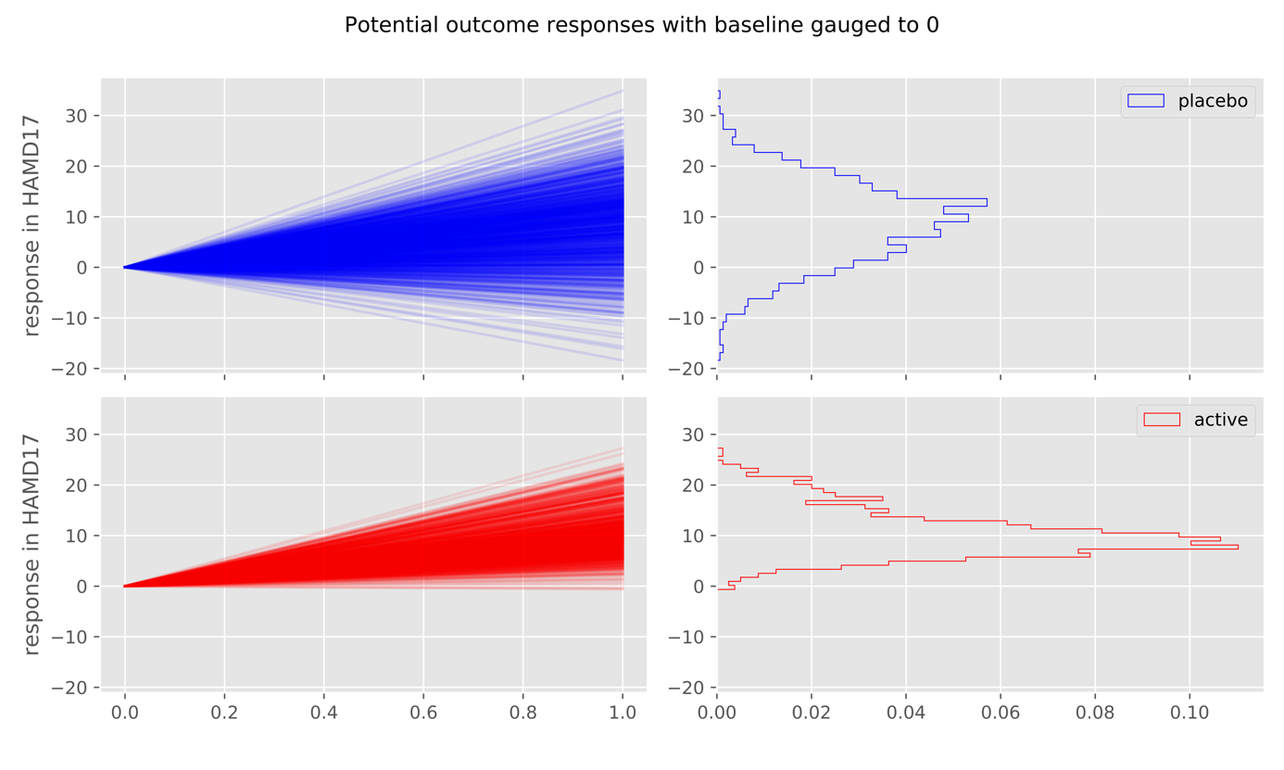

**Figure 8:** Change score of 1000 simulated patients under placebo (blue) and under active treatment (red) for ρ = - 0.8, SDTE = 6.5 (6.4 in this simulation) and VR = 0.6.

**Figure 9:** Individual treatment effect of 100 simulated patients, ρ = - 0.8, SDTE = 6.5 and VR = 0.6. Value at x = 0 depicts response under placebo, value at x = 1 response under active treatment. Slopes represent individual treatment effect, which has high heterogeneity in this simulation. Blue lines indicated improvement under active treatment, red lines deterioration.