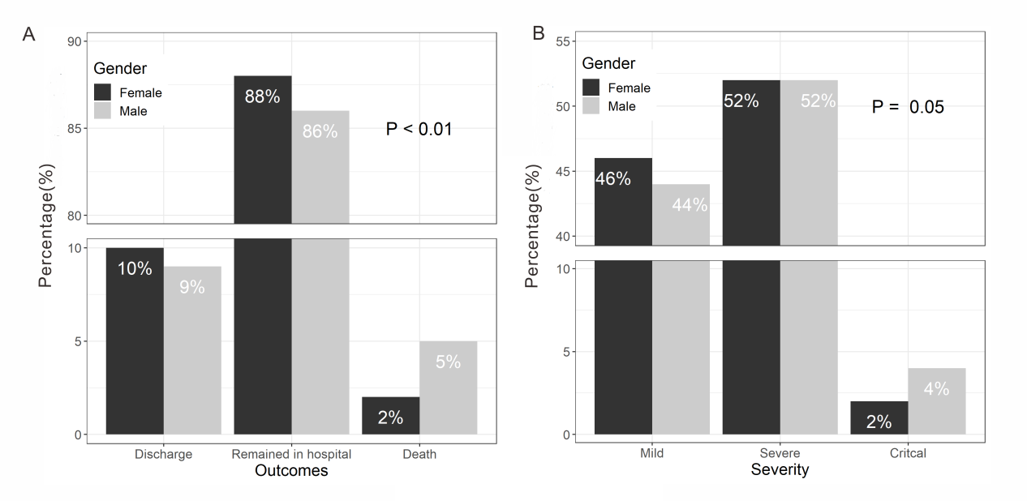

eFigure 1. Clinical Outcomes and Disease Severity of 1902 COVID-19 patients.
A, Outcomes of male and female patients. B, disease severity of male and female patients. Chi square test indicates significant differences in distribution of outcomes(p<0.01) (FigureS1 A) and disease severity (p=0.05) (FigureS1 B) between male and female patients.

