Supplementary materials

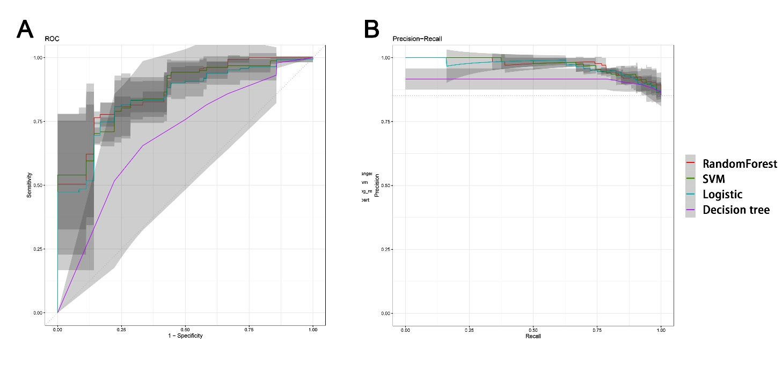

Prediction models were built using logistic regression, decision tree, random forest (RF) and support vector machine (SVM). The left panel and right panel represents the ROC curve and precision-recall curve respectively, plotted based on those models.