Supplemental Appendix

Aerosol and surface stability of SARS-2 (HCoV-19) compared to SARS-CoV
Neeltje van Doremalen^{1*}, Trenton Bushmaker^{1*}, Dylan H. Morris^{2*}, Myndi G. Holbrook¹, Amandine Gamble³, Brandi N. Williamson¹, Natalie J. Thornburg⁴, Susan I. Gerber⁴, James O. Lloyd-Smith^{3,5}, Emmie de Wit¹, Vincent J. Munster¹

- Laboratory of Virology, Division of Intramural Research, National Institute of Allergy and Infectious Diseases, National Institutes of Health, Hamilton, MT, USA
- Dept. of Ecology and Evolutionary Biology, Princeton University, Princeton, NJ, USA
- Dept. of Ecology and Evolutionary Biology, University of California, Los Angeles, Los Angeles, CA, USA
- Division of Viral Diseases, National Center for Immunization and Respiratory Diseases, Centers for Disease Control and Prevention, Atlanta, GA, USA.
- Fogarty International Center, National Institutes of Health, Bethesda, MD, USA

* These authors contributed equally to this article

Supplemental methods

Bayesian regression model description
Here we describe in detail the Bayesian regression model that we used to estimate exponential decay rates and half-lives.

In the model notation that follows, the symbol ~ denotes that a random variable is distributed according to the given distribution. Normal distributions are parametrized as Normal(mean, standard deviation). Positive-constrained normal distributions (“Half-Normal”) are parametrized as Half-Normal(mode, standard deviation). We use <Distribution Name>CDF(x, parameters) to denote the cumulative distribution function of a probability distribution, so for example NormalCDF(5, 0, 1) is the value of the Normal(0, 1) cumulative distribution function at 5.

Our data consist of 10 experimental conditions: 2 viruses (HCoV-19 and SARS-CoV) by 5 environmental conditions (aerosols, polypropylene, stainless steel copper and cardboard). Each has three replicates, and multiple time-points for each replicate. We analyze the two viruses separately. For each, we denote by y_{ijk} the measured log₁₀ titer in experimental condition i during replicate j at time-point k. To construct our likelihood function, we need to know the probability of observing a given log₁₀ titer measurement y_{ijk} given values of the parameters.

Because our titer data are estimated and recorded in increments of 1/n_{wells} log₁₀TCID₅₀/mL, where n_{wells} is the number of wells used for endpoint titration, our log₁₀ titer values are interval-censored – only known to within a range of width 1/n_{wells}. In addition, there is a degree of measurement noise in the titration process itself.

To model this, we assume that in each experimental condition i, there is a true underlying log₁₀ titer x_{ijk} that is measured with some amount of experimental noise or error ε_{ijk} and then observed as an interval-censored value y_{ijk} ≈ x_{ijk} + ε_{ijk}. We model the measurement errors ε_{ijk} as Normally distributed with a standard deviation σ_{i} that is shared by all samples in the given experimental condition; this reflects the fact that some experimental setups may be more or less noisy than others.

ε_{ijk} ~ Normal(0, σ_{i})

We model the probability of observing an interval-censored log₁₀ titer value y_{ijk} given a true underlying log₁₀ titer x_{ijk} and a measurement error standard deviation σ_{i} as:

P(y_{ijk} | x_{ijk}, σ_{i} ) = NormalCDF(y_{ijk}, x_{ijk}, σ_{i}) – NormalCDF(y_{ijk} – 1/n_{wells}, x_{ijk}, σ_{i})

This reflects the probability given a true value x_{ijk} plus the measurement error x_{ijk} + ε_{ijk} falls between y_{ijk} – 1/n_{wells} and y_{ijk}. Due to the log₁₀ titer imputation technique used, a titer in that range is most likely to be rounded up and reported as y_{ijk}.

The detection limit of our experiment is 0.5 log₁₀ TCID₅₀/mL. The probability of observing an undetectable measured log₁₀ titer value y_{ijk} given a true log₁₀ titer value x_{ijk} is given by:

P(y_{ijk} ≤ 0.5 | x_{ijk}, σ_{i}) = NormalCDF(0.5, x_{ijk}, σ_{i})

We then model each replicate j for experimental condition i as starting with some true initial log₁₀ titer x_{ij}(0) = x_{ij0}. We assume that viruses in experimental condition i decay exponentially at a rate λ_{i} over time t. It follows that

x_{ij}(t) = x_{ij0} – λ_{i}t
where t_{k} is the k^{th} measured time-point.

Model prior distributions
We place a weakly informative Normal prior distribution on the initial log₁₀ titers x_{ij0} to rule out implausibly large or small values (e.g. in this case undetectable log₁₀ titers or log₁₀ titers much higher than the deposited concentration), while allowing the data to determine estimates within plausible ranges:

x_{ij0} ~ Normal(4.5, 2.5)

We likewise placed a weakly informative Half-Normal prior on the exponential decay rates λ_{i}:

λ_{i} ~ Half-Normal(0.5, 4)

We placed a weakly informative Half-Normal prior on the standard deviations of the experimental error distributions σ_{i}:
σ_{i} ~ Half-Normal(0, 2)

Markov Chain Monte Carlo Methods
We drew posterior samples using Stan, which implements a No-U-Turn Sampler (a form of Markov Chain Monte Carlo). We ran four replicate chains from random initial conditions for 2000 iterations, with the first 1000 iterations as a warmup/adaptation period. We saved the final 1000 iterations from each chain, giving us a total of 4000 posterior samples. We assessed convergence by inspecting trace plots and examining R̂ and effective sample size (n_{eff}) statistics (R̂ for all parameters ≤ 1.003, n_{eff} for all parameters ≥28% of total samples).

Supplemental Figures

Figures S1–S5 show Bayesian fits to individual replicate virus decay data for each virus. Replicates are shown in panel columns, viruses in panel rows. Lines are 50 random draws per panel from the posterior distribution of fitted lines, to show level of uncertainty. Time axis on same scale across all figures, shown out to the latest time taken to reach an undetectable titer (96 hours, for all replicates of both viruses on plastic).
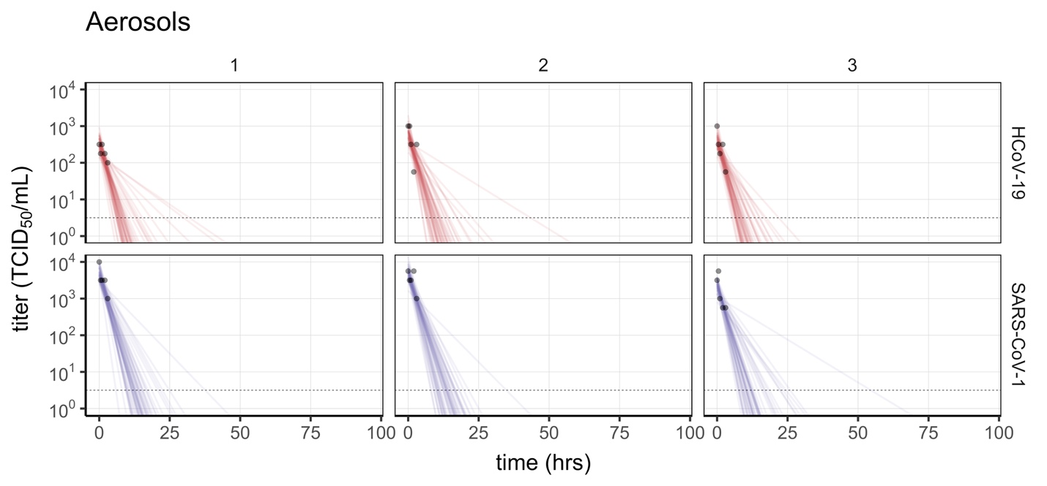
Figure S1. Individual replicate fits for aerosols. Columns show replicates, rows show virus (HCoV-19 above, SARS-CoV-1 below). Lines are 50 random draws per panel from the posterior distribution of fitted lines, to show level of uncertainty.

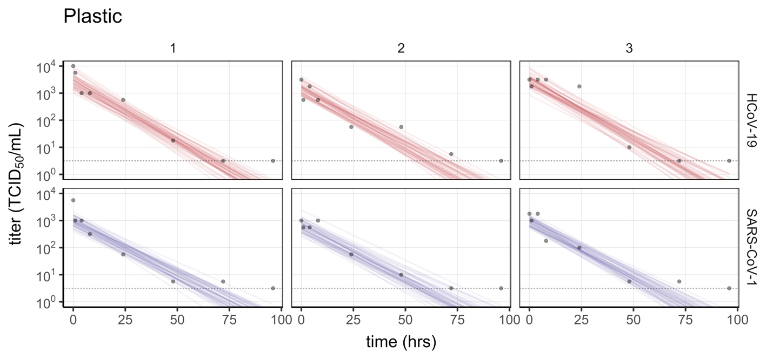
Figure S2. Individual replicate fits for plastic (polypropylene). Columns show replicates, rows show virus (HCoV-19 above, SARS-CoV-1 below). Lines are 50 random draws per panel from the posterior distribution of fitted lines, to show level of uncertainty.

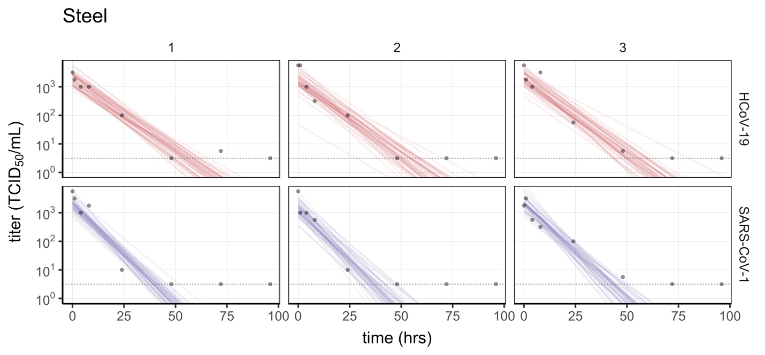
Figure S3. Individual replicate fits for steel. Columns show replicates, rows show virus (HCoV-19 above, SARS-CoV-1 below). Lines are 50 random draws per panel from the posterior distribution of fitted lines, to show level of uncertainty.

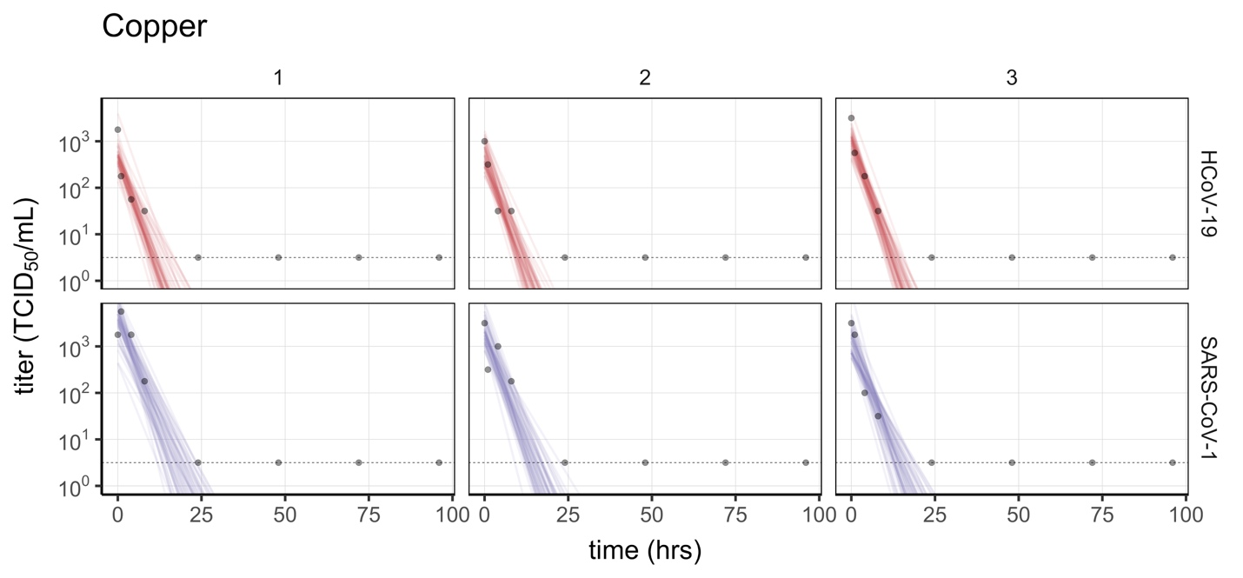
Figure S4. Individual replicate fits for copper. Columns show replicates, rows show virus (HCoV-19 above, SARS-CoV-1 below). Lines are 50 random draws per panel from the posterior distribution of fitted lines, to show level of uncertainty.

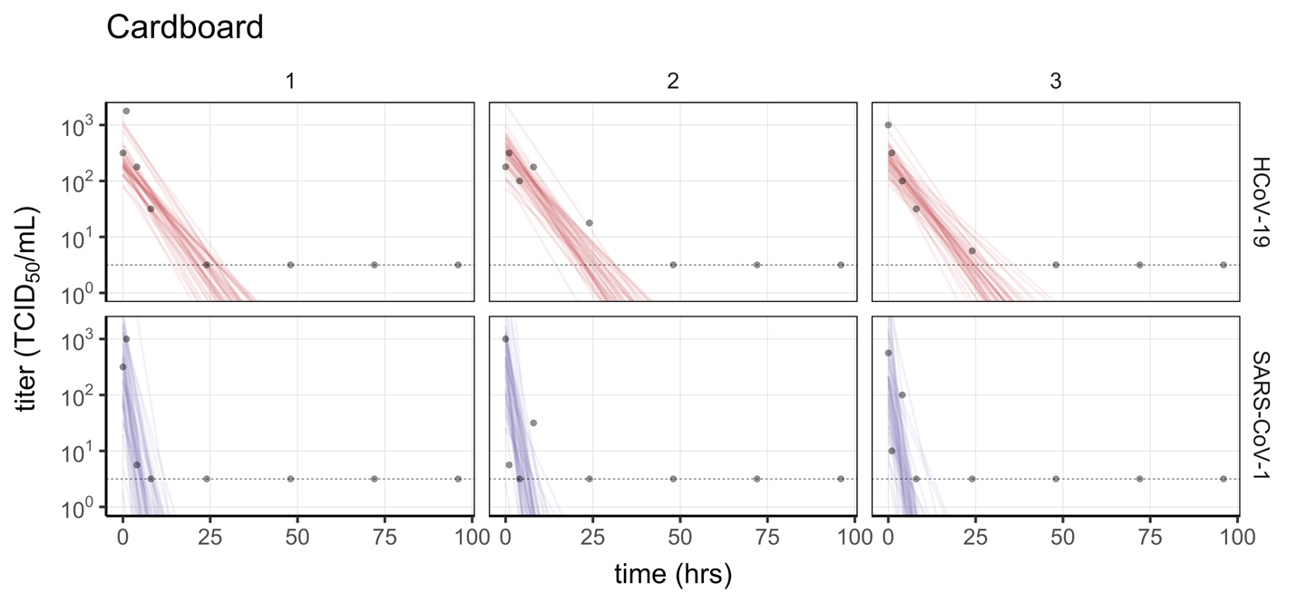
Figure S5. Individual replicate fits for cardboard. Columns show replicates, rows show virus (HCoV-19 above, SARS-CoV-1 below). Lines are 50 random draws per panel from the posterior distribution of fitted lines, to show level of uncertainty. Fits are substantially poorer for SARS than for HCoV-19, and data do not follow a linear downward trend over time, suggesting that the difference in observed decay rates should be interpreted with caution.

