Supporting information

Supplementary Note

I. Global holiday datasets and air travel statistics for understanding seasonal population movements across countries and years

To understand the seasonality of human movements and the impact of holidays (e.g. Lunar New Year holiday) on population travel across years and countries, four steps were taken to collate, validate and understand datasets of holidays and human movements: 1) collating national public holidays, observance, and working days on weekend for countries or territories across the globe in 2010s; 2) collating school holidays in 2019 and generating the school holiday data from 2010 to 2018; 3) merging and aggregating data of public and school holidays to generate time series at daily, weekly, and monthly basis; 4) collating monthly statistics of air passengers travelling internally and internationally, compared with the seasonal distribution of holidays.
Public holiday data collection
A standardized data collection form were used to gather following information of holiday on a country by country basis from 2010 to 2019. We focused on nationwide public holidays, also named national holiday, bank holiday, or official holiday in different counties, which are established by law or announced by the authorities of nations or territories. First, we searched the information of public holidays for each single country or territory in Google. Where data for a given country were available from multiple publicly available sources, we prioritized the data from the official websites of central or federal governments or authorities. If we cannot find the data from official websites, other websites with openly available data were also considered, including: the Time and Date (www.timeanddate.com/holidays/), the Festivo (https://getfestivo.com/countries), the Office Holidays (https://www.officeholidays.com/countries), and the Bhutanese Calendar (https://www.bhutanesecalendar.com).

However, comparing with the data in the second half of 2010s, the data in 2010-2014 were not widely available on the Internet. We identified the missing data in the dataset by comparing the records of holidays for each region between years, especially with the data in 2019. For missing data of public holidays that were tied to a specific day of the year, we interpolated the records into the dataset. For public holidays change dates across years as they land on a certain day of the week in a certain month or follow other calendar systems like the Lunar Calendar, specifically we searched the dates for these holidays in those calendar systems, and then merged with the datasets.

School holiday data collection
School holidays also impact the patterns of population movements. Here we focused on the holidays of primary and secondary schools. Because the short holidays or mid-term breaks are commonly overlapped with public holidays (e.g., the Easter or Thanksgiving), we focused on the school holidays with a long break (>2 weeks), e.g., summer or winter holidays, breaks between academic years. We searched the information of school holidays for each single country or territory in Google. We prioritized the data from the official websites of central or federal governments or authorities. If the data at country level were unavailable, we collected data of school holidays at capital regions, announced by local governments or educational departments. For example, the school holiday data in China were changed across province, and we used the school holidays in Beijing. For those countries without available data from official websites, we also searched public available data from websites including: the School Holidays (https://school-holidays.net/), the Public Holidays Asia (https://publicholidays.asia/), the School Holidays Europe (https://www.schoolholidayseurope.eu/), and the Holiday Calendar (https://holidaycalendar.com/)

Due to the changing dates of school academic years and terms across schools, regions and countries, median dates were used for different beginning and end dates of holidays across regions within a country for the same year. As historical data of school holidays are not widely available to be obtained from websites and the school terms are normally repeated during similar period across the years, we firstly collated the data of school holidays starting in 2019, and then generated the beginning and end dates of school holidays in 2009-2018 using the same time in 2019. If the beginning dates in 2010-2018 were on Thursday or Friday, they were adjusted to the nearest Saturday, and if the end dates in 2010-2018 were on Monday or Tuesday, they were adjusted to the nearest Sunday. We created time series at daily basis for each country or territory from 1 January 2010 through 31 December 2019, merged with public and school holiday data. Finally, the daily time series were aggregated to generate monthly time series by calculating how many days in each month were school and public holidays.

Monthly airline passenger statistics across years and countries
To understand the seasonality of holidays and their impact on human movements, we also collated monthly statistics of air passengers travelling domestically and internationally, compared against seasonal patterns of public and school holidays. The air travel data from 2010 to 2018 were systematically searched and collected from the national offices of statistics or departments of transportation, or annual reports of airports (http://aot.listedcompany.com/transport.html). We also used openly accessible database of air passengers at airport level from the websites, e.g. the Anna Aero (https://www.anna.aero/databases/), and aggregated all data from airport level to national level. We merged all data into a time series at monthly basis including the following variables: ISO3166-alpha3 code of each country or territory, year, month, total volume of air passengers, volume of internal air travellers, and volume of international air travellers.

A total of 91 countries or territories have available data (Figure S10), with more of countries in Europe, North America, and East Asia have air travel statistics from 2010 to 2018. However, only limited data for several years were available for countries in Africa, South America and West Asia. We compared the air travel data from official statistics and other sources. We found that there were slightly different of air traffic data between two data sources for the some countries. The main reasons are i) some countries, e.g. Australia and Canada, only reported the monthly statistics of traffic for the major airports or airlines; ii) the data from other data sources at the airport level might report total number of incoming and outgoing passengers for an airport, then passengers might be counted twice when they travelled domestically, especially for vast countries, e.g. USA, Canada, or China. To overcome these, we only used the data from other datasets at airport level for the countries and years without available official statistical data, and then transformed the actual monthly traffic data to relative values by ranking monthly volumes of air travellers within each year (Figure S10). There were more people travelling around July – August, the summer in the northern hemisphere, and high volume of air travel in July – August and December – January in the southern hemisphere. This is highly correlated with the timing and duration of public and school holidays (Figure S11).

II. Data sources of cases with novel coronavirus infections

The total numbers of cases of novel coronavirus (2019-nCoV) infections reported by province in China and by country were obtained from the websites of the Sina News https://news.sina.cn/zt_d/yiqing0121, with the data collated from the websites of national and local health authorities. The days of travelling from Wuhan, illness onset, first medical visit, and hospitalization of imported cases in provinces (excluding Hubei Province) of China and other countries were collated from the following websites:
- http://gx.sina.com.cn/news/gx/2020-01-24/detail-iihnzhha4423379.shtml?from=gx_cnxh
- http://hc.jiangxi.gov.cn/doc/2020/01/22/137549.shtml
- http://news.china.com.cn/2020-01/23/content_75643380.htm
- http://news.china.com.cn/txt/2020-01/23/content_75642508.htm
- http://news.cnstock.com/news,bwkx-197001-4480536.htm
- http://news.workercn.cn/32843/202001/23/200123115628638.shtml
- http://news.xmnn.cn/xmnn/2020/01/22/100656796.shtml
- http://news.xmnn.cn/xmnn/2020/01/22/100656796.shtml and https://m.weibo.cn/status/4464259805726673?
- http://wjw.hunan.gov.cn/wjw/xxgk/gzdt/zyxw_1/202001/t20200122_11163560.html
- http://wjw.jiangsu.gov.cn/art/2020/1/23/art_7290_8955651.html
- http://wjw.nmg.gov.cn/doc/2020/01/24/284997.shtml
- http://wsjkw.cq.gov.cn/tzgg/20200121/249730.html
- http://wsjkw.gd.gov.cn/zwyw_yqxx/content/post_2876057.html
- http://wsjkw.gd.gov.cn/zwyw_yqxx/content/post_2877668.html
- http://wsjkw.hlj.gov.cn/index.php/Home/Zwgk/show/newsid/7698/navid/42/id/3
- http://wsjkw.km.gov.cn/c/2020-01-22/3267609.shtml
- http://wsjkw.sh.gov.cn/xwfb/20200121/8fa3da87b0014c9db1308c76cbfe835f.html
- http://www.bbtnews.com.cn/2020/0122/333568.shtml
- http://www.bjnews.com.cn/news/2020/01/22/677946.html
- http://www.bjnews.com.cn/news/2020/01/22/678127.html
- http://www.bjnews.com.cn/news/2020/01/24/678809.html
- http://www.bjnews.com.cn/news/2020/01/24/679099.html
- http://www.chinanews.com/sh/2020/01-23/9067672.shtml
- http://www.cs.com.cn/xwzx/hg/202001/t20200121_6019199.html
- http://www.fcgs.gov.cn/wjw/zwgk/202001/t20200125_93696.html
- http://www.hebwst.gov.cn/index.do?id=394856&templet=content&cid=14
- http://www.nhc.gov.cn/yjb/s3578/202001/930c021cdd1f46dc832fc27e0cc465c8.shtml
- http://www.nnnews.net/yaowen/p/3021969.html
- http://www.sohu.com/a/368573184_120214181
- http://www.sohu.com/a/368942353_114988
- http://www.xinhuanet.com/world/2020-01/24/c_1125498544.htm
- https://baijiahao.baidu.com/s?id=1656387834433173903&wfr=spider&for=pc
- https://baijiahao.baidu.com/s?id=1656427296749156119&wfr=spider&for=pc
- https://baijiahao.baidu.com/s?id=1656529973714798234&wfr=spider&for=pc
- https://baijiahao.baidu.com/s?id=1656578420184524801&wfr=spider&for=pc
- https://baijiahao.baidu.com/s?id=1656593400736651054&wfr=spider&for=pc
- https://baijiahao.baidu.com/s?id=1656594579983530961&wfr=spider&for=pc
- https://baijiahao.baidu.com/s?id=1656603308265312741&wfr=spider&for=pc
- https://baijiahao.baidu.com/s?id=1656603487332867925&wfr=spider&for=pc
- https://baijiahao.baidu.com/s?id=1656609616249630455&wfr=spider&for=pc
- https://cbgc.scol.com.cn/news/219477
- https://focustaiwan.tw/society/202001245001
- https://m.weibo.cn/status/4464245485576951?
- https://mp.weixin.qq.com/s/mgFNlaqPMB-_vwNvLRKQmw
- https://mp.weixin.qq.com/s/Y6KDD39wR8JLonG-N2kJHg
- https://new.qq.com/omn/20200125/20200125A01X9500.html
- https://new.qq.com/omn/20200125/20200125A06DOX00.html
- https://news.163.com/special/epidemic/?spssid=7283291fcdba1d8c2d13ee3da2cfb760&spsw=7&spss=other
- https://pr.moph.go.th/?url=pr/detail/2/04/137232/
- https://pr.moph.go.th/?url=pr/detail/2/04/137484/
- https://tech.sina.com.cn/roll/2020-01-22/doc-iihnzahk5804410.shtml
- https://www.cdc.gov/media/releases/2020/p0121-novel-coronavirus-travel-case.html
- https://www.channelnewsasia.com/news/asia/wuhan-virus-malaysia-confirms-first-3-cases-all-patients-related-12331172
- https://www.channelnewsasia.com/news/singapore/wuhan-virus-pneumonia-singapore-confirms-first-case-12312860
- https://www.info.gov.hk/gia/general/202001/21/P2020012100842.htm and https://focustaiwan.tw/society/202001210019
- https://www.mhlw.go.jp/stf/newpage_09079.html
- https://www.mhlw.go.jp/stf/newpage_09100.html
- https://www.moh.gov.sg/news-highlights/details/two-more-cases-of-confirmed-imported-case-of-novel-coronavirus-infection-in-singapore
- https://www.pbs.org/newshour/health/cdc-confirms-second-u-s-case-of-novel-coronavirus-in-chicago
- https://www.scmp.com/news/asia/east-asia/article/3047463/china-coronavirus-japan-confirms-second-case-health-ministry
- https://www.scmp.com/news/hong-kong/health-environment/article/3047193/china-coronavirus-first-case-confirmed-hong-kong
- https://www.sinchew.com.my/content/content_2205270.html
- https://www.theguardian.com/science/2020/jan/25/coronavirus-five-people-in-nsw-being-tested-for-deadly-disease
- https://www.thelancet.com/pb-assets/Lancet/pdfs/S0140673620301549.pdf
- https://www.thepaper.cn/newsDetail_forward_5610903
- https://www.thepaper.cn/newsDetail_forward_5639569
- https://www.washingtonpost.com/world/coronavirus-china-live-updates/2020/01/24/4e678f9c-3e03-11ea-afe2-090eb37b60b1_story.html
- https://www.who.int/csr/don/14-january-2020-novel-coronavirus-thailand-ex-china/en/
- https://www.who.int/csr/don/17-january-2020-novel-coronavirus-japan-ex-china/en/
- https://www.who.int/csr/don/21-january-2020-novel-coronavirus-republic-of-korea-ex-china/en/

Table S1. Top 30 ranked cities in mainland China receiving travellers from Wuhan during the two weeks before the city’s lockdown.
Rank | City | Population (million)* | Province | Volume (%)**
1 | Xiangfan | 5.6 | Hubei | 7.53
2 | Xianning | 2.5 | Hubei | 6.47
3 | Jingzhou | 5.7 | Hubei | 6.42
4 | Beijing | 21.7 | Beijing | 6.30
5 | Yichang | 4.1 | Hubei | 5.45
6 | Huangshi | 2.5 | Hubei | 5.28
7 | Huanggang | 6.3 | Hubei | 4.95
8 | Xiaogan | 4.9 | Hubei | 4.62
9 | Xiantao | 3.5 | Hubei | 4.23
10 | Shiyan | 3.4 | Hubei | 4.18
11 | Jingmen | 2.9 | Hubei | 3.67
12 | Enshi | 3.3 | Hubei | 3.55
13 | Shanghai | 24.2 | Shanghai | 2.91
14 | Guangzhou | 14.0 | Guangdong | 2.44
15 | Suizhou | 2.2 | Hubei | 2.38
16 | Zhengzhou | 9.6 | Henan | 2.28
17 | Ezhou | 1.1 | Hubei | 1.88
18 | Tianjin | 15.6 | Tianjin | 1.66
19 | Hangzhou | 9.0 | Zhejiang | 1.61
20 | Jiaxing | 4.6 | Zhejiang | 1.41
21 | Changsha | 7.6 | Hunan | 1.19
22 | Xi'an | 8.3 | Shaanxi | 1.14
23 | Nanjing | 8.3 | Jiangsu | 1.09
24 | Shenzhen | 10.2 | Guangdong | 1.07
25 | Chongqing | 30.9 | Chongqing | 0.95
26 | Nanchang | 5.4 | Jiangxi | 0.66
27 | Chengdu | 14.3 | Sichuan | 0.64
28 | Hefei | 7.9 | Anhui | 0.61
29 | Fuzhou | 7.6 | Fujian | 0.57
30 | Dongguan | 8.3 | Guangdong | 0.52
 | Other | 1115.9 |  | 18.75
 | Total | 1371.5 |  | 100.00
* 2016 population, National Bureau of Statistics, P.R. China.
** Percentage of travellers leaving Wuhan city within 2 weeks before the LNY’s Day in 2015. Data were obtained from Baidu, Inc.

Table S2. Top 30 ranked cities in mainland China receiving travellers from Wuhan during the two weeks since LNY’s Day.
Rank | City | Population (million)* | Province | Volume (%)**
1 | Yichang | 4.1 | Hubei | 7.48
2 | Jingzhou | 5.7 | Hubei | 6.65
3 | Xiangfan | 5.6 | Hubei | 6.48
4 | Huanggang | 6.3 | Hubei | 5.91
5 | Beijing | 21.7 | Beijing | 5.56
6 | Xiaogan | 4.9 | Hubei | 5.16
7 | Xianning | 2.5 | Hubei | 4.25
8 | Xiantao | 3.5 | Hubei | 4.22
9 | Shanghai | 24.2 | Shanghai | 3.97
10 | Shiyan | 3.4 | Hubei | 3.89
11 | Jingmen | 2.9 | Hubei | 3.51
12 | Huangshi | 2.5 | Hubei | 3.46
13 | Guangzhou | 14.0 | Guangdong | 3.07
14 | Enshi | 3.3 | Hubei | 3.01
15 | Suizhou | 2.2 | Hubei | 2.50
16 | Ezhou | 1.1 | Hubei | 2.26
17 | Zhengzhou | 9.6 | Henan | 2.13
18 | Changsha | 7.6 | Hunan | 1.78
19 | Tianjin | 15.6 | Tianjin | 1.65
20 | Shenzhen | 10.2 | Guangdong | 1.24
21 | Xi'an | 8.3 | Shaanxi | 1.24
22 | Nanjing | 8.3 | Jiangsu | 1.13
23 | Hangzhou | 9.0 | Zhejiang | 1.12
24 | Jiaxing | 4.6 | Zhejiang | 1.04
25 | Nanchang | 5.4 | Jiangxi | 0.83
26 | Chongqing | 30.9 | Chongqing | 0.82
27 | Fuzhou | 7.6 | Fujian | 0.82
28 | Hefei | 7.9 | Anhui | 0.78
29 | Suzhou | 10.6 | Jiangsu | 0.51
30 | Dongguan | 8.3 | Guangdong | 0.47
 | Other | 1119.5 |  | 13.04
 | Total | 1371.5 |  | 100.00
* 2016 population, National Bureau of Statistics, P.R. China.
** Percentage of travellers leaving Wuhan city within 2 weeks since the first day of the Chinese New Year in 2015.

Table S3. The rank of provinces in mainland China receiving travellers from Wuhan city around LNY’s Day.
Rank | Within 2 weeks before LNY’s Day |  |  | Within 2 weeks since LNY’s Day
 | Province* | Population (million) ª | Volume (%) ^{b} | Province* | Population (million) ª | Volume (%) ^{b}
1 | Beijing | 21.5 | 16.07 | Beijing | 21.5 | 13.50
2 | Guangdong | 113.5 | 12.19 | Guangdong | 113.5 | 13.32
3 | Henan | 96.1 | 9.48 | Shanghai | 24.2 | 9.64
4 | Shanghai | 24.2 | 9.25 | Henan | 96.1 | 7.95
5 | Zhejiang | 57.4 | 8.19 | Zhejiang | 57.4 | 7.22
6 | Jiangsu | 80.5 | 5.51 | Jiangsu | 80.5 | 6.81
7 | Hunan | 69.0 | 4.80 | Hunan | 69.0 | 6.29
8 | Shaanxi | 38.6 | 4.54 | Shaanxi | 38.6 | 4.98
9 | Tianjin | 15.6 | 4.11 | Tianjin | 15.6 | 4.00
10 | Shandong | 100.5 | 3.66 | Shandong | 100.5 | 3.89
11 | Sichuan | 83.4 | 3.13 | Fujian | 39.4 | 3.70
12 | Jiangxi | 46.5 | 2.75 | Anhui | 63.2 | 3.27
13 | Fujian | 39.4 | 2.72 | Jiangxi | 46.5 | 2.90
14 | Anhui | 63.2 | 2.62 | Sichuan | 83.4 | 2.13
15 | Chongqing | 31.0 | 2.15 | Chongqing | 31.0 | 2.00
16 | Hebei | 75.6 | 1.94 | Hebei | 75.6 | 1.74
17 | Yunnan | 48.3 | 1.22 | Liaoning | 43.6 | 1.21
18 | Guangxi | 49.3 | 1.10 | Yunnan | 48.3 | 1.08
19 | Liaoning | 43.6 | 1.06 | Guangxi | 49.3 | 1.00
20 | Hainan | 9.3 | 0.58 | Shanxi | 37.2 | 0.62
21 | Shanxi | 37.2 | 0.54 | Hainan | 9.3 | 0.48
22 | Guizhou | 36.0 | 0.47 | Guizhou | 36.0 | 0.46
23 | Heilongjiang | 37.7 | 0.40 | Heilongjiang | 37.7 | 0.41
24 | Xinjiang | 24.9 | 0.40 | Xinjiang | 24.9 | 0.33
25 | Gansu | 26.4 | 0.32 | Jilin | 27.0 | 0.31
26 | Jilin | 27.0 | 0.31 | Gansu | 26.4 | 0.26
27 | Inner Mongolia | 25.3 | 0.29 | Inner Mongolia | 25.3 | 0.25
28 | Ningxia | 6.9 | 0.11 | Ningxia | 6.9 | 0.11
29 | Qinghai | 6.0 | 0.07 | Qinghai | 6.0 | 0.10
30 | Tibet | 3.4 | 0.03 | Tibet | 3.4 | 0.03
* All provinces have reported imported and/or local confirmed cases, as of January 30, 2020.
ª 2016 population, National Bureau of Statistics, P.R. China.
^{b} Percentage of travellers leaving Wuhan city within 2 weeks since the first day of the LNY in 2015. Data were obtained from Baidu, Inc.
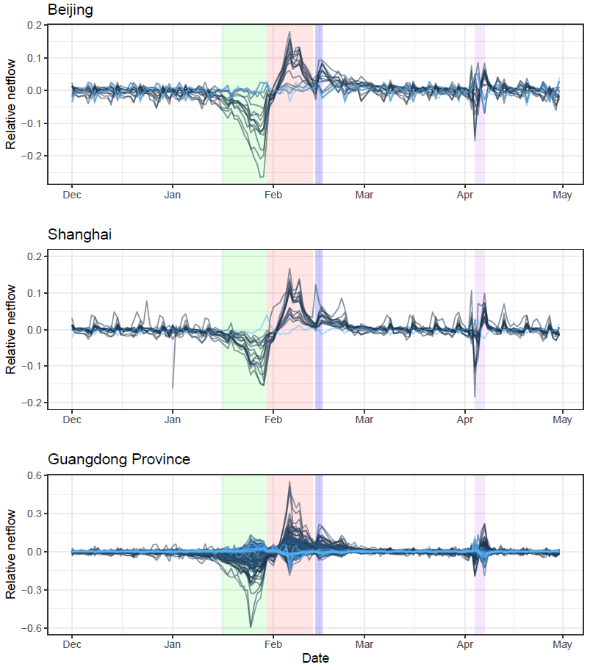

Figure S1. Patterns of daily human movement by county in Beijing, Shanghai, and Guangdong Province across five months.
(A) Beijing. (B) Shanghai. (C) Guangdong province. Shadow colours: green - 2 weeks before LNY’s Day; red - 2 weeks since LNY’s Day; blue - Lantern Festival and weekend; purple - Tomb Sweeping holiday and weekend. Relative netflow = (Inflow – Outflow)/population, based on the population movement data in 2013-2014 obtained from Baidu, Inc.
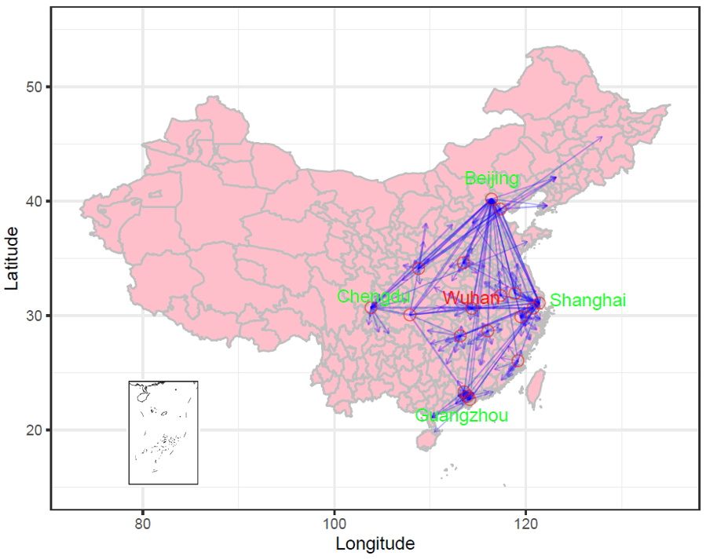

Figure S2. Estimated connectivity of cities in mainland China receiving travellers from 18 high-risk cities (red circles) with 2019-nCoV infections or importations during the four weeks following LNY’s Day.
The arrows show the link and direction of the risk of importation at city level, preliminarily defined as the percentage of travellers received by each city (top 10 ranked cities) out of the total volume of travellers leaving each high-risk city (18 cities), based on the population movement data in 2015 obtained from Baidu, Inc. The high-risk cities include Wuhan in Hubei province and 17 cities (Beijing, Shanghai, Guangzhou, Zhengzhou, Tianjin, Hangzhou, Jiaxing, Changsha, Xi’an, Nanjing, Shenzhen, Chongqing, Nanchang, Chengdu, Hefei, Fuzhou, and Dongguan) in other provinces receiving high volume of travellers from Wuhan during the two weeks before the city’s lockdown on January 23rd, 2020.

Table S4. Top 30 ranked cities across the globe receiving airline travellers from 18 high-risk cities (Figure S2) in mainland China from February to April, representing three-month air traffic after LNY’s holiday without travel restrictions.
Rank | City | Country/region | Volume  (in thousands) |  | Risk (%)*
1 | Bangkok | Thailand | 1062.9 |  | 7.86
2 | Hong Kong | Hong Kong, China | 1001.7 |  | 7.41
3 | Taipei | Taiwan, China | 857.5 |  | 6.34
4 | Seoul | South Korea | 757.9 |  | 5.61
5 | Tokyo | Japan | 714.3 |  | 5.28
6 | Singapore | Singapore | 568.1 |  | 4.20
7 | Phuket | Thailand | 492.8 |  | 3.65
8 | Osaka | Japan | 434.1 |  | 3.21
9 | Kuala Lumpur | Malaysia | 382.7 |  | 2.83
10 | Macau | Macau, China | 260.4 |  | 1.93
11 | Denpasar Bali | Indonesia | 222.2 |  | 1.64
12 | Sydney | Australia | 207.4 |  | 1.53
13 | Chiang Mai | Thailand | 156.9 |  | 1.16
14 | Melbourne | Australia | 154.5 |  | 1.14
15 | Los Angeles | United States | 154.5 |  | 1.14
16 | New York | United States | 145.9 |  | 1.08
17 | Dubai | U.A.E | 144.9 |  | 1.07
18 | Nha Trang | Viet Nam | 143 |  | 1.06
19 | London | United Kingdom | 142.1 |  | 1.05
20 | Ho Chi Minh City | Viet Nam | 142 |  | 1.05
21 | Nagoya | Japan | 140.1 |  | 1.04
22 | Kota Kinabalu | Malaysia | 130.4 |  | 0.96
23 | Phnom Penh | Cambodia | 127.5 |  | 0.94
24 | Krabi | Thailand | 125.2 |  | 0.93
25 | Manila | Philippines | 121.9 |  | 0.90
26 | Siem Reap | Cambodia | 121.4 |  | 0.90
27 | Paris | France | 119.5 |  | 0.88
28 | Jakarta | Indonesia | 113.9 |  | 0.84
29 | Kaohsiung | Taiwan, China | 107.6 |  | 0.80
30 | Frankfurt | Germany | 103.3 |  | 0.76
 | Other |  | 4158.2 |  | 30.77
 | Total |  | 13514.9 |  | 100
* Relative risk was preliminary defined as the percentage of airline travellers received by each city out of the total volume of travellers leaving high-risk cities (18 cities), based on air travel data from February to April 2018, obtained from the International Air Travel Association (IATA).

Table S5. Top 30 ranked countries or regions receiving airline travellers from 18 high-risk cities (Figure S2) in mainland China from February to April, representing three-month air traffic after LNY’s holiday without travel restrictions.
Rank | Country/region | Volume (in thousands) | Risk *
1 | Thailand | 2031.9 | 15.03
2 | Japan | 1563.3 | 11.57
3 | Hong Kong, China | 1001.7 | 7.41
4 | Taiwan, China | 979.7 | 7.25
5 | South Korea | 936.6 | 6.93
6 | United States | 773.3 | 5.72
7 | Malaysia | 634.3 | 4.69
8 | Singapore | 568.1 | 4.20
9 | Viet Nam | 468.4 | 3.47
10 | Australia | 455.6 | 3.37
11 | Indonesia | 412.5 | 3.05
12 | Cambodia | 262.9 | 1.95
13 | Macao, China | 260.4 | 1.93
14 | Philippines | 250.3 | 1.85
15 | Germany | 234.9 | 1.74
16 | Canada | 208.5 | 1.54
17 | United Kingdom | 190.7 | 1.41
18 | U.A.E | 162.3 | 1.20
19 | Italy | 152.9 | 1.13
20 | Russia | 151.3 | 1.12
21 | France | 137.9 | 1.02
22 | New Zealand | 120.7 | 0.89
23 | India | 106.7 | 0.79
24 | Spain | 105.8 | 0.78
25 | Turkey | 66.5 | 0.49
26 | Egypt | 57.5 | 0.43
27 | Sri Lanka | 55.7 | 0.41
28 | Maldives | 50.7 | 0.37
29 | Netherlands | 44.9 | 0.33
30 | Myanmar | 43.3 | 0.32
 | Other | 1025.6 | 7.59
 | Total | 13514.9 | 100
* Relative risk was preliminary defined as the percentage of airline travellers received by each city out of the total volume of travellers leaving high-risk cities (18 cities), based on air travel data from February to April 2018, obtained from the International Air Travel Association (IATA).

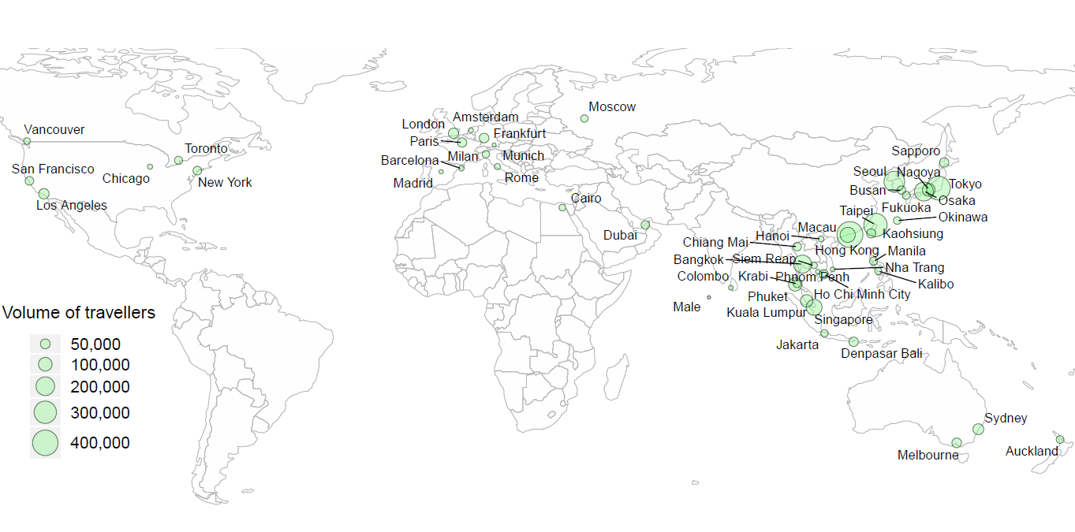

Figure S3: Geographic distribution of cities across the globe receiving airline travellers from 18 high-risk cities (Figure S2) in mainland China from February to April, representing three-month air traffic after LNY’s holiday without travel restrictions.
This map is based on air passenger data from February to April 2018, obtained from the International Air Travel Association (IATA). The LNY’s Day in 2018 started from February 16th, 2018. The volume of airline travellers of the top 50 ranked cities is presented.

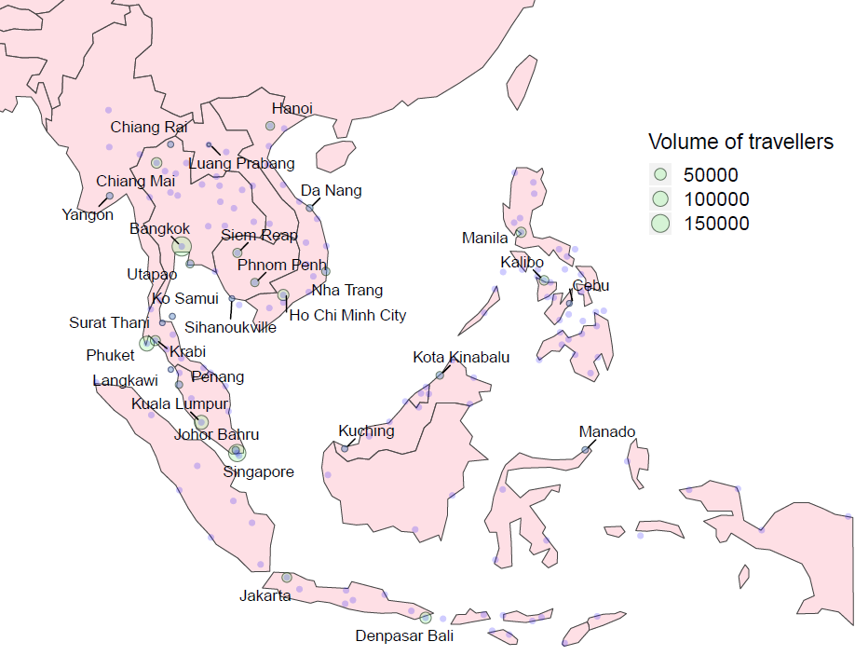

Figure S4. Geographic distribution of cities in Southeast Asia receiving airline travellers from 18 high-risk cities (Figure S2) in mainland China from February to April, representing three-month air traffic after LNY’s holiday without travel restrictions.
The volume of airline travellers of the top 30 ranked cities is presented. Based on air travel data from February to April 2018, obtained from the International Air Travel Association (IATA). The 18 high-risk cities are Wuhan in Hubei Province and 17 cities (Beijing, Shanghai, Guangzhou, Zhengzhou, Tianjin, Hangzhou, Jiaxing, Changsha, Xi’an, Nanjing, Shenzhen, Chongqing, Nanchang, Chengdu, Hefei, Fuzhou, Dongguan) in other provinces receiving high volume of travellers from Wuhan before the LNY.

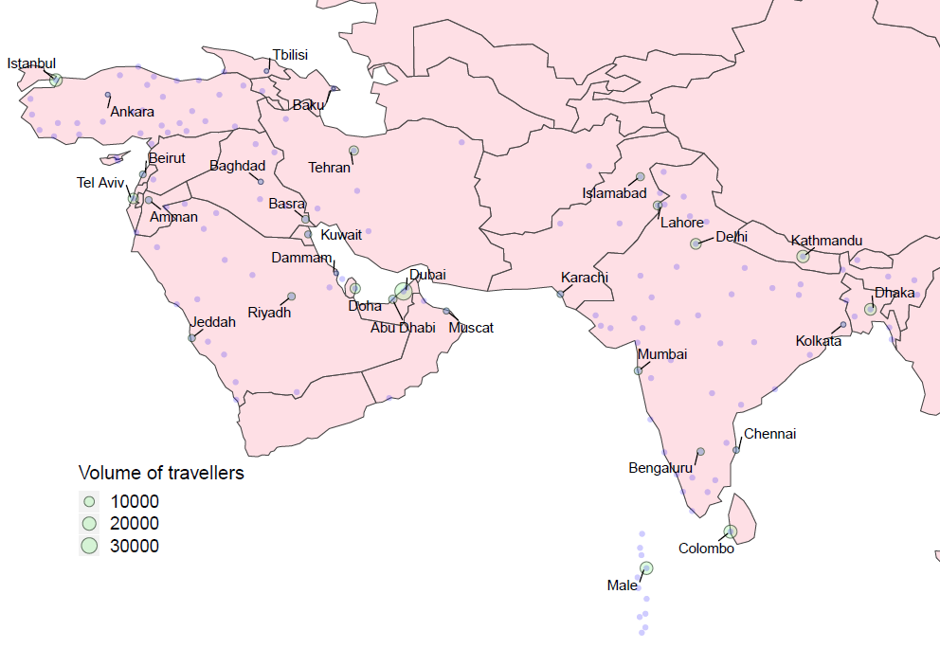

Figure S5. Geographic distribution of cities in Southern and Western Asia receiving airline travellers from 18 high-risk cities (Figure S2) in mainland China from February to April, representing three-month air traffic after LNY’s holiday without travel restrictions.
The volume of airline travellers of the top 30 ranked cities is presented. Based on air travel data from February to April 2018, obtained from the International Air Travel Association (IATA). The 18 high-risk cities are Wuhan in Hubei Province and 17 cities (Beijing, Shanghai, Guangzhou, Zhengzhou, Tianjin, Hangzhou, Jiaxing, Changsha, Xi’an, Nanjing, Shenzhen, Chongqing, Nanchang, Chengdu, Hefei, Fuzhou, Dongguan) in other provinces receiving high volume of travellers from Wuhan before the LNY.

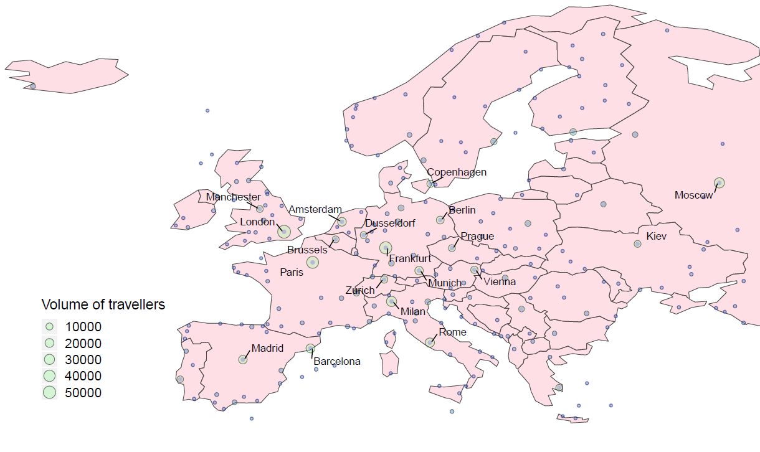

Figure S6. Geographic distribution of cities in Europe receiving airline travellers from 18 high-risk cities (Figure S2) in mainland China from February to April, representing three-month air traffic after LNY’s holiday without travel restrictions.
The volume of airline travellers of the top 20 ranked cities is presented. Based on air travel data from February to April 2018, obtained from the International Air Travel Association (IATA). The 18 high-risk cities are Wuhan in Hubei Province and 17 cities (Beijing, Shanghai, Guangzhou, Zhengzhou, Tianjin, Hangzhou, Jiaxing, Changsha, Xi’an, Nanjing, Shenzhen, Chongqing, Nanchang, Chengdu, Hefei, Fuzhou, Dongguan) in other provinces receiving high volume of travellers from Wuhan before the LNY.

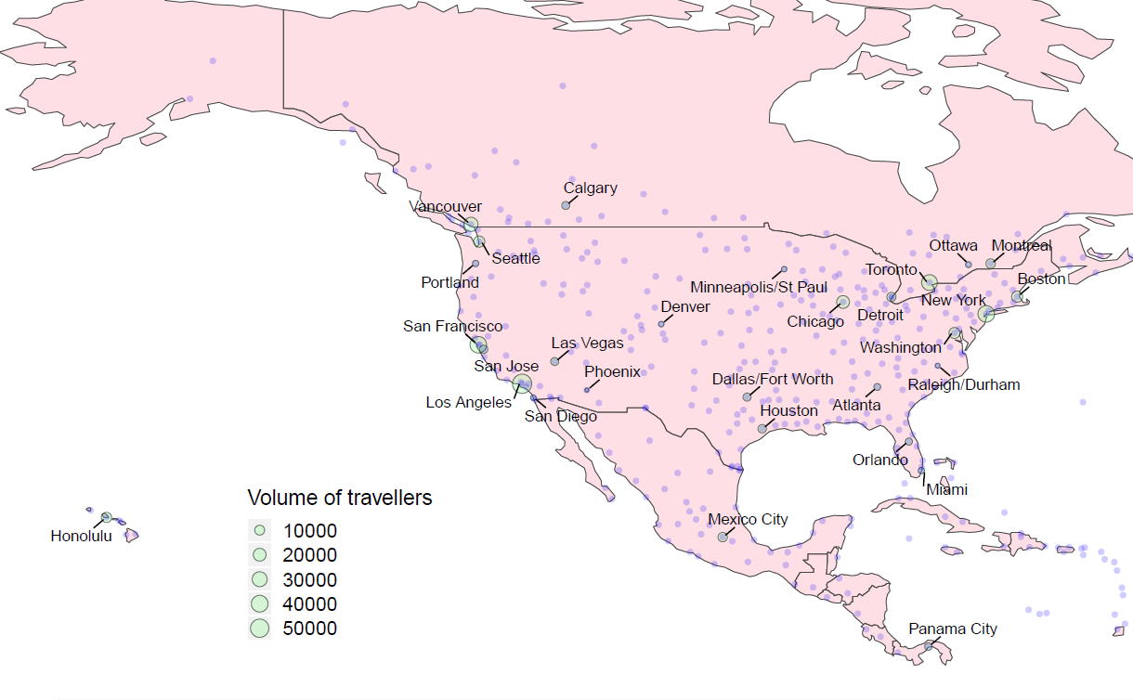

Figure S7. Geographic distribution of cities in Northern and Central America receiving airline travellers from 18 high-risk cities (Figure S2) in mainland China from February to April, representing three-month air traffic after LNY’s holiday without travel restrictions.
The volume of airline travellers of the top 30 ranked cities is presented. Based on air travel data from February to April 2018, obtained from the International Air Travel Association (IATA). The 18 high-risk cities are Wuhan in Hubei Province and 17 cities (Beijing, Shanghai, Guangzhou, Zhengzhou, Tianjin, Hangzhou, Jiaxing, Changsha, Xi’an, Nanjing, Shenzhen, Chongqing, Nanchang, Chengdu, Hefei, Fuzhou, Dongguan) in other provinces receiving high volume of travellers from Wuhan before the LNY.

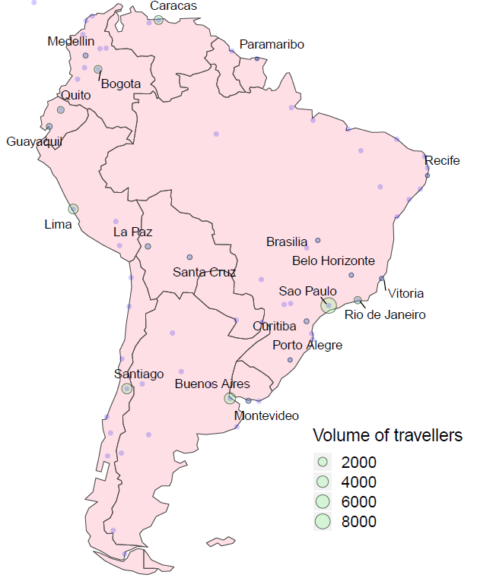

Figure S8. Geographic distribution of cities in Southern America receiving airline travellers from 18 high-risk cities (Figure S2) in mainland China from February to April, representing three-month air traffic after LNY’s holiday without travel restrictions.
The volume of airline travellers of the top 20 ranked cities is presented. Based on air travel data from February to April 2018, obtained from the International Air Travel Association (IATA). The 18 high-risk cities are Wuhan in Hubei Province and 17 cities (Beijing, Shanghai, Guangzhou, Zhengzhou, Tianjin, Hangzhou, Jiaxing, Changsha, Xi’an, Nanjing, Shenzhen, Chongqing, Nanchang, Chengdu, Hefei, Fuzhou, Dongguan) in other provinces receiving high volume of travellers from Wuhan before the LNY.

Table S6. Top 30 ranked cities in Africa receiving airline travellers from 18 high-risk cities (Figure S2) in mainland China from February to April, representing three-month air traffic after LNY’s holiday without travel restrictions.
Rank | City | Country/region | Volume | %*
1 | Cairo | Egypt | 56735 | 20.49
2 | Johannesburg | South Africa | 20530 | 7.42
3 | Mauritius | Mauritius | 18297 | 6.61
4 | Addis Ababa | Ethiopia | 17882 | 6.46
5 | Casablanca | Morocco | 15787 | 5.70
6 | Nairobi | Kenya | 12859 | 4.64
7 | Entebbe | Uganda | 8246 | 2.98
8 | Accra | Ghana | 8211 | 2.97
9 | Lagos | Nigeria | 8087 | 2.92
10 | Lusaka | Zambia | 7672 | 2.77
11 | Dar Es Salaam | Tanzania | 6769 | 2.44
12 | Algiers | Algeria | 6074 | 2.19
13 | Luanda | Angola | 5994 | 2.16
14 | Khartoum | Sudan | 5412 | 1.95
15 | Abuja | Nigeria | 4193 | 1.51
16 | Lubumbashi | Congo (Kinshasa) | 3546 | 1.28
17 | Abidjan | Cote D'Ivoire | 3511 | 1.27
18 | Cape Town | South Africa | 3461 | 1.25
19 | Conakry | Guinea | 3455 | 1.25
20 | Tunis | Tunisia | 2912 | 1.05
21 | Libreville | Gabon | 2786 | 1.01
22 | Harare | Zimbabwe | 2665 | 0.96
23 | Dakar | Senegal | 2659 | 0.96
24 | Maputo | Mozambique | 2560 | 0.92
25 | Antananarivo | Madagascar | 2515 | 0.91
26 | Nouakchott | Mauritania | 1955 | 0.71
27 | Malabo | Equatorial Guinea | 1864 | 0.67
28 | Mahe Island | Seychelles | 1850 | 0.67
29 | Durban | South Africa | 1815 | 0.66
30 | Ndola | Zambia | 1796 | 0.65
* The percentage of airline travellers received by each city in Africa out of the total volume of travellers leaving high-risk cities (18 cities) into Africa, based on air travel data from February to April 2018, obtained from the International Air Travel Association (IATA).

Table S7. African countries or territories receiving airline travellers from 18 high-risk cities (Figure S2) in mainland China from February to April, representing three-month air traffic after LNY’s holiday without travel restrictions.
Rank | Country/region | Volume | %* | Rank | Country/region | Volume | %*
1 | Egypt | 57516 | 20.77 | 27 | Seychelles | 1863 | 0.67
2 | South Africa | 26405 | 9.54 | 28 | Botswana | 1627 | 0.59
3 | Ethiopia | 18393 | 6.64 | 29 | Djibouti | 1602 | 0.58
4 | Mauritius | 18297 | 6.61 | 30 | Mali | 1587 | 0.57
5 | Morocco | 16974 | 6.13 | 31 | Congo (Brazzaville) | 1500 | 0.54
6 | Nigeria | 13734 | 4.96 | 32 | Chad | 1425 | 0.51
7 | Kenya | 13185 | 4.76 | 33 | Rwanda | 1386 | 0.50
8 | Zambia | 9471 | 3.42 | 34 | Sierra Leone | 1330 | 0.48
9 | Tanzania | 8388 | 3.03 | 35 | Namibia | 1207 | 0.44
10 | Uganda | 8246 | 2.98 | 36 | Malawi | 1139 | 0.41
11 | Ghana | 8211 | 2.97 | 37 | Benin | 890 | 0.32
12 | Algeria | 7887 | 2.85 | 38 | Togo | 858 | 0.31
13 | Angola | 5994 | 2.16 | 39 | Lesotho | 853 | 0.31
14 | Sudan | 5433 | 1.96 | 40 | Reunion | 809 | 0.29
15 | Congo (Kinshasa) | 5248 | 1.90 | 41 | Niger | 790 | 0.29
16 | Mozambique | 3928 | 1.42 | 42 | Liberia | 711 | 0.26
17 | Cote D'Ivoire | 3511 | 1.27 | 43 | South Sudan | 711 | 0.26
18 | Guinea | 3455 | 1.25 | 44 | Burkina Faso | 406 | 0.15
19 | Tunisia | 2912 | 1.05 | 45 | Gambia | 365 | 0.13
20 | Gabon | 2786 | 1.01 | 46 | Central African Rep | 339 | 0.12
21 | Cameroon | 2734 | 0.99 | 47 | Cape Verde | 276 | 0.10
22 | Zimbabwe | 2716 | 0.98 | 48 | Eritrea | 246 | 0.09
23 | Senegal | 2659 | 0.96 | 49 | Burundi | 232 | 0.08
24 | Madagascar | 2515 | 0.91 | 50 | Comoros | 178 | 0.06
25 | Mauritania | 1955 | 0.71 | 51 | Somalia | 68 | 0.02
26 | Equatorial Guinea | 1864 | 0.67 | 52 | Guinea-Bissau | 52 | 0.02
* The percentage of airline travellers received by each city in Africa out of the total volume of travellers leaving high-risk cities (18 cities) into Africa, based on air travel data from February to April 2018, obtained from the International Air Travel Association (IATA).

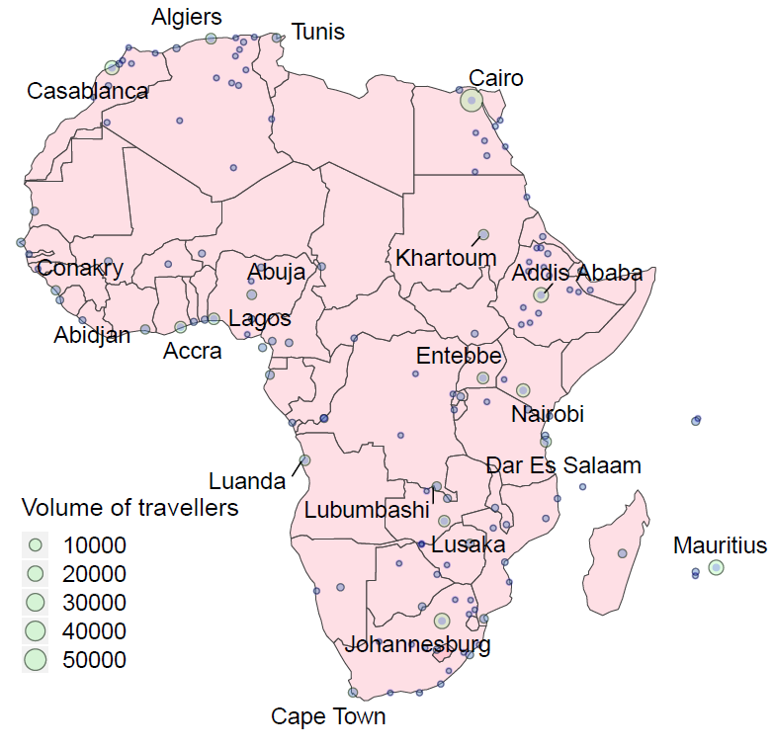

Figure S9. Geographic distribution of African cities receiving airline travellers from 18 high-risk cities (Figure S2) in mainland China from February to April, representing three-month air traffic after LNY’s holiday without travel restrictions.
The volume of airline travellers of the top 30 ranked cities is presented. Based on air travel data from February to April 2018, obtained from the International Air Travel Association (IATA). The 18 high-risk cities are Wuhan in Hubei Province and 17 cities (Beijing, Shanghai, Guangzhou, Zhengzhou, Tianjin, Hangzhou, Jiaxing, Changsha, Xi’an, Nanjing, Shenzhen, Chongqing, Nanchang, Chengdu, Hefei, Fuzhou, Dongguan) in other provinces receiving high volume of travellers from Wuhan before the LNY.

Table S8. Top 30 ranked destiantions outside of mainland China receiving airline travellers infected with 2019-nCoV from Wuhan in mainland China during the two weeks before the city’s lockdown on 23 January, 2020.
Rank | Top 30 countries or regions |  |  |  |  | Top 30 cities
 | Countries or regions | Volume (%)ª | Infections^{b} | Adjusted infections^{c} | City |  | Countries or regions | Volume (%)ª | Infections^{b} | Adjusted infections^{c}
1 | Thailand | 14860 (24.8) | 207 (119, 335) | 74 (42, 119) | Bangkok |  | Thailand | 7754 (12.9) | 108 (62, 175) | 38 (22, 62)
2 | Japan | 5712 (9.5) | 80 (46, 129) | 28 (16, 46) | Hong Kong |  | Hong Kong, China | 3924 (6.6) | 55 (31, 88) | 19 (11, 31)
3 | Taiwan, China | 4854 (8.1) | 68 (39, 109) | 24 (14, 39) | Taipei |  | Taiwan, China | 3635 (6.1) | 51 (29, 82) | 18 (10, 29)
4 | Malaysia | 4044 (6.7) | 56 (32, 91) | 20 (11, 32) | Tokyo |  | Japan | 3564 (6) | 50 (28, 80) | 18 (10, 29)
5 | Hong Kong, China | 3924 (6.5) | 55 (31, 88) | 19 (11, 31) | Phuket |  | Thailand | 2875 (4.8) | 40 (23, 65) | 14 (8, 23)
6 | Australia | 3780 (6.3) | 53 (30, 85) | 19 (11, 30) | Singapore |  | Singapore | 2588 (4.3) | 36 (21, 58) | 13 (7, 21)
7 | Singapore | 2588 (4.3) | 36 (21, 58) | 13 (7, 21) | Seoul |  | South Korea | 2102 (3.5) | 29 (17, 47) | 10 (6, 17)
8 | United States | 2432 (4.1) | 34 (19, 55) | 12 (7, 19) | Kota Kinabalu |  | Malaysia | 2044 (3.4) | 28 (16, 46) | 10 (6, 16)
9 | South Korea | 2190 (3.7) | 30 (17, 49) | 11 (6, 18) | Sydney |  | Australia | 1744 (2.9) | 24 (14, 39) | 9 (5, 14)
10 | Indonesia | 2050 (3.4) | 29 (16, 46) | 10 (6, 16) | Macau |  | Macao, China | 1720 (2.9) | 24 (14, 39) | 9 (5, 14)
11 | Macao, China | 1720 (2.9) | 24 (14, 39) | 9 (5, 14) | Denpasar Bali |  | Indonesia | 1503 (2.5) | 21 (12, 34) | 7 (4, 12)
12 | U.A.E. | 1460 (2.4) | 20 (12, 33) | 7 (4, 12) | Dubai |  | U.A.E. | 1459 (2.4) | 20 (12, 33) | 7 (4, 12)
13 | Viet Nam | 1412 (2.4) | 20 (11, 32) | 7 (4, 11) | Melbourne |  | Australia | 1331 (2.2) | 19 (11, 30) | 7 (4, 11)
14 | Cambodia | 1155 (1.9) | 16 (9, 26) | 6 (3, 9) | Kaohsiung |  | Taiwan, China | 1213 (2) | 17 (10, 27) | 6 (3, 10)
15 | France | 928 (1.5) | 13 (7, 21) | 5 (3, 7) | Surat Thani |  | Thailand | 1200 (2) | 17 (10, 27) | 6 (3, 10)
16 | Philippines | 812 (1.4) | 11 (6, 18) | 4 (2, 7) | Osaka |  | Japan | 1078 (1.8) | 15 (9, 24) | 5 (3, 9)
17 | Canada | 792 (1.3) | 11 (6, 18) | 4 (2, 6) | Ho Chi Minh City |  | Viet Nam | 1046 (1.8) | 15 (8, 24) | 5 (3, 8)
18 | Italy | 712 (1.2) | 10 (6, 16) | 4 (2, 6) | Chiang Mai |  | Thailand | 1036 (1.7) | 14 (8, 23) | 5 (3, 8)
19 | New Zealand | 663 (1.1) | 9 (5, 15) | 3 (2, 5) | Kuala Lumpur |  | Malaysia | 1010 (1.7) | 14 (8, 23) | 5 (3, 8)
20 | United Kingdom | 675 (1.1) | 9 (5, 15) | 3 (2, 5) | Krabi |  | Thailand | 913 (1.5) | 13 (7, 21) | 5 (3, 7)
21 | Germany | 346 (0.6) | 5 (3, 8) | 2 (1, 3) | Paris |  | France | 862 (1.4) | 12 (7, 19) | 4 (2, 7)
22 | Russia | 295 (0.5) | 4 (2, 7) | 1 (1, 2) | Penang |  | Malaysia | 793 (1.3) | 11 (6, 18) | 4 (2, 6)
23 | Myanmar | 236 (0.4) | 3 (2, 5) | 1 (1, 2) | Manila |  | Philippines | 724 (1.2) | 10 (6, 16) | 4 (2, 6)
24 | India | 178 (0.3) | 2 (1, 4) | 1 (1, 1) | San Francisco |  | United States | 700 (1.2) | 10 (6, 16) | 3 (2, 6)
25 | Maldives | 188 (0.3) | 3 (2, 4) | 1 (1, 2) | Rome |  | Italy | 622 (1) | 9 (5, 14) | 3 (2, 5)
26 | Spain | 202 (0.3) | 3 (2, 5) | 1 (1, 2) | Sihanoukville |  | Cambodia | 582 (1) | 8 (5, 13) | 3 (2, 5)
27 | Sri Lanka | 158 (0.3) | 2 (1, 4) | 1 (0, 1) | Los Angeles |  | United States | 556 (0.9) | 8 (4, 13) | 3 (2, 4)
28 | Bangladesh | 122 (0.2) | 2 (1, 3) | 1 (0, 1) | Jakarta |  | Indonesia | 537 (0.9) | 7 (4, 12) | 3 (2, 4)
29 | Netherlands | 91 (0.2) | 1 (1, 2) | 0 (0, 1) | Auckland |  | New Zealand | 536 (0.9) | 7 (4, 12) | 3 (2, 4)
30 | Pakistan | 96 (0.2) | 1 (1, 2) | 0 (0, 1) | London |  | United Kingdom | 518 (0.9) | 7 (4, 12) | 3 (1, 4)
 | Other | 1237 (2.1) | 17 (10, 28) | 6 (4, 10) | Other |  |  | 9743 (16.3) | 136 (78, 219) | 48 (28, 78)
 | Total | 59912  (100) | 834  (478, 1349) | 297  (170, 480) | Total |  |  | 59912  (100) | 834  (478, 1349) | 297  (170, 480)
ª Based on air passenger data in February 2018, obtained from the International Air Travel Association (IATA). The LNY’s Day in 2018 started from February 16th, 2018.
^{b} Based on an overall infection rate of 1.39% (16/1149; 95% UI: 0.80% - 2.25%) in citizens evacuated from Wuhan before February 1st, 2020, reported by Singapore (1.08%, 1/92), South Korea (1.36%, 5/368), Japan (1.42%, 8/565), and Germany (1.61%, 2/124), we made preliminary estimates of airline travellers that may have been infected with 2019-nCoV from Wuhan two weeks prior to the city’s lockdown.
^{c} Based on an adjusted infection rate of 0.50% (95% UI: 0.28% - 0.80%), calculated by using the 6.4 days (95%CI 5.8-7.1) of doubling time of cases (Wu J, Leung K, and Leung GM. Lancet, 2020, doi: 10.1016/S0140-6736(20)30260-9), days (9) from Wuhan’s lockdown to the last evacuation day (February 1st, 2020) of the four countries, and overall infection rate of 1.39% (16/1149; 95% UI: 0.80% - 2.25%) in evacuees: adjusted infection rate = infection rate in evacuees × 6.4 days ÷ 9 days ÷ 2.

Table S9. Top 30 ranked cities across the globe receiving airline travellers from 18 high-risk cities (Figure S2) in mainland China from February to April, representing three-month air traffic after LNY’s holiday with travel banned from Wuhan and 50% reduction of travel from other cities.
Rank | Top 30 countries or regions |  | Top 30 cities
 | Countries/regions | Volume (%)* | City | Countries/regions | Volume (%)*
1 | Thailand | 971.5 (14.4) | Bangkok | Thailand | 508.3 (7.7)
2 | Japan | 765.6 (11.5) | Hong Kong | Hong Kong, China | 488.9 (7.4)
3 | Hong Kong, China | 488.9 (7.4) | Taipei | Taiwan, China | 418.6 (6.4)
4 | Taiwan, China | 475.4 (7.3) | Seoul | South Korea | 371.6 (5.6)
5 | South Korea | 460.7 (7.0) | Tokyo | Japan | 346.8 (5.3)
6 | United States | 380.3 (5.1) | Singapore | Singapore | 277.1 (4.2)
7 | Malaysia | 301.3 (4.4) | Phuket | Thailand | 237.7 (3.6)
8 | Singapore | 277.1 (4.2) | Osaka | Japan | 213.9 (3.3)
9 | Viet Nam | 231.5 (3.5) | Kuala Lumpur | Malaysia | 184.5 (2.8)
10 | Australia | 219.2 (3.2) | Macau | Macau, China | 124.6 (1.9)
11 | Indonesia | 199.4 (2.8) | Denpasar Bali | Indonesia | 106.2 (1.6)
12 | Cambodia | 128.5 (2.0) | Sydney | Australia | 99.7 (1.5)
13 | Macau, China | 124.6 (1.9) | Los Angeles | United States | 76.1 (1.2)
14 | Germany | 116.1 (1.8) | Melbourne | Australia | 74.5 (1.1)
15 | Philippines | 123 (1.8) | Nagoya | Japan | 69.2 (1.1)
16 | United Kingdom | 93.5 (1.4) | Chiang Mai | Thailand | 75.6 (1.1)
17 | Canada | 102.2 (1.4) | London | United Kingdom | 69.7 (1.1)
18 | Italy | 73.9 (1.1) | New York | United States | 72.1 (1.1)
19 | U.A.E | 77.4 (1.1) | Ho Chi Minh City | Viet Nam | 69.3 (1.1)
20 | Russia | 74.7 (1.0) | Nha Trang | Viet Nam | 71.4 (1.1)
21 | France | 66 (0.9) | Phnom Penh | Cambodia | 62.5 (1.0)
22 | India | 52.3 (0.8) | Dubai | U.A.E | 68.7 (1.0)
23 | New Zealand | 59 (0.8) | Siem Reap | Cambodia | 60.3 (0.9)
24 | Spain | 52 (0.7) | Paris | France | 57 (0.9)
25 | Egypt | 28.8 (0.4) | Kota Kinabalu | Malaysia | 59.2 (0.9)
26 | Maldives | 24.6 (0.4) | Manila | Philippines | 59.1 (0.9)
27 | Sri Lanka | 27.5 (0.4) | Krabi | Thailand | 59.5 (0.9)
28 | Turkey | 32.9 (0.4) | Frankfurt | Germany | 51 (0.8)
29 | Laos | 17 (0.3) | Jakarta | Indonesia | 55.6 (0.8)
30 | Myanmar | 20.8 (0.3) | Kaohsiung | Taiwan, China | 49.6 (0.8)
 | Other | 511.4 (10.3) | Other |  | 2038.8 (30.9)
 | Total | 6577.1 (100) | Total |  | 6577.1 (100)
* In thousand. Based on air travel data from February to April 2018, obtained from the International Air Travel Association (IATA). The 18 high-risk cities are Wuhan in Hubei Province and 17 cities (Beijing, Shanghai, Guangzhou, Zhengzhou, Tianjin, Hangzhou, Jiaxing, Changsha, Xi’an, Nanjing, Shenzhen, Chongqing, Nanchang, Chengdu, Hefei, Fuzhou, Dongguan) in other provinces.

Table S10. Top 30 ranked cities across the globe receiving airline travellers from 18 high-risk cities (Figure S2) in mainland China from February to April, representing three-month air traffic after LNY’s holiday with travel banned from Wuhan and 90% reduction of travel from othe cities.
Rank | Top 30 countries or regions |  | Top 30 cities
 | Countries/regions | Volume (%)* | City | Countries/regions | Volume (%)*
1 | Thailand | 194.3 (14.6) | Bangkok | Thailand | 101.7 (7.8)
2 | Japan | 152.9 (11.5) | Hong Kong | Hong Kong, China | 97.8 (7.5)
3 | Hong Kong, China | 97.8 (7.5) | Taipei | Taiwan, China | 83.7 (6.4)
4 | Taiwan, China | 95 (7.3) | Seoul | South Korea | 74.3 (5.7)
5 | South Korea | 92.2 (7.1) | Tokyo | Japan | 69.4 (5.3)
6 | United States | 75 (5.1) | Singapore | Singapore | 55.4 (4.2)
7 | Malaysia | 60.3 (4.4) | Phuket | Thailand | 47.5 (3.6)
8 | Singapore | 55.4 (4.2) | Osaka | Japan | 42.8 (3.3)
9 | Viet Nam | 46.3 (3.5) | Kuala Lumpur | Malaysia | 36.9 (2.8)
10 | Australia | 43.9 (3.3) | Macau | Macau, China | 24.9 (1.9)
11 | Indonesia | 39.8 (2.8) | Denpasar Bali | Indonesia | 21.2 (1.6)
12 | Cambodia | 25.7 (2.0) | Sydney | Australia | 19.9 (1.5)
13 | Macau, China | 24.9 (1.9) | Chiang Mai | Thailand | 15.1 (1.2)
14 | Germany | 23 (1.8) | Los Angeles | United States | 15.2 (1.2)
15 | Philippines | 24.5 (1.8) | Melbourne | Australia | 14.9 (1.1)
16 | Canada | 20.1 (1.5) | Nagoya | Japan | 13.8 (1.1)
17 | United Kingdom | 18.7 (1.4) | London | United Kingdom | 13.9 (1.1)
18 | Italy | 14.7 (1.1) | New York | United States | 14.4 (1.1)
19 | U.A.E | 15.4 (1.1) | Ho Chi Minh City | Viet Nam | 13.9 (1.1)
20 | Russia | 14.5 (1.0) | Nha Trang | Viet Nam | 14.3 (1.1)
21 | France | 13.1 (0.9) | Phnom Penh | Cambodia | 12.5 (1.0)
22 | India | 10.3 (0.8) | Dubai | U.A.E | 13.7 (1.0)
23 | New Zealand | 11.7 (0.8) | Siem Reap | Cambodia | 12.1 (0.9)
24 | Spain | 10.5 (0.7) | Paris | France | 11.4 (0.9)
25 | Egypt | 5.7 (0.4) | Kota Kinabalu | Malaysia | 11.8 (0.9)
26 | Maldives | 4.9 (0.4) | Manila | Philippines | 11.8 (0.9)
27 | Sri Lanka | 5.5 (0.4) | Krabi | Thailand | 11.9 (0.9)
28 | Turkey | 6.5 (0.4) | Frankfurt | Germany | 10.2 (0.8)
29 | Laos | 3.4 (0.3) | Jakarta | Indonesia | 11.1 (0.8)
30 | Myanmar | 4.1 (0.3) | Kaohsiung | Taiwan, China | 9.9 (0.8)
 | Other | 101.1 (9.7) | Other |  | 403.8 (30.5)
 | Total | 1311.2 (100) | Total |  | 1311.2 (100)
* In thousand. Based on air travel data from February to April 2018, obtained from the International Air Travel Association (IATA). The 18 high-risk cities are Wuhan in Hubei Province and 17 cities (Beijing, Shanghai, Guangzhou, Zhengzhou, Tianjin, Hangzhou, Jiaxing, Changsha, Xi’an, Nanjing, Shenzhen, Chongqing, Nanchang, Chengdu, Hefei, Fuzhou, Dongguan) in other provinces.

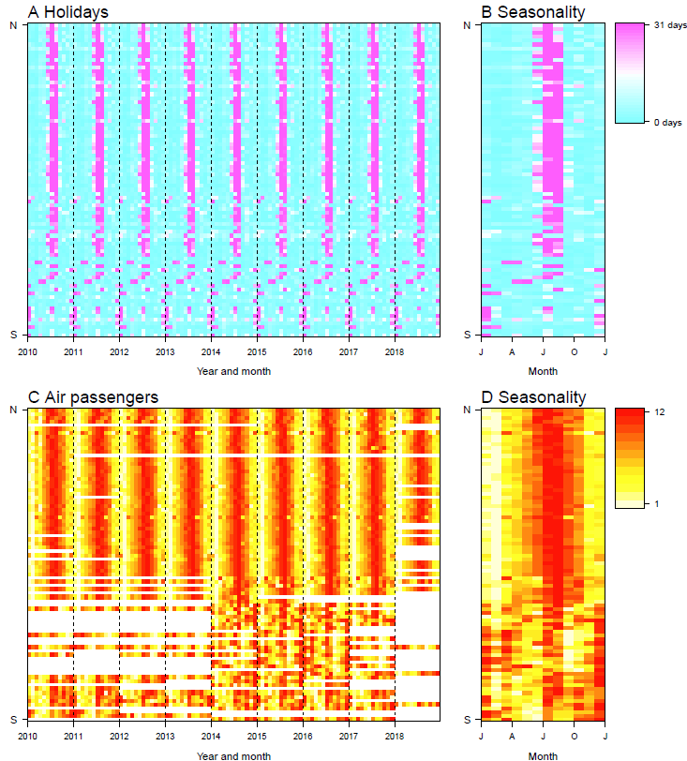

Figure S10. Seasonal patterns of holidays and air travel across 91 countries, 2010-2018.
(A) Days of public and school holidays in each month. (B) The seasonality of holidays, presented by averaged days of holidays in the same month across years. (C) The rank of monthly volume of demostic and international air passengers. The month with higher volume has a higher rank (from the lowest to the highest: 1-12) in each year. The months without data are coloured white. (D) The seasonality of air travel, presented by averaged rank for the same period across years. Each row in the heatmap represents a country/territory, sorted by the latitudes of their capitals from North to South.
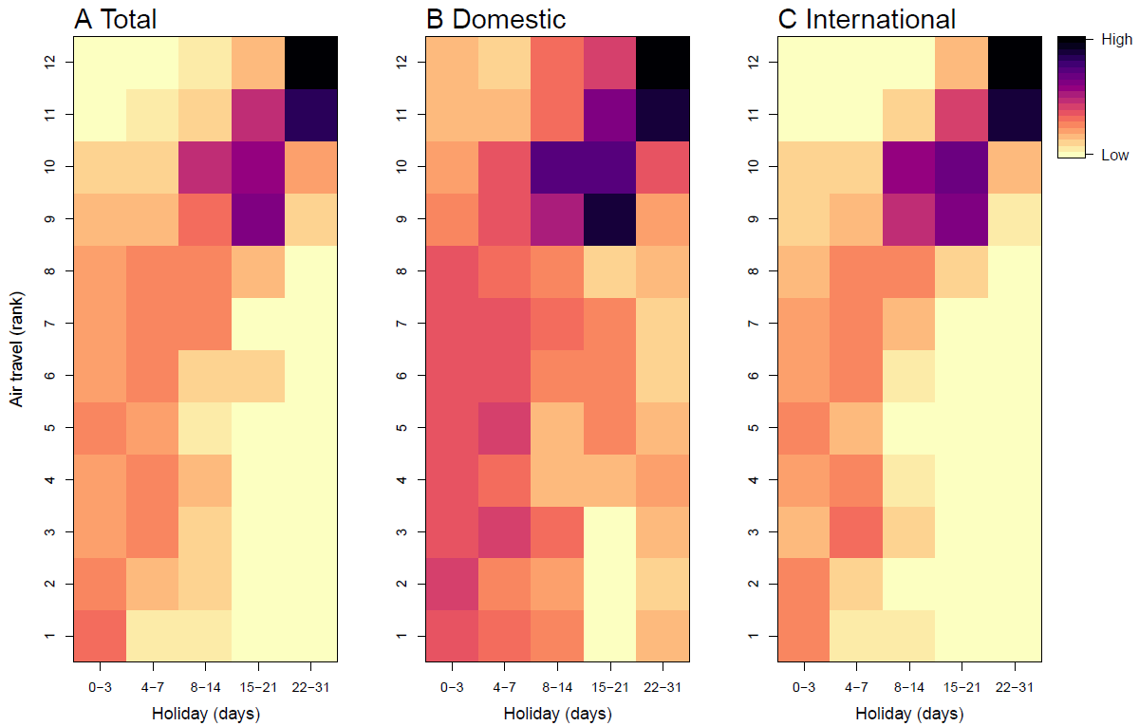

Figure S11. Correlations between days of holidays and volume of air travel on a monthly basis across 91 countries.
(A) Domestic and international travel. (B) Domestic travel. (C) International travel.

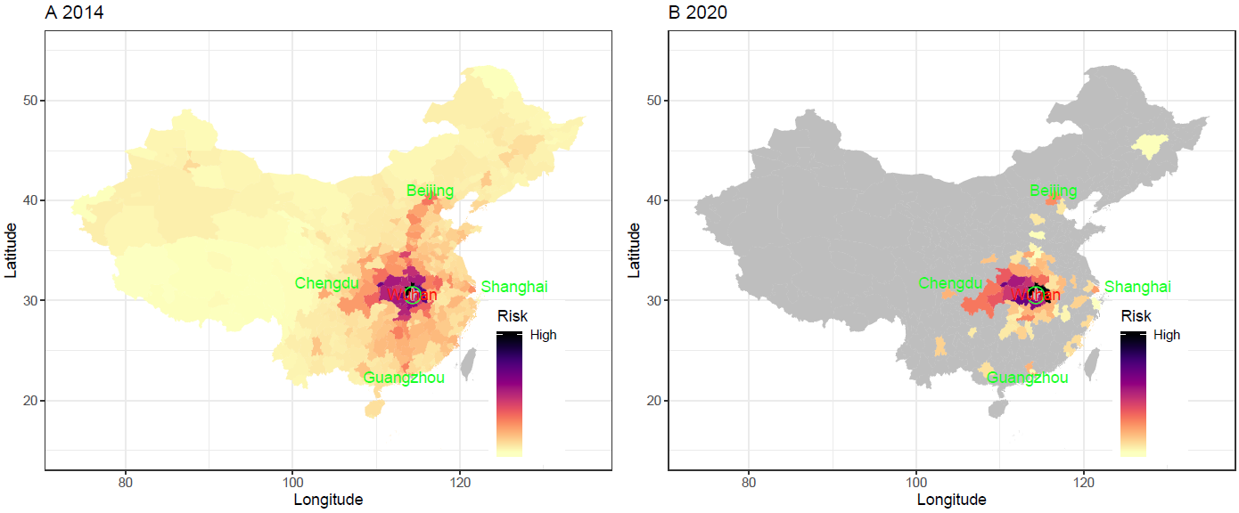

Figure S12. Estimated risks of cities in mainland China receiving travellers with 2019-nCoV infections from Wuhan during the two weeks before the city’s lockdown, based on the 2014 and 2020 Baidu data, respectively.
(A) using 2014 data. (B) using 2020 data, with the data of top 50 ranked origin and destination cities that are available on the website of Baidu Migration (https://qianxi.baidu.com/), since January 1st, 2020. The risk of importation for each destination city was preliminarily defined as the percentage of travellers received by each city out of the total volume of travellers leaving Wuhan during the two weeks before the city’s lockdown, 2 days prior to LNY’s Day.

