Supplementary information for: Modeling the Epidemic Dynamics and Control of COVID-19 Outbreak in China

Shilei Zhao^{1,2,3}, Hua Chen^{1,2,3,4,*}

¹ CAS Key Laboratory of Genomic and Precision Medicine, Beijing Institute of Genomics, Chinese Academy of Sciences, Beijing 100101, China
² China National Center for Bioinformation, Beijing 100101, China
³ School of Future Technology, University of Chinese Academy of Sciences, Beijing 100049, China
⁴ CAS Center for Excellence in Animal Evolution and Genetics, Chinese Academy of Sciences, Kunming 650223, China
*Correspondence: chenh@big.ac.cn

Supplementary data

Table S.1: Number of confirmed infections from January 20th, 2020 to February 21th, 2020
Date | Wuhan | Hubei | China | Beijing | Shanghai | Guangzhou | Shenzhen
1-20 | 258 | 270 | 291 | 5 | 2 | - | 9
1-21 | 363 | 375 | 440 | 10 | 9 | 2 | 14
1-22 | 425 | 444 | 571 | 22 | 16 | 5 | 15
1-23 | 495 | 549 | 830 | 26 | 20 | 7 | 15
1-24 | 572 | 729 | 1287 | 36 | 33 | 14 | 20
1-25 | 618 | 1052 | 1975 | 51 | 40 | 14 | 27
1-26 | 698 | 1423 | 2744 | 68 | 53 | 39 | 36
1-27 | 1590 | 2714 | 4515 | 80 | 66 | 51 | 49
1-28 | 1905 | 3554 | 5974 | 91 | 80 | 63 | 63
1-29 | 2261 | 4586 | 7711 | 111 | 101 | 79 | 86
1-30 | 2639 | 5806 | 9692 | 132 | 128 | 106 | 110
1-31 | 3215 | 7153 | 11791 | 156 | 153 | 137 | 170
2-1 | 4109 | 9074 | 14380 | 183 | 177 | 175 | 196
2-2 | 5142 | 11177 | 17236 | 191 | 193 | 189 | 226
2-3 | 6384 | 13522 | 20471 | 228 | 208 | 216 | 269
2-4 | 8351 | 16678 | 24363 | 253 | 233 | 237 | 289
2-5 | 10117 | 19665 | 28060 | 274 | 254 | 255 | 314
2-6 | 11618 | 22112 | 31211 | 297 | 269 | 284 | 334
2-7 | 13603 | 24953 | 34598 | 315 | 281 | 298 | 351
2-8 | 14982 | 27100 | 37251 | 326 | 292 | 304 | 364
2-9 | 16902 | 29631 | 40235 | 337 | 295 | 313 | 368
2-10 | 18454 | 31728 | 42708 | 342 | 302 | 317 | 375
2-11 | 19558 | 33366 | 44730 | 352 | 306 | 323 | 386
2-12 | 32994 | 48206 | 59882 | 366 | 313 | 327 | 391
2-13 | 35991 | 51986 | 63932 | 372 | 318 | 328 | 400
2-14 | 37914 | 54406 | 66576 | 375 | 326 | 335 | 406
2-15 | 39462 | 56249 | 68584 | 380 | 328 | 338 | 414
2-16 | 41152 | 58182 | 70635 | 381 | 331 | 339 | 415
2-17 | 42752 | 59989 | 72528 | 387 | 333 | 339 | 416
2-18 | 44412 | 61682 | 74279 | 393 | 333 | 339 | 416
2-19 | 45027 | 62457 | 75101 | 395 | 333 | 339 | 416
2-20 | 45346 | 63088 | 75993 | 396 | 334 | 339 | 416
2-21 | 45660 | 63454 | 76392 | 399 | 334 | 343 | 417
Data is collected from National Health Commission of China and the local Health Commissions.

Supplementary Figures

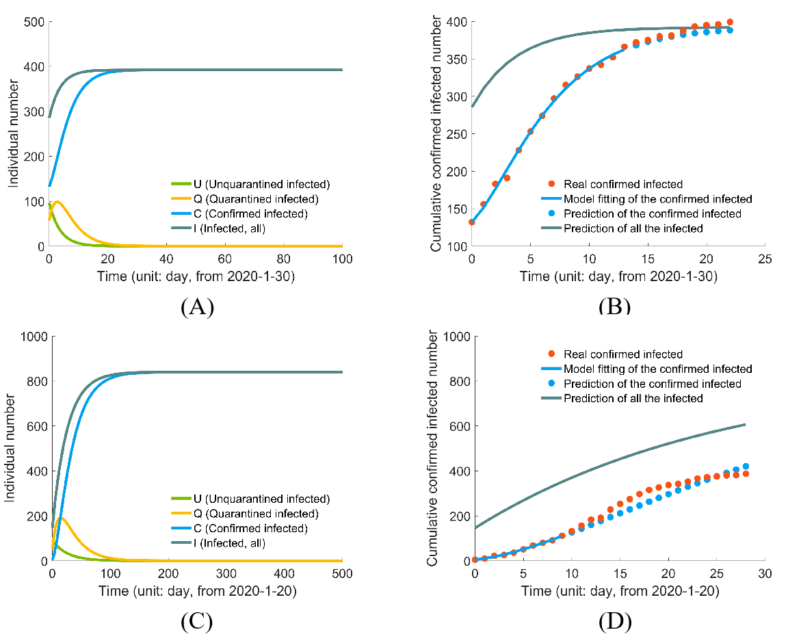
Figure S.1. Inferring epidemic dynamics in Beijing: (A) prediction using stage Ⅱ data; (B)model-fitting and testing with stage Ⅱ data. The first 15 data points (from 1-30) are used to optimize the parameters, and the remaining data points are used to test the model; (C) prediction using stage Ⅰ data; (D) model-fitting and testing with stage Ⅰ data. The first 10 data points (from 1-20) are used to optimize the parameters, the remaining data points are used to test the model.

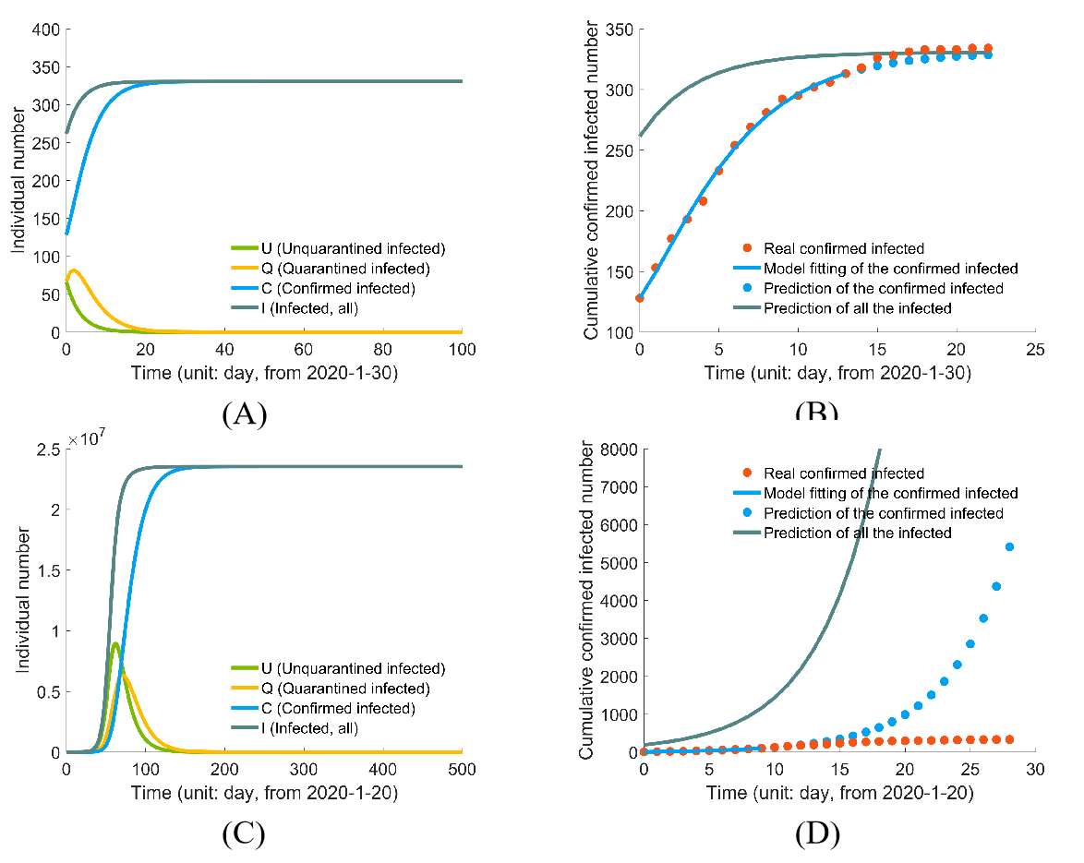
Figure S.2. Inferring epidemic dynamics in Shanghai: (A) prediction using stage Ⅱ data; (B) model-fitting and testing with stage Ⅱ data. The first 15 data points (from 1-30) are used to optimize the parameters, and the remaining data points are used to test the model; (C) prediction using stage Ⅰ data; (D) model-fitting and testing with stage Ⅰ data. The first 10 data points (from 1-20) are used to optimize the parameters, the remaining data points are used to test the model.
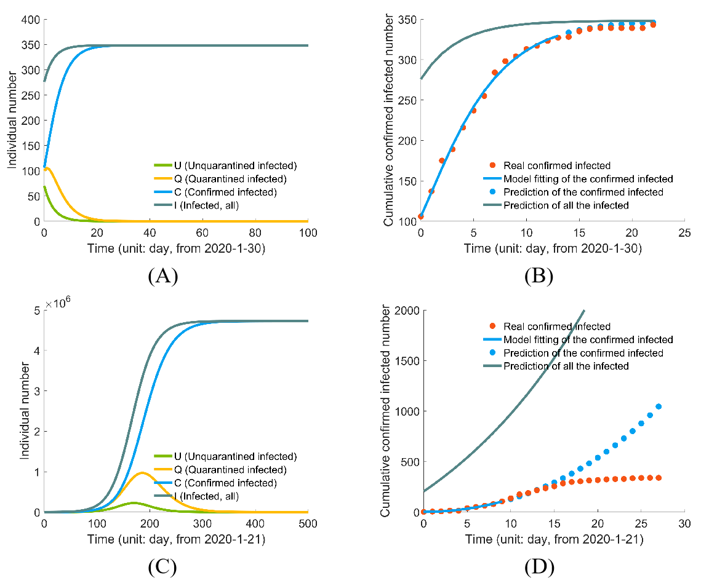
Figure S.3. Inferring epidemic dynamics in Guanzhou: (A) prediction using stage Ⅱ data; (B)model-fitting and testing with stage Ⅱ data. The first 15 data points (from 1-30) are used to optimize the parameters, and the remaining data points are used to test the model; (C) prediction using stage Ⅰ data; (D) model-fitting and testing with stage Ⅰ data. The first 10 data points (from 1-20) are used to optimize the parameters, the remaining data points are used to test the model.
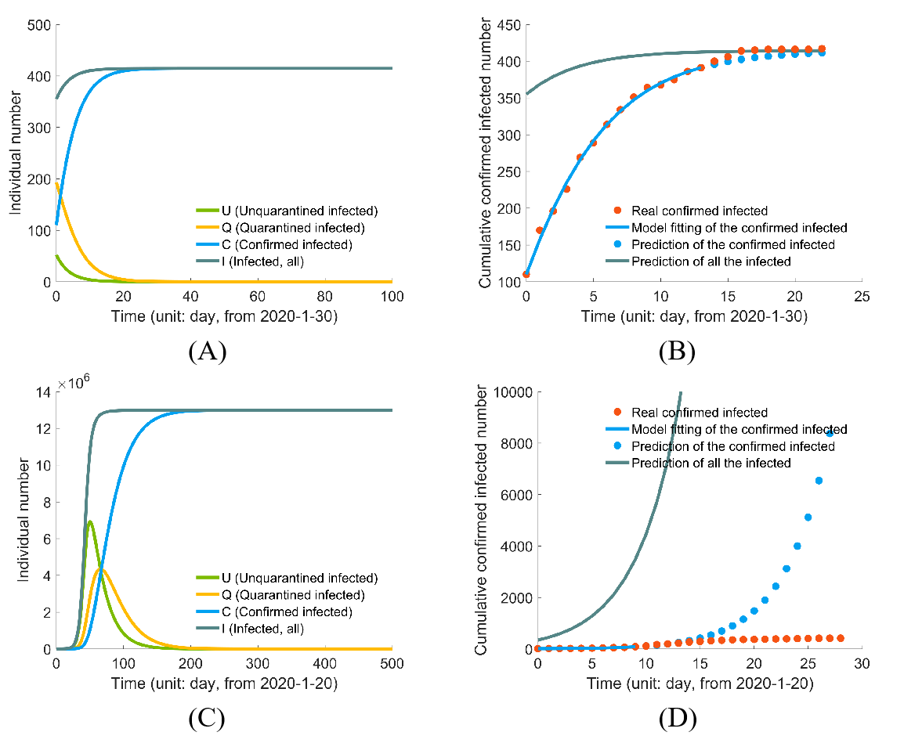
Figure S.4. Inferring epidemic dynamics in Shenzhen: (A) prediction using stage Ⅱ data; (B) model-fitting and testing with stage Ⅱ data. The first 15 data points (from 1-30) are used to optimize the parameters, and the remaining data points are used to test the model; (C) prediction using stage Ⅰ data; (D) model-fitting and testing with stage Ⅰ data. The first 10 data points (from 1-20) are used to optimize the parameters, the remaining data points are used to test the model.

Comparison of loss functions
We compared three different loss functions (see Eqns S1, S2, S3 below). The first two are weighted by the confirmed infection numbers, and the third one is the un-weighted loss function we used in the paper. The results with the three loss functions are shown in Figure S5 for China (excluding Hubei) and in Figure S6 for Hubei (excluding Wuhan). The estimated values of the final infected in China (excluding Hubei) are 13638.9891, 13621.8964, and 13322.1858 respectively. The estimations seem robust. The estimations have a larger deviation in Figure R2 with the values 19814.9048, 19523.3124, 17678.7119 respectively. The weighted loss function may better integrate information across the whole epidemic. On the other hand, the observed confirmed numbers contain more uncertainty in the early time of the epidemic for many reasons. Thus in practice, we tried different types of loss functions and chose the one according to their performance on the test data (the data points of the last several days, see Figs S5-S6 below).

The three loss functions are:
(S1)
(S2)
(S3)

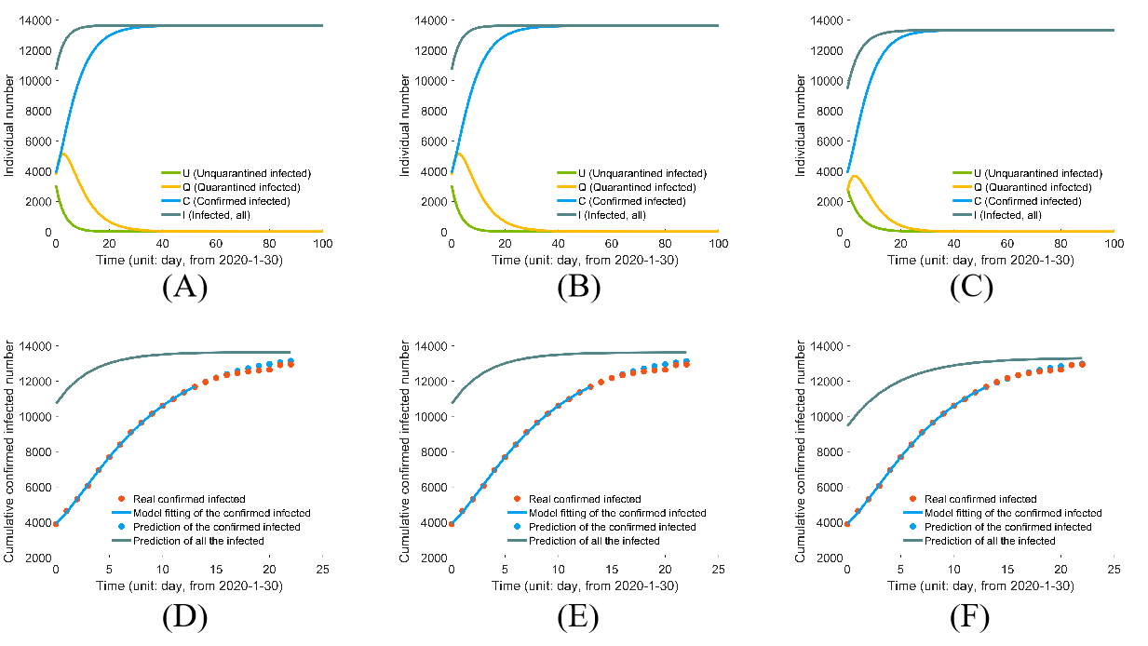
Figure S.5: Comparing the estimation of the epidemic in China (excluding Hubei) using different loss functions: (A) prediction using loss function (S1); (B) prediction using loss function (S2); (C) prediction using loss function (S3); (D) model-fitting and testing with loss function (S1); (E) model-fitting and testing with loss function (S2); (F) model-fitting and testing with loss function (S3).

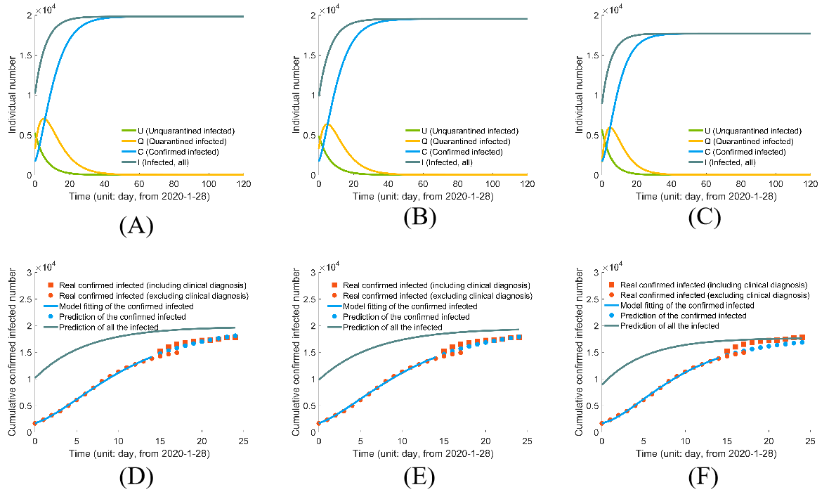
Figure S.6: Comparing the estimation of the epidemic in Hubei (excluding Wuhan) using different loss functions: (A) prediction using loss function (S1); (B) prediction using loss function (S2); (C) prediction using loss function (S3); (D) model-fitting and testing with loss function (S1); (E) model-fitting and testing with loss function (S2); (F) model-fitting and testing with loss function (S3).

