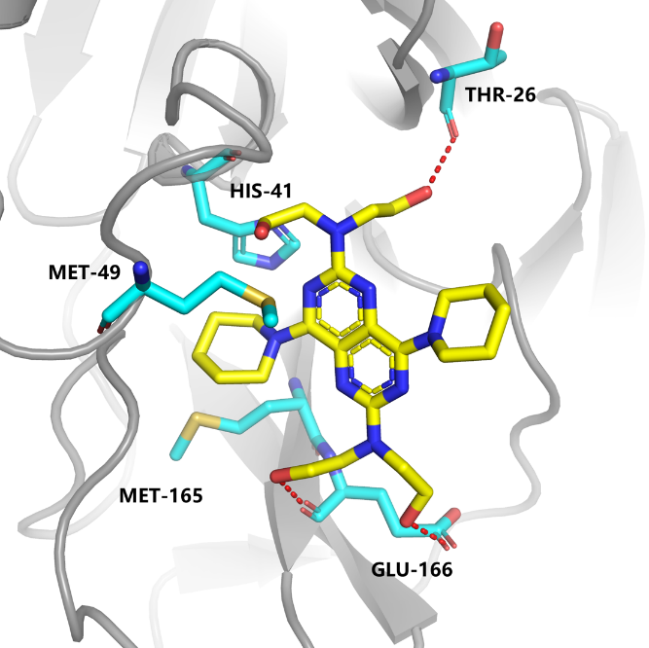
Figure S1. The putative binding pattern of dipyridamole (DIP) and the HCoV-19 protease Mpro. The main driving forces for the binding of DIP with Mpro include H-bond interactions with Glu166 and Thr26 and hydrophobic interactions with the hydrophobic pocket consisted of His41, Met49, and Met165. Red dotted line represents H-bond.

