On the treatment effect heterogeneity of antidepressants in major depression.
A Bayesian meta-analysis

Supplementary data

Studies included in quantitative synthesis
(meta-analysis)
(n = 169)
Studies included in
qualitative synthesis
(n = 169)
Studies assessed for eligibility
(n = 304)
Studies screened
(n = 522 )

Eligibility

Included

Screening

Studies excluded, no placebo group
(n = 218)

Studies excluded, outcome of interest not reported
(n = 135)

Figure 1: PRISMA 2009 Flow Diagram.

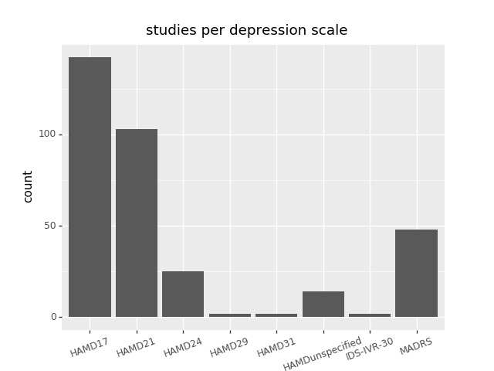
Figure 2: Boxplot depicting the number of included studies per respective depression scale.

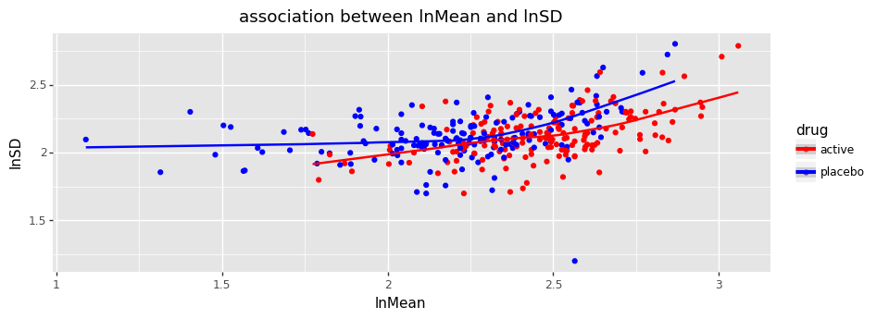
Figure 3: Association between the mean and the standard deviation of response in the treatment and the placebo group, depicted on a logarithmic scale.

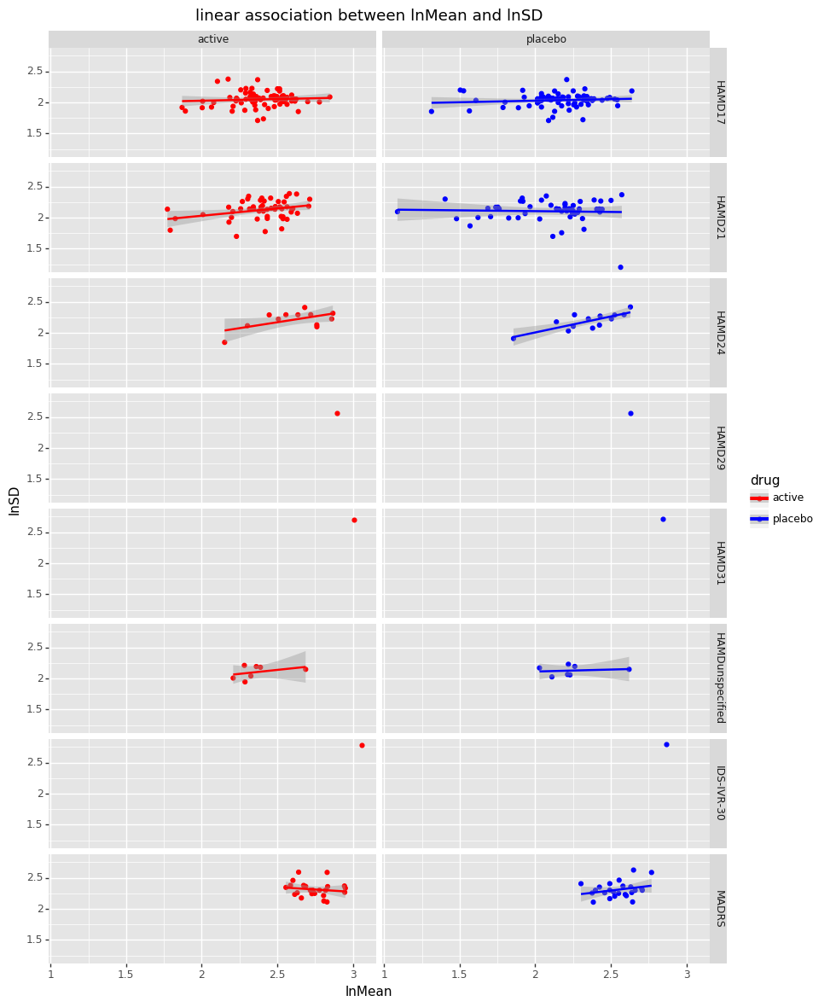
Figure 4: Logarithmic association between the mean and the standard deviation of response in the treatment and the placebo group by depression scale. As can be seen from the data, the degree of association varies between depression scales.
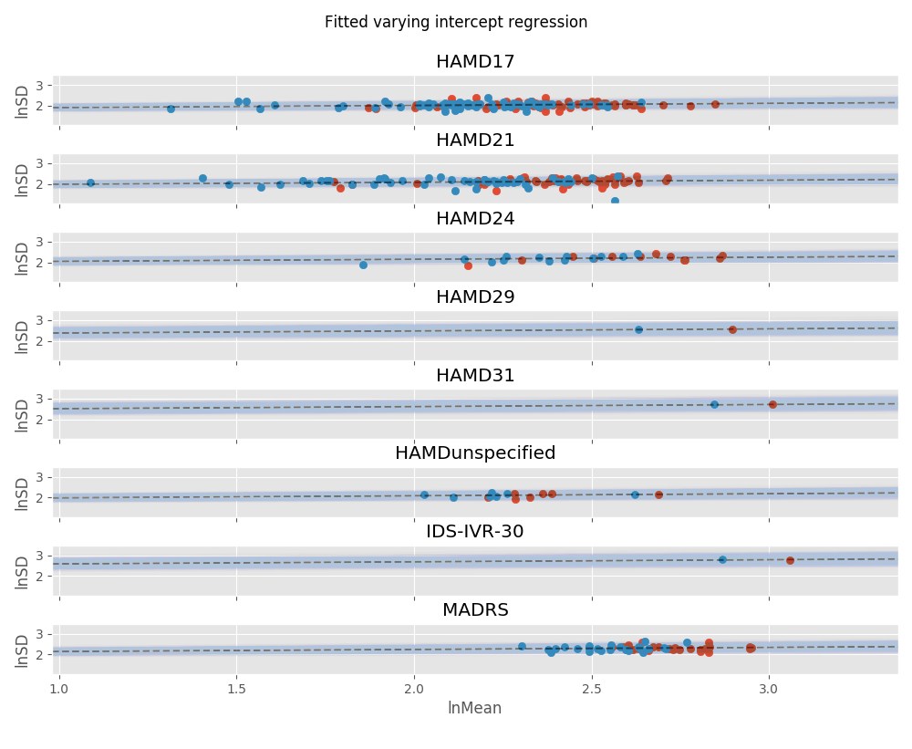
Figure 5: Fitting the same correlational slope to all depression scales, using a fitted varying intercepts regression.
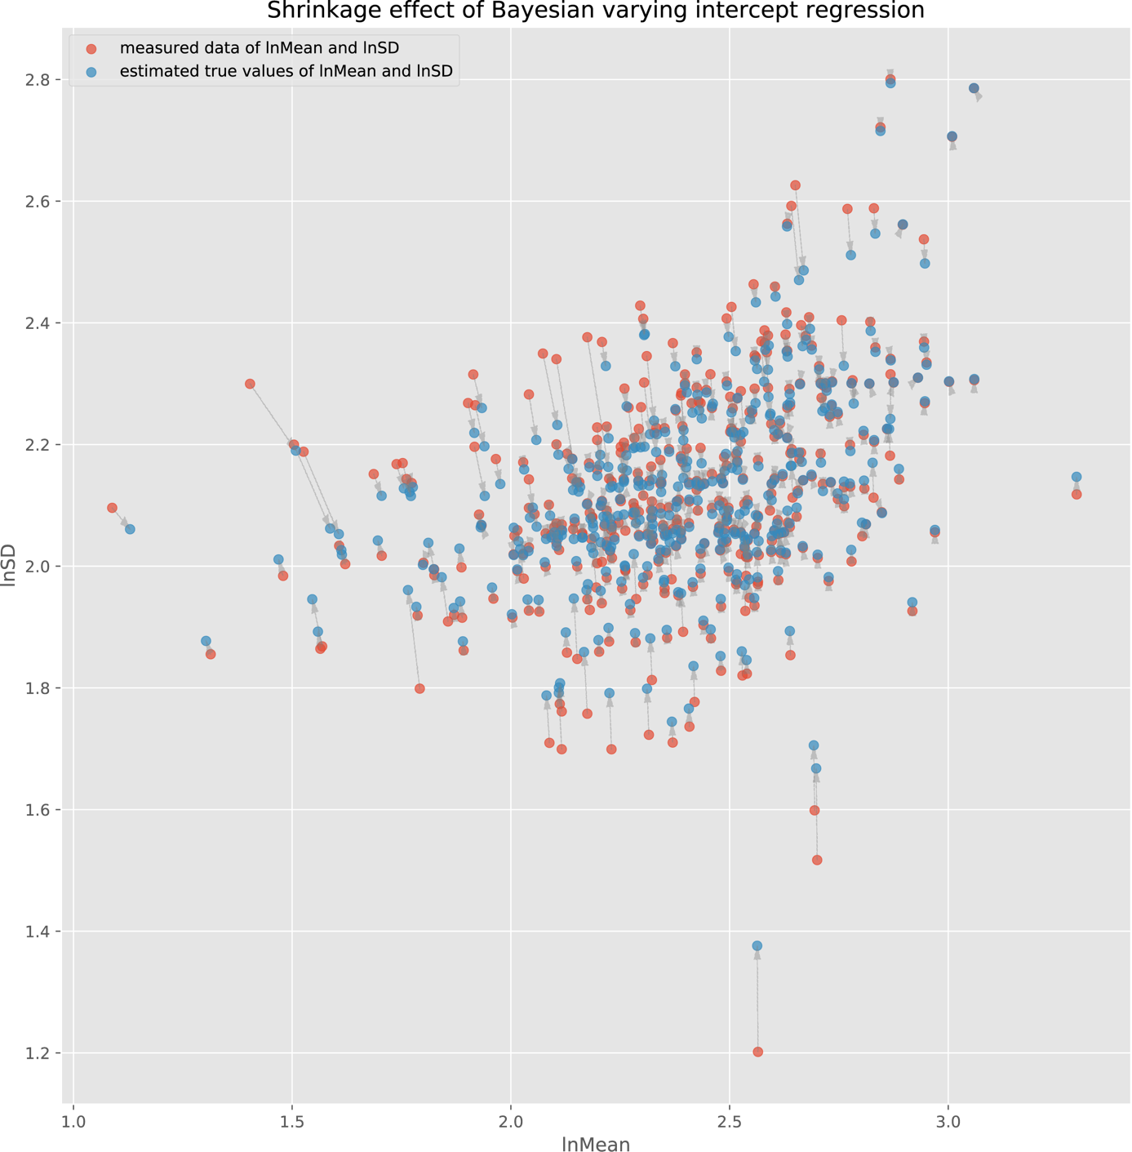
Figure 6: Shrinkage effect of Bayesian multi-level meta-regression model.

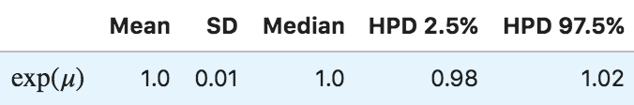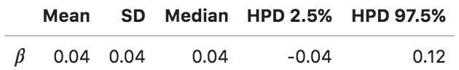
Table 1: Posterior statistics for the mu and beta coefficients of the REMR.

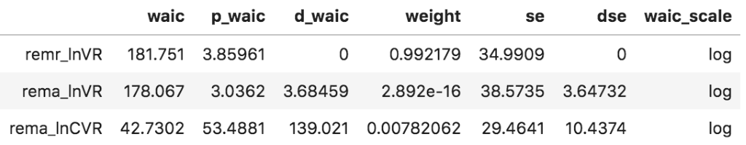
Table 2: WAIC statistics for the three different models. REMR: Random-effects meta-regression, REMA: Random-effects meta-analysis. The WAIC score signifies the pointwise prediction accuracy of fitted Bayesian models. Here, higher values of WAIC indicate a better out-of-sample predictive fit (“better” model).

