Figure S2.

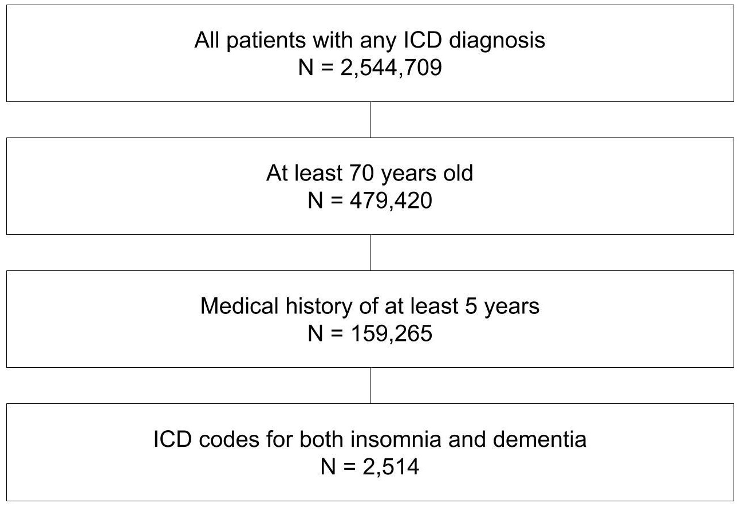

CONSORT diagram describing the inclusion criteria and resulting cohort filtration for the EHR-based insomnia and AD or dementia comorbidity analysis. We first filtered for patients that have at least one ICD code diagnosis, then for those that are at least 70 years old, and finally for those with at least five years of past clinical history in our system (which corresponds to 65 years old starting point in our data).

