C:\Users\rmjldba\OneDrive - University College London\cross-cohort\bp\analysis\output\forest_smed_dbp.tifC:\Users\rmjldba\OneDrive - University College London\cross-cohort\bp\analysis\output\forest_smed_hyper.tif

 

**Supplementary Figure 1. Education-related difference in mean diastolic blood pressure (left panels, mmHg) and hypertension prevalence (right panels, %) in midlife (42-46 years, from birth cohort data) and across adulthood (≥25 years, from repeated cross-sectional data).** Note: estimates are the Slope Index of Inequality (absolute difference in outcome between the lowest and highest educational attainment groups).

C:\Users\rmjldba\OneDrive - University College London\cross-cohort\bp\analysis\output\forest_smed_bpmed.tif 

**Supplementary Figure 2. Education-related differences in blood pressure lowering medication use (%) in midlife (42-46 years, from birth cohort data, left panel) and across adulthood (≥25 years, from repeated cross-sectional data, right panel).** Note: estimates are the Slope Index of Inequality (absolute difference in outcome between the lowest and highest educational attainment groups).

 C:\Users\rmjldba\OneDrive - University College London\cross-cohort\bp\analysis\output\forest_smed_untreated.tif 

**Supplementary Figure 3. Socioeconomic position across life and mean difference in systolic blood pressure (mmHg) in midlife (42-46 years, from birth cohort data, left panels) and across adulthood (≥25 years, from repeated cross-sectional data, right panel); without adjusting for blood pressure-lowering treatment.** Note: estimates are the Slope Index of Inequality (absolute difference in outcome between the lowest and highest educational attainment groups).

**Females (cohorts) Males (cohorts) Females (HSE) Males (HSE)**

**C:\Users\rmjldba\OneDrive - University College London\cross-cohort\bp\analysis\output\forest_smed_females.tifC:\Users\rmjldba\OneDrive - University College London\cross-cohort\bp\analysis\output\forest_smed_males.tif**

**Supplementary Figure 4. Early life socioeconomic position and mean difference in systolic blood pressure (mmHg) in midlife (42-46 years, from birth cohort data, left panels) and across adulthood (≥25 years, from repeated cross-sectional data, right panel); analyses stratified by gender.** Note: estimates are the Slope Index of Inequality (absolute difference in outcome between the lowest and highest educational attainment groups).

**Females (cohorts) Males (cohorts)**

**C:\Users\rmjldba\OneDrive - University College London\cross-cohort\bp\analysis\output\forest_fsc_females.tifC:\Users\rmjldba\OneDrive - University College London\cross-cohort\bp\analysis\output\forest_fsc_males.tif**

**…Supplementary Figure 4 continued.**

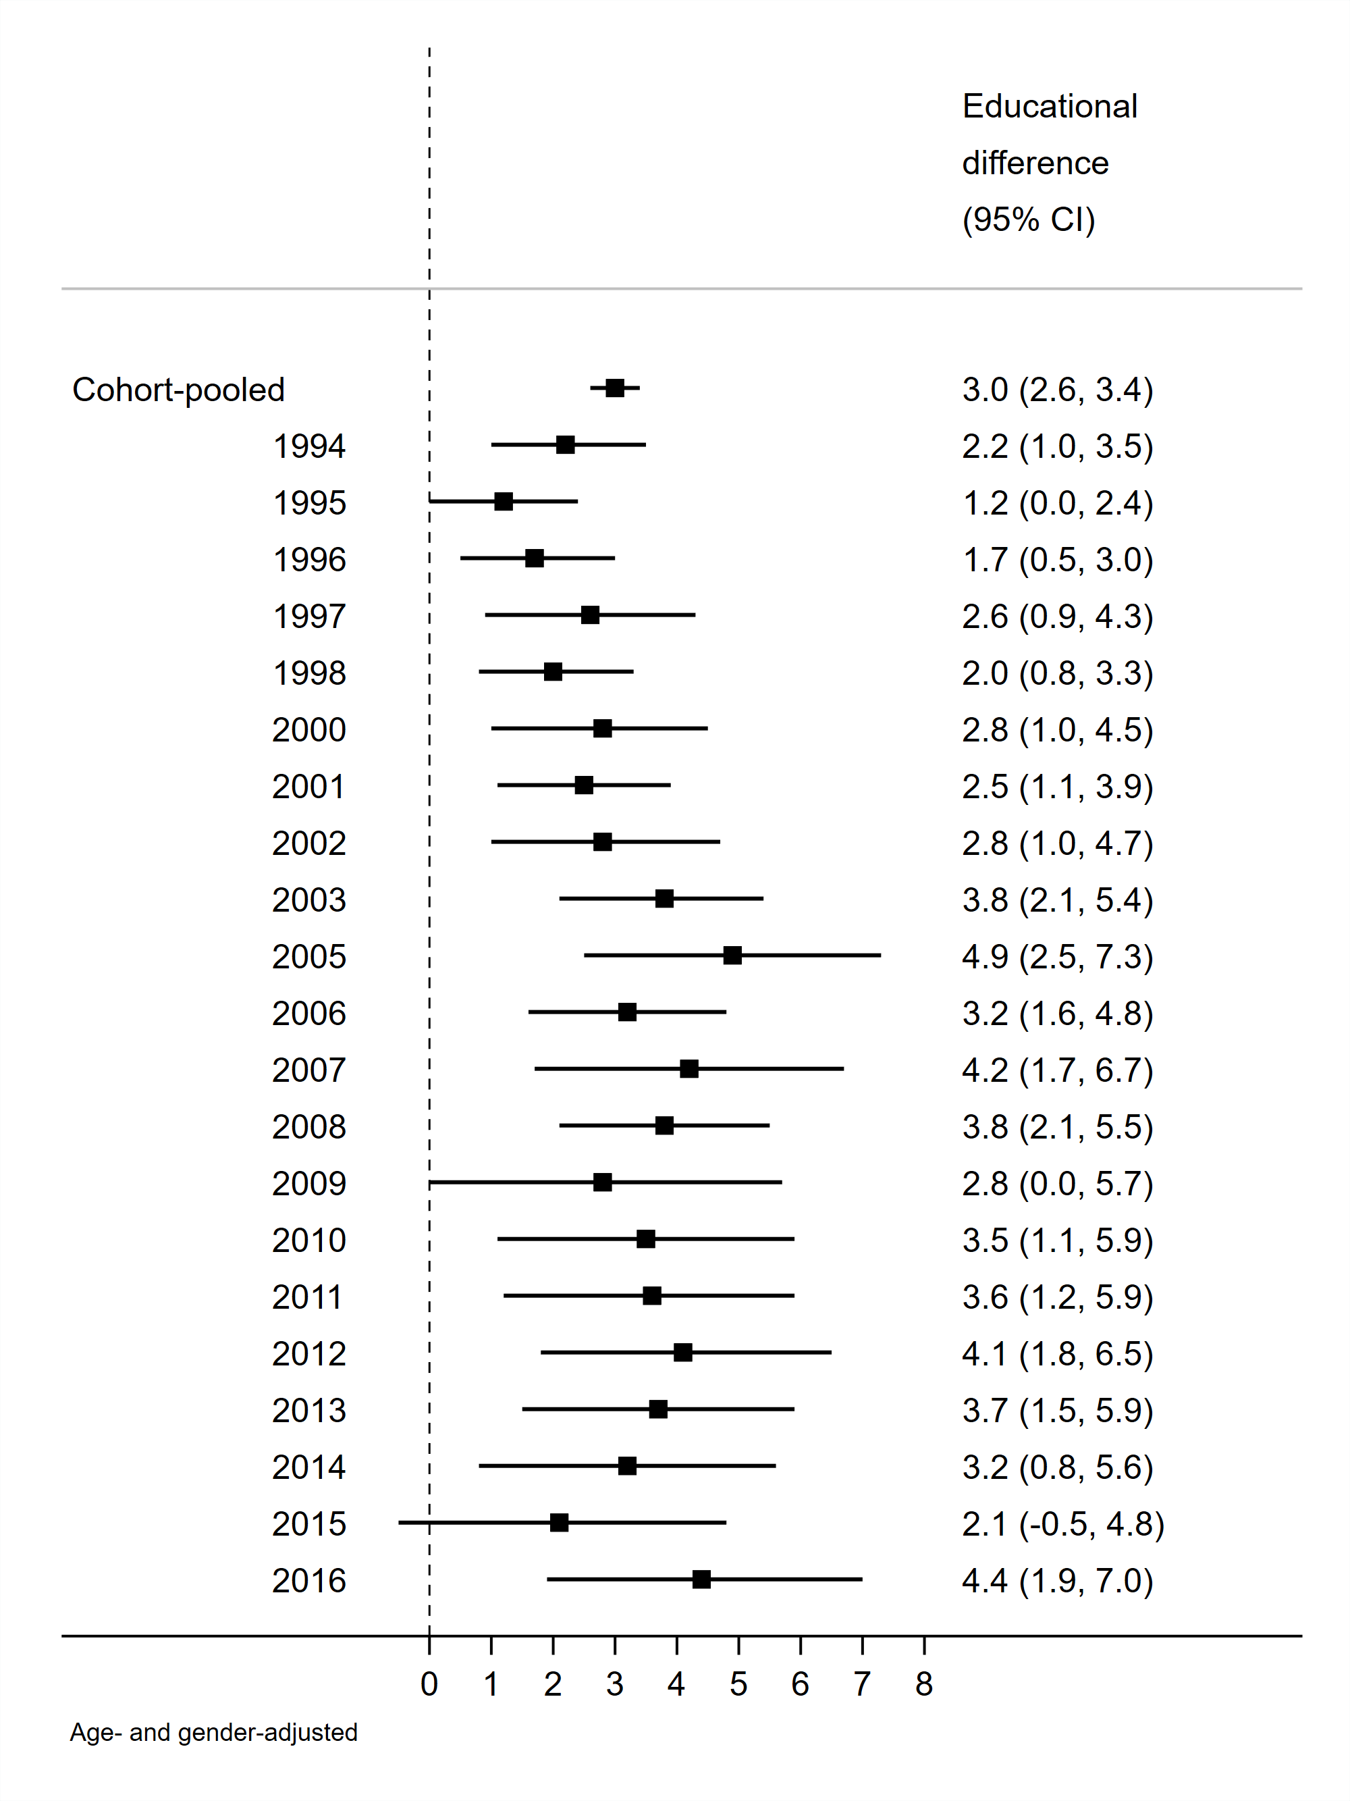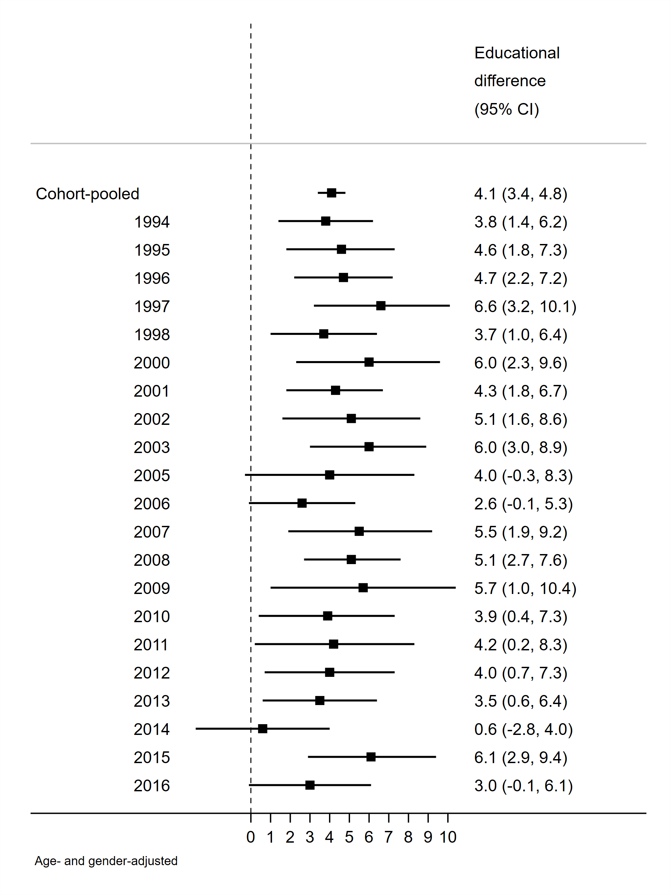

**Supplementary Figure 5. Education-related difference in mean systolic blood pressure (mmHg) in those aged 25-54 years (left panel) or 55 years and older (right panel); data from repeated cross-sectional data.** Note: estimates are the Slope Index of Inequality (absolute difference in outcome between the lowest and highest educational attainment groups).