Figure 1: symptoms associated with self-medication.

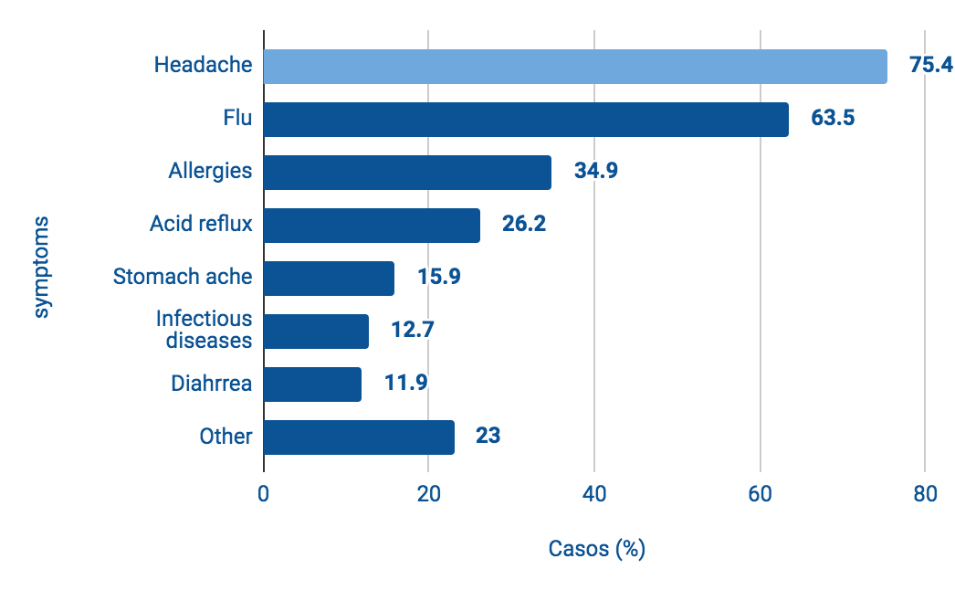

Figure 2: Sources of advice associated with self-medication
