Supplementary Information
Method

Table S1. List of inclusion and exclusion criteria for patients with knee pain and healthy pain-free controls
Inclusion criteria | Exclusion criteria
- Must have self-reported chronic knee pain (pain for most of the day and pain for >14 days/month) | - Aged < 18 years
- Must be pre-operative status | - Pregnancy
- Knee pain was their primary pain | - Major medical/neurological/psychiatric comorbidities
- Able to give informed consent | - Other significant medical condition
 | - Metallic agents embedded in body (e.g. shrapnel, aneurysm clips)

Table S2. List of medication taken by patients
Participant | Medication taken
1 | Levothyroxine, Omeprazole, iron supplement
2 | none
3 | ibuprofen (1 x 400mg 3 hours before visit), atorvastatin, lansoprazole, cetirizine
4 | fibrogel, trospium chloride
5 | atenolol 50mg, ramipril 10mg,
6 | metformin 500mg, NovoRapid FlexPen 100mg, marol 100mg, candesartan 16mg, tramadol 50mg (taken 6 hours before visit), aspirin 75mg , bendroflomethiazide 2.5mg, fenbid 5% gel, lanzoprozole 15mg, lantus 100 units, laxido orange powder sachets, paracetamol 500mg (taken 6 hours before visit)
7 | codeine phosphate 2 x 30 mg/day, simvastatin 40mg, amitriptyline 10mg, voltarol gel , paracetamol
8 | ramipril 5mg, amipril 5mg, glucosamine & cod liver oil and garlic tablet
9 | paracetamol 1000mg (>4 hours before visit)
10 | amlodipine 5mg, aspirin 75mg, beclometasone 50mg, betamethasone valerate 0.025% cream, bisoprolol 10mg, cichocaine 0.5%, fenbid 5% gel, furosemide 40mg, glyceryl trinitraide 400mg, mometasore 50mg, nicorandil 10mg & 20mg, omeprazole 20mg, ramipril 10mg, simvastatin 20mg, Tardisc XL
11 | Amitriptyline 20mg/day, Amlodipine 10mg/day, Citalopram 20mg/day, Omeprazole 20mg/day, Paracetamol 4 x 1000mg/day, Ramipril 2.5mg/day, Rizatriptan 5mg, Tramadol 4 x 100mg/day (taken 1, 4 and 14 hours before visit)
12 | Cocodamol, codeine 8mg, Acid reflux
13 | Glucoside, Omeprazole 10mg, Paracetamol 2 x 500mg (taken 2 hours before visit), Codeine 30mg (taken 2 hours before visit)
14 | Aspirin 75mg, Atorvastatin 80mg, Betahistine 16mg, Bisoprolol 2.5mg, Cetirizine 10mg, Clenil Modulite 200mg, dermol 500 lotion, Enalapril 5mg, Febuxostat 80mg, Glyceryl Trinitride 400mg, Haclan 4 microgram/sqcm - 7.5cm, Lantus 100 units/ml, Levothyroxine sodium 25mg, Metformin 500mg, Mirtazapine 15mg, Omeprazole 10mg, Paracetamol 500mg (taken 20 hours before visit), Salbutamol 100microgram, Senna 7.5mg, Quinine bisulfate 300mg, Tardisc XL
15 | Alphosyl shampoo, cetraben cream, Docusate 100mg, Hydroxyzine 25mg, ibuprofen 400mg, laxido oral powder sachet, lyrica 300mg (taken 1 and 5 hours before visit), nefopam 30mg (taken 1 and 5 hours before visit), paracetamol 500mg (taken 1 and 5 hours before visit), ranitridine 150mg, tramadol 50mg (taken 1 and 5 hours before visit)
16 | Zapain 30mg/500mg tabs, Gabapentin 300mg, Citalopram 20mg, Atorvastatin 10mg, Lansoprazole 30mg, Flecainide 50mg x 2/day, Bisoprolol 2.5mg, Aspirin 75mg
17 | metformin, lansoprazole 30mg, naproxen 500mg x2, Amitriptyline 10mg, Greenlan lancets (0.35mm/28 gauge), Gliclazide 40& 80mg, Simvastatin 40mg, Metformin 1000mg x 2/day
18 | Finasteride + doxa, atorvastatin, paracetamol (taken 23 hours before visit)
19 | statins
20 | Amitriptyline 10mg, Cetirizine 10mg, co-codamol 30mg/500mg (taken 8 hours before visit), Fenbid Forte 10/gel, Naproxen 500mg (taken 8 hours before visit), Nefopam 30mg (taken 8 hours before visit), Omeprazole 40mg, Simvastatin 40mg,
21 | Loperimide, Paracetamol 500mg x 2 (taken 14 hours before visit), Volterol (taken 15 hours before visit)
22 | livothyroxine, amitryptiline (20mg) (taken 15 hours before visit)
23 | Warfarin replacement, statin, gabapentin 500mg (taken 3 hours before visit), tramadol (taken 3 hours before visit), dihydrocodeine (1/20) (taken 3 hours before visit), ibuprofen 400mg x 2 (taken 3 hours before visit), paracetamol 500mg x 2 (taken 3 hours before visit)
24 | Blood pressure tablet, lansoprazole, paracetamol 500mg (taken 23 hours before visit)
25 | Duloxetine 30mg (taken 4 and 15 hours before visit), Amitryptiline 50mg, Docusate 100mg x 2/day, Omeprazole 20mg, Amlodipine 10mg, Atorvastatin 20mg, paracetamol 500mg max x 8, losartan 100mg
26 | Atorvastatin 80mg, Lidocaine 5% plaster (applied only at night), Paracetamol (taken 3 hours before visit), Ramipril 5mg, Aspirin 75mg, Atenolol 50mg
27 | Amlodipine, Seroxin 100mg, Bezofibrate, Omeprazole, naproxen (but not today), morphine patches (3 day), pregabalin (taken >1 hour before visit), amitriptiline
28 | Ibuprofen (taken ~12 hours before visit)
29 | Amlodipine 10mg, lansoprazole 30mg, naproxen 500mg (taken >1 hour before visit), Liptor 20mg, Paracetamol 500mg as needed, Codeine phosphate 15mg
30 | none
31 | Linzaprazole, atenolol, aspirin, feramous, Omaprazole, Cocodamol 300/500mg x 2 (taken 3 hours before visit), naproxen 50mg (taken 3 hours before visit),
32 | none
33 | Indapramide 2.5mg, Sokkarto SR 500mg, Irbesartan 300mg, Empagliflozin 10mg,, insulin
34 | none
35 | *no data
36 | Thyroxine, antihistamine, Paracetamol, ibuprofen as needed
37 | Adcal D3 750mg x 2/day, Amitriptiyline 10mg x 3/day, Aspirin 75mg, Folic acid 5mg, Hylotear 0.1% eye-drop, Methorexate 2.5mg x 1/week, Mirabegran 50mg, paracetamol (taken 3 hours before visit)
38 | Clonidine 25mg x 2 (taken >3 hours before visit)
39 | Gabapentin as needed, cortisone injections x 1-2/year
40 | paracetamol as needed, bisoprolol, statins, aspirin, Omiprazole
41 | inhaler fostair, alopurinol, salbutamol (not taken on visit day)
42 | Naproxen 500mg as needed, Omeprazole 20mg, Atrovastatin 20mg
43 | Amitriptyline 75mg, Amlodipine 5mg, Dihydrocodeine 60mg x 2 twice/day (one dose taken 8 hours before visit), Pregabalin 100mg x 3/day (100mg taken 8 hours before visit), Warfarin 3mg
44 | Paracetamol (taken ~1 hour before visit)

Pressure Algometry
Pressure pain thresholds (PPT) were assessed using a handheld pressure algometer with a 1-cm² probe (Somedic AB, Sösdala, Sweden). Pressure was increased by 30kPa/s until the subject perceived that the stimulus had changed from a pressure sensation to a painful sensation. At this point, the subject pressed a response button and the probe was withdrawn. The PPT value was then recorded as the pressure applied at the time of the button press. PPTs were recorded from two sites, one knee (the most painful knee in knee pain participants and either knee in a control) and the sternum. Specifically, the knee was assessed 2 cm distal to the infero-medial aspect of the patella and the sternum was assessed 3 cm distal to the sternal notch. After a practise assessment on either site, PPTs were recorded in triplicate. These three recordings were then averaged (per site) for further analysis. Lower PPT scores are indicative of increased pain sensitivity.

Cuff Pressure Algometry
Pain sensitivity of the deep-tissue was assessed via cuff pressure stimuli using a computer-controlled cuff algometer (NociTech and Aalborg University, Denmark). This consisted of two 13 cm single chamber tourniquet cuffs (VBM, Sulz, Germany) connected to a computer-controlled air compressor and an electronic 10 cm VAS rating system (Aalborg University). These cuffs were placed at the level of the head of the gastrocnemius muscle on either leg. The electronic VAS (sliding resistor) samples at 10 Hz, with 0 cm indicating “no pain” and 10 cm indicated “maximum pain”.

Pressure detection and tolerance threshold
One cuff at a time, pressure was increased by 1 kPa/s and the participants were instructed to rate the pain intensity of the cuff continuously on the electronic VAS until the pain tolerance level was reached. When the participants’ tolerance level was reached they were instructed to press a stop button which concluded the test and instantaneously deflated the cuff. The pressure pain detection threshold (PDT) was defined as the pressure at which the VAS score exceeded 1cm on the scale(1, 2). The pain tolerance threshold (PTT) was defined as the pressure recorded at the point the participant had to press the stop button.

Temporal Pain Summation by Cuff Algometry
Ten repeated cuff pressure stimulations (1-second duration with a 2-second inter-stimulus-interval) with an intensity equal to the PTT were applied to side of the most painful knee (in OA participants) and either leg in controls. Participants were instructed to rate the pain intensity continuously throughout the stimulation using the VAS scale and to not return the VAS slider to zero between cuff stimulations. The cuff retained a constant pressure of 5 kPa between stimulations to ensure that the cuff did not move on the leg during assessment. The VAS score immediately after each individual cuff stimulus was recorded. For subsequent analysis, the temporal summation (TS) score was calculated by subtracting the mean VAS score of the first to fourth cuff stimulations (VAS-I) from the mean VAS score of the 8th to 10th cuff stimulations (VAS-III)(2, 3).

Conditioning Pain Modulation by Cuff Algometry
The cuff on either leg was utilised to assess conditioned pain modulation (CPM). The painful conditioning stimulus was applied via the cuff to the contralateral side, with the inflation pressure set to 70% of the participants cuff PTT. PDT was then simultaneously assessed on the ipsilateral leg via the second cuff (test stimulus). CPM was then measured by subtracting the unconditioned PDT score from the conditioned PDT score. A higher CPM score indicate a larger modulatory effect of the conditioning stimulus.

Results
Component 12 vs individual QST measures
A posthoc analysis of the individual QST scores were carried out to further explore the relationship between the component 12 network and QST measures in pain patients, corrected for age and sex. The same analysis was carried out for the mean CBF of the positive loading for component 12 (that was found to be correlated to the QST factor score). Both the network score and mean CBF of Component 12 was significantly or trended to be correlated with all measures except the temporal summation score (table S3 and S4).

Table S3. Pearson correlation between component 12 and QST measures
Component 12 Network score vs: | r | p
PPT sternum | 0.41 | 0.009*
PPT knee | 0.36 | 0.021*
TS | 0.03 | 0.842
CPM | 0.29 | 0.069
PDT affected leg | 0.39 | 0.012*
PTL affected leg | 0.34 | 0.03*
PDT unaffected leg | 0.39 | 0.012*
PTL unaffected leg | 0.29 | 0.075

Table S4. Pearson correlation between component 12 mean CBF of positive loadings and QST measures
Component 12 mean CBF vs: | r | p
PPT sternum | 0.4 | 0.011*
PPT knee | 0.32 | 0.042*
TS | 0.09 | 0.603
CPM | 0.39 | 0.012*
PDT affected leg | 0.4 | 0.01*
PTL affected leg | 0.37 | 0.018*
PDT unaffected leg | 0.38 | 0.016*
PTL unaffected leg | 0.32 | 0.045*

Five discriminating components vs individual QST and affect measures
The five discriminating component network scores were correlated with the individual measures using a Pearson correlation that were included in the factor scores for QST (table 5, component 12 can be found in table 3) and affect (table 6) in pain patients, correcting for age and sex.

Table S5. Component network scores correlated with QST measures
 |  |  | PPT sternum | PPT knee | TS | CPM | PDT affected leg | PTL affected leg | PDT unaffected leg | PTL unaffected leg
Component 2 | r |  | 0.135 | 0.193 | -0.122 | 0.068 | 0.037 | 0.073 | -0.092 | 0.074
 | p |  | 0.405 | 0.233 | 0.454 | 0.676 | 0.820 | 0.655 | 0.572 | 0.650
Component 6 | r |  | -0.064 | -0.006 | -0.356 | -0.083 | 0.142 | -0.123 | 0.118 | -0.155
 | p |  | 0.696 | 0.972 | 0.024 | 0.609 | 0.381 | 0.448 | 0.469 | 0.341
Component 8 | r |  | 0.135 | -0.018 | 0.201 | 0.016 | -0.061 | 0.030 | -0.049 | -0.077
 | p |  | 0.405 | 0.911 | 0.213 | 0.920 | 0.706 | 0.856 | 0.766 | 0.637
Component 13 | r |  | -0.135 | -0.199 | 0.168 | -0.078 | -0.306 | -0.023 | -0.267 | 0.032
 | p |  | 0.405 | 0.218 | 0.299 | 0.631 | 0.055 | 0.886 | 0.096 | 0.844

Table S6. Component network scores correlated with affect measures
 |  | PCS helplessness | PCS magnification | PCS rumination | BDI-II negative thoughts | BDI-II negative behaviours | Trait anxiety (STAI-T)
Component 2 | r | -0.123 | -0.074 | -0.148 | 0.011 | -0.173 | -0.092
 | p | 0.443 | 0.648 | 0.355 | 0.946 | 0.280 | 0.568
Component 6 | r | -0.161 | 0.018 | -0.127 | -0.008 | -0.065 | -0.062
 | p | 0.313 | 0.911 | 0.429 | 0.961 | 0.688 | 0.701
Component 8 | r | 0.102 | 0.201 | 0.129 | 0.064 | -0.050 | 0.071
 | p | 0.528 | 0.208 | 0.423 | 0.689 | 0.758 | 0.657
Component 12 | r | -0.046 | 0.047 | 0.054 | -0.033 | -0.087 | -0.118
 | p | 0.773 | 0.771 | 0.739 | 0.836 | 0.589 | 0.464
Component 13 | r | 0.239 | 0.200 | 0.127 | 0.213 | 0.305 | 0.193
 | p | 0.132 | 0.211 | 0.429 | 0.182 | 0.052 | 0.227

PAG CBF Analysis
The exploratory analysis of the PAG CBF was carried out using an ROI created by combining three 6 mm spherical ROIs derived from Roy et al.(4) (spheres were centred on MNI_{xyz} coordinates 0 -24 -4; 0 -26 -6; 0 -29 -8). Group comparisons were corrected for age, sex and mean global grey matter CBF. Knee pain patients exhibited significantly greater CBF of the PAG than healthy controls (t(71)=2.74, p=.008).

Fig. S1. Mean CBF extracted from the PAG and compared between knee pain patients and healthy pain-free controls (corrected for age, sex and mean global greay matter CBF).

Medication effects
Comparison of the CBF values extracted from the unified component (positive loadings, negative loadings and remaining regions) between those on antidepressants or opioid medication and those who were not, did not yield any significant differences (all p>0.4). The correlation between the QST factor score and the CBF of component 12 positive loadings plotted below, did not reveal a systematic effect of medication (Dark blue: patients on opioid medication, Red: patients on antidepressants, Purple: patients on both opioid and antidepressant medication, Light blue: all other patients).

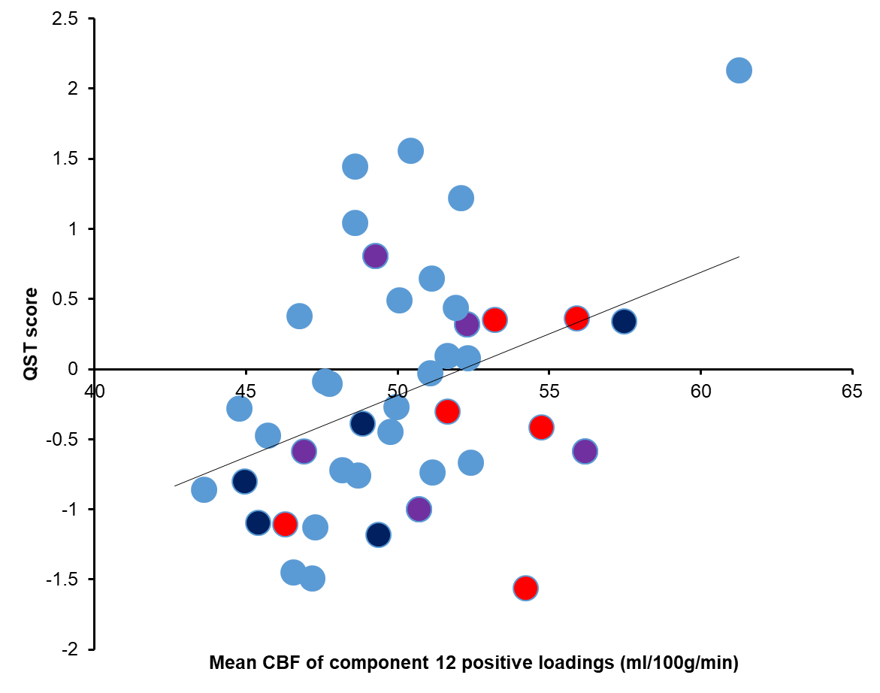

Fig. S2. Mean CBF of component 12 positive loadings colour-coded to signify patients on: opioid medication (dark blue), antidepressants (red), opioid and antidepressants (purple) and all other patients (blue).

References
1. Rathleff MS, Petersen KK, Arendt-Nielsen L, Thorborg K, Graven-Nielsen T (2016) Impaired Conditioned Pain Modulation in Young Female Adults with Long-Standing Patellofemoral Pain: A Single Blinded Cross-Sectional Study. Pain Med Malden Mass 17(5):980–988.
2. Vaegter HB, Graven-Nielsen T (2016) Pain modulatory phenotypes differentiate subgroups with different clinical and experimental pain sensitivity. Pain 157(7):1480–1488.
3. Petersen KK, et al. (2017) Age Interactions on Pain Sensitization in Patients With Severe Knee Osteoarthritis and Controls. Clin J Pain 33(12):1081–1087.
4. Roy M, et al. (2014) Representation of aversive prediction errors in the human periaqueductal gray. Nat Neurosci 17(11):1607–1612.

