**Supplementary Information**

Gender specific pharmacotherapy for blocking transition to chronic back pain: a randomized trial

Diane Reckziegel1,2, Pascal Tétreault2, Mariam Ghantous2, Kenta Wakaizumi1,3, Bogdan Petre2, Lejian Huang1,2, Rami Jabakhanji1,2,3, Taha Abdullah2, Etienne Vachon-Presseau2, Sara Berger2, Alexis Baria2, James W Griffith1,4, Marwan N Baliki1,3, Thomas J Schnitzer1,5,6, & A Vania Apkarian1,2,6,7,*

1Center for Chronic Pain and Drug Abuse, Northwestern University Feinberg School of Medicine, Chicago, USA; 2Department of Physiology, Northwestern University Feinberg School of Medicine, Chicago, USA; 3Shirley Ryan AbilityLab, Chicago, USA; 4Department of Medical Social Sciences, Northwestern University Feinberg School of Medicine, Chicago, USA; 5Department of Rheumatology, Northwestern University, Feinberg School of Medicine, Chicago, USA; 6Department of Physical Medicine and Rehabilitation, Northwestern University Feinberg School of Medicine, Chicago, USA; 7Department of Anesthesia, Northwestern University Feinberg School of Medicine, Chicago, USA

*Correspondence to:

Dr Vania Apkarian, Department of Physiology, Northwestern University, Feinberg School of Medicine, 300 E. Superior Street, Tarry Building, Chicago, IL, 60611, USA.

[a-apkarian@northwestern.edu](mailto:a-apkarian@northwestern.edu)

+1 (312) 503-0404

Supplementary Note 1. Trial development

Supplementary Note 2. Inclusion and exclusion criteria

Supplementary Note 3. Modeling risk for transition to chronic back pain

Supplementary Figure S1A-E. Model properties

Supplementary Figure S2. Residual pain trajectories for each participant

Supplementary Figure S3. Vital signs

Supplementary Figure S4. Influence of baseline characteristics on residual pain

Supplementary Table S1. Demographics.

Supplementary Table S2. Summary of available data

Supplementary Table S3. Baseline pain and pain-related questionnaire characteristics

Supplementary Table S4. Exploratory comparisons of secondary outcomes as a function of treatment type

Supplementary Table S5. Cluster membership and correlation coefficients

Supplementary Table S6. Baseline pain and pain-related questionnaire measures between males and females and as a function of the two treatment types

Supplementary Table S7. Exploratory comparisons of secondary pain measures and pain-related questionnaire outcomes at six months after treatment, in females and males as a function of treatment type

Supplementary Table S8. Baseline characteristics of blood

Supplementary Table S9. General adverse events information

Supplementary Table S10. Incidence of specific adverse events

Supplementary Table S11. Serious adverse events

Supplementary Note 4. Use of cannabinoids

References

**Supplementary note 1: Trial Development**

Clinicaltrials.gov submission receipt date: September 17, 2013

Clinicaltrials.gov first public posting data: September 26, 2013

First patient screening date: February 9, 2015

First patient dosing date: February 25, 2015

Final data collection date: September 25, 2017

**Supplementary note 2: List of inclusion and exclusion criteria**

*Inclusion criteria*

* History of low back pain with duration between 4-20 weeks (original protocol limited pain duration between 4-12 weeks; it was amended on date 1/12/2016 [IRB ID: STU00081444-MOD0013] to improve recruitment rate);
* Signs and symptoms of radiculopathy: positive straight leg raising test with dermatomal radiation and/or myotomal weakness and/or reflex asymmetry, pain must radiate into buttock or below;
* Average reported pain intensity greater than 4 (on phone NRS scale from 0 to 10) on the week before baseline assessments and the week preceding treatment.

*Exclusion criteria*

* Previous (distinct) episodes of back pain onset (more than 3 distinct episodes of back pain lasting for a total of more than 4 weeks) in the previous year;
* Evidence of acute vertebral fracture;
* Low back pain associated with any systemic signs or symptoms, e.g., fever, chills;
* Symptoms of neuropathy due to diabetes Type I or Type II;
* Chronic neurologic conditions, including Parkinson’s disease, Alzheimer’s disease, and other conditions associated with dementia;
* Significant other medical diseases such as congestive heart failure, coronary or peripheral vascular disease, chronic obstructive lung disease, or malignancy;
* History of glaucoma or narrow angle glaucoma;
* Presence of undiagnosed skin lesions or history of melanoma;
* Presence of severe cardiovascular or pulmonary disease, bronchial asthma, renal, hepatic or endocrine disease;
* History of myocardial infarction with residual cardiac arrhythmia;
* History of gastrointestinal bleeding or peptic ulcer;
* Diagnosis of current depression (assessed via BDI, total > 28 are excluded) or psychiatric disorder requiring treatment, or such a diagnosis in the previous 6 months;
* Use of therapeutic doses of antidepressant medications (i.e., tricyclic antidepressants, SSRIs, SNRIs; low doses used only in the evening for sleep will be allowed if dose is not changed;
* Current use of recreational drugs or recent history of alcohol abuse (pattern of drinking having social, financial or physical consequences) or drug abuse (urine screening);
* Current use of cannabinoids (4 participants tested positive; 3 completed the study, in these blood test at the end of the study confirmed cannabinoid use; excluding these subjects does not importantly alter results, see below);
* High dose opioid prophylaxis, defined as > 50mg morphine equivalent/day;
* Use of MAOIs, currently or within the past 2 weeks;
* Prior use of levodopa;
* Use of any of the following drugs: bromocryptine, linezolid, metoclopramide, phenothiazines, promethazine/codeine, isoniazid, rifampin, pyrazinamide;
* Oral iron supplementation;
* Currently taking levodopa or dopaminergic drugs
* In the judgment of the investigator, unable or unwilling to follow protocol and instructions
* For those receiving MRI: intra-axial implants (e.g. spinal cord stimulators or pumps), all exclusion criteria for MR safety: any metallic implants, pacemaker, brain or skull abnormalities, tattoos on large body parts, and claustrophobia;
* Pregnancy or inability to use an effective method of birth control in sexually active men and women while taking the study drug and for one week thereafter. Barrier contraceptives (condoms or diaphragm) with spermicide, intrauterine devices (IUD’s), hormonal contraceptives, oral contraceptive pills, surgical sterilization, and complete abstinence are examples of effective methods of contraception;
* Following laboratory abnormalities: liver function tests (SGOT/SGPT) greater than twice the upper limit of normal; unexplained anemia (Hgb 13.5 to 17.5 g/dL for men, 12.0 to 15.5g/dL for women); evidence of renal insufficiency (creatinine >upper limit of normal) or any other abnormality that the principal investigator feels puts the participant at risk during the study. A blood re-test could occur for all enrolled subjects within one month of the first blood draw due to potential risk for renal impairment with NSAIDs at this dosage;
* History of chronic opioid use for pain management;
* Any medical condition that in the investigator’s judgment may prevent the individual from completing the study or put the individual at undue risk.
* Contraindications to use of study product, based on any of the following:
* Hypersensitivity to carbidopa/levodopa or other constituents of the carbidopa/levodopa capsules;
* Hypersensitivity to lactose or other constituents of the placebo capsules;
* Hypersensitivity to naproxen or other constituents of the naproxen capsules;
* Hypersensitivity to acetaminophen or other constituents of the acetaminophen tablets;
* Taking concomitant medication which may be adversely affected by omeprazole to a degree that alters subject’s safety;

**Supplementary Note 3: Modeling risk for transition to chronic back pain**

The Apkarian lab previously reported ten different factors (behavioral, brain anatomical and brain physiological parameters) contributing to risk of transitioning to chronic back pain (CBP)1-6. To identify a comprehensive multivariate model for risk for chronic pain, we competed these parameters with each other in our full SBP data set from our previous longitudinal observational study, and in relation to healthy controls and CBP data. Behavioral parameters were not strong enough to contribute unique variance. Thus, we were limited to brain properties.

We wanted both an anatomical and a functional marker as a way to mitigate any idiosyncratic modality specific measurement error (e.g. subject moves their head at precisely the wrong time; that affects one modality measurement but not the other). Regional mean FA was our best and strongest predictor.1 Many of the other anatomical and functional predictors showed collinearity with FA, and thus could not be used. Functional connectivity of the hippocampus to the cortex was the most independent predictor.4 However, to protect against whole-brain artifacts we reanalyzed this result using a more constrained brain mask and searching for brain regions where degree (number of functional connections from a region to the mask; ABLM analysis7]) predicted who in the future (at different timepoints from entry visit 1, to v3 = 6 months, and to v4 = 1 year) was recovering (SBPr) or persisting (SBPp, that is transitioning to CBP). The cortical mask used was the whole limbic brain (10767 voxels) from a previous study6 in addition to the reverse inference map from neurosynth8 for the term "pain" (16752 voxels, in 2x2x2 mm space). This mask defined the voxels in which we searched for relevant functional connectivity. The mask includes sensorimotor cortex, a large section extending from supramarginal gyrus to the central opercular cortex and insula, a cluster encompassing hippocampus and amygdala, ventral frontal cortex, both laterally and medially, cingulate cortex, thalamus, ventral striatum, and rostral components of the brainstem, including the PAG. The mask is left right symmetric by design, and is dubbed limbic-pain mask. (Figure S2A).

**

**Supplementary Figure S1A:** **Model properties:** Limbic-pain mask is outlined in red.

Within the limbic-pain mask we searched for brain regional functional connections differentiating between SBPp and SBPr (n=68) defined at v4 (1 year). Results identified 3 brain regions (Figure S2B: medial prefrontal cortex (mPFC), and left and right anterior hippocampus, recapitulating previously published results.2,3,6

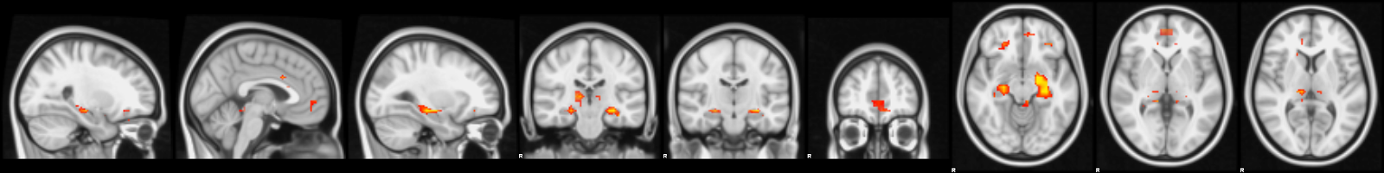

**Supplementary Figure S1B:** **Model properties:** Brain regions differentiating between SBPp and SBPr within the limbic-pain mask at V4.

Multiple regression analyses showed that using a single functional connectivity region (right hippocampus degree count, from ABLM, rHippFXN) together with mean FA was sufficient and performed adequately. We chose the lateralized ROI as it should better protect against trivial artifacts. The resultant model could adequately predict change in pain from entry to 6 months later (NRS1 – NRS3)/NRS1) at high accuracy (Figure S2C), as well as at 1 year at a similar accuracy. Importantly the two model parameters were uncorrelated (Figure S2D). The final model properties at V3 (6 months) are illustrated (Figure S2E).

*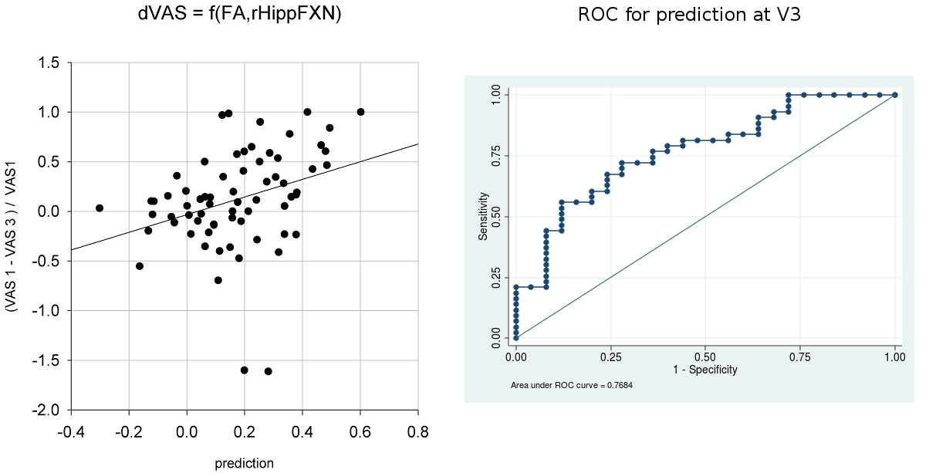***Supplementary Figure S1C:** **Model properties:** Prediction of v3 outcome by FA and rHippFXN - Notice that the receiver operating characteristic curve (ROC) shows good prediction of both persisting and recovering subjects at the extremes.

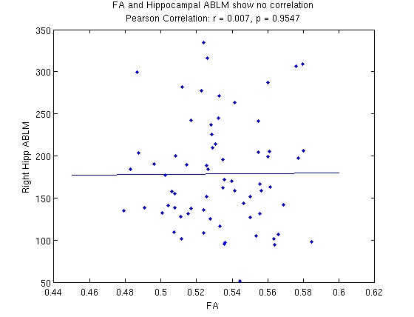

**Supplementary Figure S1D:** **Model properties:** FA and rHippFXN (degree, ABLM) are uncorrelated.

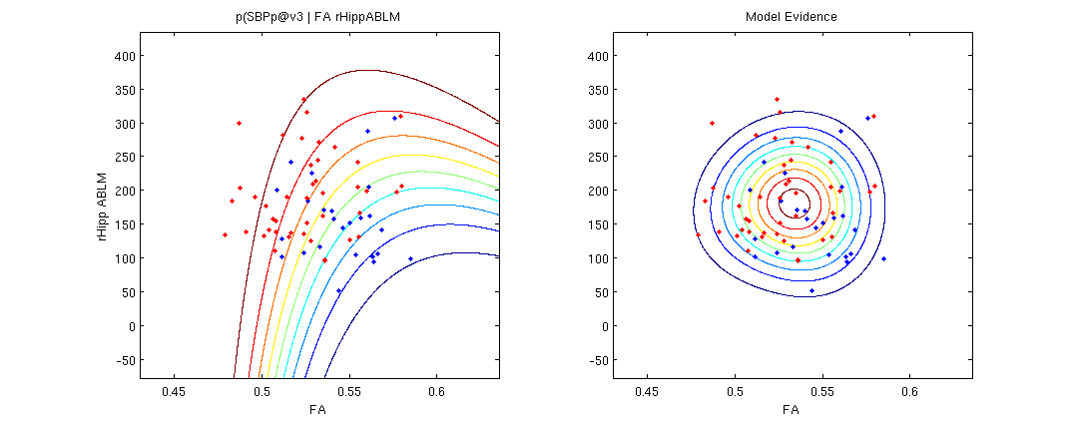

**Supplementary Figure S1E:** **Model properties:** Bayes naïve model, p( persisting @ v3 | FA, rhipp ABLM). Model evidence is shown on the right.

Thus, our final Bayes naïve classifier model employed to stratify patients in the present study used two brain markers to predict risk for CBP: These were the mean FA of white matter regions of interest: involving parts of the left superior longitudinal fasciculus, left internal and external capsules, and part of the corpus callosum, that together predicted persistence of low-back pain at one year in previous work;1 and the number of functional connectivity links (degree count, De) between the right anterior hippocampus and the limbic-pain mask. We used isotropic multivariate Gaussian fit to determine probability of recovering SBP (SBPr) relative to those with persisting SBP (that is transitioning to CBP, SBPp) from our previous longitudinal dataset. Bayes rule was used to weight these likelihoods against each other to determine probability of recovery:

$$P(rec | FA, De)=\frac{P(rec)*P(FA, De | rec) }{P\left(rec\right)*P(FA, De | rec)+P(per)*P(FA, De | per)}$$

where $P\left(rec\right)\sim 0.4$ and $P\left(per\right)= 1 – P\left(rec\right)$ correspond to the incidences of recovery and persistence in our previous longitudinal study, and constitute our empirical priors. $P(FA, De | rec)$ is the probability of recovery given FA and De, and is specified by the isotropic multivariate Gaussian fit to the original SBP subjects who recovered. Similarly, $P(FA, De | per)$ is the probability of persistence fit to the original SBP subjects who persisted in pain.

To account for FA intensity differences resulting from an upgrade in the magnetic resonance scanner that occurred since our priors' data was acquired, we calculated a linear scaling factor from healthy controls (n=11) who had undergone diffusion MRI scans before and after scanner upgrade, and this intensity correction factor was applied to FA results collected on the upgraded scanner (all data for the current study).

In the current study, every participant eligible for MRI underwent an initial brain scan, and brain derived FA and De measures were entered into the equation above to identify probability for recovery. This measure was used to stratify participants into treatment and no-treatment arms. Participants who could not be scanned were assumed to belong to the persisting category (as expected incidence rate for persisting category was ~80%) and were entered into the treatment arm.

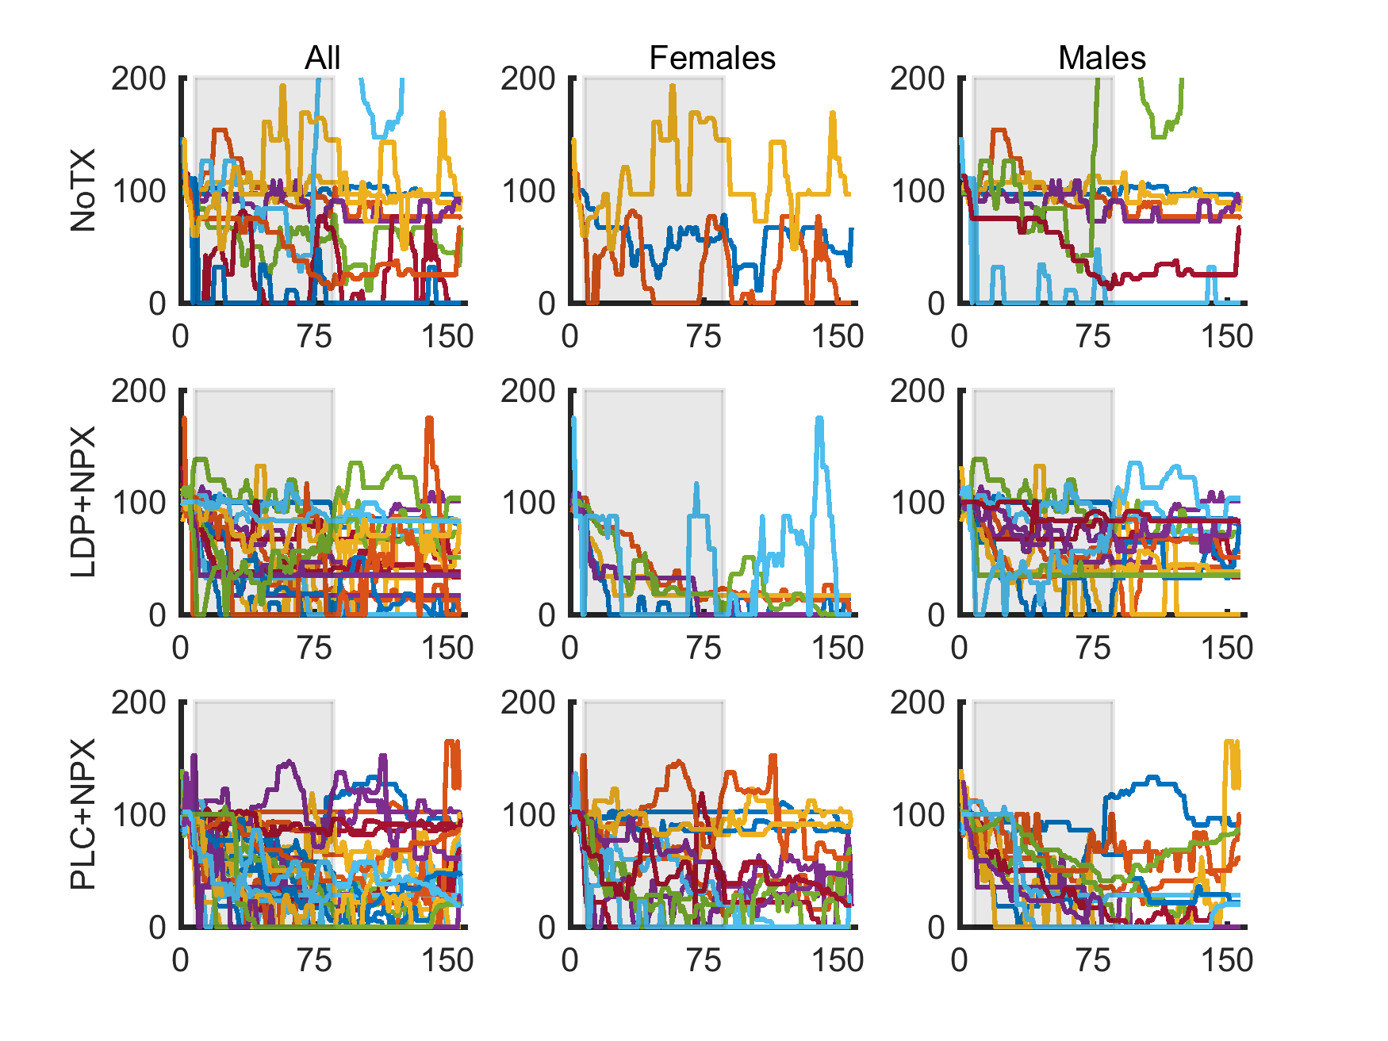

**Supplementary Figure 2.** Residual pain trajectories for each participant. The line plot depicts individual residual pain intensity trajectories over time per study arm and gender, during baseline, treatment and post-treatment observation phases (displayed are 7, 78 and 73 days of duration for each phase, respectively). Residual pain intensity presented high fluctuations at the individual level. It is also visually apparent that treatment is most efficacious in females treated with LDP+NPX, as well as in males treated with PLC+NPX. Treatment phase is indicated by grey background. LDP+NPX, levodopa/carbidopa + naproxen; PLC+NPX, placebo + naproxen; NoTx, no treatment.

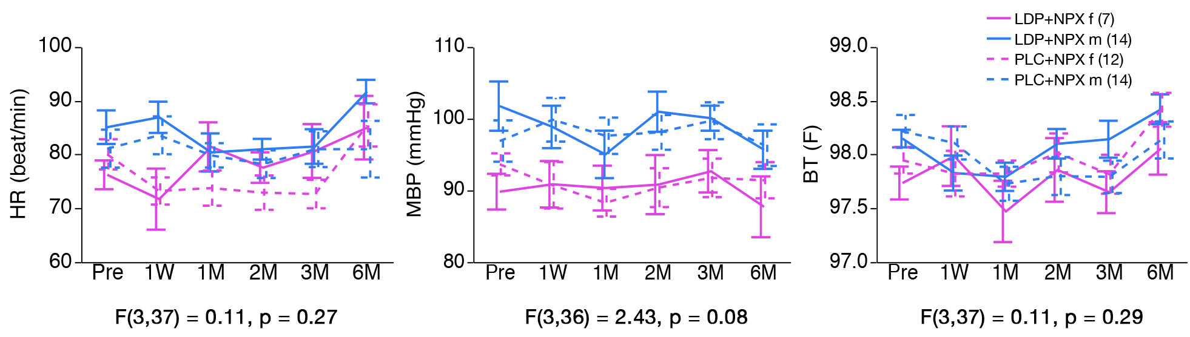

**Supplementary Figure 3.** Vital signs. The figure depicts mean trajectories of heart rate, blood pressure and body temperature for males and females in each treatment group. These parameters were not influenced by treatment. We only observe higher MBP in males. Thus, studied treatments did not influence vital signs. Baseline values (Pre) represent the average from the three visits prior to treatment. Error bars represent +/- SEM. LDP+NPX, levodopa/carbidopa + naproxen; PLC+NPX, placebo + naproxen; HR, heart rate; MPB, mean blood pressure; BT, body temperature. SEM, standard error of the mean; M, month; W, week.

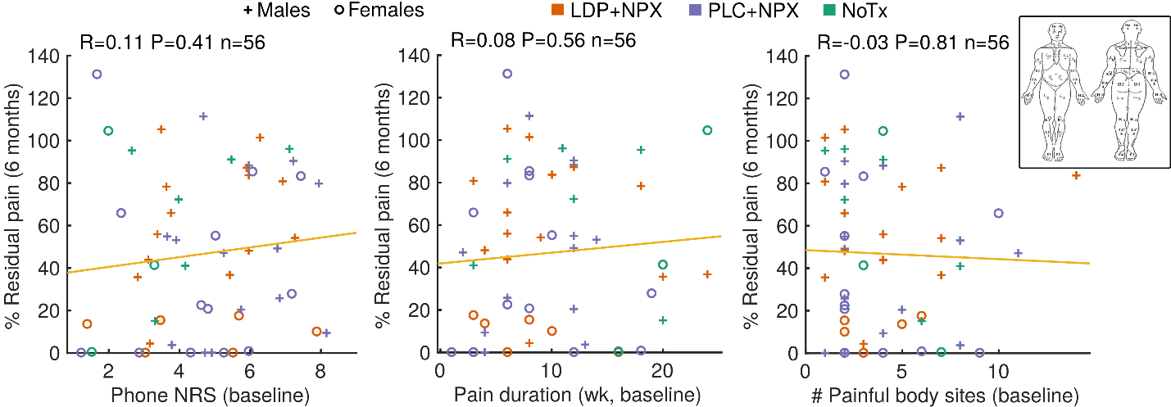

**Supplementary Figure 4.** Influence of baseline characteristics on residual pain.There was no influence of baseline pain intensity (Phone NRS 1-week average prior to start of treatment), duration of back pain (in weeks, wk, at baseline) and number of painful body sites (which always included lower back, and indicates the number of regions marked as painful on the displayed body map) on the extent of residual pain at six months from start of treatment. These results did not change when treatment subgroups were examined. Depicted are subjects from all three study arms, where orange represents LDP+NPX, purple corresponds to PLC+NPX, and green represents NoTx. LDP+NPX, levodopa/carbidopa + naproxen; PLC+NPX, placebo + naproxen; NoTx, no treatment.



**Supplementary Table 1.** Baseline demographics and patient characteristics. Mean demographic characteristics were comparable across study groups. LDP+NPX, levodopa/carbidopa + naproxen; PLC+NPX, placebo + naproxen; NoTx, no-treatment; BMI, body mass index.



**Supplementary Table 2.** Summary of available data.Most measures were available in the large majority of participants.NRS, numerical rating scale; MPQ, McGill Pain Questionnaire - Short Form: visual analog scale (MPQ/vas), sensory (MPQ/s) and affective components of pain (MPQ/a); Pain/c, current pain (PainDETECT); Pain/4w (PainDETECT), average pain over the past four weeks; PSQ, Pain Sensitivity Questionnaire: minor (PSQ/min) and moderate (PSQ/mod); PDI, Pain Disability Index; PDt, PainDETECT; PCS, Pain Catastrophizing Scale: rumination (PCS/r), magnification (PCS/m), and helplessness (PCS/h); PASS, Pain Anxiety Symptoms Scale: cognitive suffering (PASS/c), escape-avoidance behaviors (PASS/e), fear of pain (PASS/f), and physiological symptoms of anxiety (PASS/a); BDI, Beck Depression Inventory; and PANAS, Positive and Negative Affect Scale: negative (PANAS/n); BL, baseline.



**Supplementary Table 3.** Baseline pain and pain-related questionnaire characteristics. Majority of these characteristics were not different between treatment arms, only phone NRS showed a trend. One-way ANOVA. LDP+NPX, levodopa/carbidopa + naproxen; PLC+NPX, placebo + naproxen; NoTx, no-treatment; NRS, numerical rating scale (scale 0-10); MPQ, McGill Pain Questionnaire - Short Form: visual analog scale (MPQ/vas; scale 0-100), sensory (MPQ/s; scale 0-42) and affective components of pain (MPQ/a; scale 0-14); Pain/c, current pain (PainDETECT; scale 0-10); Pain/4w (PainDETECT; scale 0-10), average pain over the past four weeks; PSQ, Pain Sensitivity Questionnaire: minor (PSQ/min; scale 0-10) and moderate (PSQ/mod; scale 0-10); PDI, Pain Disability Index (scale 0-70); PDt, PainDETECT (scale 0-35); PCS, Pain Catastrophizing Scale: rumination (PCS/r; scale 0-16)), magnification (PCS/m; scale 0-12), and helplessness (PCS/h; 0-24); PASS, Pain Anxiety Symptoms Scale: cognitive suffering (PASS/c; scale 0-25), escape-avoidance behaviors (PASS/e; 0-25), fear of pain (PASS/f; 0-25), and physiological symptoms of anxiety (PASS/a; scale 0-25); BDI, Beck Depression Inventory (scale 0-63); and PANAS, Positive and Negative Affect Scale: negative (PANAS/n; scale 10-50).



**Supplementary Table 4.** Exploratory comparisons of secondary outcomes as a function of treatment type.For each scale we calculated improvement, or recovery, with treatment as: [(value at baseline – value at 6-months)/value at baseline]; where baseline value is average of 3 baseline visits. The phone NRS recovery was based on the average ratings over a week at baseline and at 6-months. Thus, positive numbers imply improvement or recovery (0.0 = no change; 1.0 = full recovery), negative numbers imply worsening. One-way ANOVA was performed for extent of recovery in all measures between LDP+NPX, PLC+NPX and NoTx, at 6 months from start of treatments (p-values not corrected for multiple comparisons). Post-hoc Tukey's test identified differences between LDP+NPX and NoTx (†p < 0.05) and PLC+NPX and NoTx (#p < 0.05). LDP+NPX, levodopa/carbidopa + naproxen; PLC+NPX, placebo + naproxen; NoTx, no-treatment; NRS, numerical rating scale; MPQ, McGill Pain Questionnaire - Short Form: visual analog scale (MPQ/vas), sensory (MPQ/s) and affective components of pain (MPQ/a); Pain/c, current pain (PainDETECT); Pain/4w (PainDETECT), average pain over the past four weeks; PSQ, Pain Sensitivity Questionnaire: minor (PSQ/min) and moderate (PSQ/mod); PDI, Pain Disability Index; PDt, PainDETECT; PCS, Pain Catastrophizing Scale: rumination (PCS/r), magnification (PCS/m), and helplessness (PCS/h); PASS, Pain Anxiety Symptoms Scale: cognitive suffering (PASS/c), escape-avoidance behaviors (PASS/e), fear of pain (PASS/f), and physiological symptoms of anxiety (PASS/a); BDI, Beck Depression Inventory; and PANAS/n, Negative Affect Scale.



**Supplementary Table 5.** Cluster membership and correlation coefficients.Identified clusters were named according to the variables they contained. LDP+NPX, levodopa/carbidopa + naproxen; PLC+NPX, placebo + naproxen; NoTx, no-treatment; NRS, numerical rating scale; MPQ, McGill Pain Questionnaire - Short Form: visual analog scale (MPQ/vas), sensory (MPQ/s) and affective components of pain (MPQ/a); Pain/c, current pain (PainDETECT); Pain/4w (PainDETECT), average pain over the past four weeks; PSQ, Pain Sensitivity Questionnaire: minor (PSQ/min) and moderate (PSQ/mod); PDI, Pain Disability Index; PDt, PainDETECT; PCS, Pain Catastrophizing Scale: rumination (PCS/r), magnification (PCS/m), and helplessness (PCS/h); PASS, Pain Anxiety Symptoms Scale: cognitive suffering (PASS/c), escape-avoidance behaviors (PASS/e), fear of pain (PASS/f), and physiological symptoms of anxiety (PASS/a); BDI, Beck Depression Inventory; PANAS, Positive and Negative Affect Scale: negative (PANAS/n).



**Supplementary Table 6.** Baseline pain and pain-related questionnaire measures between males and females as a function of the two treatment types. NRS, which reflects the level of pain during study visits, was lower in LDP+NPX females than PLC+NPX females at baseline [two-way ANOVA (p=0.02), with post-hoc Tukey test, *p < 0.05], however these groups did not differ in any other baseline characteristics, including other pain intensity measures.LDP+NPX, levodopa/carbidopa + naproxen; PLC+NPX, placebo + naproxen; NoTx, no-treatment; NRS, numerical rating scale; MPQ, McGill Pain Questionnaire - Short Form: visual analog scale (MPQ/vas), sensory (MPQ/s) and affective components of pain (MPQ/a); Pain/c, current pain (PainDETECT); Pain/4w (PainDETECT), average pain over the past four weeks; PSQ, Pain Sensitivity Questionnaire: minor (PSQ/min) and moderate (PSQ/mod); PDI, Pain Disability Index; PDt, PainDETECT; PCS, Pain Catastrophizing Scale: rumination (PCS/r), magnification (PCS/m), and helplessness (PCS/h); PASS, Pain Anxiety Symptoms Scale: cognitive suffering (PASS/c), escape-avoidance behaviors (PASS/e), fear of pain (PASS/f), and physiological symptoms of anxiety (PASS/a); BDI, Beck Depression Inventory; PANAS, Positive and Negative Affect Scale: negative (PANAS/n). Note the NoTX arm was not used in gender comparisons.



**Supplementary Table 7.** Exploratory comparisons of secondary pain measures and pain-related questionnaire outcomes at six months after randomization, in females and males as a function of treatment type. For each scale we calculated improvement, or recovery, with treatment as: [(value at baseline – value at 6-months)/value at baseline]; where baseline value is average of 3 baseline visits. The phone NRS recovery was based on the average ratings over a week at baseline and at 6-months. Thus, positive numbers imply improvement or recovery (0.0 = no change; 1.0 = full recovery), negative numbers imply worsening. Groups differ significantly or show a tendency for difference in the extent of improvement across all pain intensity outcome measures, with LDP+NPX females presenting larger recovery from pain. Two-way ANOVAs (p-values not corrected for multiple comparisons) and post-hoc Dunnett's tests. *p < 0.05, **p < 0.01, compared to LDP+NPX females. LDP+NPX, levodopa/carbidopa + naproxen; PLC+NPX, placebo + naproxen; NRS, numerical rating scale; MPQ, McGill Pain Questionnaire - Short Form: visual analog scale (MPQ/vas), sensory (MPQ/s) and affective components of pain (MPQ/a); Pain/c, current pain (PainDETECT); Pain/4w (PainDETECT), average pain over the past four weeks; PSQ, Pain Sensitivity Questionnaire: minor (PSQ/min) and moderate (PSQ/mod); PDI, Pain Disability Index; PDt, PainDETECT; PCS, Pain Catastrophizing Scale: rumination (PCS/r), magnification (PCS/m), and helplessness (PCS/h); PASS, Pain Anxiety Symptoms Scale: cognitive suffering (PASS/c), escape-avoidance behaviors (PASS/e), fear of pain (PASS/f), and physiological symptoms of anxiety (PASS/a); BDI, Beck Depression Inventory; PANAS, Positive and Negative Affect Scale: negative (PANAS/n).



**Supplementary Table 8.** Baseline characteristics of blood. Groups did not differ in baseline blood characteristics (one-way ANOVA). WCC, white blood cell count; RCC, red blood cell count; HGB, hemoglobin; HCT, hematocrit; PC, platelet cell count; UN, urea nitrogen; AST, asparate aminotransferase; ALT, alanine aminotransferase; ALP, alkaline phosphatase; IU, international units; LDP+NPX, levodopa/carbidopa + naproxen; PLC+NPX, placebo + naproxen; NoTx, no-treatment.



**Supplementary Table 9.** General adverse events information. There were no differences in the overall incidence of adverse events between treatment arms. In particular, the number of AEs related to medication did not differ between LDP+NPX and PLC+NPX. Fisher's exact test. LDP+NPX, levodopa/carbidopa + naproxen; PLC+NPX, placebo + naproxen; Tx, treatment; AE, adverse event.



**Supplementary Table 10.** Incidence of specific adverse events. Incidence of specific adverse events did not differ between LDP+NPX and PLC+NPX. Depicted are events that occurred in at least two patients in any one of the treatment arms. Percentages are calculated based number of subjects. Fisher’s exact test. LDP+NPX, levodopa/carbidopa + naproxen; PLC+NPX, placebo + naproxen.



**Supplementary Table 11.** Serious adverse events.Five serious adverse events were experienced by three participants. Only one of these subjects completed the study; he experienced worsening angina and coronary artery disease at the end of treatment phase but chose to continue participation. One male subject developed esophageal varices during the post-treatment phase and was discontinued from the study due to non-compliance. A female participant became pregnant during the treatment period. She stopped treatment, was discontinued from the study, and at a later date had a miscarriage. All SAEs were judged to be unrelated to the medication. Percentage of cases was computed based on number of subjects in the related study arm. SAE, serious adverse event; LDP, levodopa/carbidopa; NPX, naproxen.

**Supplementary Note 4.** Use of Cannabinoids.

Four participants tested positive for cannabinoids. One discontinued the study and three completed study participation. All these three participants received PLC+NPX. In order to verify whether cannabinoids impacted our findings, we repeated the main statistics involving PLC+NPX after excluding these subjects. Results are as follows:

- Figure 1b: Fisher's exact test (LDP+NPX vs PLC+NPX): P=1 (originally)

P=0.7 (after exclusions)

Fisher's exact test (treated vs NoTx): P=0.12 (originally)

P=0.16 (after exclusions)

- Figure 1c: Mann-Whitney U test (LDP+NPX vs PLC+NPX): P=0.5 (originally)

P=0.4 (after exclusions)

Mann-Whitney U test (treated vs NoTx): P=0.07 (originally) P=0.07 (after exclusions)

- Figure 2b: ANOVA gender*treatment interaction: F(1,43)=8.16, P=0.007 (originally)

F(1,40)=7.41, P=0.01 (after exclusions)

Mann-Whitney U test (LDP+NPX females vs PLC+NPX females): P=0.06 (originally)

P=0.09 (after exclusions)

Mann-Whitney U test (LDP+NPX males vs PLC+NPX males): P=0.06 (originally)

P=0.06 (after exclusions)

Thus, our main findings were not impacted by participants using cannabinoids.

REFERENCES

1. Mansour, A.R.*, et al.* Brain white matter structural properties predict transition to chronic pain. *Pain* **154**, 2160-2168 (2013).

2. Baliki, M.N.*, et al.* Corticostriatal functional connectivity predicts transition to chronic back pain. *Nat Neurosci* **15**, 1117-1119 (2012).

3. Mutso, A.A.*, et al.* Reorganization of hippocampal functional connectivity with transition to chronic back pain. *J Neurophysiol* **111**, 1065-1076 (2014).

4. Mutso, A.A.*, et al.* Abnormalities in hippocampal functioning with persistent pain. *J Neurosci* **32**, 5747-5756 (2012).

5. Petre, B.*, et al.* Smoking increases risk of pain chronification through shared corticostriatal circuitry. *Hum Brain Mapp* **36**, 683-694 (2015).

6. Vachon-Presseau, E.*, et al.* Corticolimbic anatomical characteristics predetermine risk for chronic pain. *Brain* **139**, 1958-1970 (2016).

7. Mansour, A.*, et al.* Global disruption of degree rank order: a hallmark of chronic pain. *Sci Rep* **6**, 34853 (2016).

8. Yarkoni, T., Poldrack, R.A., Nichols, T.E., Van Essen, D.C. & Wager, T.D. Large-scale automated synthesis of human functional neuroimaging data. *Nat Methods* **8**, 665-670 (2011).