**Supplemental Figure 1-7**  
**S1 Fig. RNA electrophoresis, amplification curve of qRT-PCR and standard curve of control cDNA  
S2 Fig. Hierarchical clustering and volcano plot for differentially expressed lncRNA profiles in the Screening Cohort  
S3 Fig. LncRNA expressions between clinically diagnosed PTB patients and non-TB disease controls in the Selection and Validation Cohorts  
S4 Fig. AUC values of support vector machine models for clinically diagnosed PTB cases versus non-TB disease controls  
S5 Fig. qPCR analysis of *ENST00000497872* expression in BCG-infected THP-1 cells**

**S1 Fig.** **RNA electrophoresis, amplification curve of qRT-PCR and standard curve of control cDNA**.

(A), RNA electrophoresis. Marker: DNA marker (100~2000bp).

(B), Amplification curve of qRT-PCR. The left set of amplification curves indicates the endogenous control *GAPDH*, and the right set of amplification curves indicates the lncRNA gene.

(C), Standard curve of control cDNA.Cq values (i.e., crossing points) are plotted versus the log10 [cDNA quantity]. Some information for the standard curve: Y = -3.252 X + 36.524, R2 = 0.9973, reaction efficiency = 2.030, error = 0.0154.



**S2 Fig. Hierarchical clustering and volcano plot for differentially expressed lncRNA profiles in the Screening Cohort.**

(A), Heatmap of lncRNA profile generated by hierarchical clustering. Pink bar, clinically diagnosed PTB patients with negative MTB evidence, herein referred to as NPTB for short; cyan bar, healthy subjects (HS, for short). Downregulated lncRNAs are depicted in green and upregulated in orange.

(B), Volcano plot. The signal values were distributed in the corresponding area after the data normalization. The green dots and orange dots are significantly down- and upregulated lncRNA distributions, respectively.



**S3 Fig. LncRNA expressions between clinically diagnosed PTB patients and non-TB disease controls in the Selection and Validation Cohorts.** Clinically diagnosed PTB patients with negative MTB evidence, herein referred to as NPTB for short. *ENST00000497872* and *n333737* show statistical significance (p-value < 0.0001 after age-adjustment for both the Selection and Validation Cohorts) in group comparison, and n335265 indicates a p-value of 0.080 and 0.110 in the Selection Cohort and Validation Cohort, respectively. These error bar plots demonstrate the median and interquartile range. Mann-Whitney U test was used to compare the differences between groups.

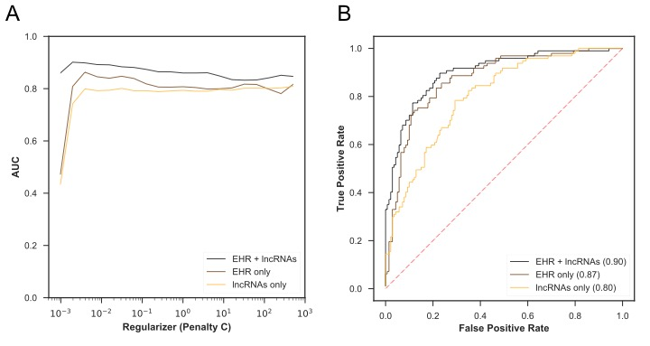 **S4 Fig. AUC values of support vector machine models for clinically diagnosed PTB cases versus non-TB disease controls.**

(A), AUC values in the validation set of the Selection Cohort with tuning parameter Penalty C. Penalty C is a regularization parameter, which aims to trade off the misclassification of training examples against the simplicity of the decision surface and to reduce the redundancy between features. The hyper-parameter set with a maximum AUC in the validation set was finally used to establish the models.

(B), AUC values of different models in the independent Validation Cohort.

../../流式%20和参考文献/1%20Supplemental%20Figure%208%20lncRNA%20AL.pdf

**S5 Fig. qPCR analysis of *ENST00000497872* expression in BCG-infected THP-1 cells.** Following infection with BCG from 6 h to 72 h, the relative expression level of *ENST00000497872* (named lnc AL, for short) was significantly elevated in LV-lnc AL cells and reduced in shRNA-lnc AL cells. Negative control group, BCG treated THP-1 cells with stably expressing LV-control or shRNA-control; shRNA-lnc AL group, BCG treated THP-1 cells with stably expressing shRNA-lnc AL; LV-lnc AL group, BCG treated THP-1 cells with stably overexpressing LV-lnc AL.

The expression results of lnc AL in BCG treated THP-1 cells with stably expressing LV-control and shRNA-control are similar, and the average values of these two kinds of negative controls are regarded as the values in the negative control; Blank control (BCG treated THP-1 cells) was not shown in the figure. Results shown are the average of triplicate experiments.