Supplementary Table 1: Number of skin disease cases in Atwima Mponua district between January–October 2023 (pre-intervention period) and November 2023–September 2024 (intervention period)
Skin disease: | Number of skin disease cases:
Skin disease: | Pre-intervention  period | Intervention  period
Skin disease: | CHPS facilities & health centres* | CHPS facilities & health centres† | District hospital‡
Any skin disease | 3 192 | 7 458 | 3 296
By specific skin disease:
Complex wound | 24 | 478 | 623
Inflammatory dermatosis | 976 | 616 | 778
Ringworm | 102 | 1 085 | 149
Scabies | 15 | 1 398 | 18
Any other skin disease:
Buruli ulcer | 0 | 1 | 0
Leprosy | 0 | 2 | 0
Yaws (confirmed) | 0 | 5 | 0
Yaws (unconfirmed) | 6 | 18 | 0
Any other wound | 1 169 | 893 | 235
Any other non-wound | 900 | 2 962 | 1 493

Notes: Buruli ulcer, leprosy and yaws (confirmed) defined as cases recorded on skin NTD01 form with confirmed (positive) diagnosis. Yaws (unconfirmed) diagnosis defined as clinical diagnosis of ‘Yaws’ recorded in consulting room register only. *: Total of 103 618 person-years at risk: 3 facilities with missing data (6, 7 and 9 months respectively) and 13 facilities with no missing data (10 months). †: Total of 120 933 person-years at risk: 16 facilities with no missing data (11 months). ‡: total of 23 070 person-years at risk: 1 facility with no missing data (11 months).

Supplementary Table 2: Incidence of skin diseases in Atwima Mponua district at district hospital versus CHPS facilities and health centres, within intervention period (November 2023–September 2024)
Intervention period
(District hospital versus CHPS facilities and health centres)
 | Incidence rate  (95% CI)  District hospital | Crude IRR*  (95% CI) | Adjusted IRR†  (95% CI)
 | Intervention | Crude IRR*  (95% CI) | Adjusted IRR†  (95% CI)
Any skin disease | 142.9 (138.1, 147.8) | 0.43 (0.41, 0.45) | 0.42 (0.41, 0.44)
By specific skin disease:
Complex wound‡ | 27.0 (25.0, 29.2) | 0.15 (0.13, 0.16) | 0.14 (0.12, 0.16)
Inflammatory dermatoses§ | 33.7 (31.4, 36.2) | 0.15 (0.14, 0.17) | 0.15 (0.13, 0.17)
Ringworm | 6.46 (5.50, 7.58) | 1.39 (1.17, 1.65) | 1.38 (1.16, 1.63)
Scabies | 0.8 (0.5, 1.2) | 14.81 (9.31, 23.59) | 14.51 (9.11, 23.10)
Any other skin disease | 74.9 (71.45, 78.52) | 0.43 (0.40, 0.45) | 0.42 (0.40, 0.45)
By patient characteristic:
Sex:
Male | 113.7 (107.8, 119.9) | 0.53 (0.50, 0.56) | 0.53 (0.49, 0.56)
Female | 174.1 (166.5, 182.0) | 0.36 (0.34, 0.38) | 0.35 (0.33, 0.37)
Age group:
PSAC (0-4 years) | 213.5 (198.0, 230.2) | 0.69 (0.63, 0.75) | 0.69 (0.63, 0.75)
SAC (5-17 years) | 79.0 (72.8, 85.8) | 0.62 (0.57, 0.69) | 0.62 (0.57, 0.68)
Young adult (18-39 years) | 126.2 (118.5, 134.4) | 0.32 (0.29, 0.34) | 0.32 (0.29, 0.34)
Older adult (≥40 years) | 214.4 (202.0, 227.6) | 0.25 (0.23, 0.27) | 0.25 (0.23, 0.27)
Place of residence:
Very rural | [Insufficient observations] |  | -
Rural | 23.1 (20.4, 26.1) | 2.37 (2.08, 2.69) | -
Urban | 95.5 (88.87, 102.56) | 0.66 (0.60, 0.71) | -

IRR = incidence rate ratio; CI = confidence interval, PSAC = Pre-school age children, SAC = School age children. Incidence is expressed as cases per 1,000 resident population per year. *: Total of 10 754 observations. Missing data for sex (n=32); age group (n=113); place of residence (n=3 011). †: Total of 10 619 observations, mutually adjusted for patient sex and age group only. ‡: Defined as a recorded diagnosis of [Dermatitis] or [Pruritus] at CHPS facility or health centre; or a relevant [ICD-10 code] diagnosis at district hospital. §: Defined as an individual with two or more records of [Wound] or [Ulcer] within a two week period (pre-intervention: CHPS facility or health centre); an individual registered on a ‘wound tracker’ OR an individual recorded in OPD register with two or more records of [Wound] or [Ulcer] within a two week period (intervention: CHPS facility or health centre); or an individual with two or more diagnostic or procedural codes classified as wound or ulcer related within a two week period (intervention: district hospital).
Supplementary Table 3: Prevalence of any skin disease amongst cross-sectional survey participants in Atwima Mponua district; July–September 2024
Characteristic: | Participant with skin disease | Survey prevalence | Age (years) | Sex (male) | Known to health system* | ICC
Characteristic: | n= | /10 000 persons  (95% CI) | Median (IQR) | % | % | ICC
Any skin disease | 2 393 | 559.1 (537.5, 581.3) | 10 (5, 24) | 53.0 | 30.2 | 0.10
Non skin-NTD:
Inflammatory dermatoses | 105 | 24.5 (20.1, 29.7) | 18 (12, 42) | 42.9 | 32.4 | 0.13
Ringworm | 1 094 | 255.1 (240.4, 270.5) | 10 (6, 18) | 58.6 | 23.2 | 0.15
Scabies | 570 | 133.2 (122.5, 144.5) | 9 (4, 21) | 49.1 | 35.4 | 0.31
Skin NTD:
Buruli ulcer | 1 | 0.2 (0.01, 1.3) | 56 (-) | 0 | 100.0 | -
Leprosy | 5 | 1.2 (0.4, 2.7) | 39 (37, 56) | 60.0 | 60.0 | -
Active yaws | 8 | 1.9 (0.8, 3.7) | 10.5 (8.5, 13) | 50.0 | 0 | 0.80
Wound:
Wound (traumatic) | 194 | 45.3 (39.2, 52.2) | 14 (8, 43) | 59.3 | 28.4 | 0.18
Wound (non-traumatic)† | 48 | 11.2 (8.3, 14.9) | 42.5 (15, 55) | 54.2 | 62.5 | 0.26
Other:
Any other skin disease‡ | 525 | 112.7 (112.4, 133.5) | 9 (3, 24) | 46.2 | 38.7 | 0.13

*: Defined as those reporting current or ever receiving care from a health facility for the reported skin disease. †: Includes cases suspected for buruli ulcer (ulcerative) and suspected active yaws (ulcer). ‡: Includes cases suspected for scabies only but negative final diagnosis (n=1), or leprosy only but negative final diagnosis (n=2)

Supplementary Table 4: Mean and median financial cost of care seeking for patients with skin NTDs and complex wounds, by patient characteristics and visit time point
Characteristic: | Before index visit |  | During and after index visit |  |  |  |  |  | Regression analysis
Characteristic: |  |  | Study facility |  | Non-study facility |  | Combined
Characteristic: | Mean | Median | Mean | Median | Mean | Median | Mean | Median | Coefficient* | p-value
Sex:
Female | 800.35 | 150 | 155.63 | 70 | 352.4 | 162.65 | 196.03 | 76.46 | REF | -
Male | 849.48 | 206.33 | 189.99 | 79.09 | 262.07 | 110 | 229.82 | 100 | -0.11 | 0.624
Age:
<18 | 361.07 | 75 | 103.01 | 25 | 170.16 | 227.18 | 113.46 | 29 | REF | -
18-60 | 1033.41 | 187.62 | 204.34 | 100 | 328.1 | 110 | 256.15 | 125 | 1.42 | <0.001
>60 | 802.89 | 172 | 230.05 | 133.93 | 272.11 | 69 | 294.5 | 144.93 | 1.18 | 0.011
Occupation:
None | 680.20 | 170.24 | 147.86 | 47.5 | 214.33 | 196.53 | 166.57 | 54.92 | REF | -
Casual | 510.00 | 510 | 41.17 | 10 | 0 | 0 | 41.17 | 10 | -1.18 | 0.171
Informal | 930.67 | 161 | 192.86 | 100 | 328.05 | 105 | 246.3 | 120 | -0.09 | 0.781
Formal | 0 | 0 | 236 | 60 | 300 | 300 | 278.86 | 80 | -0.79 | 0.37
Accessed care with NHIS:
No | 419.1 | 95 | 186.84 | 99.09 | 114.89 | 40 | 203.55 | 99.09 | REF | -
Yes | 1062.93 | 340 | 169.88 | 70 | 382.71 | 196.53 | 220.2 | 95 | 0.45 | 0.077
Wealth quintile:
Poorest | 841.92 | 177.5 | 179.53 | 70 | 278.05 | 196.53 | 221.43 | 95 | REF | -
Poorer | 740.35 | 170.24 | 137.92 | 63.73 | 231.64 | 50 | 182.96 | 80.23 | -0.05 | 0.884
Middle | 1090.67 | 800 | 142.29 | 60 | 577.22 | 326.67 | 189.74 | 60 | -0.60 | 0.096
Richer | 1953.24 | 190.21 | 190.37 | 110 | 182.29 | 125 | 221.18 | 110 | -0.26 | 0.471
Richest | 218.88 | 108 | 225.73 | 96.14 | 419.19 | 231.57 | 260.66 | 99.09 | 0.12 | 0.745
Number of visits:
<4 visits | 598.74 | 100 | 78.83 | 20 | 131.5 | 90 | 85.34 | 20 | REF | -
4 to 10 visits | 546.79 | 340 | 215.06 | 128 | 366.4 | 312 | 232.11 | 130 | 1.19 | <0.001
>10 | 1646.01 | 1600 | 306.49 | 180 | 754.18 | 312 | 413.17 | 230 | 1.94 | <0.001
Constant | - |  | - |  |  |  |  |  | 2.36 | <0.001
R-squared | - |  | - |  |  |  |  |  | 0.2 | -
F-test | - |  | - |  |  |  |  |  | 6.66 | <0.001
N | 49 |  | 361 |  | 49 |  | 361 |  | 361
Total: | 826.42 | 170.24 | 175.05 | 75 | 295.25 | 112 | 215.12 | 98.19 | -

* Adjusted coefficients are from a semi-log regression of the association between total financial cost and patient characteristics.

Supplementary Table 5: Total patient costs, by visit time point and cost type
Cost type | Cost category | n | Mean | Median | 25th percentile | Interquartile | 75th percentile | Minimum | Maximum | Zero cost | Missing | Toral N (n+Missing)
Before index visit
Medical expenditure | Sub-total | 43 | 581.35 | 100 | 6 | 494 | 500 | 0 | 10000 | 9 | 6 | 49
 | Consultation | 41 | 339.51 | 0 | 0 | 50 | 50 | 0 | 10000 | 27 | 8 | 49
 | Drugs | 39 | 222 | 40 | 0 | 150 | 150 | 0 | 2000 | 17 | 10 | 49
 | Wound dressing | 39 | 62.05 | 0 | 0 | 10 | 10 | 0 | 1000 | 29 | 10 | 49
Non-medical expenditure | Sub-total | 41 | 222.15 | 28 | 0 | 200 | 200 | 0 | 3100 | 12 | 8 | 49
 | Food/Accommodation | 40 | 48.77 | 0 | 0 | 5.5 | 5.5 | 0 | 1300 | 29 | 9 | 49
 | Transportation | 40 | 178.93 | 20 | 0 | 137 | 137 | 0 | 1800 | 11 | 9 | 49
Total financial cost (medical and non-medical) [A] | Sub-total | 43 | 793.16 | 108 | 30 | 770 | 800 | 0 | 10324 | 5 | 6 | 49
Total financial cost (imputed) |  | 49 | 826.42 | 170.24 | 50 | 850 | 900 | 0 | 10324 | 4 | 0 | 49
Productivity loss [B] | Sub-total | x | x | x | x | x | x | x | x | x | x | x
Total cost [A+B] | Total | 43 | 793.16 | 108 | 30 | 770 | 800 | 0 | 10324 | 5 | 6 | 49
During and after index visit (study facility)
Medical expenditure | Sub-total | 334 | 102.84 | 20 | 0 | 120 | 120 | 0 | 1930 | 146 | 27 | 361
 | Consultation | 320 | 26.13 | 0 | 0 | 0 | 0 | 0 | 1930 | 261 | 41 | 361
 | Drugs | 318 | 46.23 | 0 | 0 | 30 | 30 | 0 | 1700 | 206 | 43 | 361
 | Wound dressing | 327 | 34.51 | 0 | 0 | 30 | 30 | 0 | 750 | 227 | 34 | 361
Non-medical expenditure | Sub-total | 357 | 72.58 | 20 | 0 | 84 | 84 | 0 | 1440 | 145 | 4 | 361
 | Food/Accommodation | 342 | 5.06 | 0 | 0 | 0 | 0 | 0 | 360 | 304 | 19 | 361
 | Transportation | 355 | 68.12 | 14 | 0 | 80 | 80 | 0 | 1440 | 151 | 6 | 361
Total expenditure (medical and non-medical) [A] | Sub-total | 358 | 168.32 | 60 | 2 | 208 | 210 | 0 | 3190 | 87 | 3 | 361
Total cost (imputed) |  | 361 | 175.05 | 75 | 10 | 200 | 210 | 0 | 3190 | 78 | 0 | 361
Productivity loss [B] | Sub-total | 361 | 372.72 | 18.16 | 18.16 | 299.64 | 317.8 | 9.08 | 13075.2 | 0 | 0 | 361
Total cost [A+B] | Total | 361 | 539.64 | 197.12 | 38.16 | 494.24 | 532.4 | 13.62 | 13125.2 | 0 | 0 | 361
During and after index visit (non-study facility)
Medical expenditure | Sub-total | 41 | 154.29 | 50 | 15 | 185 | 200 | 0 | 1080 | 7 | 8 | 49
 | Consultation | 39 | 28.33 | 0 | 0 | 0 | 0 | 0 | 500 | 32 | 10 | 49
 | Drugs | 40 | 80.97 | 10 | 0 | 55 | 55 | 0 | 800 | 19 | 9 | 49
 | Wound dressing | 39 | 50.82 | 0 | 0 | 15 | 15 | 0 | 900 | 27 | 10 | 49
Non-medical expenditure | Sub-total | 42 | 164.48 | 12 | 0 | 100 | 100 | 0 | 1720 | 18 | 7 | 49
 | Food/Accommodation | 41 | 22.93 | 0 | 0 | 0 | 0 | 0 | 750 | 37 | 8 | 49
 | Transportation | 42 | 142.1 | 12 | 0 | 100 | 100 | 0 | 1720 | 18 | 7 | 49
Total expenditure (medical and non-medical) [A] | Sub-total | 42 | 315.1 | 105 | 30 | 282 | 312 | 0 | 2140 | 5 | 7 | 49
Total cost (imputed) |  | 49 | 295.25 | 112 | 30 | 282 | 312 | 0 | 2140 | 5 | 0 | 49
Productivity loss [B] | Sub-total | x | x | x | x | x | x | x | x | x | x | x
Total cost [A+B] | Total | 42 | 315.1 | 105 | 30 | 282 | 312 | 0 | 2140 | 5 | 7 | 49
Combined facilities (study facility and non-study facility)
Medical expenditure | Sub-total | 336 | 121.05 | 27.5 | 0 | 135 | 135 | 0 | 1930 | 139 | 25 | 361
 | Consultation | 324 | 29.22 | 0 | 0 | 0 | 0 | 0 | 1930 | 249 | 35 | 359
 | Drugs | 324 | 55.37 | 0 | 0 | 42.5 | 42.5 | 0 | 1700 | 186 | 35 | 359
 | Wound dressing | 329 | 40.33 | 0 | 0 | 40 | 40 | 0 | 930 | 217 | 30 | 359
Non-medical expenditure | Sub-total | 357 | 91.93 | 20 | 0 | 100 | 100 | 0 | 1780 | 139 | 4 | 361
 | Food/Accommodation | 345 | 7.74 | 0 | 0 | 0 | 0 | 0 | 750 | 296 | 15 | 360
 | Transportation | 356 | 84.69 | 20 | 0 | 92.5 | 92.5 | 0 | 1780 | 136 | 4 | 360
Total expenditure (medical and non-medical) [A] | Sub-total | 358 | 205.28 | 70 | 4 | 246 | 250 | 0 | 3190 | 83 | 3 | 361
Total cost (imputed) |  | 361 | 215.12 | 98.19 | 10 | 270 | 280 | 0 | 3190 | 73 | 0 | 361
Productivity loss [B] | Sub-total | 361 | 372.72 | 18.16 | 18.16 | 299.64 | 317.8 | 9.08 | 13075.2 | 0 | 0 | 361
Total cost [A+B] | Total | 361 | 576.3 | 198.16 | 38.16 | 555.04 | 593.2 | 13.62 | 13187.2 | 0 | 0 | 361

Supplementary Figure 1: Map of study site (Atwima Mponua district) within Republic of Ghana (upper panel) and at district level (lower panel)
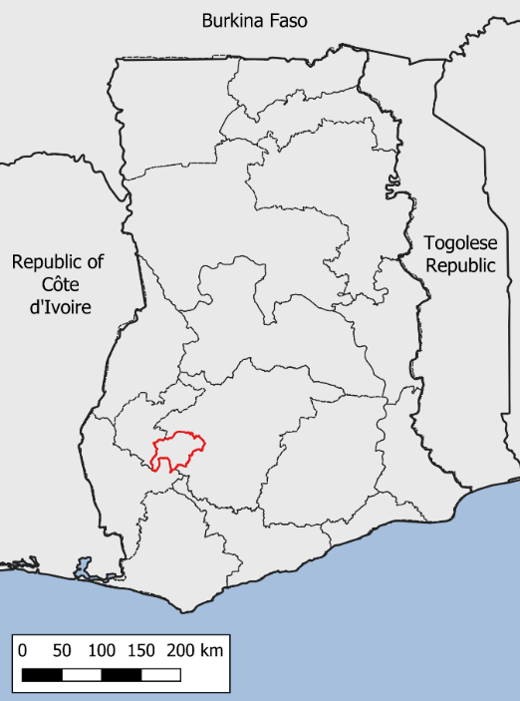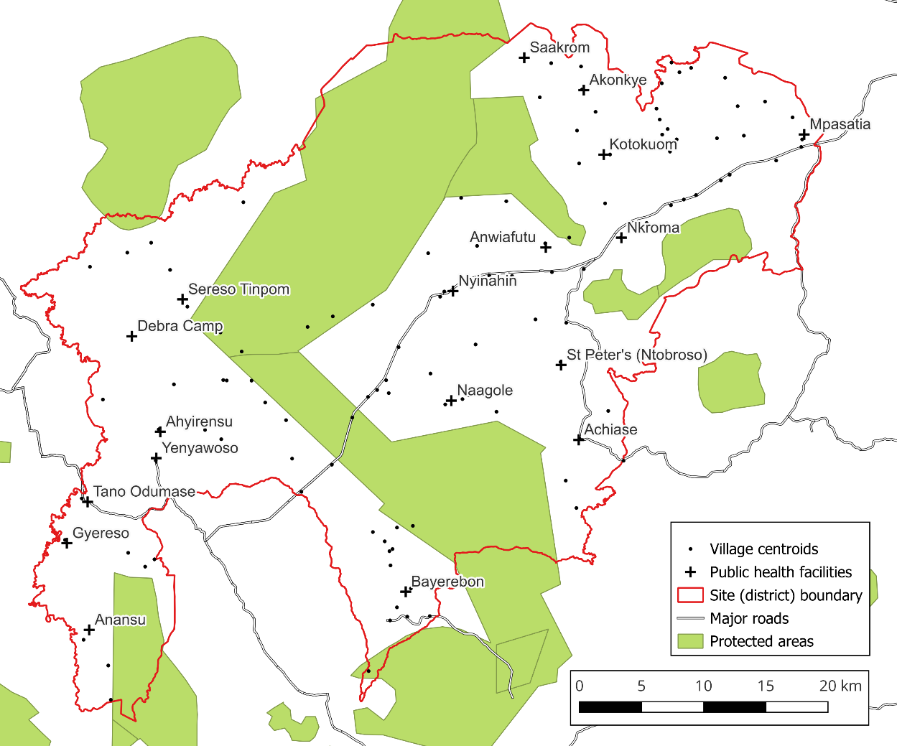

Supplementary Figure 2: Association between community-level incidence and endline prevalence
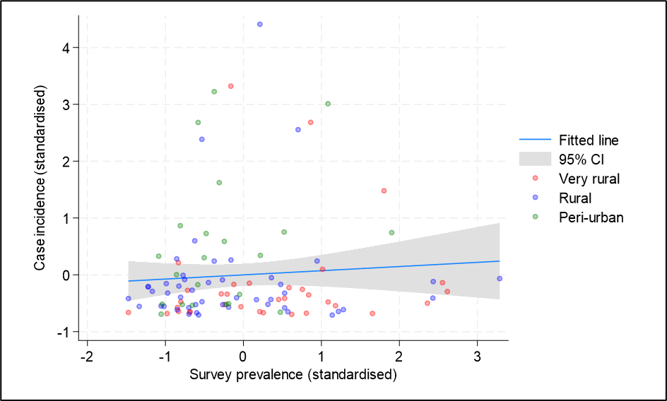
Scatter plot of standardised community-level prevalance of skin conditions at endline survey (July–September 2024) versus standardised community-level incidence of skin conditions (November 2023–September 2024) amongst endline survey communities. R² (coefficient of determination)=0.006

Supplementary Figure 3: Provider costs, by health facility and resource category

Supplementary Figure 4: Provider costs, by activity and resource category

