Supplementary Materials

Tan ST, Kwan AT, Rodríguez-Barraquer I, Singer BJ, Park HJ, Lewnard JA, Sears D, and Lo NC. Infectiousness of SARS-CoV-2 breakthrough infections and reinfections during the Omicron wave. Nature Medicine 2022.

Contents

Technical Appendix 3

References 13

Supplemental Tables 14

Supplemental Figures 20

Technical Appendix
In this technical appendix, we provide further description of the study design and environment, data, model structure, and statistical analysis.

SARS-CoV-2 testing, quarantine, and isolation practices within California state prisons
Testing practices for SARS-CoV-2 varied over time within the California state prison system. The majority of tests were polymerase chain reaction (PCR). Residents were tested both reactively, if residents were symptomatic or were considered close contacts of a confirmed COVID-19 case, and systematically (weekly) during periods of high transmission. Following a positive test, most residents were not tested for the following 90 days. The distributions for the number of tests received by residents in the study population and the time between tests over the study period are shown in Figure A1.

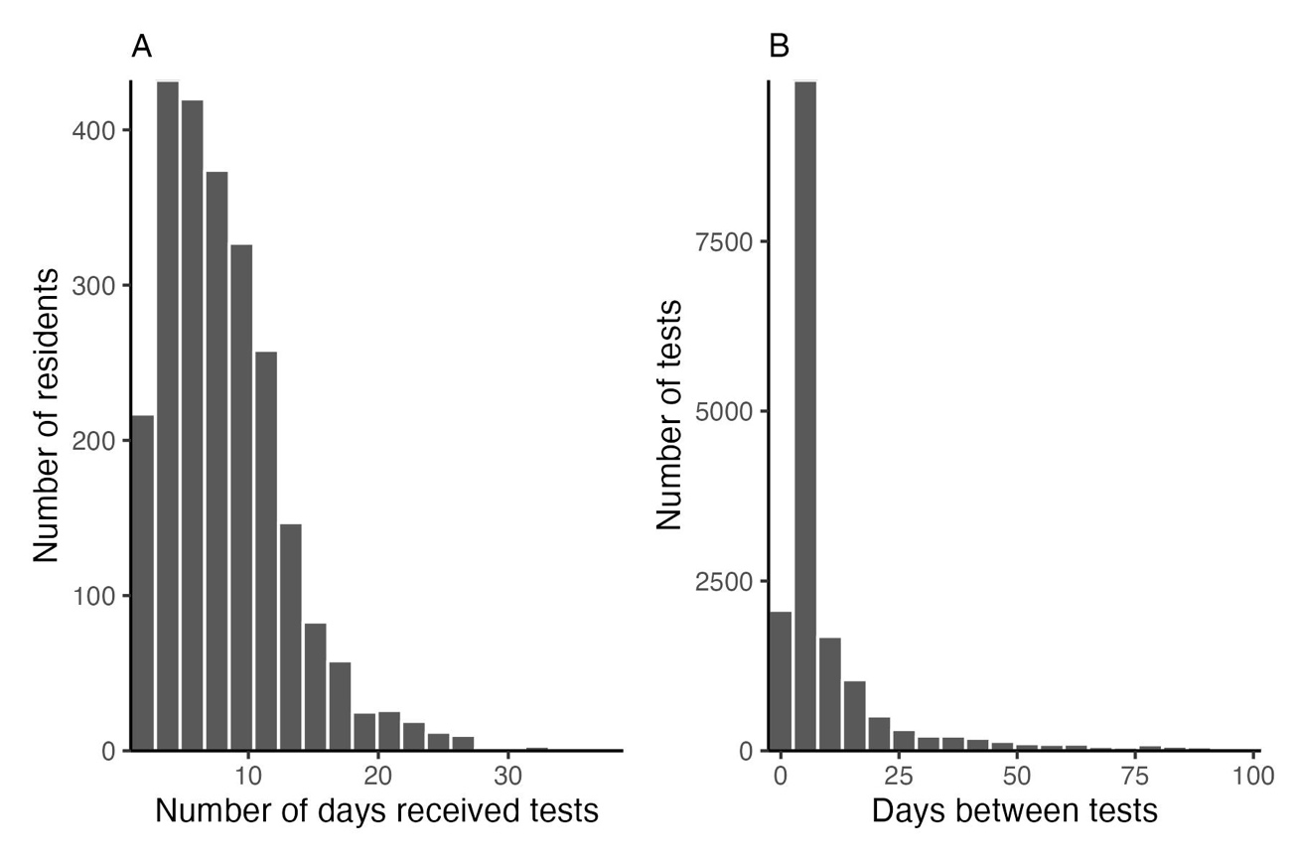
Figure A1: Distribution of the number of tests and time between tests taken in the study population over the study period.

When residents received a positive SARS-CoV-2 test result, they were moved into isolation for 10-14 days. Isolation included single cell occupancy (provided there was sufficient housing within the prison) or group isolation with other residents with active SARS-CoV-2 infection. Residents generally remained in their assigned housing while their SARS-CoV-2 test results were pending unless they were symptomatic.

Additional methodology for SARS-CoV-2 testing data
We excluded any false positive or inconclusive test results from the data (0.5% of tests). Often multiple tests were collected from residents on the same day. If multiple SARS-CoV-2 tests were collected from a resident on the same day with conflicting results (0.1% of tests), we excluded all tests from that day if: 1) the type of any test collected was unknown; or 2) the resident received multiple SARS-CoV-2 PCR tests with conflicting results. If a resident received both a SARS-CoV-2 antigen test and a SARS-CoV-2 PCR test on the same day with conflicting results, we excluded the result from the antigen test.

Additional methodology for COVID-19 index case definition and infectious period
We defined a SARS-CoV-2 infection as any conclusive positive SARS-CoV-2 test in a resident unless they had a prior infection in the preceding 90 days and no negative SARS-CoV-2 PCR test in the interim. We assumed a 5-day infectious period based on literature, although this was varied in sensitivity analysis (1). We shortened the assumed 5-day infectious period for a COVID-19 index case if the resident had a negative rapid antigen test during the infectious period. We excluded index cases if the resident had a negative PCR test during the infectious period to mitigate potential bias due to delayed detection of cases.

Additional methodology for close contacts of COVID-19 index case
If any close contact tested positive for SARS-CoV-2 within 2 days of the index case’s first positive test, we excluded the index case to limit bias from misattribution of close contacts. We additionally excluded close contacts that were considered a secondary case for multiple index cases to mitigate misattribution and bias in the study design, though only 1 contact was excluded from the final study population for this reason. Close contacts were excluded if they had a prior SARS-CoV-2 infection in the 90 days leading up to the first exposure with the index case unless they had a negative PCR test in the interim (24% of close contacts). Close contacts were required to have a negative SARS-CoV-2 test within 2 days of first exposure to the index case and have follow up testing data between 3 days after first exposure and 14 after last exposure. 12% of close contacts of eligible index cases were missing initial negative SARS-CoV-2 tests, 9% of close contacts were missing follow up testing data, and 15% of close contacts were missing both initial and follow up testing data. We evaluated differences between eligible close contacts and close contacts that were excluded (missing either testing within 2 days of first exposure or follow-up testing data) since testing occurred on a volunteer basis (see Table A1) but found these groups to be similar overall. We also varied inclusion and exclusion criteria surrounding testing in close contacts in sensitivity analyses.

Table A1. Characteristics of included and excluded close contacts.
 | Included close contacts (N=1388) (N (%) or mean (SD)) | Excluded close contacts (N=1171) (N (%) or mean (SD))
Sex
Female | 41 (3%) | 1 (0%)
Male | 1347 (97%) | 1170 (100%)
Age (years) | 40.2 (11.8) | 39.4 (11)
Race/ethnicity
American Indian/Alaskan Native | 14 (1%) | 11 (1%)
Asian or Pacific Islander | 10 (1%) | 16 (1%)
Black | 351 (25%) | 362 (31%)
Hispanic | 750 (54%) | 573 (49%)
White | 215 (16%) | 172 (15%)
Other | 48 (4%) | 37 (3%)
COVID-19 risk score (range 0-12) | 1.2 (1.6) | 1 (1.5)
Prior infection | 565 (41%) | 419 (36%)
Vaccination status
Unvaccinated | 197 (14%) | 220 (19%)
Ad26.COV2 | 159 (11%) | 112 (9.6%)
Completed only primary series | 73 (46%) | 46 (41%)
Received booster or additional doses | 86 (54%) | 66 (59%)
BNT162b2 | 246 (18%) | 176 (15%)
Received 1 dose of primary series | 3 (1.2%) | 2 (1.1%)
Completed only primary series | 49 (20%) | 40 (23%)
Received booster or additional doses | 194 (79%) | 134 (76%)
mRNA-1273 | 786 (57%) | 663 (57%)
Received 1 dose of primary series | 28 (3.6%) | 20 (3%)
Completed only primary series | 239 (30%) | 220 (33%)
Received booster or additional doses | 519 (66%) | 423 (64%)

We defined secondary SARS-CoV-2 infections as close contacts who tested positive for SARS-CoV-2 during the follow up period. The distribution of time between a secondary infection’s first exposure to an index case and their first positive test is shown in Figure A2.

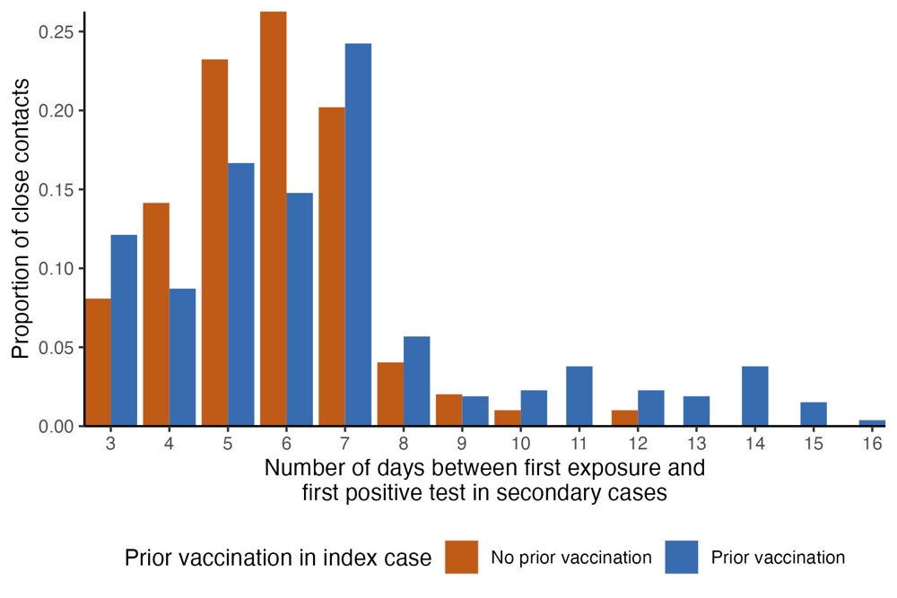
Figure A2: Distribution of the number of days between a secondary case’s first exposure to an index case and their first positive test

Given residents were frequently moved, including for isolation, we plotted the number of days of close contact with the index case during their infectious period for the study period. The distribution of exposure time, stratified by the index case’s vaccination status is shown in Figure A3.

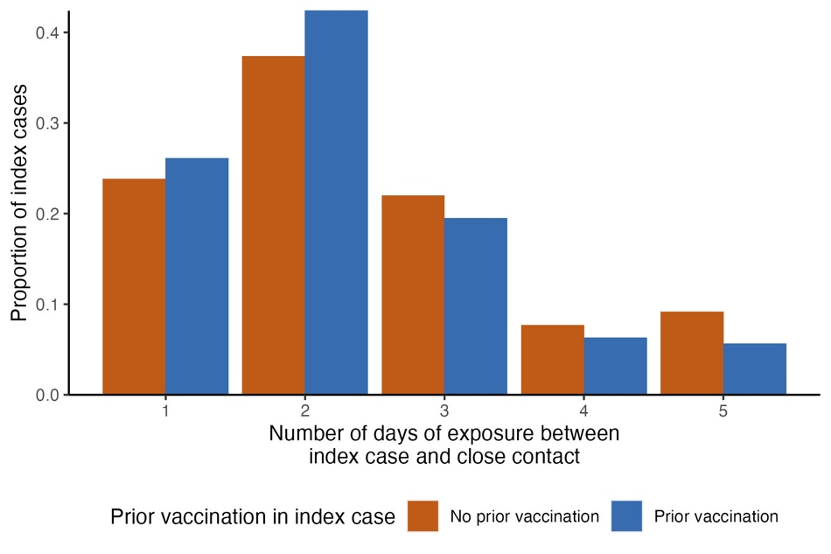
Figure A3: Distribution of the number of days of exposure between the index case during their infectious period and the close contact

Additional methodology for study population
We limited our index case-close contact pairs to those co-residing in cells with solid walls and doors because: 1) this cell type provided a more consistent transmission environment allowing comparison between facilities while other cell types were more variable; 2) cells without solid walls/doors (e.g., cells with doors made of bars or perforated metal) often had significant air exchange with surrounding cells (above/below, adjacent) which limited attribution of infection to the index case (versus residents in nearby cells) (2,3). We similarly only included solid door rooms of up to 10 residents to reduce potential for misattribution of secondary cases. We limited the close contact to be living in the same cell with the index case to improve consistency for comparison and definition of contact.

Given the strict inclusion and exclusion criteria in our study design, almost all index cases (in the subset of the incarcerated population included in our study) had only one close contact. After applying all study criteria, only 13 index cases had more than one valid close contact; 12 of the 13 index cases had 2 valid contacts and the remaining index case had 3 valid contacts. Since very few index cases had more than one valid contact and index cases had at most 3 valid contacts, we randomly selected a single close contact to allow for a more parsimonious statistical approach without the use of repeated measures.

Matching
We used the MatchIt package to perform 1:10 matching without replacement of unvaccinated index cases to vaccinated cases (4). We first estimated propensity scores for index case’s probability of being vaccinated, based on their age, prior SARS-CoV-2 infection history, and COVID-19 risk score using logistic regression. COVID-19 weighted risk score was generated by California Correctional Health Care Services (CCHCS) and reflects literature understanding of comorbidities most associated with severe COVID-19 complications upon infection (5).

We created two distance matrices that reflect pairwise differences between index cases in: 1) propensity scores (caliper = 0.1); and 2) days from first positive test (caliper = 30). We scaled the distance matrix for difference in days to have the same range as the distance matrix for propensity scores and averaged the two distance matrices for matching. The weighting of propensity score versus days from first positive test was varied in sensitivity analysis. Index cases were also matched exactly by institution. Balance in matching variables before and after matching is shown in a love plot in Figure A4. The distribution of the number of vaccinated index case matches for unvaccinated index cases is shown in the histogram in Figure A5, and the distribution of the distance between matches is shown in Figure A6. Each observation was weighted based on the number of matches.

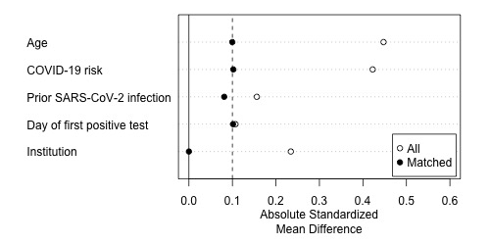
Figure A4: Standardized mean differences in matching variables before and after matching

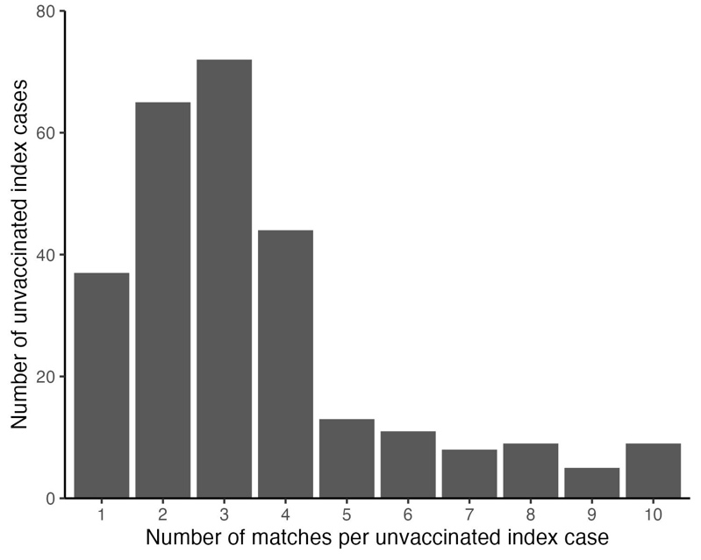
Figure A5: Distribution of the number of vaccinated index case matches for unvaccinated index cases
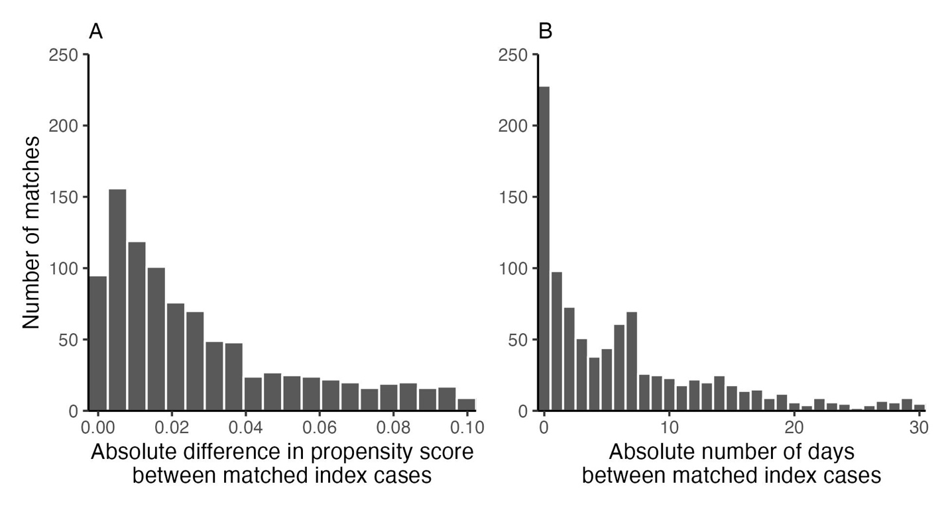
Figure A6: Distribution of the distance between matched unvaccinated and vaccinated index cases based on propensity score and number of days between first positive test

We conducted an alternative analysis that defined an index case’s vaccine status by number of doses (rather than binary) and assessed the relationship between number of vaccine doses and risk of secondary infection in close contacts. Matches were reweighted within vaccine groups following the Matchit packages specifications for weighting matched observations (4). Covariate balance across vaccinated groups is shown in Table S1, and results are shown in Table S4. As a sensitivity analysis, we performed separate matching for each of the three vaccinated groups to a single reference group (unvaccinated group) to maximize covariate balance.

Concern about misclassification of secondary SARS-CoV-2 infections
To address concerns about misclassification of secondary SARS-CoV-2 infection among close contacts of index cases (specifically testing too early to capture infection), we further examined the frequency and timing of follow up testing among close contacts. Close contacts included in the study population received on average 2 SARS-CoV-2 tests (IQR: 1-2) during the follow up period. Close contacts received their first follow up test 6.2 days (IQR: 4-7) after first exposure to an index case. The last follow up SARS-CoV-2 test among close contacts that received >1 follow up test (68% of close contacts) was on average 12.2 days (IQR: 11-14) after first exposure. The distributions for the number of tests received during follow up and timing of follow up are similar between close contacts of unvaccinated and vaccinated index cases and are shown in Figure A7. Among all close contacts, we found that the timing of the last eligible test in the close contact is 10.6 days after first exposure (IQR: 7-14) for those with a vaccinated index case and is 10 days after first exposure (IQR: 6-14) for those with an unvaccinated index case. Given most testing in close contacts was sufficiently after the exposure period, the frequency of follow up testing, and the balanced timing in follow up testing between vaccinated and unvaccinated index cases, the risk of misclassification is overall low.

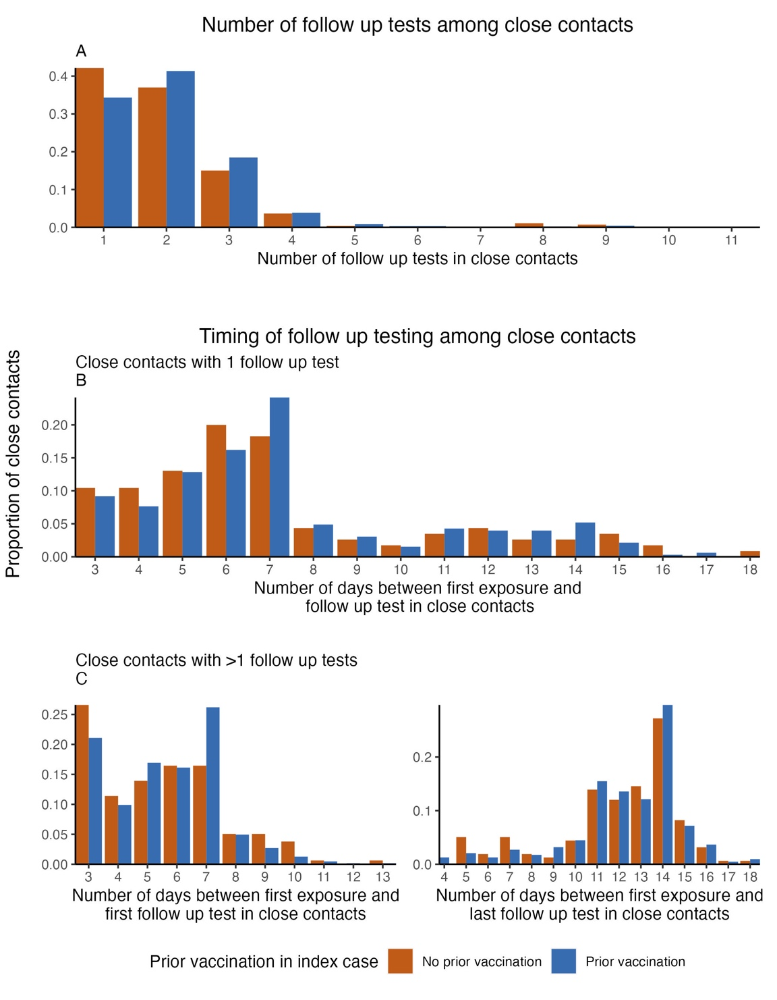
Figure A7: Distribution of the number of follow up tests and the timing of testing among close contacts in the study population

Pre-analysis plan
The pre-analysis plan is publicly available (6). The final analysis had minor deviations from the initial plan. We removed the random effects for each index case since the final dataset did not include repeated measures data (<0.1% of dataset, which was removed). We removed the inclusion criteria that index cases must have a negative PCR SARS-CoV-2 test in the 8 days prior to first positive test in order to achieve an adequate sample size. This change would not be expected to have differential implications for eligibility of index cases who were vaccinated and unvaccinated. We increased the number of matches to 1:10 to maximize sample size. During the review process, we added number of exposure days as a covariate in the regression.

IRB approval
This study was approved by the University of California, San Francisco Institutional Review Board as IRB #: 21-34030, and includes the following information. The research meets all conditions of 45 CFR 305(a), and is permissible under the following category: 45 CFR 46.306(a)(2)(ii) Study of prisons as institutional structures or of prisoners as incarcerated persons, provided that the study presents no more than minimal risk and no more than inconvenience to the subjects.

The requirement for individual Research HIPAA Authorization is waived for all subjects. The use or disclosure of the requested information does not adversely affect the rights and welfare of the individuals and involves no more than a minimal risk to their privacy based on, at least, the presence of the following elements: (1) an adequate plan to protect the identifiers from improper use and disclosure; (2) an adequate plan to destroy the identifiers at the earliest opportunity consistent with conduct of the research, unless there is a health or research justification for retaining the identifiers or if such retention is otherwise required by law; (3) adequate written assurances that the requested information will not be reused or disclosed to any other person or entity, except as required by law, for authorized oversight of the research study, or for other research for which the use or disclosure of the requested information would be permitted by the Privacy Rule; (4) the research could not practicably be conducted without the waiver; and (5) the research could not practicably be conducted without access to and use of the requested information.

The IRB approves the waiver or alteration of informed consent described in the application; the research: is no more than minimal risk to subjects; could not practicably be done without the waiver or alteration; could not practicably be done without identifiable information and biospecimens (if applicable); will not adversely affect rights and welfare of subjects with the waiver or alteration; and will provide subjects with additional pertinent information after participation, whenever it is appropriate. The waiver or alteration of informed consent applies to all subjects.

Data sharing
Data requests may be made to CCHCS and are subject to controlled access due to requirements to enhance protection of this vulnerable incarcerated population. Therefore, de-identified person-level data from this dataset is not publicly available. Requests for data access for study replication or new analyses can be made here: http://cdcrdata.miraheze.org/wiki/Request_data.

Sensitivity analyses
We conducted several sensitivity analyses to assess robustness of study findings as outlined below.

Alternative COVID-19 vaccination status in close contacts
In the primary analysis, we controlled for vaccination status in close contacts in terms of number of vaccine doses received 14 days prior to first exposure to index case. We also conducted the regression analysis when treating the close contact’s COVID-19 vaccination status as a binary variable representing any prior vaccination and when combining prior vaccination and prior SARS-CoV-2 infection (Table S4).

Alternative matching for number of vaccine doses
For the main analysis examining the relationship between number of vaccine doses and infectiousness of index cases, we reweighted matches between unvaccinated and vaccinated index cases in three groups based on number of vaccine doses (≥3 doses). To address concerns on covariate imbalance across the three vaccinated groups, we conducted a separate analysis where we matched the three vaccinated groups separately to a single reference group (unvaccinated group). All other matching specifications remained the same (Table S5).

Interaction between prior vaccination and natural infection
We assessed for a statistical interaction in the primary analysis between vaccination and prior natural infection in index cases. The remainder of the statistical specifications remained unchanged (Table S6).

Time since most recent vaccination or natural infection
We estimated the unadjusted attack rate of infection among vaccinated index cases, stratified by time since most recent COVID-19 vaccination (Figure S2). We performed three additional regression analyses to evaluate whether time since last vaccine, time since last infection, or time since last vaccine or infection had a relationship with the infectiousness of a SARS-CoV-2 infection. In these analyses, the coefficient of interest was the index case’s time since most recent vaccination or natural infection. The remainder of the analyses remained the same, controlling for all pre-specified covariates in the main analysis (Table S7).

Sensitivity to exclusion criteria
We conducted two sensitivity analyses that relaxed exclusion criteria for index cases and close contacts. In the first analysis, we included close contacts that tested positive within the first 2 days of exposure to an index case. In the second analysis, we removed the requirement that close contacts have a negative test within 2 days of first exposure to an index case. All other aspects of study design remained the same (Table S8).

Alternative matching
We repeated the primary analysis with sensitivity analyses on the matching process. We varied the ratio of matches (1:4 matching instead of 1:10) and the calipers of both propensity scores (caliper = 0.05 and caliper = 0.2, instead of 0.1) and time (caliper = 15 days, instead of 30). We tested the sensitivity of matches and study outcomes to the balance between propensity scores and time in the distance matrix; we formulated the distance matrix as a weighted average of differences in propensity scores and time (in 1:3 and 3:1 ratios). We evaluated study outcomes when including race and sex in the propensity score and when not including a propensity score (matching only on time and institution). We additionally repeated the analysis without matching, estimating robust errors instead of cluster-robust errors in the Poisson regression model (Table S9).

Alternative infectious period
We tested the impact of varying assumptions about the start and duration of the infectious period on study outcomes, maintaining all other inclusion and exclusion criteria of the study. In this sensitivity analysis, we assumed the infectious period began on the day of an index case’s positive test and had a duration of 7 days. We included index cases that received a negative PCR test in the last two days of their infectious period and shortened the infectious period accordingly. In another version of this sensitivity analysis, we also varied the start of the infectious period; we assumed the infectious period began 2 days prior to an index case’s first positive test and had a duration of 1) 5 days and 2) 7 days (Table S10). In both of these sensitivity analyses, we additionally excluded index cases that had a negative test in the 2 days prior to their first positive test.

Ad26.COV2 vaccine
In the main analysis, we did not explicitly account for vaccine type. However, since Ad26.COV2 has lower vaccine effectiveness than mRNA vaccines available in the incarcerated population, we conducted a sensitivity analysis where we excluded index cases that received the Ad26.COV2 vaccine. We removed index cases that received the Ad26.COV2 vaccine then followed the matching and regression procedures of the primary analysis (Table S11).

Alternative regression model
We used Poisson regression in the main analysis since coefficients are easier to interpret than those in logistic regression and may be more robust with model misspecification (7). As a sensitivity analysis, we performed the primary analysis using a logistic regression model instead of a robust Poisson model, incorporating weights from matching as well as cluster-robust standard errors based on matching group membership. We report the odds ratios of infection given prior vaccination or prior infection and 95% confidence intervals (Table S12).

References

1. He X, Lau EHY, Wu P, et al. Temporal dynamics in viral shedding and transmissibility of COVID-19. Nat Med. 2020;26(5):672-675. doi:10.1038/s41591-020-0869-5
2. Duarte C, Cameron DB, Kwan AT, Bertozzi SM, Williams BA, McCoy SI. COVID-19 outbreak in a state prison: a case study on the implementation of key public health recommendations for containment and prevention. BMC Public Health. 2022;22(1):977. doi:10.1186/s12889-022-12997-1
3. Kwan, A., Sklar, R., Cameron, D.B., Schell, R.C., Bertozzi, S.M., McCoy, S.I., Williams, B. and Sears, D.A. Respiratory pandemic preparedness learnings from the June 2020 COVID-19 outbreak at San Quentin California State Prison. Int J Prison Health. 2022;ahead-of-print(ahead-of-print).
4. Introduction. Accessed June 9, 2022. https://cran.r-project.org/web/packages/MatchIt/vignettes/MatchIt.html
5. Supplemental/Covid weighted risk scoring. Main. Published April 13, 2021. Accessed April 27, 2022. https://cdcrdata.miraheze.org/wiki/Supplemental/Covid_weighted_risk_scoring
6. sophttan/CDCR-CalProtect. GitHub. Accessed June 9, 2022. https://github.com/sophttan/CDCR-CalProtect
7. Zou G. A Modified Poisson Regression Approach to Prospective Studies with Binary Data. Am J Epidemiol. 2004;159(7):702-706. doi:10.1093/aje/kwh090

Tables
Table S1: Characteristics of COVID-19 index cases by number of COVID-19 vaccine doses in California prisons
 | Index cases (N=1226) (N (%) or mean (SD))
 | No COVID-19 vaccination (N=273) | 1 dose of COVID-19 vaccine (N=76) | 2 doses of COVID-19 vaccine (N=337) | >3 doses of COVID-19 vaccine  (N=540)
Sex
Female | 8 (3%) | 0 (0%) | 7 (4%) | 31 (3%)
Male | 265 (97.1) | 76 (100.0) | 327 (97.0) | 520 (96.3)
Age (years) | 36.3 (10) | 33.4 (7.8) | 37 (10.2) | 41.1 (10.8)
Race
American Indian/Alaskan Native | 0 (0%) | 1 (1%) | 2 (1%) | 8 (2%)
Asian or Pacific Islander | 4 (2%) | 1 (1%) | 5 (2%) | 6 (1%)
Black | 89 (33%) | 22 (29%) | 95 (28%) | 104 (19%)
Hispanic | 121 (44%) | 35 (46%) | 146 (43%) | 221 (41%)
Mexican | 24 (9%) | 6 (8%) | 48 (14%) | 92 (17%)
White | 28 (10%) | 10 (13%) | 32 (10%) | 94 (17%)
Other* | 7 (3%) | 1 (1%) | 9 (3%) | 15 (3%)
COVID-19 risk score (range: 0-12)** | 0.7 (1.3) | 0.6 (0.8) | 0.8 (1%) | 1.2 (1.5)
Number of days of exposure between index case and close contact | 2.4 (1.2) | 2.43 (1) | 2.3 (1%) | 2.2 (1.1)
Prior infection | 84 (31%) | 33 (43%) | 123 (37%) | 200 (37%)
Vaccination status
Unvaccinated | 273 (100%) | - | - | -
Ad26.COV2 | - | 58 (76%) | 55 (16%) | -
Completed only primary series | - | 58 (100%) | - | -
Received booster or additional doses | - | - | 55 (100%) | -
BNT162b2 | - | 5 (6.6%) | 55 (16%) | 128 (24%)
Received 1 dose of primary series | - | 5 (100%) | - | -
Completed only primary series | - | - | 55 (100%) | -
Received booster or additional doses | - | - | - | 128 (100%)
mRNA-1273 | - | 13 (17%) | 227 (67%) | 412 (76%)
Received 1 dose of primary series | - | 13 (100%) | - | -
Completed only primary series | - | - | 227 (100%) | -
Received booster or additional doses | - | - | - | 412 (100%)
History of prior natural infection and vaccination status reflect the index case’s vaccination and natural infection status on the day of first positive test
*Other race/ethnicity based on self-reported data and those with mixed race/ethnicity
**COVID-19 risk score was estimated by California Correctional Health Care Services as weighted sum of different comorbidities most associated with severe COVID-19 complications (5)

Table S2: Unadjusted estimates of the attack rate of SARS-CoV-2 infection among close contacts of index cases by COVID-19 vaccination and SARS-CoV-2 infection history in index cases
Attack rate (%) (95% CI) | No prior vaccination | Prior vaccination
No prior infection | 39.2 (32.2, 46.5) | 31.5 (27.8, 35.4)
Prior infection | 29.8 (20.5, 40.9) | 21.3 (17.3, 26)

Table S3: Primary analysis of the relationship of COVID-19 vaccination and prior SARS-CoV-2 infection on infectiousness of Omicron SARS-CoV-2 infections
Relative % change in attack rate of infection in close contact
(95% CI)
Index case | Prior vaccination only | -22.4 (-36, -6)
 | Prior infection only | -22.6 (-38.5, -2.7)
Close contact | Duration of exposure (per day) | 6.9 (-2.3, 16.9)
 | Number of vaccine doses
 | 1 dose | 1.3 (-8.1, 11.8)
 | 2 doses | 2.7 (-15.5, 24.9)
 | ≥3 doses | 4.1 (-22.4, 39.6)
 | Prior infection only | -19.1 (-34.9, 0.6)
Institution | SARS-CoV-2 incidence in the 7 days preceding the positive test in the index case (per natural log increase in incidence) | 10.2 (-4.8, 27.6)
The primary analysis estimated the relationship of the index cases’ vaccine status and prior natural infection history on attack risk of SARS-CoV-2 infection in the close contact. We adjusted for potential confounders, including the duration of exposure between index cases and close contacts, number of COVID-19 vaccine doses and prior natural infection history in close contacts as well as institution SARS-CoV-2 incidence.

Table S4: Sensitivity analyses testing alternative definitions of COVID-19 vaccination status in index cases and close contacts on the infectiousness of Omicron SARS-CoV-2 infections
 | COVID-19 vaccination status | Relative % change in attack rate of infection in close contact  (95% CI)
Index case | Prior vaccination | -22.4 (-36, -6)
 | Number of vaccine doses
 | 1 dose | -11.4 (-17.4, -5.1)
 | 2 doses | -21.5 (-31.7, -9.9)
 | ≥3 doses | -30.5 (-43.5, -14.4)
Close contact | Prior vaccination | 2.3 (-21.8, 33.7)
 | Number of vaccine doses
 | 1 dose | 1.3 (-8.1, 11.8)
 | 2 doses | 2.7 (-15.5, 24.9)
 | ≥3 doses | 4.1 (-22.4, 39.6)
 | Prior vaccination or infection | -10.5 (-33.4, 20.2)
This sensitivity analysis represents distinct regression analyses measuring the infectiousness of SARS-CoV-2 infections in index cases among close contacts under different definitions of COVID-19 vaccine status in the index case and close contact. The sensitivity analysis was conducted by starting with the primary model and making a single change to either the index case or close contact’s vaccine status under three definitions: (1) any vaccination as a binary variable; (2) vaccination as number of doses; (3) combined any vaccination and/or prior infection as binary definition. Weights for vaccinated index cases were rebalanced for the analysis defining vaccine status in index cases as number of doses.

Table S5: Sensitivity analysis matching vaccinated index cases to unvaccinated index cases to examine relationship between number of COVID-19 vaccine doses and infectiousness of Omicron SARS-CoV-2 infections
Index case number of vaccine doses | Relative % change in attack rate of infection in close contact  (95% CI)
1 dose | -12.4 (-18.2, -6.2)
2 doses | -23.2 (-33.1, -12)
≥3 doses | -32.8 (-45.2, -17.5)
To understand the relationship between the number of vaccine doses in an index case and their infectiousness, we reweighted matches from the primary analysis to reflect three separate vaccine groups (1 dose, 2 dose, 3 doses). In this sensitivity analysis, we matched unvaccinated cases with the three vaccinated groups with 1:10 matching. All other aspects of the analysis remained the same.

Table S6: Assessment of statistical interaction between COVID-19 vaccination and prior SARS-CoV-2 infection in the index case on the infectiousness of Omicron SARS-CoV-2 infections
Index case | Relative % change in attack rate of infection in close contact (95% CI)
 | Without interaction term | With interaction term
Prior vaccination | -22.4 (-36, -6) | -22.6 (-37.7, -3.9)
Prior infection | -22.6 (-38.5, -2.7) | -23.2 (-47.9, 13.4)
Interaction between vaccination and prior infection | -- | 0.9 (-36.2, 59.7)

Table S7: Estimating the relationship between time since most recent COVID-19 vaccine dose or natural infection on infectiousness of Omicron SARS-CoV-2 infections
 | Relative % change in attack rate of infection in close contact (95% CI)
Time since last COVID-19 vaccine dose (per 5 weeks) | 6.4 (2.3, 10.6)
Time since most recent SARS-CoV-2 infection (per 5 weeks) | 4.7 (-3.6, 13.7)
Time since most recent vaccine or infection (per 5 weeks) | 4.7 (1.9, 7.6)
We conducted three regression analyses estimating the relationship between: 1) time since most recent vaccination and risk of transmission of infection; 2) time since most recent infection and risk of transmission of infection; 3) time since most recent vaccination or infection and risk of transmission of infection. All analyses were adjusted for prior vaccination and/or infection in the index case as well as close contact and institution-specific characteristics. Of note, these analyses assume a SARS-CoV-2 infection (whereas immunity from vaccine and/or natural infection may prevent infection soon after vaccine and/or natural infection) thus limiting the ability to detect a relationship.

Table S8: Sensitivity analysis on inclusion and exclusion criteria of the primary study design
 | Index case | Relative % change in attack rate of infection in close contact  (95% CI)
Removing requirement for negative test in close contact within 2 days of first exposure | Prior vaccination | -19 (-32.7, -2.6)
 | Prior infection | -20.7 (-36.7, -0.6)
Including close contacts that test positive within 2 days after first exposure | Prior vaccination | -23 (-35.4, -8.3)
 | Prior infection | -17.4 (-33.7, 2.9)

Table S9: Sensitivity analysis testing alternative matching specifications for primary analysis on the infectiousness of Omicron SARS-CoV-2 infections
Matching specification |  | Index case | Relative % change in attack rate of infection in close contact (95% CI)
Varying choice of caliper | Caliper of propensity score = 0.2 | Prior vaccination | -21 (-35.2, -3.8)
 |  | Prior infection | -25.3 (-41.3, -5.1)
 | Caliper of days between index cases = 15 | Prior vaccination | -23.4 (-36.7, -7.4)
 |  | Prior infection | -21.9 (-38, -1.6)
Varying k in 1:k matching | 1:4 matching | Prior vaccination | -21.2 (-35.2, -4.2)
 |  | Prior infection | -21.8 (-38.6, -0.5)
Varying weights between propensity score and time | 1:3 ratio | Prior vaccination | -21 (-34.9, -4)
 |  | Prior infection | -22.1 (-38, -2.2)
 | 3:1 ratio | Prior vaccination | -23.5 (-36.8, -7.3)
 |  | Prior infection | -24.5 (-40.7, -3.7)
Overall changes to propensity score | Matching without propensity score | Prior vaccination | -22.1 (-35.5, -5.9)
 |  | Prior infection | -23.6 (-39.7, -3.1)
 | Propensity score with sex and race | Prior vaccination | -24.2 (-36.9, -8.9)
 |  | Prior infection | -22.7 (-37.6, -4.1)
 | No matching | Prior vaccination | -23 (-36.7, -6.4)
 |  | Prior infection | -23 (-39.8, -1.5)

Table S10: Sensitivity analysis testing alternative definitions of infectious period in index case for primary analysis on the infectiousness of Omicron SARS-CoV-2 infections
Start of infectious period | Duration of infectious period | Index case | Relative % change in attack rate of infection in close contact (95% CI)
Begins day of first positive test | 7 days | Prior vaccination | -20.3 (-34.7, -2.9)
 |  | Prior infection | -20.7 (-37.5, 0.6)
Begins 2 days prior to first positive test | 5 days | Prior vaccination | -13.9 (-28.4, 3.7)
 |  | Prior infection | -22.7 (-38.9, -2.2)
 | 7 days | Prior vaccination | -12.5 (-26.9, 4.7)
 |  | Prior infection | -21 (-37.7, 0.2)

Table S11: Primary analysis excluding index cases that received the Ad26.COV2 vaccine
Index case | Relative % change in attack rate of infection in close contact (95% CI)
Prior vaccination | -21.6 (-35, -5.4)
Prior infection | -19.1 (-36.9, 3.8)

Table S12: Primary analysis using logistic regression model to evaluate the
infectiousness of Omicron SARS-CoV-2 infections
Index case | Odds ratio of infection in close contact (95% CI)
Prior vaccination | 0.66 (0.48, 0.91)
Prior infection | 0.68 (0.49, 0.95)
Note: The primary analysis used a robust Poisson regression model, while this sensitivity
analysis used a logistic regression model.

Table S13: Estimation of the fraction of secondary transmission attributable to Omicron SARS-CoV-2 infections stratified by prior COVID-19 vaccination and natural infection history
 | Fraction of transmission from SARS-CoV-2 infections (%) (95% CI)
 | Within secondary cases in study population | Among all Omicron SARS-CoV-2 infections | Among Omicron SARS-CoV-2 infections with complete prior infection history
No prior vaccination or infection | 20.4 (16.4, 25) | 23.5 (27.7, 19.8) | 14.9 (18, 12.2)
Prior vaccination only | 51.8 (46.5, 57) | 52.8 (51.2, 53.8) | 48.2 (48.1, 47.8)
Prior infection only | 6.9 (4.6, 10.1) | 4.4 (4.1, 4.7) | 6.6 (6.3, 6.8)
Both prior vaccination and infection | 20.9 (16.9, 25.6) | 19.3 (17, 21.6) | 30.4 (27.6, 33.2)
We estimated the attributable fraction of transmission from SARS-CoV-2 infection among secondary cases, stratified by different vaccine and immune statuses of the index case. We performed this analysis under three circumstances: (1) study population; (2) among all confirmed SARS-CoV-2 infections in the study period; and (3) among confirmed SARS-CoV-2 infections in residents that were incarcerated before April 2020 due to underreporting of prior infection history. Further Methods description is available in the main text.

Figures
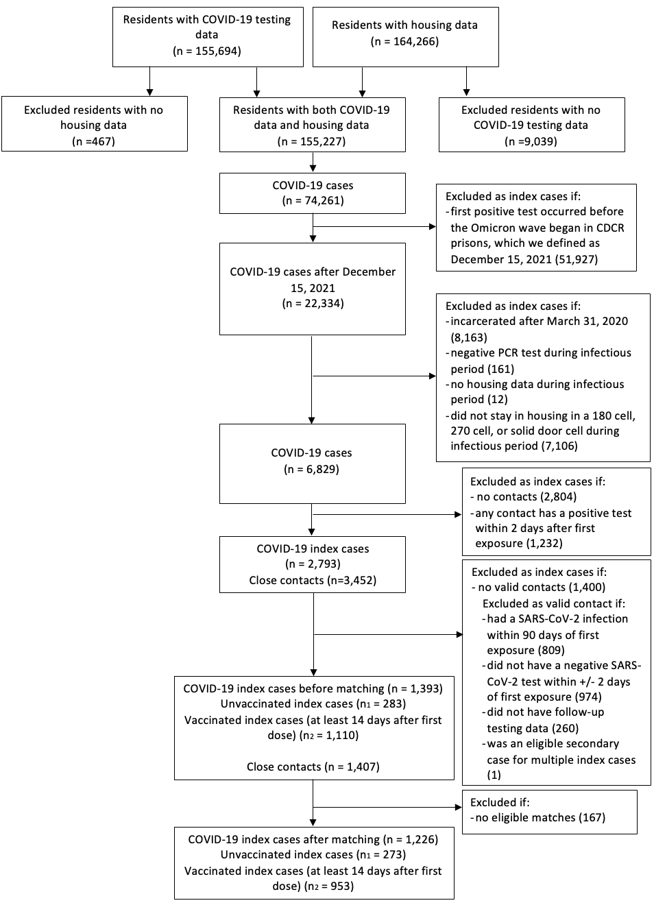
Figure S1: Study population flow chart. We obtained data on residents incarcerated in the California state prison system from March 1, 2020, to May 20, 2022, who were diagnosed with COVID-19 based on a positive molecular test. We applied the inclusion and exclusion criteria to the index case of COVID-19 and the close contact who shared a cell for at least one night. The sample size at each step is plotted in the figure.
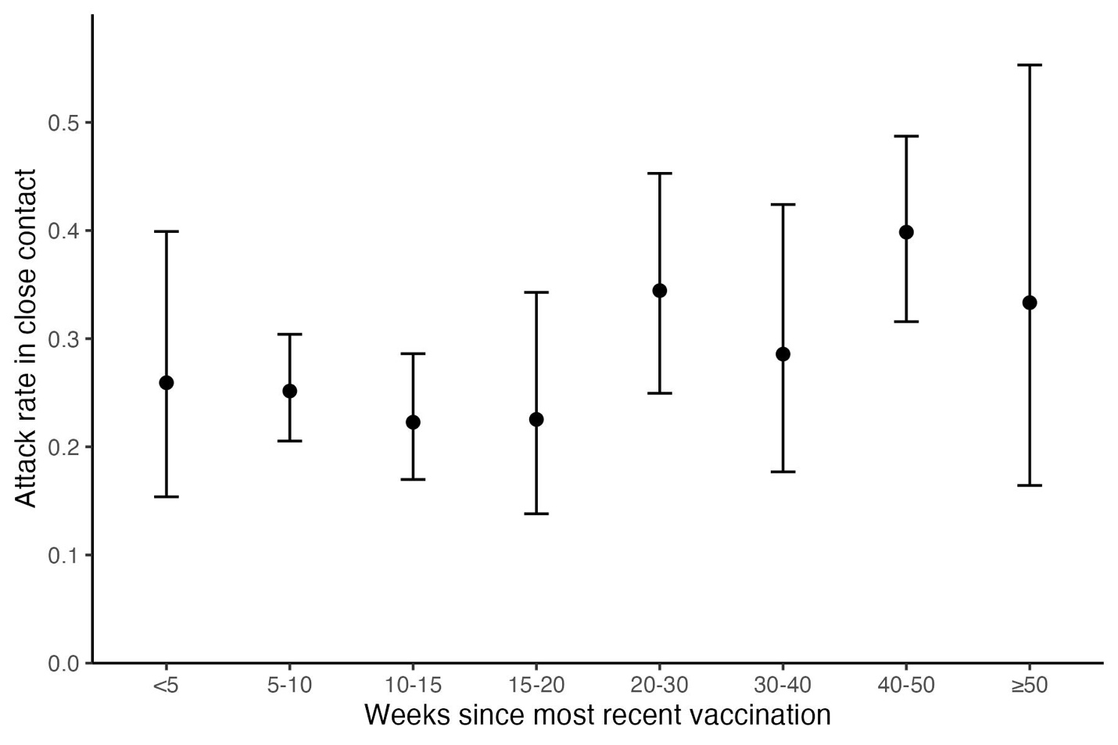
Figure S2: Unadjusted estimates of the attack rate of Omicron SARS-CoV-2 infection of vaccinated index cases by time since the index cases’ most recent vaccine dose. We plotted the unadjusted attack rate and 95% binomial confidence intervals for vaccinated index cases, stratified by time (in weeks) since the index cases’ most recent vaccine dose prior to first positive SARS-CoV-2 test. The adjusted estimates from the regression model are available in Table S5.

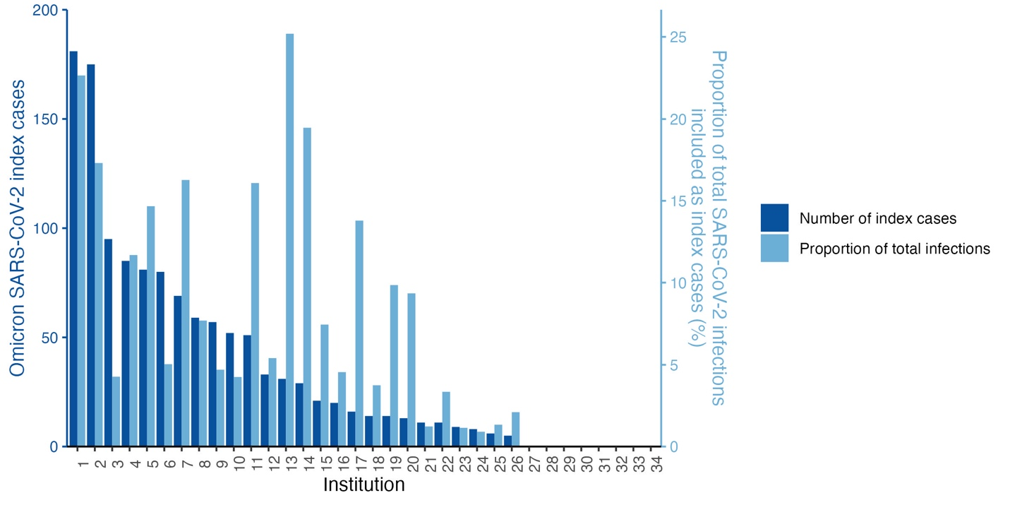
Figure S3: Omicron SARS-CoV-2 infections included as index cases by institution. We plotted the absolute number of index cases included in the analysis by institution (dark blue) with y-axis on left. We plotted the proportion of total Omicron SARS-CoV-2 infections included as index cases by institution (light blue) with y-axis on right. Infections from some institutions are overrepresented in our final sample due to our strict inclusion and exclusion criteria established to address confounding and misattribution concerns.

