SUPPLEMENT
Table S1: Definitions of highly prevalent risk factors and comorbidities measured in the NA-ACCORD and included in the PEARL model
Risk factor or comorbidity | Data source | Definition
Smoking | EHR and patient-reported surveys (when available) | Ever having EHR-based evidence or patient-reported smoking (collected via surveys) while under observation
Obesity | EHR | Body mass index ≥30 kg/m2 (height and weight measurements are exported from EHR)
Hepatitis C virus infection | EHR | Ever having EHR-based evidence of HCV infection while under observation, defined as:  1) a positive HCV antibody test, OR  2) a detectable HCV RNA, OR  3) the presence of an HCV genotype test
Depression¹ | EHR | An absorbing state from the month/day/year an individual has a major depressive disorder diagnosis.
Anxiety¹ | EHR | An absorbing state from the month/day/year an individual has a generalized anxiety disorder diagnosis
Dyslipidemia² | EHR | An absorbing state from the month/day/year an individual first meets the following definition:  1) total cholesterol ≥240 mg/dL, OR  2) HDL ≤40 mg/dL for men or ≤50 for women, OR  3) LDL ≥130 mg/dL, OR  4) lipid-lowering medication prescription
Hypertension³ | EHR | An absorbing state from the month/day/year an individual first meets the following definition:  1) prescription of anti-hypertension medications, AND  2) a hypertension diagnosis
Stage ≥3 Chronic Kidney Disease³ | EHR | An absorbing state from the month/day/year an individual first meets the following definition: ever had eGFR <60 mL/min/1.73m2 consistently for at least 3 months  eGFR estimated using CKD-Epi equation that included an indicator for race.
Diabetes³ | EHR | An absorbing state from the month/day/year an individual first meets the following definition:  1) HgA1c >6.5%, OR  2) diabetes specific medication was prescribed OR  3) a Type 2 or unspecified diabetes diagnosis was recorded and diabetes-related medications were prescribed
Myocardial infarction⁴ | EHR with validation by cardiologists | An absorbing state from the month/day/year an individual who screens positive for a potential MI event has a validated MI event (regardless of MI type) as determined by an adjudication process.  Once an MI event is validated, no subsequent events are investigated.
Cancer (all types)⁵ | Cancer registries or EHR data that is validated for cancer diagnosis | An absorbing state from the month/day/year an individual first meets the following definition:  1) Validated cancer diagnosis (all types) confirmed in a cancer registry  2) Validated cancer diagnosis (all types) confirmed with review of the patient’s EHR following screening positive for a potential cancer diagnosis
End-stage Renal Disease (ESLD)⁶ | EHR data that is validated for cancer diagnosis | An absorbing state from the month/day/year an individual who screens positive for a potential ESLD event has a validated MI event as determined with review of the patient’s EHR
Abbreviations:
EHR=electronic health record
1. Lang R, et al. The prevalence of mental health disorders in people with HIV and the effects on the HIV Care Continuum. AIDS. 2022;In press.
2. Drozd D, et al. Increased risk of myocardial infarction in HIV-infected individuals in North American compared with the general population. Journal of Acquired Immune Deficiency Syndrome. 2017 Aug 15;75(5):568-576.
3. Wong C, et al. First occurrence of diabetes, chronic kidney disease, and hypertension among North American HIV-infected adults, 2000-2013. Clinical Infectious Diseases. 2017 Feb 15;64(4):459-467.
4. Crane HM, et al. Lessons learned from the design and implementation of myocardial infarction adjudication tailored for HIV clinical cohorts. American Journal of Epidemiology. 2014 Apr 15;179(8):996-1005.
5. Silverberg MJ, et al. Cumulative incidence of cancer among persons with HIV in North America: A cohort study. Annals of Internal Medicine. 2015 Oct 6;163(7):507-518.
6. Kitahata MM, et al. Ascertainment and verification of end-stage renal disease and end-stage liver disease in the North American AIDS Cohort Collaboration on Research and Design. AIDS Research and Treatment. 2015:923194.
Table S2: Prevalence and incidence functions applied to PEARL agents who have initiated ART
a1) Anxiety prevalence estimates (from the NA-ACCORD)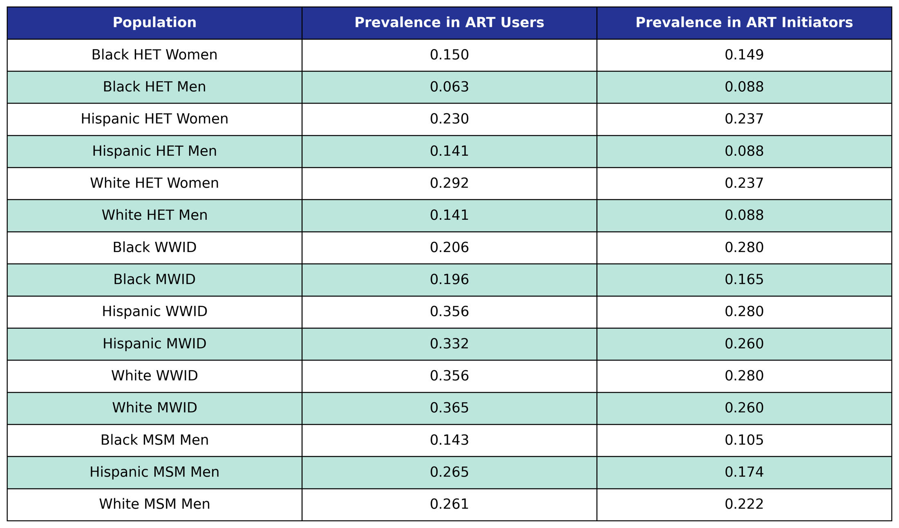
Prevalence in the 2009 ART user population is taken from the 2009 NA-ACCORD population, while prevalence in ART initiators was taken from the 2009 - 2017 NA-ACCORD ART initiator population.
a2) Coefficient estimates from anxiety incidence functions (from the NA-ACCORD)
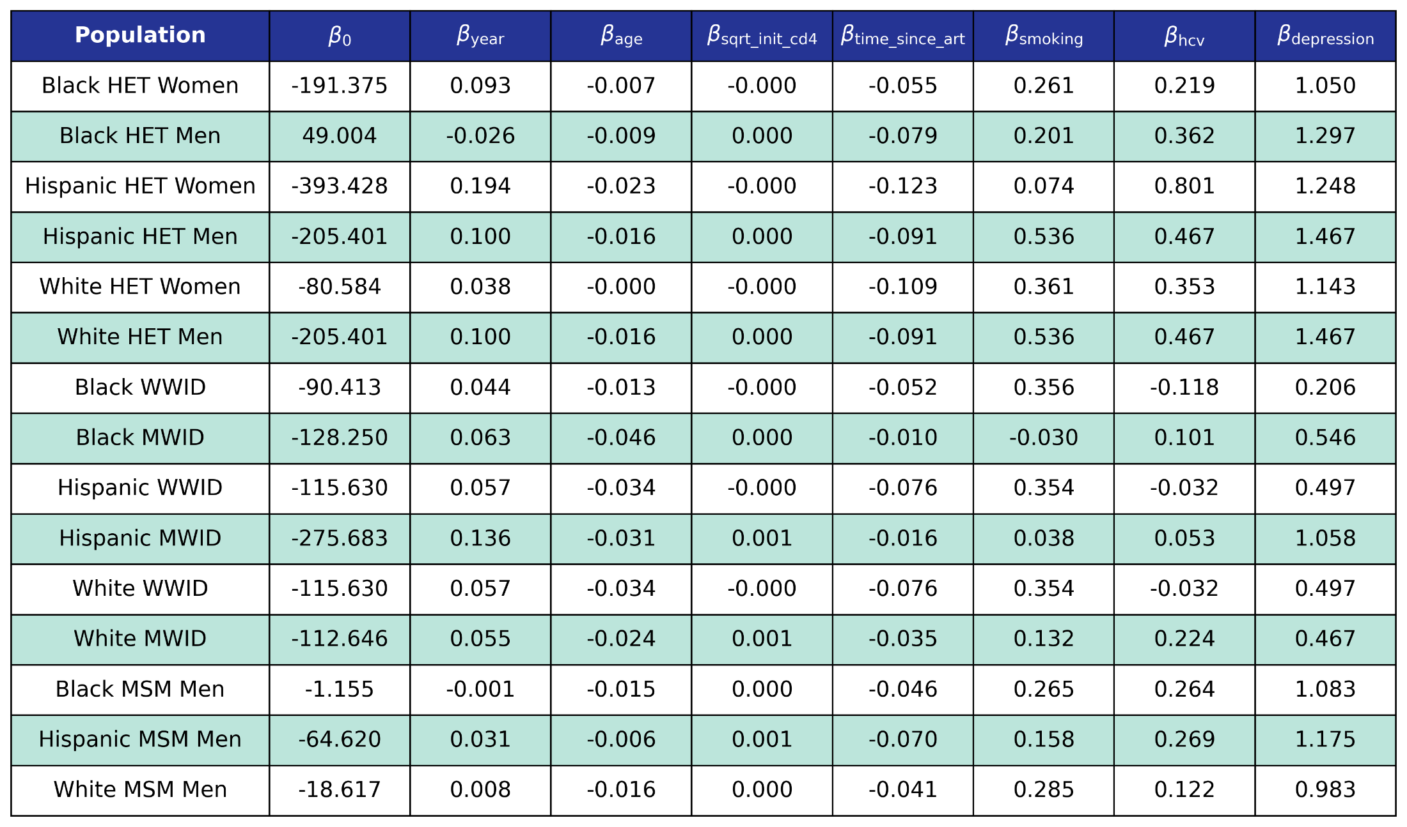
We use logistic regression to model the probability of incidence of anxiety as a function of calendar year (year), age (age), square root of CD4 count at ART initiation (sqrt_init_cd4), number of years since ART initiation (time_since_art), smoking status (smoking), HCV status (hcv) and depression status (depression). The status variables are encoded as Boolean variables.

b1) Depression prevalence estimates (from the NA-ACCORD)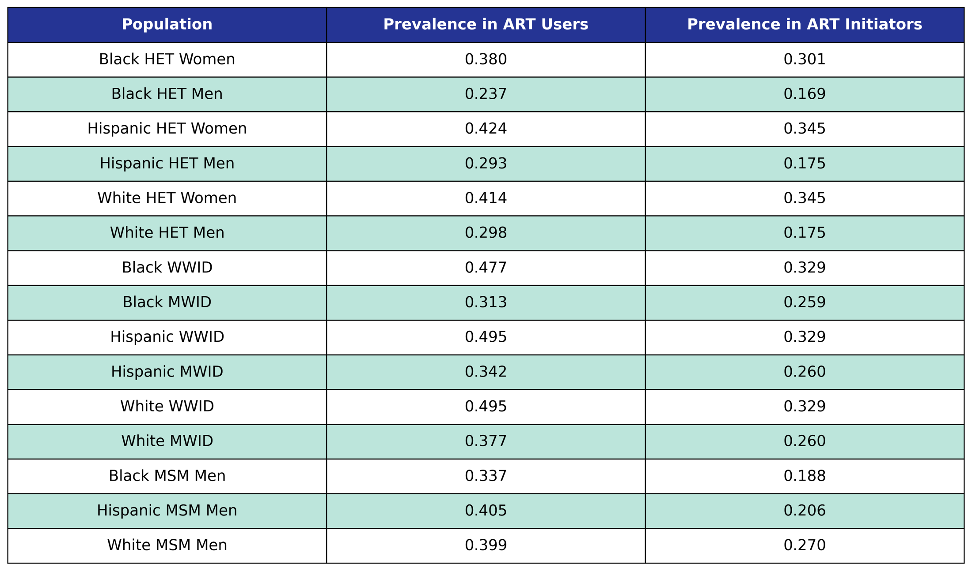
Prevalence in the 2009 ART user population is taken from the 2009 NA-ACCORD population, while prevalence in ART initiators was taken from the 2009 - 2017 NA-ACCORD ART initiator population.
b2) Coefficient estimates from depression incidence functions (from the NA-ACCORD)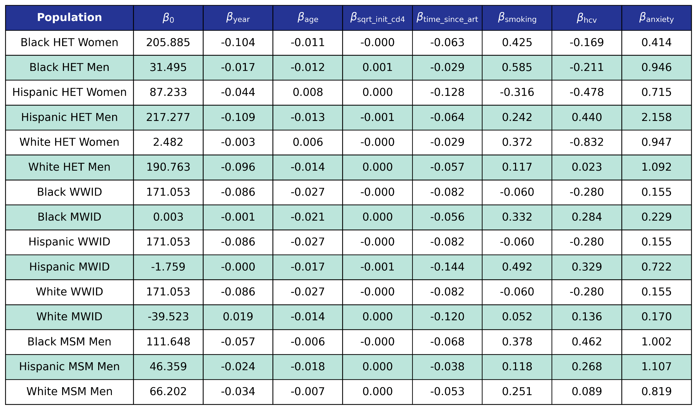
We use logistic regression to model the probability of incidence of depression as a function of calendar year (year), age (age), square root of CD4 count at ART initiation (sqrt_init_cd4), number of years since ART initiation (time_since_art), smoking status (smoking), HCV status (hcv) and anxiety status (anxiety). The status variables are encoded as Boolean variables.

c1) Stage ≥3 chronic kidney disease prevalence estimates (from the NA-ACCORD)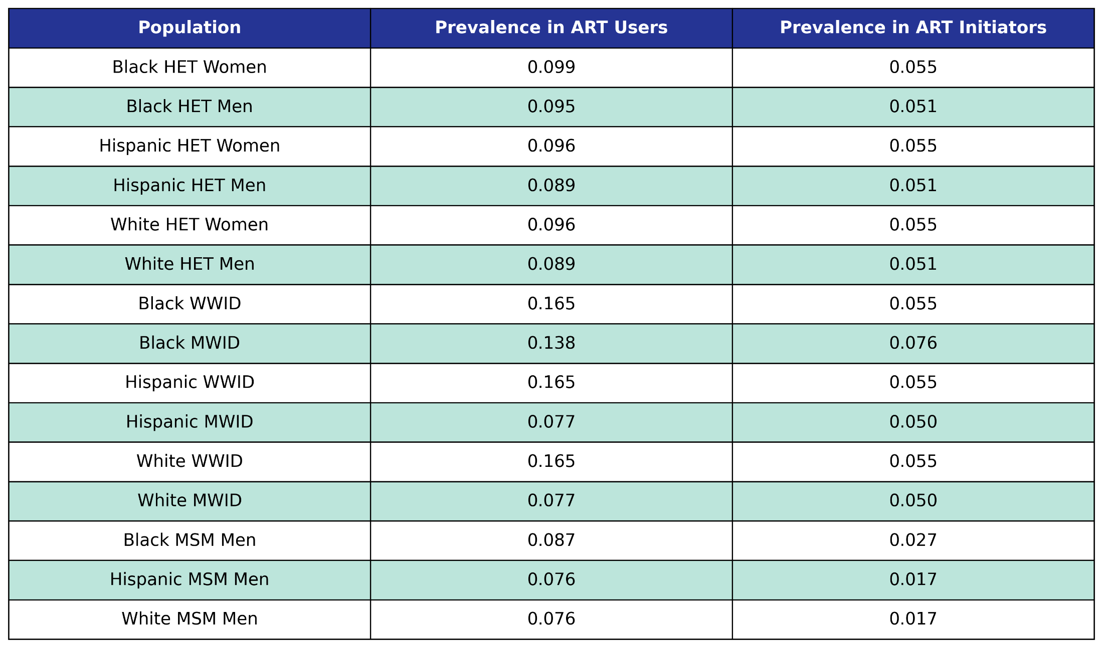
Prevalence in the 2009 ART user population is taken from the 2009 NA-ACCORD population, while prevalence in ART initiators was taken from the 2009 - 2017 NA-ACCORD ART initiator population.

c2) Coefficient estimates from stage ≥3 chronic kidney disease incidence functions (from the NA-ACCORD)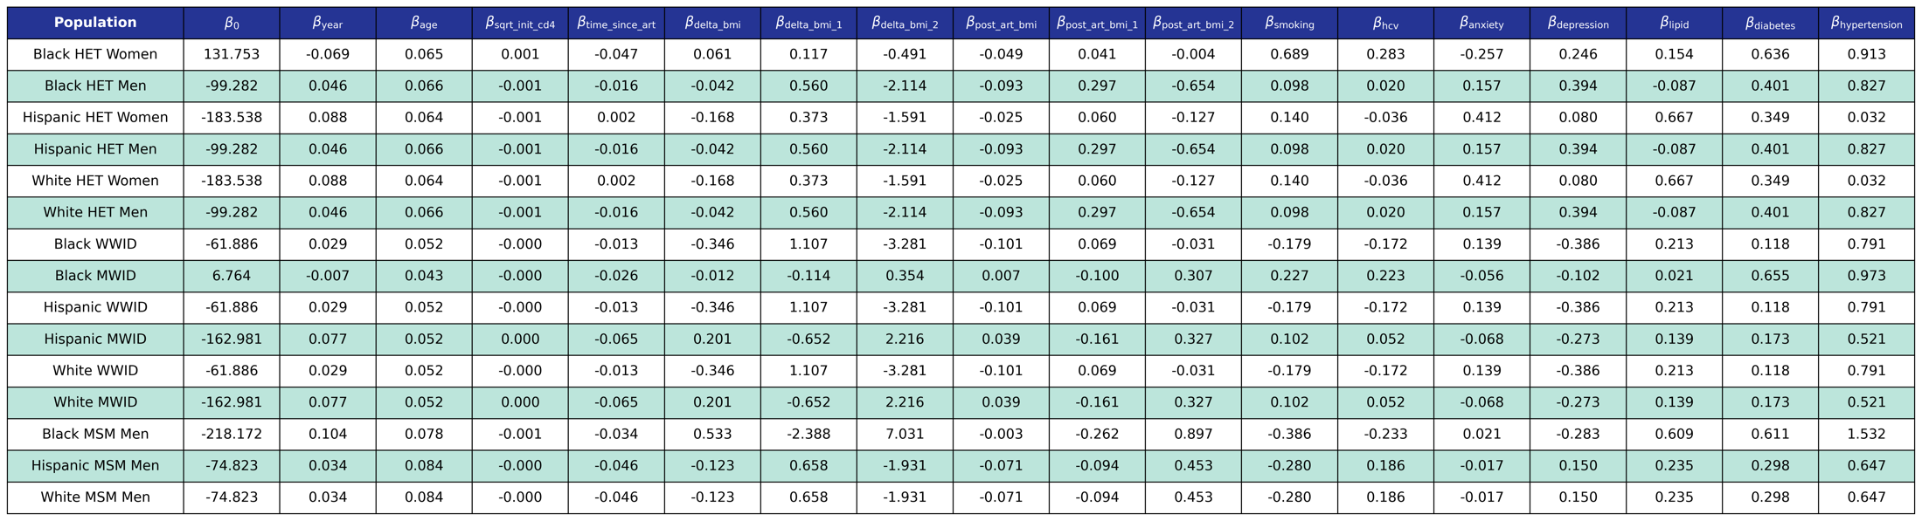
We use logistic regression to model the probability of incidence of this comorbidity as a linear function of calendar year (year), age (age), square root of CD4 count at ART initiation (sqrt_init_cd4), number of years since ART initiation (time_since_art), change in BMI after ART initiation (delta_bmi) and BMI after ART initiation (post_art_bmi) modeled as restricted cubic splines (see https://pearlhivmodel.org/method_details.html for knots), smoking status (smoking), hepatitis C virus (hcv), anxiety (anxiety), depression (depression), dyslipidemia (lipid), diabetes (diabetes), and hypertension (hypertension).

d1) Dyslipidemia prevalence estimates (from the NA-ACCORD)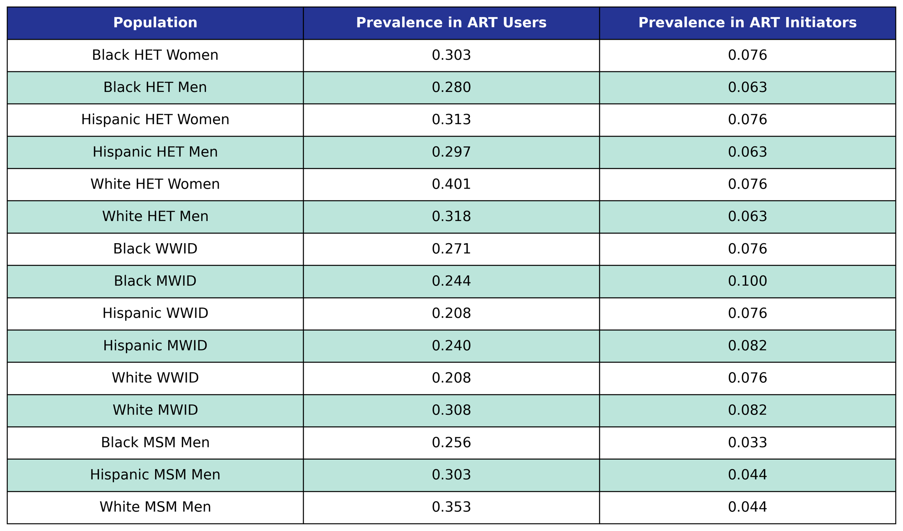
Prevalence in the 2009 ART user population is taken from the 2009 NA-ACCORD population, while prevalence in ART initiators was taken from the 2009 - 2017 NA-ACCORD ART initiator population.

d2) Coefficient estimates from dyslipidemia incidence functions (from the NA-ACCORD)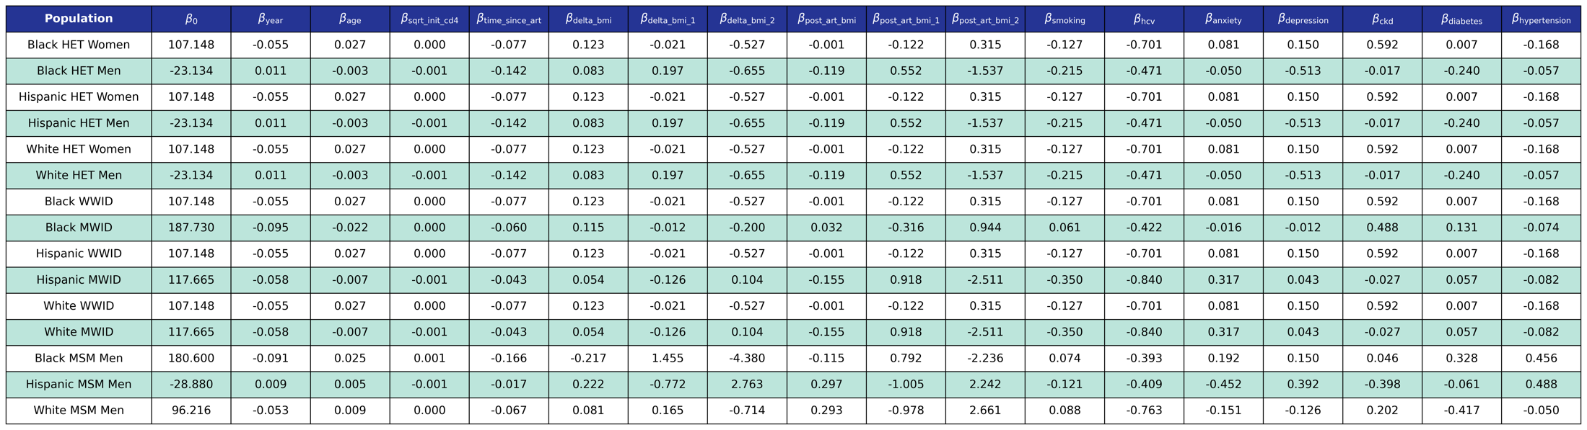

We use logistic regression to model the probability of incidence of this comorbidity as a linear function of calendar year (year), age (age), square root of CD4 count at ART initiation (sqrt_init_cd4), number of years since ART initiation (time_since_art), change in BMI after ART initiation (delta_bmi) and BMI after ART initiation (post_art_bmi) modeled as restricted cubic splines (see https://pearlhivmodel.org/method_details.html for knots), smoking status (smoking), hepatitis C virus (hcv), anxiety (anxiety), depression (depression), stage ≥3 chronic kidney disease (ckd), diabetes (diabetes), and hypertension (hypertension).

e1) Diabetes prevalence estimates (from the NA-ACCORD)
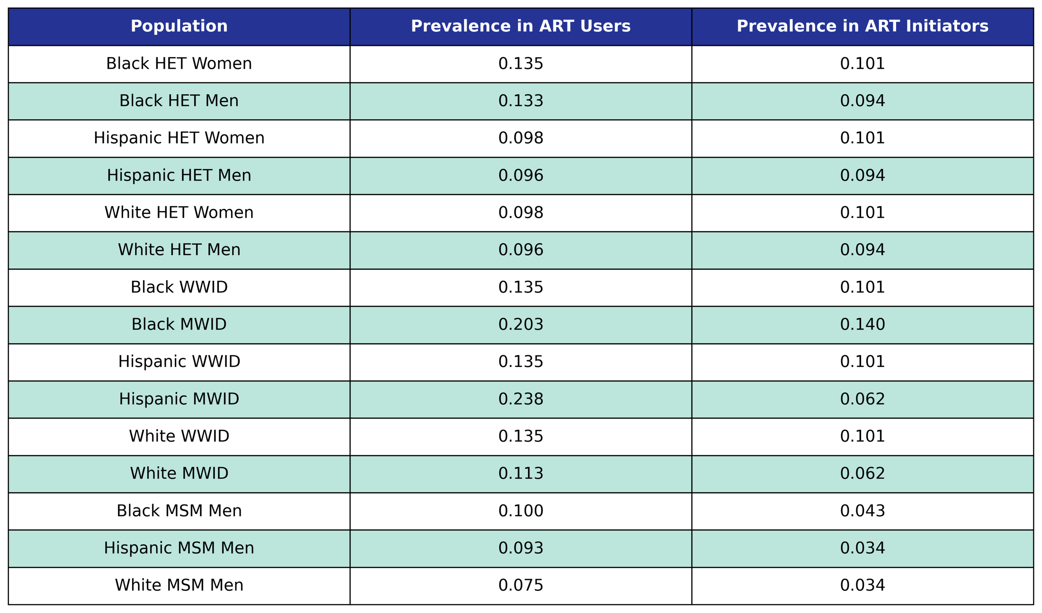
Prevalence in the 2009 ART user population is taken from the 2009 NA-ACCORD population, while prevalence in ART initiators was taken from the 2009 - 2017 NA-ACCORD ART initiator population.

e2) Coefficient estimates from diabetes incidence functions (from the NA-ACCORD)
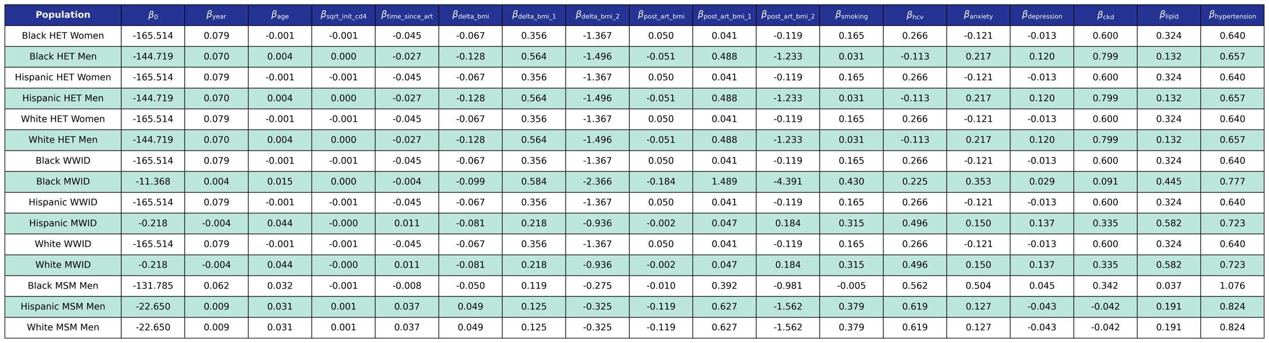
We use logistic regression to model the probability of incidence of this comorbidity as a linear function of calendar year (year), age (age), square root of CD4 count at ART initiation (sqrt_init_cd4), number of years since ART initiation (time_since_art), change in BMI after ART initiation (delta_bmi) and BMI after ART initiation (post_art_bmi) modeled as restricted cubic splines (see https://pearlhivmodel.org/method_details.html for knots), smoking status (smoking), hepatitis C virus (hcv), anxiety (anxiety), depression (depression), stage ≥3 chronic kidney disease (ckd), dyslipidemia (lipids), and hypertension (hypertension).

f1) Hypertension prevalence estimates (from the NA-ACCORD)
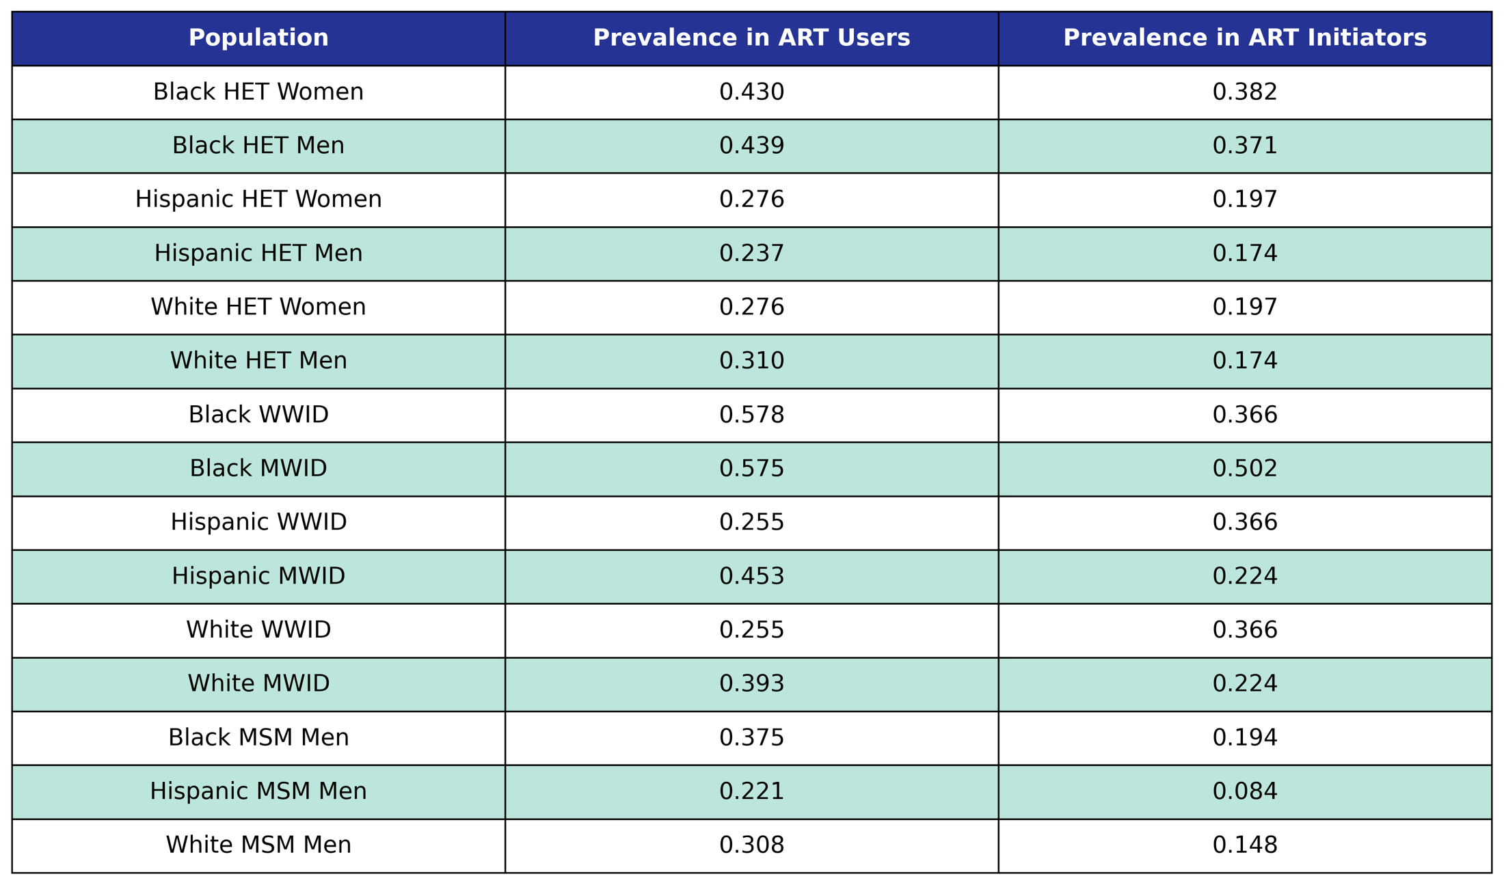
Prevalence in the 2009 ART user population is taken from the 2009 NA-ACCORD population, while prevalence in ART initiators was taken from the 2009 - 2017 NA-ACCORD ART initiator population.

f2) Coefficient estimates from hypertension incidence functions (from the NA-ACCORD)
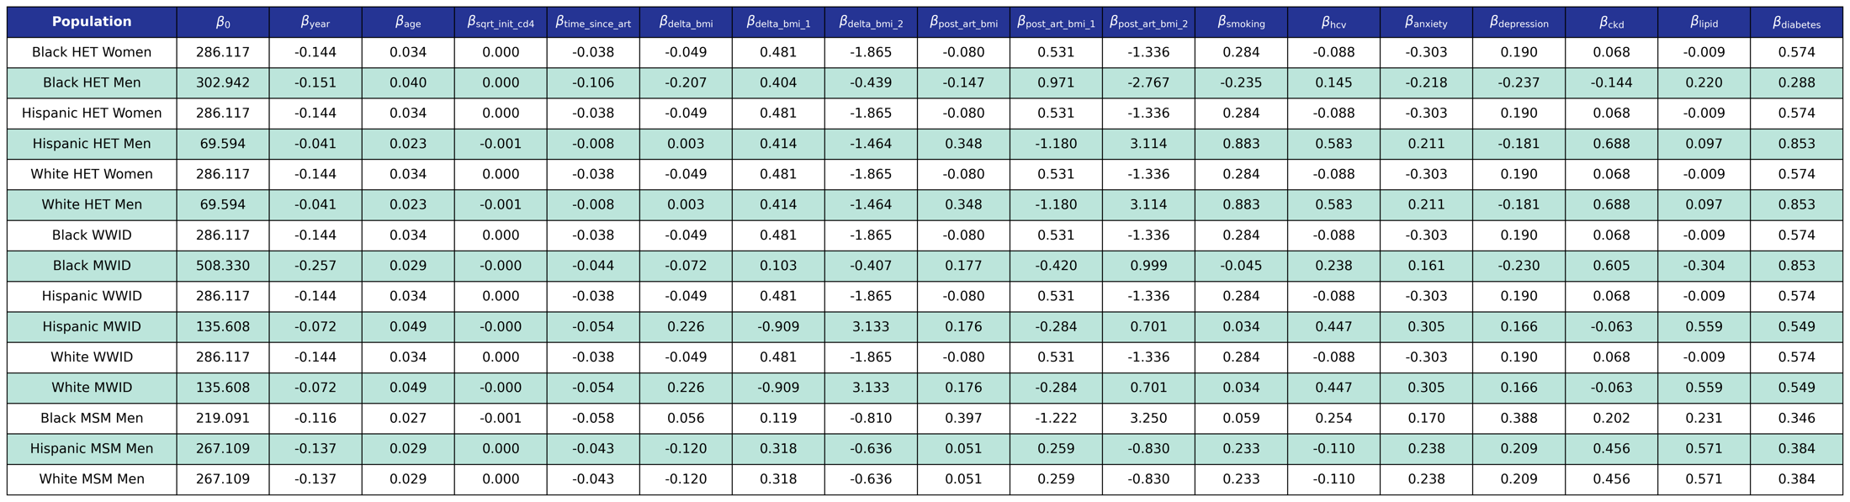
We use logistic regression to model the probability of incidence of this comorbidity as a linear function of calendar year (year), age (age), square root of CD4 count at ART initiation (sqrt_init_cd4), number of years since ART initiation (time_since_art), change in BMI after ART initiation (delta_bmi) and BMI after ART initiation (post_art_bmi) modeled as restricted cubic splines (see https://pearlhivmodel.org/method_details.html for knots), smoking status (smoking), hepatitis C virus (hcv), anxiety (anxiety), depression (depression), stage ≥3 chronic kidney disease (ckd), dyslipidemia (lipids), and diabetes (diabetes).

g1) Cancer prevalence estimates (from the NA-ACCORD)
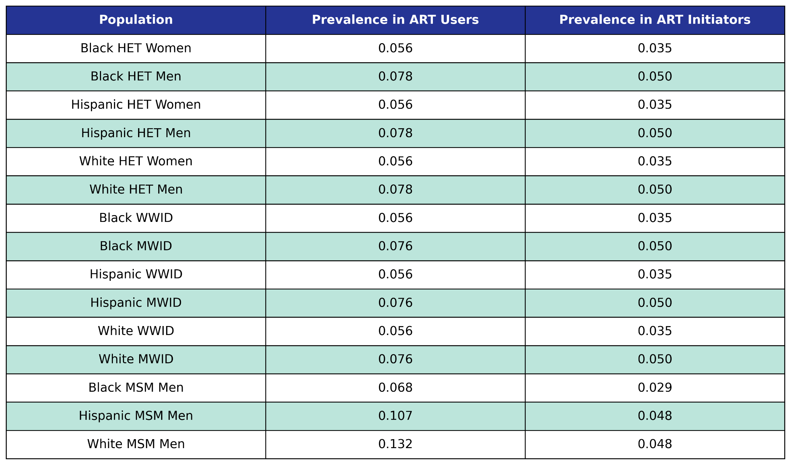
Prevalence in the 2009 ART user population is taken from the 2009 NA-ACCORD population, while prevalence in ART initiators was taken from the 2009 - 2017 NA-ACCORD ART initiator population.

g2) Coefficient estimates from cancer incidence functions (from the NA-ACCORD)
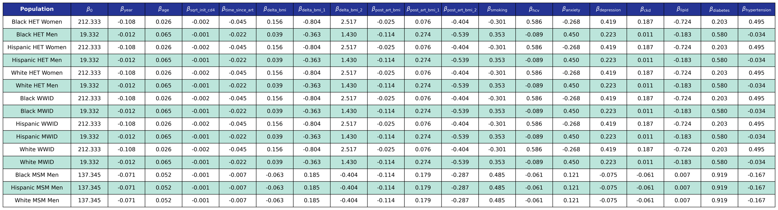
We use logistic regression to model the probability of incidence of this comorbidity as a linear function of calendar year (year), age (age), square root of CD4 count at ART initiation (sqrt_init_cd4), number of years since ART initiation (time_since_art), change in BMI after ART initiation (delta_bmi) and BMI after ART initiation (post_art_bmi) modeled as restricted cubic splines (see https://pearlhivmodel.org/method_details.html for knots), smoking status (smoking), hepatitis C virus (hcv), anxiety (anxiety), depression (depression), stage ≥3 chronic kidney disease (ckd), dyslipidemia (lipid), diabetes (diabetes), and hypertension (hypertension).

h1) End-stage liver disease prevalence estimates (from the NA-ACCORD)
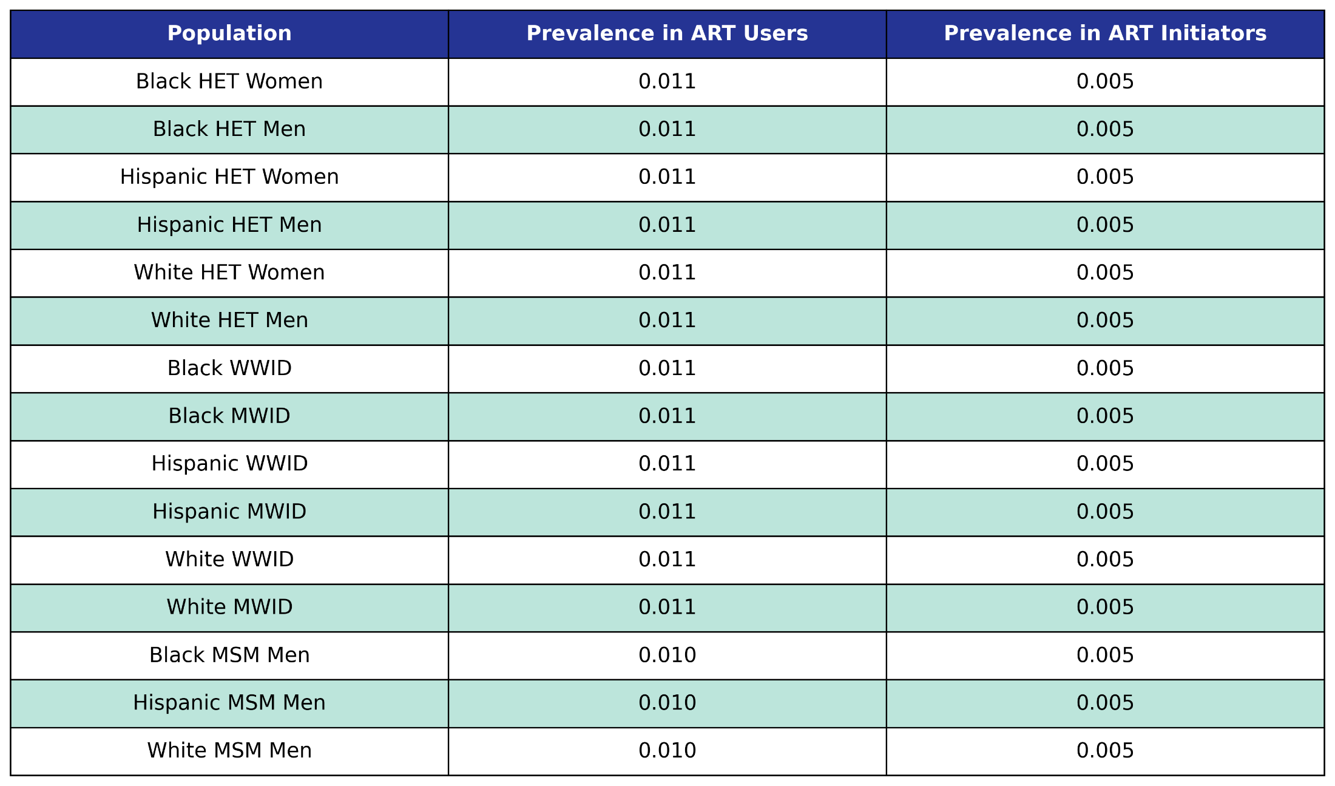
Prevalence in the 2009 ART user population is taken from the 2009 NA-ACCORD population, while prevalence in ART initiators was taken from the 2009 - 2017 NA-ACCORD ART initiator population.

h2) Coefficient estimates from end-stage liver disease incidence functions (from the NA-ACCORD)
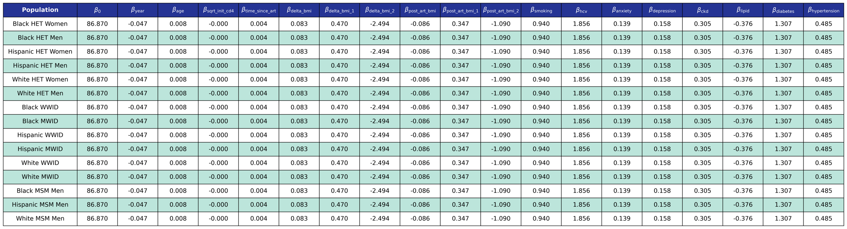
We use logistic regression to model the probability of incidence of this comorbidity as a linear function of calendar year (year), age (age), square root of CD4 count at ART initiation (sqrt_init_cd4), number of years since ART initiation (time_since_art), change in BMI after ART initiation (delta_bmi) and BMI after ART initiation (post_art_bmi) modeled as restricted cubic splines (see https://pearlhivmodel.org/method_details.html for knots), smoking status (smoking), hepatitis C virus (hcv), anxiety (anxiety), depression (depression), stage ≥3 chronic kidney disease (ckd), dyslipidemia (lipid), diabetes (diabetes), and hypertension (hypertension).

i1) Myocardial infarction prevalence estimates (from the NA-ACCORD)
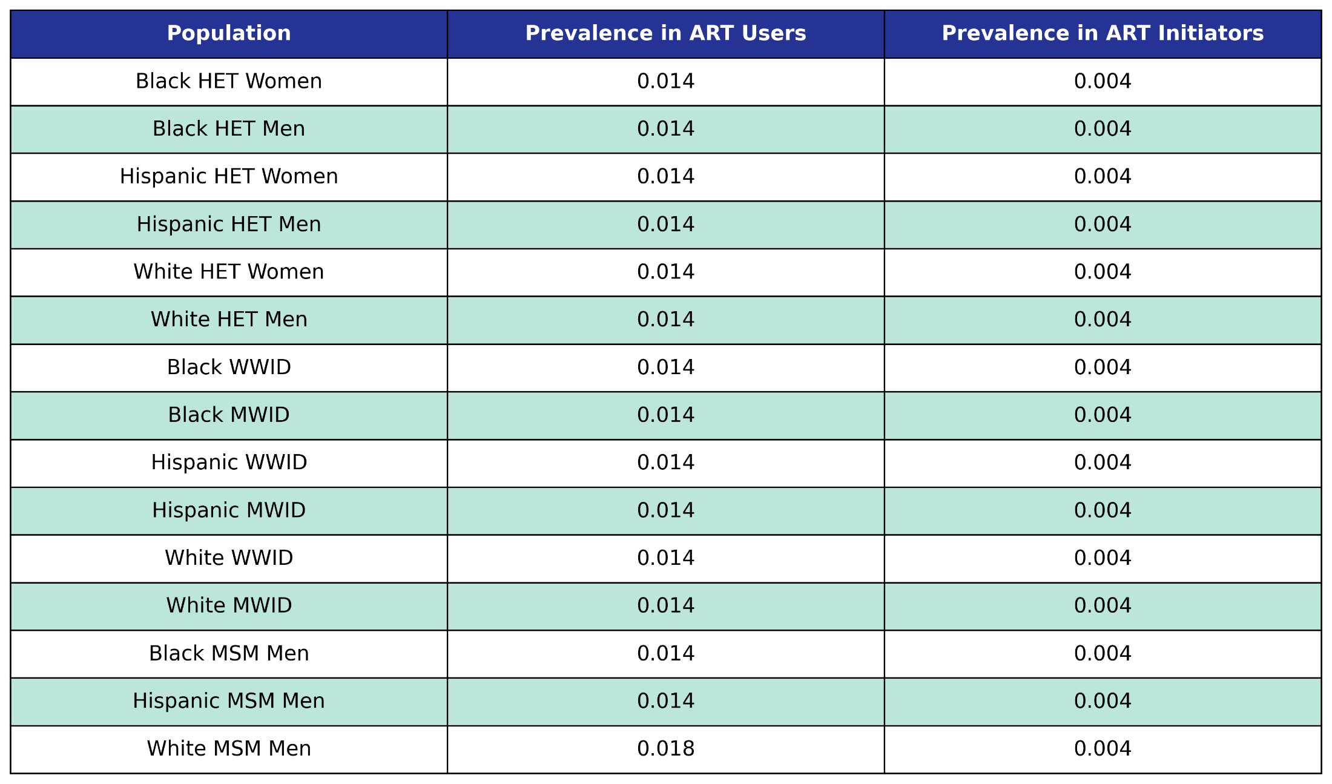Prevalence in the 2009 ART user population is taken from the 2009 NA-ACCORD population, while prevalence in ART initiators was taken from the 2009 - 2017 NA-ACCORD ART initiator population.

i2) Coefficient estimates from myocardial infarction incidence functions (from the NA-ACCORD)
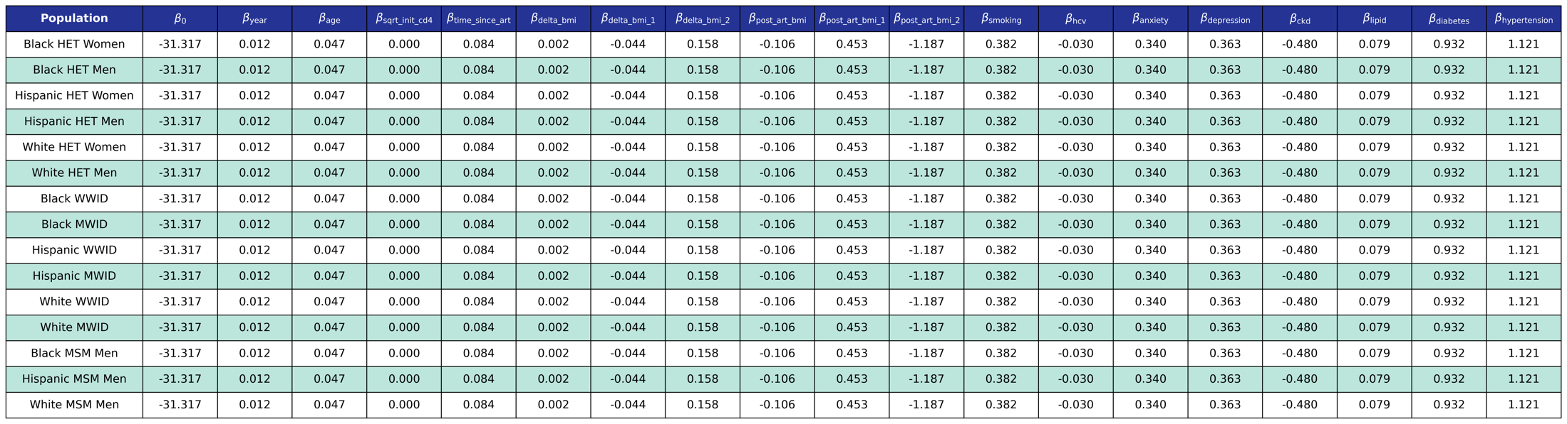
We use logistic regression to model the probability of incidence of this comorbidity as a linear function of calendar year (year), age (age), square root of CD4 count at ART initiation (sqrt_init_cd4), number of years since ART initiation (time_since_art), change in BMI after ART initiation (delta_bmi) and BMI after ART initiation (post_art_bmi) modeled as restricted cubic splines (see https://pearlhivmodel.org/method_details.html for knots), smoking status (smoking), hepatitis C virus (hcv), anxiety (anxiety), depression (depression), stage ≥3 chronic kidney disease (ckd), dyslipidemia (lipid), diabetes (diabetes), and hypertension (hypertension).

Table S3: PEARL a) in-care and b) dis-engaged from care mortality functions that include comorbidity presence
a) Coefficient estimates from mortality functions for those in-care
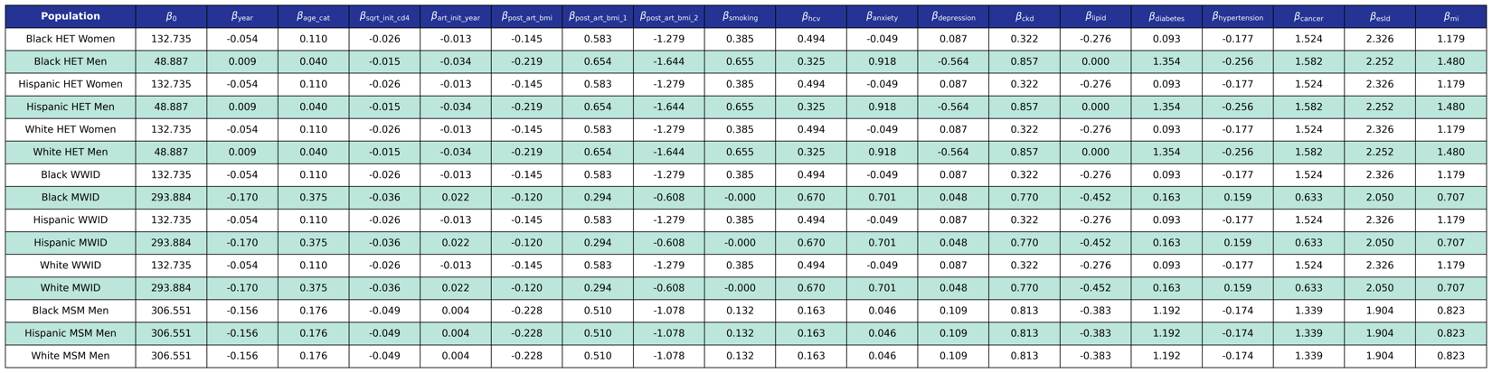
We use logistic regression to model the probability of dying in care as a function of calendar year (year), 10 year age category (age_cat), CD4 count at ART initiation (sqrt_init_cd4), year of ART initiation (art_init_year), BMI after ART initiation (post_art_bmi) modeled as a restricted cubic spline (see https://pearlhivmodel.org/method_details.html for knots), smoking status (smoking), hepatitis C virus (hcv), anxiety (anxiety), depression (depression), stage ≥3 chronic kidney disease (ckd), dyslipidemia (lipids), diabetes (diabetes), hypertension (hypertension), cancer (cancer), end-stage liver disease (esld), and myocardial infarction (mi). The coefficients were estimated using a Generalized Estimating Equation (GEE) with a logit link and an unstructured correlation structure using the geepack software package for R. The NA-ACCORD dataset was restricted to the years 2009-2015 and each patient is represented by a data point for each year they were alive and under observation in NA-ACCORD.

b) Coefficient estimates from mortality functions for those dis-engaged from care and ART
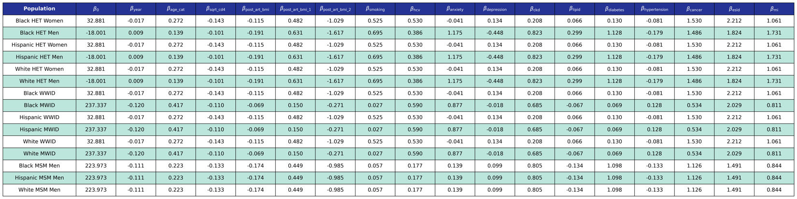
We use logistic regression to model the probability of dying out of care as a function of calendar year (year), 10 year age category (age_cat), CD4 count (sqrt_cd4), BMI after ART initiation (post_art_bmi) modeled as a restricted cubic spline (see https://pearlhivmodel.org/method_details.html for knots), smoking status (smoking), hepatitis C virus (hcv), anxiety (anxiety), depression (depression), stage ≥3 chronic kidney disease (ckd), dyslipidemia (lipids), diabetes (diabetes), hypertension (hypertension), cancer (cancer), end-stage liver disease (esld), and myocardial infarction (mi). The coefficients were estimated using a Generalized Estimating Equation (GEE) with a logit link and an unstructured correlation structure using the geepack software package for R. The NA-ACCORD dataset was restricted to the years 2009-2015.

Figure S1: Comorbidity incidence validation plots, by subgroup. Black line=observed annual incidence from the NA-ACCORD; gray shading = the 95% confidence intervals of the observed annual incidence from the NA-ACCORD data. Blue line=projected annual incidence from PEARL. Orange plot shading signals <75% PEARL estimates [total of 7 observed incidence (2009-2015) for MI and ESLD and 9 observed incidence (2009-2017) for all other comorbidities] are within +/-5% of the observed incidence or the 95% confidence interval of the observed incidence [whichever is larger].
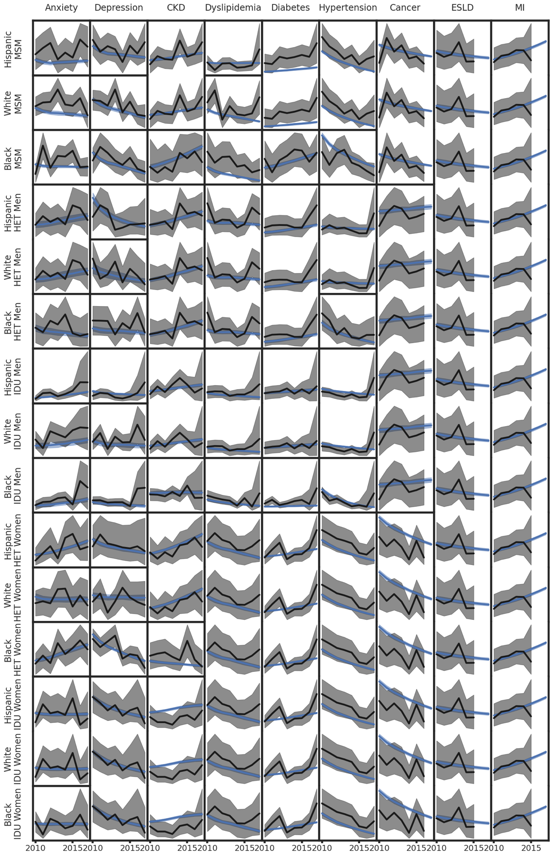
Footnotes:
The y axis is unlabeled and is not the same scale in each plot.

Figure S2: Comorbidity prevalence validation plots, by subgroup. Black line=observed annual prevalence from the NA-ACCORD; gray shading = the 95% confidence intervals of the observed annual prevalence from the NA-ACCORD data. Blue line=projected annual prevalence from PEARL. Orange plot = <75% PEARL estimates [total of 7 observed prevalence (2009-2015) for MI and ESLD and 9 observed prevalence (2009-2017) for all other comorbidities] are within +/-5% of the observed prevalence or the 95% confidence interval of the observed prevalence [whichever is larger]. Please note that the orange plots occur among Hispanic sub-groups, white heterosexual men, and Black/AA and White women who injected drugs; these groups have smaller observed sample sizes and were combined with other subgroups resulting in differences between the NA-ACCORD observed estimates and PEARL estimates.

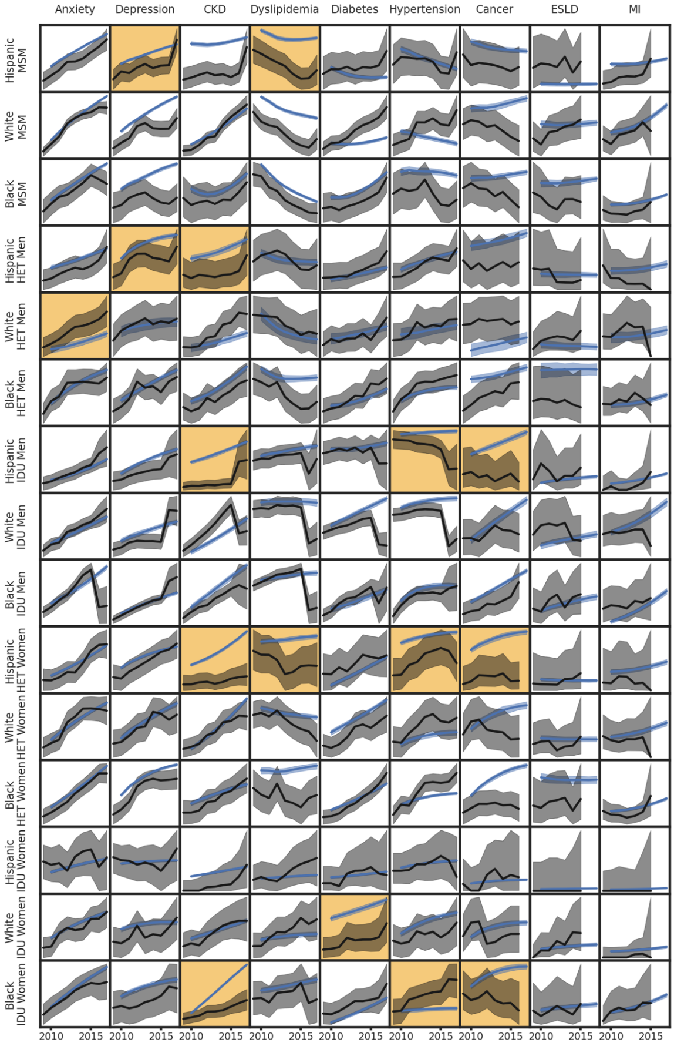
Footnotes:
The y axis is unlabeled and is not the same scale in each plot.
For subgroups with small observed sample size in the NA-ACCORD, the ordered collapsing strategy is: 1) by race/ethnicity, 2) by gender.

Table S4: Characteristics of the PEARL-simulated agents using ART, 2020 and 2030

 | 2020 (Projected) |  | 2030 (Projected)
 | PEARLª |  | PEARLª
 | N = | 674,531 [667,269, 680,808] | N = | 914,738 [879,768, 946,129]
Characteristics | n [95% interquartile range] | % [95% interquartile range] | n [95% interquartile range] | % [95% interquartile range]
Age (in years)
<20 | 699 [623, 777] | 0.1% [0.1%, 0.1%] | 1,210 [644, 1,914] | 0.1% [0.1%, 0.2%]
20-24 | 11,452 [11,045, 11,923] | 1.7% [1.6%, 1.8%] | 12,238 [9,983, 15,393] | 1.3% [1.1%, 1.7%]
25-29 | 40,556 [39,526, 41,461] | 6.0% [5.9%, 6.1%] | 40,794 [35,940, 46,208] | 4.5% [4.0%, 5.0%]
30-34 | 66,908 [65,750, 68,228] | 9.9% [9.8%, 10.0%] | 78,542 [71,076, 86,728] | 8.6% [8.0%, 9.2%]
35-39 | 63,128 [62,239, 63,976] | 9.4% [9.3%, 9.4%] | 101,300 [94,395, 108,110] | 11.1% [10.7%, 11.5%]
40-44 | 61,290 [60,471, 62,008] | 9.1% [9.0%, 9.2%] | 102,383 [97,978, 106,340] | 11.2% [11.0%, 11.4%]
45-49 | 80,046 [79,011, 81,014] | 11.9% [11.8%, 12.0%] | 85,847 [82,747, 89,462] | 9.4% [9.2%, 9.6%]
50-54 | 98,716 [97,661, 99,655] | 14.6% [14.6%, 14.7%] | 81,764 [78,706, 85,619] | 8.9% [8.7%, 9.2%]
55-59 | 101,289 [100,374, 102,209] | 15.0% [14.9%, 15.1%] | 95,226 [92,746, 98,155] | 10.4% [10.2%, 10.7%]
60-64 | 76,974 [76,159, 77,640] | 11.4% [11.3%, 11.5%] | 103,896 [101,773, 106,004] | 11.4% [11.1%, 11.7%]
65-69 | 44,785 [44,299, 45,235] | 6.6% [6.6%, 6.7%] | 95,728 [94,241, 97,315] | 10.5% [10.2%, 10.8%]
70-74 | 19,800 [19,506, 20,051] | 2.9% [2.9%, 3.0%] | 65,606 [64,550, 66,473] | 7.2% [7.0%, 7.4%]
≥75 | 8,969 [8,740, 9,146] | 1.3% [1.3%, 1.4%] | 48,778 [47,990, 49,430] | 5.3% [5.2%, 5.5%]
Male sex | 518,620 [512,548, 524,273] | 76.9% [76.5%, 77.2%] | 714,764 [682,892, 745,401] | 78.3% [77.1%, 79.4%]
Race
White | 218,290 [214,789, 221,569] | 32.4% [32.0%, 32.8%] | 261,230 [244,612, 277,367] | 28.7% [27.1%, 30.4%]
Black/AA | 298,157 [294,257, 302,535] | 44.2% [43.7%, 44.7%] | 395,170 [377,556, 417,044] | 43.2% [41.6%, 45.0%]
Hispanic | 157,923 [155,092, 161,338] | 23.4% [23.0%, 23.8%] | 256,343 [238,487, 277,014] | 28.1% [26.5%, 29.8%]
Sub-groups
MSM | 406,590 [400,695, 411,771] | 60.2% [59.8%, 60.6%] | 587,148 [557,766, 615,889] | 64.2% [62.7%, 65.7%]
White MSM | 156,942 [153,957, 160,091] | 23.3% [22.9%, 23.7%] | 180,206 [165,009, 195,275] | 19.7% [18.3%, 21.2%]
Black/AA MSM | 144,577 [141,991, 147,215] | 21.4% [21.0%, 21.8%] | 218,374 [205,294, 231,056] | 23.9% [22.3%, 25.3%]
Hispanic MSM | 104,670 [102,075, 107,565] | 15.5% [15.2%, 15.9%] | 188,080 [171,296, 206,202] | 20.6% [19.1%, 22.3%]
Men who injected drugs (MWID)^{b} | 59,818 [58,188, 61,571] | 8.9% [8.6%, 9.1%] | 65,672 [58,566, 72,660] | 7.2% [6.4%, 8.0%]
White MWID | 23,652 [22,821, 24,596] | 3.5% [3.4%, 3.6%] | 29,460 [25,892, 32,940] | 3.2% [2.8%, 3.6%]
Black/AA MWID | 21,163 [20,455, 21,960] | 3.1% [3.0%, 3.3%] | 17,748 [14,339, 21,402] | 1.9% [1.6%, 2.3%]
Hispanic MWID | 15,000 [14,319, 15,856] | 2.2% [2.1%, 2.3%] | 18,506 [15,363, 22,119] | 2.0% [1.7%, 2.4%]
Women who injected drugs (WWID) | 27,804 [27,214, 28,423] | 4.1% [4.0%, 4.2%] | 31,149 [28,571, 33,665] | 3.4% [3.1%, 3.8%]
White WWID | 9,592 [9,385, 9,815] | 1.4% [1.4%, 1.5%] | 13,401 [12,641, 14,275] | 1.5% [1.4%, 1.6%]
Black/AA WWID | 14,222 [13,789, 14,647] | 2.1% [2.0%, 2.2%] | 12,936 [11,170, 14,740] | 1.4% [1.2%, 1.6%]
Hispanic WWID | 3,994 [3,744, 4,258] | 0.6% [0.6%, 0.6%] | 4,820 [3,716, 5,969] | 0.5% [0.4%, 0.7%]
Heterosexual men | 52,364 [50,896, 53,932] | 7.8% [7.5%, 8.0%] | 62,334 [55,279, 69,611] | 6.8% [6.0%, 7.6%]
White heterosexual men | 6,840 [6,552, 7,200] | 1.0% [1.0%, 1.1%] | 9,369 [8,129, 10,942] | 1.0% [0.9%, 1.2%]
Black/AA heterosexual men | 34,418 [33,156, 35,637] | 5.1% [4.9%, 5.3%] | 39,848 [33,775, 45,447] | 4.4% [3.7%, 5.0%]
Hispanic heterosexual men | 11,108 [10,645, 11,564] | 1.6% [1.6%, 1.7%] | 12,998 [10,805, 15,224] | 1.4% [1.2%, 1.7%]
Heterosexual women | 128,017 [125,848, 130,489] | 19.0% [18.7%, 19.3%] | 167,442 [158,018, 178,617] | 18.3% [17.2%, 19.5%]
White heterosexual women | 21,160 [20,568, 21,912] | 3.1% [3.0%, 3.2%] | 28,882 [26,130, 32,486] | 3.2% [2.8%, 3.6%]
Black/AA heterosexual women | 83,713 [82,236, 85,718] | 12.4% [12.2%, 12.7%] | 106,270 [99,595, 115,531] | 11.7% [10.8%, 12.6%]
Hispanic heterosexual women | 23,094 [22,053, 23,926] | 3.4% [3.3%, 3.6%] | 31,992 [27,464, 35,894] | 3.5% [3.0%, 4.0%]
Mental Comorbidities
Anxiety | 246,192 [243,773, 248,355] | 36.5% [36.3%, 36.7%] | 428,545 [415,882, 441,413] | 46.9% [46.4%, 47.6%]
Depression | 317,676 [314,736, 320,336] | 47.1% [47.0%, 47.3%] | 445,518 [433,042, 457,839] | 48.8% [48.3%, 49.3%]
≥1 mental comorbidity | 405,332 [401,727, 408,753] | 60.1% [59.9%, 60.3%] | 589,178 [570,913, 607,285] | 64.5% [64.0%, 65.1%]
Physical Comorbidities
Chronic Kidney Disease | 111,940 [110,943, 112,766] | 16.6% [16.5%, 16.7%] | 227,423 [222,269, 231,579] | 24.9% [24.3%, 25.5%]
Dyslipidemia | 184,860 [183,476, 186,227] | 27.4% [27.2%, 27.5%] | 234,910 [230,381, 239,349] | 25.7% [25.2%, 26.3%]
Diabetes | 105,239 [104,253, 106,039] | 15.6% [15.5%, 15.7%] | 219,064 [213,758, 224,026] | 24.0% [23.5%, 24.6%]
Hypertension | 239,688 [237,624, 241,812] | 35.5% [35.4%, 35.7%] | 287,116 [279,586, 295,007] | 31.4% [30.9%, 32.0%]
Cancer | 75,944 [75,271, 76,556] | 11.3% [11.2%, 11.3%] | 104,010 [101,267, 106,318] | 11.4% [11.2%, 11.6%]
End-Stage Liver Disease | 9,062 [8,903, 9,251] | 1.3% [1.3%, 1.4%] | 13,334 [13,036, 13,726] | 1.5% [1.4%, 1.5%]
Myocardial Infarction | 21,934 [21,629, 22,205] | 3.2% [3.2%, 3.3%] | 72,294 [71,454, 72,971] | 7.9% [7.7%, 8.2%]
Physical Multimorbidity
No physical comorbidities | 237,779 [234,498, 241,111] | 35.3% [35.0%, 35.4%] | 314,013 [294,246, 332,028] | 34.3% [33.3%, 35.2%]
1 physical comorbidity | 226,742 [224,319, 229,149] | 33.6% [33.5%, 33.7%] | 275,250 [263,964, 285,241] | 30.1% [29.9%, 30.3%]
≥2 physical comorbidities | 209,865 [208,443, 211,142] | 31.1% [31.0%, 31.3%] | 325,266 [319,409, 330,676] | 35.5% [34.7%, 36.5%]
Mental and physical multimorbidity
≥2 mental or physical comorbidities | 393,150 [389,986, 395,791] | 58.3% [58.1%, 58.5%] | 579,564 [564,560, 593,592] | 63.4% [62.5%, 64.5%]
≥1 mental and ≥2 physical comorbidities | 139,335 [138,445, 140,283] | 20.7% [20.5%, 20.8%] | 232,310 [228,637, 235,724] | 25.4% [24.8%, 26.1%]
ART status
PWH using ART | 674,531 [667,269, 680,808] | n/a | 914,738 [879,768, 946,129] | n/a
ART initiators | 32,963 [31,720, 34,059] | n/a | 33,324 [28,488, 37,749] | n/a
Disengaged from ART use^{d} | 41,884 [41,375, 42,430] | n/a | 33,208 [31,780, 34,612] | n/a
Footnotes:
AA=African American
ART=antiretroviral therapy
PEARL = ProjEcting Age, multimoRbidity, and poLypharmacy in Adults with HIV
PWH=people with HIV
MSM=men who have sex with men
ªValues represent the median and uncertainty ranges for each simulated outcome across 200 random simulation replications.
^{b}MSM who also have MWID as their HIV acquisition risk factor were include in the MWID HIV acquisition risk group.
^{c}Percentages in this table are calculated using the median numerator and median denominator from 200 simulation runs of the PEARL model so that percentages will sum to 100%.
^{d}PEARL projections of PWH using ART do not include 41,884 [41,375, 42,430] and 33,208 [31,780, 34,612] people who initiated ART but were not using ART treatments in 2020 and 2030 (respectively) and people of ‘other’ race and ethnicities.

Table S5: PEARL-projected multimorbidity prevalence, by yearª and within each subgroup of PWH using ART in the US
Subgroup | Multimorbidity measurement | 2009 | 2010 |  | 2011 |  | 2012 |  | 2013 |  | 2014 |  | 2015 |  | 2016 |  | 2017 |  | 2018 |  | 2019 |  | 2020 |  | 2021 |  | 2022 |  | 2023 |  | 2024 |  | 2025 |  | 2026 |  | 2027 |  | 2028 |  | 2029 |  | 2030
Overall | ≥1 Ment. | 51% | 53% |  | 54% |  | 55% |  | 56% |  | 56% |  | 57% |  | 58% |  | 58% |  | 59% |  | 60% |  | 60% |  | 61% |  | 61% |  | 62% |  | 62% |  | 62% |  | 63% |  | 63% |  | 64% |  | 64% |  | 64%
Overall | ≥2 Phys. | 25% | 26% |  | 27% |  | 27% |  | 28% |  | 28% |  | 29% |  | 29% |  | 30% |  | 30% |  | 31% |  | 31% |  | 32% |  | 32% |  | 32% |  | 33% |  | 33% |  | 34% |  | 34% |  | 35% |  | 35% |  | 36%
Overall | ≥2 Any | 50% | 52% |  | 53% |  | 53% |  | 54% |  | 55% |  | 55% |  | 56% |  | 57% |  | 57% |  | 58% |  | 58% |  | 59% |  | 59% |  | 60% |  | 60% |  | 61% |  | 61% |  | 62% |  | 62% |  | 63% |  | 63%
Overall | ≥1 Ment. & 2 Phys. | 13% | 14% |  | 15% |  | 16% |  | 17% |  | 17% |  | 18% |  | 19% |  | 19% |  | 20% |  | 20% |  | 21% |  | 21% |  | 22% |  | 22% |  | 23% |  | 23% |  | 23% |  | 24% |  | 24% |  | 25% |  | 25%
White MSM | ≥1 Ment. | 56% | 57% |  | 58% |  | 59% |  | 60% |  | 61% |  | 62% |  | 63% |  | 64% |  | 64% |  | 65% |  | 66% |  | 66% |  | 67% |  | 67% |  | 68% |  | 68% |  | 69% |  | 69% |  | 70% |  | 70% |  | 71%
White MSM | ≥2 Phys. | 25% | 26% |  | 26% |  | 26% |  | 26% |  | 27% |  | 27% |  | 27% |  | 28% |  | 28% |  | 29% |  | 29% |  | 29% |  | 30% |  | 30% |  | 31% |  | 32% |  | 32% |  | 33% |  | 33% |  | 34% |  | 35%
White MSM | ≥2 Any | 52% | 54% |  | 54% |  | 55% |  | 55% |  | 56% |  | 57% |  | 58% |  | 58% |  | 59% |  | 60% |  | 60% |  | 61% |  | 62% |  | 62% |  | 63% |  | 64% |  | 64% |  | 65% |  | 66% |  | 66% |  | 67%
White MSM | ≥1 Ment. & 2 Phys. | 14% | 15% |  | 16% |  | 16% |  | 17% |  | 17% |  | 18% |  | 18% |  | 19% |  | 19% |  | 20% |  | 20% |  | 21% |  | 21% |  | 22% |  | 23% |  | 23% |  | 24% |  | 24% |  | 25% |  | 26% |  | 26%
Black/AA MSM | ≥1 Ment. | 43% | 44% |  | 45% |  | 45% |  | 46% |  | 46% |  | 47% |  | 47% |  | 48% |  | 48% |  | 48% |  | 48% |  | 49% |  | 49% |  | 49% |  | 49% |  | 49% |  | 49% |  | 49% |  | 49% |  | 49% |  | 49%
Black/AA MSM | ≥2 Phys. | 22% | 23% |  | 23% |  | 22% |  | 22% |  | 22% |  | 23% |  | 23% |  | 23% |  | 23% |  | 24% |  | 24% |  | 24% |  | 25% |  | 25% |  | 26% |  | 26% |  | 27% |  | 27% |  | 28% |  | 29% |  | 29%
Black/AA MSM | ≥2 Any | 42% | 43% |  | 43% |  | 43% |  | 43% |  | 43% |  | 43% |  | 43% |  | 44% |  | 44% |  | 44% |  | 45% |  | 45% |  | 45% |  | 45% |  | 46% |  | 46% |  | 46% |  | 47% |  | 47% |  | 48% |  | 48%
Black/AA MSM | ≥1 Ment. & 2 Phys. | 9% | 11% |  | 11% |  | 11% |  | 12% |  | 12% |  | 12% |  | 13% |  | 13% |  | 13% |  | 14% |  | 14% |  | 14% |  | 15% |  | 15% |  | 15% |  | 16% |  | 16% |  | 16% |  | 17% |  | 17% |  | 17%
Hispanic MSM | ≥1 Ment. | 56% | 58% | 58% |  | 58% |  | 59% |  | 59% |  | 60% |  | 61% |  | 61% |  | 62% |  | 62% |  | 63% |  | 63% |  | 64% |  | 65% |  | 65% |  | 65% |  | 66% |  | 66% |  | 67% |  | 67% |  | 67%
Hispanic MSM | ≥2 Phys. | 19% | 20% | 19% |  | 19% |  | 19% |  | 19% |  | 19% |  | 19% |  | 19% |  | 19% |  | 20% |  | 20% |  | 20% |  | 20% |  | 20% |  | 20% |  | 20% |  | 21% |  | 21% |  | 21% |  | 21% |  | 21%
Hispanic MSM | ≥2 Any | 46% | 48% | 49% |  | 48% |  | 49% |  | 49% |  | 50% |  | 50% |  | 51% |  | 52% |  | 52% |  | 53% |  | 53% |  | 54% |  | 55% |  | 55% |  | 56% |  | 56% |  | 57% |  | 57% |  | 58% |  | 58%
Hispanic MSM | ≥1 Ment. & 2 Phys. | 11% | 12% | 12% |  | 12% |  | 13% |  | 13% |  | 13% |  | 14% |  | 14% |  | 14% |  | 14% |  | 15% |  | 15% |  | 15% |  | 15% |  | 15% |  | 16% |  | 16% |  | 16% |  | 16% |  | 16% |  | 17%
White MWID | ≥1 Ment. | 60% | 62% | 63% |  | 64% |  | 65% |  | 66% |  | 67% |  | 68% |  | 69% |  | 69% |  | 70% |  | 71% |  | 72% |  | 73% |  | 74% |  | 74% |  | 75% |  | 76% |  | 77% |  | 78% |  | 78% |  | 79%
White MWID | ≥2 Phys. | 25% | 28% | 30% |  | 31% |  | 32% |  | 34% |  | 35% |  | 36% |  | 37% |  | 38% |  | 38% |  | 39% |  | 40% |  | 40% |  | 41% |  | 41% |  | 41% |  | 41% |  | 42% |  | 42% |  | 42% |  | 42%
White MWID | ≥2 Any | 56% | 59% | 60% |  | 61% |  | 62% |  | 63% |  | 64% |  | 65% |  | 66% |  | 67% |  | 68% |  | 69% |  | 69% |  | 70% |  | 71% |  | 71% |  | 72% |  | 72% |  | 73% |  | 74% |  | 74% |  | 75%
White MWID | ≥1 Ment. & 2 Phys. | 15% | 18% | 19% |  | 21% |  | 22% |  | 23% |  | 24% |  | 26% |  | 27% |  | 28% |  | 28% |  | 29% |  | 30% |  | 31% |  | 31% |  | 32% |  | 33% |  | 33% |  | 33% |  | 34% |  | 34% |  | 35%
Black/AA MWID | ≥1 Ment. | 45% | 47% | 48% |  | 49% |  | 51% |  | 52% |  | 53% |  | 55% |  | 56% |  | 57% |  | 58% |  | 60% |  | 61% |  | 62% |  | 63% |  | 65% |  | 66% |  | 67% |  | 69% |  | 70% |  | 71% |  | 73%
Black/AA MWID | ≥2 Phys. | 36% | 39% | 41% |  | 43% |  | 44% |  | 46% |  | 47% |  | 48% |  | 49% |  | 50% |  | 51% |  | 52% |  | 52% |  | 53% |  | 53% |  | 54% |  | 54% |  | 54% |  | 54% |  | 53% |  | 53% |  | 53%
Black/AA MWID | ≥2 Any | 57% | 60% | 62% |  | 64% |  | 65% |  | 67% |  | 68% |  | 69% |  | 70% |  | 71% |  | 72% |  | 73% |  | 74% |  | 75% |  | 76% |  | 76% |  | 77% |  | 78% |  | 78% |  | 79% |  | 79% |  | 80%
Black/AA MWID | ≥1 Ment. & 2 Phys. | 16% | 19% | 20% |  | 22% |  | 23% |  | 24% |  | 26% |  | 27% |  | 28% |  | 29% |  | 30% |  | 31% |  | 32% |  | 33% |  | 34% |  | 35% |  | 36% |  | 36% |  | 37% |  | 38% |  | 38% |  | 38%
Hispanic MWID | ≥1 Ment. | 56% | 58% | 59% |  | 60% |  | 62% |  | 63% |  | 64% |  | 66% |  | 67% |  | 68% |  | 70% |  | 71% |  | 72% |  | 74% |  | 76% |  | 77% |  | 79% |  | 80% |  | 82% |  | 84% |  | 85% |  | 87%
Hispanic MWID | ≥2 Phys. | 30% | 33% | 34% |  | 35% |  | 36% |  | 38% |  | 39% |  | 40% |  | 41% |  | 42% |  | 43% |  | 44% |  | 45% |  | 46% |  | 47% |  | 47% |  | 49% |  | 50% |  | 51% |  | 53% |  | 55% |  | 57%
Hispanic MWID | ≥2 Any | 58% | 60% | 62% |  | 63% |  | 64% |  | 65% |  | 67% |  | 68% |  | 70% |  | 71% |  | 73% |  | 74% |  | 75% |  | 77% |  | 78% |  | 79% |  | 81% |  | 82% |  | 84% |  | 85% |  | 86% |  | 88%
Hispanic MWID | ≥1 Ment. & 2 Phys. | 17% | 19% | 21% |  | 22% |  | 23% |  | 25% |  | 26% |  | 27% |  | 29% |  | 30% |  | 31% |  | 32% |  | 34% |  | 35% |  | 36% |  | 38% |  | 39% |  | 41% |  | 43% |  | 45% |  | 47% |  | 50%
White WWID | ≥1 Ment. | 67% | 70% | 72% |  | 73% |  | 74% |  | 75% |  | 76% |  | 77% |  | 77% |  | 78% |  | 78% |  | 79% |  | 79% |  | 79% |  | 80% |  | 80% |  | 81% |  | 81% |  | 81% |  | 82% |  | 82% |  | 83%
White WWID | ≥2 Phys. | 20% | 23% | 25% |  | 27% |  | 29% |  | 31% |  | 32% |  | 33% |  | 34% |  | 35% |  | 36% |  | 37% |  | 38% |  | 39% |  | 40% |  | 41% |  | 42% |  | 42% |  | 43% |  | 44% |  | 45% |  | 46%
White WWID | ≥2 Any | 54% | 59% | 62% |  | 65% |  | 67% |  | 69% |  | 70% |  | 71% |  | 72% |  | 73% |  | 74% |  | 74% |  | 75% |  | 75% |  | 76% |  | 76% |  | 77% |  | 77% |  | 78% |  | 78% |  | 79% |  | 79%
White WWID | ≥1 Ment. & 2 Phys. | 13% | 16% | 19% |  | 20% |  | 22% |  | 24% |  | 25% |  | 26% |  | 27% |  | 28% |  | 29% |  | 30% |  | 31% |  | 32% |  | 33% |  | 34% |  | 34% |  | 35% |  | 36% |  | 37% |  | 38% |  | 39%
Black/AA WWID | ≥1 Ment. | 58% | 62% | 64% |  | 66% |  | 67% |  | 69% |  | 70% |  | 71% |  | 72% |  | 73% |  | 74% |  | 75% |  | 75% |  | 76% |  | 76% |  | 77% |  | 78% |  | 78% |  | 78% |  | 79% |  | 79% |  | 79%
Black/AA WWID | ≥2 Phys. | 35% | 40% | 43% |  | 47% |  | 50% |  | 53% |  | 56% |  | 58% |  | 61% |  | 63% |  | 65% |  | 67% |  | 69% |  | 71% |  | 72% |  | 73% |  | 74% |  | 75% |  | 76% |  | 77% |  | 78% |  | 78%
Black/AA WWID | ≥2 Any | 63% | 67% | 70% |  | 73% |  | 75% |  | 77% |  | 79% |  | 81% |  | 83% |  | 84% |  | 86% |  | 87% |  | 88% |  | 89% |  | 90% |  | 91% |  | 91% |  | 92% |  | 92% |  | 93% |  | 93% |  | 93%
Black/AA WWID | ≥1 Ment. & 2 Phys. | 20% | 24% | 28% |  | 31% |  | 34% |  | 37% |  | 39% |  | 42% |  | 44% |  | 47% |  | 49% |  | 51% |  | 52% |  | 54% |  | 55% |  | 57% |  | 58% |  | 59% |  | 60% |  | 61% |  | 62% |  | 63%
Hispanic WWID | ≥1 Ment. | 67% | 70% | 72% |  | 73% |  | 74% |  | 75% |  | 76% |  | 77% |  | 78% |  | 78% |  | 79% |  | 79% |  | 79% |  | 80% |  | 80% |  | 81% |  | 81% |  | 81% |  | 81% |  | 82% |  | 82% |  | 82%
Hispanic WWID | ≥2 Phys. | 20% | 24% | 26% |  | 29% |  | 31% |  | 33% |  | 35% |  | 37% |  | 38% |  | 40% |  | 41% |  | 43% |  | 44% |  | 45% |  | 46% |  | 47% |  | 48% |  | 49% |  | 50% |  | 50% |  | 51% |  | 52%
Hispanic WWID | ≥2 Any | 54% | 59% | 63% |  | 65% |  | 68% |  | 70% |  | 71% |  | 73% |  | 74% |  | 75% |  | 76% |  | 77% |  | 78% |  | 79% |  | 79% |  | 80% |  | 80% |  | 80% |  | 81% |  | 81% |  | 81% |  | 82%
Hispanic WWID | ≥1 Ment. & 2 Phys. | 13% | 17% | 19% |  | 21% |  | 23% |  | 25% |  | 27% |  | 29% |  | 30% |  | 32% |  | 33% |  | 34% |  | 35% |  | 36% |  | 38% |  | 39% |  | 39% |  | 40% |  | 41% |  | 42% |  | 43% |  | 44%
White Heterosexual Men | ≥1 Ment. | 40% | 41% | 41% |  | 41% |  | 41% |  | 41% |  | 42% |  | 42% |  | 42% |  | 42% |  | 43% |  | 43% |  | 43% |  | 44% |  | 44% |  | 44% |  | 45% |  | 45% |  | 46% |  | 46% |  | 47% |  | 48%
White Heterosexual Men | ≥2 Phys. | 22% | 23% | 23% |  | 23% |  | 24% |  | 24% |  | 25% |  | 26% |  | 26% |  | 27% |  | 28% |  | 28% |  | 29% |  | 30% |  | 31% |  | 32% |  | 33% |  | 34% |  | 35% |  | 36% |  | 37% |  | 39%
White Heterosexual Men | ≥2 Any | 41% | 42% | 42% |  | 42% |  | 42% |  | 43% |  | 44% |  | 44% |  | 45% |  | 46% |  | 47% |  | 48% |  | 49% |  | 50% |  | 51% |  | 52% |  | 53% |  | 54% |  | 55% |  | 56% |  | 57% |  | 58%
White Heterosexual Men | ≥1 Ment. & 2 Phys. | 9% | 10% | 10% |  | 10% |  | 11% |  | 11% |  | 12% |  | 12% |  | 12% |  | 13% |  | 13% |  | 14% |  | 14% |  | 15% |  | 15% |  | 16% |  | 16% |  | 17% |  | 18% |  | 18% |  | 19% |  | 20%
Black/AA Heterosexual Men | ≥1 Ment. | 29% | 30% | 32% |  | 33% |  | 34% |  | 35% |  | 36% |  | 37% |  | 37% |  | 38% |  | 39% |  | 39% |  | 40% |  | 40% |  | 41% |  | 41% |  | 41% |  | 42% |  | 42% |  | 42% |  | 42% |  | 43%
Black/AA Heterosexual Men | ≥2 Phys. | 28% | 29% | 30% |  | 30% |  | 31% |  | 31% |  | 32% |  | 33% |  | 34% |  | 35% |  | 35% |  | 36% |  | 37% |  | 38% |  | 39% |  | 40% |  | 40% |  | 41% |  | 42% |  | 43% |  | 44% |  | 45%
Black/AA Heterosexual Men | ≥2 Any | 41% | 43% | 44% |  | 44% |  | 46% |  | 47% |  | 48% |  | 49% |  | 50% |  | 51% |  | 52% |  | 52% |  | 53% |  | 54% |  | 55% |  | 55% |  | 56% |  | 57% |  | 58% |  | 58% |  | 59% |  | 60%
Black/AA Heterosexual Men | ≥1 Ment. & 2 Phys. | 8% | 9% | 10% |  | 10% |  | 11% |  | 11% |  | 12% |  | 13% |  | 13% |  | 14% |  | 15% |  | 15% |  | 16% |  | 16% |  | 17% |  | 17% |  | 18% |  | 19% |  | 19% |  | 20% |  | 20% |  | 21%
Hispanic Heterosexual Men | ≥1 Ment. | 39% | 42% | 44% |  | 45% |  | 46% |  | 47% |  | 48% |  | 48% |  | 49% |  | 49% |  | 49% |  | 50% |  | 50% |  | 50% |  | 51% |  | 51% |  | 51% |  | 52% |  | 52% |  | 52% |  | 53% |  | 53%
Hispanic Heterosexual Men | ≥2 Phys. | 19% | 20% | 21% |  | 22% |  | 22% |  | 23% |  | 24% |  | 25% |  | 26% |  | 27% |  | 28% |  | 29% |  | 30% |  | 31% |  | 32% |  | 33% |  | 34% |  | 35% |  | 37% |  | 38% |  | 39% |  | 40%
Hispanic Heterosexual Men | ≥2 Any | 37% | 40% | 42% |  | 44% |  | 45% |  | 47% |  | 48% |  | 49% |  | 50% |  | 52% |  | 53% |  | 54% |  | 55% |  | 56% |  | 56% |  | 57% |  | 58% |  | 59% |  | 60% |  | 61% |  | 62% |  | 63%
Hispanic Heterosexual Men | ≥1 Ment. & 2 Phys. | 7% | 9% | 10% |  | 10% |  | 11% |  | 12% |  | 13% |  | 13% |  | 14% |  | 15% |  | 15% |  | 16% |  | 17% |  | 17% |  | 18% |  | 19% |  | 19% |  | 20% |  | 21% |  | 22% |  | 22% |  | 23%
White Heterosexual Women | ≥1 Ment. | 59% | 60% | 62% |  | 63% |  | 64% |  | 66% |  | 67% |  | 68% |  | 69% |  | 69% |  | 70% |  | 71% |  | 72% |  | 72% |  | 73% |  | 74% |  | 74% |  | 75% |  | 75% |  | 76% |  | 76% |  | 77%
White Heterosexual Women | ≥2 Phys. | 23% | 26% | 28% |  | 29% |  | 31% |  | 32% |  | 34% |  | 35% |  | 37% |  | 38% |  | 40% |  | 41% |  | 43% |  | 44% |  | 46% |  | 47% |  | 49% |  | 50% |  | 51% |  | 53% |  | 54% |  | 56%
White Heterosexual Women | ≥2 Any | 53% | 57% | 59% |  | 60% |  | 62% |  | 64% |  | 65% |  | 67% |  | 68% |  | 69% |  | 70% |  | 71% |  | 72% |  | 74% |  | 75% |  | 76% |  | 77% |  | 78% |  | 78% |  | 79% |  | 81% |  | 82%
White Heterosexual Women | ≥1 Ment. & 2 Phys. | 14% | 16% | 18% |  | 19% |  | 21% |  | 22% |  | 24% |  | 25% |  | 27% |  | 28% |  | 30% |  | 31% |  | 32% |  | 34% |  | 35% |  | 37% |  | 38% |  | 40% |  | 41% |  | 42% |  | 44% |  | 45%
Black/AA Heterosexual Women | ≥1 Ment. | 47% | 50% | 52% |  | 54% |  | 55% |  | 57% |  | 58% |  | 58% |  | 59% |  | 60% |  | 60% |  | 61% |  | 61% |  | 62% |  | 62% |  | 63% |  | 64% |  | 64% |  | 65% |  | 65% |  | 66% |  | 67%
Black/AA Heterosexual Women | ≥2 Phys. | 28% | 30% | 31% |  | 32% |  | 33% |  | 34% |  | 35% |  | 36% |  | 36% |  | 37% |  | 38% |  | 38% |  | 39% |  | 39% |  | 40% |  | 40% |  | 41% |  | 42% |  | 42% |  | 43% |  | 43% |  | 44%
Black/AA Heterosexual Women | ≥2 Any | 50% | 53% | 55% |  | 57% |  | 58% |  | 59% |  | 60% |  | 61% |  | 62% |  | 63% |  | 64% |  | 65% |  | 65% |  | 66% |  | 67% |  | 67% |  | 68% |  | 69% |  | 69% |  | 70% |  | 71% |  | 72%
Black/AA Heterosexual Women | ≥1 Ment. & 2 Phys. | 13% | 15% | 17% |  | 18% |  | 19% |  | 20% |  | 21% |  | 22% |  | 23% |  | 23% |  | 24% |  | 25% |  | 25% |  | 26% |  | 26% |  | 27% |  | 27% |  | 28% |  | 29% |  | 29% |  | 30% |  | 31%
Hispanic Heterosexual Women | ≥1 Ment. | 56% | 59% | 61% |  | 62% |  | 64% |  | 65% |  | 66% |  | 68% |  | 69% |  | 70% |  | 71% |  | 72% |  | 73% |  | 75% |  | 76% |  | 77% |  | 79% |  | 80% |  | 81% |  | 83% |  | 84% |  | 86%
Hispanic Heterosexual Women | ≥2 Phys. | 20% | 23% | 25% |  | 26% |  | 28% |  | 30% |  | 31% |  | 33% |  | 34% |  | 36% |  | 38% |  | 39% |  | 41% |  | 43% |  | 44% |  | 46% |  | 47% |  | 49% |  | 50% |  | 52% |  | 53% |  | 55%
Hispanic Heterosexual Women | ≥2 Any | 48% | 52% | 54% |  | 57% |  | 59% |  | 61% |  | 63% |  | 65% |  | 67% |  | 69% |  | 70% |  | 72% |  | 74% |  | 75% |  | 77% |  | 78% |  | 80% |  | 81% |  | 83% |  | 84% |  | 85% |  | 86%
Hispanic Heterosexual Women | ≥1 Ment. & 2 Phys. | 11% | 13% | 15% |  | 17% |  | 18% |  | 20% |  | 22% |  | 23% |  | 25% |  | 26% |  | 28% |  | 29% |  | 31% |  | 33% |  | 34% |  | 36% |  | 38% |  | 40% |  | 41% |  | 43% |  | 45% |  | 47%
Footnotes:
AA=African American
PEARL = ProjEcting Age, multimoRbidity, and poLypharmacy in Adults with HIV
PWH=people with HIV
MSM=men who have sex with men
MWID=men who had injection drug use as their HIV acquisition risk factor
WWID=men who had injection drug use as their HIV acquisition risk factor
≥1 Ment. = Anxiety or depression or both (i.e., ≥1 of the mental comorbidities included)
≥2 Phys. = physical multimorbidity, defined as ≥2 physical comorbidities
≥2 Any = physical or mental multimorbidity, defined as ≥2 physical or mental comorbidities
≥1 Ment. & 2 Phys. = mental comorbidity and physical multimorbidity, defined as ≥1 mental comorbidity and ≥2 physical comorbidities
ªAlthough these estimates are all PEARL projections, 2010 was during the calibration period (where observed NA-ACCORD data were available to inform the estimates) and 2020 and 2030 were projection periods (without observed NA-ACCORD data).

Table S6: PEARL-projected comorbidity and multimorbidity prevalence [95% interquartile range], by subgroup, in 2010ª, 2020, and 2030
Subgroup | Comorbidity /  Multimorbidity | 2010 | 2020 | 2030
Overall | Anxiety | 24.1% [23.9%, 24.2%] | 36.5% [36.3%, 36.7%] | 46.9% [46.4%, 47.6%]
Overall | Depression | 39.9% [39.7%, 40.1%] | 47.1% [47.0%, 47.3%] | 48.8% [48.3%, 49.3%]
Overall | CKD | 10.0% [10.0%, 10.1%] | 16.6% [16.5%, 16.7%] | 24.9% [24.3%, 25.5%]
Overall | Dyslipidemia | 30.2% [30.1%, 30.3%] | 27.4% [27.2%, 27.5%] | 25.7% [25.2%, 26.3%]
Overall | Diabetes | 11.5% [11.4%, 11.6%] | 15.6% [15.5%, 15.7%] | 24.0% [23.5%, 24.6%]
Overall | Hypertension | 36.7% [36.6%, 36.9%] | 35.5% [35.4%, 35.7%] | 31.4% [30.9%, 32.0%]
Overall | Cancer | 9.5% [9.5%, 9.6%] | 11.3% [11.2%, 11.3%] | 11.4% [11.2%, 11.6%]
Overall | ESLD | 1.2% [1.2%, 1.2%] | 1.3% [1.3%, 1.4%] | 1.5% [1.4%, 1.5%]
Overall | MI | 1.6% [1.6%, 1.6%] | 3.2% [3.2%, 3.3%] | 7.9% [7.7%, 8.2%]
Overall | ≥1 Ment. | 53.1% [52.9%, 53.2%] | 60.1% [59.9%, 60.3%] | 64.5% [64.0%, 65.1%]
Overall | ≥2 Phys. | 26.4% [26.3%, 26.6%] | 31.1% [31.0%, 31.3%] | 35.5% [34.7%, 36.5%]
Overall | ≥2 Any | 52.0% [51.9%, 52.2%] | 58.3% [58.1%, 58.5%] | 63.4% [62.5%, 64.5%]
Overall | ≥1 Ment. & ≥2 Phys. | 14.3% [14.2%, 14.4%] | 20.7% [20.5%, 20.8%] | 25.4% [24.8%, 26.1%]
White MSM | Anxiety | 28.8% [28.5%, 29.1%] | 44.2% [43.9%, 44.4%] | 53.8% [52.5%, 55.2%]
White MSM | Depression | 41.7% [41.3%, 42.0%] | 49.5% [49.2%, 49.8%] | 53.0% [51.9%, 54.4%]
White MSM | CKD | 8.3% [8.2%, 8.5%] | 15.9% [15.7%, 16.1%] | 26.9% [25.6%, 28.4%]
White MSM | Dyslipidemia | 35.1% [34.8%, 35.3%] | 31.2% [30.8%, 31.5%] | 29.4% [27.9%, 31.1%]
White MSM | Diabetes | 7.6% [7.5%, 7.8%] | 9.0% [8.9%, 9.2%] | 13.9% [13.2%, 14.6%]
White MSM | Hypertension | 31.0% [30.7%, 31.3%] | 28.9% [28.6%, 29.2%] | 26.6% [25.8%, 27.6%]
White MSM | Cancer | 13.7% [13.5%, 13.9%] | 14.8% [14.6%, 15.0%] | 15.8% [15.1%, 16.6%]
White MSM | ESLD | 1.1% [1.0%, 1.1%] | 1.2% [1.1%, 1.2%] | 1.4% [1.3%, 1.4%]
White MSM | MI | 1.9% [1.8%, 2.0%] | 3.7% [3.6%, 3.8%] | 10.0% [9.4%, 10.8%]
White MSM | ≥1 Ment. | 57.3% [57.0%, 57.6%] | 65.7% [65.4%, 66.0%] | 70.7% [69.5%, 72.0%]
White MSM | ≥2 Phys. | 25.7% [25.4%, 25.9%] | 29.0% [28.6%, 29.4%] | 34.8% [32.8%, 36.9%]
White MSM | ≥2 Any | 53.8% [53.5%, 54.1%] | 60.3% [59.9%, 60.8%] | 67.1% [64.8%, 69.7%]
White MSM | ≥1 Ment. & ≥2 Phys. | 14.9% [14.7%, 15.1%] | 20.5% [20.2%, 20.7%] | 26.2% [24.6%, 28.0%]
Black/AA MSM | Anxiety | 15.5% [15.2%, 15.8%] | 22.5% [22.2%, 22.7%] | 26.6% [26.2%, 27.2%]
Black/AA MSM | Depression | 35.4% [35.0%, 35.7%] | 39.8% [39.6%, 40.1%] | 39.4% [38.8%, 40.1%]
Black/AA MSM | CKD | 8.5% [8.3%, 8.8%] | 11.4% [11.2%, 11.6%] | 21.4% [20.6%, 22.2%]
Black/AA MSM | Dyslipidemia | 24.6% [24.2%, 24.9%] | 16.8% [16.6%, 17.0%] | 13.0% [12.5%, 13.5%]
Black/AA MSM | Diabetes | 10.3% [10.0%, 10.5%] | 15.1% [14.8%, 15.2%] | 26.9% [26.1%, 27.6%]
Black/AA MSM | Hypertension | 38.6% [38.2%, 39.0%] | 37.3% [37.0%, 37.6%] | 33.2% [32.6%, 33.9%]
Black/AA MSM | Cancer | 7.2% [7.0%, 7.4%] | 7.8% [7.6%, 7.9%] | 8.0% [7.7%, 8.2%]
Black/AA MSM | ESLD | 1.1% [1.0%, 1.2%] | 1.3% [1.2%, 1.3%] | 1.5% [1.4%, 1.6%]
Black/AA MSM | MI | 1.4% [1.3%, 1.5%] | 2.4% [2.4%, 2.5%] | 5.9% [5.6%, 6.2%]
Black/AA MSM | ≥1 Ment. | 44.4% [44.1%, 44.8%] | 48.5% [48.2%, 48.8%] | 49.5% [48.9%, 50.2%]
Black/AA MSM | ≥2 Phys. | 22.7% [22.4%, 23.1%] | 24.1% [23.8%, 24.4%] | 29.3% [28.4%, 30.4%]
Black/AA MSM | ≥2 Any | 43.5% [43.2%, 43.9%] | 44.6% [44.2%, 44.9%] | 48.2% [47.0%, 49.4%]
Black/AA MSM | ≥1 Ment. & ≥2 Phys. | 10.6% [10.4%, 10.8%] | 14.0% [13.8%, 14.2%] | 17.4% [16.7%, 18.1%]
Hispanic MSM | Anxiety | 29.2% [28.8%, 29.6%] | 43.2% [42.8%, 43.6%] | 53.0% [51.8%, 54.2%]
Hispanic MSM | Depression | 43.0% [42.6%, 43.4%] | 50.9% [50.5%, 51.3%] | 53.8% [52.5%, 55.3%]
Hispanic MSM | CKD | 7.7% [7.5%, 8.0%] | 9.3% [9.1%, 9.5%] | 13.1% [12.3%, 13.8%]
Hispanic MSM | Dyslipidemia | 30.1% [29.7%, 30.5%] | 29.3% [28.9%, 29.7%] | 31.9% [30.5%, 33.3%]
Hispanic MSM | Diabetes | 9.1% [8.9%, 9.3%] | 8.4% [8.2%, 8.6%] | 10.8% [10.4%, 11.3%]
Hispanic MSM | Hypertension | 22.3% [21.8%, 22.7%] | 18.5% [18.3%, 18.8%] | 15.1% [14.6%, 15.6%]
Hispanic MSM | Cancer | 10.9% [10.6%, 11.1%] | 10.0% [9.8%, 10.2%] | 9.4% [9.1%, 9.7%]
Hispanic MSM | ESLD | 1.1% [1.0%, 1.2%] | 1.1% [1.0%, 1.2%] | 1.2% [1.1%, 1.2%]
Hispanic MSM | MI | 1.4% [1.3%, 1.5%] | 2.1% [2.0%, 2.1%] | 4.4% [4.1%, 4.8%]
Hispanic MSM | ≥1 Ment. | 57.5% [57.1%, 57.9%] | 62.9% [62.6%, 63.3%] | 67.5% [66.3%, 68.8%]
Hispanic MSM | ≥2 Phys. | 19.5% [19.2%, 19.9%] | 19.7% [19.3%, 20.0%] | 21.3% [20.0%, 22.5%]
Hispanic MSM | ≥2 Any | 48.4% [47.9%, 48.8%] | 52.9% [52.4%, 53.3%] | 58.3% [56.4%, 60.4%]
Hispanic MSM | ≥1 Ment. & ≥2 Phys. | 11.7% [11.4%, 12.0%] | 14.5% [14.2%, 14.8%] | 16.6% [15.6%, 17.7%]
White MWID | Anxiety | 38.4% [37.7%, 39.2%] | 51.1% [50.4%, 51.8%] | 65.2% [63.9%, 66.7%]
White MWID | Depression | 39.2% [38.6%, 40.0%] | 46.3% [45.6%, 47.0%] | 51.5% [50.7%, 52.5%]
White MWID | CKD | 8.7% [8.3%, 9.1%] | 18.4% [17.9%, 19.0%] | 30.2% [28.7%, 31.8%]
White MWID | Dyslipidemia | 31.3% [30.6%, 32.0%] | 30.5% [29.7%, 31.4%] | 25.9% [24.4%, 27.7%]
White MWID | Diabetes | 12.2% [11.8%, 12.6%] | 19.5% [19.0%, 20.1%] | 23.9% [22.5%, 25.7%]
White MWID | Hypertension | 40.9% [40.1%, 41.6%] | 43.5% [42.6%, 44.3%] | 38.7% [37.3%, 40.5%]
White MWID | Cancer | 8.5% [8.1%, 8.9%] | 14.9% [14.4%, 15.4%] | 18.5% [17.5%, 19.9%]
White MWID | ESLD | 1.4% [1.2%, 1.6%] | 2.3% [2.1%, 2.5%] | 2.8% [2.5%, 3.1%]
White MWID | MI | 1.6% [1.4%, 1.7%] | 5.0% [4.7%, 5.3%] | 11.6% [10.6%, 13.0%]
White MWID | ≥1 Ment. | 62.2% [61.6%, 63.0%] | 71.0% [70.4%, 71.7%] | 79.4% [78.3%, 80.5%]
White MWID | ≥2 Phys. | 27.9% [27.2%, 28.4%] | 38.9% [38.2%, 39.9%] | 42.0% [39.6%, 45.0%]
White MWID | ≥2 Any | 58.7% [58.0%, 59.4%] | 68.6% [67.8%, 69.5%] | 74.8% [73.0%, 77.3%]
White MWID | ≥1 Ment. & ≥2 Phys. | 17.6% [17.0%, 18.1%] | 29.2% [28.6%, 30.1%] | 34.6% [32.6%, 37.3%]
Black/AA MWID | Anxiety | 21.0% [20.5%, 21.6%] | 33.9% [33.2%, 34.5%] | 55.4% [54.6%, 56.2%]
Black/AA MWID | Depression | 32.9% [32.3%, 33.5%] | 42.6% [41.9%, 43.3%] | 48.4% [46.9%, 50.2%]
Black/AA MWID | CKD | 15.3% [14.8%, 15.9%] | 25.9% [25.1%, 26.7%] | 29.0% [26.0%, 33.0%]
Black/AA MWID | Dyslipidemia | 24.9% [24.3%, 25.4%] | 26.7% [26.1%, 27.5%] | 23.7% [21.7%, 26.2%]
Black/AA MWID | Diabetes | 21.0% [20.3%, 21.5%] | 26.3% [25.7%, 27.0%] | 30.4% [28.4%, 32.9%]
Black/AA MWID | Hypertension | 60.1% [59.4%, 60.7%] | 62.4% [61.7%, 63.1%] | 58.0% [56.4%, 59.5%]
Black/AA MWID | Cancer | 8.7% [8.4%, 9.2%] | 17.8% [17.2%, 18.3%] | 22.1% [19.7%, 25.4%]
Black/AA MWID | ESLD | 1.6% [1.4%, 1.7%] | 2.9% [2.7%, 3.1%] | 3.4% [3.0%, 4.0%]
Black/AA MWID | MI | 1.7% [1.5%, 1.8%] | 6.7% [6.3%, 7.0%] | 16.3% [13.7%, 19.5%]
Black/AA MWID | ≥1 Ment. | 46.8% [46.2%, 47.4%] | 59.6% [59.0%, 60.3%] | 72.8% [71.7%, 74.0%]
Black/AA MWID | ≥2 Phys. | 39.4% [38.7%, 40.1%] | 51.6% [50.5%, 52.5%] | 52.7% [48.2%, 58.8%]
Black/AA MWID | ≥2 Any | 60.3% [59.7%, 60.9%] | 73.3% [72.4%, 74.1%] | 79.9% [77.2%, 83.3%]
Black/AA MWID | ≥1 Ment. & ≥2 Phys. | 18.6% [18.1%, 19.0%] | 31.4% [30.6%, 32.2%] | 38.5% [35.0%, 42.8%]
Hispanic MWID | Anxiety | 34.7% [33.7%, 35.5%] | 55.3% [54.3%, 56.2%] | 83.5% [81.9%, 85.2%]
Hispanic MWID | Depression | 37.4% [36.5%, 38.2%] | 50.8% [50.0%, 51.6%] | 57.8% [56.8%, 59.2%]
Hispanic MWID | CKD | 8.6% [8.1%, 9.1%] | 17.4% [16.7%, 18.0%] | 25.1% [22.6%, 28.2%]
Hispanic MWID | Dyslipidemia | 24.9% [24.2%, 25.7%] | 29.4% [28.5%, 30.3%] | 27.3% [24.8%, 29.9%]
Hispanic MWID | Diabetes | 24.2% [23.4%, 24.9%] | 28.0% [27.0%, 29.1%] | 43.4% [42.0%, 45.2%]
Hispanic MWID | Hypertension | 46.4% [45.4%, 47.2%] | 48.0% [46.8%, 48.9%] | 50.1% [48.4%, 51.8%]
Hispanic MWID | Cancer | 8.6% [8.1%, 9.1%] | 15.9% [15.3%, 16.6%] | 30.5% [29.6%, 31.4%]
Hispanic MWID | ESLD | 1.7% [1.5%, 1.9%] | 3.3% [3.0%, 3.6%] | 3.4% [2.9%, 4.1%]
Hispanic MWID | MI | 1.6% [1.4%, 1.8%] | 6.2% [5.7%, 6.5%] | 15.4% [13.3%, 18.1%]
Hispanic MWID | ≥1 Ment. | 58.1% [57.2%, 59.0%] | 71.0% [70.1%, 71.8%] | 86.9% [85.8%, 88.1%]
Hispanic MWID | ≥2 Phys. | 32.7% [31.7%, 33.5%] | 43.9% [42.5%, 45.2%] | 56.6% [53.7%, 60.1%]
Hispanic MWID | ≥2 Any | 60.3% [59.3%, 61.2%] | 74.0% [72.7%, 75.1%] | 87.6% [85.8%, 89.9%]
Hispanic MWID | ≥1 Ment. & ≥2 Phys. | 19.3% [18.6%, 20.1%] | 32.3% [31.2%, 33.4%] | 50.1% [47.2%, 53.2%]
White WWID | Anxiety | 39.6% [38.6%, 40.6%] | 60.7% [59.9%, 61.7%] | 72.2% [71.3%, 73.2%]
White WWID | Depression | 51.8% [50.6%, 52.9%] | 54.4% [53.5%, 55.4%] | 49.5% [48.4%, 50.6%]
White WWID | CKD | 17.8% [16.9%, 18.6%] | 27.9% [27.1%, 28.7%] | 36.2% [34.9%, 37.7%]
White WWID | Dyslipidemia | 21.7% [20.9%, 22.8%] | 24.3% [23.4%, 25.3%] | 22.1% [21.2%, 23.0%]
White WWID | Diabetes | 14.4% [13.6%, 15.2%] | 23.2% [22.3%, 24.1%] | 38.1% [37.3%, 39.0%]
White WWID | Hypertension | 27.5% [26.4%, 28.3%] | 36.7% [35.7%, 37.8%] | 37.6% [36.8%, 38.5%]
White WWID | Cancer | 7.6% [7.0%, 8.1%] | 10.7% [10.2%, 11.3%] | 8.1% [7.6%, 8.5%]
White WWID | ESLD | 1.5% [1.2%, 1.8%] | 2.5% [2.1%, 2.8%] | 3.0% [2.7%, 3.4%]
White WWID | MI | 1.5% [1.3%, 1.8%] | 3.5% [3.1%, 3.8%] | 8.6% [8.0%, 9.3%]
White WWID | ≥1 Ment. | 70.2% [69.3%, 71.3%] | 78.7% [78.0%, 79.6%] | 82.6% [81.6%, 83.5%]
White WWID | ≥2 Phys. | 23.0% [22.2%, 23.8%] | 37.4% [36.4%, 38.4%] | 45.6% [44.4%, 46.9%]
White WWID | ≥2 Any | 59.1% [58.1%, 60.2%] | 74.3% [73.5%, 75.2%] | 79.2% [77.9%, 80.2%]
White WWID | ≥1 Ment. & ≥2 Phys. | 16.2% [15.6%, 17.1%] | 30.2% [29.3%, 31.1%] | 38.8% [37.6%, 40.0%]
Black/AA WWID | Anxiety | 23.7% [23.0%, 24.3%] | 46.0% [45.1%, 46.9%] | 59.4% [58.0%, 61.2%]
Black/AA WWID | Depression | 49.9% [49.0%, 50.7%] | 55.7% [54.6%, 56.6%] | 53.8% [51.6%, 56.1%]
Black/AA WWID | CKD | 21.8% [21.3%, 22.6%] | 68.6% [67.8%, 69.3%] | 90.6% [89.8%, 91.6%]
Black/AA WWID | Dyslipidemia | 27.5% [26.8%, 28.2%] | 31.4% [30.4%, 32.4%] | 30.5% [28.0%, 33.9%]
Black/AA WWID | Diabetes | 14.7% [14.1%, 15.2%] | 29.0% [28.2%, 29.7%] | 48.4% [46.9%, 50.1%]
Black/AA WWID | Hypertension | 58.5% [57.6%, 59.2%] | 59.2% [58.3%, 60.0%] | 55.5% [53.3%, 58.2%]
Black/AA WWID | Cancer | 7.5% [7.1%, 8.0%] | 10.7% [10.2%, 11.2%] | 7.6% [7.0%, 8.5%]
Black/AA WWID | ESLD | 1.4% [1.3%, 1.6%] | 2.1% [1.9%, 2.3%] | 2.2% [1.9%, 2.5%]
Black/AA WWID | MI | 1.6% [1.4%, 1.9%] | 5.8% [5.5%, 6.2%] | 18.4% [16.7%, 21.2%]
Black/AA WWID | ≥1 Ment. | 61.5% [60.7%, 62.3%] | 74.7% [74.0%, 75.5%] | 79.3% [77.8%, 81.3%]
Black/AA WWID | ≥2 Phys. | 39.7% [38.7%, 40.5%] | 67.2% [66.0%, 68.3%] | 78.2% [75.9%, 81.3%]
Black/AA WWID | ≥2 Any | 67.4% [66.5%, 68.1%] | 87.0% [86.2%, 87.8%] | 93.4% [92.0%, 95.2%]
Black/AA WWID | ≥1 Ment. & ≥2 Phys. | 24.4% [23.6%, 25.1%] | 50.6% [49.4%, 51.6%] | 62.8% [60.1%, 66.2%]
Hispanic WWID | Anxiety | 39.2% [37.8%, 41.4%] | 60.0% [58.6%, 61.9%] | 70.3% [68.3%, 73.6%]
Hispanic WWID | Depression | 51.6% [50.1%, 53.0%] | 55.5% [54.1%, 57.1%] | 51.3% [48.6%, 55.5%]
Hispanic WWID | CKD | 18.5% [17.4%, 19.6%] | 35.7% [33.7%, 37.6%] | 46.6% [41.5%, 54.7%]
Hispanic WWID | Dyslipidemia | 22.1% [20.7%, 23.1%] | 27.8% [26.0%, 29.3%] | 26.9% [24.1%, 31.0%]
Hispanic WWID | Diabetes | 14.3% [13.2%, 15.3%] | 23.5% [22.3%, 24.9%] | 37.6% [36.1%, 40.1%]
Hispanic WWID | Hypertension | 27.8% [26.6%, 29.2%] | 37.4% [36.0%, 38.8%] | 38.0% [36.6%, 39.2%]
Hispanic WWID | Cancer | 7.7% [6.9%, 8.4%] | 11.5% [10.3%, 12.6%] | 8.8% [7.7%, 10.2%]
Hispanic WWID | ESLD | 1.5% [1.1%, 1.9%] | 2.1% [1.8%, 2.7%] | 2.6% [2.2%, 3.1%]
Hispanic WWID | MI | 1.6% [1.1%, 2.0%] | 4.3% [3.7%, 5.0%] | 11.7% [9.9%, 14.4%]
Hispanic WWID | ≥1 Ment. | 70.0% [68.7%, 71.2%] | 79.1% [77.7%, 80.5%] | 82.2% [80.3%, 85.3%]
Hispanic WWID | ≥2 Phys. | 23.6% [22.2%, 24.9%] | 42.6% [40.7%, 44.4%] | 51.8% [47.8%, 57.8%]
Hispanic WWID | ≥2 Any | 59.3% [57.8%, 60.9%] | 77.3% [75.8%, 78.8%] | 81.7% [78.4%, 86.9%]
Hispanic WWID | ≥1 Ment. & ≥2 Phys. | 16.6% [15.5%, 17.8%] | 34.2% [32.5%, 36.1%] | 43.7% [39.8%, 49.9%]
White Heterosexual Men | Anxiety | 14.9% [13.8%, 16.1%] | 23.3% [22.3%, 24.3%] | 36.4% [35.3%, 37.6%]
White Heterosexual Men | Depression | 31.1% [29.7%, 32.3%] | 33.0% [32.1%, 34.1%] | 29.5% [28.2%, 31.1%]
White Heterosexual Men | CKD | 9.4% [8.3%, 10.4%] | 15.7% [14.9%, 16.4%] | 27.3% [25.7%, 29.2%]
White Heterosexual Men | Dyslipidemia | 30.5% [29.0%, 31.9%] | 24.6% [23.7%, 25.6%] | 26.0% [24.7%, 27.4%]
White Heterosexual Men | Diabetes | 10.2% [9.2%, 11.3%] | 14.5% [13.7%, 15.2%] | 25.4% [24.4%, 26.2%]
White Heterosexual Men | Hypertension | 31.6% [30.2%, 33.1%] | 34.8% [33.7%, 35.9%] | 35.3% [33.7%, 36.8%]
White Heterosexual Men | Cancer | 8.5% [7.6%, 9.5%] | 11.2% [10.5%, 12.1%] | 13.1% [12.2%, 14.0%]
White Heterosexual Men | ESLD | 1.1% [0.8%, 1.5%] | 0.9% [0.7%, 1.1%] | 0.7% [0.6%, 1.0%]
White Heterosexual Men | MI | 1.5% [1.1%, 1.8%] | 2.6% [2.2%, 3.0%] | 5.2% [4.6%, 6.0%]
White Heterosexual Men | ≥1 Ment. | 40.5% [38.9%, 41.8%] | 43.0% [41.9%, 44.2%] | 47.6% [46.5%, 49.0%]
White Heterosexual Men | ≥2 Phys. | 23.2% [22.0%, 24.4%] | 28.5% [27.3%, 29.7%] | 38.9% [36.7%, 41.0%]
White Heterosexual Men | ≥2 Any | 41.9% [40.5%, 43.6%] | 47.8% [46.6%, 48.9%] | 58.3% [56.2%, 60.9%]
White Heterosexual Men | ≥1 Ment. & ≥2 Phys. | 9.7% [8.8%, 10.6%] | 13.8% [13.0%, 14.7%] | 19.9% [18.6%, 21.4%]
Black/AA Heterosexual Men | Anxiety | 7.7% [7.4%, 8.1%] | 13.5% [13.2%, 14.0%] | 14.4% [14.0%, 15.0%]
Black/AA Heterosexual Men | Depression | 24.9% [24.4%, 25.5%] | 33.2% [32.6%, 33.8%] | 37.2% [35.8%, 39.1%]
Black/AA Heterosexual Men | CKD | 10.0% [9.6%, 10.5%] | 17.4% [17.0%, 17.8%] | 29.7% [27.6%, 32.3%]
Black/AA Heterosexual Men | Dyslipidemia | 27.5% [26.9%, 28.1%] | 26.3% [25.7%, 26.9%] | 27.2% [25.9%, 28.9%]
Black/AA Heterosexual Men | Diabetes | 13.8% [13.3%, 14.2%] | 18.7% [18.2%, 19.1%] | 29.0% [27.9%, 30.7%]
Black/AA Heterosexual Men | Hypertension | 45.8% [45.1%, 46.4%] | 48.7% [48.3%, 49.3%] | 45.4% [44.4%, 46.7%]
Black/AA Heterosexual Men | Cancer | 8.3% [7.9%, 8.6%] | 10.1% [9.8%, 10.5%] | 12.1% [11.4%, 12.9%]
Black/AA Heterosexual Men | ESLD | 1.2% [1.1%, 1.4%] | 1.2% [1.1%, 1.3%] | 1.0% [0.8%, 1.1%]
Black/AA Heterosexual Men | MI | 1.4% [1.3%, 1.6%] | 2.7% [2.5%, 2.8%] | 6.3% [5.7%, 7.2%]
Black/AA Heterosexual Men | ≥1 Ment. | 30.2% [29.6%, 30.8%] | 39.3% [38.7%, 39.8%] | 42.7% [41.5%, 44.4%]
Black/AA Heterosexual Men | ≥2 Phys. | 29.0% [28.4%, 29.6%] | 36.2% [35.6%, 36.8%] | 45.1% [42.6%, 48.2%]
Black/AA Heterosexual Men | ≥2 Any | 42.7% [42.0%, 43.3%] | 52.4% [51.7%, 53.0%] | 59.9% [57.6%, 63.3%]
Black/AA Heterosexual Men | ≥1 Ment. & ≥2 Phys. | 8.9% [8.4%, 9.3%] | 15.2% [14.7%, 15.6%] | 20.8% [19.3%, 22.7%]
Hispanic Heterosexual Men | Anxiety | 15.2% [14.5%, 16.1%] | 25.8% [24.9%, 26.7%] | 38.5% [37.0%, 39.9%]
Hispanic Heterosexual Men | Depression | 35.0% [34.1%, 35.8%] | 45.2% [44.0%, 46.2%] | 42.1% [39.7%, 45.4%]
Hispanic Heterosexual Men | CKD | 9.3% [8.8%, 10.0%] | 16.0% [15.3%, 16.7%] | 27.6% [25.8%, 30.4%]
Hispanic Heterosexual Men | Dyslipidemia | 29.4% [28.4%, 30.4%] | 26.9% [26.1%, 27.7%] | 27.4% [25.8%, 29.4%]
Hispanic Heterosexual Men | Diabetes | 10.3% [9.6%, 11.0%] | 15.7% [15.1%, 16.4%] | 25.7% [24.6%, 27.1%]
Hispanic Heterosexual Men | Hypertension | 25.3% [24.3%, 26.4%] | 33.8% [32.8%, 34.7%] | 35.9% [34.0%, 38.5%]
Hispanic Heterosexual Men | Cancer | 8.3% [7.7%, 9.0%] | 10.8% [10.3%, 11.5%] | 12.9% [12.1%, 14.0%]
Hispanic Heterosexual Men | ESLD | 1.2% [0.9%, 1.4%] | 1.0% [0.9%, 1.2%] | 0.8% [0.7%, 1.0%]
Hispanic Heterosexual Men | MI | 1.4% [1.2%, 1.7%] | 2.5% [2.2%, 2.8%] | 6.1% [5.2%, 7.0%]
Hispanic Heterosexual Men | ≥1 Ment. | 42.0% [41.0%, 43.2%] | 49.7% [48.7%, 50.9%] | 52.9% [50.8%, 55.4%]
Hispanic Heterosexual Men | ≥2 Phys. | 20.1% [19.1%, 21.0%] | 29.3% [28.2%, 30.3%] | 39.8% [37.2%, 43.6%]
Hispanic Heterosexual Men | ≥2 Any | 40.5% [39.3%, 41.6%] | 53.6% [52.2%, 54.7%] | 63.0% [60.2%, 67.2%]
Hispanic Heterosexual Men | ≥1 Ment. & ≥2 Phys. | 8.6% [8.0%, 9.3%] | 16.1% [15.3%, 16.9%] | 22.9% [21.0%, 25.6%]
White Heterosexual Women | Anxiety | 32.3% [31.5%, 33.1%] | 49.9% [49.4%, 50.6%] | 60.2% [59.1%, 61.3%]
White Heterosexual Women | Depression | 43.6% [42.9%, 44.5%] | 56.5% [55.8%, 57.3%] | 62.7% [61.1%, 64.3%]
White Heterosexual Women | CKD | 11.1% [10.5%, 11.7%] | 33.7% [33.0%, 34.4%] | 64.0% [61.1%, 67.1%]
White Heterosexual Women | Dyslipidemia | 40.2% [39.4%, 40.9%] | 36.7% [35.9%, 37.5%] | 33.4% [31.5%, 35.5%]
White Heterosexual Women | Diabetes | 10.8% [10.2%, 11.3%] | 20.9% [20.3%, 21.4%] | 36.1% [34.9%, 37.1%]
White Heterosexual Women | Hypertension | 29.0% [28.2%, 29.7%] | 31.7% [31.0%, 32.2%] | 29.1% [28.1%, 30.1%]
White Heterosexual Women | Cancer | 6.8% [6.4%, 7.2%] | 9.5% [9.1%, 9.8%] | 8.3% [7.9%, 8.8%]
White Heterosexual Women | ESLD | 1.2% [1.0%, 1.4%] | 1.1% [1.0%, 1.3%] | 1.3% [1.1%, 1.4%]
White Heterosexual Women | MI | 1.5% [1.3%, 1.7%] | 3.4% [3.1%, 3.6%] | 8.7% [7.7%, 9.4%]
White Heterosexual Women | ≥1 Ment. | 60.4% [59.6%, 61.2%] | 71.0% [70.4%, 71.7%] | 76.9% [75.7%, 77.8%]
White Heterosexual Women | ≥2 Phys. | 26.0% [25.3%, 26.7%] | 41.1% [40.3%, 41.9%] | 56.0% [53.2%, 58.6%]
White Heterosexual Women | ≥2 Any | 56.6% [55.8%, 57.3%] | 71.4% [70.6%, 72.2%] | 81.5% [79.3%, 83.4%]
White Heterosexual Women | ≥1 Ment. & ≥2 Phys. | 15.9% [15.3%, 16.5%] | 31.0% [30.3%, 31.8%] | 45.4% [42.9%, 47.7%]
Black/AA Heterosexual Women | Anxiety | 16.4% [16.0%, 16.7%] | 30.6% [30.3%, 31.0%] | 48.8% [47.9%, 49.5%]
Black/AA Heterosexual Women | Depression | 41.3% [40.9%, 41.7%] | 49.8% [49.5%, 50.2%] | 48.3% [47.4%, 49.2%]
Black/AA Heterosexual Women | CKD | 10.6% [10.3%, 10.9%] | 13.6% [13.3%, 13.8%] | 13.9% [13.4%, 14.4%]
Black/AA Heterosexual Women | Dyslipidemia | 30.8% [30.3%, 31.1%] | 31.5% [31.0%, 31.9%] | 30.0% [28.6%, 31.0%]
Black/AA Heterosexual Women | Diabetes | 14.4% [14.1%, 14.8%] | 24.1% [23.8%, 24.4%] | 38.6% [37.7%, 39.3%]
Black/AA Heterosexual Women | Hypertension | 44.3% [43.9%, 44.8%] | 47.5% [47.2%, 47.9%] | 46.1% [45.5%, 46.6%]
Black/AA Heterosexual Women | Cancer | 6.9% [6.7%, 7.1%] | 10.2% [10.0%, 10.4%] | 9.3% [9.0%, 9.7%]
Black/AA Heterosexual Women | ESLD | 1.2% [1.1%, 1.3%] | 1.1% [1.1%, 1.2%] | 1.2% [1.1%, 1.3%]
Black/AA Heterosexual Women | MI | 1.4% [1.3%, 1.5%] | 3.3% [3.2%, 3.4%] | 10.3% [9.6%, 10.8%]
Black/AA Heterosexual Women | ≥1 Ment. | 50.4% [50.0%, 50.8%] | 60.9% [60.6%, 61.3%] | 66.6% [65.7%, 67.3%]
Black/AA Heterosexual Women | ≥2 Phys. | 29.7% [29.4%, 30.1%] | 38.2% [37.7%, 38.6%] | 44.1% [42.7%, 45.4%]
Black/AA Heterosexual Women | ≥2 Any | 53.2% [52.9%, 53.7%] | 64.6% [64.1%, 65.0%] | 71.7% [70.2%, 72.9%]
Black/AA Heterosexual Women | ≥1 Ment. & ≥2 Phys. | 15.2% [14.9%, 15.6%] | 24.6% [24.2%, 25.0%] | 30.8% [29.5%, 31.9%]
Hispanic Heterosexual Women | Anxiety | 24.9% [24.1%, 25.6%] | 49.1% [48.5%, 49.7%] | 78.3% [77.9%, 78.9%]
Hispanic Heterosexual Women | Depression | 46.2% [45.3%, 47.0%] | 58.7% [58.2%, 59.4%] | 60.5% [59.4%, 62.1%]
Hispanic Heterosexual Women | CKD | 10.6% [10.2%, 11.1%] | 30.2% [29.5%, 31.0%] | 59.1% [55.9%, 63.2%]
Hispanic Heterosexual Women | Dyslipidemia | 32.1% [31.3%, 32.8%] | 33.9% [33.1%, 34.6%] | 31.8% [29.9%, 34.3%]
Hispanic Heterosexual Women | Diabetes | 10.8% [10.3%, 11.3%] | 21.6% [21.1%, 22.2%] | 39.1% [38.1%, 40.3%]
Hispanic Heterosexual Women | Hypertension | 29.1% [28.5%, 29.9%] | 32.6% [32.0%, 33.3%] | 30.2% [29.1%, 31.5%]
Hispanic Heterosexual Women | Cancer | 6.9% [6.4%, 7.2%] | 10.0% [9.7%, 10.4%] | 8.5% [8.0%, 9.2%]
Hispanic Heterosexual Women | ESLD | 1.2% [1.0%, 1.3%] | 1.1% [0.9%, 1.2%] | 1.1% [1.0%, 1.3%]
Hispanic Heterosexual Women | MI | 1.4% [1.2%, 1.6%] | 3.0% [2.7%, 3.2%] | 8.0% [7.3%, 9.0%]
Hispanic Heterosexual Women | ≥1 Ment. | 58.6% [57.8%, 59.2%] | 72.3% [71.7%, 72.8%] | 85.7% [85.3%, 86.1%]
Hispanic Heterosexual Women | ≥2 Phys. | 22.8% [22.2%, 23.5%] | 39.3% [38.5%, 40.2%] | 54.7% [52.0%, 58.4%]
Hispanic Heterosexual Women | ≥2 Any | 51.6% [50.8%, 52.4%] | 72.1% [71.4%, 72.9%] | 86.2% [84.7%, 88.2%]
Hispanic Heterosexual Women | ≥1 Ment. & ≥2 Phys. | 13.5% [13.0%, 14.1%] | 29.4% [28.7%, 30.2%] | 47.0% [44.8%, 50.0%]
Footnotes:
AA = African American
PEARL = ProjEcting Age, multimoRbidity, and poLypharmacy in Adults with HIV
PWH = people with HIV
MSM = men who have sex with men
MWID = men who had injection drug use as their HIV acquisition risk factor
WWID = men who had injection drug use as their HIV acquisition risk factor
≥1 Ment. = Anxiety or depression or both (i.e., ≥1 of the mental comorbidities included)
≥2 Phys. = physical multimorbidity, defined as ≥2 physical comorbidities
≥2 Any = physical or mental multimorbidity, defined as ≥2 physical or mental comorbidities
≥1 Ment. & 2 Phys. = mental comorbidity and physical multimorbidity, defined as ≥1 mental comorbidity and ≥2 physical comorbidities
CDK = Stage ≥3 chronic kidney disease
ESLD = End-stage liver disease
MI = myocardial infarction
ªAlthough these estimates are all PEARL projections, 2010 was during the calibration period (where observed NA-ACCORD data were available to inform the estimates) and 2020 and 2030 were projection periods (without observed NA-ACCORD data).

Figure S3a-o: Projected prevalence (and shaded 95% credibility intervals) of individual comorbidities, by subgroup

- White men who have sex with men

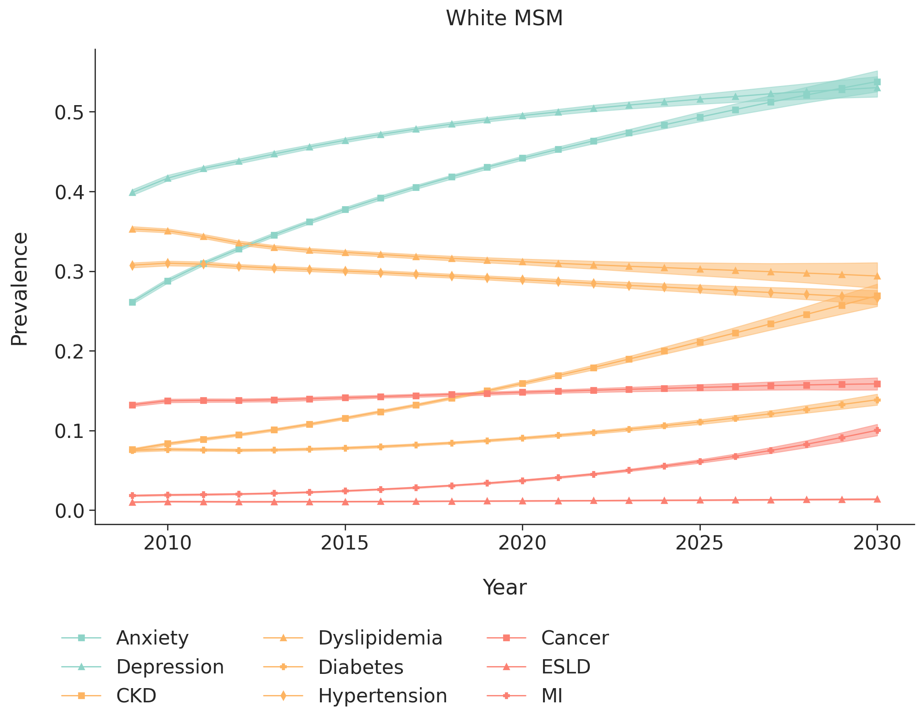
- Black/African American men who have sex with men
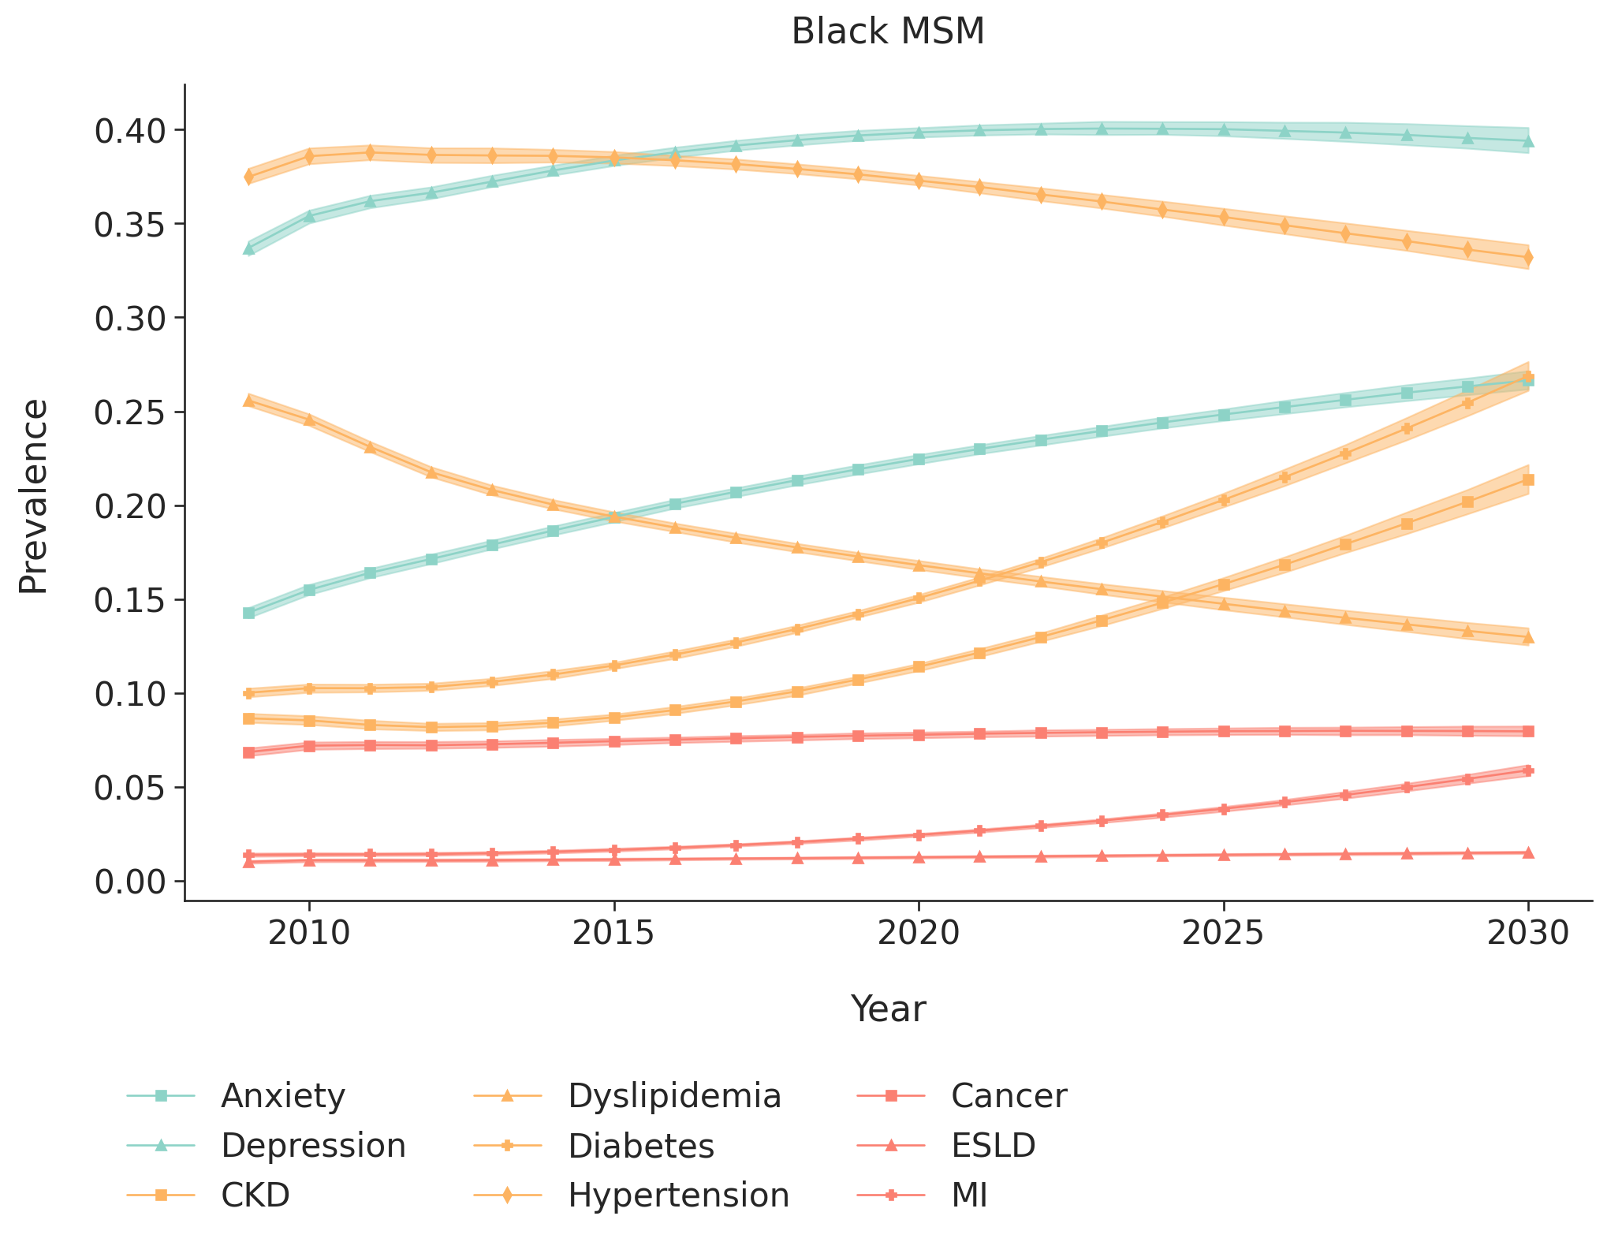
- Hispanic men who have sex with men

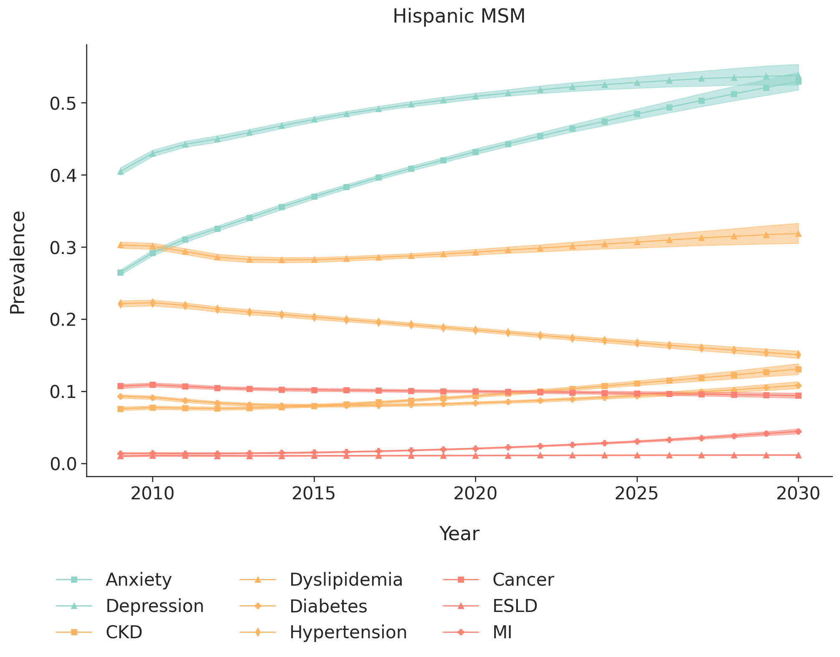
- White men with injection drug use as their HIV acquisition risk factor

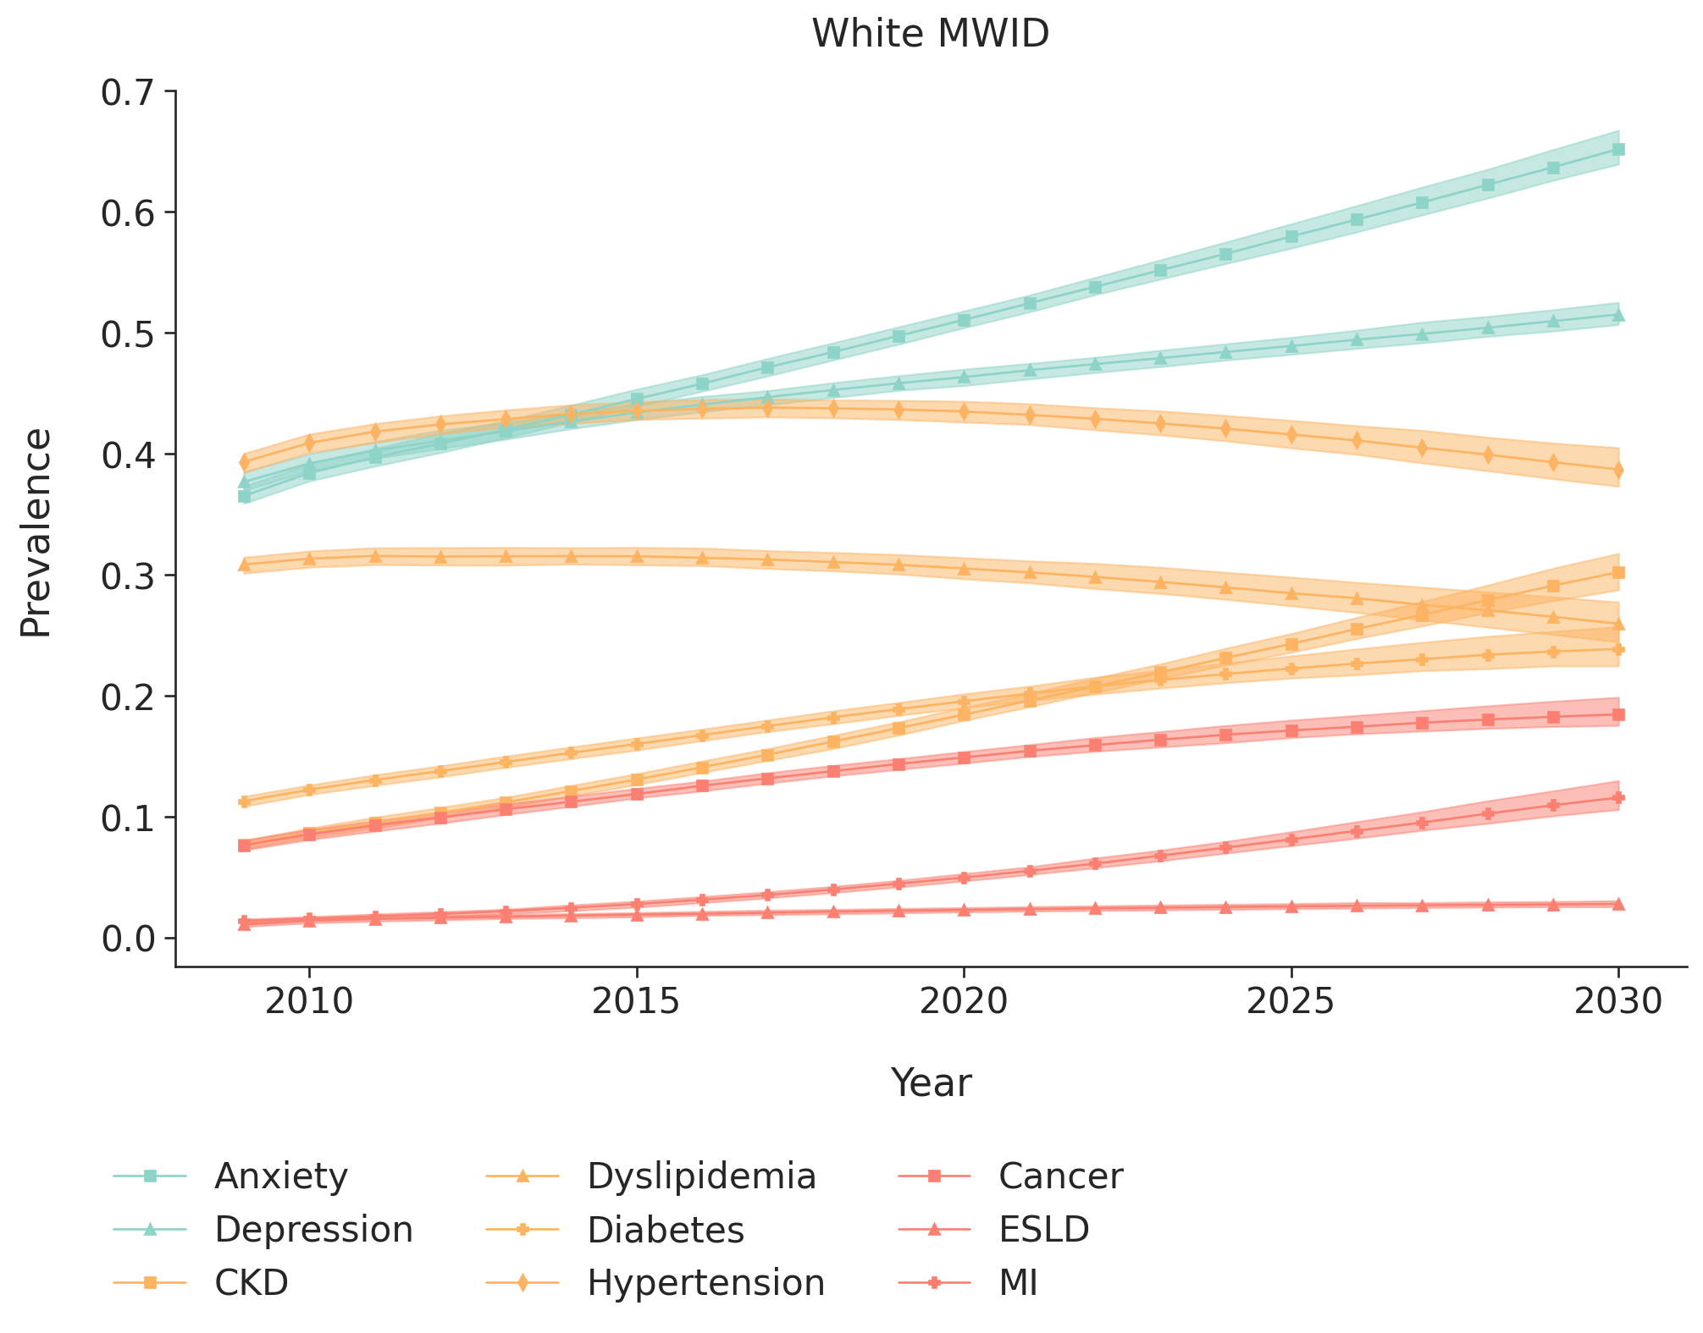
- Black/African American men with injection drug use as their HIV acquisition risk factor

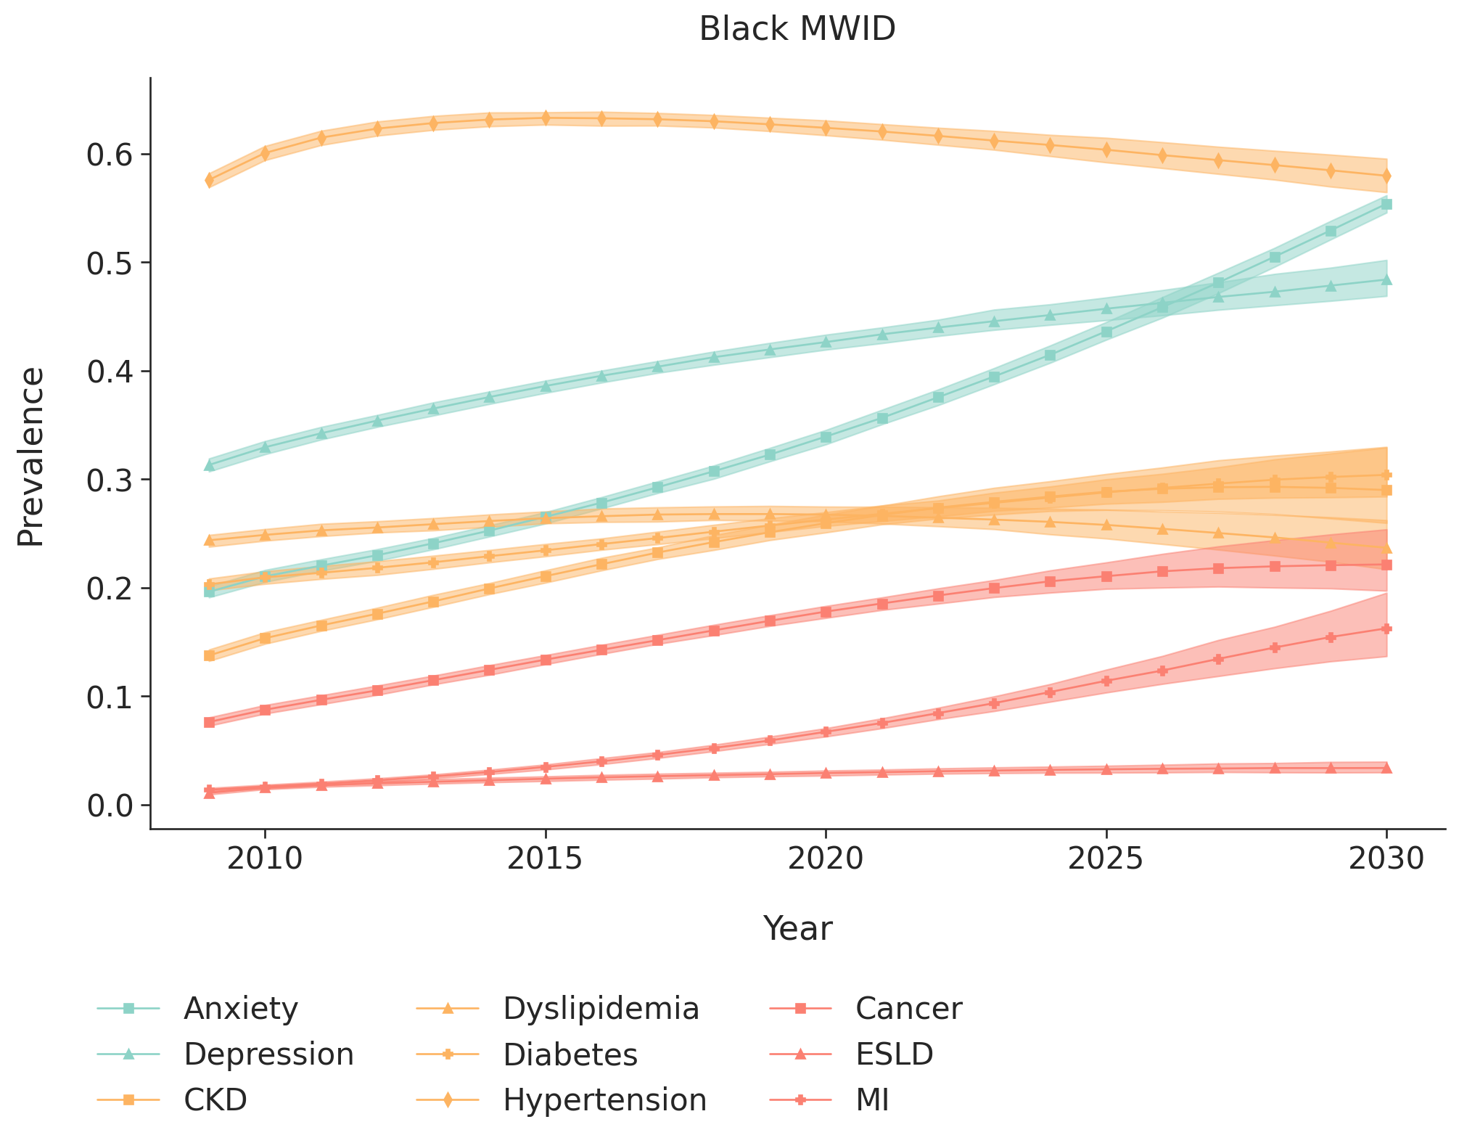
- Hispanic men with injection drug use as their HIV acquisition risk factor

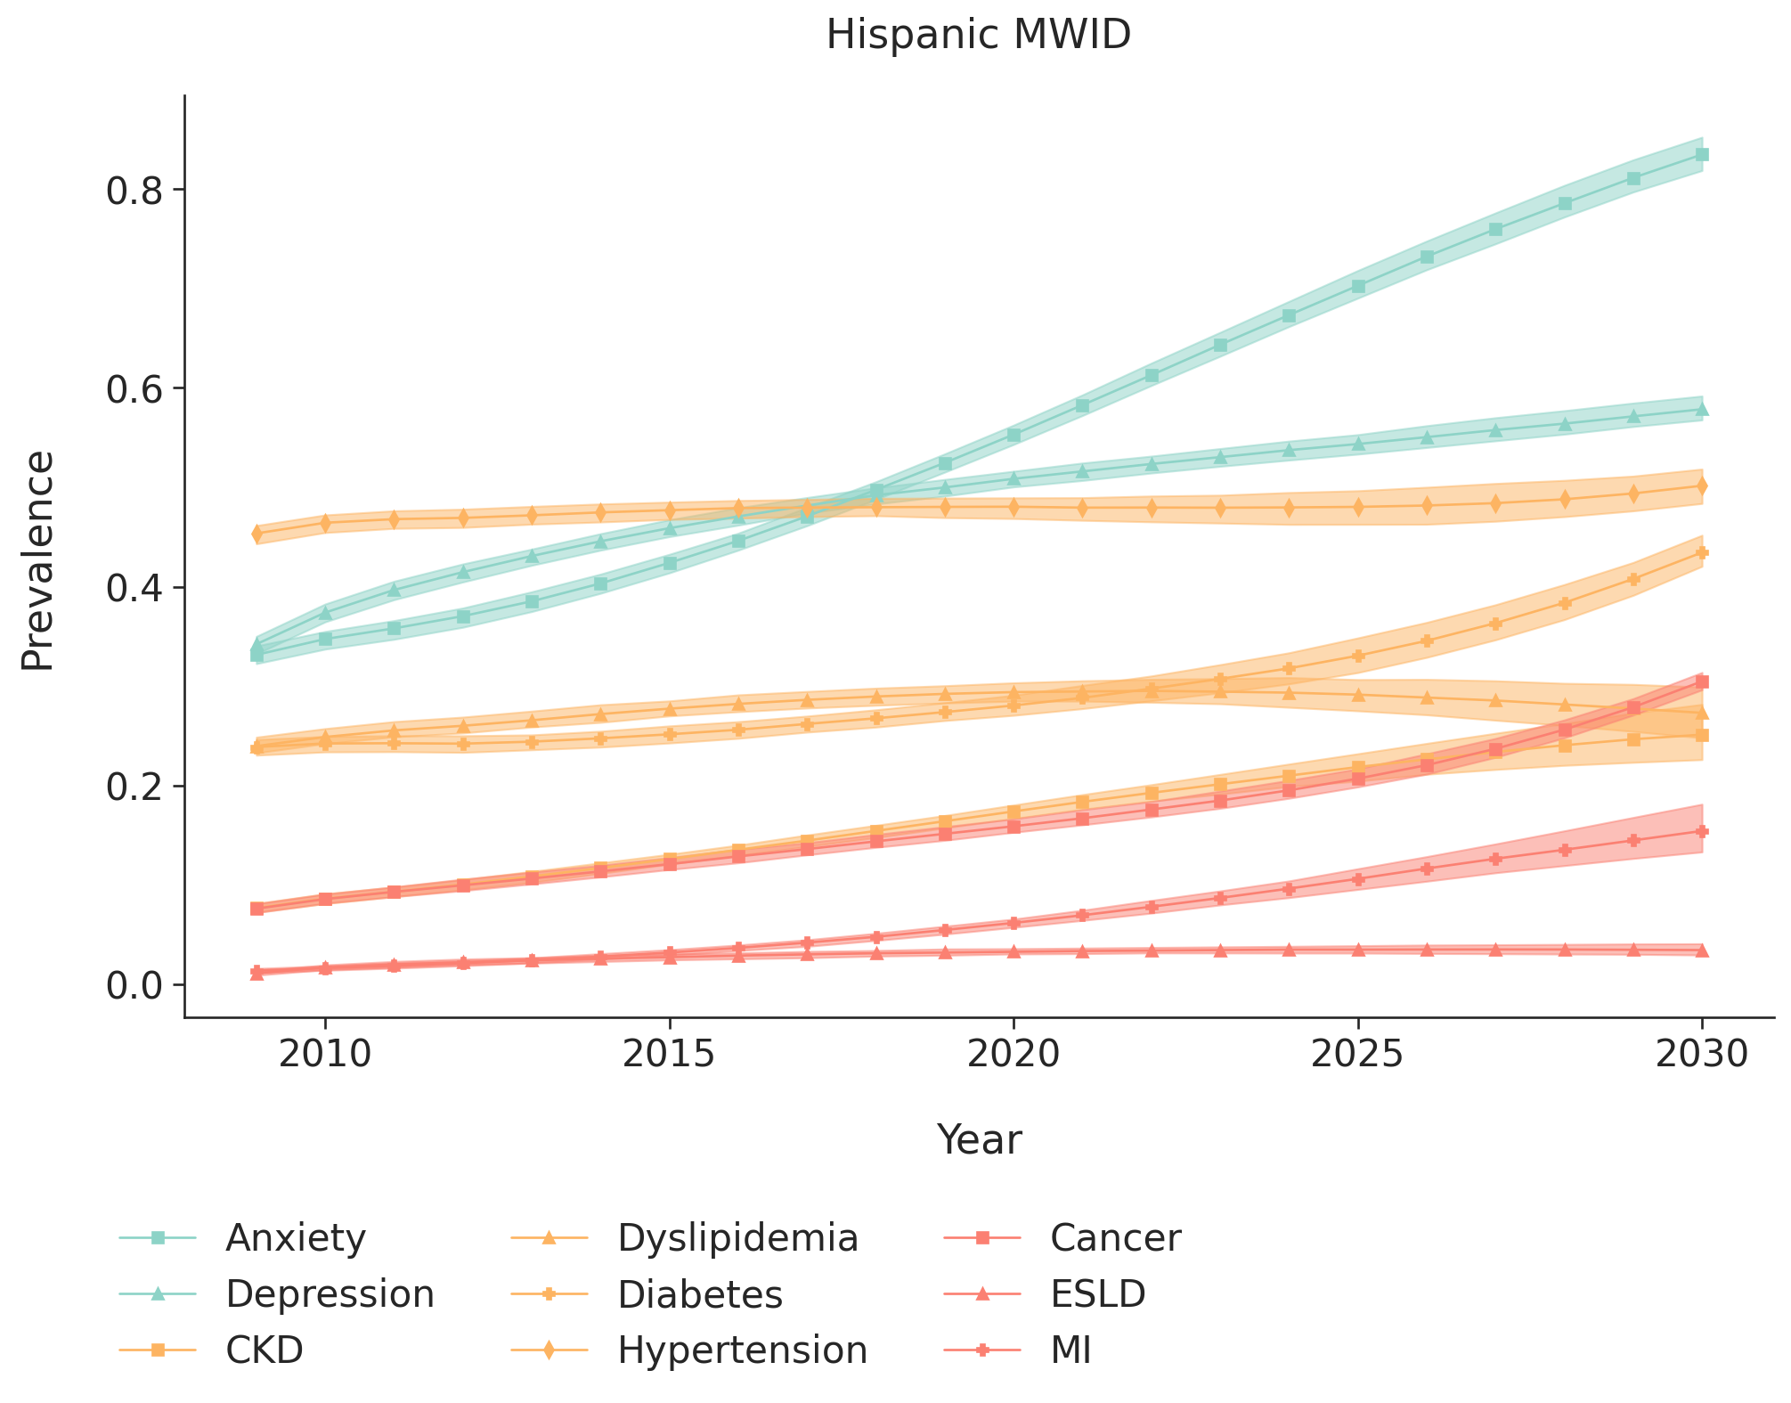
- White women with injection drug use as their HIV acquisition risk factor

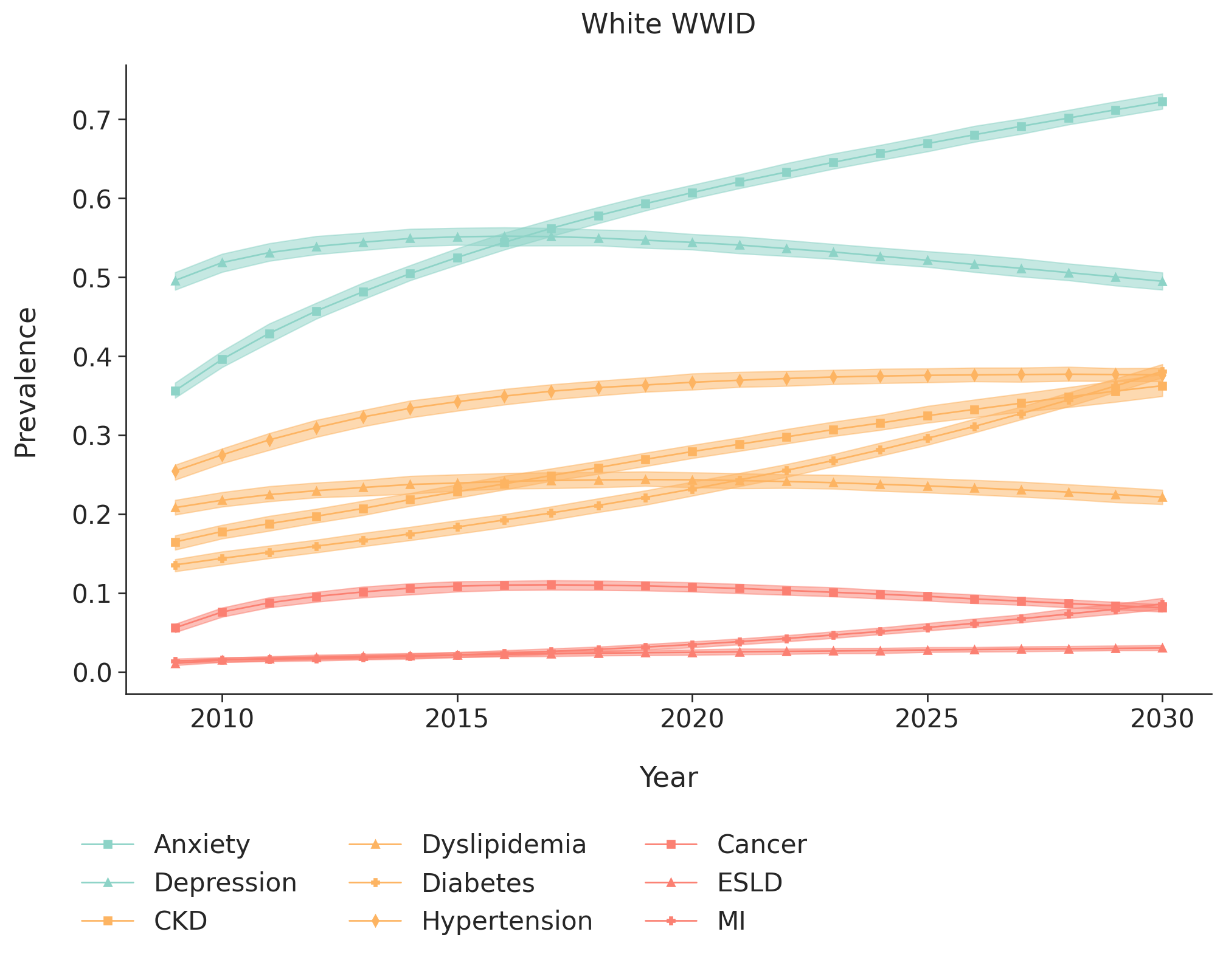
- Black/African American women with injection drug use as their HIV acquisition risk factor
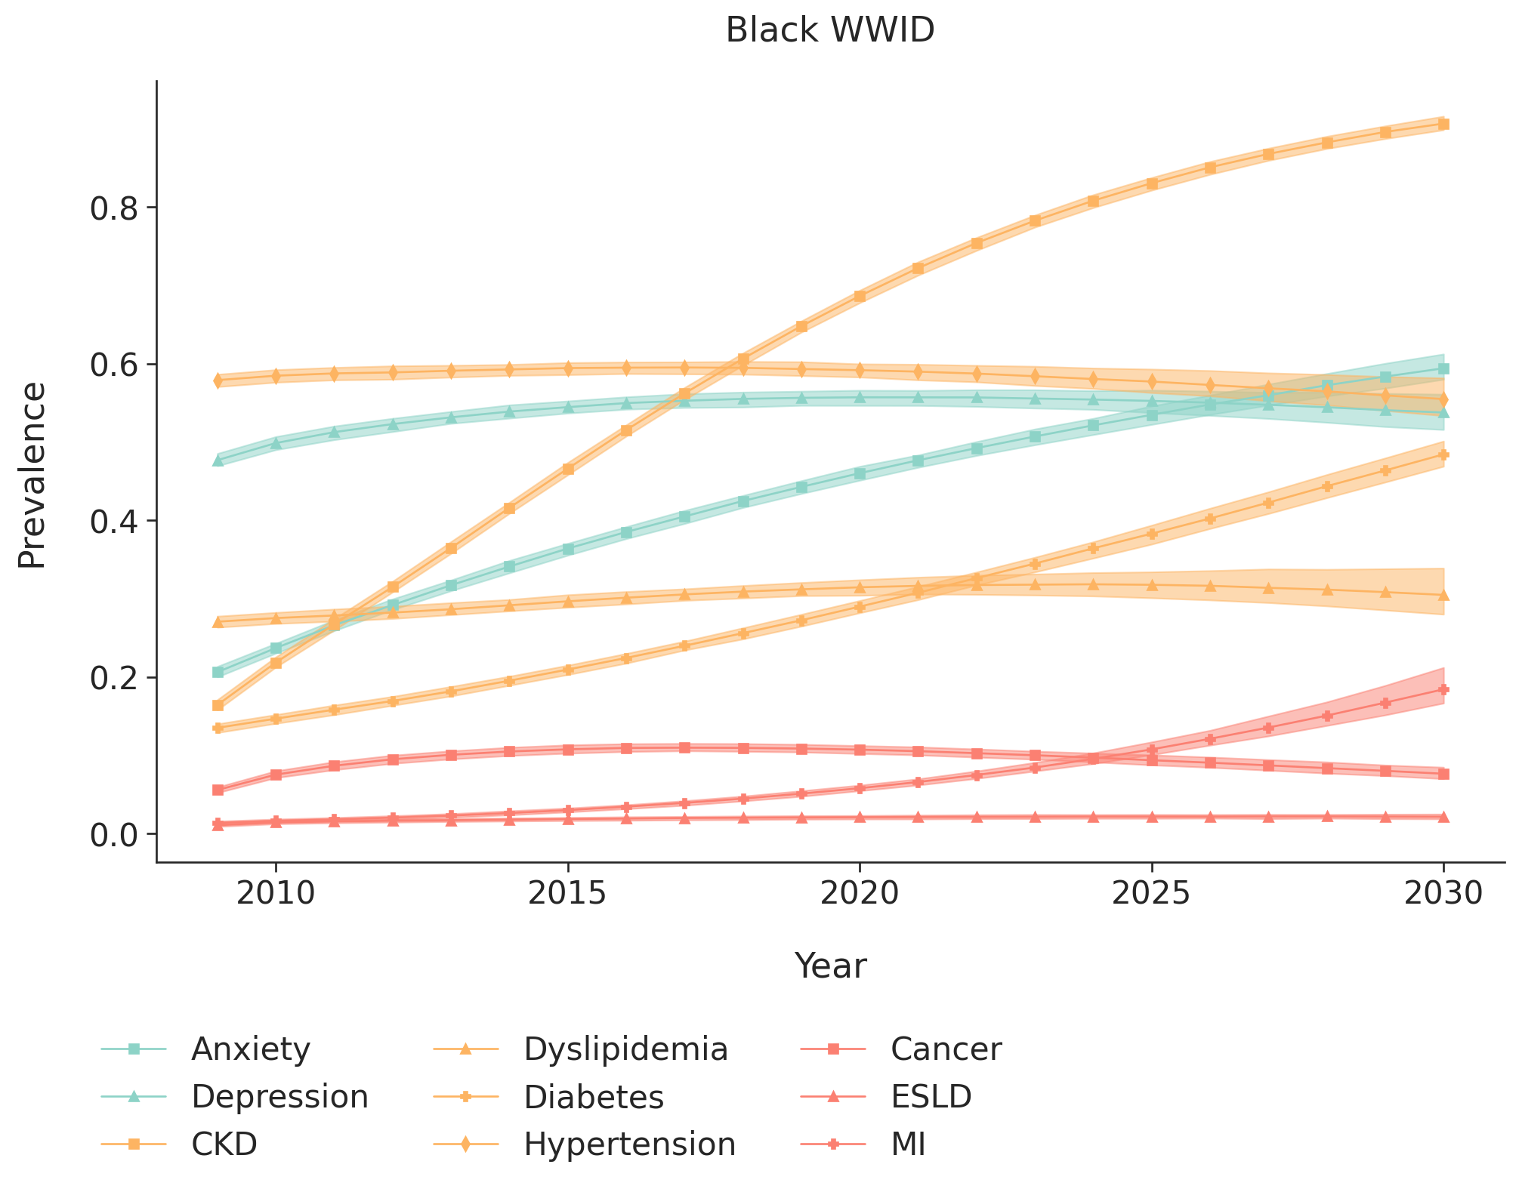
- Hispanic women with injection drug use as their HIV acquisition risk factor
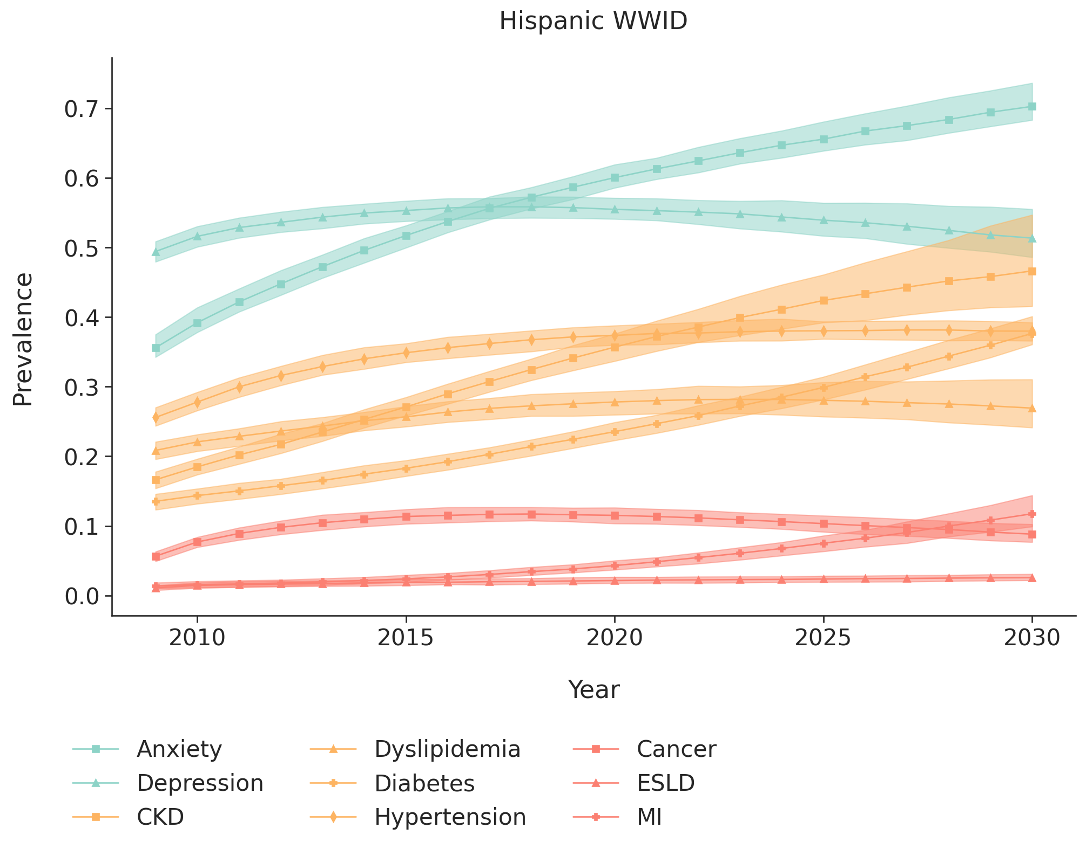
- White heterosexual men
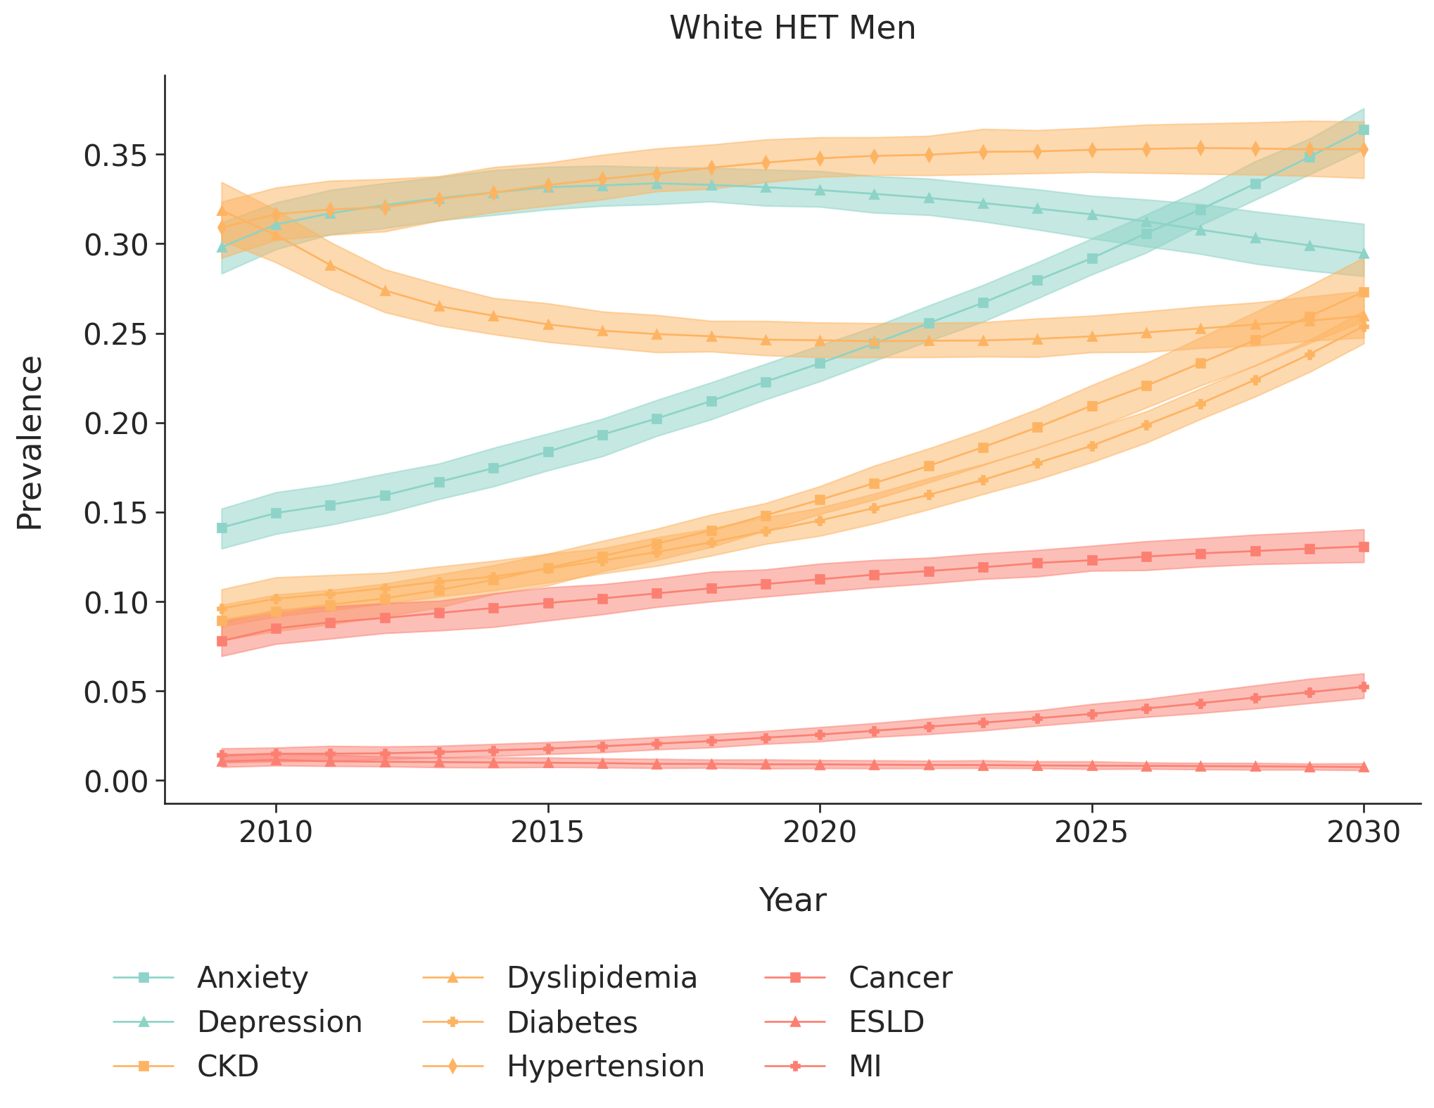
- Black/African American heterosexual men
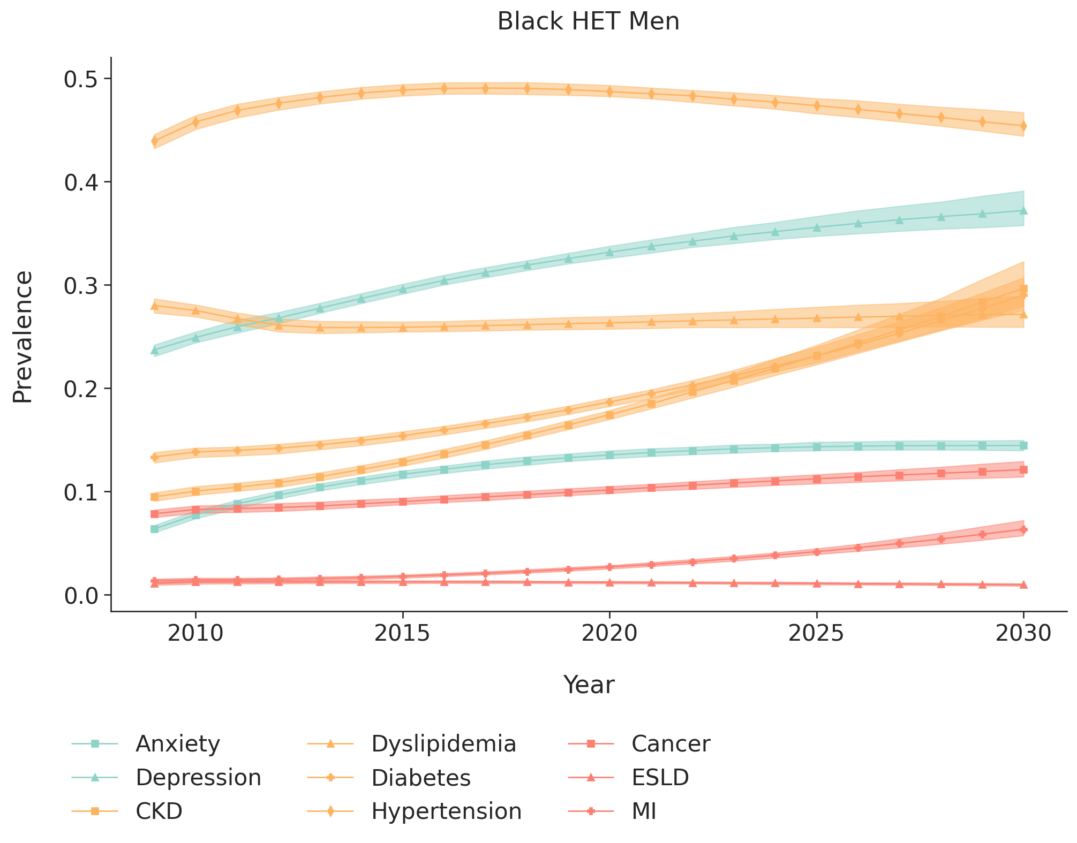
- Hispanic heterosexual men
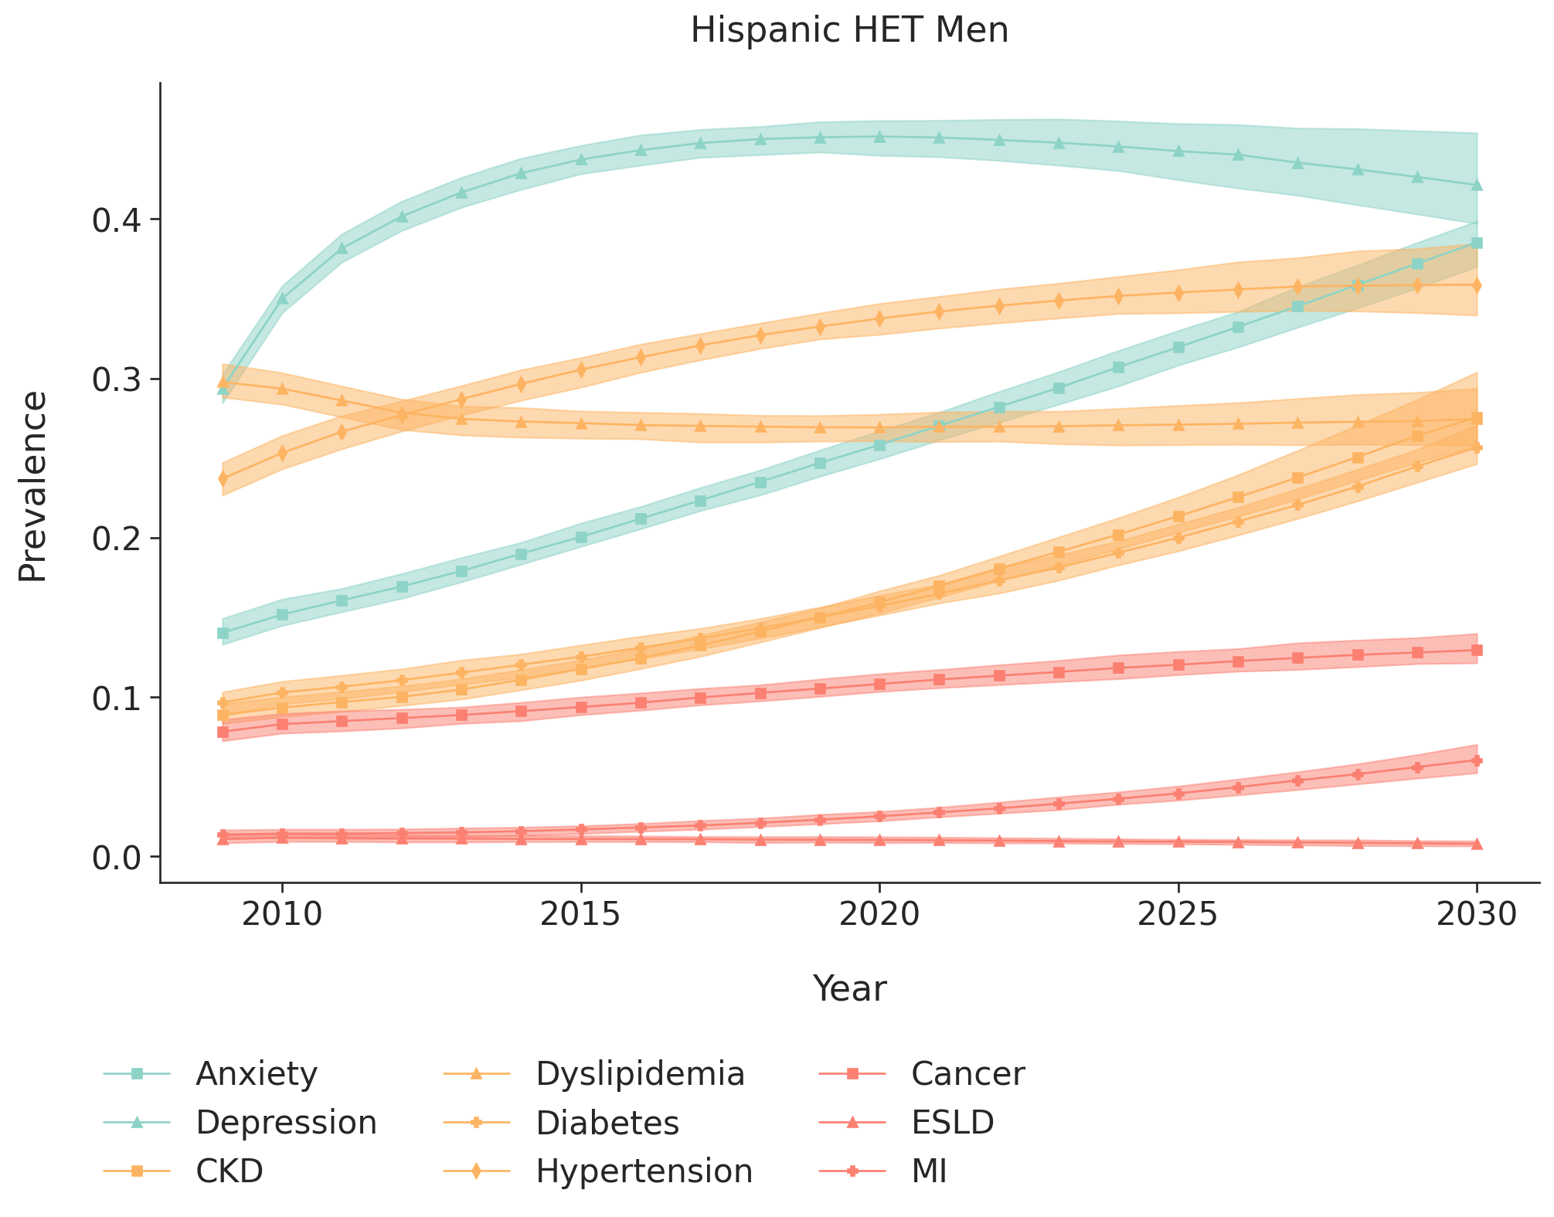
- White heterosexual women
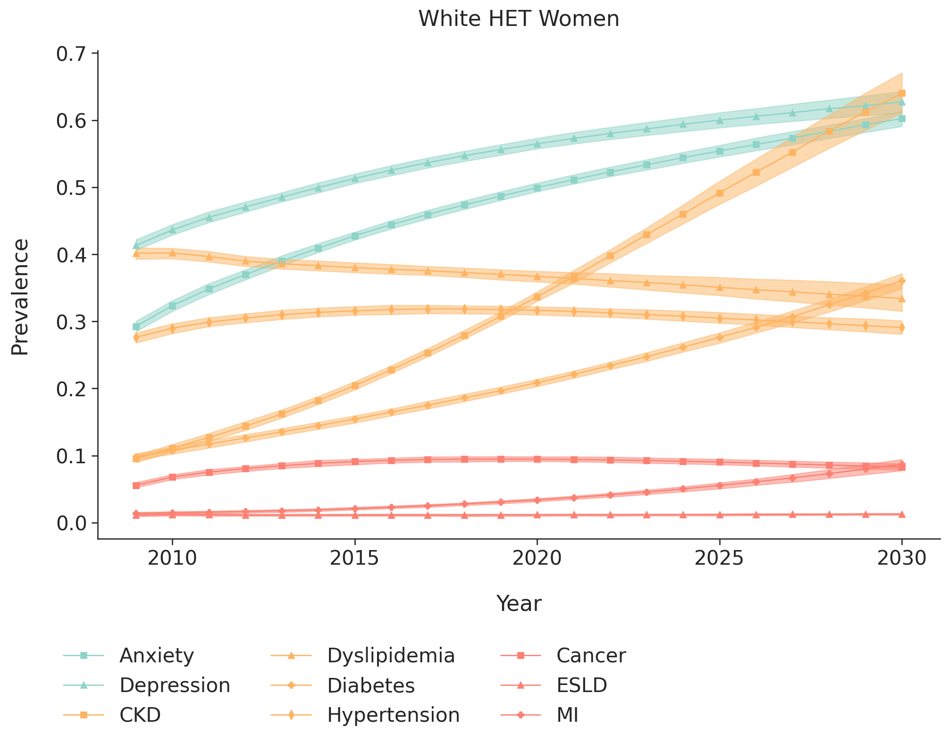
- Black/African American heterosexual women
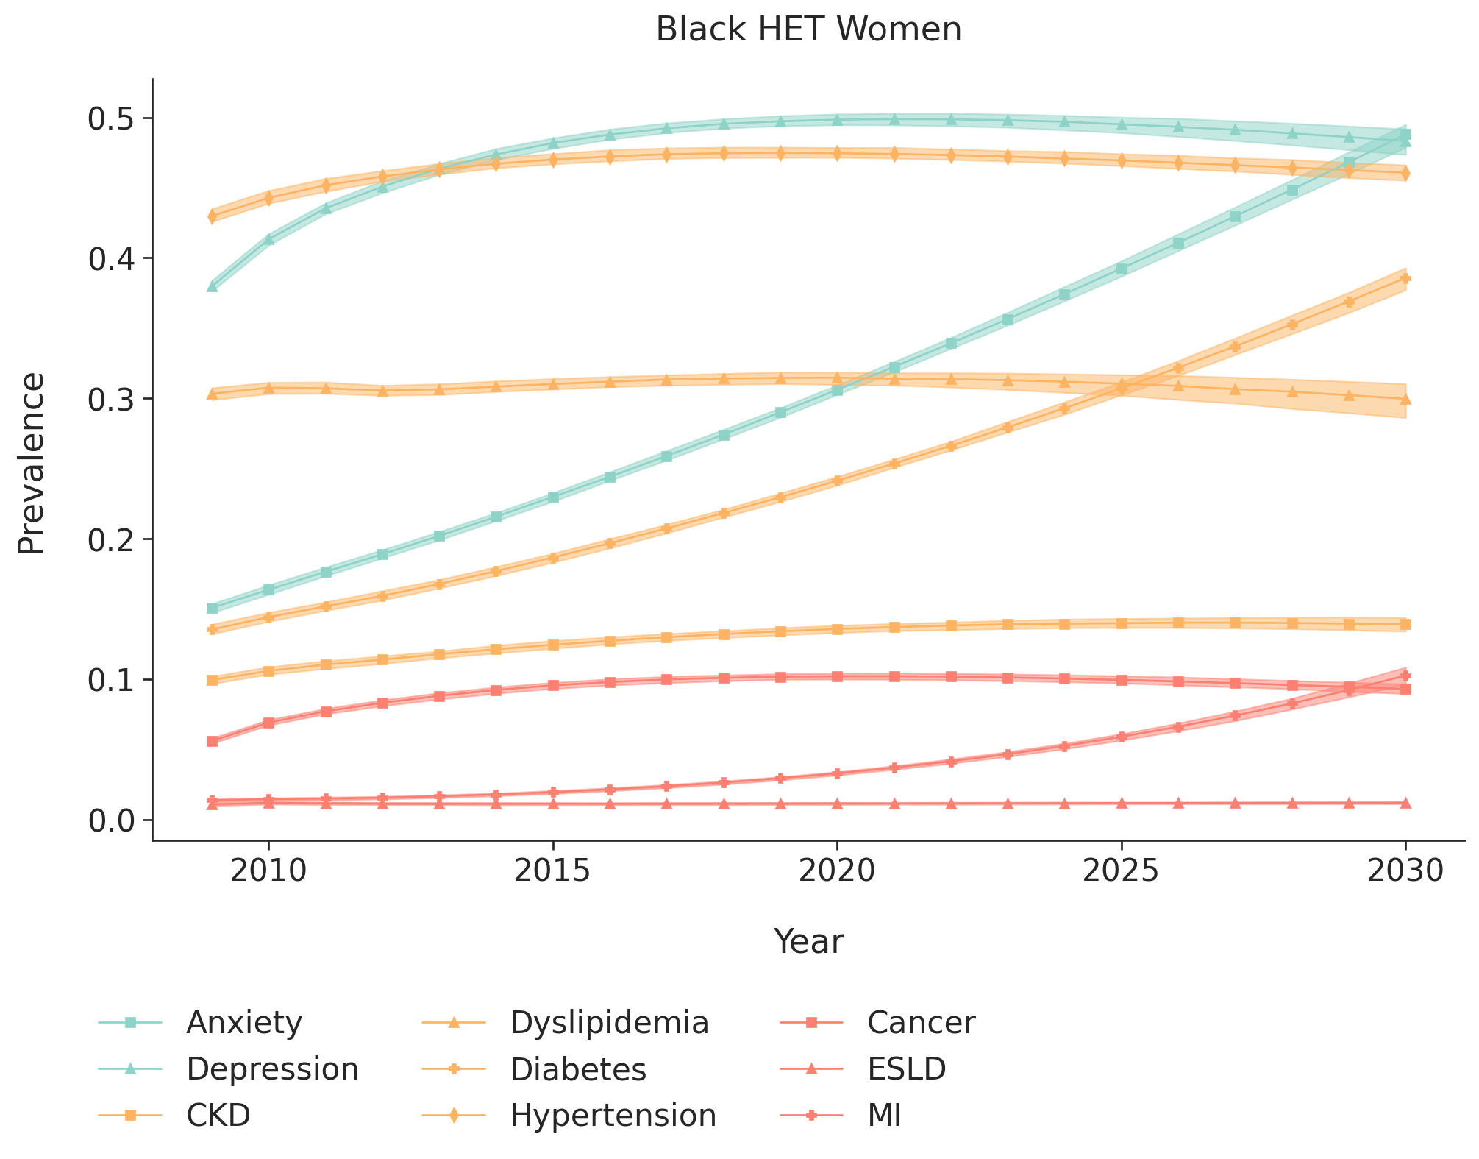
- Hispanic heterosexual women
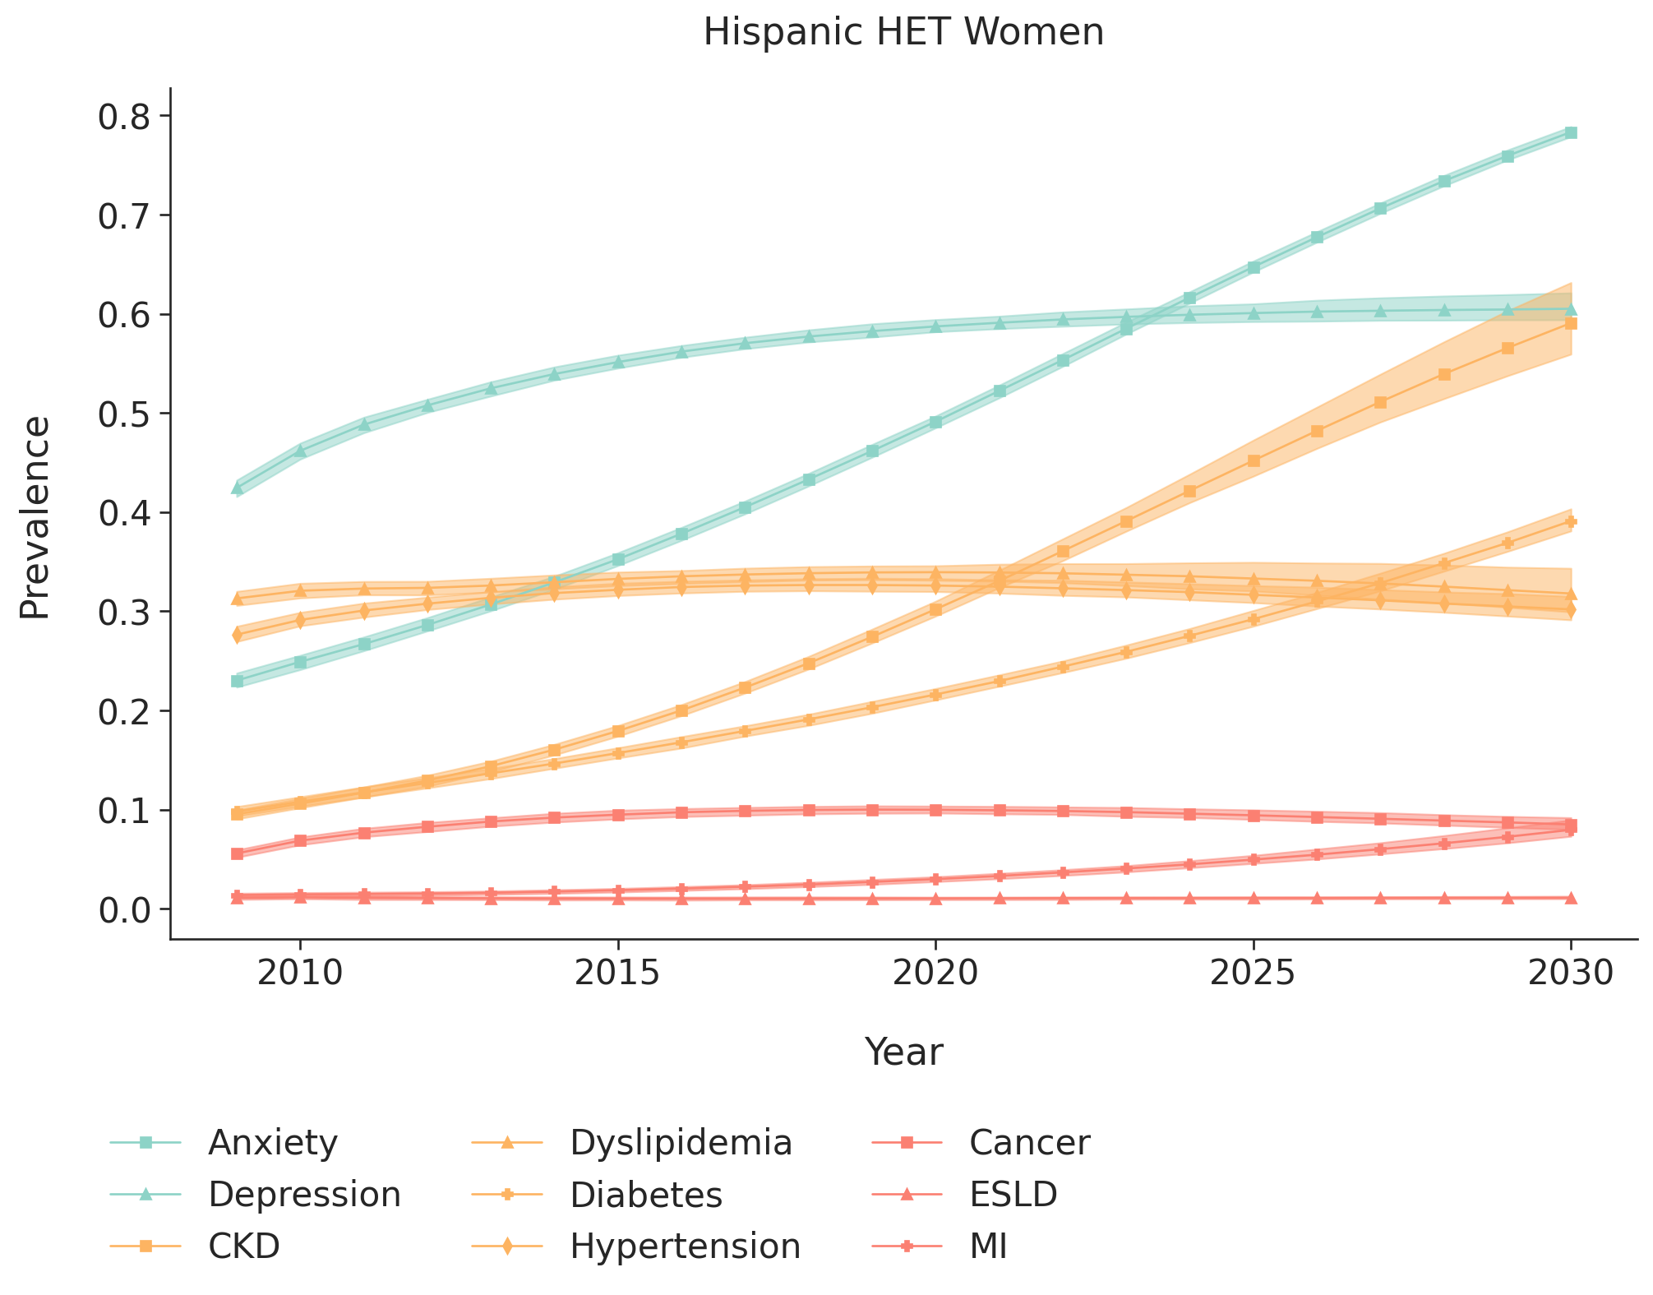
Footnotes:
CKD=stage ≥3 chronic kidney disease
ESLD=end-stage renal disease
MI=myocardial infarction
The 95% interquartile range is estimated as the 2.5% and 97.5% range of results from running the simulation 200 times.

