Supplementary material for Optimal Respiratory Syncytial Virus intervention programmes using Nirsevimab in England and Wales

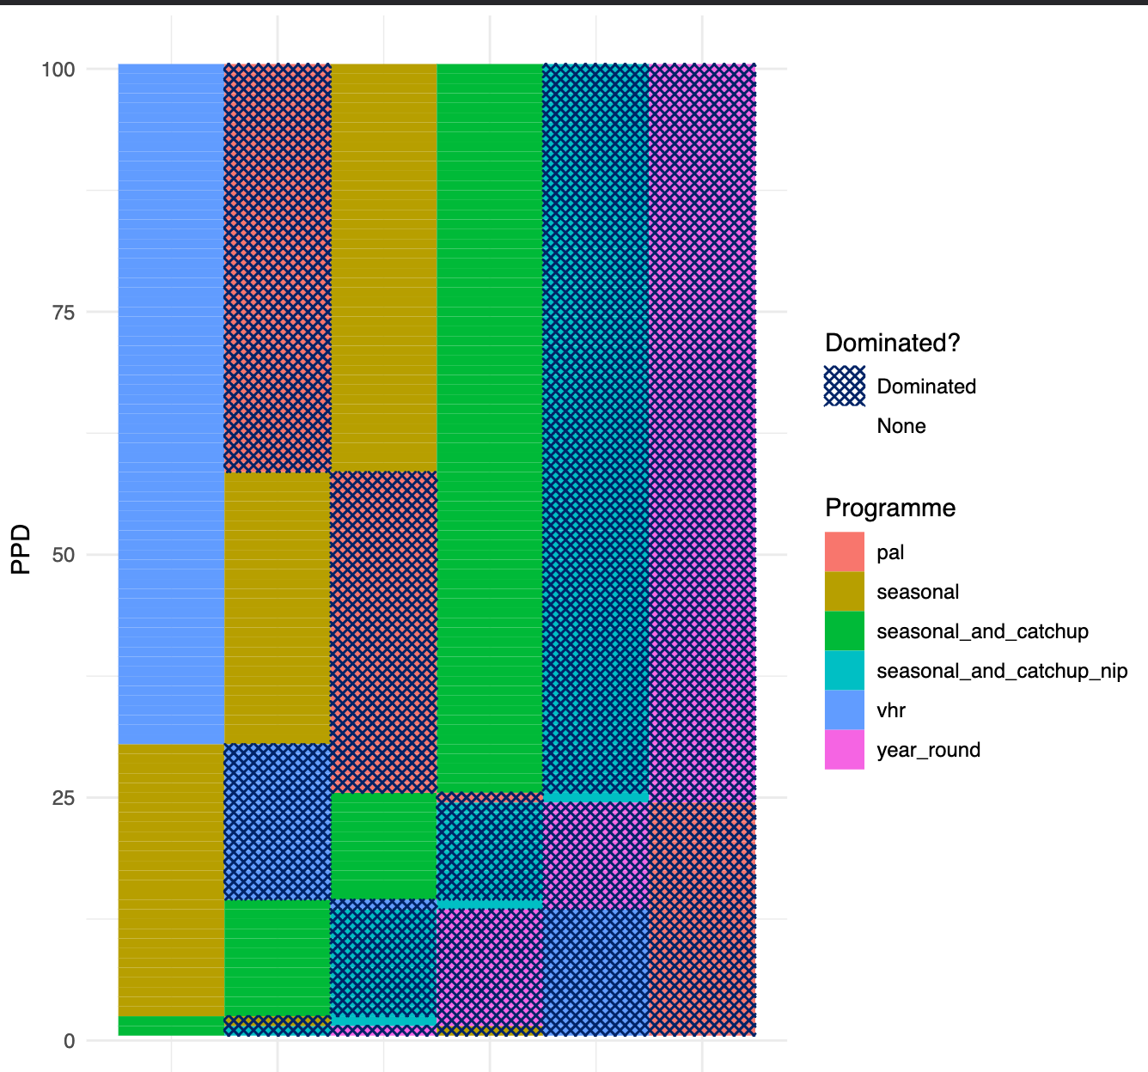
Figure S1. Dominance structure for each PPPD. The programmes are ranked in each row in order of cheapest to most expensive (left to right rows) for a given PPPD. Then the dominated programmes (programmes which are more expensive but offer less health benefit than a cheaper programme) on each row are shown through crisscrossed patterns.

Parameter | Base value | Other values
Average period of protection (days) | 150 | 250, 360
Coverage | 90% | 70%
Age of first vaccination | Birth | 2 months of age
ICER threshold (£/QALY) | 20000 | 15000
Table S1. Parameters associated with the sensitivity

