Supplement 2: Supplementary tables and figures

Table of Contents
Figure S1: Epidemic curves, final epidemic size and epidemic duration (scenarios A, X, Y, Z) 2
Figure S2: Epidemic curves, final epidemic size and epidemic duration (scenarios A to I) 3
Table S1: Sensitivity analysis - scenarios including weekly introduction of 1 additional monkeypox case among high-risk MSM 4

Figure S1: Epidemic curves, final epidemic size and epidemic duration (scenarios A, X, Y, Z)
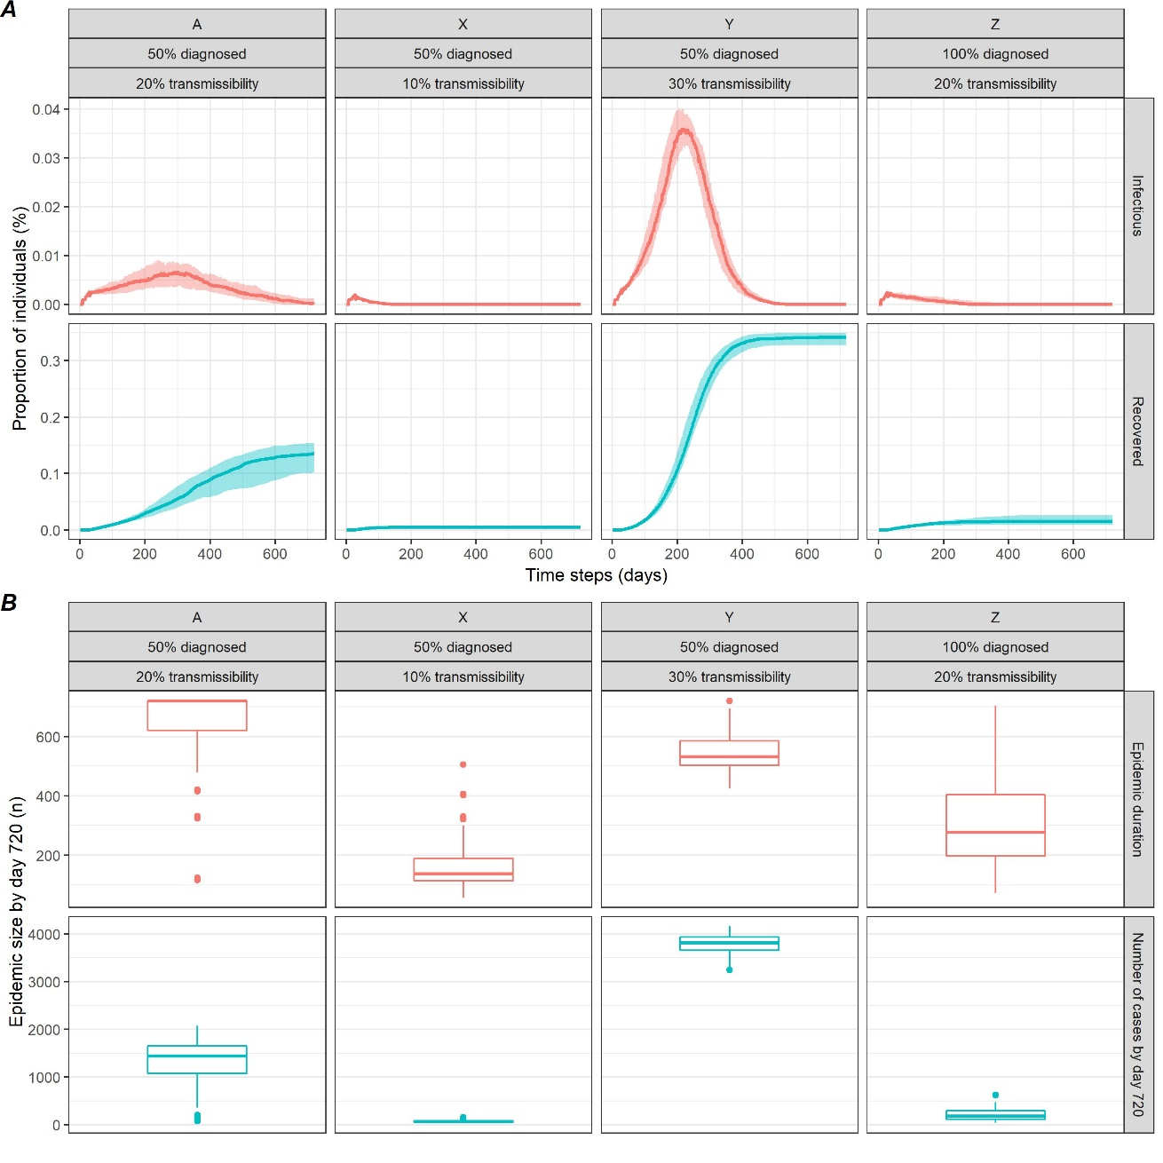
Figure S2: Epidemic curves, final epidemic size and epidemic duration (scenarios A to I)
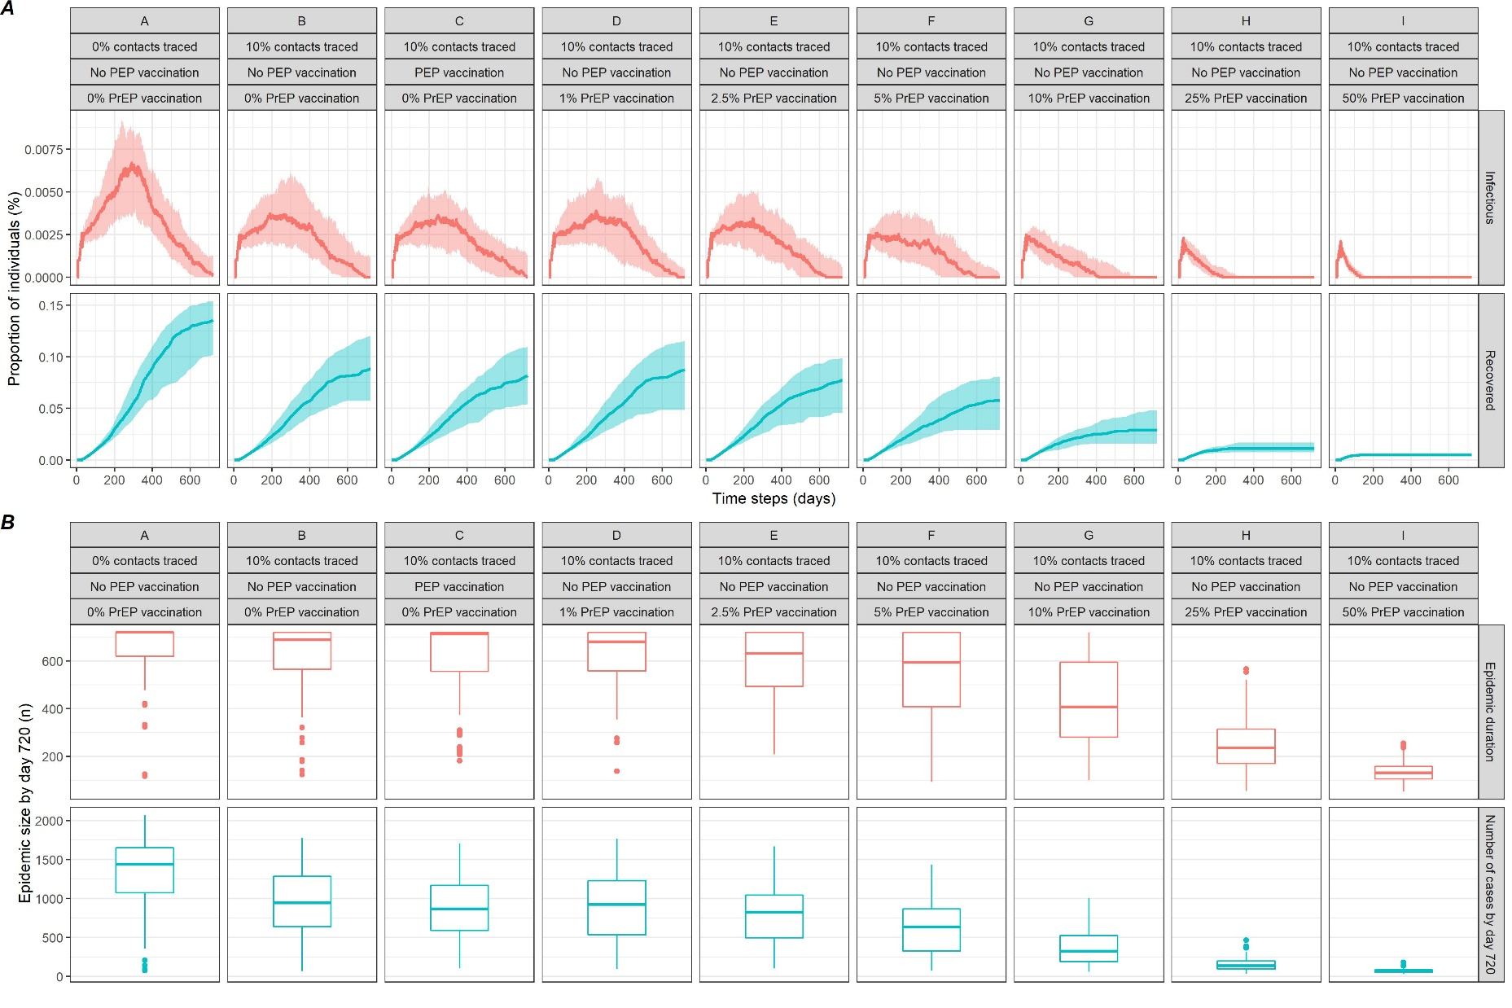

Table S1: Sensitivity analysis - scenarios including weekly introduction of 1 additional monkeypox case among high-risk MSM
Scenario | Probability of transmission per sexual encounter (%) | Proportion of undiagnosed cases (%) | Proportion of Contacts Traced (%) | PEP vaccination | PrEP vaccination = Proportion of HR-MSM vaccinated at day 1 (%) | Proportion of ongoing epidemics at day 720 (%) | Number of cases by day 720, median (IQR) | Number of people vaccinated, median (IQR) | Reduction in number of cases compared to scenario A (%)
A | 20 | 50 | 0 | No | 0 | 100 | 2,253 (2,114 - 2437) | 0 | REF
B | 20 | 50 | 10 | No | 0 | 100 | 1,969 (1,832 - 2,114) | 0 | 13
C | 20 | 50 | 10 | Yes | 0 | 100 | 1,890 (1,750 - 1,980) | 140 (131 - 152) | 16
D | 20 | 50 | 10 | No | 1 | 100 | 1,896 (1,760 - 2,042) | 30.6 (31 - 31) | 16
E | 20 | 50 | 10 | No | 2.5 | 100 | 1,844 (1,752 - 1,950) | 75.3 (75 - 75) | 18
F | 20 | 50 | 10 | No | 5 | 100 | 1,706 (1,554 - 1,819) | 150.6 (151 - 151) | 24
G | 20 | 50 | 10 | No | 10 | 100 | 1,454 (1,338 - 1,540) | 300 (300 - 300) | 35
H | 20 | 50 | 10 | No | 25 | 100 | 948 (886 - 1,005) | 750.6 (751 - 751) | 58
I | 20 | 50 | 10 | No | 50 | 100 | 525 (493 - 559) | 1,500 (1,500 - 1,500) | 77
X | 10 | 50 | 0 | No | 0 | 100 | 493 (469 - 529.5) | 0 | -
Y | 30 | 50 | 0 | No | 0 | 100 | 4,188 (4,062 - 4,306) | 0 | -
Z | 20 | 0 | 0 | No | 0 | 100 | 1,177 (1,068 - 1,267) | 0 | -
IQR = interquartile range; MSM = men who have sex with men; HR-MSM = high-risk MSM; PEP = post-exposure prophylactic (vaccination); PrEP = pre-exposure prophylactic (vaccination)

