Supplementary material

 | Institution A | Institution B
Number of subjects | 60 | 20
Females/Males | 38/22 | 15/5
Age mean ± standard deviation [range] years | 49±11 [29–77] | 35±7 [21–46]
EDSS median [range] | 2.0 [0-7.5] | 1.5 [0-4.0]
Total number of CL | 2247 | 192
Median number of CL per subject (IQR) | 21 (54) | 1 (10)

Supp. Table 1. Metadata information of the two datasets considered.

 | CLAIMS leukocortical lesion number |  | Ground truth leukocortical lesion number |  | CLAIMS intracortical/subpial lesion number |  | Ground truth intracortical/subpial lesion number
 | 𝝆 | p-value | 𝝆 | p-value | 𝝆 | p-value | 𝝆 | p-value
EDSS | 0.46 | 0.0002 | 0.47 | 0.0002 | 0.37 | 0.0037 | 0.46 | 0.0003
25TW | 0.39 | 0.0021 | 0.39 | 0.0025 | 0.37 | 0.004 | 0.41 | 0.0011
9HPT | 0.43 | 0.0006 | 0.38 | 0.0025 | 0.40 | 0.0016 | 0.38 | 0.0028
SDMT | -0.57 | <0.0001 | -0.47 | 0.0002 | -0.52 | <0.0001 | -0.48 | 0.0002

Supp. Table 2. Spearman correlation coefficient 𝝆 (and its relative p-value) computed between four disability measures and the manual and automated CL count, subdivided per CL type. Both counts show a moderate correlation for all four measures.

 | Lesion-wise
Models | LTPR | LFPR | Classification Accuracy
CLAIMS | 0.61 | 0.29 | 0.81
CLAIMS_DA | 0.71 | 0.29 | 0.84
MSLAST | 0.48 | 0.31 | -

Supp. Table 3. Lesion-wise metrics obtained with a minimum lesion volume of 6μL for CLAIMS, CLAIMS_DA, and MSLAST. In bold are the best results for each metric. No significant differences (p>0.05) were observed between the three models on a patient-wise level for both LTPR and LFPR. MSLAST did not classify CL in multiple types.

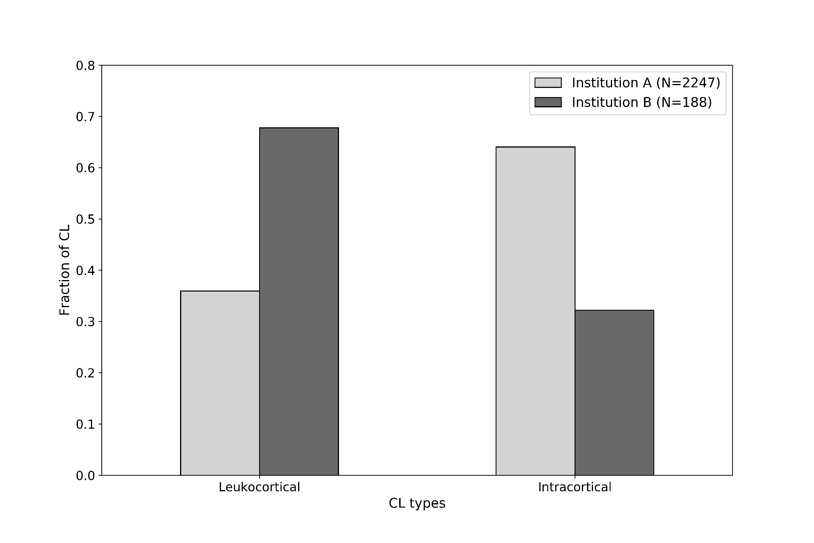
Supp. Figure 1. Fraction of leukocortical and intracortical/subpial CL in dataset A and B. N refers to the total number of CL in each dataset.

