- 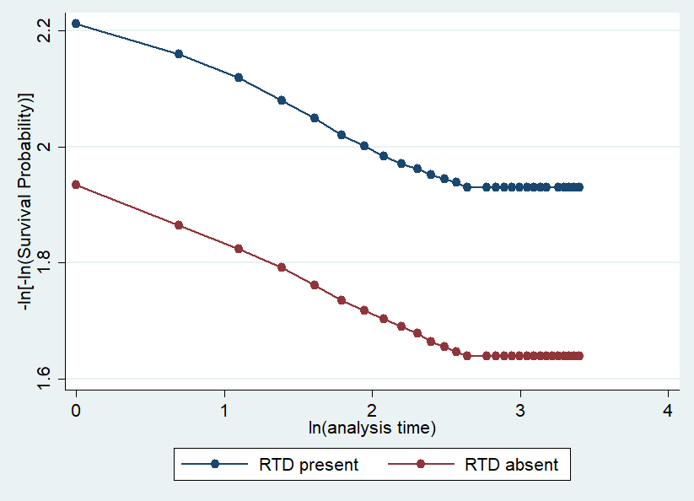
- 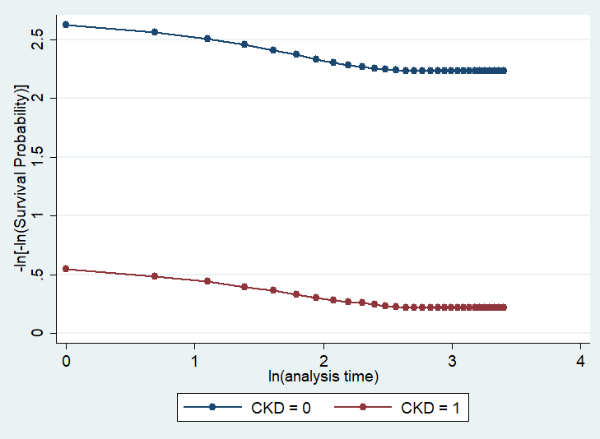
- 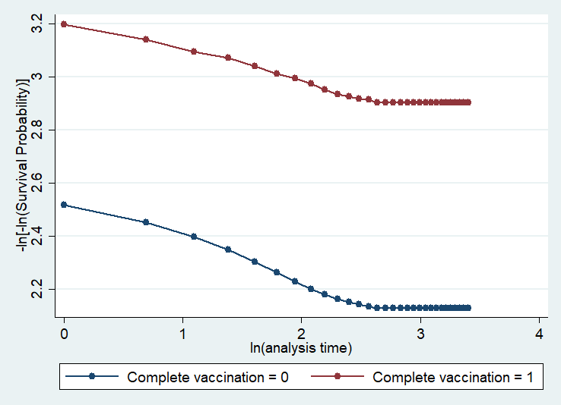
Supplementary Figure 1: Log-log plots for the covariates of (a) RTD, (b) CKD and (c) complete vaccination.

