Table S1. Vaccine effectiveness against infection by Omicron or Delta among adults aged ≥18 years by vaccine schedule and time since latest dose
 |  |  | Vaccine effectiveness (95% CI)
 |  |  | Any combination of 2 mRNA vaccines  for primary series |  | 2 doses of BNT162b2  for primary series
Doses | Vaccine products | Days since latest dose | Omicron | Delta | Omicron | Delta
First 2 doses | Variable | 7-59 | 6 (-25, 30) | 84 (81, 86) | -2 (-38, 25) | 82 (79, 85)
 |  | 60-119 | -13 (-38, 8) | 81 (79, 82) | -22 (-51, 2) | 78 (76, 80)
 |  | 120-179 | -35 (-58, -16) | 80 (79, 81) | -37 (-62, -17) | 77 (76, 79)
 |  | 180-239 | -43 (-71, -20) | 74 (71, 76) | -48 (-79, -23) | 73 (70, 76)
 |  | ≥240 | -17 (-63, 16) | 70 (66, 75) | -23 (-76, 13) | 66 (60, 71)
Third dose | Any mRNA | 0-6 | 1 (-39, 29) | 88 (85, 91) | -1 (-47, 30) | 87 (83, 90)
 |  | ≥7 | 36 (19, 50) | 93 (92, 94) | 38 (20, 52) | 93 (91, 94)
 | BNT162b2 | 0-6 | -3 (-47, 28) | 87 (83, 90) | -5 (-52, 28) | 87 (83, 90)
 |  | ≥7 | 34 (15, 49) | 93 (91, 94) | 37 (18, 51) | 93 (91, 94)
 | mRNA-1273 | 0-6 | 25 (-85, 69) | 94 (86, 97) | ¶ | 92 (43, 99)
 |  | ≥7 | 56 (10, 79) | 93 (90, 96) | 78 (-59, 97) | 95 (80, 99)
¶Vaccine effectiveness estimated as 100% based on zero vaccinated test-positive cases.

Figure S1. Vaccine effectiveness against infection by Omicron or Delta among adults aged ≥18 years by vaccine schedule and time since latest dose
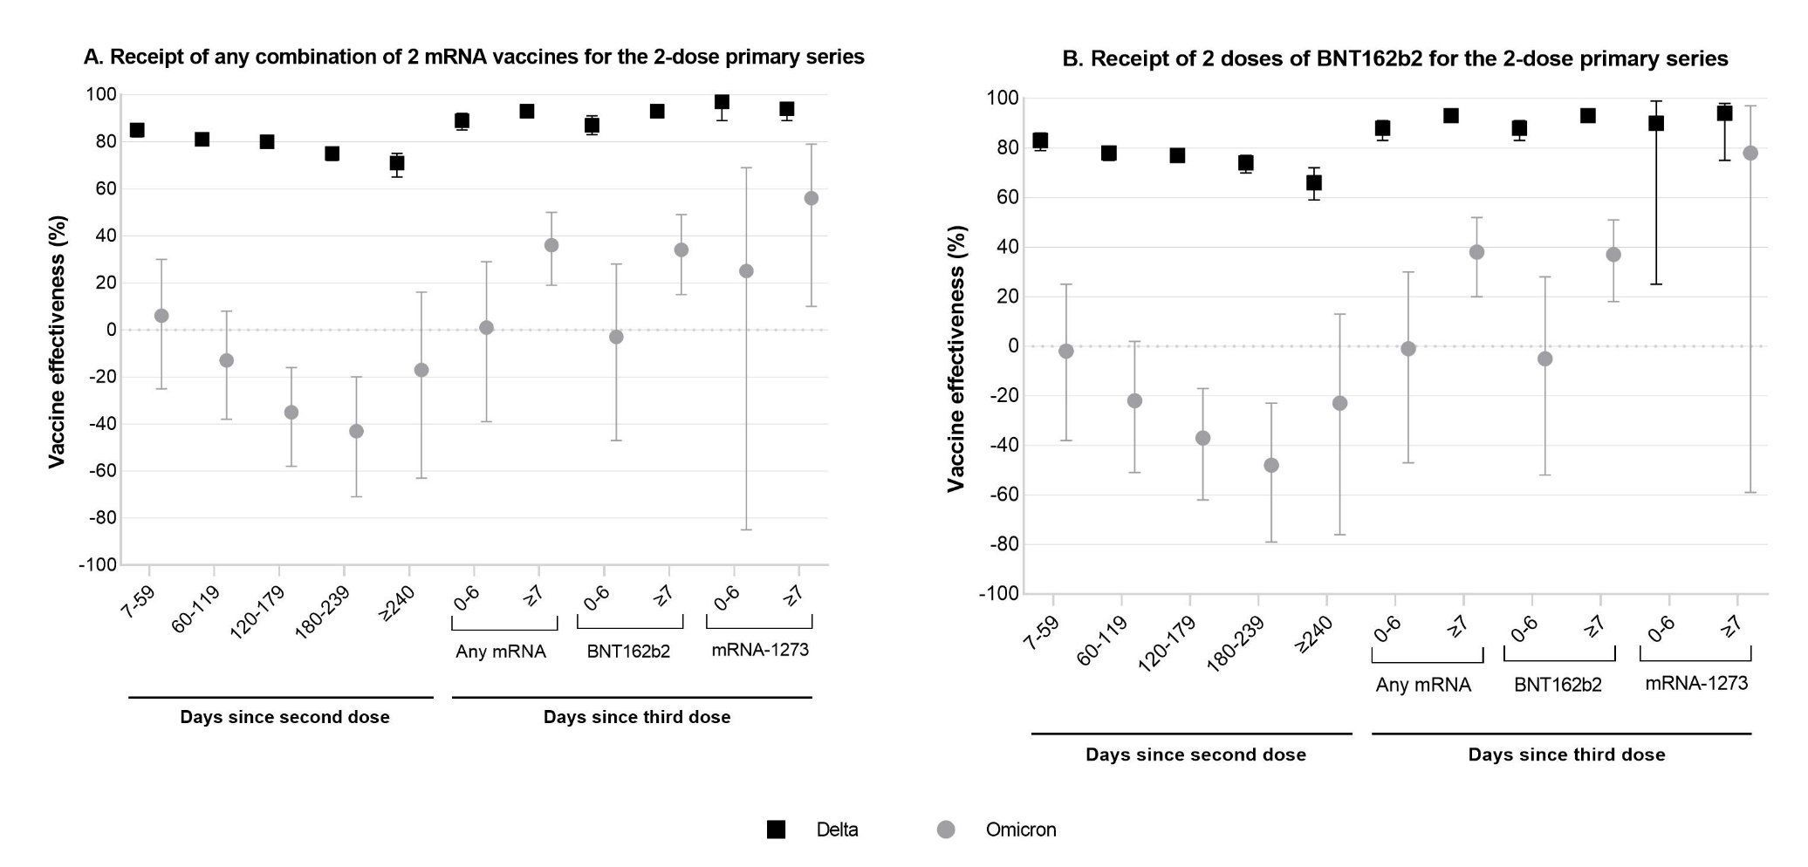
Vaccine effectiveness for mRNA-1273 0-6 days after the third dose was estimated as 100% based on zero vaccinated test-positive cases and was therefore not presented in panel B.

