Appendix:
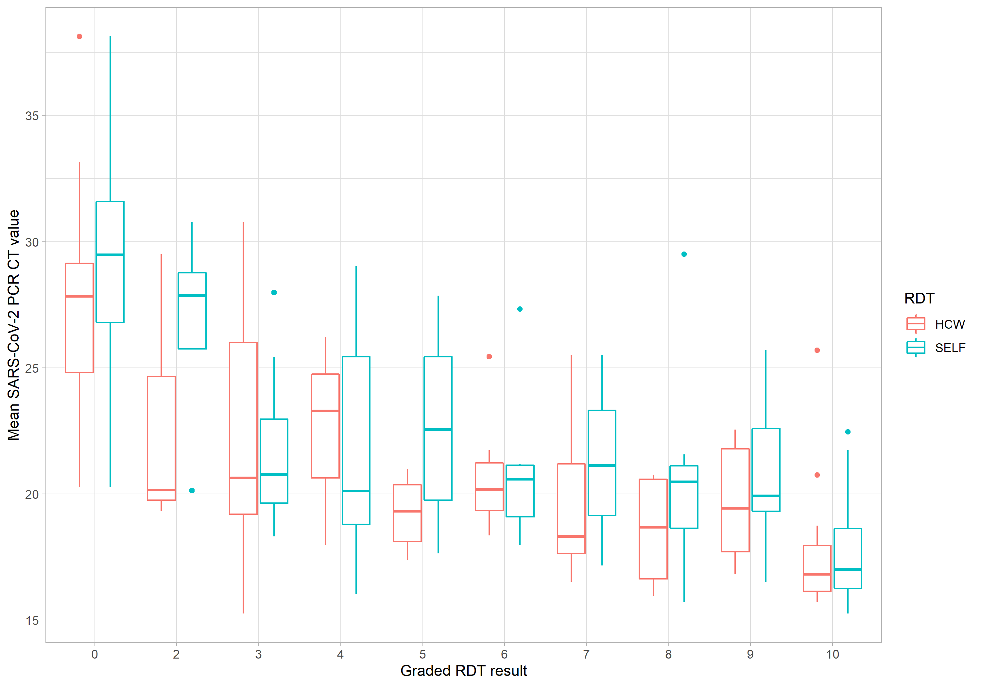
A box plot comparing self-taken and healthcare worker taken swabs tested by Covios® RDT by mean PCR CT value.

Self-taken and HCW taken Covios® Ag RDT results by RT-PCR CT range.
