Supplementary material 1: Qatar population pyramid
Gomeseria, Ronald. (2020). "Landscape Structure and Implications for Sustainable Environmental
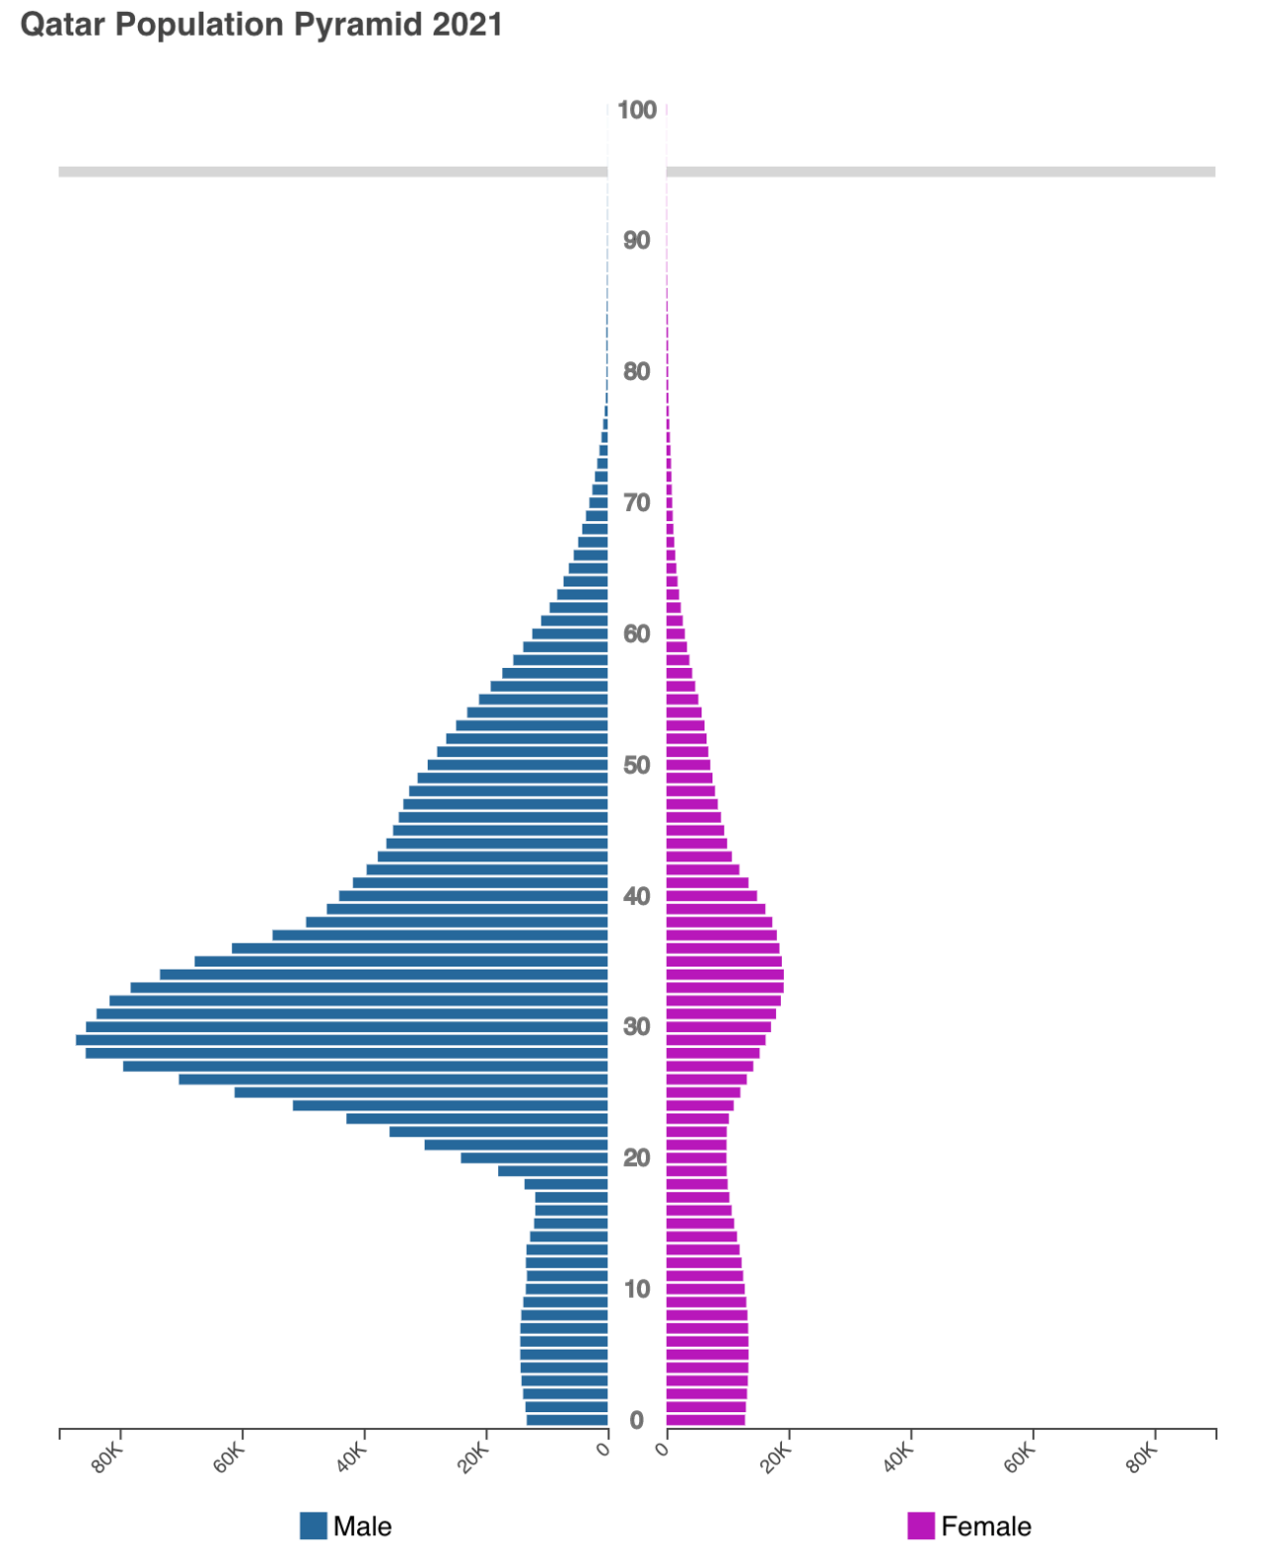
Management". 10.17605/OSF.IO/JXSK5.

