Appendix B
Table S2. Model fit indices. Model fit indices for Latent Profile Analysis. Lower
absolute values indicate better model fit.

Solution | BIC | ICL | BLRT (p)
1 cluster | -2313.26 | -2313.26
2 clusters | -1081.72 | -1081.82 | 1382.06 (0.001)
3 clusters | -614.58 | -616.65 | 617.65 (0.001)
4 clusters | -466.96 | -468.20 | 298.14 (0.001)
5 clusters | -575.41 | -579.63 | 42.07 (0.78)

For sensitivity analyses, we used ICL and obtained similar results. Likewise, BLRT indicated that the 4-cluster solution was a better fit than a 1-cluster solution (P = .001), 2-cluster solution (P = .001), and 3-cluster solution (P = .001). As there was no statistical difference between a 5- and 4-cluster solution (P = .78), the 4-cluster solution provided the optimal fit based on parsimony (see Figure S2).
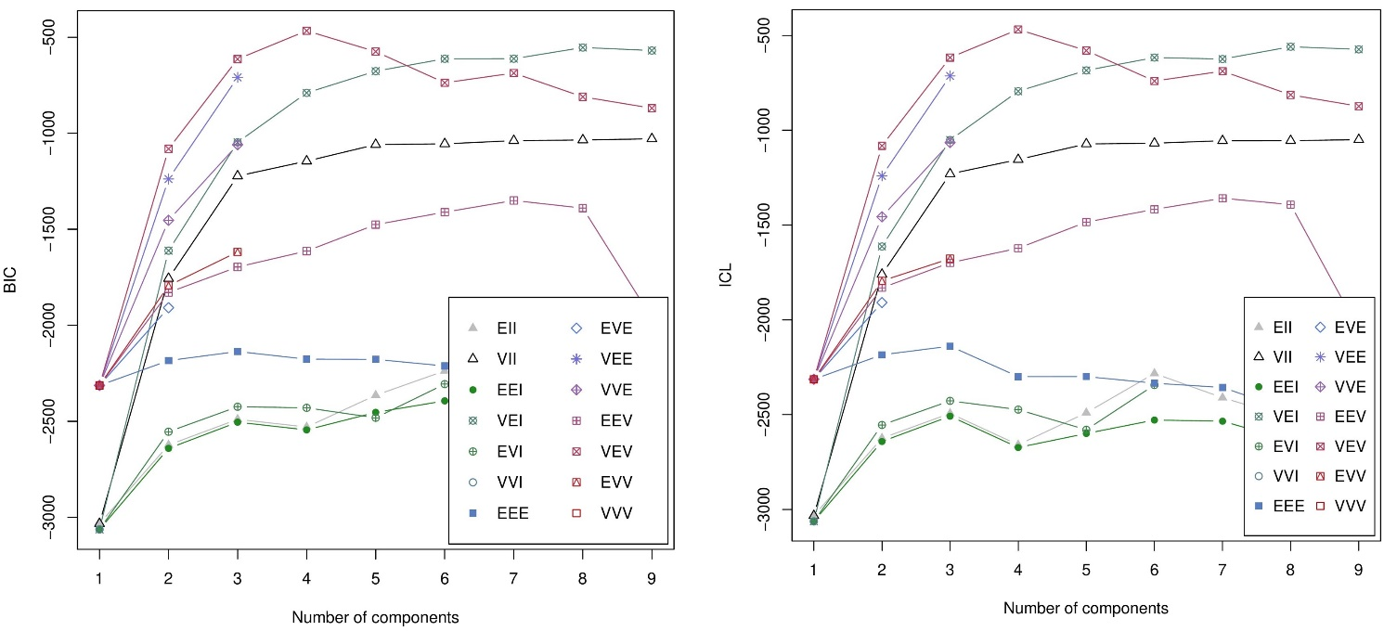
Figure S2. BIC and ICL plots. The optimal number of clusters was determined using the (A) Bayesian Information Criterion (left) and (B) Integrated Completed Likelihood Criterion (right). Lower absolute BIC and ICL values represented better model fit.

