Supplementary materials

Supplementary Table 1. Demographic and clinical characteristics of 414 consecutive surgical patients with histopathologically confirmed glioblastoma in Southeast Scotland between April 2012 and May 2020 stratified by clinical threshold for MGMT promoter methylation

Supplementary Table 2. Multivariable survival analysis of 191 patients with methylated glioblastoma using an accelerated failure time model

Supplementary Table 3. Multivariable survival analysis of 248 patients with glioblastoma who received 60Gy of radiotherapy

Supplementary Table 4. Multiple logistic regression on deaths within 2 years of glioblastoma diagnosis

Supplementary Table 5. Multivariable survival analysis of 138 older (≥65 years) patients

Supplementary Table 6. Interaction models between logarithmically transformed MGMT promoter methylation and temozolomide use on survival in 414 glioblastoma patients

Supplementary Table 7. Interaction models between MGMT promoter methylation subgroups and temozolomide use on survival in 414 glioblastoma patients

Supplementary Figure 1. Histograms showing the distribution of total concomitant and adjuvant temozolomide cycles stratified by MGMT methylation groups

Supplementary Table 1. Demographic and clinical characteristics of 415 consecutive surgical patients with histopathologically confirmed glioblastoma in Southeast Scotland between April 2012 and May 2020 stratified by clinical threshold for MGMT promoter methylation
Characteristics | Overall  N = 414  N (%) | Unmethylated†  N = 223  N (%) | Methylated†  N = 191  N (%)
Age at diagnosis (median, IQR) | 61 (54-68) | 62 (54-68) | 61 (53-68)
Sex
Male | 238 (57.5) | 147 (65.9) | 91 (47.6)
Female | 176 (42.5) | 76 (34.1) | 100 (52.4)
Post-operative KPS
<70 | 62 (15.0) | 34 (15.2) | 28 (14.7)
70+ | 352 (85.0) | 189 (84.8) | 163 (85.3)
Extent of resection‡
Biopsy | 158 (38.2) | 90 (40.4) | 68 (35.6)
Subtotal | 88 (21.3) | 43 (19.3) | 45 (23.6)
Gross total | 168 (40.6) | 90 (40.4) | 78 (40.8)
Temozolomide regimen§
None | 176 (42.5) | 112 (50.2) | 64 (33.5)
Non-completed | 172 (41.5) | 95 (42.6) | 77 (40.3)
Standard | 66 (15.9) | 16 (7.2) | 50 (26.2)
Radiotherapy
None | 48 (11.6) | 26 (11.7) | 22 (11.5)
<60Gy | 118 (28.5) | 76 (34.1) | 42 (22.0)
60Gy | 248 (59.9) | 121 (54.3) | 127 (66.5)

†Clinical threshold for MGMT promoter methylation was 6.4%, above which indicated the presence of MGMT methylation. ‡Subtotal resection represented 50-89% resection of contrast-enhancing tumour, gross total resection represented ≥90% resection. §Standard temozolomide was in accordance with the Stupp protocol, non-completed regimen referred to less than the total dose of the standard regimen. IQR = interquartile range; KPS = Karnofsky Performance Score. To avoid multiple testing, no p-values are reported in this table.

Supplementary Table 2. Multivariable survival analysis of 191 patients with methylated glioblastoma using an accelerated failure time model

Variable | No. of patients | HR (95% CI) | p-value
MGMT promoter methylation
Logarithmic continuous | 191 | 0.89 (0.71-1.12) | 0.314
Temozolomide regimen§
None | 64 | ref | -
Non-completed | 77 | 0.31 (0.21-0.47) | <0.001
Standard | 50 | 0.16 (0.10-0.27) | <0.001
Age at diagnosis (per year) | 191 | 1.03 (1.01-1.04) | 0.002
Post-operative KPS
<70 | 28 | ref | -
≥70 | 163 | 0.33 (0.20-1.55) | 0.440
Extent of Resection‡
Biopsy | 68 | ref | -
Subtotal | 45 | 0.97 (0.61-1.55) | 0.896
Gross total | 78 | 0.49 (0.33-0.75) | <0.001
Radiotherapy
None | 22 | ref | -
<60Gy | 42 | 0.26 (0.14-0.48) | <0.001
60Gy | 127 | 0.22 (0.12-0.40) | <0.001

‡Subtotal resection represented 50-89% resection of contrast-enhancing tumour, gross total resection represented ≥90% resection. §Standard temozolomide was in accordance with the Stupp protocol, non-completed regimen referred to less than the total dose of the standard regimen. HR = Hazard ratio; CI = confidence interval; KPS = Karnofsky Performance Score.

Supplementary Table 3. Multivariable survival analysis of 248 patients with glioblastoma who received 60Gy of radiotherapy

Variables | No. of patients | Model 1 |  | Model 2
 |  | HR (95% CI) | p-value | HR (95% CI) | p-value
MGMT promoter methylation†
Logarithmic continuous | 248 | 0.70 (0.63-0.78) | <0.001 | - | -
Unmethylated | 121 | - | - | ref | -
Low methylation | 52 | - | - | 0.56 (0.39-0.81) | 0.002
High methylation | 75 | - | - | 0.35 (0.26-0.49) | <0.001
Temozolomide regimen§
None | 53 | ref | - | ref | -
Non-completed | 133 | 0.63 (0.45-0.90) | 0.011 | 0.62 (0.44-0.88) | 0.007
Standard | 62 | 0.20 (0.13-0.31) | <0.001 | 0.19 (0.12-0.30) | <0.001
Age at diagnosis (per year) | 248 | 1.04 (1.02-1.05) | <0.001 | 1.04 (1.02-1.05) | <0.001
Post-operative KPS
<70 | 9 | ref | - | ref | -
≥70 | 239 | 0.21 (0.10-0.41) | <0.001 | 0.20 (0.10-0.41) | <0.001
Extent of Resection‡
Biopsy | 58 | ref | - | ref | -
Subtotal | 57 | 1.40 (0.94 -2.08) | 0.098 | 1.34 (0.90-2.00) | 0.148
Gross total | 133 | 0.66 (0.47-0.94) | 0.019 | 0.68 (0.48-0.96) | 0.029

Model 1 used the logarithmically transformed MGMT methylation values; Model 2 used the three methylation groups determined by clinical threshold and the Youden Index. †High and low methylation groups generated using Youden Index with optimal cut-off point of 25.9%. Unmethylated group represented <6.4% methylation (clinical threshold). ‡Subtotal resection represented 50-89% resection of contrast-enhancing tumour, gross total resection represented ≥90% resection. §Standard temozolomide was in accordance with the Stupp protocol, non-completed regimen referred to less than the total dose of the standard regimen. HR = hazard ratio; CI = confidence interval; MGMT = O-6 methylguanine-DNA methyltransferase; KPS = Karnofsky Performance Score; ref = reference.

Supplementary Table 4. Multiple logistic regression on deaths within 2 years of glioblastoma diagnosis

Variables | No. of patients | Model 1 |  | Model 2
 |  | OR (95% CI) | p-value | OR (95% CI) | p-value
MGMT promoter methylation†
Logarithmic continuous | 414 | 0.45 (0.33-0.61) | <0.001 | - | -
Unmethylated | 223 | - | - | ref | -
Low methylation | 81 | - | - | 0.33 (0.13-0.84) | 0.019
High methylation | 110 | - | - | 0.14 (0.06-0.32) | <0.001
Temozolomide regimen§
None | 176 | ref | - | ref | -
Non-completed | 172 | 0.16 (0.04-0.52) | 0.006 | 0.15 (0.03-0.49) | 0.004
Standard | 66 | 0.02 (0.00-0.07) | <0.001 | 0.02 (0.00-0.09) | <0.001
Age at diagnosis (per year) | 414 | 1.05 (1.02-1.08) | <0.001 | 1.05 (1.02-1.08) | <0.001
Extent of Resection‡
Biopsy | 158 | ref | - | ref | -
Subtotal | 88 | 0.99 (0.34-2.94) | 0.986 | 0.86 (0.30-2.50) | 0.800
Gross total | 168 | 0.41 (0.16-0.98) | 0.049 | 0.42 (0.17-0.99) | 0.053

Model 1 used the logarithmically transformed MGMT methylation values; Model 2 used the three methylation groups determined by clinical threshold and the Youden Index. †High and low methylation groups generated using Youden Index with optimal cut-off point of 25.9%. Unmethylated group represented <6.4% methylation (clinical threshold). ‡Subtotal resection represented 50-89% resection of contrast-enhancing tumour, gross total resection represented ≥90% resection. §Standard temozolomide was in accordance with the Stupp protocol, non-completed regimen referred to less than the total dose of the standard regimen. OR = Odds ratio; CI = confidence interval; MGMT = O-6 methylguanine-DNA methyltransferase; KPS = Karnofsky Performance Score; ref = reference.

Supplementary Table 5. Multivariable survival analysis of 168 older (≥65 years) patients

Variables | No. of patients | Model 1 |  | Model 2
 |  | HR (95% CI) | p-value | HR (95% CI) | p-value
MGMT promoter methylation†
Logarithmic continuous | 168 | 0.86 (0.75-0.99) | 0.03 | - | -
Unmethylated | 92 | - | - | ref | -
Low methylation | 30 | - | - | 0.60 (0.39-0.94) | 0.026
High methylation | 46 | - | - | 0.67 (0.43-1.05) | 0.0.81
Temozolomide regimen§
None | 93 | ref | - | ref | -
Non-completed | 65 | 0.48 (0.33-0.69) | <0.001 | 0.48 (0.34-0.70) | <0.001
Standard | 10 | 0.15 (0.07-0.34) | <0.001 | 0.15 (0.07-0.33) | <0.001
Age at diagnosis (per year) | 168 | 0.94 (0.89-1.00) | 0.042 | 0.95 (0.90-1.00) | 0.056
Post-operative KPS
<70 | 25 | ref | - | ref | -
≥70 | 143 | 0.34 (0.21-0.55) | <0.001 | 0.34 (0.21-0.55) | <0.001
Extent of Resection‡
Biopsy | 63 | ref | - | ref | -
Subtotal | 40 | 0.84 (0.52-1.36) | 0.475 | 0.82 (0.51-1.33) | 0.425
Gross total | 65 | 0.44 (0.28-0.68) | <0.001 | 0.41 (0.27-0.64) | <0.001
Radiotherapy
None | 23 | ref | - | ref | -
<60Gy | 82 | 0.58 (0.35-0.97) | 0.037 | 0.57 (0.34-0.95) | 0.031
60Gy | 63 | 0.40 (0.22-0.76) | 0.005 | 0.39 (0.21-0.74) | 0.004

Model 1 used the logarithmically transformed MGMT methylation values; Model 2 used the three methylation groups determined by clinical threshold and the Youden Index. †High and low methylation groups generated using Youden Index with optimal cut-off point of 25.9%. Unmethylated group represented <6.4% methylation (clinical threshold). ‡Subtotal resection represented 50-89% resection of contrast-enhancing tumour, gross total resection represented ≥90% resection. §Standard temozolomide was in accordance with the Stupp protocol, non-completed regimen referred to less than the total dose of the standard regimen. HR = hazard ratio; CI = confidence interval; MGMT = O-6 methylguanine-DNA methyltransferase; KPS = Karnofsky Performance Score; ref = reference.

Supplementary Table 6. Interaction models between logarithmically transformed MGMT promoter methylation and temozolomide use on survival in 414 glioblastoma patients

 | HR (95% CI) | p-value
Interaction between MGMT and TMZ§
No TMZ | ref | -
log(MGMT) + no TMZ | 1.07 (0.95-1.21) | 0.258
log(MGMT) + non-completed TMZ regimen | 0.79 (0.55-1.13) | 0.197
log(MGMT) + standard TMZ regimen | 0.25 (0.13-0.46) | <0.001
Age at diagnosis (per year) | 1.03 (1.01-1.04) | <0.001
Post-operative KPS
<70 | ref | -
≥70 | 0.41 (0.30-0.56) | <0.001
Extent of Resection‡
Biopsy | ref | -
Subtotal | 0.99 (0.75-1.32) | 0.969
Gross total | 0.55 (0.43-0.71) | <0.001
Radiotherapy
None | ref | -
<60Gy | 0.35 (0.24-0.49) | <0.001
60Gy | 0.29 (0.19-0.42) | <0.001

Hazard ratios were reparameterised from the models. Model 1 used the logarithmically transformed MGMT methylation values; Model 2 used the three methylation groups determined by clinical threshold and the Youden Index. §Standard temozolomide was in accordance with the Stupp protocol, non-completed regimen referred to less than the total dose of the standard regimen. HR = hazard ratio; CI = confidence interval; MGMT = O-6 methylguanine-DNA methyltransferase; TMZ = temozolomide; ref = reference.

Supplementary Table 7. Interaction models between MGMT promoter methylation subgroups and temozolomide use on survival in 414 glioblastoma patients

 | HR (95% CI) | p-value
Interaction between MGMT and TMZ§
Unmethylated + no TMZ | ref | -
Unmethylated + non-completed TMZ regimen | 0.79 (0.58-1.09) | 0.153
Unmethylated + standard TMZ regimen | 0.23 (0.13-0.42) | <0.001
Low methylation + no TMZ | 1.20 (0.79-1.81) | 0.392
Low methylation + non-completed TMZ regimen | 0.29 (0.18-0.45) | <0.001
Low methylation + standard TMZ regimen | 0.13 (0.07-0.25) | <0.001
High methylation + no TMZ | 1.18 (0.79-1.76) | 0.428
High methylation + non-completed TMZ regimen | 0.27 (0.18-0.40) | <0.001
High methylation + standard TMZ regimen | 0.13 (0.08-0.22) | <0.001
Age at diagnosis (per year) | 1.02 (1.01-1.03) | <0.001
Post-operative KPS
<70 | ref | -
≥70 | 0.41 (0.30-0.57) | <0.001
Extent of Resection‡
Biopsy | ref | -
Subtotal | 0.97 (0.73-1.29) | 0.824
Gross total | 0.54 (0.42-0.70) | <0.001
Radiotherapy
None | ref | -
<60Gy | 0.37 (0.26-0.53) | <0.001
60Gy | 0.29 (0.20-0.43) | <0.001

Hazard ratios were reparameterised from the models. Model 1 used the logarithmically transformed MGMT methylation values; Model 2 used the three methylation groups determined by clinical threshold and the Youden Index. §Standard temozolomide was in accordance with the Stupp protocol, non-completed regimen referred to less than the total dose of the standard regimen. HR = hazard ratio; CI = confidence interval; MGMT = O-6 methylguanine-DNA methyltransferase; TMZ = temozolomide; ref = reference.

Supplementary Figure 1. Histograms showing the distribution of total concomitant and/or adjuvant temozolomide cycles stratified by MGMT methylation groups in those receiving non-completed temozolomide regimen

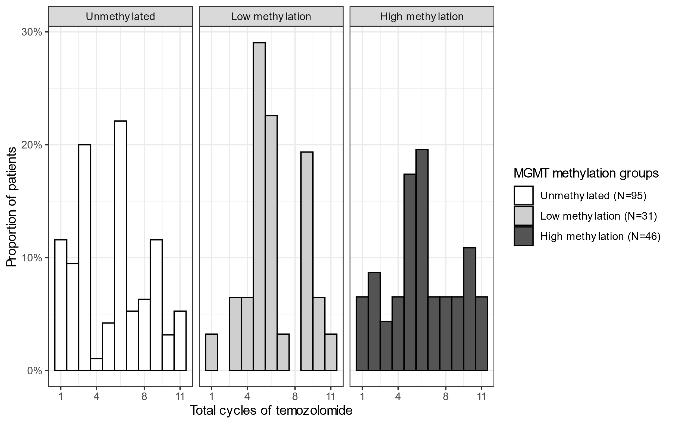
There were 172 patients receiving less than standard temozolomide regimen. 6 weeks of concomitant daily temozolomide with radiotherapy were considered 6 cycles. Adjuvant temozolomide cycles referred to 28-day cycles when temozolomide was taken for 5 days within each cycle.

